A Report on 'The Assimilation Game' by Samuel Stark

In the previous report, I looked at the results of a questionnaire I sent around the school on the game. The results showed that people wanted a game that was short, with a realistic art style. This influenced the direction I went in when starting to making the game, and when one of my friends suggested that the game be based on the Borg from Star Trek, I immediately realized that it would fit perfectly. In short, the game will be short, but with a story, will have simplified RPG elements and a realistic art style, and be based around the Borg.

The Game Design

The game is a top-down horizontal shoooter, where enemies come in from the left and right sides of the screen, while the player moves around the screen and shoots at them. The user controls their ship by using WSAD to move and using the mouse to shoot. The player has health, and if it runs out, the player dies and the game returns to the main menu.

The game is structured similarly to Mega Man and Mighty No. 9. The levels take place in different areas of space, with the end-of-level bosses using different pieces of technology that you assimilate after they are defeated. These pieces of technology are powerful against other bosses, so defeating bosses in a certain order is encouraged. This lets me program in a difficulty curve for new players but experienced gamers can jump right in and do the levels in any order.

So far, the enemies only move across the screen and shoot at you, but I hope to put in enemies that move across the screen similar to how they move in the old shoot-em-ups like 1942 and R-Type, where they move up and down as well. The bosses will normally be stationary, large enemies with large weapons, and a lot of health.

The normal enemies will also leave items when they die, and you can pick the items up for temporary powerups like in the Kirby games. These are lost on death or when a level ends. Some of the powerups will be:
1) A sentry gun that will attach to the top of your ship and shoot at nearby enemies
2) A shield that protects you from incoming damage from where you are facing
3) A booster that attaches to your back and increases forward movement speed

The Graphical Design

This game is centred around the Borg, an alien race from Star Trek that seek to become the ultimate life form by taking technology and adding it to themselves, a process known as assimilation. They have a very distinctive UI design based on green circles. This is what the menu design of the game will be based on as well.

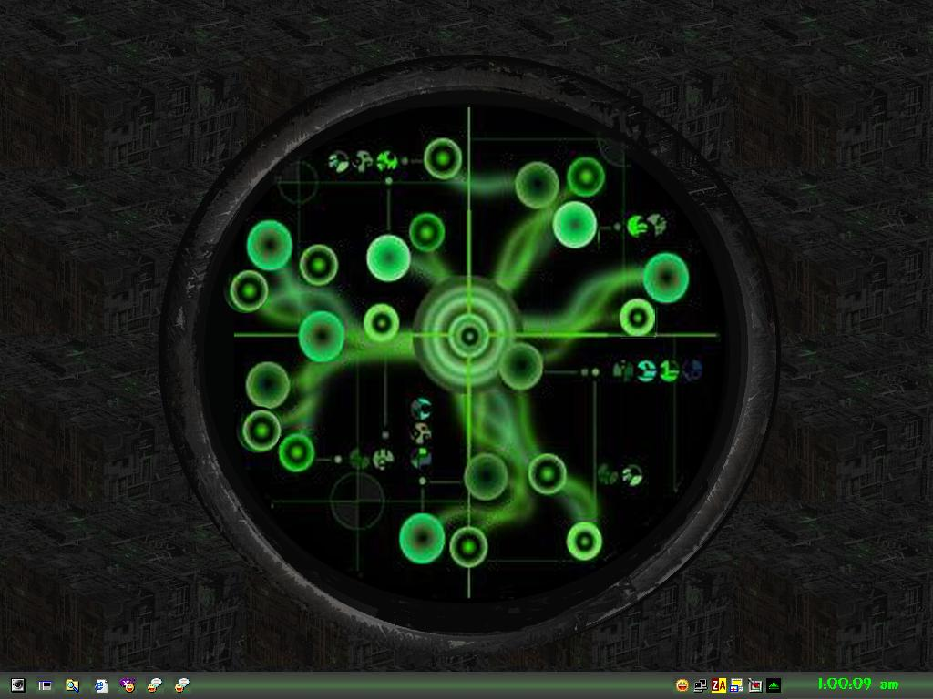
The base for all of the menu is a black circle with an outline similar to the design of the ship. There is a central node in the middle with lots of little nodes connecting to it. The buttons the player use will be the little nodes, with text on them to show the player what they do.

Whenever a button is clicked, a signal will be sent to the central node from the button that was clicked, and the central node expands to fill the screen and then displays the menu the button specified.

The in-game UI is a little bit different, because it is based more on the ship design, and not on the Borg's computers. In the upper-left and upper-right corners there are parts of a Borg ship texture. These are what the score and health of the player are displayed on. The score is displayed in numbers that change colour to give a sense of pulsing energy, and the health is displayed as a bar that gets shorter and changes colour from green to black as the player loses health.

The Borg ship that you play as in-game has the typical Borg ship look, but as that is quite hard to see in space, I made the green bits glow to make the ship stand out. This has an added bonus of making it look more authentic, as the Borg ships from Star Trek also 'pulse'.

The enemy design hasn't been finalized, but it will mainly be based on the Federation ships from Star Trek: Voyager, and the final boss will be the Voyager ship from that show.

The Program Architecture

The game is based on the Unity engine, but there is still a lot that needs to be programmed before the game is good. The GameObjects normally communicate by collision, but they can also call functions in others from scripts if they so choose. The main components of that game are as follows: There are the Handlers, which manage things like the score, the UI, and the screen; There are the enemies, who use state machines to move/attack; There are the powerups, that apply a state to the player on collision; and there is the player, who move/attack based on input, which Unity handles.

