**→ ACORS Clothing ←**

|  |  |  |
| --- | --- | --- |
| ACORS CONSULTING SERVICES CONTACT INFORMATION | | |
| Name: | E-Mail Address: | Phone: |
| Kun Tang | kun_t90@hotmail.com | (312) 882-1766 |
| Chris Thomas | webmaster102@gmail.com | (516) 361-6214 |
| Zhiwei Zhang | 314005617@qq.com | (347) 238-7982 |

**I. PURPOSE**

The purpose of this document is to describe the design and implementation of the ACOR System. This document translates the “User Functional Requirements” described in the functional requirement document into the technical specification that defines the solution of the system.

This document details the design of the functional requirements that are deemed in scope for development and implementation as described in the functional requirement document. The design consists of three integrated modules (Customer, Employee and Manager) that facilitate the core user functions and business operations of the system.

**1.1 Methodology**:

The Rapid Application Development methodology is used to define the specifications of the system. Prototype of screens is used throughout this document to provide a visual depiction of the specifications and to provide clarity of the design.

**1.2 Document Organization**:

This document is divided into the following main sections as described below. Some sections are further divided into sub-sections according to business functions or roles.

**1.2.1 Overview**:

This section states the purpose or primary role of the ACOR System within the Institute’s cooperation, and the user and business functions it is expected to facilitate.

**1.2.2 Application Architecture**:

This section provides a general overview of the application architecture. It includes information about shared or common services, and elements considered in the design phase to create the general layout and design of the system to ensure consistency across all modules.

**1.2.3 Detailed Application Design**:

This section defines the technical specifications of the application. The details are organized by modules (Customer, Employee and Manager) to provide a clear and consistent flow of the design and operation of the module, each service within the module, and the operation of the service from the point of access or login and user service selection, to user input or operation, to the corresponding system processing of specified business rules and expected output. Special design consideration has been implemented to reduce human errors and to maintain accuracy of data by using preset field values and dynamically building field selection values based on specific conditions being met.

In addition, actual prototypes or screens are used in this section to define the specifications related to the specific user functional requirements.

**1.2.4 System Infrastructure Design**:

This section defines the layout and design of the backend data structure. It includes details about the database foundation that include data entities and their relationships. It provides a detailed view of the database objects (tables), fields and attributes.

**1.2.5 Technology**:

This section describes the technologies that make up the system environment and the components required to access and use the system.

**1.2.6 Appendix**:

This section includes supplemental information.

**II. OVERVIEW**

The ACOR System is an online web-based system. This is a self-service system that enables users to quickly, easily, and conveniently access and use the services of the Online Ordering System in a safe and secure manner. This system addresses customer clothing ordering needs, and administrative and business operational needs of the online corporation.

**III. SYSTEM DESCRIPTION**

To illustrate writing database applications, our team will develop a web-based ordering and reporting system for Apex Clothing, a clothing seller, to support its operations. The system is called The Apex Clothing Ordering & Reporting System, or just ACORS. It will allow customers to place orders, look at past orders, and the suppliers to update clothes and customer data, and generate reports. The ACORS database will store information about clothes such as their sizes, brands, prices, genders, styles, quantities in stock, customer and order information, and so on.

Although ACORS is a relatively simple application from a database perspective, the user interface makes it complex. Before we start designing ACORS, we will need tis requirements. Specifying the requirements to cover every aspect of even a simple software system precisely and unambiguously is a non-trivial task and our team will show a detailed requirement as follows.

**ACORS FUNCTIONALITY**

* 1. Apex Clothing is a clothes seller that:
     1. Buys clothes from retailers and distributors
     2. Sells clothes to customers.

3.2 Apex Clothing needs ACORS so that it can support its growing online business in an automated fashion. The ACORS web interface should allow customers to buy clothes by providing functionality, for example, to:

* + 1. Search for clothes
    2. Register and login
    3. Place orders
    4. Lookup order status
  1. ACORS should allow Apex Clothing employees to perform tasks such as

3.3.1. Look up customer information,

3.3.2. Generate sales reports for various periods,

3.3.3. Generate sales per clothes reports for various periods,

3.3.4. Generate sales per customer reports for various periods,

3.3.5. List the top *n* clothes in sales,

3.3.6. List the top *n* customers in sales,

3.3.7. Generate a variety of analysis report

|  |  |  |
| --- | --- | --- |
| **WORK ALLOCATION** | **Database Management**  [RDBMS, Schemas, SQL] | Zhiwei Zhang |
| **Application (Front-End)** [HTML/CSS/JavaScript] | Chris Thomas |
| **Server-Side (Back-End)**  [JDBC/Java Server Faces] | Kun Tang |
| * Though the work is allocated to different members in the team, members should contact with each other frequently to make sure that everything goes well in each part. | | |

|  |  |  |
| --- | --- | --- |
| **Month:** | **Week:** | **Task:** |
| **February** | 2 | General System Description;  Time schedule;  Task distribution;  Requirements. |
| 3 | Complete design document |
| 4 | Implementation begins |
| 5 | Implementation |
| 6 | Implementation |
| **March** | 7 | Implementation |
| 8 (Midterm: March 13th15th) | Hand in the current system |
| 9 | Implementation and Testing |
| 10 | Testing |
| **April** | 11 | Manual Preparation |
| 12 | User Manual |
| 13 | Final exam preparation |
| 14 | PPT and other final preparation |
| **May** | 15 | Demonstration |
| 16 | Final Examination |

**IV. SYSTEM ARCHITECTURE**

The application design consists of two integrated modules, Customer and Employee, to assist the functional requirements of each role.

* 1. **Services**:

|  |  |  |  |
| --- | --- | --- | --- |
| **Ordering** | | **Reporting** | |
| Customer | Employee | Customer | Employee |
| Register  Login  Search  Place Order  Payment  Confirmation | Register  Login  Deals with order | Lookup order status  Update order status  Update personal information | See above in *ACORS Functionality (#3)* |

* 1. **User Interface Overview**:
     1. The user interface design provides a dynamic look and feel throughout the entire system. It consists of a combination of HTML and Java Server format webpages, designed mainly in Adobe Dreamweaver and NetBeans 7.0.
  2. **General Layout & Design**:
     1. The overall layout and design of the system is to create a user-friendly experience and a safe and secure system environment for both the customer and employee.
  3. **Screens** (See further info on next page):

|  |  |  |
| --- | --- | --- |
| **Screen Name:** | **Filename:** | **Module:** |
| Homepage | Index.jsp | Customer, Employee |
| Register | Register. jsp | Customer, Employee |
| Login | Login. jsp | Customer, Employee |
| Basic Search | BasicSearch. jsp | Customer, Employee |
| Advanced Search | AdvancedSearch. jsp | Customer, Employee |
| Place Order | Order. jsp | Customer |
| Payment | Payment. jsp | Customer |
| Confirmation | Confirm. jsp | Customer |
| Order Status | OrderStatus. jsp | Customer |
| Customer Information | CInfo. jsp | Customer, Employee |
| Product Information | ProductInfo. jsp | Customer, Employee |

* 1. **File Structure**:
     1. Reference for a view of the ACORS site root folder and sub folders that contain the screen files, scripts, and images will be upon request.
  2. **User Front-End Screen-Shots**:
     1. **Homepage**:



* + 1. **Registration**:

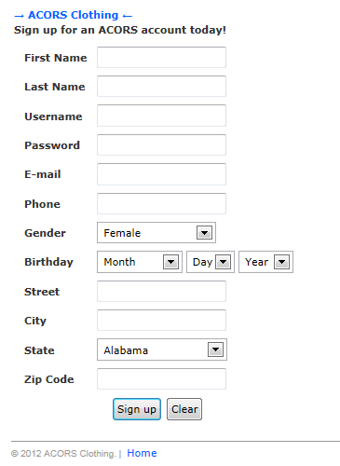

* + 1. **Login**:

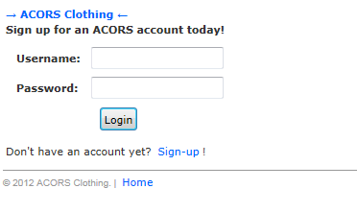

* + 1. **Basic Search**:

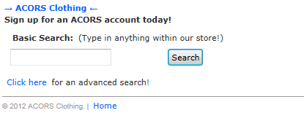

* + 1. **Advanced Search**:

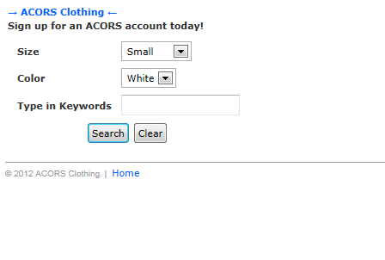

* + 1. **Placing Orders**:

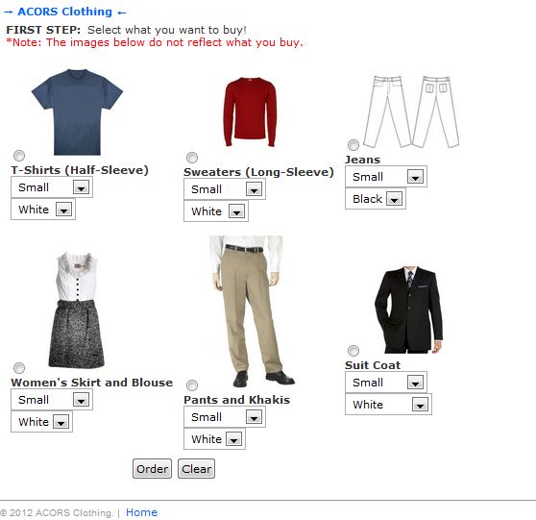

* + 1. **Payment**:

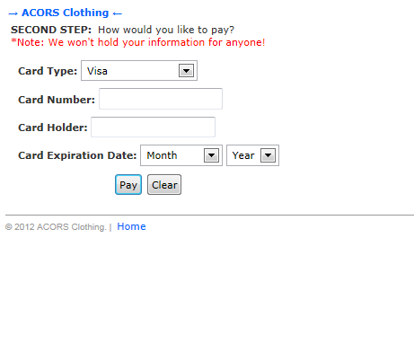

* + 1. **Confirmation**:

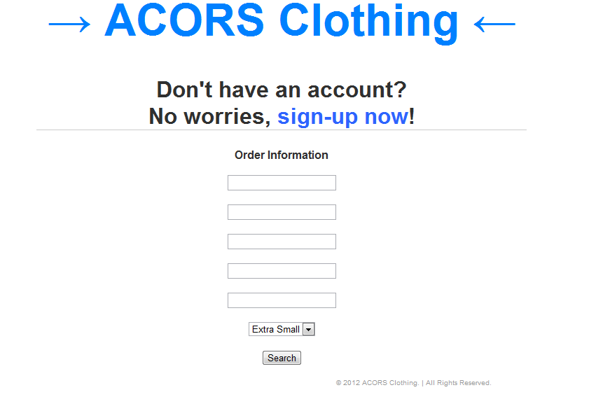

* + 1. **Order Status**:



* + 1. **Customer Information**:



* + 1. **Product Information**:



**V. SYSTEM INFRASTRUCTURE DESIGN**

**5.1 Entity-Relationship Diagram**

The following section defines the entity sets and relationship set between database objects.

**1**

**M**

**1**

**M**

**Customer Registration**

CID

CLoginID

CPassword

Has

**Staff Login**

SLoginID

SPassword

Has

**User**

UID

UPassword

**1**

Has

**1**

**1**

**M**

Has

**1**

**Order Details**

OID

PID

**Customer Information**

CID

FName

LName

Gender

Order

**N**

**Product**

PID

ProductName

Brand

Size

Category

Price

Gender

Remainder

**1**

**1**

Has

**1**

Has

**1**

**Credit Card**

CID

CardID

FName

LName

CardType

SecurityNum

ExpiryDate

Has

**1**

**M**

**Shipping Address**

Street

City

State

Zip

OID

CID

**1**

**Billing Address**

Street

City

State

Zip

CardID

Has

**1**

**5.2 Entity Sets**

1. User (UID, UPassword)

2. CustomerRegistration (CID, CLoginID, CPassword, UID references User）

3. CustomerInformation (FName, LName, Gender, Tel, CID references Customer Registration)

2. StaffLogin (SLoginID, SPassword, UID references User)

3. Product (PID, ProductName, Brand, Size, Category, Price, Gender, Remainder)

6. Order (Quanity, Price, OrderDate, OID refrences Order Details)

7. OrderDetails (OID, CID references Customer Information, PID references Product)

8. CreditCard (FName, LName, CardType, CardID, SecutityNum, ExpiryDate, CID references Customer Information)

9. ShippingAddress (Street, City, State, Zip, CID reference Customer Information, OID references Order)

10. BillingAddress (Street, City, State, Zip, CardID references Credit Card)

**5.3 Tables**

The system database design consists of the following objects. These objects are listed in Table ID (name) below.

|  |  |
| --- | --- |
| **Object#** | **Table ID** |
| **1** | **User** |
| **2** | **Customer Registration** |
| **3** | **Staff Log In** |
| **4** | **Customer Information** |
| **5** | **Product** |
| **6** | **Order** |
| **7** | **Order Detail** |
| **8** | **Credit Card** |
| **9** | **Shipping Address** |
| **10** | **Billing Address** |

**5.4 Database Objects**

The following section defines the specifications of each table as shown in the objects below. Details include the table name, fields, and attributes.

**User**

|  |  |  |  |  |  |
| --- | --- | --- | --- | --- | --- |
| **Field** | **Type** | **Null** | **Key** | **Default** | **Extra** |
| UID | varchar(50) | × | PRI |  |  |
| UPassword | varchar(50) | × |  |  |  |

**Customer Registration**

|  |  |  |  |  |  |
| --- | --- | --- | --- | --- | --- |
| **Field** | **Type** | **Null** | **Key** | **Default** | **Extra** |
| **CID** | varchar(50) | × | **PRI** |  |  |
| CLoginID | varchar(50) | × | PRI |  |  |
| CPassword | varchar(50) | × |  |  |  |

**Staff Log In**

|  |  |  |  |  |  |
| --- | --- | --- | --- | --- | --- |
| **Field** | **Type** | **Null** | **Key** | **Default** | **Extra** |
| SLoginID | varchar(50) | × | PRI |  |  |
| SPassword | varchar(50) | × |  |  |  |

**Product**

|  |  |  |  |  |  |
| --- | --- | --- | --- | --- | --- |
| **Column** | **Type** | **Null** | **Key** | **Default** | **Extra** |
| PID | varchar(100) | × | PRI |  |  |
| ProductName | varchar(50) | × |  |  |  |
| Brand | varchar(50) | × |  |  |  |
| Size | varchar(10) | × |  |  |  |
| Category | varchar(50) | × |  |  |  |
| Price | numeric(10,2) | × |  |  |  |
| Gender | varchar(50) | × |  |  |  |
| Remainder | int | × |  |  |  |

**Order**

|  |  |  |  |  |  |
| --- | --- | --- | --- | --- | --- |
| **Field** | **Type** | **Null** | **Key** | **Default** | **Extra** |
| **OID** | **varchar(50)** | × | **PRI** |  |  |
| Price | numeric(10,2) | × |  |  |  |
| ProductName | varchar(50) | × |  |  |  |
| Quanity | int | × |  |  |  |

**Order Details**

|  |  |  |  |  |  |
| --- | --- | --- | --- | --- | --- |
| **Field** | **Type** | **Null** | **Key** | **Default** | **Extra** |
| **OID** | **varchar(50)** | × | **PRI** |  |  |
| CID | varchar(50) | × | **PRI** |  |  |
| PID | varchar(50) | × | **PRI** |  |  |

**Customer information**

|  |  |  |  |  |  |
| --- | --- | --- | --- | --- | --- |
| **Column** | **Type** | **Null** | **Key** | **Default** | **Extra** |
| CID | varchar(50) | × | PRI |  |  |
| FName | varchar(50) | × |  |  |  |
| LName | varchar(50) | × |  |  |  |
| Gender | varchar(50) | × |  |  |  |
| Tel | varchar(20) | √ |  |  |  |

**Credit Card**

|  |  |  |  |  |  |
| --- | --- | --- | --- | --- | --- |
| **Column** | **Type** | **Null** | **Key** | **Default** | **Extra** |
| CID | varchar(50) | × | PRI |  |  |
| FName | varchar(50) | × |  |  |  |
| LName | varchar(50) | × |  |  |  |
| CardType | varchar(20) | × |  |  |  |
| CardID | nchar(16) | × | PRI |  |  |
| SecurityNum | nchar(4) | × |  |  |  |
| ExpiryDate | datetime | × |  |  |  |

**Shipping Address**

|  |  |  |  |  |  |
| --- | --- | --- | --- | --- | --- |
| **Column** | **Type** | **Null** | **Key** | **Default** | **Extra** |
| CID | varchar(50) | × | PRI |  |  |
| OID | varchar(50) | × | PRI |  |  |
| Street | text | × |  |  |  |
| City | varchar(50) | × |  |  |  |
| State | varchar(50) | × |  |  |  |
| Zip | varchar(50) | × |  |  |  |

**Billing Address**

|  |  |  |  |  |  |
| --- | --- | --- | --- | --- | --- |
| **Column** | **Type** | **Null** | **Key** | **Default** | **Extra** |
| CardID | nchar(16) | × | PRI |  |  |
| Street | varchar(50) | × |  |  |  |
| City | varchar(50) | × |  |  |  |
| State | varchar(50) | × |  |  |  |
| Zip | varchar(50) | × |  |  |  |