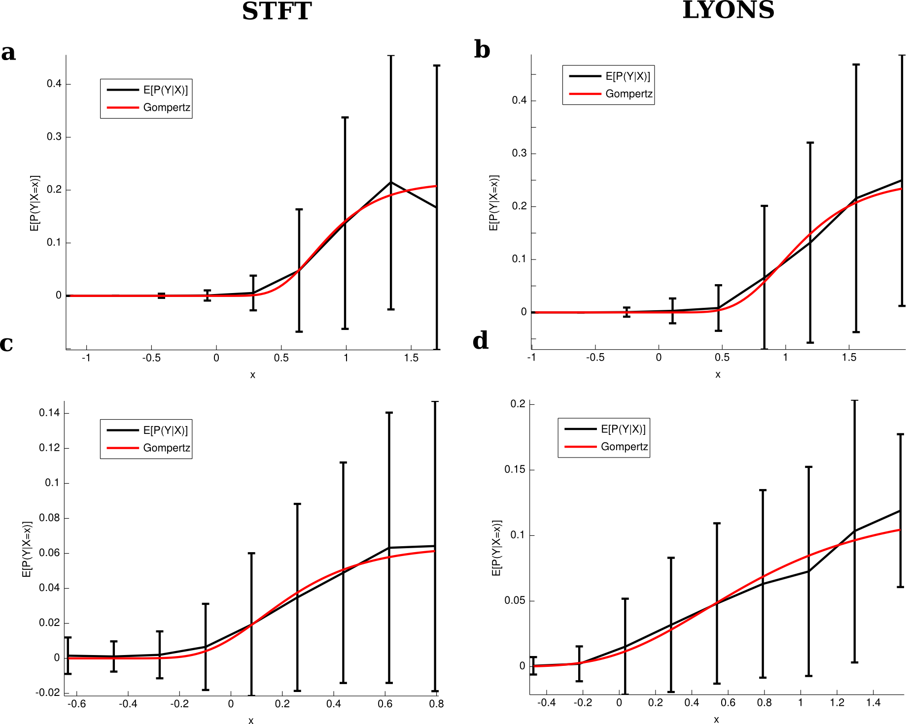
Figure 1: Plots of the linear-prediction conditioned PSTH (black) and gompertz curves fit to it (red). These curves are a way of visualizing potential output nonlinearities given a fixed linear model. They show a tendency towards sigmoids, both for STFT preprocessing (left column) and Lyon's preprocessing (right column).

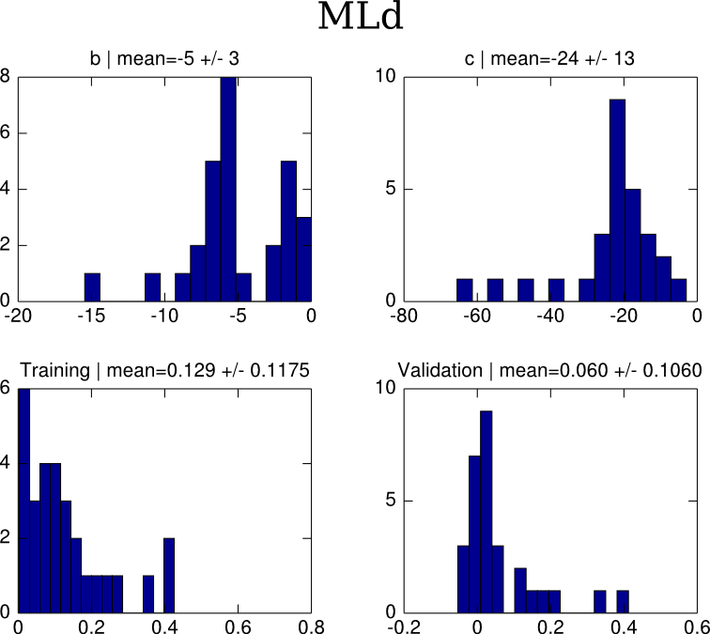
Figure 2: Summary data for nonlinear sigmoid fits for Mld cells. Upper histograms are paramers b and c of the gompertz curve. Lower plots are the performance ratios for training and validation data.

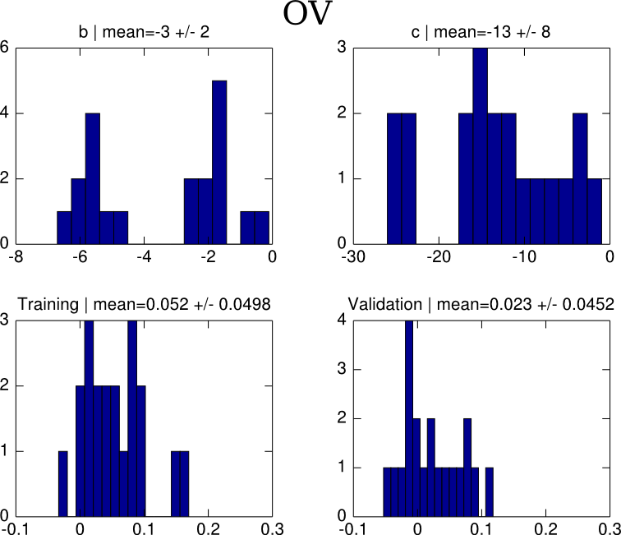
Figure 3: Summary data for nonlinear sigmoid fits for OV cells. Upper histograms are paramers b and c of the gompertz curve. Lower plots are the performance ratios for training and validation data.

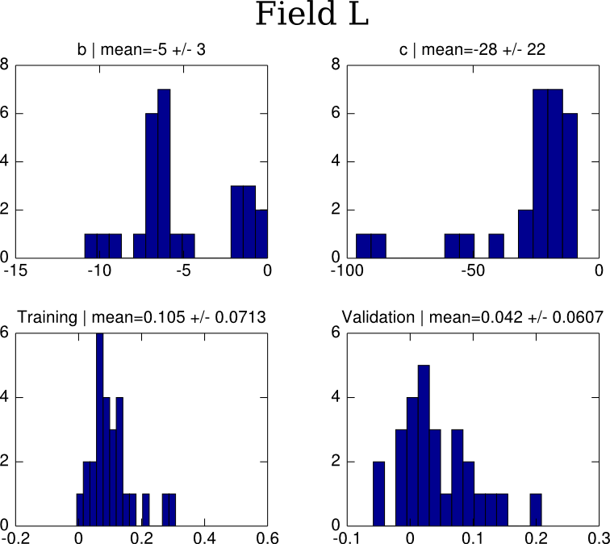

Figure 4: Summary data for nonlinear sigmoid fits for Field L cells. Upper histograms are paramers b and c of the gompertz curve. Lower plots are the performance ratios for training and validation data.

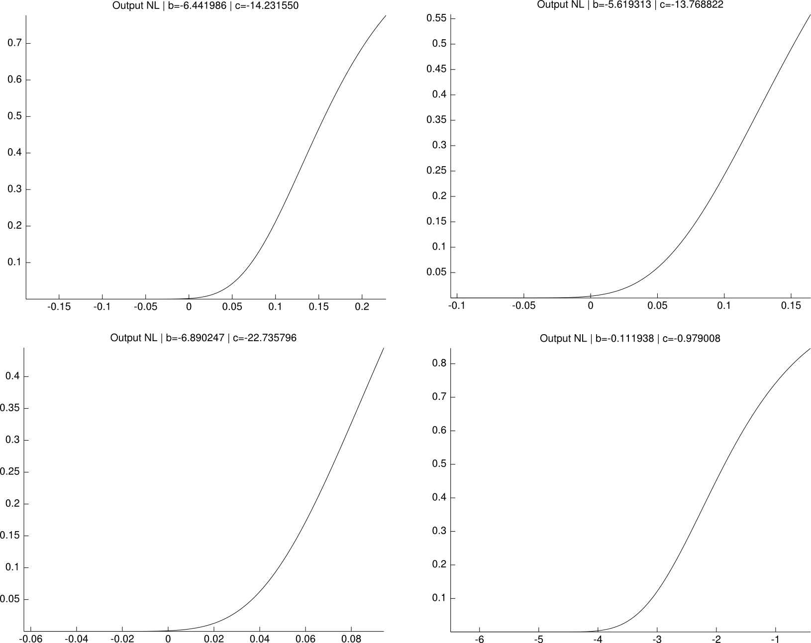
Figure 5: Output nonlinearities fit using a staggard optimization procedure for 4 cells. Most did not saturate within the range of the linear outputs for the given stimuli, although two counter-examples to this statement are provided here.

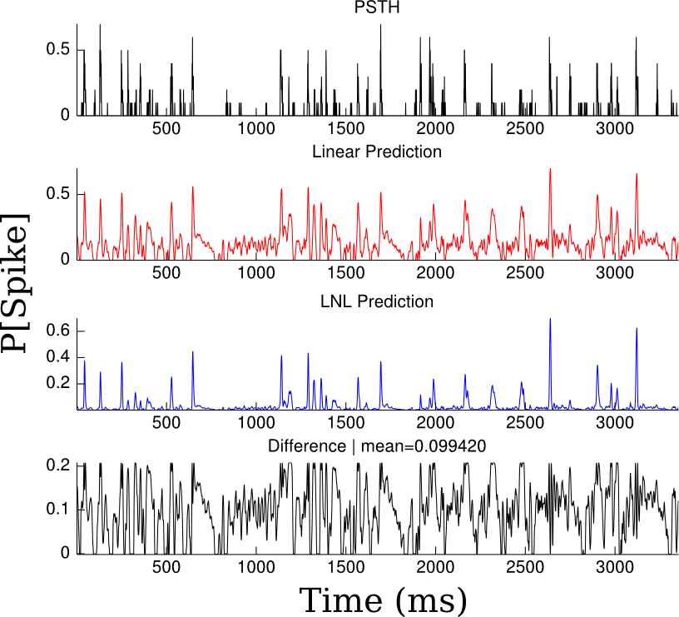
Figure 6: Sigmoidal output nonlinearities mainly serve to reduce noise in the linear prediction. The top panel is the PSTH, red trace is the linear prediction, blue trace is the linear-nonlinear model with a sigmoidal output nonlinearity, and the bottom black trace is LNL prediction subtracted from the linear prediction. The mean of the difference between traces was below 0.25 for all cells. This implies that the sigmoidal output nonlinearity improved performance primarily by “squashing” low-amplitude spurious predictions in the linear output.

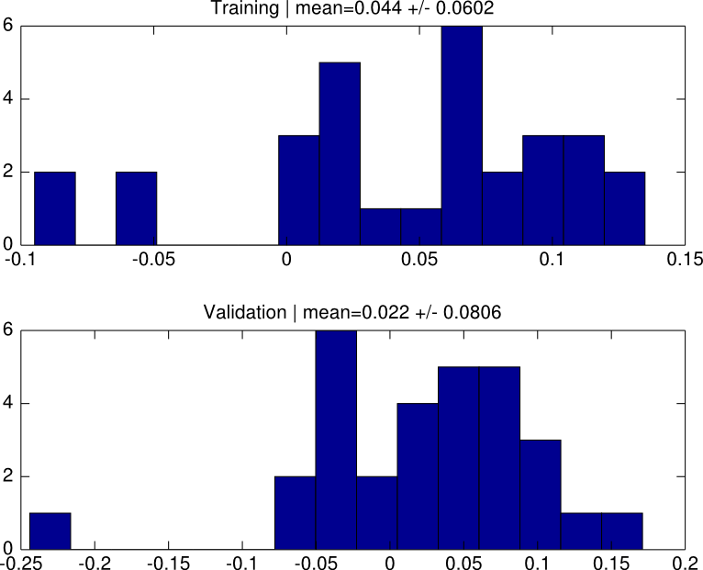
Figure 7: Linear Lyon's model outperforms linear-nonlinear models with spectrogram preprocessing only on training data, not validation data. These are histograms of the differences between performance ratios for training data (top) and validation data (bottom). The bottom histogram results are not statistically significant.

