Fast mobile star.

Introduction.

This sun works fast enough on mobile devices and each part of it (core, halo, prominences) contains a sufficient number of settings that will allow you to make your own unique star.

Asset content:
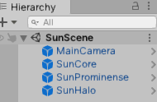
1. Main camera - simple camera
2. The core of the Sun is based on a 720p polygon sphere mesh, contains two textures and one material, a sun surface texture and a noise texture and one shader
3 Solar Prominence is a particle system based on visual effects graph. Contains one solar prominence texture and particle system.
4.Solar Halo - This is a post effect imitation of the process using a shader contains: two materials and two shaders.
The first shader is very easy to use and uses sliders, the second shader has no sliders and is intended for deep settings.
For a simple halo effect, it's enough to use a simple material, not a deep one.
5. A bonus is a sky material with six textures in a resolution of 2048x2048

How to use it all:
1. The core of the sun.
By clicking on the SunCore object in the hierarchy, you will see the core material in the inspector, expanding its parameters, you will see the following:
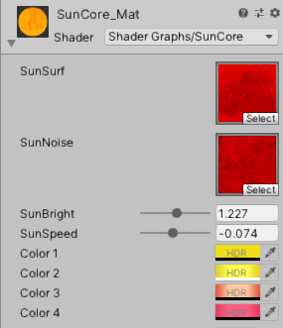

1.1 The core material has two sliders for sun brightness and sun speed
With the brightness slider, you adjust the brightness of the sun, but you can achieve a greater effect by changing the HDR color, but more on that later.
Sun Speed ​​- This slider gives you control over the speed at which the sun's surface evolves.

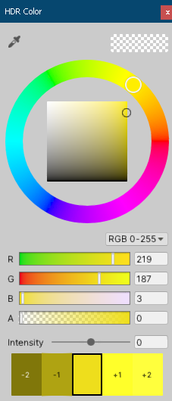
1.2
Colors 1
Colors 2
Colors 3
Colors 4
this is the HDR color, by clicking on which you will see the color palette can be changed by the circular slider,
the color saturation changes in the square field, the RGB drop-down list, and the R,G,B sliders we don't need it either.
But intensity has a strong impact on the overall picture.

They give full control over the color of the sun's core, changing the intensity, changing colors along the circular slider,
for these four colors, you can achieve both realistic effects and the most fantastic alien stars.

2. SunProminences.
By clicking on the object solar prominences in the hierarchy, you will see in Inspector the properties of the particle system in the inspector.
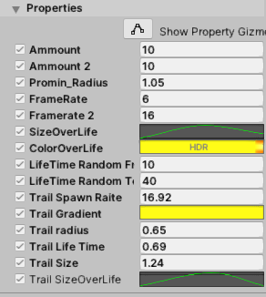

2.1 Ammount - the number of generated prominences.
2.2 Promin_Radius -this is the radius of the surface from which the prominences arise.

2.3 FrameRate - the speed of playing the animation of prominences (the number of frames per second).

2.4 SizeOverLife - this curve gives an indication of the prominence of what size they have at each interval of their life.
By clicking on the curve, you can change it, create your own or change the existing one, I recommend only moving the midpoint of the curve up or down, so the result is the most realistic.

2.5 ColorOverLife is an HDR gradient that allows you to set the color of prominences at every moment of their life. Click on the gradient and you can modify it.

2.6 HDR gradient editor:
The left edge of the gradient is the birth of a prominence, and the right edge of the gradient is its death.
Leave Blend mode is more realistic.
the upper sliders above the gradient are responsible for transparency, you can change the Alpha of the click field on the slider and see the effect.
The lower sliders are the colors, change them to your comfort, but if you need a yellow sun, it is better to leave it as it is :-)
The location moves the selected slider.
Below you will see gradient presets, in particular for the blue star.

2.7 Lifetime random from - the minimum number of the lifetime of a prominence in seconds

2.8 Lifetime random to - maximum number of prominence lifetime.

2.9 Trail spawn rate - the number of generated trails

2.10 Trail gradient see point 2.6 of this document.

2.11 Trail radius is the distance from the surface of the star that trails can fly away.

2.12 Trail size - trail size by thickness :-)

2.13 Trail size over life - this curve gives an indication of the trails of what size they have at each interval of their life.
By clicking on the curve, you can change it, create your own or change the existing one, I recommend only moving the midpoint of the curve up or down, so the result is the most realistic.

3.Sun Halo

By clicking on the halo sun object in the hierarchy, you will see the halo material in the inspector, expanding its parameters, you will see the following:
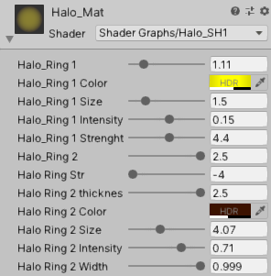

Halo is superimposed on a model containing about 500 polygons, and the material shader itself consists of two rings, each with its own color.
Basically, by manipulating with these colors, you will achieve the effect you want.
The first ring is closer to the sun and has a brighter color, the second is farther and darker, however this is at your discretion, all the settings are in front of you.

3.1
halo ring 1 - first ring energy effect

3.2
Halo ring 1 color - this is the HDR color, by clicking on which you will see the color palette can be changed by the circular slider,
the color saturation changes in the square field, the RGB drop-down list, and the R,G,B sliders we don't need it either.
you mai play with A slider, but i dont do it. Intensity has a strong impact on the overall picture.

3.3
Halo Ring 1 size - controls the size of the inner halo ring

3.3.1
Halo Ring 1 intensity - Inner ring intensity

3.3.2
Halo Ring 1 strenght -Inner ring strenght

3.4
Halo ring 2 = second ring energy effect

3.5
Halo ring str - Outer ring strenght

3.6
Halo Ring 2 thickness - thickness of outer ring

3.7
Halo Ring 2 color - this is the HDR color, by clicking on which you will see the color palette can be changed by the circular slider,
the color saturation changes in the square field, the RGB drop-down list, and the R,G,B sliders we don't need it either.
you mai play with A slider, but i dont do it. Intensity has a strong impact on the overall picture.

3.8
Halo Ring 2 Size - Size of outer ring

3.9
Halo Ring 2 intensity - outer ring intensity

4.0
Halo Ring 2 width - width of outer ring

5.0 textures are not compressed you must choise you prefer compression metod.

Bonus - deep tweak halo material - DeepTweak_Halo_Mat 1 and shader - Deep_Tweak_Halo_SH2. I left this shader the way I use it myself, there are no sliders restrictions,
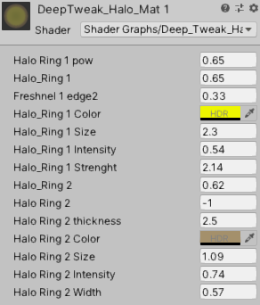
and by manipulating the values ​​in the material you can achieve the most unexpected results, for any need.

If something is still not clear, write to me at dim@veerdna.ru

Thank you for purchasing the asset and use it for your benefit :-)

