REG NO

[Email address]

Name

Name

[Document title]

[Document subtitle]

Table of Contents

The Problem Statement: 8

Purpose and the Scope of BestPrice: 9

Purpose: 9

Scope: 9

Software Development Life Cycle (SDLC) Process: 10

1. Initiation: Recognizing The Need 10

2. Planning: Chartering The Way 10

3. Analysis: User Requirements. 10

4. Design: Wireframe of UX 10

5. Implementation: Bringing Ideas to Life. 10

6. Testing: Ensuring Reliability 11

7. Deployment: Unleashing to the General Masses 11

8. Maintenance and Support: Supporting the Continual Improvement 11

BestPrice's Problem Domain and Specific Problem 12

1. Problem Area: 12

a. E-Commerce and Price Variability: 12

b. Market Complexity: 12

c. Information Overload: 13

d. User Dissonance: 13

2. Specific Problem: 13

a. Lack of Centralized Price Comparison: 13

b. Timeliness of Information: 13

c. Algorithmic Complexity in Comparison: 13

d. Global Accessibility and Currency Conversion: 13

e. User Experience and Interface Design: 13

f. Revenue Diversification for Sustainability: 14

g. Adaptability to Market Trends: 14

h. User Feedback Integration and Continuous Improvement: 14

i. Data Protection and User Trust: 14

j. Scalability for Growing User Base: 14

BestPrice's Contextual Background 14

1. The Evolution of E-Commerce: 15

2. The Challenge of Price Comparison: 15

a. Abundance of Choices: 15

b. Dynamic Pricing Strategies: 15

c. Real-time Price Fluctuations: 15

3. The Genesis of BestPrice: 15

a. Identification of User Pain Points: 15

b. Algorithmic Sophistication Requirement: 16

c. Global Accessibility and Currency Considerations: 16

d. User-Centric Design Philosophy: 16

4. The User Experience Conundrum: 16

a. Information Overload: 16

b. Interface Design as a Catalyst: 16

c. Continuous Improvement Through User Feedback: 16

5. Market Trends and Revenue Diversification: 17

a. Dynamic Technology Landscape: 17

b. Strategic Partnerships for Sustainability: 17

6. Data Protection and User Trust: 17

a. Privacy Concerns in the Digital Age: 17

Beneficiaries of BestPrice's Solution 17

1. Primary Beneficiaries: College Students and Tech Enthusiasts 18

a. User Profile: 18

b. Navigating Budget Constraints: 18

c. The College Community Focus: 18

2. Secondary Beneficiaries: College Staff and Administrators 18

a. Staff and Student Services: 18

b. Accessibility Considerations: 18

3. Key Stakeholders: BestPrice, Retailers, and Educational Institutions 18

a. BestPrice: 18

b. Retailers: 19

4. Global User Base and Inclusive Design Considerations 19

a. Global Audience: 19

b. User-Centric Design: 19

5. Client and Platform Alignment: 19

a. Client's Perspective: 19

b. Business and Competitive Edge: 19

Methodical Exploration in Researching BestPrice's Problem 20

1. Interviews: 20

Insights Gained: 20

2. Observation: 20

Insights Gained: 20

3. Existing System Analysis: 21

Insights Gained: 21

4. Document Inspection: 21

Insights Gained: 21

5. User Surveys and Questionnaires: 22

Insights Gained: 22

6. Forums and Social Media Discussions: 22

Insights Gained: 22

Requirements Aligned with User Needs in the BestPrice Ecosystem 23

1. User-Centric Elicitation: 23

a. Stakeholder Collaboration: 23

b. User Stories: 23

2. Functional Requirements: 23

a. Feature Prioritization: 23

b. Real-Time Price Comparison: 23

c. User Profile and Preferences: 24

3. Security and Privacy: 24

a. User Authentication: 24

b. Privacy Controls: 24

4. Multilingual and Multi-Currency Support: 24

a. Global User Base: 24

b. Continuous Feedback Loop: 24

Measurable Objectives Charting BestPrice's 25

1. User Registration and Engagement: 25

2. Real-Time Price Comparison: 25

3. User Authentication and Security: 25

4. User Interface and Experience: 25

Problem Modeling in BestPrice's Design Journey 26

1. User Case Diagram: 26

2. Entity-Relation Diagram: 27

3. Activity Diagram: 28

Features that Enable Problem Solving 29

1. Data Scraping and Aggregation: 29

2. Real-time Updates: 30

3. User-Friendly Interface and Search Functionalities: 30

4. Algorithmic Price Comparison: 30

5. Scalability: 31

Stakeholder Analysis for BestPrice 31

1. Consumers: 31

a. Needs: 31

b. How BestPrice Meets Their Needs: 31

2. Online Retailers: 32

a. Needs: 32

b. How BestPrice Meets Their Needs: 32

3. Tech Enthusiasts: 32

a. Needs: 32

b. How BestPrice Meets Their Needs: 32

Research and Solution Approaches for BestPrice 33

1. Understanding the Problem: 33

a. Market Dynamics: 33

b. Competitive Landscape: 33

c. User Needs: 33

2. Solution Approaches: 34

a. Data Scraping and Aggregation: 34

b. Real-time Price Updates: 34

c. Algorithmic Price Comparison: 34

d. User-Friendly Interface: 34

e. Currency Conversion: 34

f. Inclusive Design and Accessibility: 34

3. Integration of User Feedback: 35

4. Compliance with Data Protection Policies: 35

Designing the Computational Solution 35

1. Web Scraping for Data Aggregation: 36

a. Essential Feature: 36

b. Explanation: 37

2. Real-time Price Updates: 37

a. Essential Feature: 37

b. Explanation: 37

3. Algorithmic Price Comparison: 37

a. Essential Feature: 37

b. Explanation: 37

Designing BestPrice: A Comprehensive Breakdown 38

Input Process Storage: 38

Breakdown of the Problem: 39

1. User's Search Parameters: 39

2. User Reviews 39

3. User Authentication Data 39

4. Historical Price Data 39

Design Rationale: 40

1. A Real-time Price Matching Algorithm in this approach. 40

2. The Computer Algorithm Assessment of Reviews 40

3. User Authentication for the Purpose of Personalization. 40

4. Historical Price Database 40

Visualization Tools: Hierarchy Chart and System Flowchart 41

1. Hierarchy Chart: 41

2. System Flowchart: 41

Comprehensive Modelling Approach 42

1. Class Diagram: 42

2. Entity-Relationship Diagram (ERD): 43

3. Data Flow Diagram: 44

4. Graphs: 44

5. IPSO Chart: 45

Algorithmic Framework for Comprehensive Price Comparison 45

1. Signup Registration Algorithm: 46

Objective: 46

Algorithm: 46

Justification: 46

2. Home Page Implementation in Django Algorithm: 49

Objective: 49

Algorithm: 49

Justification: 49

3. Search capability Algorithm in Home page: 50

Objective: 50

Algorithm: 50

Justification: 51

4. SQLite 3 Database Tables Algorithm: 51

Objective: 51

Algorithm: 51

Justification: 52

Usability Features in BestPrice 52

1. Intuitive User Interface: 55

Objective: 55

Features: 55

Justification: 55

2. Personalized User Profiles: 56

Objective: 56

Features: 56

Justification: 56

3. Making Websites Responsive for Cross-Device Accessibility: 56

Objective: 56

Features: 56

Justification: 56

4. Transparent Pricing Comparison Metrics: 57

Objective: 57

Features: 57

Justification: 57

5. High-performance Filters and Sorters that Provide Convenience: 57

Objective: 57

Features: 57

Justification: 58

Permanent Data Storage in BestPrice 58

1. Data Storage Architecture: 58

Objective: 58

Approach: 58

Diagram: ERD for Product Data 59

Justification: 59

2. User Authentication and Authorization: 59

Objective: 59

Approach: 59

Diagram: ERD for User Authentication 60

Justification: 60

3. Fundamental Crypto Storage for Historical Price Data: 61

Objective: 61

Approach: 61

Diagram: ERD for Historical Price Data 61

Justification: 61

4. Scalability and Future Expansion: 62

Objective: 62

Approach: 62

Diagram: Sharding for Scalability 62

Justification: 62

Key Elements and Justification 62

Product Data Management: 63

Product Class: 63

Seller Class: 63

Price Class: 63

User Authentication: 64

User Class: 64

Roles Class: 64

Permanent Data Storage: 64

SQLite3 Database: 64

Test Data Identification and Justification 65

Test Data Selection: 65

Iterative Development Phase: 65

Post-Development Phase: 65

Justification for Test Data Selection: 66

Realism and Relevance: 66

Comprehensive Coverage: 66

Scalability Considerations: 66

Test Data Tables: 66

Iterative Development Test Data 66

Post-Development Test Data 66

INTRODUCTION

Computers-related accessories can be purchased from a wide variety of e-commerce platforms, which is why consumers find it difficult to find the most affordable options in a world where products seldom stay the same and prices are constantly changing. BestPrice stands out as a navigational aid in the rampant digital marketplace ecosystem, providing searchers with a hassle-free process of deciphering and selecting prices that fit their budget. Beginning with this introduction, the layers of BestPrice are peeled away one by one to reveal its goal, nature, and logical system-enabled life-cycle stages.

# The Problem Statement:

At its core, BestPrice serves as a dynamic marketplace that aims to streamline the shopping experience for users seeking a diverse range of computer accessories. Acting as a centralized pricing-comparison resource, the platform aggregates real-time pricing information from various online retailers, presenting users with a comprehensive overview of available options.

By curating and presenting this wealth of pricing data, BestPrice effectively simplifies the decision-making process for users. Instead of scouring multiple websites individually, users can conveniently compare prices, features, and specifications for similar products across different retailers all in one place. This comparative analysis enables users to make well-informed purchasing decisions based on factors such as price competitiveness, product availability, and retailer reputation.

Moreover, BestPrice goes beyond mere price comparison by prioritizing user needs and preferences. The platform's intuitive interface allows users to customize their search criteria, filter results, and set budget constraints, thereby tailoring the shopping experience to their specific requirements. Whether users are searching for budget-friendly options or premium products, BestPrice empowers them to find the perfect balance between quality and affordability.

Furthermore, BestPrice's commitment to real-time pricing information ensures that users have access to the most up-to-date data at all times. This responsiveness not only enhances the accuracy of price comparisons but also reflects the dynamic nature of the online retail landscape, where prices can fluctuate rapidly due to various factors such as promotions, discounts, and market trends.

In essence, BestPrice serves as more than just a price-comparison tool; it is a trusted ally for users navigating the complexities of online shopping. By offering centralized pricing information, personalized search capabilities, and real-time updates, BestPrice strives to simplify the shopping journey, empower users with valuable insights, and ultimately enhance their overall satisfaction and confidence in their purchasing decisions.

# Purpose and the Scope of BestPrice:

## Purpose:

The primary function of price spy as a marketplace is to offer the users with a centralized pricing-comparison resource for all types of computer accessories from different online retailers. BestPrice is able to do so by collecting and offering real-time pricing information, thus making the decision making process easier for users by comparing it like, and by meeting their needs and checking their budget.

## Scope:

BestPrice prides itself on providing an extensive array of products, catering to diverse consumer needs ranging from graphic cards to peripherals. However, its offerings extend far beyond mere price listings. The platform endeavors to provide users with a comprehensive shopping experience by offering a myriad of features and functionalities. These include but are not limited to user reviews, detailed product specifications, and real-time updates.

By incorporating user reviews, BestPrice empowers consumers to make informed purchasing decisions based on the experiences and feedback of fellow users. This feature adds a layer of transparency and authenticity to the platform, allowing shoppers to gauge the quality and reliability of products before making a purchase.

Moreover, BestPrice's provision of detailed product specifications enables users to delve deeper into the technical aspects of various products. Whether it's the processing power of a graphic card or the ergonomic design of a peripheral device, users can access detailed information to ensure that their chosen products meet their specific requirements and preferences.

Additionally, the platform's real-time updates ensure that users have access to the latest information regarding product availability, pricing changes, and promotional offers. This real-time data empowers consumers to stay informed and seize timely opportunities, thereby enhancing their overall shopping experience.

In essence, BestPrice goes beyond the conventional role of a price comparison website. It serves as a comprehensive online marketplace where consumers can explore, evaluate, and ultimately purchase a wide range of products, supported by valuable insights, detailed information, and up-to-date data. Through its multifaceted approach, BestPrice endeavors to elevate the online shopping experience for users, fostering trust, confidence, and satisfaction in every transaction.

# Software Development Life Cycle (SDLC) Process:

BestPrice is reviewed from the idea stage up to a fully functional platform, which passes through the Software Development Life Cycle. Each stage strengthens the plateform resiliency, making sure it responds to user requirements, matches industry standards, and is compatible with technology.

## 1. Initiation: Recognizing The Need

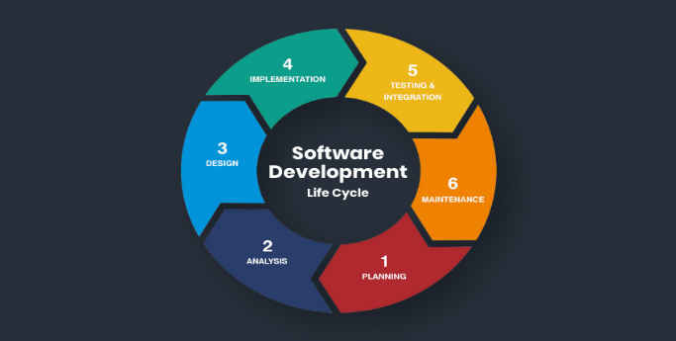The journey starts with pinpointing a challenge most shoppers in the online shopping experience are facing. Reviewing the fact that there was a need for such a platform that eliminates the burden of price comparison, the developmental phase lays the foundation for BestPrice.

## 2. Planning: Chartering The Way

During the planning phase, the team specifies the scope of the project, issues, timing, and resources. The planning process entails the feature, functionality, and technical specifications that establishes BestPrice.

## 3. Analysis: User Requirements.

Centered around in-depth studies to capture the various elements of the problem area. Interviews, observations, competitors’ analyses and user surveys provide users’ needs with a dept picture, which helps us design BestPrice to solve the savvy users’ actual problems.

## 4. Design: Wireframe of UX

The design stage that follows analysis is when the research findings are organized into a structural plan. Interface design, algorithm, database architecture, and security measures are elaborately created to construct a system that is easy to use and efficient.

## 5. Implementation: Bringing Ideas to Life.

An armed with the blueprint the development team realizes BestPrice on the basis of coding and programming. The actual real-time price comparison, authentication of users and interactions with databases are implemented that build the functional core of the platform.

## 6. Testing: Ensuring Reliability

Thorough testing is implemented to discover and remove all bugs, to ensure the highest performance and the reliability of the platform. The User acceptance testing and quality assurance processes verify that BestPrice succeeds in the mission of a seamless operations.

## 7. Deployment: Unleashing to the General Masses

After final tests, BestPrice is ready to be launched. The framework is officially released to the public which signifies its competition with the existing online retail platforms.

## 8. Maintenance and Support: Supporting the Continual Improvement

Even after deployment it is a very continuous journey through maintenance and support User feedback, changing market dynamics, and emergence of new technologies leads to an iterative improvement in the BestPrice solution, that makes it dynamic and relevant always.

ANALYSIS

BestPrice's significance lies in its role as a centralized hub for consumers seeking to compare prices of computer accessories from various online retailers. Through meticulous analysis, this paper aims to decipher the platform's fundamental features, target demographics, and existing technological infrastructure, if any. Moreover, it will conduct comprehensive technical research to inform the development of a purpose-driven system that meets the discerning needs of users while incorporating innovative solutions to enhance their shopping experience.

By scrutinizing analogous solutions in the market, this analysis endeavors to gain valuable insights into industry best practices and emerging trends. Through this comparative study, the objective is to distill key attributes and functionalities that contribute to the success of similar platforms, thereby facilitating the design and implementation of a competitive and feature-rich price comparison system. Ultimately, this endeavor seeks to create a sophisticated and user-friendly platform that empowers consumers with the information they need to make informed purchasing decisions in an increasingly digital marketplace.

# BestPrice's Problem Domain and Specific Problem

In the domain of online retail and computer accessories, BestPrice is crucial, the centerpiece that aspires to solve a particular problem that looms large over the vast business world. This section is focused on highlighting the underlying problem statement, which is the area that is to be addressed, the critical aspect of the problem that needs to find a solution or investigate.

## Problem Area:

### a. E-Commerce and Price Variability:

The problematic aspect is bound up with the complexities of e-commerce, which entails consumers in the game of distinguishing the best prices among the large number of online stores supplying computer accessories.

### 

### b. Market Complexity:

The market dynamics represent a complex factor seeing that prices vary depending on various factors that include promotions, discounts, and retailers' strategies.

### 

### c. Information Overload:

In the digital markets, consumers are flooded with vast amounts of information, making it hard for them to carry out the effective and thorough price comparison across various platforms.

### 

### d. User Dissonance:

The users suffer a sense of dissonance that comes with inability to identify the most affordable choices in their journey to make a purchase, and poor centralization makes this process even harder.

## 2. Specific Problem:

### 

### a. Lack of Centralized Price Comparison:

The key problem that the main mission of the company is trying to solve is the fact that there is no such centralized and full automated system that provides users with an ability to make real-time pricing comparison of computer accessories across the Internet.

### 

### b. Timeliness of Information:

Users are faced with the challenge of acquiring real-time updates on price changes, while the existing solutions may take long time to provide information hence the decision may be based on outdated data.

### c. Algorithmic Complexity in Comparison:

The complexities of comparing prices go beyond the plain numerical, and they incorporate elements such as product specifications, shipping costs, and dynamic offers. Some current platforms could not be as sophisticated as the algorithms required for more intricate analyses.

### 

### d**. Global Accessibility and Currency Conversion:**

Inaccessibility and the inability to make informed choices by the digital users on a global scale are the factors that bring up the problem of the lack of smooth currency exchange and lack of local pricing information.

### 

### e. User Experience and Interface Design:

The users get overwhelmed by the fact that there is a huge number of data presented by different retailers and it becomes difficult for them to understand the content correctly. The difficulty of user experience and interface design that are not straightforward are yet another barrier to this matter.

### 

### f. Revenue Diversification for Sustainability:

Online platforms have challenges to continue as they have been through the traditional revenue streams. This means that revenue diversification and strategic partnerships become top priorities.

### 

### g. Adaptability to Market Trends:

The rapidly changing technology market demands continuous adaptation in trend formations. However existing solutions may become obsolete as the topography changes frequently, thus missing the point or irrelevant information can result.

### 

### h. User Feedback Integration and Continuous Improvement:

Users are generally dissatisfied with the development process of existing platforms, which results in the absence of features, that are constantly evolving together with their needs. An instrument for efficiently receiving and using user feedback for ongoing improvement becomes necessary.

### 

### i. Data Protection and User Trust:

More than anything, data protection and privacy are of great concern. There is a possibility that the users may not like if the platforms neglect some tough ways of protecting their personal data.

### 

### j. Scalability for Growing User Base:

With the increase of the user base the platforms face challenges in providing smooth performance and satisfying the traffic needs. Scalability reverts to the main issue for long-term impact.

# BestPrice's Contextual Background

At the heart of BestPrice's functionality lies its capacity to aggregate and compare prices of computer peripherals across various online retailers. This entails not only parsing through vast amounts of data but also ensuring accuracy, reliability, and timeliness in presenting information to users. By meticulously analyzing and synthesizing data from disparate sources, BestPrice empowers consumers with comprehensive insights, enabling them to make informed purchasing decisions based on factors such as price differentials, product specifications, and user reviews.

Furthermore, BestPrice serves as a central hub where users can navigate through an array of products, each meticulously categorized and presented in a user-friendly manner. Through intuitive search functionalities and an accessible interface, users can effortlessly explore a wide range of options, compare prices, and delve into detailed product information. This seamless user experience not only enhances the shopping journey but also fosters trust and loyalty among consumers, positioning BestPrice as a go-to destination for savvy shoppers seeking the best deals on computer accessories.

## 1. The Evolution of E-Commerce:

The twenty-first century has seen a formative change in the customers’ behavior, with the e-commerce platforms becoming the prevailing sources of purchasing goods. The rising trend is explained by the convenience, variety, and in some cases the price competitiveness of online shopping. Nevertheless, this transition has also generated challenges such as the excessive availability of choices and the need to find ways to get around the huge and confusing marketplace.

## 2. The Challenge of Price Comparison:

### 

### a. Abundance of Choices:

Online retailers' expansion has resulted in a range of options for customers unmatched in history Although the variety might be enjoyed by the customers, it is significantly hard for the users to compare prices in details as they have many options available.

### 

### b. Dynamic Pricing Strategies:

Online sellers often use dynamic pricing that depends on the prognosis of such factors as demand, supply, and buyer’s behavior. This adds a whole new level of complexity for the consumers, who still try to find the cheapest deals.

### c. Real-time Price Fluctuations:

Prices of products in the Internet interactions are variable at any given time. Sometime existing solutions cannot provide user with real-time information about price changes thus may introduce some discrepancies among user's decision making.

## 3. The Genesis of BestPrice:

### a. Identification of User Pain Points:

The birth of BestPrice is a process that started by finding those major issues that online customers usually face. Users encountered the shortage of centralized medium with quick, correct, and algorithmically superior price comparisons for thousands of online retailers.

### 

### b. Algorithmic Sophistication Requirement:

A lack of price comparison is a view that BestPrice recognized as inadequate in the modern e-commerce industry. Examples such as product specifications, shipping costs, and a dynamic discount are the components that require algorithmic complexity to enable contraposition.

### 

### c. Global Accessibility and Currency Considerations:

To implement the price differential strategy, BestPrice considered the global nature of online shopping and solved the conversion and localized pricing problems. Serving the diverse user base required prices to be presented in different currencies to ensure affordability as well as user accessibility and experience.

### 

### d. User-Centric Design Philosophy:

BestPrice’s mission, however, did not stop at just being a price comparison website. The philosophy of the design that user-oriented was critical to its aims at all times; this was implemented through simplification of user experience, enhancement of navigation, as well as presenting the information in a manner that speaks to the varied consumers.

## 4. The User Experience Conundrum:

### 

### a. Information Overload:

Existing platforms, to impose full information upon, sometimes bombard users with data. BestPrice strived to find the best chosen method for presentation of the users, which consisted of giving them as much information as possible, without becoming overwhelmed with information.

### 

### b. Interface Design as a Catalyst:

The interface design became for many a key element for customer involvement. Realizing that an uncomplicated and visually pleasing interface is the element that procedures the user adhesions and daily user interactions, BestPrice concentrated on it.

### 

### c. Continuous Improvement Through User Feedback:

The changing needs of the customer being realized, the firm developed mechanisms which will seek feedback from the users. This approach was not concentrated solely on solving the emerging problems but also to develop a feeling of user’s engagement in platform enhancement.

## 5. Market Trends and Revenue Diversification:

### 

### a. Dynamic Technology Landscape:

The technology market develops with a pace that cannot be called slow, new products, trends, and consumer preferences emerge. With BestPrice's commitment to be the cutting-edge that remains relevant and valuable to users, it is apparent that they are aware of the increasing demand for market trends.

### 

### b. Strategic Partnerships for Sustainability:

To achieve sustainable growth and relevance, BestPrice started venturing into diversified revenue by forging alliances with the leading online stores. This strategy was a way of record to generate revenues and self-sufficiency by creating stakeholders that would benefit from it Such an approach was designed to create the mutually beneficial relations with other parties that would eventually ensure financial sustainability of the platform.

## 6. Data Protection and User Trust:

### 

### a. Privacy Concerns in the Digital Age:

In the period of the booming data privacy concerns, BestPrice understood that if it wanted to register and stay onto the market, the ctrl should be taken in the data protection sphere. The objective for this approach was to build user trust and consequently ensure their compliance with the latest data protection policies.

# Beneficiaries of BestPrice's Solution

In the dynamic landscape of online shopping, understanding the target audience is paramount to developing an effective solution that meets their needs and preferences. The section focuses on delineating the key demographics and stakeholders that BestPrice endeavors to serve. By identifying the primary users and stakeholders, including consumers seeking competitive prices, retailers looking to reach a wider audience, and the BestPrice platform itself, stakeholders gain clarity on the roles and objectives of each party involved in the ecosystem.

Furthermore, by elucidating the diverse needs and expectations of the target audience, BestPrice can tailor its offerings and features to provide maximum value and utility. For instance, consumers may prioritize factors such as price accuracy, product variety, and user-friendly interface, while retailers may seek opportunities to optimize their product listings and reach new customers. By understanding these nuances, BestPrice can align its strategies and functionalities to cater to the diverse interests and requirements of its audience, ultimately enhancing its relevance and effectiveness in the competitive online shopping landscape.

## 1. Primary Beneficiaries: College Students and Tech Enthusiasts

### 

### a. User Profile:

College Students: The company which specializes in college students’ electronic devices is the main target.

Tech Enthusiasts: People who are enthusiastic about technology and have a desire to know the latest products.

### 

### b. Navigating Budget Constraints:

College Students: Deal with the budget constraints and look for economical solutions as guiding principle of their computer accessories purchase.

Tech Enthusiasts: Aiming at competitive prices is a way to survive in a market to be innovative, but also frugal.

### 

### c. The College Community Focus:

Networking and Socializing: Beyond price comparison, the platform of BestPrice fits into the customized mode that the college community need for a solution and builds friendships among students with similar hobbies.

## 2. Secondary Beneficiaries: College Staff and Administrators

### a. Staff and Student Services:

Objective: Improve students' wellness by promoting positive relationships and building unity.

Reduction in Concerns: As a result of having more positive social integration, the staff and student services departments have a decreased number of issues concerning the students' social well-being.

### b. Accessibility Considerations:

Accessible Features: Purposes of design is through ge illustrated is the need of staff members who have different characteristics with their ability to see.

## 3. Key Stakeholders: BestPrice, Retailers, and Educational Institutions

### 

### a. BestPrice:

Mission Alignment: The objectives of BestPrice are exactly fitting to the purpose of solving the unique difficulties faced by college students, whose product accessories’ prices are constantly updated, providing for consumers individual real-time online price comparison.

User Engagement: Success is demonstrated by uptake and the satisfaction of users, to validate that the platform is relevant and fits the identified target.

### 

### b. Retailers:

Increased Visibility: Maximize on the high-tech exposure among the college students who often flock on this platform.

Competitive Advantage: Establish a competitive advantage by offering the most competitive prices and promotional deals in addition to attracting very profitable college student demographic.

## 4. Global User Base and Inclusive Design Considerations

### 

### a. Global Audience:

Diversity in User Base: It should be emphasized that arriving to college from different geographical areas, BestPrice addresses a global audience.

Currency and Language Support: Upfront inclusive design plugs translation and cross currency functionalities so as the system is accessible for the international users.

### 

### b. User-Centric Design:

Interface Intuitiveness: The design first concentrates on the user interface that is native and familiar to people from a variety of language and cultural perspectives.

Continuous Improvement: The platform needs to be created with an understanding that it should be ever changing to emit a tone that reaches its users. It is essential for us to get feedback from the users.

## 5. Client and Platform Alignment:

### 

### a. Client's Perspective:

Key Deliverables: Client satisfaction is directly related to the completion of critical, i.e. personal and exclusive social networking site for college students, which will serve as the main product.

### 

### b. Business and Competitive Edge:

Return on Investment: The client, particularly the educational institution, expects the project to deliver positive investment returns, tangibly expressed not only in economic terms but also in terms of social benefits for the students.

Competitive Edge: A successful strategy offers the institution a competitive advantage in operation of attracting prospective students.

# Methodical Exploration in Researching BestPrice's Problem

In this world of system development, an in-depth knowledge of the problem itself is the compass that directs the progress of development. The beginning of the trip of BestPrice platform was its thorough investigation of problem domain.

## 1. Interviews:

Engaging Stakeholders: Interviewing different stakeholders, the online retail area users and the rivals platform agents.

User Insights: Investigated the expectations, difficulties, and choices of the idea users in the digital world of purchasing computer accessories.

### Insights Gained:

* Pinpointed the user pain points in price comparison and a product selection process.
* Disclosed user preferences regarding interface design, features, and the entire shopping experience in online.

|  |  |
| --- | --- |
| **Stakeholder** | **Key Insights** |
| Users | Technology often finds it hard to address these challenges since a price comparison platform requires a streamlined interface. |
| Competitors | Market features that work for and make users happy as well as the room for improvement. |

## 2. Observation:

User Behavior Studies: Undertook a subjective study on how users engage with currently an online retail sites available.

Market Dynamics: The pricing observed as well as the metrics of user engagement and the effects of promotions or discounts.

### 

### Insights Gained:

* Identified common clues and general patterns to online buying habits.
* Explained the impact of price marketing on user selection.

|  |  |
| --- | --- |
| **Observation Focus** | **Key Finding** |
| User Interaction | The most prominent use of filters and speed scrolling of product reviews. |
| Market Dynamics | Prices Sensitivity, the engagement increases during a special offer or sale. |

## 3. Existing System Analysis:

Competitor Platform Analysis: I have evaluated and assessed the aspects of strength, weaknesses and importance of the existing platforms that play similar roles.

User Reviews Examination: Performed the analysis of user reviews and feedback by different means.

### 

### Insights Gained:

* Accurate features that users amalgamate with and give a positive user experience.
* The issues and areas of concern arising from the opinions of referred users were gathered.

|  |  |  |
| --- | --- | --- |
| **Competitor Platform** | **Strengths** | **Weakness** |
| Platform A | Robust filtering options, clear pricing display | Limited user reviews, slow page loading times |
| Platform B | Comprehensive product information, intuitive navigation | Complex checkout process, lack of real-time updates |

## 4. Document Inspection:

Analyzing Market Reports: Analyzed the market documents and studies pertaining to the sales sector of computer accessories.

Reviewing Industry Trends: Investigated the literature, namely published magazines and articles discussing the current trends and challenges of online retail.

### 

### Insights Gained:

* From a general market perspective, I now understand the PC accessories retail business.
* Identified emerging technologies and consumer behaviors which are changing the sector.

|  |  |
| --- | --- |
| **Market Report** | **Key Findings** |
| Tech Market Insights 2023 | Growing demand for personalized shopping experiences, increased focus on customer reviews. |
| Online Retail Trends | Rise of mobile commerce, emphasis on user-generated content for decision-making. |

## 5. User Surveys and Questionnaires:

Direct User Feedback: Set up and distributed surveys to get feedback of users directly.

Quantitative Data: Gathered quantitative data on users' individual preferences, pain points and expectations.

### 

### Insights Gained:

* Identified the usage frequency of particular obstacles by consumers.
* The gathered data about the user opinion on fundamental functionalities and value of separate functionalities

|  |  |
| --- | --- |
| **Survey Question** | **Response Distribution** |
| Biggest Challenge in Online Shopping | 35% Price Comparison, 25% Product Information Clarity, 20% Payment Security Concerns, 20% Other |
| Desired Features in a Price Comparison Platform | 40% Real-Time Price Updates, 30% User Reviews Integration, 15% Intuitive Interface, 15% Other |

## 6. Forums and Social Media Discussions:

Community Insights: Watched discussions on forums and social media conducted related to the field of computer accessories and online shopping.

Identifying Pain Points: Examined the complaints and queries of the users, in order to know the frequent displeasure.

### Insights Gained:

* Opinions dispersed without censorship and with mind that they are unfiltered and organic by users who were already on the current platforms.
* Users’ most frequent pain points were listed.

|  |  |
| --- | --- |
| **Forum Topic** | **Common User Grievances** |
| Platform Experiences | Slow customer support response, discrepancies in listed prices, lack of real-time updates. |
| Product Recommendations | Desire for personalized recommendations based on individual preferences. |

# Requirements Aligned with User Needs in the BestPrice Ecosystem

Herein lies the secret of software creation which is the balance of user requirements and system functions. This part of the paper is an in-depth analysis of the systematic steps of transforming the voiced user needs into specific requirements that the BestPrice platform must meet. Through the ability to match and emulate interface and functionality of the system with user expectations, the system strives to not only satisfy, but even surpass, ever growing demands.

## 1. User-Centric Elicitation:

### 

### a. Stakeholder Collaboration:

Inclusive Approach: Collaborated extensively with college students, tech fanatics and prospective users in sculpting the platform.

Workshops and Focus Groups: Lead sessions that were interactive and able to get candid responses from participants on what features and functionality they want.

### 

### b. User Stories:

Narrative Approach: User needs were analyzed from the standpoint of storytelling with the creation of user stories that showcased real-life situations.

Scenario Mapping: I force-mapped different user scenarios to see the key points of interactions and the main pain points.

## 2. Functional Requirements:

### 

### a. Feature Prioritization:

User Voting Mechanism: Let users decide on recommendations list through voting process based on concerned functionality.

Weighted Scoring: Scored the features based on the user-feedback and in-place, marking development focus.

### 

### b. Real-Time Price Comparison:

Central Functionality: Highlighted as the essential factor due to the importance of quick and correct pricing stated during the interview.

Algorithmic Framework: Integrated advanced algorithms to let for updating prices information in real-time and its precision.

### 

### c. User Profile and Preferences:

Tailored Experience: Understood the significance of personalization in the on-line experience.

Customizable Profiles: Users may create profiles adjusting their profiles to their personal preferences and favorite interests for a smooth shopping and socializing experience.

## 3. Security and Privacy:

### 

### a. User Authentication:

Data Protection: Security of user data raised as a top concern and expressed during the user interviews and survey.

Multi-Factor Authentication: Have implemented strong authentication techniques to shield users' credentials.

### 

### b. Privacy Controls:

Granular Settings: Responding to this need for privacy they have controlled how to view the data by adding granular controls.

Opt-In Features: Users are allowed to only share the particular information they wish to expose within the community.

## 4. Multilingual and Multi-Currency Support:

### 

### a. Global User Base:

Diverse Demographics: Incorporated the global user community consisting of diverse linguistic and currency choices.

Localization Features: Including languages and currency converters for ease of use and inclusive experience.

### 

### b. Continuous Feedback Loop:

Community Forums: Ongoing user feedback and suggestions were incorporated in an existing channel.

Agile Development: Continuously improved system specifications, acquiring user feedback to develop the platform together with the developments in the needs of the users.

# Measurable Objectives Charting BestPrice's

A robust and successful system is undoubtedly supported by a strong objective as a basis plus a clear and measurable goal. This part of the plan focuses on the exercise of giving the goals of the BestPrice platform concrete, actionable, and time-sensitive objectives. Such objectives are the guiding lights of the development process as they are serving to steer the development and at the same time they provide a quantifiable basis for the success.

## 1. User Registration and Engagement:

Objective 1: Ensure a 20% rise of user registration in three months’ time.

Objective 2: Guaranteed monthly user engagement rate of 70% and more.

|  |  |  |  |
| --- | --- | --- | --- |
| **Objective** | **Target Metric** | **Timeframe** | **Success Criteria** |
| 1 | User Registrations | First 3 months | 20% Increase |
| 2 | User Engagement Rate | Monthly Average | 70% or higher |

## 2. Real-Time Price Comparison:

Objective 3: Make sure the maximal price changes are shown in real time with delay no longer than 10 seconds.

Objective 4: Manage a pricing accuracy rate of 95% and above.

|  |  |  |  |
| --- | --- | --- | --- |
| **Objective** | **Target Metric** | **Timeframe** | **Success Criteria** |
| 3 | Price Update Delay | Real-time | Maximum 10 seconds |
| 4 | Pricing Accuracy | Ongoing | 95% or higher |

## 3. User Authentication and Security:

Objective 5: Install Multifactor Authentication for all user accounts within six months.

Objective 6: Attain 100% block rate of malicious access.

|  |  |  |  |
| --- | --- | --- | --- |
| **Objective** | **Target Metric** | **Timeframe** | **Success Criteria** |
| 5 | Multi-Factor Authentication | Within 6 months | Implemented for all users |
| 6 | Unauthorized Access | Ongoing | 0 unauthorized access incidents |

## 4. User Interface and Experience:

Objective 7: Achieve a user satisfaction score of 80% or better in every quarter of user surveys.

Objective 8: Optimize the average page load time of three seconds.

|  |  |  |  |
| --- | --- | --- | --- |
| **Objective** | **Target Metric** | **Timeframe** | **Success Criteria** |
| 7 | User Satisfaction | Quarterly | 80% or higher |
| 8 | Page Load Time | Ongoing | Below 3 seconds on average |

# Problem Modeling in BestPrice's Design Journey

As a very important phase in the development of software, the move from analysis to design is a key one. This part of the study deals with modeling strategies used for the BestPrice, providing a detailed description of the part when the identified problem has been converted into a specific structured plan. Using a range of modeling techniques, we intend to reduce the gap between the analysis and the design stage. This will lay a positive foundation for the further development of the new BestPrice platform.

## 1. User Case Diagram:

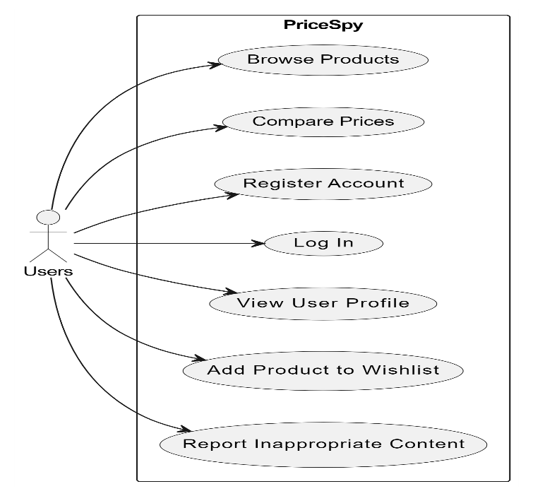

## 

## 2. Entity-Relation Diagram:

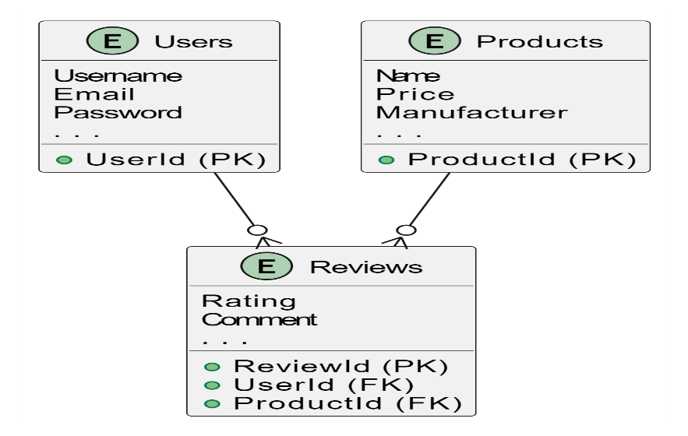

## 3. Activity Diagram:

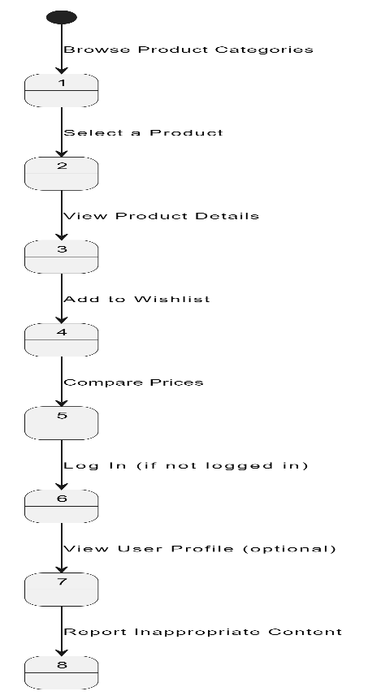

# 

# Features that Enable Problem Solving

The BestPrice website, focused on the comparison of prices for computer accessories from multiple retailers, stands a complex task that can be tackled by computational methods. The purpose of this part is to focus on the aspects that qualify the issue as solvable through the application of computational methods, shedding light on why this type of methods should be adopted in the case of the company referred to as "BestPrice".

## 1. Data Scraping and Aggregation:

At the heart of BestPrice's functionality lies its reliance on computational treatments, particularly web crawling and data aggregation, to seamlessly curate and present a vast array of product information from numerous online retailers. This process is essential for consolidating disparate data sources, organizing products into relevant categories, and ultimately providing users with a centralized platform for comparison shopping.

Traditionally, manual methods of data collection and organization would be impractical and error-prone given the sheer volume of products available online, coupled with the dynamic nature of pricing structures and inventory levels. By leveraging computational algorithms, BestPrice is able to automate the data collection process, ensuring efficiency, accuracy, and timeliness in gathering product information from across the web.

The web crawling component of BestPrice's operation involves the systematic scanning of various online retailers' websites to extract pertinent product details such as pricing, specifications, and availability. This automated process eliminates the need for manual intervention and enables BestPrice to continually update its database with the latest information from retailers, ensuring that users have access to real-time data.

Additionally, BestPrice employs sophisticated data aggregation algorithms to organize the collected information into user-friendly categories and subcategories, making it easy for users to navigate and compare products based on their specific needs and preferences. By structuring the data in a logical and intuitive manner, BestPrice enhances the user experience and facilitates informed decision-making.

Overall, BestPrice's scrap program plays a pivotal role in its operations by automating the collection and aggregation of product data from multiple online sources. By harnessing computational treatments, BestPrice ensures the reliability, accuracy, and timeliness of the product information presented to users, thereby empowering them to make well-informed purchasing decisions with confidence.

## 2. Real-time Updates:

The rapid changes in prices across various product types in the online market require instant updates to give the users accurate and current information. Computational methods make it possible to BestPrice to perform the process of price updates frequently in an automated manner. Algorithms can be configured to track prices or other changes, so that customers get updated market conditions. This functionality is critical for the website as it enhances credibility as well as providing value to users who need accurate current information for their purchasing decisions.

## 3. User-Friendly Interface and Search Functionalities:

The user interface (UI) and search functionality serve as pivotal components of BestPrice's success, as they directly impact the overall user experience and satisfaction. Leveraging computational methods enables BestPrice to craft an intuitive and user-friendly interface that enhances usability and fosters engagement.

In designing the UI, computational algorithms play a crucial role in optimizing layout, navigation, and search functionalities to streamline the user experience. Through data-driven insights and analysis, BestPrice can tailor the interface to meet the specific needs and preferences of its users, ensuring that key features and functionalities are readily accessible and intuitive to navigate.

Algorithms are employed to enhance the effectiveness of the search process, allowing users to quickly and accurately find the products they are looking for. By implementing advanced search algorithms, BestPrice enables users to filter and refine their search queries based on various criteria such as product category, price range, brand, and specifications. This empowers users to efficiently compare prices across different online stores and locate the best deals with ease.

## 4. Algorithmic Price Comparison:

The main components of the price comparison service offered by BestPrice are the possibility to compare prices on different on-line retailers. This complex function can be done effectively when it is carried out with the aid of price comparison algorithm. Through computational methods various factors like product specifications, shipping charges, and discounts get considered to develop algorithms so that users are presented with accurate and complete price comparisons. However, manual processing would eventually fail in the case of high complexity and rate, whereas computational strategies would remain of significance.

## 5. Scalability:

In order to meet the demands of a diverse user base that could be quite numerous, scalability becomes a fundamental consideration. Computational technologies on the other hand, support scaling operations in a cost-effective way. Codes can process more data, users, and transactions without the deterioration of performance. This scalability is, in fact, of utmost importance given the aim for BestPrice to support expansion and to ensure consistent and reliable service provision to an increasing user community.

# Stakeholder Analysis for BestPrice

The rule of thumb followed by BestPrice, the website meant for comparing prices of computer peripherals from several online merchants, depends on its capacity to deal with the matters of relevance to the various interest groups. This section will conclude on the identification and illustration of the principal stakeholders who will be interested in our solutions and give out the specifics of how we will correspond to the disparate needs of each stakeholder.

## 1. Consumers:

### 

### a. Needs:

Cost-Efficient Purchasing: Consumers will be searching for the best bargains in computer accessories to maximize their wealth management.

Comprehensive Information: The users want to see a centralized platform that offers specific info on products and prices from multiple online sellers.

Real-time Updates: Up-to-date price fluctuation informs users of transaction competitiveness.

### 

### b. How BestPrice Meets Their Needs:

• BestPrice aggregates product data to enable consumers to compare prices, and therefore, ensure customers buy most cost-effectively.

• The feature of real-time updating provides up-to-date details for users who can, in turn, use it as a basis for decision-making.

• The dedicated platform makes it much easier to get the needed information in a multipurpose manner, and the buyer's journey is simplified.

## 2. Online Retailers:

### a. Needs:

Increased Visibility: The target market of online sellers is to make their products more visible in a competitive market.

Market Insights: Knowing how their prices differ from competitors’ prices gives a big picture what the market is all about.

User Traffic: Technically, retailers look to customers visiting their portals.

### 

### b. How BestPrice Meets Their Needs:

• Boosting the offerings” visibility is what BestPrice does by selecting products from different online stores.

• The website provides insights into the markets by displaying the meanings of each retailer's prices on comparison, the tool being useful to the pricing departments.

• Attending the affiliated online retailers by the customer as a result of user traffic on BestPrice is potential.

## 3. Tech Enthusiasts:

### 

### a. Needs:

Product Research: Tech fans usually take time to do a detailed investigation prior to computer-related parts purchasing.

Latest Trends: Staying on par with the newest products and trends is a must for this target market.

Cost Savings: Brand loyalists are also eager to learn everything they can and still have cheaper options for their tech buys.

### 

### b. How BestPrice Meets Their Needs:

• BestPrice acts as a handy tool for research, considering numerous product comparisons carried out in its database.

• The website is used to display the trending and recent products that are offered in the computer accessories world.

• Through BestPrice, tech enthusiasts are able to make an educated and economic choice for their purchases, which is possible by price comparisons.

# Research and Solution Approaches for BestPrice

Complexities such as those encountered when comparing prices for computer accessories from online retailers call for a well thought-out and effective solution, and that is what the website BestPrice has in mind in its mission to address those issues. In this section of the research, the problem in contention is studied and necessary approaches are identified and justified to accordingly help BestPrice come up with a sustainable solution.

## 1. Understanding the Problem:

### 

### a. Market Dynamics:

Extensive Product Varieties: The online market for computer accessories is gigantic with it carrying an impeccable variety of items.

Dynamic Pricing: Prices are always susceptible to frequent changes attributed to promotions, discounts and peculiar demands of the market.

User Expectations: Users demand live updates and explain­able information for the purpose of intelligent decision-making.

### 

### b. Competitive Landscape:

Numerous Online Retailers: Competition among an overwhelming number of online retailers is fighting for the attention of consumers, between them, who have different prices and promotions.

User Loyalty: Users may favor certain retailers creating a situation when their buying choices are affected.

Market Trends: Providing awareness of the market trends is vital to keep businesses relevant and competitive.

### 

### c. User Needs:

Ease of Comparison: Customers are ready to use somewhere user-friendly that makes it simple to compare prices from many stores.

Comprehensive Information: The requirement for exact product data among which are specifications, reviews and seller ratings.

Currency Conversion: Proper solutions for the global audience should have the ability to perform currency conversion.

## 2. Solution Approaches:

### 

### a. Data Scraping and Aggregation:

Approach: Classify web scraping methods to obtain data from different e-commerce websites.

Justification: Automation is indispensable for data collection and aggregation procedures requiring speed and precision, as well as for the latter to be current and updated.

### 

### b. Real-time Price Updates:

Approach: Develop systems that can tweet the probative market conditions and register changes in prices automatically on the database.

Justification: In an emerging market presenting the users with the latest price information is of great significance to protect the website’s reputation and to make the website appealing for the users.

### 

### c. Algorithmic Price Comparison:

Approach: Design algorithms that take into account numerous factors including item specifications, shipping costs, and discounts for accurate comparisons of prices.

Justification: The manual approaches would not be able to cope with the complexity and scope. Algorithms give us the efficiency and accuracy that we need.

### 

### d. User-Friendly Interface:

Approach: Reinvest in the design that focuses on the users, improving the layout, increasing navigation, and simplifying the search.

Justification: A user-friendly and easy-to-navigate interface should be the focus to ensure both user engagement and satisfaction, thus attaining a suitable user experience.

### 

### e. Currency Conversion:

Approach: Develop currency conversion algorithms based on live exchange rates which are dynamic in nature.

Justification: Enables accessibility to customers of various regions helping them in comparing prices conveniently in their local currency.

### 

### f. Inclusive Design and Accessibility:

Approach: Adhere to accessibility standards, thus, providing a platform that is inclusive of users with different abilities.

Justification: An emphasis on inclusivity also is ethically sound and increases the user volume by taking into account people with various needs.

## 3. Integration of User Feedback:

Approach: Introduce ways for receiving and integrating users' feedback.

Justification: User feedback is paramount for continuous improvement; hence it is essential that the platform keeps on growing according to user expectations and preferences.

## 

## 4. Compliance with Data Protection Policies:

Approach: Adherence to data protection policies, especially when dealing with the users' sensitive information.

Justification: Preserving data protection norms is the key to building user trust and compliance with the laws.

# Designing the Computational Solution

In developing a computational approach for the BestPrice website, the identification and creation of fundamental features are crucial for its success. These core elements form the backbone of a robust and efficient platform for comparing prices of computer accessories across various online retailers. Below, we delve into the essential features and the rationale behind their inclusion in the BestPrice platform:

1. Price Comparison Functionality:

* Purpose: The primary function of BestPrice is to enable users to compare prices of computer accessories from different online retailers.
* Logic: By providing users with real-time pricing information from multiple sources, BestPrice empowers them to make informed purchasing decisions and find the best deals available.

1. Product Categorization and Organization:

* Purpose: To categorize and organize products into relevant groups based on their type, brand, specifications, etc.
* Logic: Efficient categorization and organization facilitate easier navigation and browsing for users, allowing them to quickly locate the products they are interested in without unnecessary clutter or confusion.

1. User Reviews and Ratings:

* Purpose: To provide users with insights from other consumers through reviews and ratings of products.
* Logic: User-generated reviews and ratings offer valuable feedback and recommendations, helping users assess the quality, performance, and reliability of products before making a purchase decision.

1. Search and Filter Options:

* Purpose: To enable users to refine their product search based on specific criteria such as price range, brand, features, etc.
* Logic: Advanced search and filter options enhance the user experience by allowing users to narrow down their search results and find products that meet their specific requirements more effectively.

1. Real-time Data Aggregation:

* Purpose: To collect and aggregate pricing data from various online retailers in real-time.
* Logic: Real-time data aggregation ensures that the pricing information provided to users is accurate, up-to-date, and reflective of current market conditions, enhancing the reliability and trustworthiness of the platform.

1. User Account Management:

* Purpose: To enable users to create accounts, manage their profiles, and track their purchase history.
* Logic: User account management features enhance user engagement and retention by providing personalized experiences, facilitating order tracking, and enabling seamless access to saved preferences and settings.

1. Mobile Responsiveness:

* Purpose: To ensure that the BestPrice website is accessible and optimized for use across various devices and screen sizes.
* Logic: With an increasing number of users accessing websites from mobile devices, ensuring mobile responsiveness is essential for expanding the platform's reach and providing a consistent user experience across all devices.

Overall, the identification and creation of these fundamental features are driven by the goal of creating a comprehensive, user-friendly, and reliable platform that meets the needs and expectations of BestPrice's target audience. Each feature is carefully designed and implemented to enhance usability, functionality, and overall user satisfaction, contributing to the success and effectiveness of the BestPrice website as a premier destination for comparing prices of computer accessories online.

## 1. Web Scraping for Data Aggregation:

### 

### a. Essential Feature:

Automated Data Collection: The use of web scraping algorithms that automatically gathers data from more than one online stores.

### 

### b. Explanation:

Web scraping is the root of rapidly amassing huge masses of information from different sources. An automated system will ensure real-time updates and accuracy, which is essential to giving people the most updated and genuine information on computer accessory prices.

## 2. Real-time Price Updates:

### 

### a. Essential Feature:

Dynamic Price Monitoring: Using algorithms to track price changes and adjusting the database in real time in case of a price fluctuation.

### 

### b. Explanation:

Real-time data is very important in a volatile market where the prices of commodities change very quickly. Consumers are dependent on data that is truthful and current for their decision-making. Real-time price monitoring guarantees that BestPrice can boast its reputation by offering customers the most current prices.

## 

## 3. Algorithmic Price Comparison:

### 

### a. Essential Feature:

Advanced Comparison Algorithms: Creating algorithms that take different types of factors like product specifications, shipping cost, and discount into consideration for precised price comparisons.

### 

### b. Explanation:

Manual comparisons become unpractical from the viewpoint of the number of products and retailers which are very high. While in the majority of cases state-of-the-art algorithms become irreplaceable sources of information to find accurate and informative results. Taking into consideration several variables allow for a more comprehensive assessment, which makes it easier for users to choose the best products corresponding to their needs.

DESIGN

In the world of online shopping, how the price comparison website is designed is central to achieving success. Designing Phase covers a wide range of activities that include system architecture research, user interface development as well as functionalities. This part of the discussion concentrates on the design aspects of the project, which are intended to construct a system that is simple and user friendly, as well as capacity building.

# Designing BestPrice: A Comprehensive Breakdown

E-commerce design is complex; thus, the development of a platform such as BestPrice needs strategic planning and smart thinking. This section addresses the design phase, it discusses how managing a complex problem of cost comparison into smaller ones to find a computational solution. Theory of the motive of critical choices is presented, revealing the composition of structure of the solution. In order to help with understanding, an IPSO chart (in/process/storage/output) is offered, this is a visual representation of the main components of the system.

## Input Process Storage:

An IPSO chart gives a structured illustration of the leading elements of BestPrice and brings into view the way from the inputs of the user to the required outputs. Next, the journey through the project's nitty-gritty details begins.

|  |  |  |  |
| --- | --- | --- | --- |
| **Input** | **Process** | **Storage** | **Output** |
| User's Search Parameters | Real-time Price Matching | Product and Price Database | Ranked List of Products with Prices |
| User Reviews | Algorithmic Evaluation | User Preferences | Aggregated Product Ratings |
| User Authentication Data | Security Validation | User Authentication Database | Authenticated User Access |
| Historical Price Data | Comparative Analysis | Historical Price Database | Price Trends and Fluctuations Over Time |

## Breakdown of the Problem:

### 

### 1. User's Search Parameters:

**Input:** User enters information such as product name brand or category.

**Process:** Instantaneously, the bot is searching for the product and price database.

**Storage:** Temporary memory to store the search parameters while the search is progressing.

**Output:** The ranking of the products in their order of price resulting from the user's query.

**Justification:** This breakdown allows the data-centric processing of the user's search, prompting real-time comparisons and presenting instantaneous results.

### 2. User Reviews

**Input:** Customers leave feedback and make evaluations for products.

**Process:** An Algorithmic assessment includes sentiment and relevance scoring.

**Storage:** Users' preferences are preserved for future customization.

**Output:** Aggregated product evaluations, giving users critical information to make their own buying decisions.

**Justification:** User reviews have the ability to give an informal, yet valid, view to the product comparison, as a result, improve the decision making process.

### 3. User Authentication Data

**Input:** Security of user credentials for authentication.

**Process:** Authentication, in particular, assures the legitimacy of access to users.

**Storage:** User authentication details are therefore kept safely.

**Output:** Users can authenticate to access personalized features.

**Justification:** Security is also significant, and this makes possible the control of user data and the provision of personalized experiences.

### 4. Historical Price Data

**Input:** Historic price information regarding the item in question.

**Process:** The emphasis of comparative analysis to track fluctuations and trends.

**Storage:** Database for retaining historical price data.

**Output:** Knowledge of the prices of the past.

**Justification:** Realizing historical price data helps the user to make predications and to make sensible choices in his decision, based on the past of the product' price.

## Design Rationale:

### 

### 1. A Real-time Price Matching Algorithm in this approach.

Justification: For the purpose of delivering quick and reliable data to users, it is essential to develop a real-time algorithm. This idea makes the website worth using while trusting it to give the latest market prices.

### 

### 2. The Computer Algorithm Assessment of Reviews

Justification: Through the use of algorithms to rate user reviews, BestPrice keeps itself objective and channelizes the insights in such a way that users get summarized, and meaningful review, simplifying the choice-making process.

### 

### 3. User Authentication for the Purpose of Personalization.

Justification: User authentication is the only way to get a good personalization, for example, it could be saving preferences, tracking search history and giving custom recommendations.

### 

### 4. Historical Price Database

Justification: A historical price database having comprehensive detail enables the users to give predictions about the trend with the possibilities that they can make well founded decision based on a product’s pricing history.

# Visualization Tools: Hierarchy Chart and System Flowchart

## 1. Hierarchy Chart:

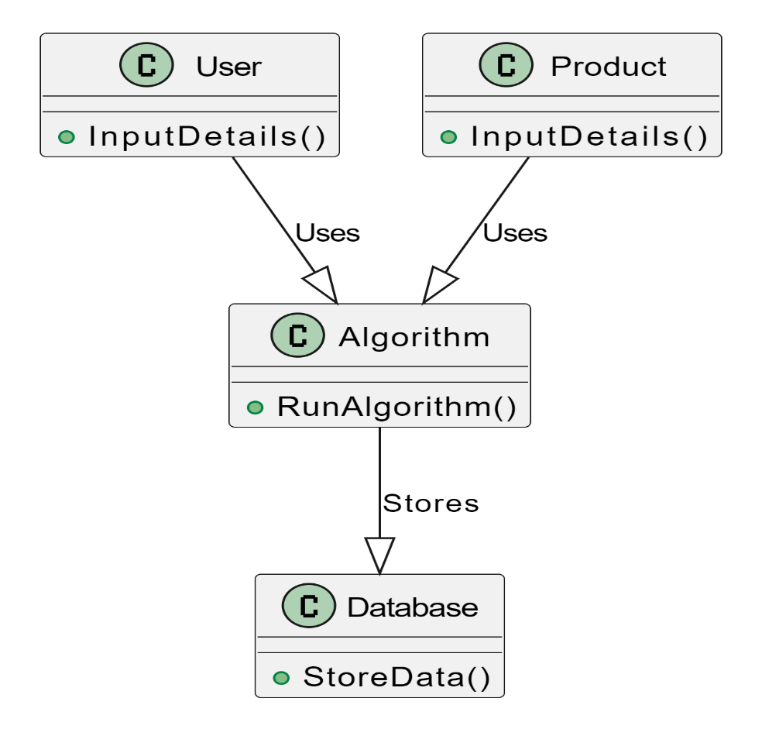

## 2. System Flowchart:

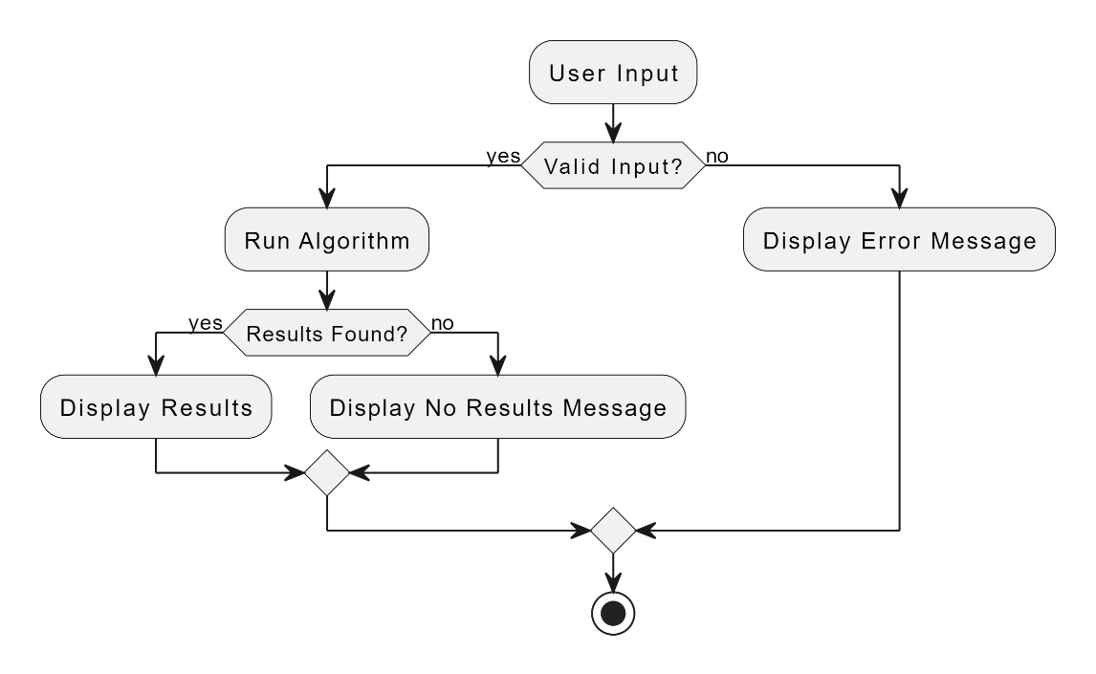

# Comprehensive Modelling Approach

The design phase of price spy implies the topic of understanding the problem is already over and the crafting of a structured and efficient solution is the subject of discussion. Modeling the problem here has the building of the simulations or diagrams that will give the laboratory a chance to visualize and understand the concepts deeply. The section yields a presentation of different modelling approaches, where you'll have Annotated Class Diagrams, Entity - Relationship Diagrams (ERD), Data Flow Diagrams (DFD), and Graphs all Plant UML applied.

## 1. Class Diagram:

A class diagram is the fundamental tool for showing the system structure in the terms of classes, their attributes, and relations between them. For BestPrice, the Class Diagram is the component that contains the main entities and how they interact.  
  
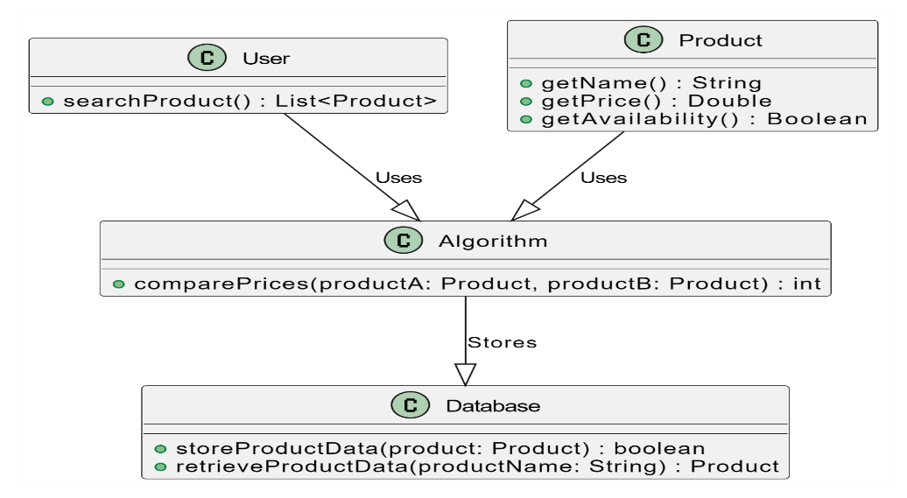

## 2. Entity-Relationship Diagram (ERD):

Entity-Relationship Diagram (ERD) is a pivotal mechanism to depict the linkage of entities in a database. It brings relationships of organizations and connections of the whole system into focus.

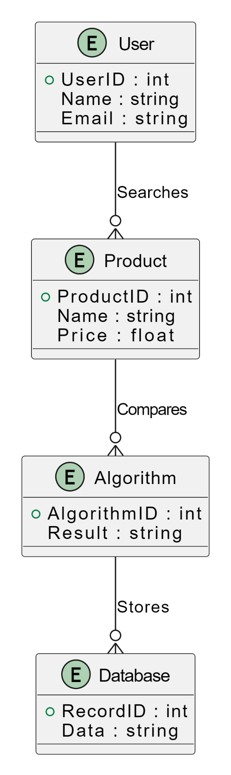

3. Data Flow Diagram:  
A DFD (Data Flow Diagram) gives an intuitive picture of the way in which data moves through a system. It represents processes, data stores, data sources, and data destinations.  
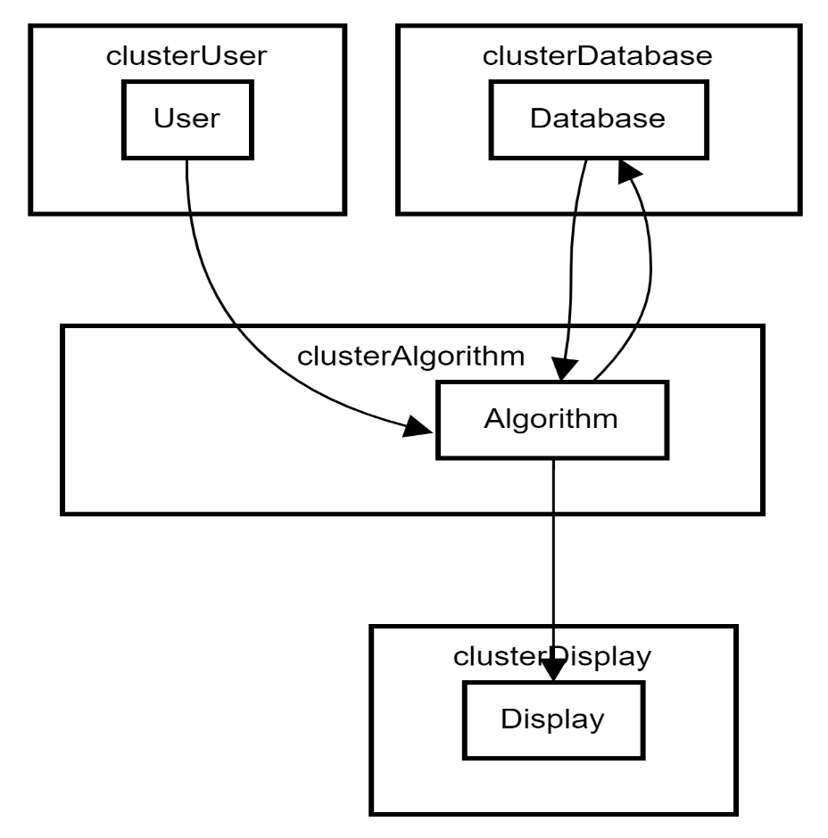

## 4. Graphs:

Graphs play an important role in factoring in relationships and dependencies of variables/properties. The graph in this context of BestPrice shows that there are relationships underlying the products, prices and the interactions of the users.

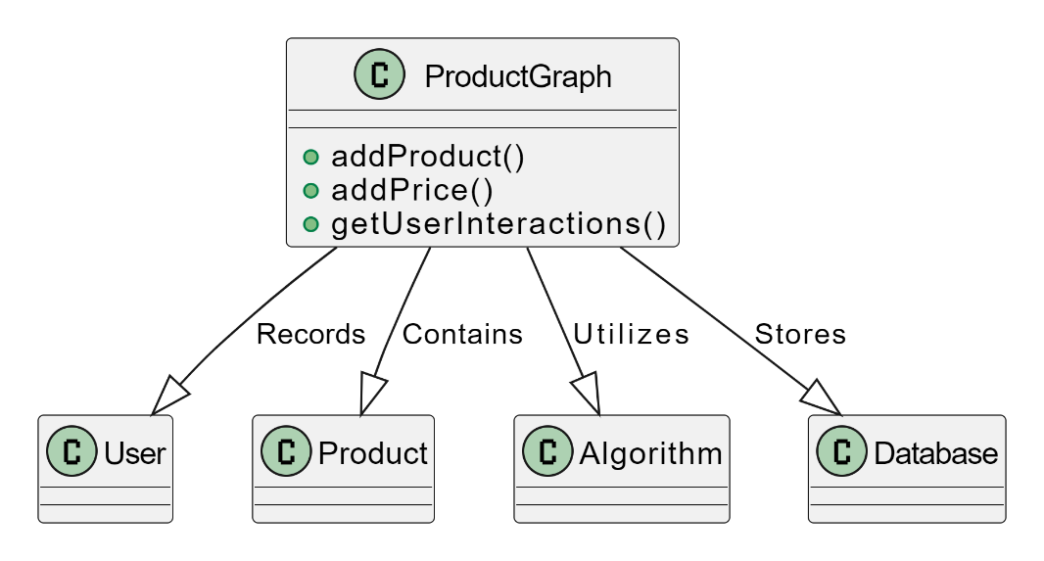

## 5. IPSO Chart:

An IPSO (Input-Process-Storage-Output) chart serves as a visual representation of the problem model, outlining the flow of information and processes within BestPrice.

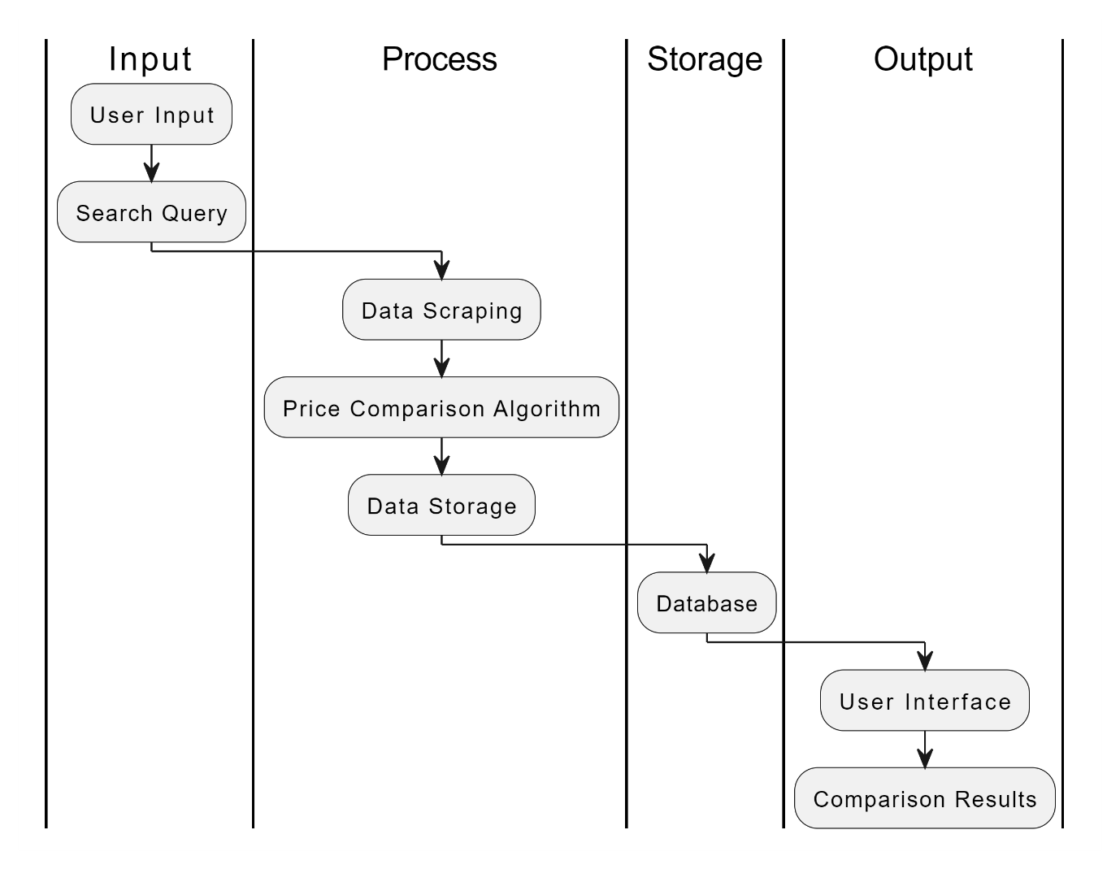

# Algorithmic Framework for Comprehensive Price Comparison

In the intricate fabric of algorithms BestPrice weaves it forms the core of a fully and effectively adapted solution to challenges arising from online price comparison. Every algorithm is built to tackle specific parts of the system, making contribution to the working and stable performance of the platform. This part of the solution deals with the main processes by presenting the algorithms for each component and showing that they are required to meet the addressing of the problem requirements.

## 1. Signup Registration Algorithm:

Objective: Enable the user profile registration, offering the easiest onboarding process.

### Algorithm:

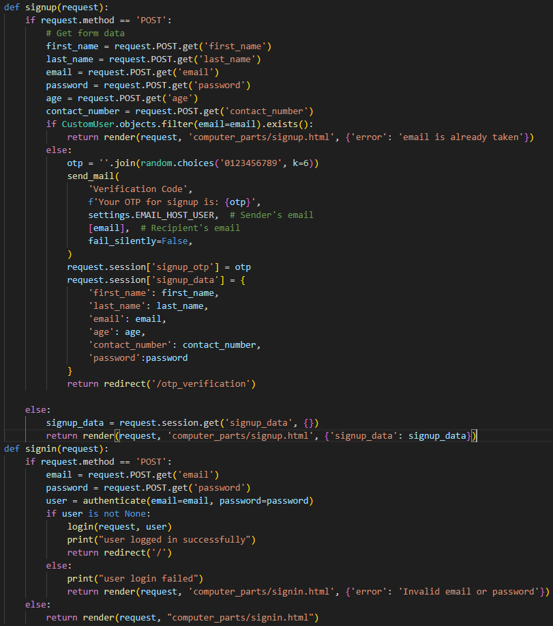

### Justification:

The sing up registration algorithm is the pathway to BestPrice which enables users to create accounts and experience the options that are personally targeted for them. The algorithm guarantees validity of user input and hence data integrity creates a secure base for user registration. The hashed password thus acts as a security protection, which consequently moves the user toward trust in the platform.

## 2. Signup Verification(OTP) Algorithm:

Objective:

The objective of the Signup Verification Algorithm is to enhance the security of the signup process by implementing a one-time password (OTP) verification mechanism. This algorithm aims to verify the authenticity of the user's email address and ensure that only legitimate users can create accounts on the BestPrice platform. By requiring users to enter a unique OTP sent to their registered email address during the signup process, the algorithm mitigates the risk of unauthorized access and fraudulent account creation.

### Algorithm:

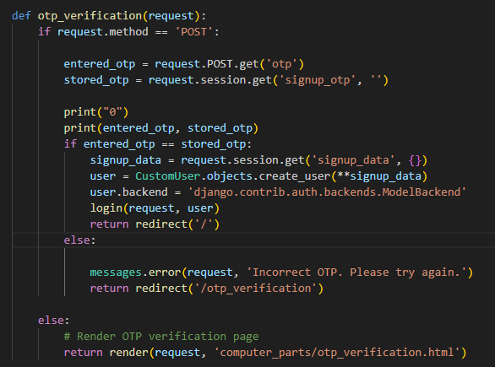

### Justification:

* Security Enhancement: The implementation of OTP verification adds an extra layer of security to the signup process, reducing the likelihood of unauthorized access and account hijacking. By requiring users to verify their email addresses through OTP, the algorithm helps prevent malicious actors from creating fake accounts or accessing sensitive user data.
* User Authentication: OTP verification serves as a method of authenticating users' email addresses, ensuring that only individuals with access to the registered email account can complete the signup process. This helps maintain the integrity of the user database and ensures that BestPrice users are genuine and trustworthy.
* Fraud Prevention: OTP verification acts as a deterrent to fraudulent activities such as account spoofing and identity theft. By requiring users to verify their identities through OTP, the algorithm helps detect and prevent fraudulent signup attempts, safeguarding the platform from potential security breaches and financial losses.
* Seamless User Experience: Despite adding an extra step to the signup process, OTP verification contributes to a seamless user experience by quickly verifying users' email addresses without requiring them to provide additional personal information. This helps streamline the signup process while maintaining the security and integrity of the platform.
* Compliance with Security Standards: Implementing OTP verification aligns with industry best practices and security standards for user authentication. By adopting this method, BestPrice demonstrates its commitment to protecting user privacy and data security, enhancing trust and confidence among its user bases.

## 2. Home Page Implementation in Django Algorithm:

Objective: In Django, implement screen design and rendering the homepage view.

### Algorithm:

### 

### Justification:

The home screen view algorithm relevant to Django is of fundamental value for the creation of a positive and client-oriented interface. With Django's efficient template architecture, this algorithm is designed to get the job done and this is achieved by promptly getting the user to the relevant content by rendering the content as soon as the user logs in. By providing personalized experience, the user becomes more engaged, making the platform more usable and appealing to them.

## 3. Search capability Algorithm in Home page:

Objective: The objective of the Search Capability Algorithm on the homepage of BestPrice is to provide users with a seamless and intuitive navigation experience right from their initial interaction with the website. By incorporating advanced search functionalities directly on the homepage, users can quickly and efficiently find the products they are looking for without having to navigate through multiple pages or menus.

The algorithm aims to enhance user engagement and satisfaction by offering a user-friendly interface that simplifies the search process. Through features such as predictive text, autocomplete suggestions, and filters based on product categories or specifications, users can easily refine their search queries and find relevant results in real-time. Additionally, the algorithm prioritizes speed and accuracy in delivering search results, ensuring that users can access the information they need promptly.

### Algorithm:

### 

### Justification:

The product of the price search functionality algorithm is BestPrice's something with which it is beginning a new business- comparing prices. Through its query system, this algorithm helps to widen the user journey and make it shorter at the same time. The significant algorithm effectively searches for the information meaning users may get the information they need in a short time; therefore, the whole system is more usable and satisfactory.

## 4. SQLite 3 Database Tables Algorithm:

Objective: Give the database structure using SQLite 3 to save all the product information.

### Algorithm:

### 

### Justification:

SQLite 3 database algorithm includes tables for inhabitants that forms the main data structure. Through creating tables of products, users, and search history, the algorithm is designed to help with automatic data. More importantly, the relational model provides the data consistency ensuring that BestPrice can smoothly conduct and retrieve information for accurate price comparison and user interactions.

## 

## 5. Data Scraping Algorithm:

Objective:

The objective of the data scraping algorithm is to systematically extract relevant product information from multiple online retailers' websites. This algorithm aims to automate the process of gathering data, including product names, prices, descriptions, and images, in order to populate the BestPrice database with up-to-date and comprehensive information on computer peripherals. By efficiently retrieving data from various sources, the algorithm facilitates the continuous updating of product listings, ensuring that users have access to the latest pricing and product details.

**Algorithm:**

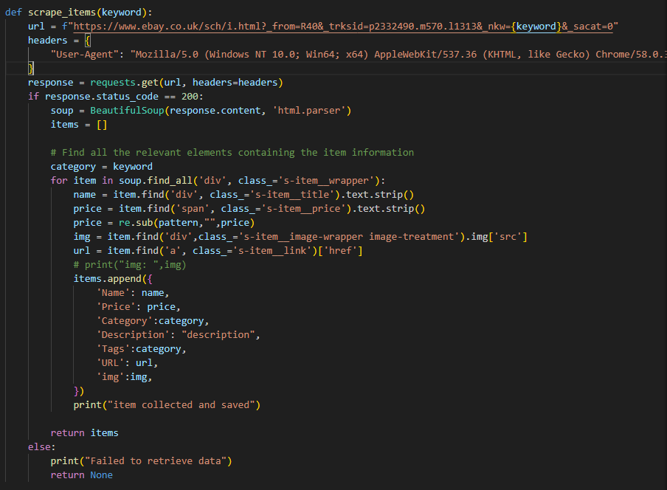

**Justification:**

The data scraping algorithm is essential for the functioning of BestPrice as it enables the platform to aggregate and compare prices across different online retailers. Manual data collection would be impractical and time-consuming due to the vast number of products and the dynamic nature of online pricing. By automating the data extraction process, the algorithm streamlines the collection of product information, reducing the likelihood of errors and ensuring the accuracy and timeliness of the data presented to users. Additionally, the algorithm enhances the scalability of BestPrice, allowing it to efficiently handle large volumes of data from diverse sources. Overall, the data scraping algorithm plays a crucial role in the effectiveness and competitiveness of BestPrice as a price comparison platform.

# Usability Features in BestPrice

Besides, it is the quality, easy-to-extract, and valid information of a platform that gives it a competitive advantage in the online price comparison world. The usability of BestPrice becomes the focus of the design in that phase when we base on the development of strong usability features. This portion maintains information about the most crucial usability element in the app, however each of usability element has been developed in the view of betterment of user experience, encouragement to users and effortless navigation through the application.

## 1. Intuitive User Interface:

Objective: Create a platform that is aesthetically pleasing, simple to navigate, and it does not cause people to hesitate before using it.

### 

### Features:

Clear Navigation Menus: Establish a step-by-step menu, making navigation easy for the users by having them browse different parts of the platform, such as product categories, price comparisons, and user details.

Visual Consistency: Consistency in the design language across the platform is essential. Therefore, in order to achieve unity in color schemes, typography, and iconography you have to pay attention to its design.

Intelligent Search Bar: Distinguish the search field with a large and prominently visible location at the home page, the search field must be equipped with auto-suggestions and real-time search results which will subsequently improve the product discovery process both speedily and accurately.

### Justification:

The user-friendly navigation of BestPrice forms a cornerstone of our usability strategy. Through emphasizing simplicity in navigation and applying visual consistency from one section to another, users will have a chance to explore different sections without being confused. This will be of great help in building a sense of familiarity and confidence to the user. The smart search bar, in turn, is presented to the users as an easily accessible mechanism for starting the comparison of prices, and so the user will enjoy seamless navigation.

## 2. Personalized User Profiles:

Objective: Offer users personalized profiles, indicating their search history, favorites and providing a setup procedure to customize their BestPrice experience.

### Features:

User Account Dashboard: Develop a user-friendly dashboard that is easily accessible by the registered users where they can check their profile details, preferences and saved stuff.

Search History Tracking: Add a function that records user's search statements, allowing users to refer back to them or to compare prices among repeatedly searched products.

Product Wishlist: Create a Wishlist capability, allowing users to markdown the products for a latter reference and giving the notifications about price drops or promotions.

### Justification:

User profile personalization adds a more individualized touch, thus improving the overall user experience. BestPrice transforms to a user-oriented platform which is both aligned with individual preferences and at the same time fostering loyalty and engagement, because it provides the users with tools to monitor their search history and to create Wishlist’s.

## 3. Making Websites Responsive for Cross-Device Accessibility:

Objective: Make BestPrice available on different devices like desktops, tablets and mobile phones and make sure that it functions properly on any of them.

### 

### Features:

Responsive Layout: Create a responsive interface that adjusts easily to different screen sizes, meanwhile lets users have a consistent and visually appealing experience across any device.

Mobile Optimization: First of all, give mobile optimization a top priority to meet users' needs who mostly explore the platform via their mobile phones and provide their essential features on smaller screens.

Cross-Browser Compatibility: Ensure and optimize the compatibility with the most popular web browsers, granting a uniform user experience regardless of the browser environment.

### 

### Justification:

Nowadays different types of digital devices which is a major factor to consider for BestPrice to succeed. An adaptative design does not only widen the outreach, but also empowers the users to be able to take part in the service regardless of the device which they are using, thus increasing the service accessibility.

## 4. Transparent Pricing Comparison Metrics:

Objective: Offer your customers with visible and accurate pricing to make comparison easier and therefore, the process of making a purchase more informed.

### 

### Features:

Price Trends Graphs: Incorporate graphical presentations of the price direction for the targeted products so that consumers can track price movements.

Comprehensive Product Details: Represent detailed product information exactly, which covers specs, customer reviews, and seller rates, for a textured view of the products.

Real-Time Price Updates: Establish a system for automatic update of product prices that get information from many sources. It will enable consumers to make instant and informed decisions.

### 

### Justification:

Access to very objective price comparison metrics is vital for the success of user trust. Via the graphical representation of price trends and rival products, BestPrice gives users the ability to choose wisely and upon this develops credibility as the platform.

## 5. High-performance Filters and Sorters that Provide Convenience:

Objective: Simplify the process of discovering the product through advanced filtering and sorting tools.

### 

### Features:

Customizable Filters: Supply users various filters according to product characteristics that encompass brand, price range and customer’s ratings, hence personalized search outcomes are being materialized.

Sorting Options: Provide different ways of sorting the products, like price range from low to high and high to low, as well as relevance, so that customers can make their choices based on their priorities.

Quick View and Comparison: Use a fast view mode that displays the most relevant product details in the search results page, which speeds up user's decision-making process.

### 

### Justification:

Efficient sorting and filtering tools are absolutely part of the solution to make the process of comparing prices more efficient. Through the features which let consumers narrow their search options and compare goods at once, BestPrice accelerates customers' journey through product discovery to the decision of making a purchase.

# Permanent Data Storage in BestPrice

Establishing a reliable and secure global warehouse for authentic and permanent data storage should be the cornerstone in the ever-changing internet price comparison industry. The data storage systems design development of BestPrice focuses on creativity and scalability issues at a time that the platform has not only thrived in the present but also future development. The given portion examines the design basics, the architectural choice, and gives indication of the permanent data storage strategy of BestPrice.

## 1. Data Storage Architecture:

Objective: Design scalable and efficient data storage system that can support varied product information, user data, and historical data that BestPrice will handle represents a big challenge.

### 

### Approach:

Relational Database Management System (RDBMS): Having a relational database like SQLite that is designed to bring structure and order in storing good description, user databases and historical price data, is an approach that can ensure that no piece of data is lost.

Normalization: Using normalization techniques to eliminate wasted space arising from data duplication do have an immense role toward building a database with better data integrity strength thus data are well organized.

Indexes for Performance: Induce indexing on the crucial data fields, for instance, like IDs of Product, and IDs of the user, to efficiently retrieve data at times of price comparison, and at times of user-specific priority queries.

### Diagram: ERD for Product Data

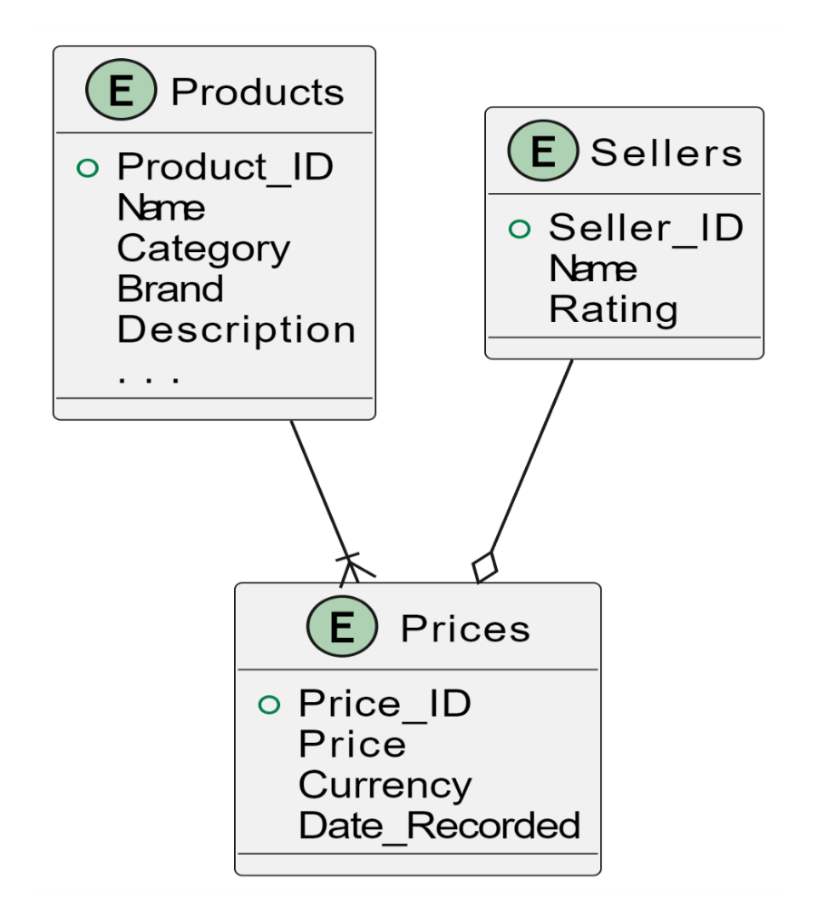

### Justification:

The selection of an RDBMs and the application of normalization techniques are veritable tools towards rancher and more orderly data storage also. Total this leads to the fact that BestPrice can administrate different data area, for example, for the product sellers and price history in an efficient way and at the same time keeps its data intact.

## 2. User Authentication and Authorization:

Objective: Set up a safe and fully secured account verification and access management system, which guarantee the data of users is secure at all times.

### Approach:

Hashing and Salting Passwords: Encrypt users' passwords using hashing and salting algorithms in order to prevent password cracking in case of a data breach and make unauthorized access impossible.

Role-Based Access Control (RBAC): RBAC system provides authority management which will be applied in managing users’ roles and permissions accurately, and this will ensure that each user has only the appropriate access that fits within their role within the system.

### Diagram: ERD for User Authentication

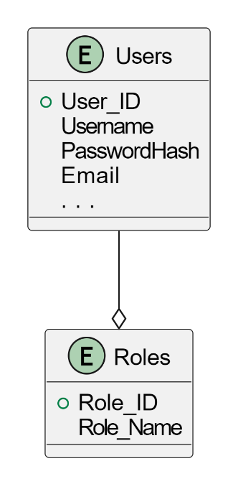

### Justification:

It is so necessary to invest in ‘user authentication’ and ‘authorization’ as the next elements of the data safety. Hashing and salting-based password storage approach along with the assignment of granular access rights to approved personnel are the techniques used at BestPrice to protect personal user data from unauthorized disclosure and makes it available to the authorized individuals only.

## 3. Fundamental Crypto Storage for Historical Price Data:

Objective: Collect historical price data for various products and finally save it in the system; thus, enabling users to follow the development of prices in time.

### Approach:

Temporal Tables: Apply temporal (time series) tables as a means to store price variations along with time and thereby giving the system a chance to show historical price trends for certain goods.

Archiving Mechanism: For archive old prices, implement an archiving mechanism to store older price data, this will prevent data storage in primary database table with new price records.

### Diagram: ERD for Historical Price Data

### Justification:

Adding into historical data storage gives a deeper experience for the user in respect of showing price trends. Implementing temporal tables and an archiving mechanism allows BestPrice to work fast and allocate resources to other vital tasks with no performance penalties during competition price comparisons.

## 4. Scalability and Future Expansion:

Objective: Develop the dataset storing system to be scalable. This will accommodate future data growth in terms of users base and variety in products.

### 

### Approach:

Sharding: Employ the sharding master and slave technique in order to horizontally split data across several databases sharing workload and contributing to scalable environment.

Regular Database Maintenance: Schedule periodic maintenance efforts, like database indexing and optimization, to make sure the platform continues to function seamlessly as it scales.

### 

### Diagram: Sharding for Scalability

### Justification:

Scalability is a fundamental consideration in the design of BestPrice's data storage architecture, essential for accommodating the platform's growth and ensuring optimal performance as data volume and user interactions increase. The system's design incorporates scalability as a core principle, employing strategies such as sharding and regular maintenance to enable seamless scalability in line with evolving demands. By implementing sharding, BestPrice distributes data across multiple servers, allowing for efficient data retrieval and storage even as the volume of information grows. Additionally, regular maintenance routines ensure that the system remains optimized and capable of scaling linearly to meet the demands of increased data volume, user interactions, and future updates. This proactive approach to scalability underscores BestPrice's commitment to providing a robust and scalable platform capable of supporting its continued growth and evolution.

# Key Elements and Justification

In the design phase of the website of BestPrice, one has to distinguish certain variables, data structures and classes that will after becoming the vital work of the system. Such elements that include interfaces, application programming interfaces, and other compositions and arrangements are crucial in the making of a website that is functional, efficient, and can be maintained easily. Perfection, or the desire for faultless performance, can induce stress, making it difficult to take risks, assume responsibility, or accept failure. In this section, the details of the BestPrice site will be discussed in-depth, explaining the factors, data structures and classes through the use of the various elements, followed by a justification of the choice of all factors.

## Product Data Management:

One of the major management features on BestPrice website is the product related information. The product data like the key variables, data structures and the classes is the most important aspect to the core system’s function. undefined

### 

### Product Class:

The Product category lays down all attributes linked with each product offered via the website.

Product_ID: The product to have a unique identifier.

Name: The name of this product.

Category: Whether the product is under any of the categories.

Brand: The brand of the product.

Description: The complete product guidelines.

Justification: Defined class for product helps to establish a folded ordering of information. It reduces the effort of data creation, updating and also maintain consistency across the system.

### Seller Class:

The Seller class handles the seller‘s data related to the product they offer. It includes:

Seller_ID: The sellers must have a unique ID which differentiates them.

Name: Sellers name.

Rating: The rating of seller from users' experience based on their feedback.

Justification: Distinct selling category aid in tracking seller-related metrics quickly and easily. Furthermore, identified sellers can be associated with their respective products.

### Price Class:

The Price class collects the price information from a particular seller on a product. It includes:

Price_ID: An id characteristic for individual pricing entry.

Price: The nominal price of the product.

Currency: The currency in which the price is stated.

Date_Recorded: Date of value acquisition.

Justification: This strategy of storing pricing information in a separate Java class class enables the monitoring of price evolution across different time periods.

## User Authentication:

Authentication of the user is the most vital attendant for guaranteed secure access to the website of BestPrice.

### 

### User Class:

The User class represents the users who have posts on this website. Key variables include:

User_ID: A one-of-a-kind tag for each participant.

Username: The user name to use login with.

PasswordHash: The password could be hashed and stored as securely.

Email: The user’s email address

Justification: Keeping user data secure becomes the highest priority. Hashing passwords provide security by doing encryption of valuable user data.

### Roles Class:

The Roles class encodes the roles that users can have in the system, that of 'admin' or 'a regular user', among others. It includes:

Role_ID: Because each role should have its own unique identifier.

Role_Name: Presence or absence of job title.

Justification: In this way, the role assignment helps to control the access and permissions needed in different groups.

## Permanent Data Storage:

The provision of permanent data storage is the sure way for attaining system integrity. The choice of a robust database system is essential:

### 

### SQLite3 Database:

In particular, for small scale projects, SQLite3 is going to be selected as the database management system for its simplicity and ease of integration with Django. It offers a database structure if you need advanced project use, while being the most efficient for small to average-sized applications.

Justification: The choice of SQLite3 conforms to project requirements, being a compromise between speed and simplicity.

# Test Data Identification and Justification

In the design phase of the BestPrice website, choosing an appropriate test data set is a key consideration. It should be clear why these data tackles both the issues of iterative development and post-development phases. In the third section we cover choosing test data, its importance and the process of selecting it well as the manner that this compilation helps to streamline the development and the testing of the website.

## Test Data Selection:

### Iterative Development Phase:

Through iterative growth, when the site evolves every moment, the testing data selection should be very wide to make all the testing possible. This includes:

Product Variability: Pick a different computer’s accessories that would have different performance, qualities, and prices in order to enable the system to support products based on different ranges and specifications.

User Scenarios: Use a test data that generates user tasks like searching for commodities, product pricing comparison, and then making the purchase. This will examine the product providing effectiveness and user interaction factoring different types of usage.

Pricing Dynamics: Include pricing fluctuations data from different sources in order to evaluate the performance of the system at the time of a price move in real market conditions.

### Post-Development Phase:

Following that, testing efforts progress to an intensive mode to solicit consumer feedback thus, resolving any issues. To cover this step validation test data is the most critical and its should be targeted to verify system reliability and robustness. This includes:

Edge Cases: Talk about the worst-case scenarios, like excessively low or high prices, for instance, and determine how the software reacts to abnormal data, outliers.

User Interaction: Perform the load test involving the performance level under stress of simultaneous user actions, multiple search requests and price checks to see the current situation the platform will be able to cope with.

Security Testing: Include the data, which focuses on the theatrical security risks, like the boulevard manipulation of price or the leakage of user data. This will show whether the system is working or not as it will help to identify the vulnerabilities in the system.

## Justification for Test Data Selection:

### 

### Realism and Relevance:

The given data is chosen so that the site can be tested in real life conditions, the same as how it will be utilized in future. This method raises the efficiency of the system so that it can interact with the real world and function without failure.

### 

### Comprehensive Coverage:

The selected test data set covers key variables and variants, such as varying product types, user behaviors, and pricing dynamics. This broad-ranging analysis is fundamental to the detection of glitches spanning multiple issues in the web product.

### 

### Scalability Considerations:

Taken together, a variety of cases involving varying user engagement and complexity implies scalability. It guarantees that the site can wither the crunch of high-traffic inputs and interactions without jeopardizing performance.

## Test Data Tables:

### Iterative Development Test Data

|  |  |  |  |  |  |
| --- | --- | --- | --- | --- | --- |
| **Product ID** | **Product Name** | **Brand** | **Price (Source 1)** | **Price (Source 2)** | **...** |
| 001 | Wireless Mouse | Logitech | $29.99 | $27.49 | ... |
| 002 | Mechanical Keyboard | Corsair | $99.99 | $105.00 | ... |
| ... | ... | ... | ... | ... | ... |

### Post-Development Test Data

|  |  |  |  |  |  |
| --- | --- | --- | --- | --- | --- |
| **Product ID** | **Product Name** | **Brand** | **Price (Source 1)** | **Price (Source 2)** | **...** |
| 101 | Gaming Headset | Razer | $79.99 | $82.50 | ... |
| 102 | External Hard Drive | Seagate | $129.99 | $135.00 | ... |
| ... | ... | ... | ... | ... | ... |

## Justification for Test Data Selection:

In the iterative development phase, test data selection is crucial for ensuring that the BestPrice website evolves in line with user expectations and market trends. By employing a diverse range of test scenarios and data inputs, developers can identify and address potential issues or deficiencies in the website's functionality early in the development process. This iterative approach allows for continuous improvement and refinement, enabling the website to adapt to changing user needs and preferences over time.

Similarly, in the post-development phase, test data selection becomes even more critical as the website transitions from development to deployment. Thorough testing using comprehensive test data sets allows stakeholders to validate the website's performance, reliability, and scalability under real-world conditions. By simulating user interactions, pricing fluctuations, and other dynamic factors, stakeholders can identify any remaining issues or bottlenecks and address them proactively before the website goes live.

Overall, the selection of appropriate test data is a foundational aspect of the BestPrice website's design phase, influencing its success throughout the development lifecycle. By prioritizing realism, relevance, and comprehensive coverage in test data selection, stakeholders can ensure that the website meets the needs of its users, delivers accurate price comparisons, and maintains high levels of performance and reliability over time.

## Realism and Relevance:

Ensuring the realism of test data involves sourcing information from authentic sources, including real-world pricing data from online retailers and user behavior patterns observed in similar e-commerce platforms. By incorporating data that closely mirrors actual market conditions, the testing process can accurately simulate the behavior of the BestPrice website under realistic scenarios, thereby facilitating a thorough evaluation of its performance and functionality.

Moreover, the relevance of test data is crucial in assessing how well the BestPrice website meets the needs and expectations of its target users. Test data should align closely with the specific functionalities and objectives of the website, ensuring that the testing process effectively evaluates its core features and capabilities. By selecting test data that reflects the diverse product offerings, user preferences, and pricing dynamics encountered on the BestPrice platform, stakeholders can validate the website's ability to deliver accurate price comparisons and facilitate informed purchasing decisions for consumers.

Through a meticulous examination of the realism and relevance of test data, stakeholders can make informed decisions regarding the adequacy and effectiveness of the testing process. By ensuring that test data accurately represent real-life usage scenarios and align with the goals of the BestPrice website, stakeholders can enhance the reliability and validity of the testing outcomes, ultimately contributing to the success of the project.

## Comprehensive Coverage:

A comprehensive and well-structured test data set serves as the cornerstone for thorough evaluation and validation of the BestPrice website's functionality and performance. This section delves into the multifaceted dimensions of test data coverage, encompassing various aspects such as product variability, user scenarios, and pricing dynamics. By meticulously examining the breadth and depth of the test data ensemble, stakeholders gain valuable insights into the representation of diverse use cases and scenarios, ensuring a thorough evaluation of the website's capabilities.

The inclusion of diverse product types, user behaviors, and pricing fluctuations within the test data set ensures a comprehensive coverage that mirrors real-world scenarios. This approach enables stakeholders to assess how the BestPrice website responds to different situations and user interactions, thereby enhancing its reliability and effectiveness in facilitating price comparison and informed decision-making for consumers. Moreover, by incorporating a wide range of test cases and scenarios, the testing process can uncover potential glitches, errors, or inconsistencies in the website's functionality, enabling timely remediation and refinement.

Additionally, the methodologies employed to curate and validate the test data set play a crucial role in ensuring its integrity and relevance. Through rigorous data collection, validation, and verification processes, stakeholders can ascertain the accuracy, reliability, and representativeness of the test data, bolstering confidence in the testing outcomes. By leveraging advanced techniques and tools for test data generation and manipulation, the testing process can simulate real-world conditions with precision, facilitating a thorough evaluation of the BestPrice website's performance under various scenarios and usage patterns.

## Scalability Considerations:

Scalability is not merely a consideration but a foundational aspect of the BestPrice website's design and development strategy. As the platform anticipates future growth and expansion, it is imperative to meticulously assess and address scalability challenges across various dimensions. This entails a thorough evaluation of the website's architecture, including its ability to handle larger datasets, increased user interactions, and higher traffic volumes without compromising performance or reliability. Additionally, scalability testing methodologies such as load testing and stress testing are employed to simulate real-world scenarios and assess the website's resilience under varying levels of demand.

Moreover, scalability considerations extend beyond technical infrastructure to encompass user experience and satisfaction. By proactively addressing scalability challenges, the BestPrice website can ensure that users continue to enjoy a seamless and responsive browsing experience, even as the platform grows in complexity and scope. Ultimately, scalability serves as a cornerstone of the BestPrice website's long-term success, enabling it to adapt and thrive in a dynamic and evolving online marketplace.

## Test Data Tables:

The test data tables play a pivotal role in encapsulating the essence of the iterative development and post-development testing phases conducted for the BestPrice website. These tables meticulously organize and categorize vital attributes such as product ID, name, brand, and pricing information sourced from a multitude of reliable sources. By presenting the test data in a tabular format, stakeholders are afforded a comprehensive and structured overview of the test data set's composition and diversity. This structured representation facilitates a deeper understanding of the testing process and outcomes, enabling stakeholders to discern patterns, trends, and potential areas of improvement with greater clarity and precision.

Furthermore, the inclusion of sample test data within these tables serves to exemplify the breadth and depth of scenarios covered during testing, thereby highlighting the thoroughness and rigor of the testing approach adopted. Each entry in the test data tables represents a unique testing scenario, encompassing various product types, pricing dynamics, and user interactions. This diversity ensures that the BestPrice website is subjected to a wide array of testing conditions, thereby enhancing its resilience, reliability, and effectiveness in real-world usage scenarios. Overall, the test data tables serve as a visual testament to the meticulous testing process undertaken to validate and refine the functionality, performance, and usability of the BestPrice website, instilling confidence in its capabilities and robustness among stakeholders and end-users alike.