**Assignment No. 4**

**PRN: 2019BTECS00067**

**Name: Vaibhav Kute**

**Aim:**

1. Design the rule based classifier : Extract the rules from decision tree build in

assignment no. 3.

2. Tabulate the results and evaluate the performance of rules generated using

following metrics :

a. Coverage

b. Accuracy

c. Toughness (size)

3. Use the following categorical data sets from UCI machine learning repository :

a. Balance Scale data set

b. Car evaluation data set

c. Breast-cancer data set

**Theory:**

Run commands:

Go to folder location of main.py file and run command :

**streamlit run main.py**

Information Gain

ID3 uses information gain as its attribute selection measure. This measure is based on

pioneering work by Claude Shannon on information theory, which studied the value or

“information content” of messages. Let node N represent or hold the tuples of partition

D. The attribute with the highest information gain is chosen as the splitting attribute for

node N. This attribute minimizes the information needed to classify the tuples in the

Before we get to Information Gain, we have to first talk about Information Entropy. In the context

of training Decision Trees, Entropy can be roughly thought of as how much variance the data

has.

For example:

Information Gain = Entropy before splitting - Entropy after splitting

What is Gain Ratio?

Proposed by John Ross Quinlan, Gain Ratio or Uncertainty Coefficient is used to normalize the

information gain of an attribute against how much entropy that attribute has. Formula of gini

ratio is given by

Gain Ratio=Information Gain/Entropy

From the above formula, it can be stated that if entropy is very small, then the gain ratio will be

high and vice versa.

Be selected as splitting criterion, Quinlan proposed following procedure,

First, determine the information gain of all the attributes, and then compute the average

information gain.

Second, calculate the gain ratio of all the attributes whose calculated information gain is larger

or equal to the computed average information gain, and then pick the attribute of higher gain

ratio to split.

What is Gini Index?

The gini index, or gini coefficient, or gini impurity computes the degree of probability of a

specific variable that is wrongly being classified when chosen randomly and a variation of gini

coefficient. It works on categorical variables, provides outcomes either be “successful” or

“failure” and hence conducts binary splitting only.

The degree of gini index varies from 0 to 1,

Where 0 depicts that all the elements be allied to a certain class, or only one class exists there.

The gini index of value as 1 signifies that all the elements are randomly zdistributed across

various classes, and

A value of 0.5 denotes the elements are uniformly distributed into some classes.

It was proposed by Leo Breiman in 1984 as an impurity measure for decision tree learning and

is given by the equation/formula;Gini index formula

where P=(p1 , p2 ,.......pn ) , and pi is the probability of an object that is being classified to a

particular class.

What is Gini Index?

The gini index, or gini coefficient, or gini impurity computes the degree of probability of a

specific variable that is wrongly being classified when chosen randomly and a variation of gini

coefficient. It works on categorical variables, provides outcomes either be “successful” or

“failure” and hence conducts binary splitting only.

The degree of gini index varies from 0 to 1,

● Where 0 depicts that all the elements be allied to a certain class, or only one class exists

there.

● The gini index of value as 1 signifies that all the elements are randomly zdistributed

across various classes, and

● A value of 0.5 denotes the elements are uniformly distributed into some classes.

It was proposed by Leo Breiman in 1984 as an impurity measure for decision tree learning and

is given by the equation/formula;

where P=(p1 , p2 ,.......pn ) , and pi is the probability of an object that is being classified to a

particular class.

Also, an attribute/feature with least gini index is preferred as root node while making a decision

tree.

Also, an attribute/feature with least gini index is preferred as root node while making a decision

tree.

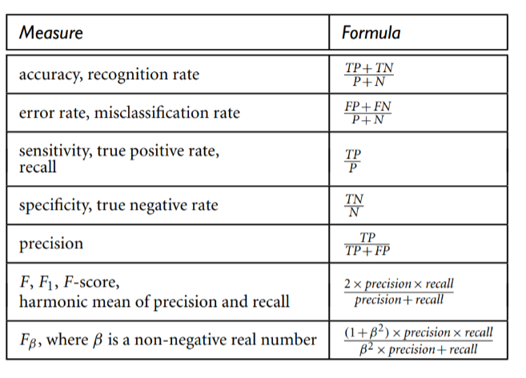

**Results/Observation(ScreenShots):**

**snapshots**

Result snapshots are included in other pdf files.

**Conclusion:**

Using streamlit GUI and python coding all the tasks are implemented well.