**Assignment No. 4**

PRN: 2019BTECS00056

Name: Rohan Bondre

**Aim:**

1. Design the rule based classifier : Extract the rules from decision tree build in assignment no. 3.

2. Tabulate the results and evaluate the performance of rules generated using following metrics :

a. Coverage

b. Accuracy

c. Toughness (size)

3. Use the following categorical data sets from UCI machine learning repository :

a. Balance Scale data set

b. Car evaluation data set

c. Breast-cancer data set

Run commands:

Go to folder location of main.py file and run command :

**streamlit run main.py**

**Results/Observation(ScreenShots):**

**snapshots**

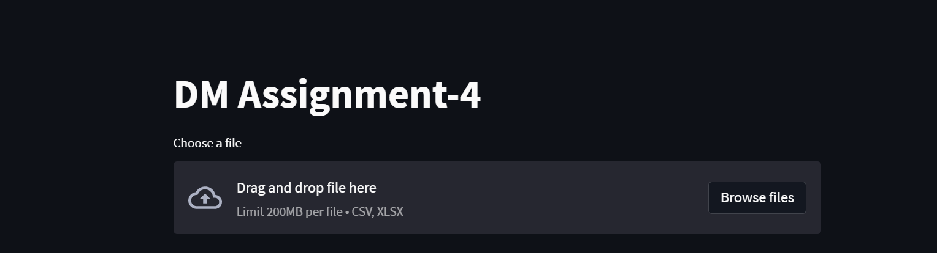

Loaded Balance Score Dataset:

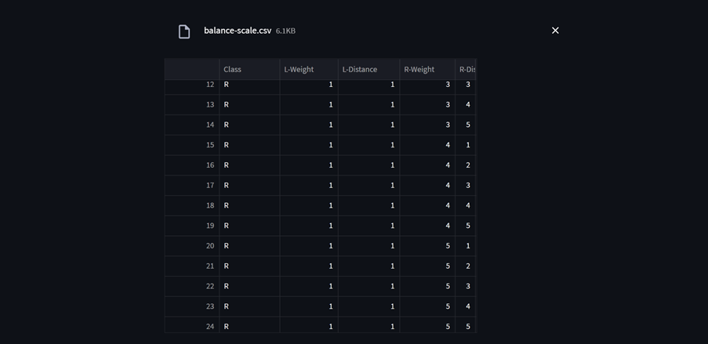

Graphical display of Dicision tree:

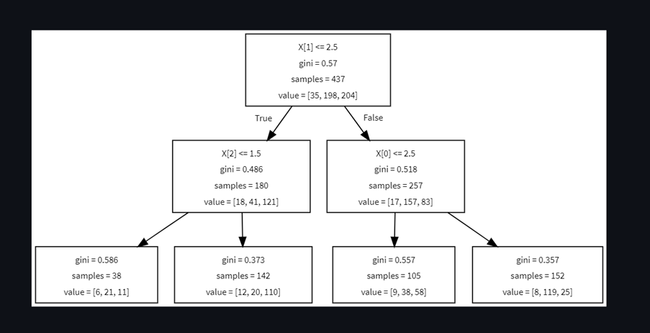

Extracted rules from dicision tree:

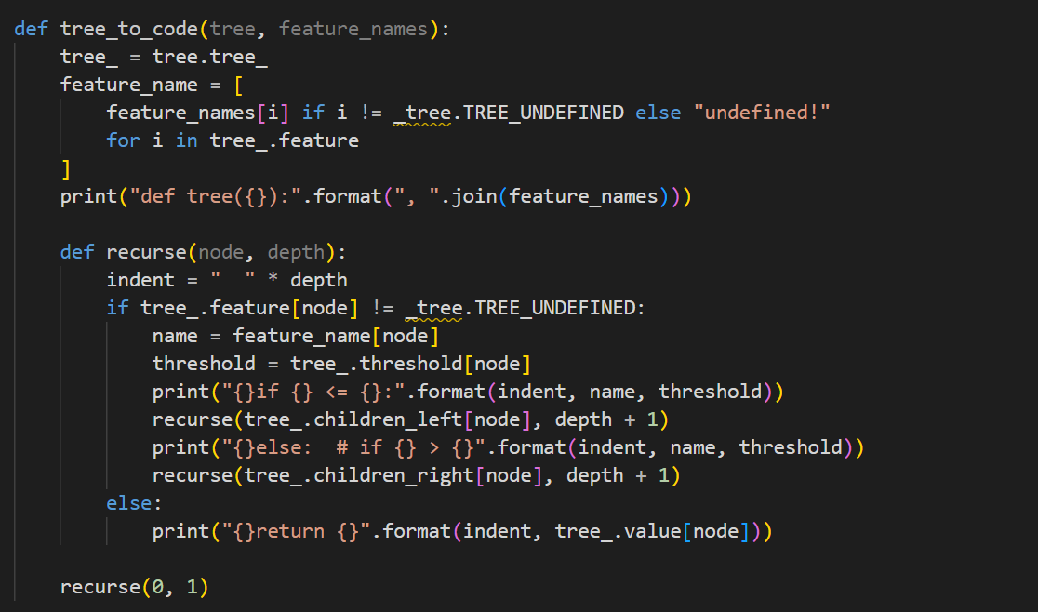

**Conclusion:**

Using the stream lit framework for UI and using python language dataset is loaded and displayed in grid form. Constructed algorithm to extract rules from dicision tree.

Stream lit is an open-source app framework for Machine Learning and Data Science teams.