**Final Year B. Tech. (CSE) – I : 2021-22**

**4CS462 : PE2 - Data Mining Lab**

**Assignment No. 5**

**Group id: DM21G12**

**Group members:**

**Abhishek More(2018BTECS00037)**

**Sushil Wagh(2018BTECS00031)**

**Title :** Design the rule based classifier : Extract the rules from decision tree build in

assignment no. 4.

**Objective/Aim :**

Tabulate the results and evaluate the performance of rules generated using

following metrics :

a. Coverage

b. Accuracy

C. Toughness (size)

Use the following categorical data sets from UCI machine learning repository :

a. Balance Scale data set

b. Car evaluation data set

C. Breast-cancer data se

**Introduction:**

**Coverage of a rule:**

The percentage of instances that satisfy the antecedent of a

rule (i.e., whose attribute values hold true for the rule’s

antecedent).

**Accuracy of a rule:**

Rule-Based Classification

The percentage of instances that satisfy both the antecedent

and consequent of a rule

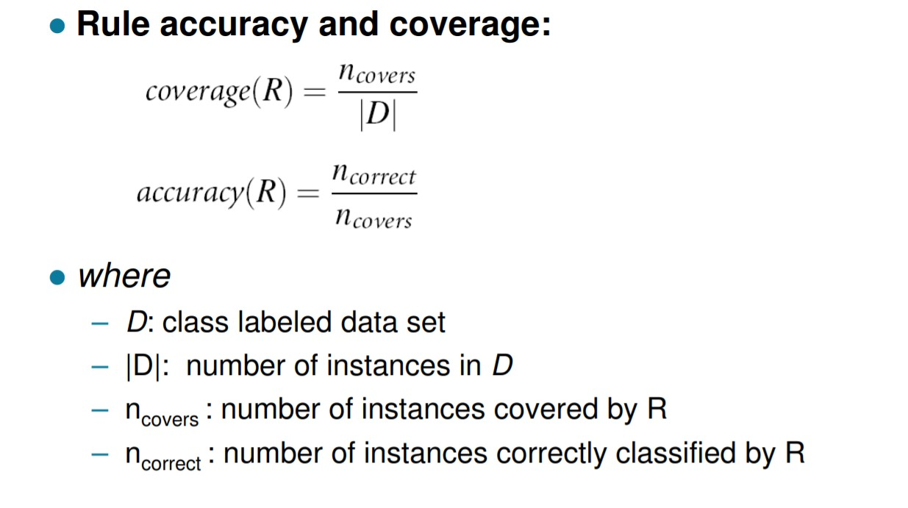

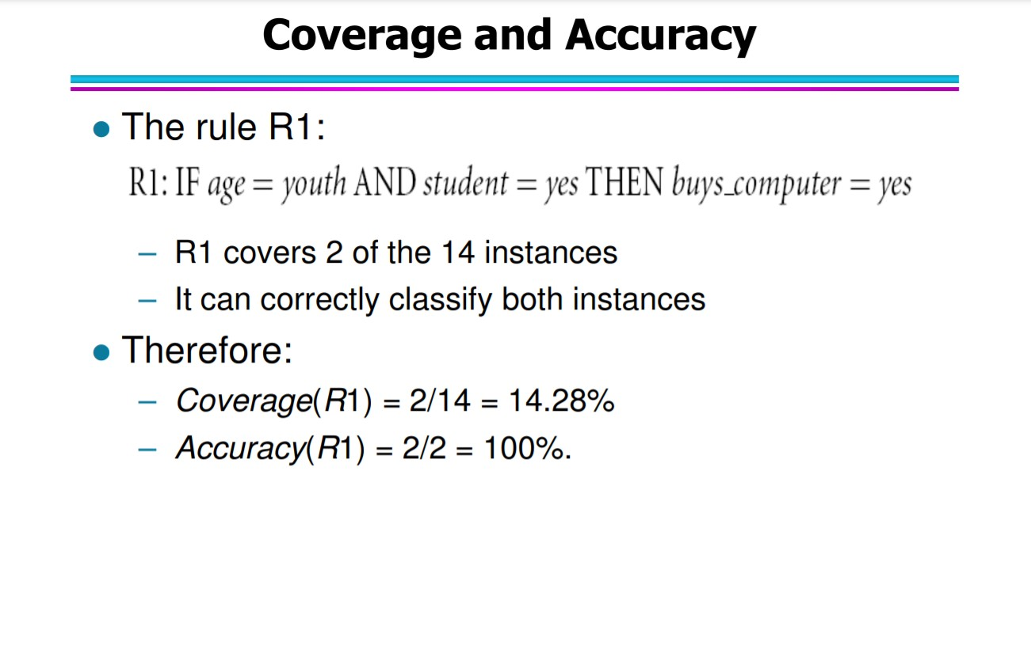

**Result/Observations/Screenshots:**

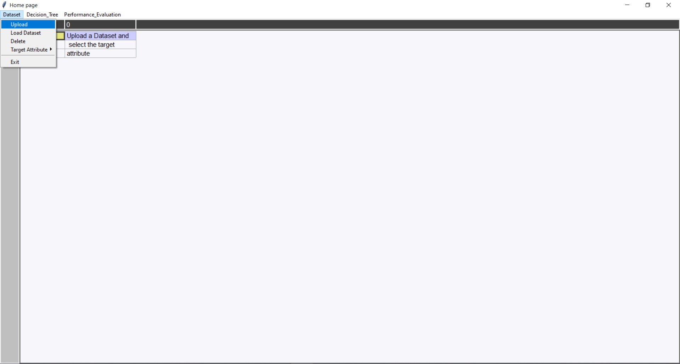

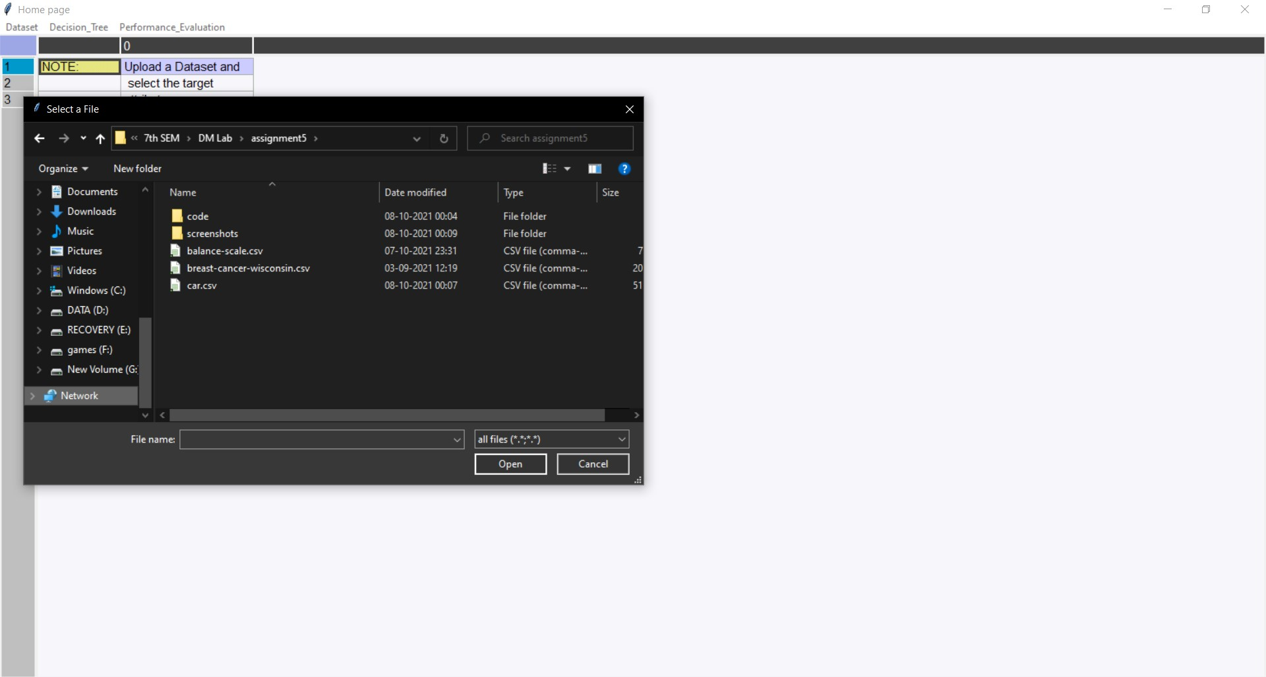

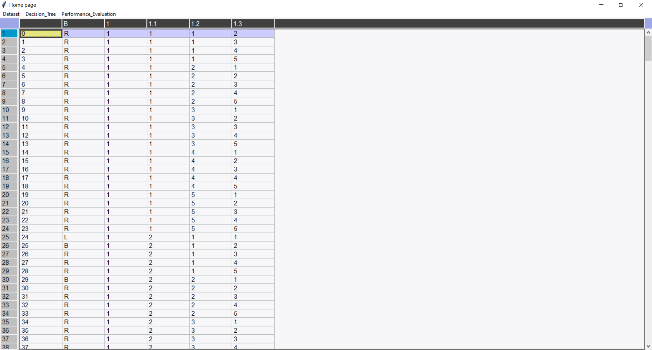

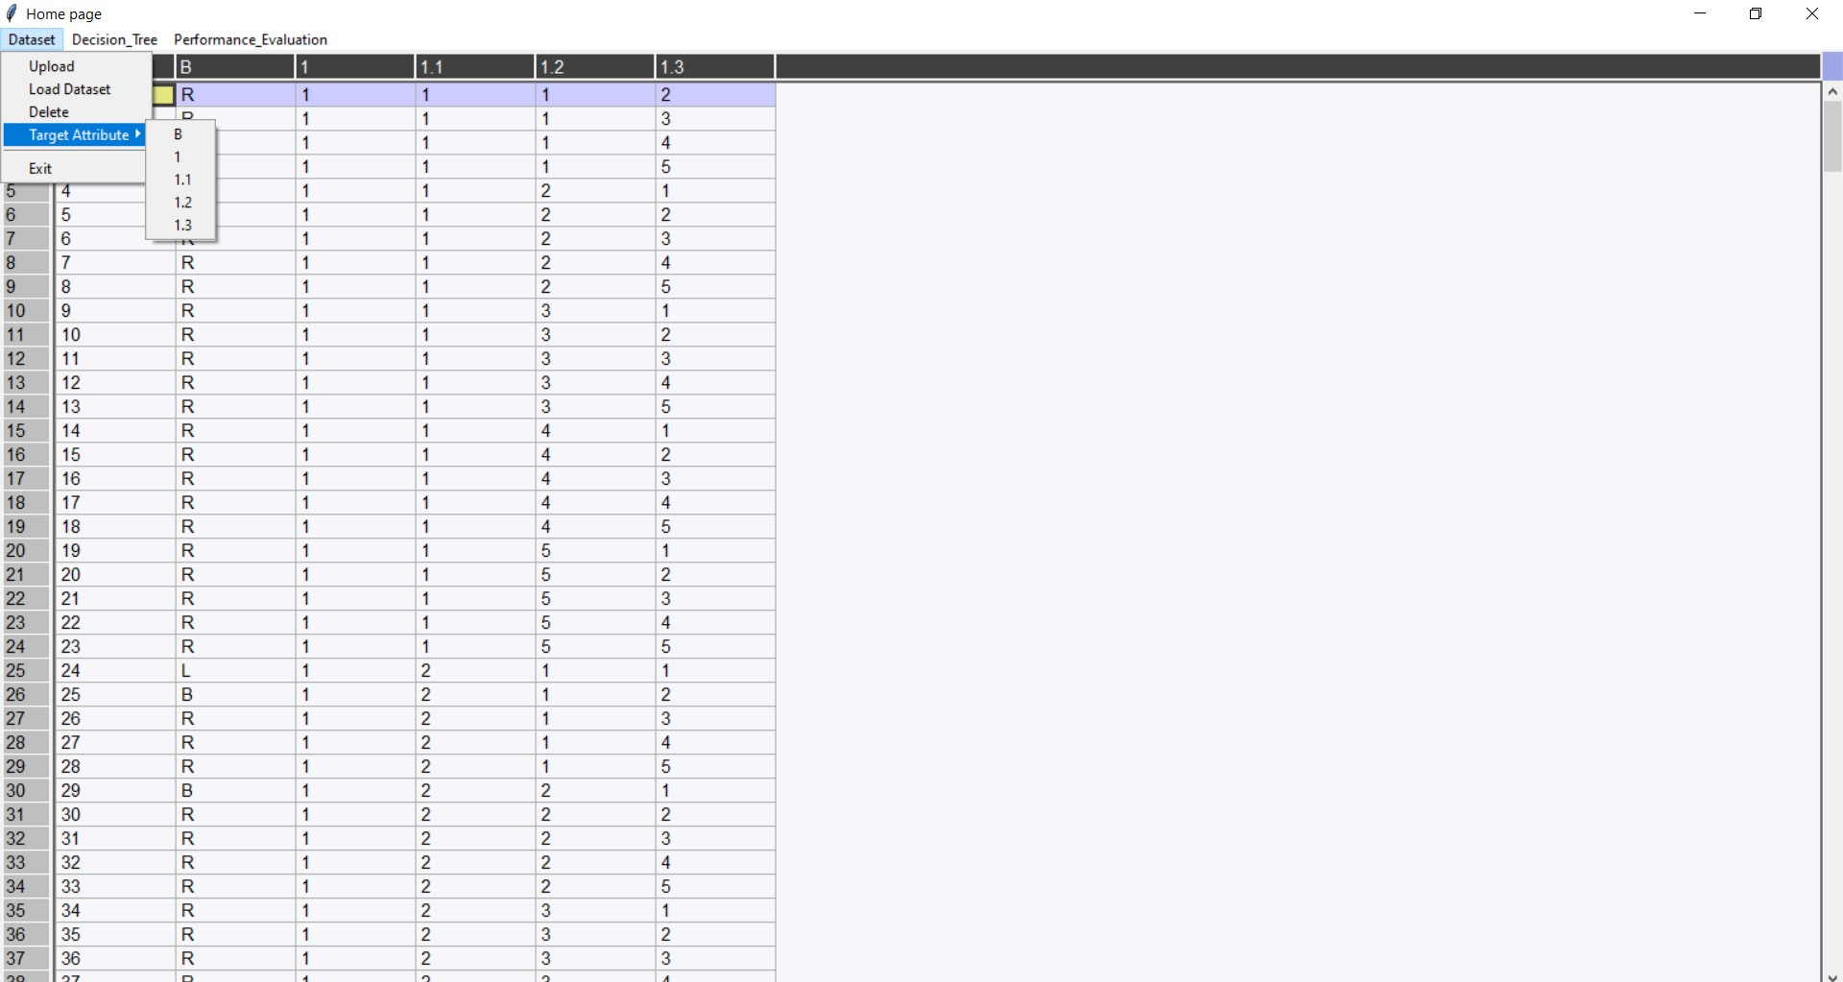

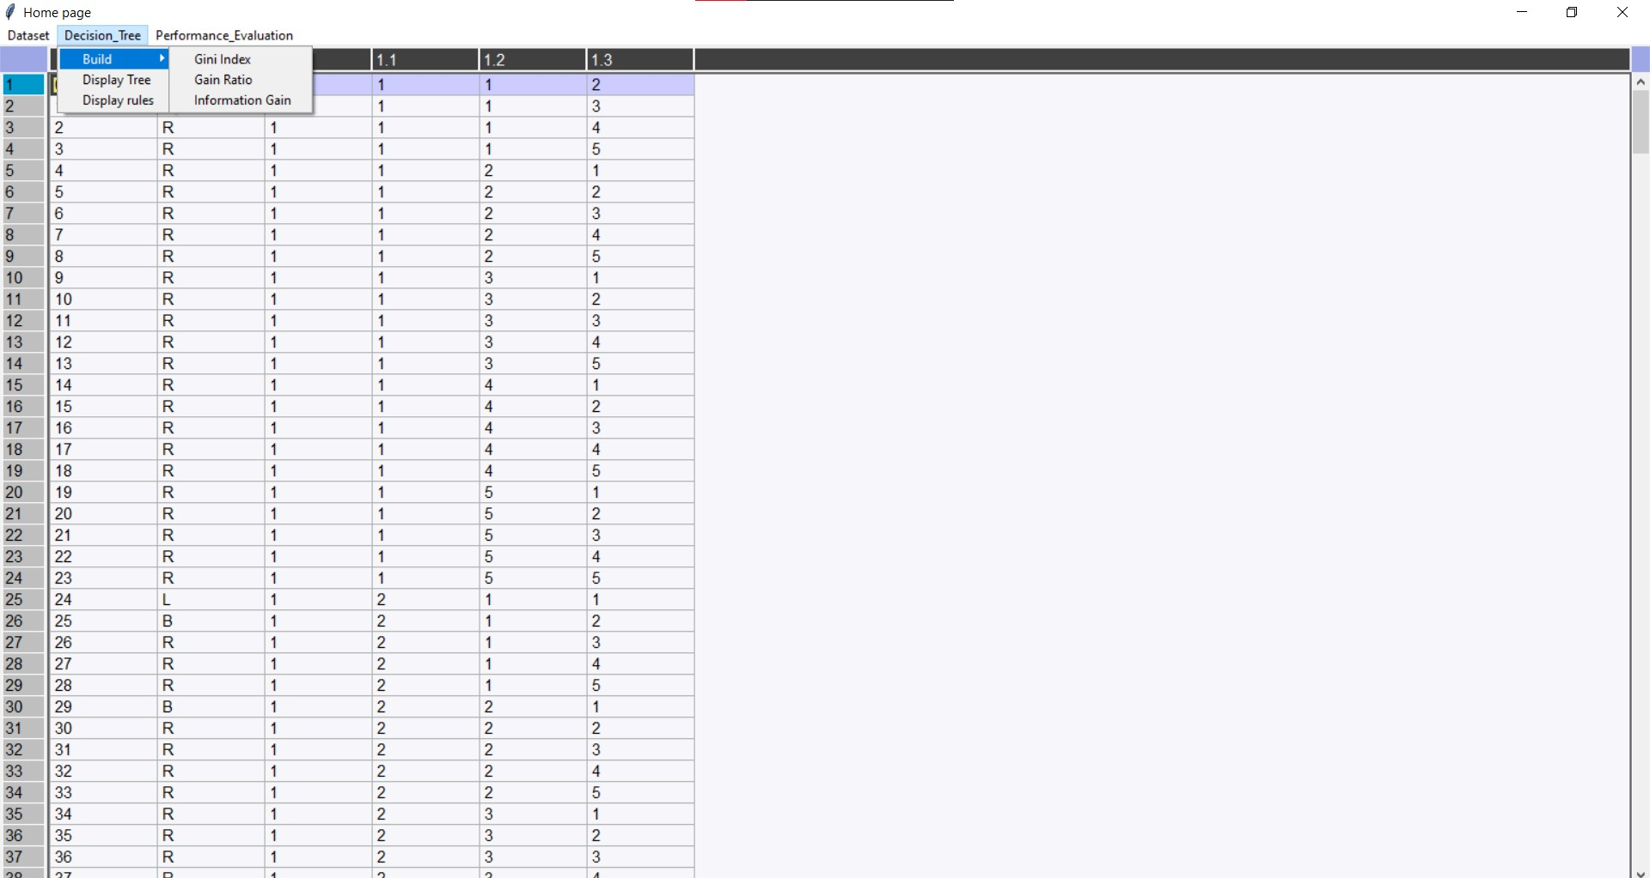

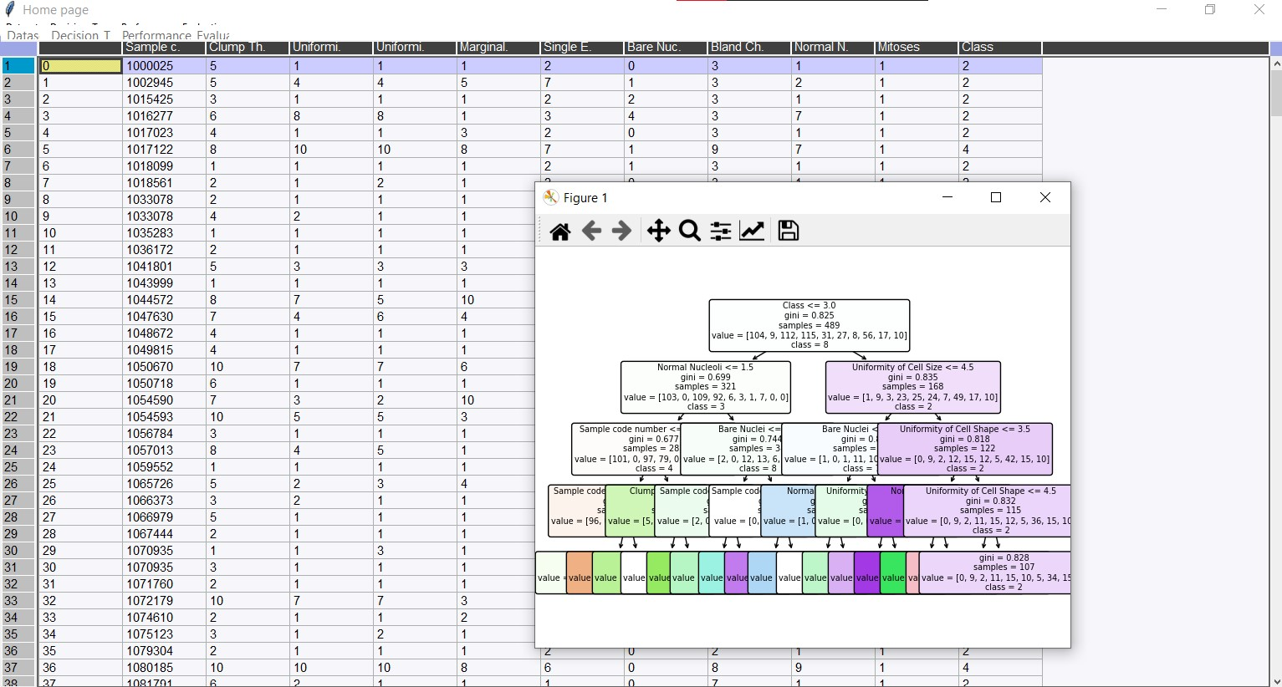

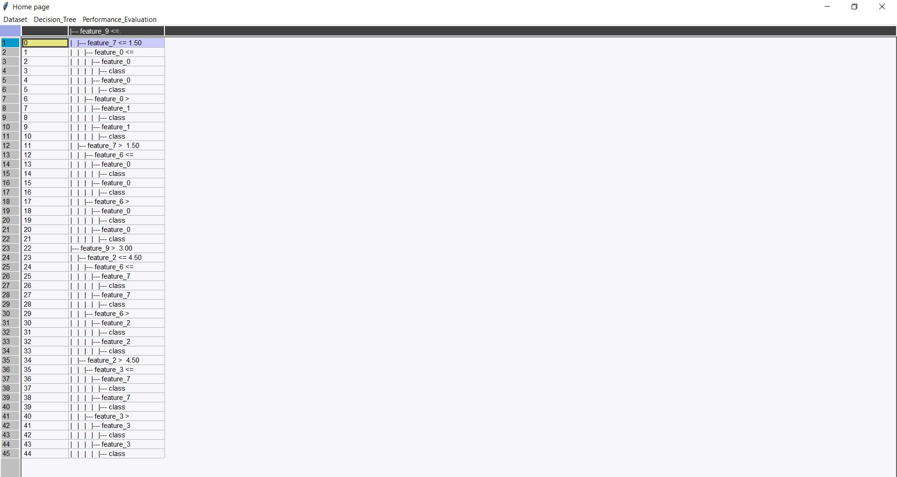

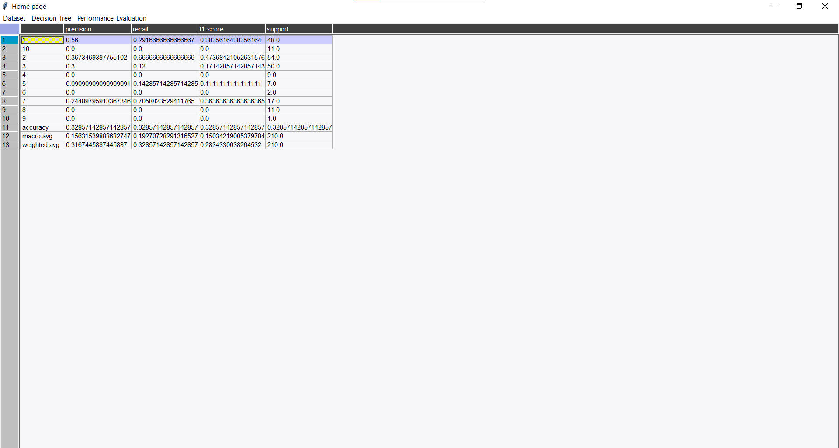

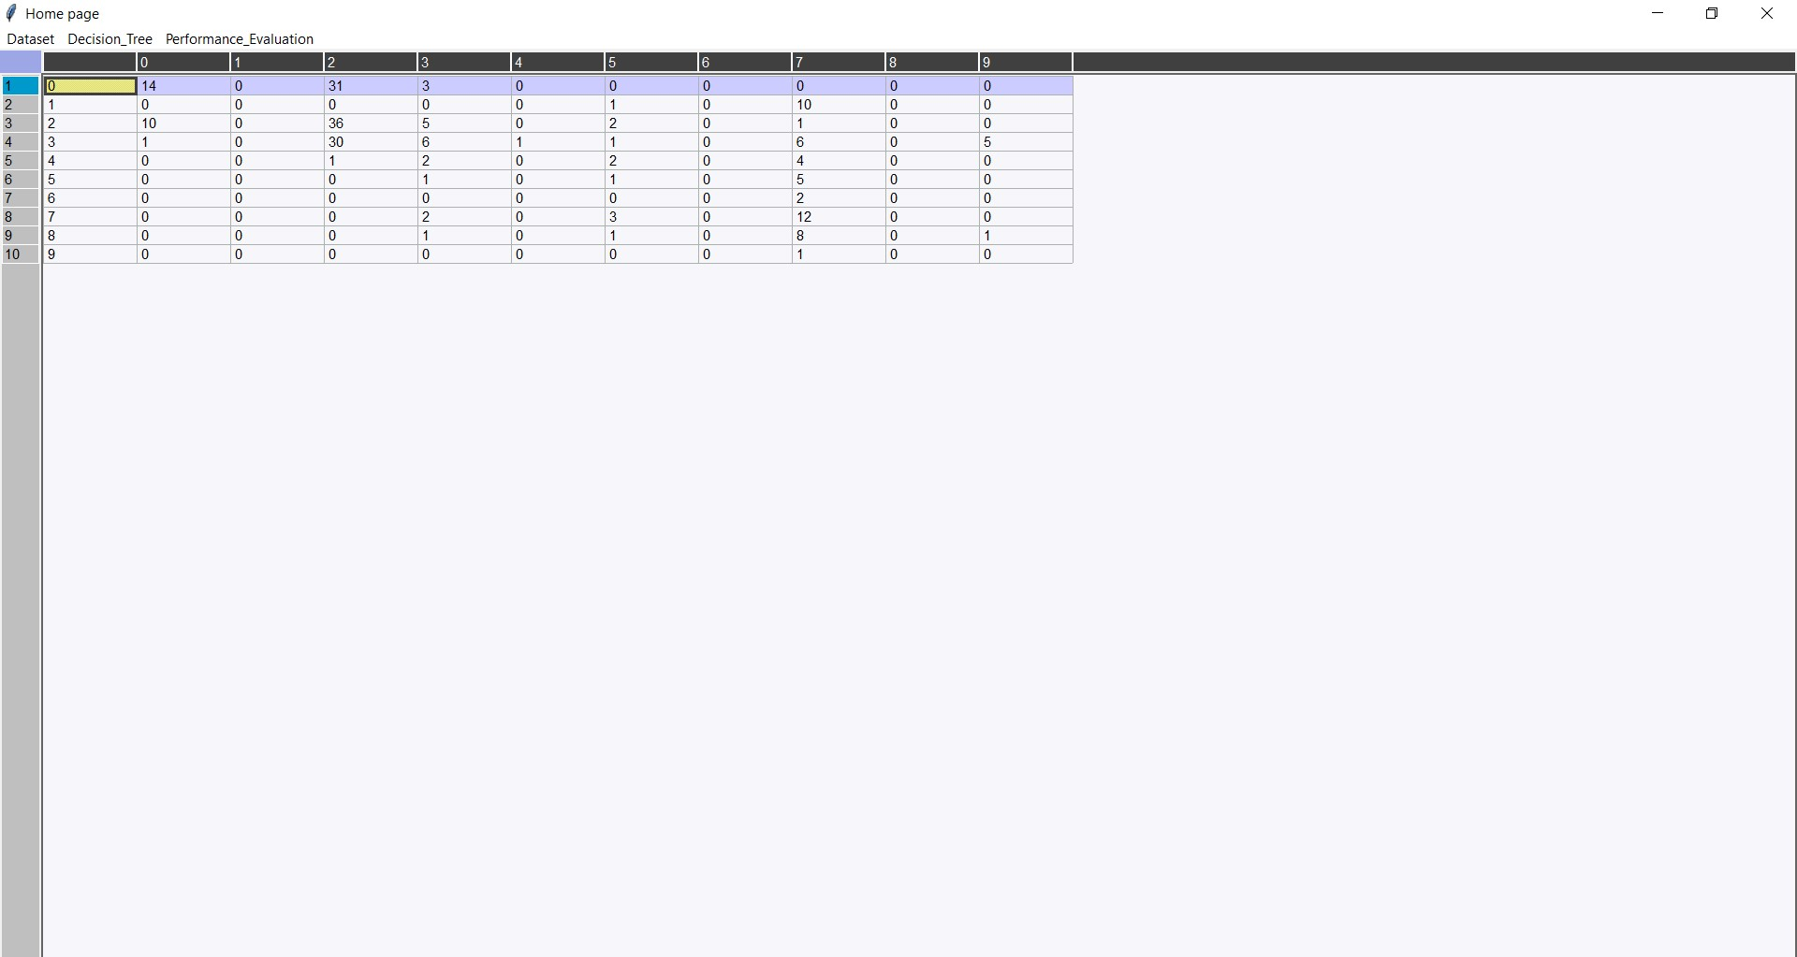

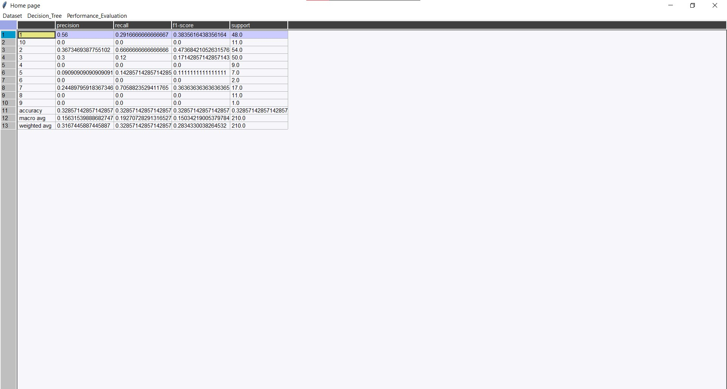

**References:**

* <http://webpages.iust.ac.ir/yaghini/Courses/Data_Mining_882/DM_05_04_Rule-Based%20Classification.pdf>
* <https://victorzhou.com/blog/information-gain/>
* <https://www.analyticssteps.com/blogs/what-gini-index-and-information-gain-decision-trees>
* <https://towardsdatascience.com/the-complete-tensorflow-tutorial-for-newbies-dc3acc1310f8>
* <https://towardsdatascience.com/beginners-guide-to-deep-learning-with-tensorflow-ca85969b2f2>