**Seasonal Patterns in Homeowner Quotes and Production**

**Introduction**

The goal of this analysis is to identify the factors driving seasonality in homeowners quotes and production (conversion) for State Farm. The analysis is based on data for quotes received in 2017 and 2018, and the variables provided include month, year, home purchase year, home/auto discount, amount of insurance, first point of contact, written indicator, credit score, homeowner age, and aggregator status.

**Data Description**

The dataset comprises homeowners quotes received in the years 2017 and 2018, containing the following variables:

* **Month**: The month when the quote was received (1-12).
* **Year**: The year when the quote was received (2017 or 2018).
* **Home Purchase Year**: The year the home was purchased.
* **Home/Auto Discount**: Indicates if the quote received a discount for also quoting auto insurance (Boolean).
* **Amount of Insurance**: The dollar amount the dwelling is insured for.
* **First Point of Contact**: The channel through which the quote was originally received (e.g., Agent, Internet).
* **Written Indicator**: Indicates if State Farm wrote/converted the policy (1 for yes, 0 for no).
* **Score**: The credit rating of the homeowner.
* **Homeowner Age**: The age of the homeowner.
* **Aggregator**: Indicates if the quote was received from an aggregator (Boolean).

The dataset includes 173,501 entries, with variables encompassing both numerical and categorical data types. Initial data inspection revealed some missing values in the Score variable, which were handled by dropping rows with missing values.

**Methodology**

*Data Cleaning and Preparation*

1. Loading and Initial Inspection: The data was loaded and inspected for missing values.
2. Handling Missing Values: Rows with missing values were dropped to ensure data quality.
3. Data Type Conversion: Columns were converted to appropriate data types, such as converting the month and year to integers, and boolean-like columns (home/auto discount, written indicator, and aggregator) to boolean types.
4. Filtering Data: To focus on relevant data, homeowners who bought their houses after 1954 were initially considered. However, based on data distribution, a more recent cutoff year (e.g., 1990) might provide a better focus.
5. Handling Outliers: Outliers in homeowner age were handled using the interquartile range (IQR) method.

*Exploratory Data Analysis (EDA)*

1. Distribution of Quotes by Month and Year: Analyzed the number of quotes received each month and year.
2. Seasonal Trends: Grouped data by month and year to observe seasonal patterns.
3. Distribution by First Point of Contact: Analyzed how the channel of the first contact influences the number of quotes.
4. Conversion Rate Analysis: Evaluated how the conversion rates vary across different months.

**Findings**

1. Seasonal Patterns: Quotes tend to increase during certain months, particularly in the spring and early summer (March to June).
2. First Point of Contact: The channel through which the quote was received (e.g., Agent, Internet) significantly impacts the volume of quotes.
3. Conversion Rates: Conversion rates vary by month, with some months showing higher conversion rates than others.
4. Home Purchase Year: More recent home purchases (post-1990) show distinct seasonal trends compared to older purchases.

**Recommendations**

1. Target Marketing Campaigns: Focus marketing efforts during peak months (March to June) to maximize quote volume.
2. Channel Optimization: Enhance and optimize channels that show higher quote volumes and conversion rates, such as the internet and agent channels.
3. Customer Segmentation: Segment customers based on home purchase year and target them with tailored offerings and discounts.

**Visuals**

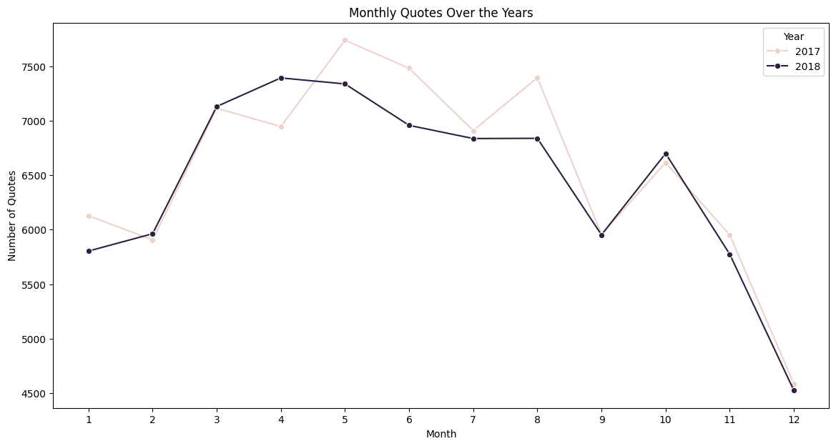

Figure 1: Monthly Quotes Distribution

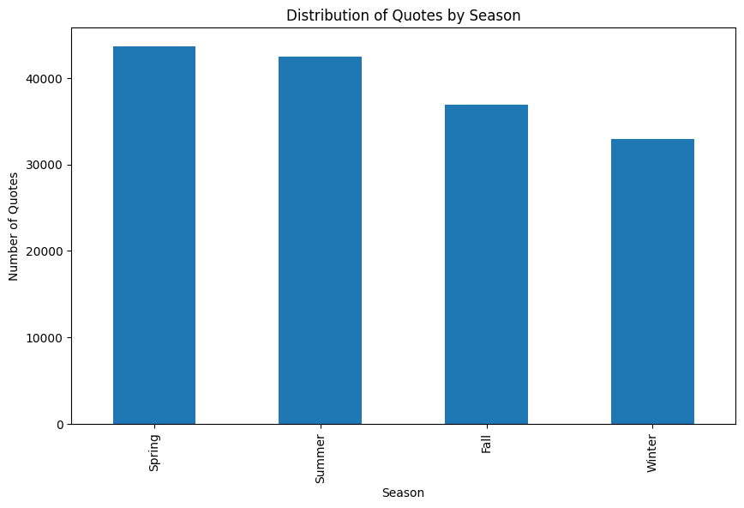

Figure 2: Seasonal Quotes Distribution

Figure 3: Seasonal Quotes Distribution

Figure 4: Impact of Home/Auto Discount