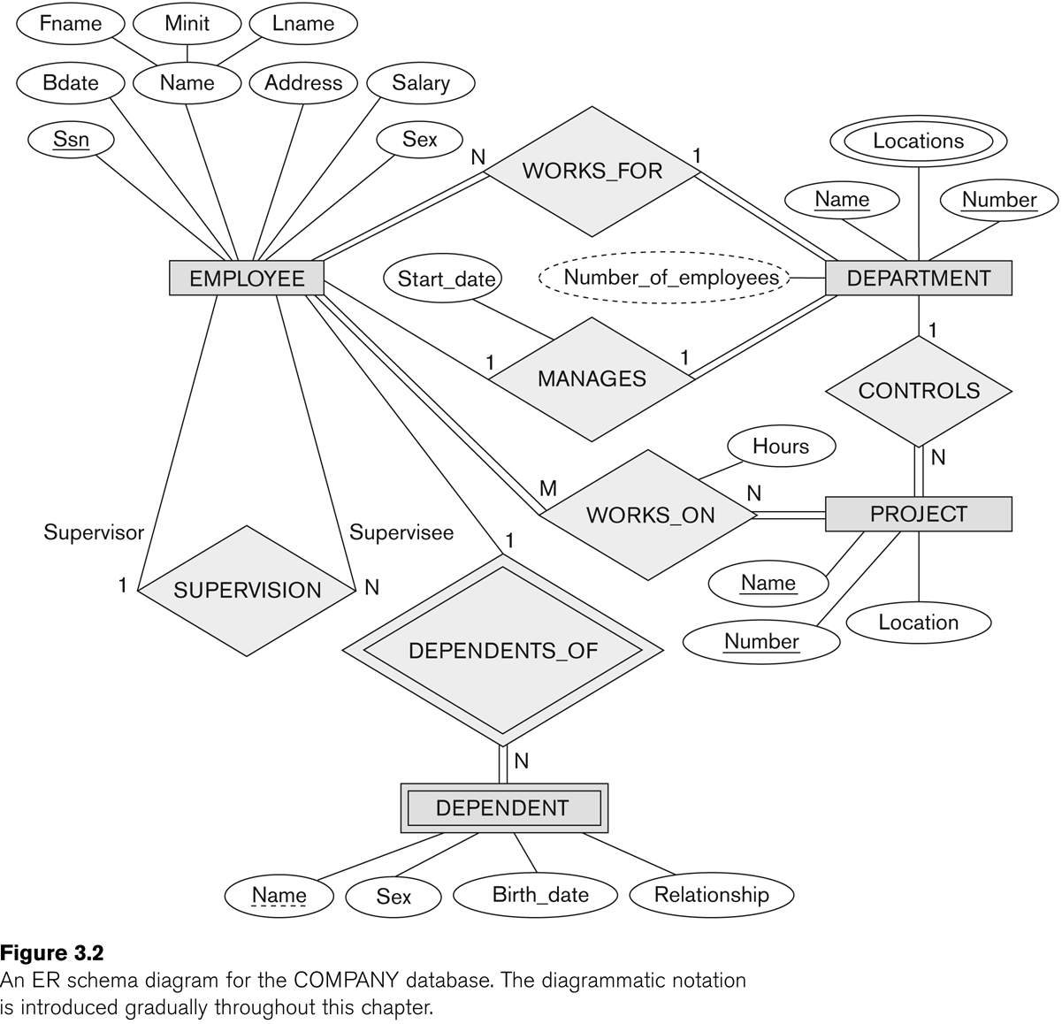1.Find out the entity type

|  |  |
| --- | --- |
| Employee | Strong entity |
| Department | Strong entity |
| Project | Strong entity |
| Dependent | Weak entity |

2.Find out the relationships

|  |  |
| --- | --- |
| Works_for | **Strong and Binary relationship** |
| Manages | **Strong and Binary relationship** |
| Works on | **Strong and Binary relationship** |
| Controls | **Strong and Binary relationship** |
| Dependents_of | **Weak and binary relationship** |
| Supervision | **Strong Recursive relationship** |

3.Describe the ER Diagram in words

This ER diagram describes about a company environment with its features.It has 4 entities and 3 of them are strong and one is weak.Namely Employee,Department,Project are **strong entities** and Dependent is a **weak entity**.

Every entity has its attributes. Employee has these attributes (Name, Address, LName, Minit, FName, Bdate, Ssn, Salary, Sex). Similarly Department (Name, Locations, Number, Number of employees) Project (Name, Number, Location) and Dependent (Name, Sex, Birth_date, Relationship) have their attributes as above.However these attributes has different characters.

Ssn attribute which belongs to Employee entity is a **key attribute**.Name,Number which belongs to project and department also a **key attribute**.Locations under the department is a **multivalued attribute** and Number of Employees is a **derived attribute**.Except supervision others are **binary relationship**.Supervision comes under **recursive relationship.**

In binary relationship there are some varieties can be seen as follows.

Works_for  **Many to one**

Manages  **One to one**

Works on  **Many to many**

Controls **One to many**

Dependents_of  **One to many**

Supervision **One to many**