# **SQL Developer Task 3 – Explanation Report**

## **Task 1: Top 5 Students by Total Score**

**Query Used:**

SELECT name,  
 (math_score + science_score + english_score) AS total_score  
FROM Students  
ORDER BY total_score DESC  
LIMIT 5;

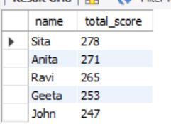

**Explanation:**

* Calculates total score dynamically.
* Uses ORDER BY to rank students in descending order.
* LIMIT 5 filters top 5 performers.

**Insight:**

Helps identify the best-performing students overall.

## **Task 2.1: Average Math Score of Students with Score > 70**

**Query Used:**

SELECT AVG(math_score) AS average_math_score  
FROM Students  
WHERE math_score > 70;

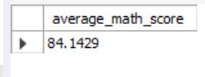

**Explanation:**

* Filters students scoring more than 70 in Math.
* Calculates average using AVG().

**Insight:**

Measures high-performing students' average in Math.

## **Task 2.2: Average Total Score for Score Range 200–250**

**Query Used:**

SELECT AVG(total) AS avg_total_score  
FROM (  
 SELECT (math_score + science_score + english_score) AS total  
 FROM Students  
) AS totals  
WHERE total BETWEEN 200 AND 250;



**Explanation:**

* Subquery calculates total score.
* Outer query filters totals between 200–250 and averages them.

**Insight:**

Highlights average of mid-to-high scoring students.

## **Task 3: Find Second-Highest Math Score**

**Query Used:**

SELECT MAX(math_score) AS second_highest_math_score  
FROM Students  
WHERE math_score < (SELECT MAX(math_score) FROM Students);



**Explanation:**

* Subquery gets the highest Math score.
* Outer query filters it out and finds the second highest using MAX ().