|  |
| --- |
| College LaSalle |
| Project - Internet Programming Technical Manual |
|  |
| Presented to: Mihai Maftei |

|  |
| --- |
| Varun Grover  10/24/2022 |

**Start by adding a short description of your project, and the languages (technologies) used**

Languages:

1. HTML
2. CSS
3. JavaScript

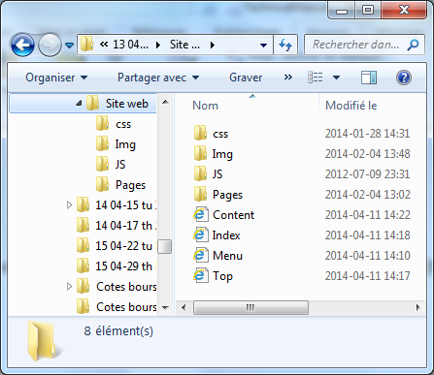**Presenting how the files/folders are organised.**

Index.html

content.html

top.html

menu.html

css

* style.css

img

* img1.jpg

js

* app.js

**Present the functions and/or methods that you create or you did use into the web project.**

|  |  |
| --- | --- |
| **Function/Method** | **Description** |
| 1. document.getElementById() | To get the content from html page |
| 1. alert() | Give alert to user |
|  |  |
|  |  |

**Present the difficulties that you have, what was the hardest and the easiest part of your project.**

… your presentation goes here …