DUAL ISSUE MIPS simulator

tl;dr: configure a tool which can calculate MIPS instructions and generate execution diagram by cycles while outputting meta data for the execution

3 parts:

* configuration reading
* execution calculation
* output printing

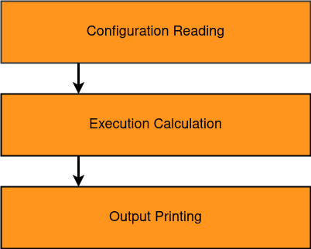

1. Configuration Reading

Two parts: validation of document & reading/parsing of the configuration

Validation part:

* configuration file exists
  + validate configuration file type
* content of configuration file is correct
  + every property has value
  + every value is corresponding to the type
  + no unreadable property is present

Reading/parsing part:

* contain settings for the execution of the MIPS simulation
* find proper class decomposition for settings
* initialize globally for the execution

1. Execution Calculation

Main logic for the program.

* + 1. Take into account the settings from the calculations
    2. Calculate cycles taken
    3. Calculate branchs taken and not taken
    4. CPI

1. Output Printing

Create file for result:

* file for dependencies
* file for time diagram
* file with prediction
* file with statistics