Di-MIPS

Practicum

# *Computer Architecture Project For Simulation Of Dual-Issue MIPS Architecture*

*Academic Year/course: 2022/23*

*Code: 21735*

Authors:

Tomas Dengra & Vasil Andreev & Vicenç Servera

**Index**

Introduction………………………………………………….1

Goals of the system…………………………………………..2

The system…………………………………………………...2

The Code……………………………………………………..6

Example of use……………………………………………..14

Further ideas………………………………………………..18

**1. Introduction**

Di-MIPS is an academic project, conducted by Tomas Dengra, Vasil Andreev and Vicenç Servera in the elective course of Computer Architectures in the University of Iles Balears during the first semester of the year 2023-2024. Its main purpose is to apply the knowledge of the material studied in the course, using tools and processes that are learned during the academic and professional realization of the students. This includes the work of communication, software engineering, software architecture, writing code and documenting the process.

The time spent on the project is 30+ hours total, including computing laboratory sessions during the course and the out-of-university sessions organized by the participants in the project. The communication during the out-of-university sessions was piloted by the platform for voice chat Discord [[discord.com]](https://discord.com/company). The methodology for the process was sorted with an informal implementation of a mixture of the iterative methodologies Agile and Kanban, dividing the process into steps of planning, designing, developing and reviewing.

During the planning, the work was split into small tasks that were then tackled by the contributors, while a review session was regulating the progress of the system weekly or biweekly. For version controlling, the technology of Git with the platform GitHub [[github.com]](https://github.com/about) was used, alongside with various tools and environment add-ons for easing the application of Git. For software environment, various code editors were used, including Visual Studio Code, Eclipse and NetBeans. The programming language of choice was Java 11 [[java.com](https://www.java.com/en/download/help/whatis_java.html)]. Documentation of the project is realized in LibreOffice Writer [[libreoffice.org](https://www.libreoffice.org/about-us/who-are-we/)], while the diagrams are created with the help of the Visual Paradigm [[visual-paradigm.com](https://www.visual-paradigm.com/aboutus/)] and DrawIO [[drawio-app.com](https://drawio-app.com/)].

Source of inspiration for the project were the lectures led by Dra. Catalina Lladó, specifically the chapter of Pipelineing, aided by the book “*Computer Organization and Design MIPS Edition: The Hardware/Software Interface*” by David A. Petersonand & John L. Henneesy.

**2. Goals Of The System**

The goal of the system is to reproduce the execution of instructions by the Dual-Issue MIPS computer architecture. The implementation of which could be used for future teaching practices. It could be used to solve problems in entry-level academic investigatory or a tool that can help the observation of more complex examples of MIPS executions. Besides that, the simulation can be further developed to form a base for future projects or to serve as a point of reference to an example of a complex execution of a set of MIPS instructions.

A general use-case is the execution of a specific set of instructions for the architecture and visualizing their timeline in cycles.

**3. The System**

The Dual-issue pipelining is a subtype of multiple issue pipelining, where the compiler groups instructions into “issue packets”. The “issue packets” are a group of instructions that can be issued on a single cycle. In the Dual-issue, these packets are made of two different instructions. The instructions in a packet are executed concurrently, so we can think about the execution of a packet as the execution of a very long instruction, which execution will be determined by the pipeline resources required.

Since the packets are executed concurrently, we cannot allow dependencies in a packet. Usually, the compiler has to reorder some instructions to remove hazards so the packets have as few “NOPs” as possible. Also, we have to consider that we can find dependencies between packages. In the case of the Dual-issue packets, the instructions are packed like follows:

* One ALU/branch instruction.
* One load/store instruction.

For example, let’s see the next set of instructions:

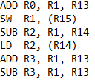Figure 3.1 – Example set of instructions

In this case, we would have:

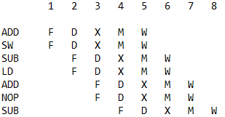Figure 3.2 – Execution of an example set of instructions for Dual-issue architecture

We can see that, until the end, the instructions are grouped in packs of 2 and, when we have an ADD followed by a SUB (two ALU instructions together), the 2-issue puts a NOP between both, even though there isn’t a dependency. The NOP is there because these two instructions were one next to the other but couldn’t be packed together.

The simulation of the Dual-Issue architecture is broken down into three phases: configuration, execution and outputting. Those layers are shown in figure 3.3. Using the configuration, we set the parameters as the number of instructions, their order, their types and the registers. Then after we start the simulation, the Di-MIPS executes code based on the data of the configuration file, creating an output file, where the results of the simulation are formatted to be read.

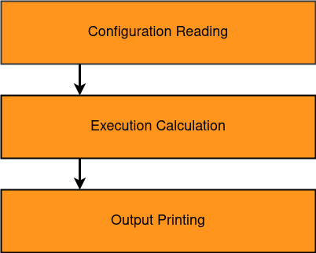Figure 3.3 – Layering of the Di-MIPS system

A detailed dive into the system will show a more complex way of communication between the different layers of the system. For example, the Configuration Reading layer has 3 components: the configuration file, the instructions file and the File_Reader class that reads from them. The user should edit the configuration file to change the parameters of the type of execution and the instruction file to set the arguments to the order and type of the instructions he wishes to simulate executions for.

Starting the Di-MIPS system will trigger the execution of the simulation in the following manner:

1. Reading from the two user-edited files.
2. Passing the data from the instruction and configuration file to the Executor class, responsible for the main logic of the interpretation of the data
3. The Executor sends the computed stages and cycles to the writer
4. The Writer handles the formatting and the writing the data into an output file

The communication of the different components is described in the communication diagram in Figure 3.4.

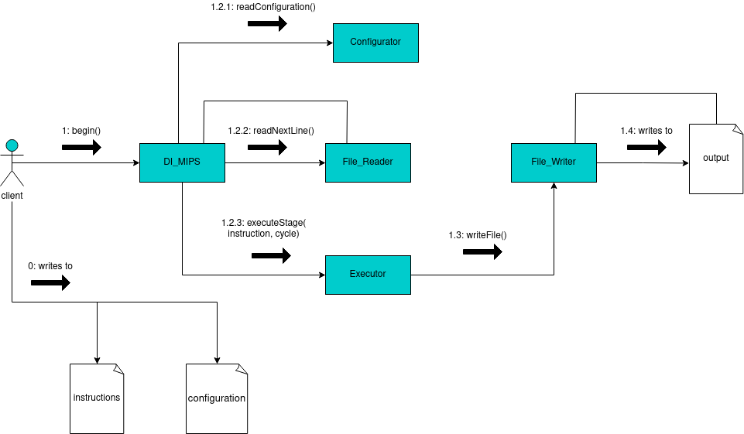Figure 3.4 – Communication diagram for the different entities of the application

**4. The Code**

4.1 Reader

The File_Reader class is the one which manages the program's input, so the instructions written by the user at "instruction.txt" and the registers declared at "register.txt" can be transformed into objects that the program can be interpreted.

The File_Reader is called by the main class DI_MIPS. When we create an object of type File_Reader, the constructor of this class automatically calls the method *initRegisters()*, which will read "register.txt" and store the read registers into the program's registers array so they can be used.

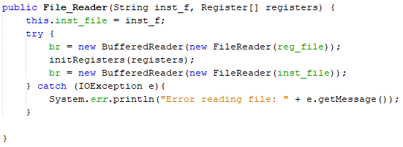Figure 4.1.1 – Constructor for the class File_Reader. We can appreciate how Java's FileReader and method *initRegisters()* are called

The method *initRegisters()* reads the registers declarations from the file “register.txt” to initialize the array of registers. These registers can be changed by the user.

**R0=0**

**R1=1**

**R2=2**

**R3=3**

**R4=4**

**R5=5**

**R6=6**

**R7=7**

**R8=8**

**R9=9**

**R10=10**

**R11=11**

**R12=12**

**R13=13**

**R14=14**

**R15=15**

Example declarations. This is a possible content for the file “register.txt”.

Later, each time another class calls the public method *getNextInstruction()*, we will be reading and passing the instruction that is just at the next line. Using Java's FileReader method *readline()* on a BufferedReader object, we can read and analyze the lines one by one. The method *getNextInstruction* also analyzes if the line is an instruction or something else (label, comment, space between lines, etc.). If the line begins with an instruction operator, this method will return an object of type instruction. If it’s something else, it will keep skipping lines until it finds an instruction or the end of file.

Check if the line is an instruction:

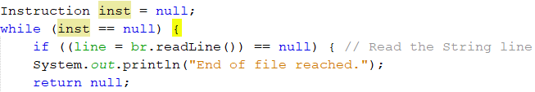Figure 4.1.2 – Beginning of *getNextInstruction()*. We can see how “*inst”* is initialized as *null* and how we look if we reached the end of the file

Pass an instruction when detected:

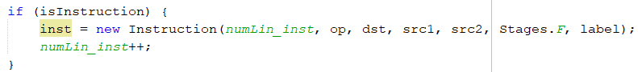Figure 4.1.3 – Ending of *getNextInstruction()*. We can see how, after proving the line is actually an instruction, “*inst”* takes its values before being returned

To know when a line is an instruction or not, *getNextInstruction()* looks for the opcode. This program is capable to detect the next kinds of instructions:

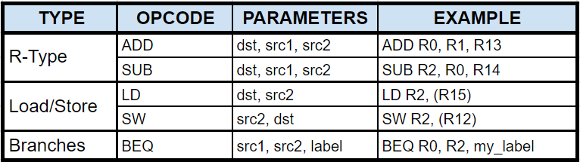Figure 4.1.4 – Table of explanation of the different kinds of instruction and its use

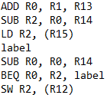Figure 4.1.5 – Example code. This is a possible content for the file “instruction.txt”

Pay attention to the label seen in the BEQ instruction. There is a method called findBranchLine() that is used, as its name suggests, to find at "instruction.txt" the label passed by parameter, placing the pointer to read the next instruction in the line just after the label so the program can continue normally. It is **important** that the labels and instructions are in different lines so this method can detect the labels properly.

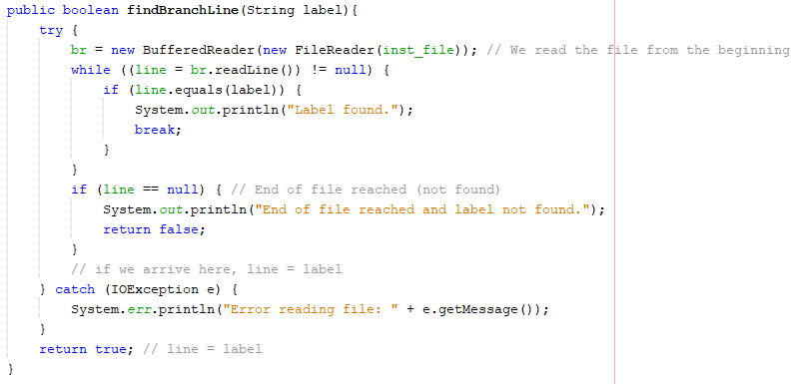Figure 4.1.6 – Method *findBranchLine()*. We can see how it restarts the reading of the document until it finds a line which is exactly the searched label

4.2 Executor

This part of the program is the one responsible for the execution of the instructions. It handles all the logic needed to make sure that the instructions on execution follow the 2-issue pipeline schema.

First of all, the main class has only one function that controls all the calls that simulate the execution of the 2-issue MIPS. This function has 4 parts, the lecture of the instruction, checking if they can be executed in the same slot, adding them to the execution and finally the execution itself. For the execution, the main function, uses the *Executor* class, which has a function *executeStage(Instruction ins)*, that simulates the execution of an instruction depending on the stage, operator, cycle and the id. To do this, the *executeStage(Instruction ins)*, checks if the Operator is a *NOP* or if the last instruction executed has stalled, if none of these two things happen, *executeStage(Instruction ins)* executes a different function depending on the operator it is dealing with. The function that is called, doesn't only simulate the execution of the pipeline, it’s really executing the calculations said by the instructions, this is an important feature, because it’s the only way we can know if a *BEQ* instruction has to be taken or not.

As we could imagine, the *Executor* needs to use the *Instruction* class to work properly. Inside an instruction, we have all the information we need to execute it, including instruction’s id, operator (ADD, LW, BEQ…), destination register, first source register, second source register, a stage where the instruction is and label (needed in case it is a branch).

At its time, the instruction needs to use the registers (destination register, first source register, second source register). The registers are all together in a static assay of registers. An object *Register* has been assigned a value in the constructor. This value, as has been said, can change during the execution of the program. In addition, the registers take into account the dependencies of the program to execute it properly. The important part of the register class id the function *hasDependency()*, that for a register in a specific instruction, returns if the register gas a RAW or WAW dependency. This function is used in the executor for every register in an instruction to check if the instruction can be executed.

Figure 4.2.1 – Calling chain of the Execution Calculation part

4.3 Writer

The File_Writer is the class that forms the core of the third logical part, the Output Printing from figure 1. It has the responsibility to take the data of the Execution Calculation, prepare it in a suitable format for reading and store it in a file. It is initialized without parameters, for simplicity, because by default it always creates the output file in the source folder, not leaving it customizable. There are two public functions: *writeStage()* for writing data to the class and *makeFile()* to write the class’s data to an output file. We use Java's FileWriter class.

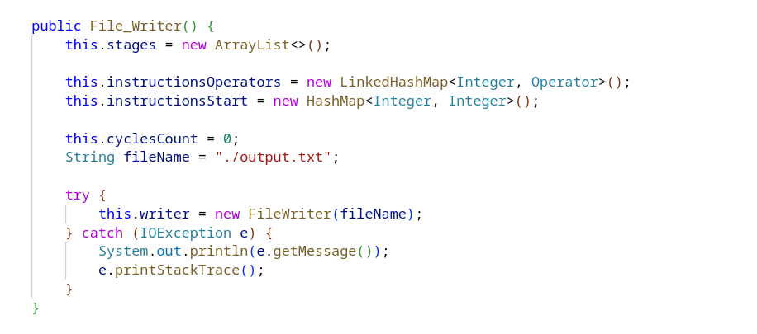Figure 4.3.1 – File_Writer public constructor

The way the class is working is that, before writing the output, it stores data in three collections:

* stages - the matrix of instructions by cycles. It is in a list format, where every element is representing one instruction. The instruction is represented as a map (Hash Map), which maps every stage of the instruction, to a specific cycle number, according to when it is executed.
* instructionsOperators - a map which relates the identification number of the instruction with the type of instruction (i.e. ADD, SW, etc.). Its implementation is a Linked Hash Map so that we can keep the order of the instruction that we put into it, with the idea to iterate through it.
* instructionsStart - another map that relates the instruction identification number with the cycle where the instruction starts execution. As we know, because many factors influence the cycle where an instruction starts, we allow a specification through this second Hash Map

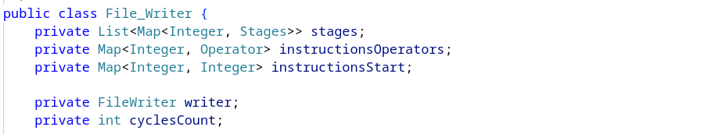Figure 4.3.2 – File_Writer data collections

The first public function there is, is the writeStage, which contains the main logic for the data manipulation of the aforementioned collections. First it updates the cycle count if it gets to a stage in the next cycle, progressing the execution. Second, it checks if the stage that is written is related to an existing instruction or is the start of a new instruction. We will omit the in-depth explanation of the data manipulation, as it is standard for the types of collections and nature of the data. It is essentially matching the ids of the instruction with the stages, until the whole matrix of instructions/cycles is written in.

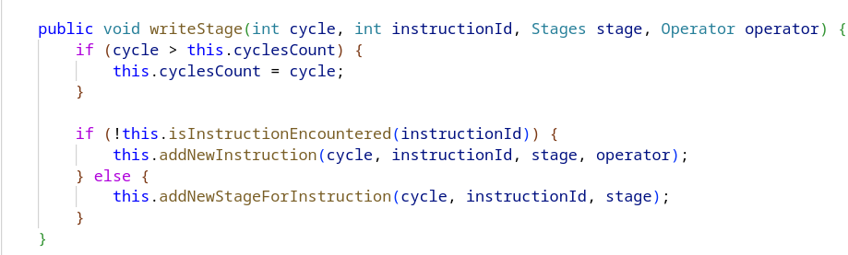Figure 4.3.3 – File_Writer’s point of connection with the Execution Calculation Layer. This is where the data manipulation for the output starts

The other part of the File_Writer is the writing of the file. We also close the writer that we opened in the constructor and handle errors.

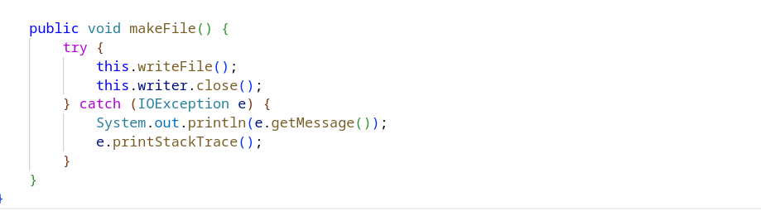Figure 4.3.4 – File_Writer’s function that executes the writing of the output file

We split the writing into three parts: printing the cycle numbers headline, the header with the timeline for the cycles; formatting the line breaks and spacings of the file and lastly - printing the stages for the corresponding instructions.

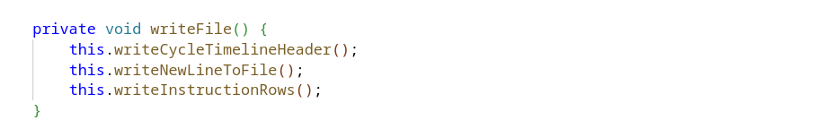Figure 4.3.5 – A deeper look at the responsibility distribution of the private functions to format the output file

For the purpose of simplicity, we will have a look at just one function from the writing to the file, as they are similar in their responsibility and logic. Here we have the writeCycleTimelineHeader:

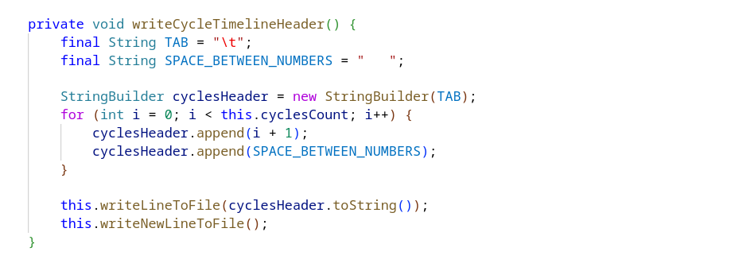Figure 4.3.6 – Function to construct the header for the output file

Knowing the cycles count, we iterate in a loop, concatenating the strings for the spacing between the cycles that we also add in a String Builder. After adding the tabulations and spacings, we finish the builder and pass the final string to the writeLineToFile function. It’s the simplest way to write a string to a file, using the write method of Java's FileWriter class.

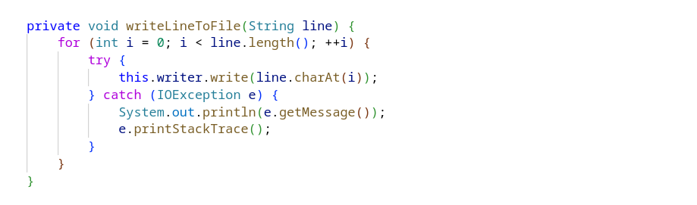Figure 4.3.7 – File_Writer’s function to directly write to file

**5. Example Of Use**

To execute the simulation of the Di-MIPS, we will orient ourselves in the directory of the project. We have two folders, the resources folder and the DI_MIPS folder, the where the project’s code can be found.

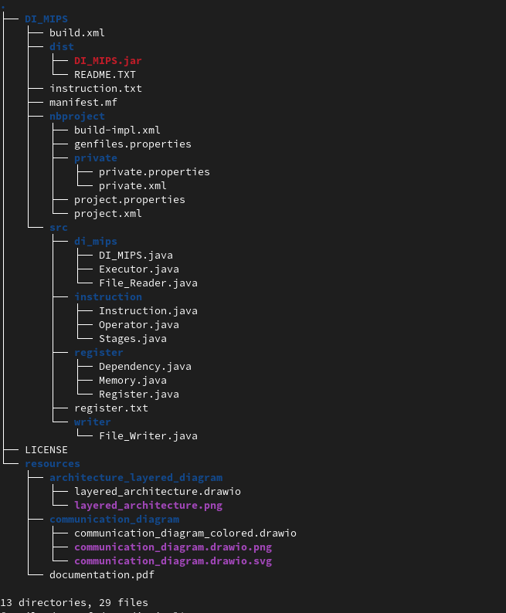Figure 5.1 – Structure of the project

We first open the project with an IDE, for example, NetBeans.

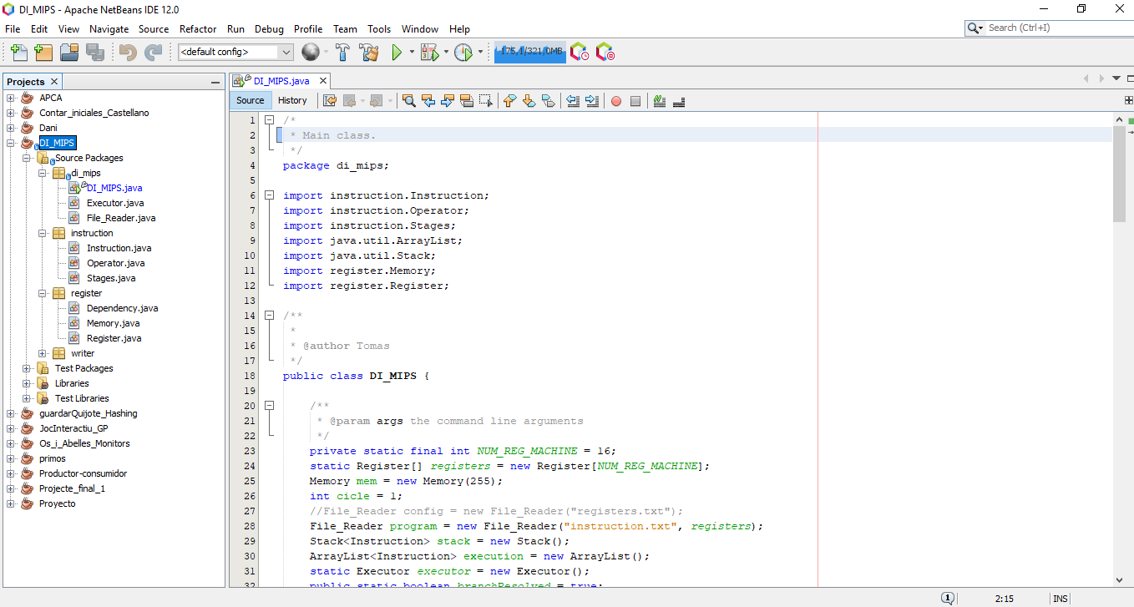Figure 5.2 – Project is opened in NetBeans

In the DI_MIPS we can locate two files – “intructions.txt” and “registers.txt”. Those are the files that the Reader will read to configure the Executor and its instructions.

In the “instructions.txt”, the possible instructions are ADD, SUB, LW, SW and BEQ. As long as we pass them the required parameters, the program will work with no problems. Any line of the file "instruction.txt" that starts with something different than an instruction operation will be detected as a label and won't be compiled as instruction. This means that, for instructions, we need to use the possible structures seen in Figure 4.1.4, but, in the rest of lines, we can write whatever we want. However, these characteristics make very important that labels/comments (non-instruction lines) are in a different line than the instruction. If the user doesn't ensure that this requirement is met, the instruction of that line won't be detected.

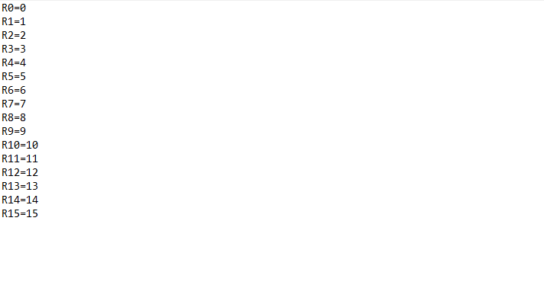Figure 5.3 – Contents of file “register.txt”

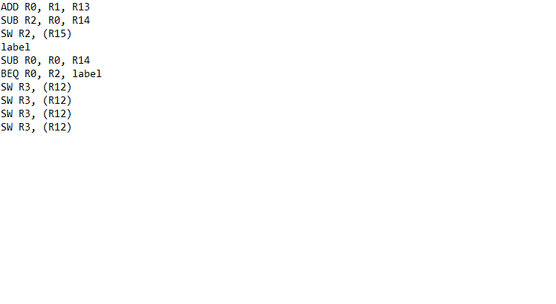Figure 5.4 – Contents of file “instructions.txt”

After we are sure with the instructions that we want to execute and the registers for the instructions, we can pass to the final step, executing the code. After execution, the result should be found in the same level as the two files. The result is a new file, called “output.txt”. Given the examples, its output corresponds to figure 5.5.

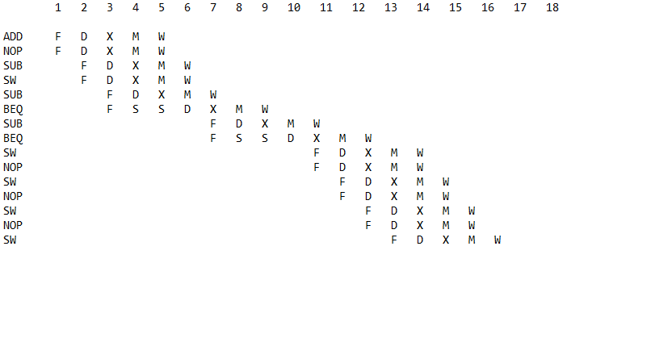Figure 5.5 – Contents of generated file “output.txt”

**6. Further ideas**

As final words, the potential of this project is not limited to its current version. A lot more can be implemented and changed to enhance and develop more complex functionality. For example, to convert this into a real-world project, an idea would be to make this project foolproof by adding validations, error messaging that directly informs the user of the current state of the system. Moreover prettify the code, unify and automate the project build process. For now, its state conforms with the academic use of an end-of-semester group work for the subject of Computer Architectures in UIB. There is enough space for improvements and new ideas. Its latest form is a public project on GitHub, whose address can be accessed at [github.com//di-mips](https://github.com/thevasi1/di-mips).