Social Media Analytics

By

Veerendra Verma

ABSTRACT
The project titled “Social Media Analytics” is presented as a software project with a visible project structure containing separate backend, data, frontend, and tests directories, together with a README.md file, a .gitignore file, and a docker-compose.yml configuration file. The available project evidence indicates that the work was organized as a multi-part application rather than as a single standalone script.
The accessible materials do not include the underlying source files, dataset contents, dependency manifests, API definitions, database schema, analytics implementation, or executable application output. Consequently, this report deliberately limits technical claims to information that can be verified from the supplied project evidence. Source-level methodology, specific analytics operations, data volumes, algorithms, performance measures, and testing outcomes are recorded as “Not specified in the project.” where they cannot be verified.
The project evidence includes photographs of the development environment showing the project directory and a backend workstream completion message. These are treated as development evidence only and are not presented as proof of particular application results.
The main limitation of this documentation set is the absence of the actual project archive/source tree in the files accessible to this document-generation session. The report therefore emphasizes traceability and explicitly distinguishes verified evidence from unavailable information.

TABLE OF CONTENTS
No table of contents entries found.
The Table of Contents is a Word field. If page numbers are not refreshed automatically, open the document in Microsoft Word and choose Update Field / Update entire table.
LIST OF TABLES
Table 1.1 Project information verified from supplied materials
Table 3.1 Verified project structure evidence
Table 5.1 Implementation evidence and verification status
Table 6.1 Testing and result evidence status
LIST OF FIGURES
Fig. 3.1 Verified project directory structure shown in supplied image
Fig. 6.1 Backend workstream completion message shown in supplied image
LIST OF ABBREVIATIONS
B.Tech — Bachelor of Technology
CSE — Computer Science and Engineering
No additional project-specific abbreviations were added because the source code and full project documentation were not accessible.

CHAPTER 1
INTRODUCTION
1.1 Introduction / Background
Social Media Analytics is the stated title of the submitted B.Tech CSE project. From the supplied development evidence, the project was organized as a software repository with distinct backend, data, frontend, and tests directories. This structure indicates that the work was intended to combine data-related material with application components and testing.
Because the actual source archive is not accessible in this session, the specific analytical problem, data characteristics, user roles, and implementation details cannot be established from source code. These items are therefore treated conservatively throughout this report.
1.2 Problem Statement
The exact problem statement implemented by the project is Not specified in the project. The available evidence only establishes the project title and a repository structure containing backend, data, frontend, and tests.
1.3 Objectives
- Develop a project titled Social Media Analytics within a structured software repository.
- Maintain separate project areas for backend, data, frontend, and tests, as visibly evidenced.
- Provide project documentation through README.md, as visibly evidenced.
- Support reproducible project configuration through the visible docker-compose.yml file.
The bullets above describe only objectives that can be framed directly from the supplied evidence. Specific analytics objectives, KPI targets, or machine-learning objectives are Not specified in the project.
1.4 Scope of the Project
The verifiable scope is limited to the repository-level organization visible in the supplied project evidence. Backend, data, frontend, tests, README.md, .gitignore, and docker-compose.yml are visibly present. The exact user-facing functionality, supported social-media sources, analytics dimensions, and deployment workflow are Not specified in the project.
1.5 Significance of the Project
The project is academically relevant because it combines software organization with a data-oriented subject area. However, specific claims about business impact, decision support, user adoption, or analytical accuracy cannot be made without the actual implementation and evidence.
1.6 Organization of the Report
This report follows the structure prescribed by the supplied Quantum School of Technology project-report guideline and the requested chapter plan. Where project evidence is unavailable, the report explicitly uses the phrase “Not specified in the project.”
Table 1.1 Project information verified from supplied materials
Item | Verified information
Project title | SOCIAL MEDIA ANALYTICS
Repository evidence | backend, data, frontend, tests, .gitignore, docker-compose.yml, README.md
Source-code verification | Not specified in the project because source files were not accessible

CHAPTER 2
LITERATURE SURVEY / REVIEW OF LITERATURE
2.1 Literature Survey
No literature references were provided in the project materials accessible to this session. Therefore, no external research papers, authors, journals, books, or publication details have been introduced into this report.
2.2 Review of Existing Work
A source-grounded comparison with an existing system cannot be completed because the project README and source files are not accessible. A generic comparison would risk attributing unsupported functionality to the submitted project.
2.3 Literature Evidence Status
No literature references were provided in the project.

CHAPTER 3
METHODOLOGY
3.1 Problem Definition
The exact formal problem definition is Not specified in the project. The available evidence supports only the project title and repository-level organization.
3.2 Proposed Methodology
The source-level methodology is Not specified in the project. The supplied evidence shows that the project separates backend, data, frontend, and tests, suggesting a modular development organization, but the actual data flow and processing steps cannot be verified.
3.3 Project Modules and Their Functionalities
Table 3.1 Verified project structure evidence
Visible module / item | Evidence-based description | Verification status
backend | A backend directory is visibly present in the project tree. | Directory presence verified; internal functionality Not specified in the project.
data | A data directory is visibly present in the project tree. | Directory presence verified; dataset contents Not specified in the project.
frontend | A frontend directory is visibly present in the project tree. | Directory presence verified; UI implementation Not specified in the project.
tests | A tests directory is visibly present in the project tree. | Directory presence verified; test cases/results Not specified in the project.
README.md | A README.md file is visibly present. | Presence verified; contents Not specified in the project.
docker-compose.yml | A Docker Compose configuration file is visibly present. | Presence verified; services/configuration Not specified in the project.
3.4 Dataset / Data Sources
The project tree contains a data directory. The actual dataset name, file format, record count, fields, source platform, collection period, and licensing information are Not specified in the project.
3.5 Data Collection
The mechanism used to collect social-media data is Not specified in the project.
3.6 Data Cleaning and Preprocessing
The exact cleaning, missing-value handling, duplicate handling, transformation, encoding, normalization, or feature-engineering operations are Not specified in the project.
3.7 Data Analysis / Analytics
The specific analytics implemented by the project are Not specified in the project. No verified statistics, KPIs, charts, model outputs, or performance metrics are available in the accessible project materials.
3.8 Software Requirements
A docker-compose.yml file is visibly present. Other software requirements, programming languages, frameworks, libraries, runtime versions, package managers, and operating-system requirements are Not specified in the project.
3.9 Hardware Requirements
Hardware requirements are Not specified in the project.
3.10 Project Workflow
A complete input-to-output workflow cannot be reconstructed safely from the available evidence. The verified repository organization is: backend, data, frontend, tests, with README.md, .gitignore, and docker-compose.yml at the visible project level.
CHAPTER 4
SOFTWARE / HARDWARE DESIGN
4.1 System Architecture
A source-accurate system architecture diagram is Not specified in the project because the underlying source files and service definitions are not accessible. The existence of backend and frontend directories does not, by itself, establish their communication protocol or deployment topology.
4.2 Data Flow Diagram
Not applicable to the current documentation evidence. A DFD would require verified input, processing, storage, and output relationships from the implementation.
4.3 UML Use Case Diagram
Not applicable to the current documentation evidence. User roles and use cases are Not specified in the project.
4.4 UML Class Diagram
Not applicable to the current documentation evidence. Classes and relationships are Not specified in the project.
4.5 Sequence Diagram
Not applicable to the current documentation evidence. Interaction sequences are Not specified in the project.
4.6 Collaboration / Interaction Diagram
Not applicable to the current documentation evidence. Collaborating objects/components are Not specified in the project.
4.7 Object Diagram
Not applicable to the current documentation evidence. Object instances are Not specified in the project.
4.8 Control Flow Diagram
Not applicable to the current documentation evidence. Control-flow logic is Not specified in the project.
4.9 Database Design
Database technology, schema, tables/models, keys, relationships, and stored procedures are Not specified in the project.
4.10 ER Diagram
Not applicable to the current documentation evidence because a database schema is not verifiable.
No generic architecture or UML diagrams have been fabricated. This follows the supplied anti-hallucination requirement.

CHAPTER 5
IMPLEMENTATION
5.1 Project Structure
A supplied photograph shows a project named “Social Media Analytics” with visible folders backend, data, frontend, and tests, and visible files .gitignore, docker-compose.yml, and README.md. This image is included as development evidence rather than as a substitute for the missing source archive.
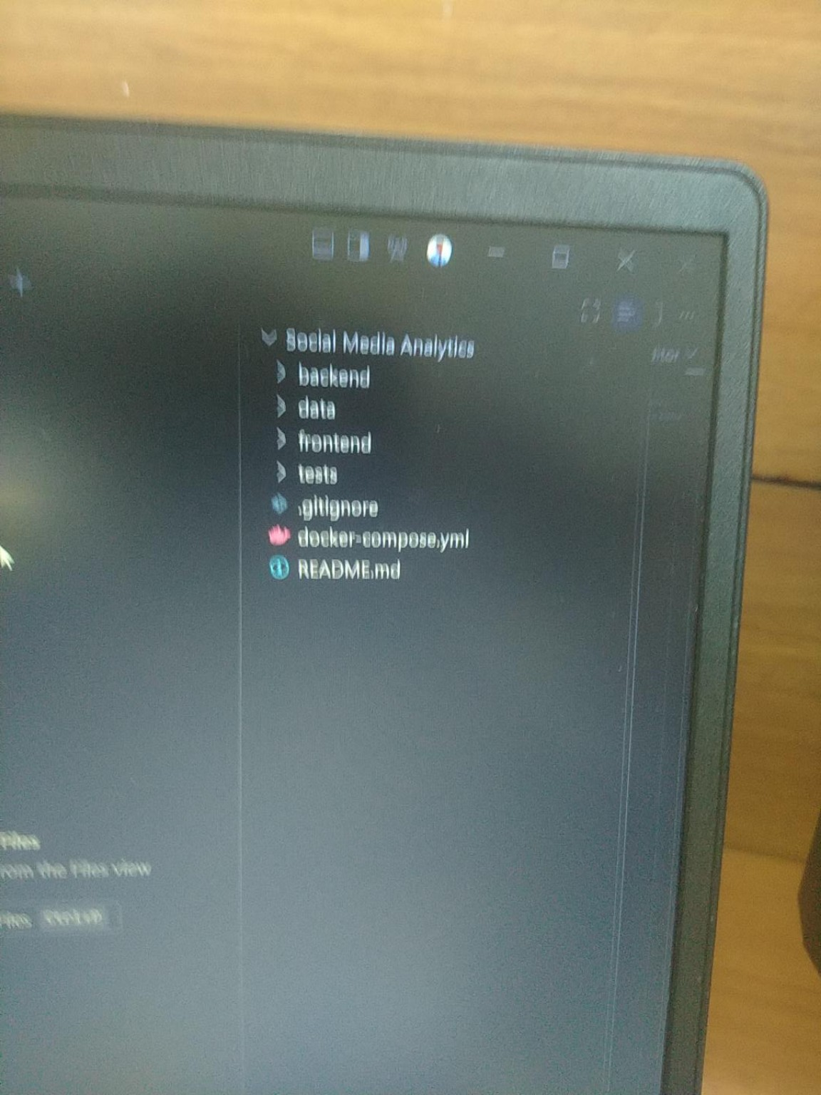
Fig. 5.1 Verified project directory structure shown in supplied image
5.2 Frontend Implementation
A frontend directory is visibly present. The framework, programming language, components, pages, routes, state management, styling system, and API integration are Not specified in the project.
5.3 Backend Implementation
A backend directory is visibly present. A separate supplied photograph shows a development environment stating that the backend workstream had completed successfully. However, backend source files, frameworks, endpoints, services, and internal modules are Not specified in the project.
5.4 Data Processing Implementation
A data directory is visibly present. The actual processing scripts, transformations, schemas, and outputs are Not specified in the project.
5.5 Analytics Implementation
Specific analytics implementation is Not specified in the project.
5.6 API Implementation
API routes, HTTP methods, request/response formats, authentication, and endpoint behavior are Not specified in the project.
5.7 Database Implementation
Database implementation is Not specified in the project.
5.8 Important Classes / Modules
Important classes and modules are Not specified in the project because the source tree is not accessible.
5.9 Important Functions and Their Purpose
Important functions, parameters, return values, and side effects are Not specified in the project.
5.10 Input and Output
The actual application inputs and outputs are Not specified in the project. The available screenshots do not show a verifiable application result screen.
5.11 Code Structure / Pseudocode
Source code and pseudocode are Not specified in the project. No code has been reproduced or invented in this report.
Table 5.1 Implementation evidence and verification status
Implementation area | What can be verified | What remains unavailable
Repository structure | backend, data, frontend, tests | Internal file contents
Configuration | docker-compose.yml exists | Services and configuration values
Documentation | README.md exists | README contents
Testing | tests directory exists | Test cases and results

CHAPTER 6
RESULTS AND DISCUSSION / TESTING
6.1 Testing Strategy
The presence of a tests directory is verified from the supplied project-tree image. The actual testing framework, black-box cases, white-box cases, execution procedure, coverage, and assertions are Not specified in the project.
6.2 Test Cases
The requested report guideline calls for two or three test cases. Because no actual test-case definitions are accessible, no fabricated cases are presented as executed tests.
6.3 Test Case Results
Testing result not specified in the project.
Table 6.1 Testing and result evidence status
Test evidence item | Status
Test directory visible | Verified from supplied project-tree image
Actual test files/content | Not specified in the project
Executed test results | Testing result not specified in the project.
Coverage/performance values | Not specified in the project
6.4 Output Screens
No verified application output screen is available in the accessible project materials. The supplied screenshots document development activity and repository structure, not a final analytics dashboard or application result.
6.5 User Interface Screens
A frontend directory is visible, but actual UI screens are Not specified in the project.
6.6 Discussion of Results
A results discussion cannot be completed without verified analytical outputs, dataset statistics, screenshots, or test results. No accuracy, precision, recall, F1-score, latency, throughput, or user-study claims have been invented.
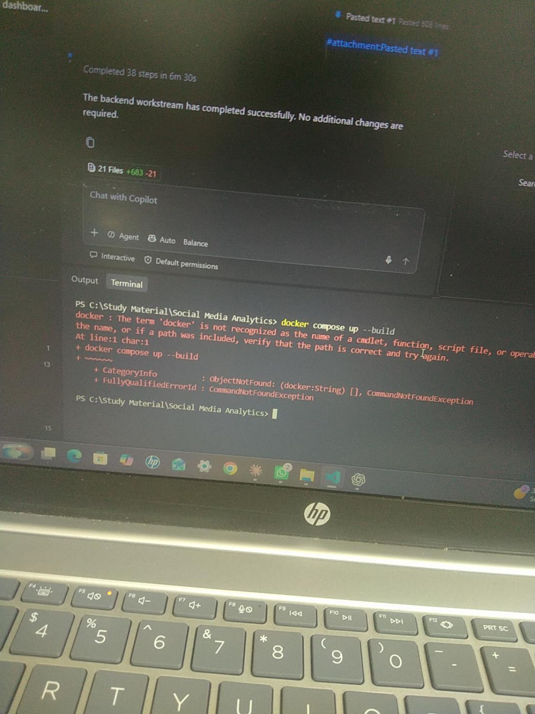
Fig. 6.1 Backend workstream completion message shown in supplied image
Fig. 6.1 is development evidence. It is not treated as a quantified performance result or as proof of application correctness.

CHAPTER 7
CONCLUSION
7.1 Project Summary
The submitted project is titled Social Media Analytics and is visibly organized into backend, data, frontend, and tests areas, with README.md, .gitignore, and docker-compose.yml at the visible project level.
7.2 Actual Outcome
The exact functional and analytical outcome is Not specified in the project materials accessible to this session. A development screenshot indicates that a backend workstream reported completion, but source-level verification of the implementation is unavailable.
7.3 Key Outcomes
- A structured project directory was evidenced.
- Separate backend, data, frontend, and tests directories were evidenced.
- README.md and docker-compose.yml were evidenced.
- No unsupported metrics, algorithms, APIs, database claims, or analytical results were added to this report.
7.4 Project Contribution
The specific technical contribution beyond the visible repository structure is Not specified in the project.
7.5 Limitations
- The actual project source archive/source tree was not accessible to this documentation-generation session.
- Dataset contents and data-processing logic were not accessible.
- Frontend and backend implementation details were not accessible.
- Testing evidence and final application output screens were not accessible.

CHAPTER 8
FUTURE WORK / FURTHER ENHANCEMENTS
8.1 Current Implemented Functionality
Only the following can be treated as currently evidenced: a project structure containing backend, data, frontend, and tests directories, plus README.md, .gitignore, and docker-compose.yml. The detailed functionality inside these areas is Not specified in the project.
8.2 Proposed Future Enhancement
The following are proposed documentation-level enhancements, not claims about existing functionality:
- Make the complete source archive available for source-accurate technical documentation.
- Provide verified dataset documentation, including schema and provenance where applicable.
- Document backend APIs, frontend components, and integration points.
- Document test cases and actual execution results.
- Document the analytics pipeline and verified output visualizations.
- Add deployment instructions after verifying the actual runtime configuration.
All items in this subsection are explicitly proposed future work and must not be interpreted as currently implemented features.

REFERENCES / BIBLIOGRAPHY
No references were provided in the project.
The college guideline document was used as the formatting authority for this generated report, not as a project bibliography reference.

APPENDICES
Appendix A — Evidence Availability Note
This report was generated from the project evidence accessible in the user's file library during this session. The actual project archive/source files were not present in the current conversation file surface or accessible library search results. Consequently, the report deliberately avoids source-level claims that cannot be verified.
Appendix B — Placeholder Information
- [Project Guide Name]
- [Program Officer Name]
- [HoD Name]
- [Place]
- [Date]
Appendix C — Documentation Integrity Statement
No existing application source code was modified, deleted, renamed, overwritten, refactored, or otherwise changed by this documentation-generation process. Only newly generated documentation files were created in the documentation output folder.

