MLOps Assignment Report: Heart Disease Prediction

Contributors
GROUP 33
- ARYAMANN SINGH - 2024aa05025
- ANANTHAN P - 2024aa05692
- BALAJI R - 2024aa05844
- BALSURE ANIKET K - 2024aa05296
- SAURAV BANSAL - 2023aa05710

Demo Video

YouTube URL

Repository Link (with setup)

GitHub Repository

1. Introduction

This report details the implementation of an end-to-end MLOps pipeline for heart disease risk prediction using the UCI Heart Disease dataset. The project demonstrates modern MLOps practices including data processing, model development, experiment tracking, CI/CD, containerization, and deployment.

2. Dataset and Data Acquisition

Dataset: UCI Heart Disease Dataset
- Source: UCI Machine Learning Repository
- Features: 13 clinical features + target
- Samples: ~300 instances
- Target: Binary (0: no disease, 1: disease)

Data Acquisition:
- Script: src/data_prep.py downloads from UCI URL
- Cleaning: Handle missing values (marked as '?'), convert to binary target
- Storage: data/raw/heart.csv

3. Exploratory Data Analysis (EDA)

Key Findings (see notebooks/eda.ipynb):
- Class Balance: Slight imbalance (~46% positive cases; 137/297).
- Correlations: Strongest correlations with target include thal and ca (positive) and thalach (negative); cp and oldpeak are also meaningfully associated.
- Distributions: Age is roughly bell-shaped; cholesterol shows clear outliers.
- Categorical Analysis: Higher chest pain types associated with disease.

Visualizations:
- Histograms for numerical features
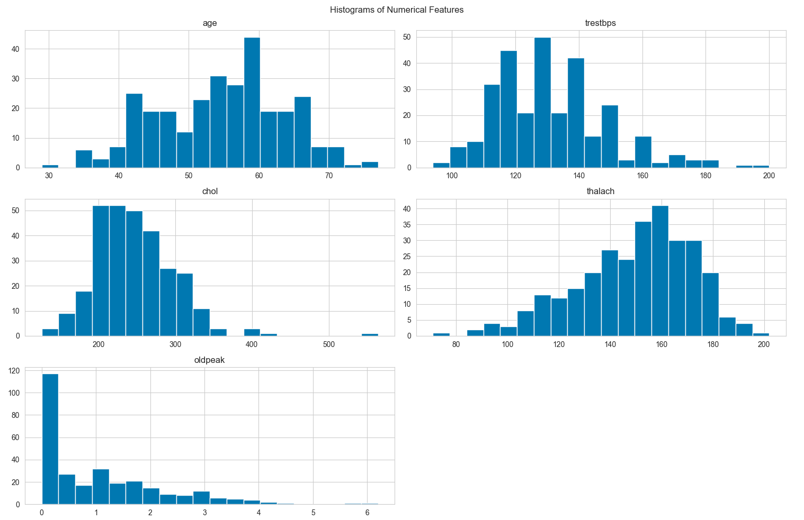
- Correlation heatmap
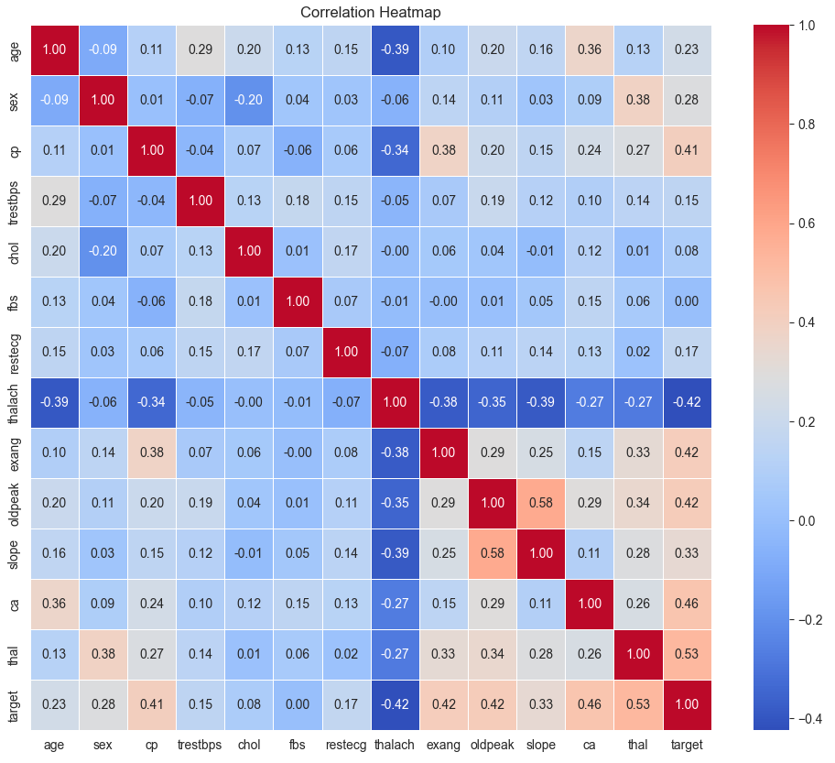
- Class balance bar plot
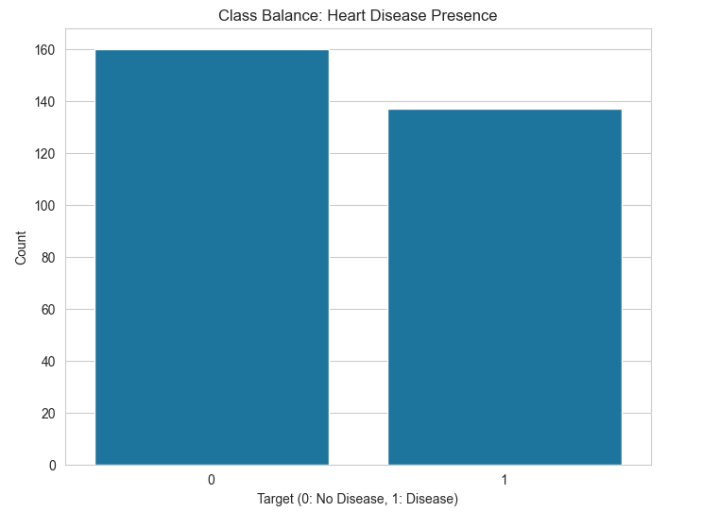
- Age distribution by target
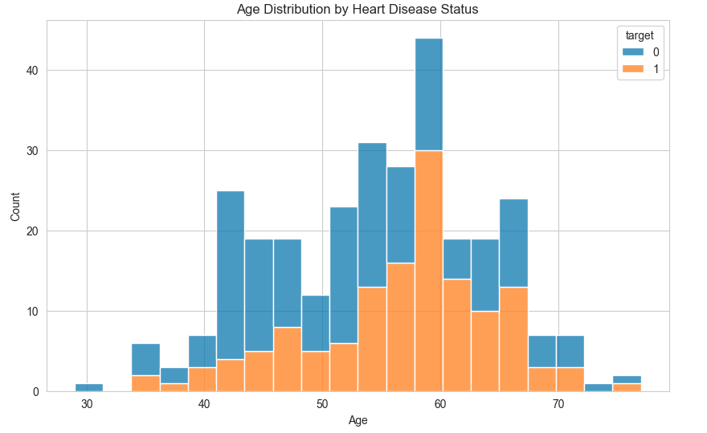

4. Feature Engineering and Model Development

Preprocessing Pipeline:
- Numerical: StandardScaler
- Categorical: OneHotEncoder (handle_unknown='ignore')
- Pipeline: ColumnTransformer + Model

Models Evaluated:
- Logistic Regression (tuned C, penalty)
- Random Forest (tuned n_estimators, max_depth)

Hyperparameter Tuning: GridSearchCV with 5-fold CV, ROC-AUC scoring

Evaluation Metrics:
- ROC-AUC (primary)
- Accuracy, Precision, Recall

Best Model: Logistic Regression (ROC-AUC: 0.9113)

5. Experiment Tracking

Tool: MLflow
- Experiments: Logged parameters, metrics, model artifacts
- Runs: Separate runs for each model with best params
- UI: mlflow ui for visualization

MLflow experiment runs and metrics
- MLflow UI - experiment list
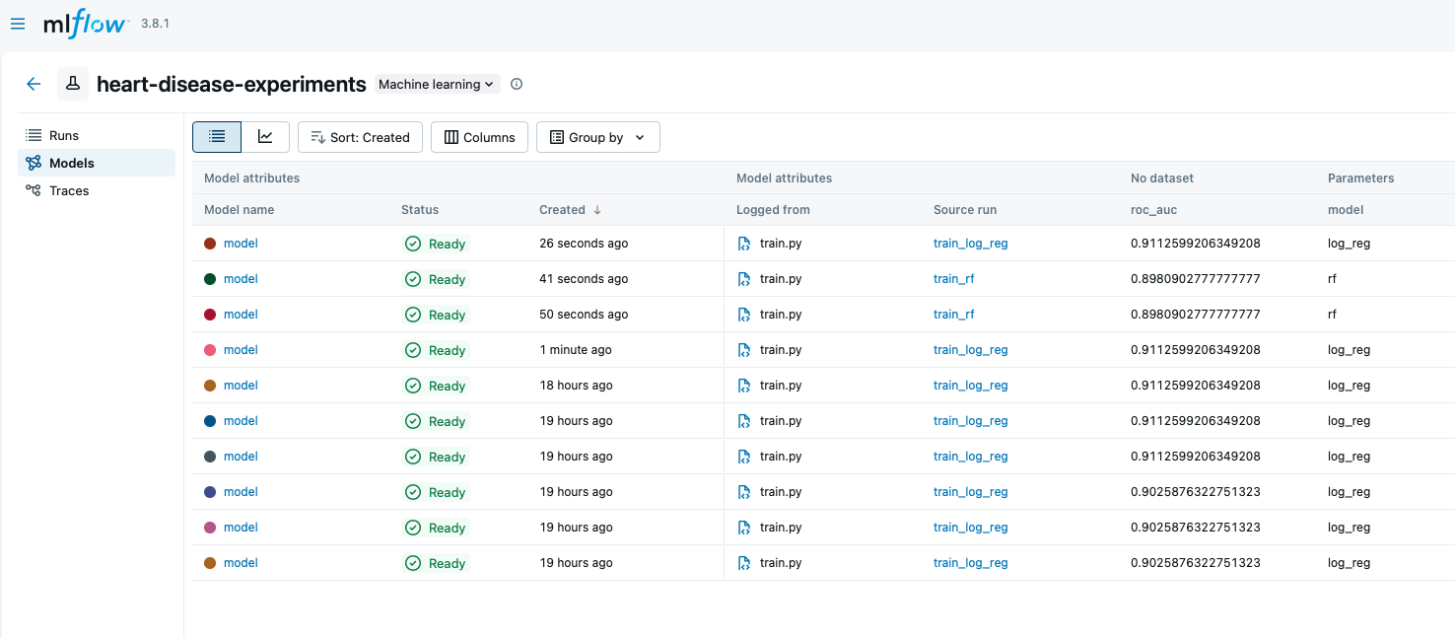
- MLflow UI - best run details
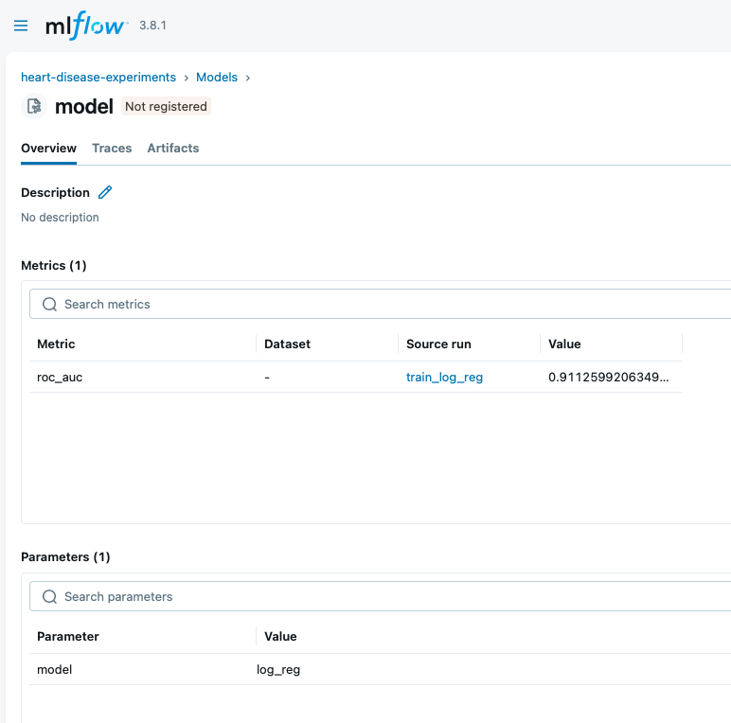

6. Model Packaging and Reproducibility

Format: Joblib pickle with sklearn Pipeline
Dependencies: requirements.txt with pinned versions
Reproducibility: Pipeline ensures consistent preprocessing

7. CI/CD Pipeline and Testing

Tool: GitHub Actions
Jobs:
- Ubuntu: Lint (flake8), test (pytest), data prep, train, upload artifact
- Windows: Test only

Tests:
- Data loading: tests/test_data.py
- Data prep: tests/test_prep.py

Artifacts: Trained model uploaded per run

8. Model Containerization

Tool: Docker
Image: Python 3.10 slim + dependencies
API: FastAPI with /predict endpoint
Testing: Local build/run with sample input

Docker build and local container test
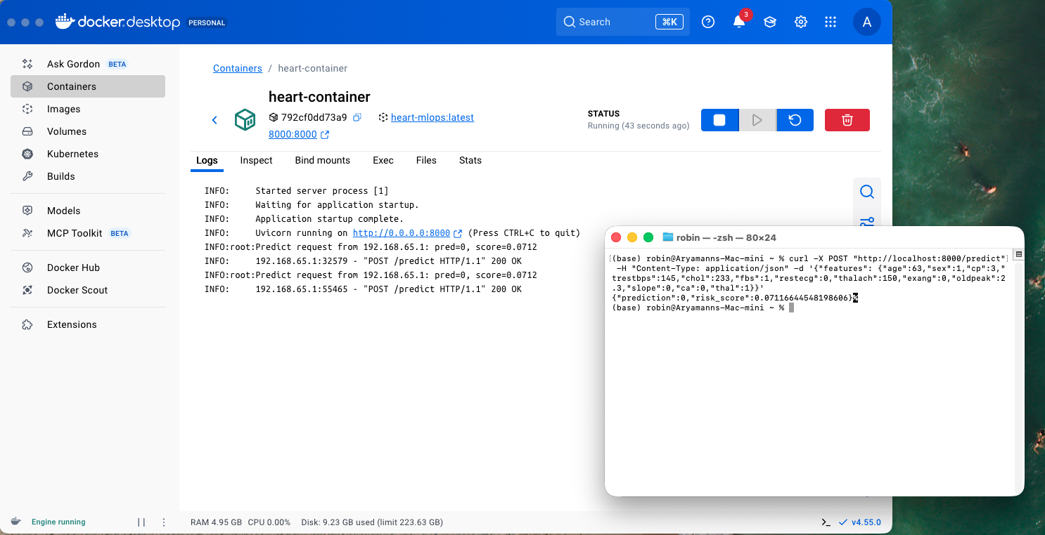

9. Production Deployment

Platform: Railway (public cloud)
URL: https://heart-mlops-production.up.railway.app
Manifests: Docker-based deployment
Service: Web service with automatic scaling
Verification: Endpoint testing with curl, deployed API functional

Railway deployment
- Railway service dashboard
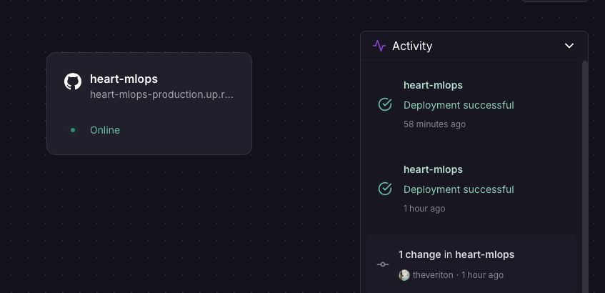
- Deployed /predict response
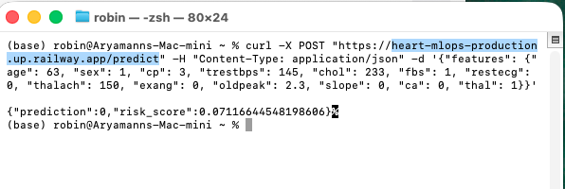

10. Monitoring and Logging

Logging: Request logging with client IP, prediction, score
Metrics: /metrics endpoint exposes Prometheus-formatted metrics (including predict_requests_total)

Monitoring Stack (Local):
- Prometheus scrapes the API metrics endpoint
- Grafana visualizes metrics from Prometheus

Monitoring Screenshots
- Prometheus targets UP
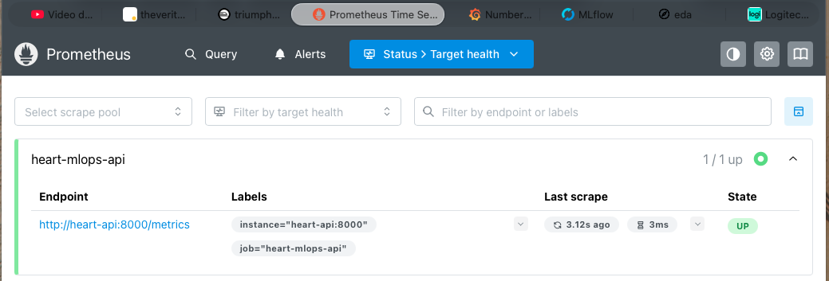
- Prometheus query for predict_requests_total
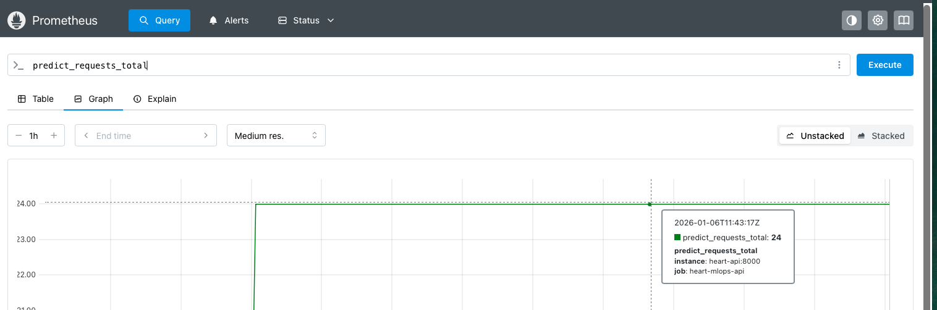
- Grafana dashboard panel showing predict_requests_total
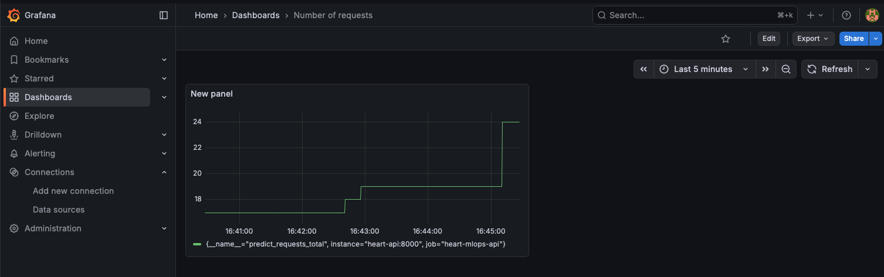

11. Architecture Diagram

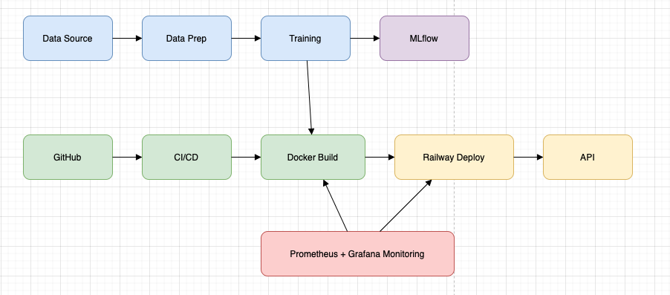

12. CI/CD Workflow Screenshots

- Build success:
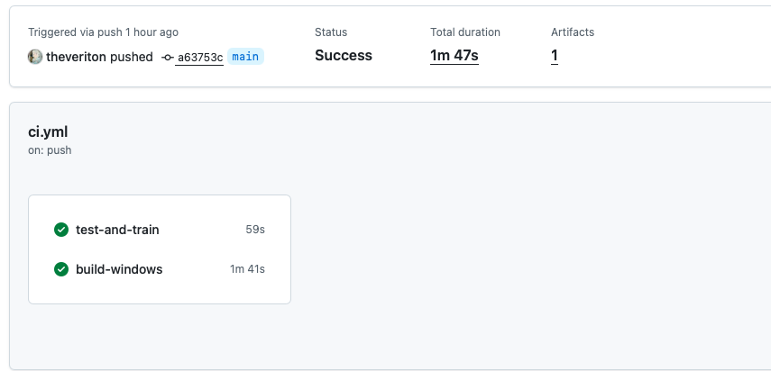
- Test results:
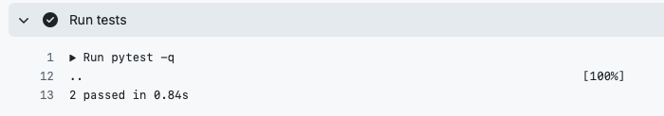
- Deployment:
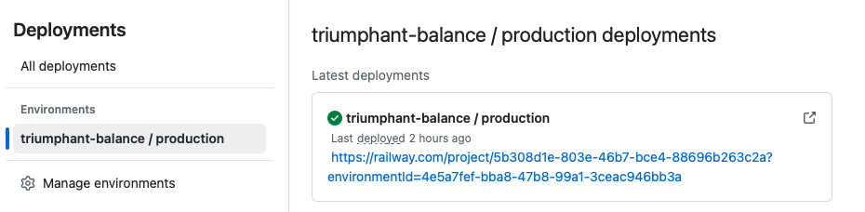
- Monitoring:
- MLflow:

15. Conclusion

The project successfully implements all MLOps requirements with automated pipelines, reproducible models, and production-ready deployment on Railway. Key achievements include hyperparameter tuning, experiment tracking, containerization, and public cloud deployment.

