Computational Physics

Exam 02

1. **Types of Equations**

Write an example of each type of equation listed below. Your examples do not need to be from real systems.

1. Linear Equation: A linear equation is one in which only the first power of u or of du∕dt appears, such as: du/dt = X(t)Y(t) [differential] or [non-diff: u(t) = X(t) + Y(t)]
2. Non-Linear Equation: A nonlinear may have higher power.

For example: dy/dt = y(t) + y2(t).

1. First Order Linear Differential Equation: A first order refers to the degree of the derivative therefore a first order linear would be of the form du/dt = X(t)Y(t).
2. Fourth Order Linear Non-Differential Equation: A derivative of order 4 that is also non-linear with powers greater than one. Example: d4y/dt4 = y(t) – y3(t).
3. Two Coupled, First Order Linear Differential Equations: Coupled in the sense that two difference variables derivatives both depend on another third variable.

Example: dx/dt = 4x + 7y and dy/dt = x – 6y.

1. **ODE Algorithms**

Explain why (and how) a 2nd-order Runge-Kutta (RK2) method is more precise (i.e., it has a smaller numerical error) than Euler’s method for solving a 2nd-order non-linear differential equation, assuming equal step sizes. Use figures to aid your explanation, if necessary. What is different between an RK2 and an RK4 method and why is RK4 more precise?

Euler’s rule just integrates across one step by using the forward difference algorithm for the derivative and looks like:

$yn+1≃yn+hf(tn,yn)$ or graphically like:

Figure 1: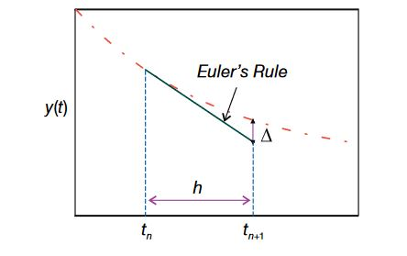

as the step size h gets smaller then the error $Δ$ decreases.

However, The Runge-Kutta Method using a different and more precise approach. The Euler Method can be thought of as a Runge-Kutta one or RK1 as it evaluates the whole interval but the RK2 evaluates the interval’s midpoint and results in smaller error $Δ$. The slope at one point can start to increase drastically in error to the next points depending on the curve. However, if you know two point values and find the midpoint between them then this slope will much better represent the slope of the next point. A comparison between figure 1 and figure 2 will give a visual representation of this.

Figure 2: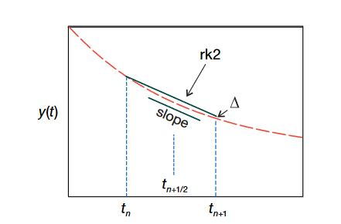

To get the Runge-Kutta Method we First have to find the value of the next point to find the midpoint value and then we can use this midpoint slope for our next point. So, we start with the Euler method as a basis to start solving and then we can build the RK2 or RK4 from it. The equation for the RK2 is: h3 and you can see similarities to the Euler method or more that the Euler method is within the RK2. You can repeat the process that was used to create the RK2 from the midpoint of the Euler to create the RK4 from the RK2 and this yields even more precision. The RK4 gives a mix of computational power, precision, and simplicity. With the RK4 there are four gradient or k terms to evaluate. This gives an even more improved accuracy of f(t,y) near the midpoint. Although rk4 is computationally more expensive than the Euler method, it is a lot more accurate at evaluating the midpoint and therefore we find a much smaller error $Δ$. The equation for RK4 is:

$$yn+1=yn+1/6\left(k1+2k2+2k3+k4\right)$$

Where: $k1=hf\left(tn,yn\right)$, $k2=hf\left(tn+\frac{h}{2},yn+\frac{k1}{2}\right)$, $k3=hf\left(tn+\frac{h}{2},yn+\frac{k2}{2}\right)$,

$k4=hf(tn+h,yn+k3)$.

In essence, we are creating more precise methods by finding the midpoints from the previous method. The slope of the midpoint between two points is more precise than the slope at one point compared to the next therefore the more midpoints calculated the more accurate our solution. The number Runge-Kutta you are solving gives you an idea of how many midpoints you are using. Each of which is solved from the previous method.