POLITICK
Claude Code UI Refresh Guide
Exact implementation guidance for reproducing the approved mobile screens
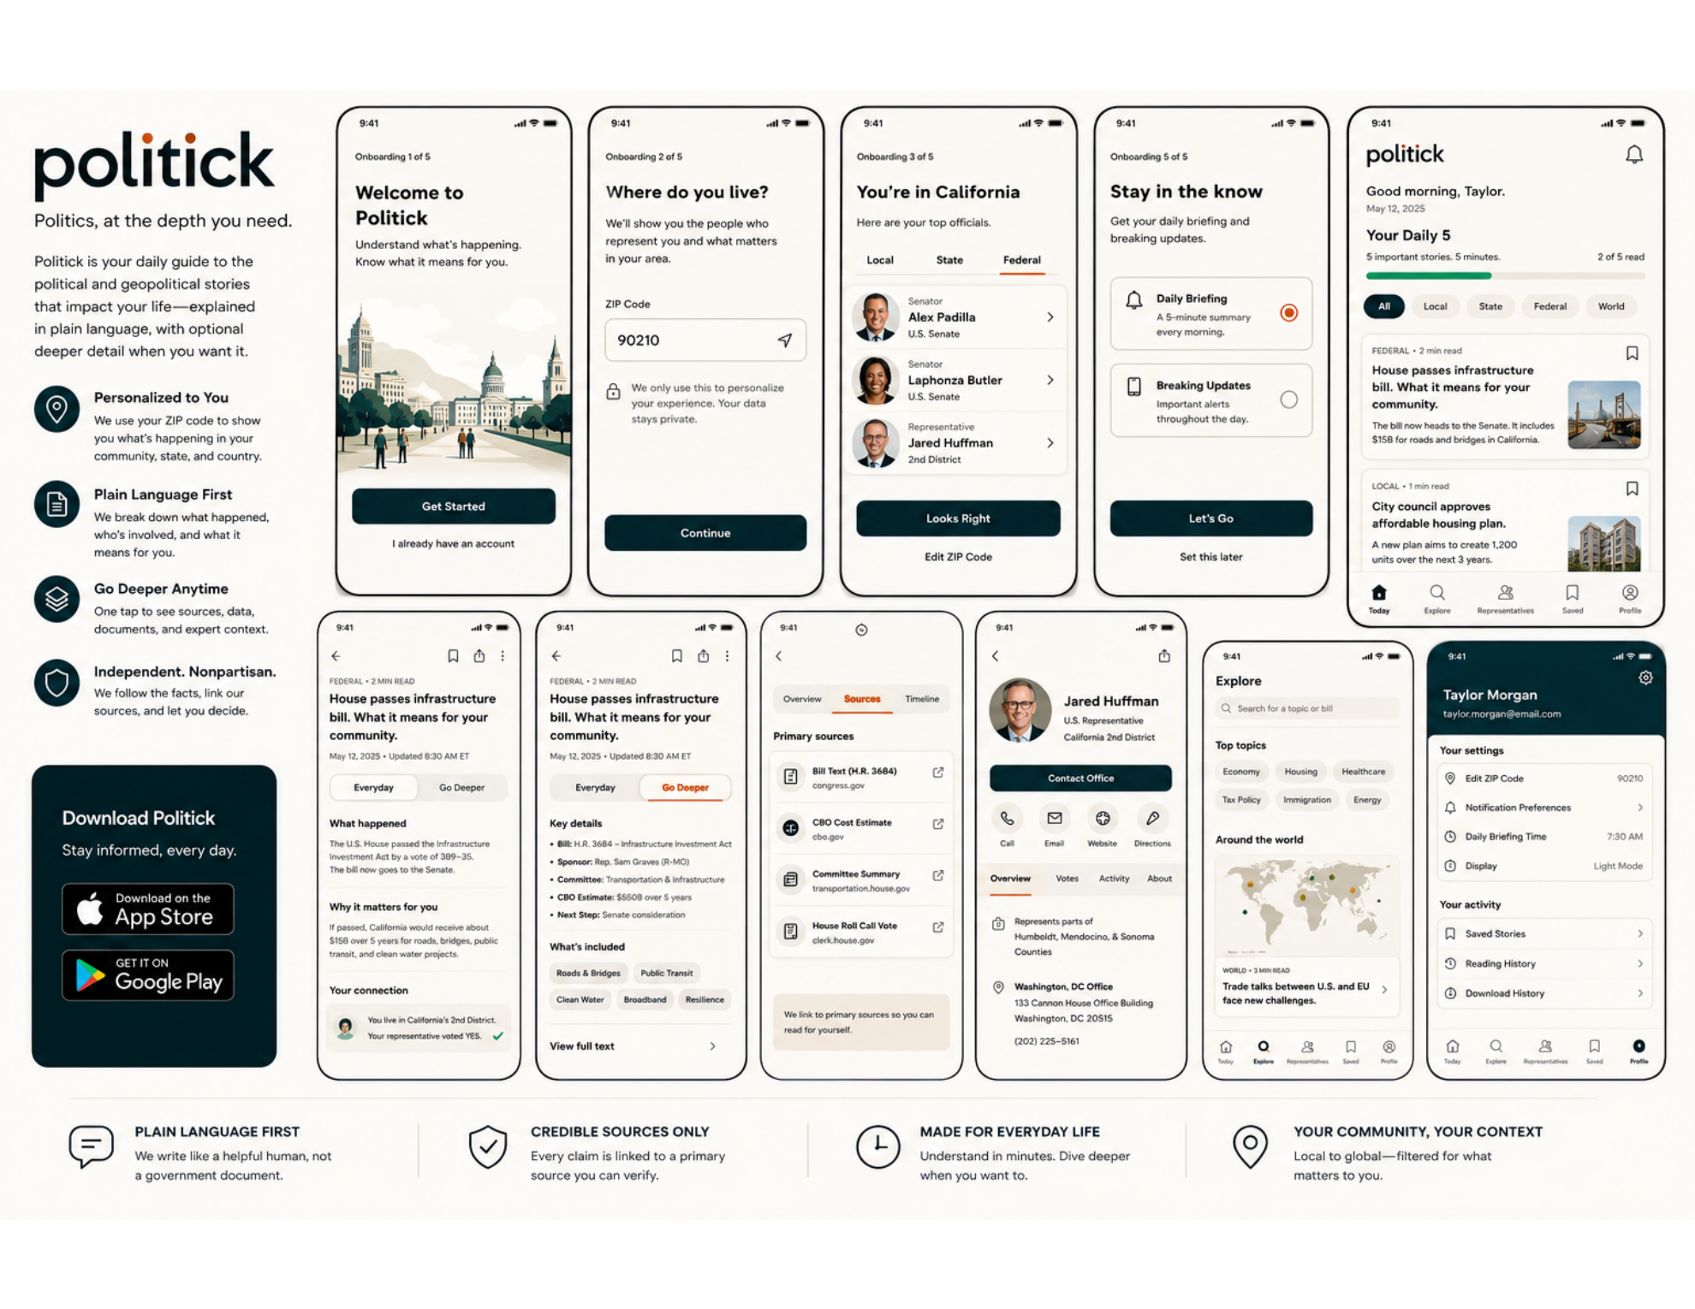
Visual source of truth
The attached mockup sheet is authoritative. Claude should reproduce its visual language and screen structure, not reinterpret the brand or substitute a generic news-app design.

Version 1.0 | August 2026

01 / DIRECTION
What Claude must preserve
The product should feel like a calm civic utility: polished, editorial, useful and politically neutral.
- Warm Paper background with crisp white cards and restrained borders.
- Lowercase politick wordmark in a modern geometric sans. Signal Gold is the only decorative brand accent.
- Deep Teal primary actions, Civic Teal active states, Civic Ink text and Slate metadata.
- Finite, structured information rather than dense dashboards or infinite-scroll news clutter.
- Plain-language hierarchy: what happened, why it matters, your connection and what comes next.
- Rounded, understated components with generous space and no dramatic shadows.
Do not redesign
Do not add patriotic imagery, red-versus-blue treatments, stars, flags, eagles, Capitol decoration, heavy gradients, glassmorphism, neon, oversized illustrations or cable-news urgency.

02 / BRAND LOCKS
Tokens and visual rules
Token | Hex | Use
Civic Ink | #101418 | Primary text, wordmark, icons
Paper | #F7F6F2 | Page background
White | #FFFFFF | Cards and sheets
Civic Teal | #167D79 | Selected controls and links
Deep Teal | #0D5F5B | Primary buttons and dark brand fields
Signal Gold | #D9A441 | Small emphasis, active underline, signal dot
Slate | #5D6670 | Secondary copy and metadata
Soft Teal | #DCEFED | Selected chips and info panels
Warm Sand | #EEE9DE | Editorial callouts
Line | #DDE1E5 | Card and control borders
Action Coral | #B84E3C | Errors and urgent deadlines only

Typography
- Use Inter for UI, cards, navigation, forms, metadata and the lowercase wordmark foundation.
- Display 32/38 700; H1 26/32 700; H2 20/26 650; H3 16/22 650; body 16/24; compact 14/20; label 12/16 650; micro 11/14 500.
- Sentence case throughout. Tiny category labels may use uppercase. Never shrink body text below 14 px.

Geometry
Element | Specification
Mobile canvas | 390 x 844 reference viewport; responsive after parity is achieved
Horizontal padding | 20 px
Base grid | 8 px; 4 px micro-adjustments
Cards | 16 px radius; 1 px Line border; white surface
Sheets | 24 px radius
Buttons | 12 px radius; 48-52 px height
Chips | Fully rounded; 32-36 px height
Touch targets | Minimum 44 x 44 px
Section spacing | 24 px
Motion | 150-220 ms slide/fade only

03 / GLOBAL SHELL
Shared structure across all mobile pages
Region | Rule
Status bar | Use native-safe top inset; never crowd the Dynamic Island or system status area.
Top app bar | 20 px side padding, 56-64 px tall. Lowercase politick wordmark or page-specific back/title controls.
Content | Single vertical column. White cards on Paper. Major sections separated by 20-24 px.
Bottom navigation | Five destinations: Today, Explore, Representatives, Saved, Profile. Active item uses Deep Teal icon and label.
Card anatomy | Eyebrow/meta -> headline -> concise context -> relevance/status -> action. Keep repeated placement consistent.
Scrolling | Natural vertical scroll. Bottom navigation remains fixed. Avoid nested scrolling except horizontal chips.

Core components
- AppHeader
- ProgressDots
- PrimaryButton
- SecondaryButton
- TextLink
- ZipInput
- PrivacyNote
- SegmentedControl
- RepresentativeRow
- NotificationChoiceCard
- DailyProgress
- TopicChip
- StoryCard
- StoryDepthTabs
- StorySection
- SourceRow
- SourceTabs
- RepresentativeHero
- ContactAction
- ProfileTabBar
- SearchField
- SettingsRow
- BottomNav
04 / ONBOARDING
Five-screen setup flow
Screen | Required layout and behavior
1. Welcome | Top progress label “Onboarding 1 of 5.” Large two-line title. Short value proposition. Calm civic illustration occupying the middle third. Full-width Deep Teal “Get Started” button and low-emphasis sign-in link.
2. ZIP code | Title “Where do you live?” Supporting text. Label and 56 px input with location/arrow affordance. Privacy note with lock icon. Continue button pinned near lower content edge; disabled until valid 5-digit ZIP.
3. Representative confirmation | Title and local context. Segmented control Local / State / Federal. White representative list card with photo, role, name, office and chevron. “Looks Right” primary action and “Edit ZIP Code” tertiary action.
4. Notifications | Title “Stay in the know.” Two large selectable cards: Daily Briefing and Breaking Updates. Radio indicator on right. Primary “Let’s Go,” tertiary “Set this later.” Default only Daily Briefing selected.
5. Completion transition | Brief confirmation state, then route into Today. Keep animation subtle: 180 ms fade/slide.

Illustration guidance
Use a flat, muted city/civic scene with natural civic context. No flags, rallies, partisan crowds, gavels or caricatures.

05 / TODAY
Daily 5 feed
- Header: lowercase politick wordmark left, notification bell right.
- Greeting and date appear before “Your Daily 5.” Use concise supporting copy such as “5 important stories. 5 minutes.”
- Progress bar is thin, teal and calm; show numerical completion at right.
- Filter chips: All, Local, State, Federal, World. One selected at a time. Selected chip uses Deep Teal fill with white text.
- Story cards are white, bordered, 16 px radius, with bookmark top-right and 72-88 px documentary thumbnail on the right.
- Each story exposes category, read time, factual headline and one-sentence practical context.
- Use a finite Daily 5 first. Additional stories may appear below under a separate “More today” heading.
StoryCard field | Treatment
Category + time | 11-12 px label; category uppercase; Slate
Headline | 16 px / 22, 650; maximum 3 lines
Summary | 14 px / 20; maximum 3 lines
Thumbnail | Documentary image; 12 px radius; no politician-only hero crops
Bookmark | 44 px hit target
Pressed state | Soft Teal tint; no dramatic scale

06 / STORY DETAIL
Everyday and Go Deeper views
Area | Everyday | Go Deeper
Header | Back, save, share, overflow | Same shared header
Story meta | Category, read time, updated timestamp | Same; preserve continuity
Depth control | Segmented tabs with Everyday active | Go Deeper active with gold underline/accent
Content | What happened, Why it matters, Your connection | Key details, bill/status facts, sponsor, committee, estimate, next step
Supporting UI | Local relevance panel and representative connection | Topic chips, source links, timeline and full-text action
Tone | Short paragraphs and plain language | More detail without changing products or becoming a dense terminal

Everyday section order
What happened -> Why it matters -> Who is involved -> What happens next -> Your connection -> What is uncertain -> Sources and update history

Source citations
- High-stakes claims receive inline source affordances, not merely a footer list.
- Updated time must be visible near the headline. Evolving stories include a “What changed” log.

07 / SOURCES
Trust as a visible product feature
- Top tabs: Overview, Sources, Timeline. Active tab uses a thin Signal Gold underline, not a red alert treatment.
- Source rows sit in a white card and include a neutral icon, source title, domain, source-type label and external-link icon.
- Preferred source order: Primary source, Official data, Nonpartisan analysis, reputable Reporting, then clearly labeled Opinion.
- Footer callout on Warm Sand: “We link to primary sources so you can read for yourself.”
- Show corrections and update history. Never hide uncertainty or disputed status.
Badge | Examples
PRIMARY | Bill text, court opinion, agency release
OFFICIAL DATA | Census, CBO, election board, agency datasets
NONPARTISAN ANALYSIS | CBO analysis, CRS, inspector general
REPORTING | Reputable fact-based reporting
OPINION | Explicitly labeled commentary only

08 / REPRESENTATIVE PROFILE
Make political representation concrete
- Hero row: circular official photo, name, office, district and share action. Avoid party-color framing.
- Full-width Deep Teal “Contact Office” action followed by four circular quick actions: Call, Email, Website, Directions.
- Tab bar: Overview, Votes, Activity, About. Active tab uses gold underline.
- Overview explains what the office controls before showing political activity.
- Use icon-and-text rows for jurisdiction, office address and phone. Keep copy compact and actionable.
- Never infer political preference from ZIP code, reading behavior or saved stories.
09 / EXPLORE AND PROFILE
Discovery and settings
Page | Specification
Explore | Title and search field. Topic chips in Warm Sand/Soft Teal. “Around the world” module with muted map and one active highlight color. Story cards beneath. Avoid complex charts on the landing page.
Profile | Deep Teal identity header with name and email. White grouped settings cards. Rows use icon, label, current value and chevron. Include ZIP, notifications, briefing time, display, saved stories, reading history, privacy and source policy.
Saved | Use the same StoryCard component with saved timestamp and optional folder/filter chips.
Empty states | Short, human copy; one clear next action; no cartoonish or celebratory treatment.

10 / IMPLEMENTATION
Recommended Claude Code architecture

Suggested stack
- Next.js App Router + TypeScript + Tailwind CSS or CSS Modules.
- Lucide icons at approximately 1.75 px stroke, rounded line caps.
- Use CSS variables for all design tokens. Do not hard-code substitute colors in components.
- Build at 390 x 844 first. Complete visual parity before responsive desktop behavior or backend integration.

Route map
Route | Screen
/onboarding/welcome | Welcome
/onboarding/location | ZIP code
/onboarding/representatives | Representative confirmation
/onboarding/notifications | Notifications
/today | Daily 5
/stories/[slug] | Everyday story
/stories/[slug]?depth=deep | Go Deeper
/stories/[slug]/sources | Sources and timeline
/representatives/[id] | Representative profile
/explore | Explore
/saved | Saved
/profile | Profile and settings

Component naming
Use predictable names that map design to code: `StoryCard/Default`, `StoryCard/Compact`, `Button/Primary`, `Chip/Selected`, `SourceRow/Primary`, `RepresentativeRow/Federal`, `Tabs/StoryDepth`.
11 / CSS TOKENS
Copy into the project
:root {
--color-ink: #101418;
--color-paper: #F7F6F2;
--color-surface: #FFFFFF;
--color-slate: #5D6670;
--color-line: #DDE1E5;
--color-teal: #167D79;
--color-teal-strong: #0D5F5B;
--color-teal-soft: #DCEFED;
--color-gold: #D9A441;
--color-sand: #EEE9DE;
--color-coral: #B84E3C;
--radius-card: 16px;
--radius-sheet: 24px;
--radius-button: 12px;
--radius-pill: 999px;
--space-1: 4px;
--space-2: 8px;
--space-3: 12px;
--space-4: 16px;
--space-6: 24px;
--space-8: 32px;
--space-12: 48px;
--mobile-gutter: 20px;
--motion-fast: 150ms;
--motion-standard: 200ms;
}
12 / ACCEPTANCE CHECKLIST
Do not mark the refresh complete until all items pass
- [ ] All screens visually match the approved mockup sheet at 390 x 844.
- [ ] Lowercase politick wordmark and gold signal dot are used consistently.
- [ ] No blue/red partisan palette, patriotic motifs or generic news-app redesign.
- [ ] Paper background, white cards, Deep Teal actions and Signal Gold accents match tokens.
- [ ] Card radii, borders, spacing and typography are consistent across routes.
- [ ] Today shows a finite Daily 5 and visible progress.
- [ ] Story detail supports Everyday and Go Deeper without feeling like separate products.
- [ ] Sources, update time, uncertainty and correction history are visible.
- [ ] Representative pages explain role and jurisdiction before political activity.
- [ ] All touch targets are at least 44 x 44 px and contrast meets WCAG 2.2 AA.
- [ ] Dynamic Type / 200% scaling does not clip essential content.
- [ ] No fake production data is presented as live; demo content is labeled or isolated in fixtures.
13 / CLAUDE KICKOFF PROMPT
Paste this into Claude Code
Read this UI guide and inspect `public/politick-approved-mockups.png` before changing code. Treat the mockup image as the visual source of truth. Refresh the Politick UI to match it exactly; do not redesign, rebrand or substitute a generic political-news aesthetic.
Build the token layer and shared components first, then implement every route at a 390 x 844 viewport. Use the approved Paper, White, Civic Ink, Civic Teal, Deep Teal, Slate, Signal Gold and Warm Sand palette. Use Inter, 20 px mobile gutters, 16 px cards, restrained 1 px borders and minimal shadows. Keep the lowercase politick wordmark and one gold signal dot.
Implement onboarding, Today / Daily 5, Everyday story detail, Go Deeper, Sources, representative profile, Explore, Saved and Profile. Preserve the exact hierarchy, spacing, card composition and bottom navigation shown in the reference. Do not add flags, stars, Capitol imagery, red-versus-blue framing, glossy gradients, glassmorphism or breaking-news visual urgency.
Use demo fixtures for content and keep components ready for real APIs. After each page, compare it against the reference at 390 x 844 and correct spacing, type, color, radius and alignment differences before moving on. Finish by running the acceptance checklist in this document and report any intentional deviations.

