Performance analysis of diversity techniques for wireless communication

Abstract—The most common problems in wireless transmission is fading. There are different kind of fading and there are numerous kind techniques to improve the transmission. In those techniques we are going to apply the diversity techniques to overcome the fading problem. Where the fading is known as variation in signal strength at the receiver. There are various number of diversity techniques will used to resolve the problems. Several techniques have the disadvantages too. We can choose the better diversity technique by analyzing and comparing with the performance of the system. Sometimes, diversity techniques can be combined together and used in wireless system to get the best result for fading problem. In this paper, we are combining three techniques known as equal gain combining, maximal gain combining and selection combining to get the better result of fading.
Keywords—fading, diversity, equal gain combining, maximal gain combining, selection combining, FDMA, TDMA, CDMA, SDMA, ISI, BER, EB/NO.

Introduction
.wireless transmission involves communication between devices without the help of any wires, cables and like any other physical connections over the distance. The main factors to consider in wireless transmission is cost effective, flexibility, convenience, speed, accessibility and constant connectivity. In wireless communication is made up of lot of components namely mobile stations, mobile equipment, base stations, subscriber identity module, mobile switching centre, base transceiver station and so on. The main moto of wireless communication is allowing many users to share a data at a without any collusions. This can achieve by using lot techniques known as frequency division multiple access(FDMA), time division multiple access(TDMA), code division multiple access(CDMA), space division multiple access(SDMA). Depending upon the allocation bandwidth the techniques also split into narrowband and wideband systems. There are lot factors that affect the transmission of data which are path loss, fading, interference, doppler shift and this parameter are affecting the data rate, reliability and rang of transmission. We are mainly concentrating fading problem and we will see how to solve this by various diversity techniques.

wireless communication
Wireless transmission involves transmission of data over a long distance without the help of wires, cables and any other electrical conductors. There should be lot of features in wireless transmission which are given below.

Cost effectiveness
In wired communication there are lot wires used for provide connection, which will result in more cost and less space. But in wireless communication does not require any wire connection to provide a better communication and which will result in low cost and more effective. Hence any company use the wireless communication will provide a cheap transmission for the users.

Flexibilty
In wired communication, the people should be in the place for communication. But in the case of wireless communication there is no need to people in place. It flexible because it will happen irrespective of their location. Due to this people can communicate one another wherever they are irrespective of their distance and location.

Convenience
In wireless communication, we use mobile phones for communicating, which are so simple and anyone can use this for communicating and there is no need for physical communication. Without any cable connection we can now connect to anyone, anywhere, anytime.

Speed
The improvement of speed also in speed. There also the improvement in speed and accuracy. Wireless remote connections are more speedy than wired ones. If anything goes wrong wireless will easily manage and work more faster than wired connection.

Accessibility
The wireless helps easy accessibility as the remote areas where ground lines can’t be properly laid, are being easily connected to network. Like in rural regions, online education will be possible by help of easy accessibility everyone can get.

Constant connectivity
Constant connectivity also ensures the stream of data transferring very smooth and make it possible. Like GPS connection between device will change whenever they are moved.

Multiple access techniques
There are multiple access schemes that are used to allow many mobile users to share data simultaneously. Which are described below.

Frequency division multiple access(FDMA)
Frequency division multiple access will split different side band for different users for accessing their networks. When the spectrum is not in use, the spectrum allocated for them will leave idle and cannot be used by anyone else. The simultaneous transmission and reception are possible in FDMA and it is very simple compare to TDMA.

Time division multiple access(TDMA)
Time division multiple access technique allow to use the same spectrum of frequency with multiple users. But they do not able use at the same time. Only one user can access the spectrum at the time. Resource are allocated on demand and it is not continuous.

Code division multiple access(CDMA)
Code division multiple access allow to allocate a fully available spectrum to the user instead of only allowing particular frequency. It much useful in voice and data transmission. The user with same code will communicate with each other.

Space division multiple access(TDMA)
Space division multiple access is the most commonly used wireless transmission technique where it working based on the MIMO which is multiple input multiple output scheme. In this all users can communicate simultaneously using the same spectrum. It completely free from interfaces. The directional spot beam antenna is used; hence we can track the moving users. This will control the radiated energy for every user by space.

Propagation mechanisms
The transmission data is split into three types depending upon the frequency ranges and distance from the ground. Which will discuss below.

Ground wave propagation
It will occurs at the frequency range till 2Mhz and distance up to 16kms. It also called as surface wave propagation

Sky wave propagation
It also called as ionosphere wave propagation, due to the transmission occurs depending upon the reflection of the ionosphere. The frequency range is from 2Mhz to 30Mhz. The propagation distance is 50Km to 400Km. It will split into different layers depending upon the critical frequency and distance.

Space wave propagation
It also called as line of sight propagation. It will split the transmitted signal into two signals, which are direct and indirect waves. Where this propagation depending upon the distance between the transmitter and receiver it also called as line of sight propagation.

Channel limitations
There are lot of variables that can affect the channel which are path loss, interference and blockage. These will affect the range of transmission, data rate and reliability of the communication we will discuss various channel characteristics as follows.

Fadding
Fading refers to fluctuation in signal strength when received at receiver. It also classified into two types as slow fading and fast fading. The time gap between first and last received signal is know as delay spread. Fading will occur because of three mechanisms which are reflection, diffraction, scattering.

Slow fading: As per name the fading occurs slowly. It will occurs when receiver is covered by buildings from the transmitter. Which also called as shadow fading due to big objects like bulidings block the direct transmission between the transmitter and receiver.

Fast fading: It refers to the rapid fluctuation in amlitude or phase of the received signal due to interference between multiple version of recived signal arrive at different time.

Path loss
Path loss is the ration of transmitted signal to the received signal power in the given path. It also functions of the propagation path. It is the vary important parameter to consider when designing the wireless communication networks. It also dependent on number of parameters like radio frequency used and nature of the terrain. Path loss will be low in free space transmission due to direct path between the transmitter and receiver.

Interference
In wireless transmission the data should encounter the interference due to variety of sources. Where we will see some interference below.

Adjacent channel interference: In adjacent channel interference the signal will have the components which are outside of the allocated bands for the signal. While transmitting the components will interfere with that outside frequencies that will create interference. It will avoid by using guard band between the allocated frequency ranges.

Co-channel interference: It also called as narrowband interference. It will occurs due to near by systems using the same transmission frequenccy range for transmission.

Inter-symbol interference: In this type of interference, the distortion in the received signal is caused by temporal spreading and consequent overlapping of individual pulse in the signal.

Attenuation
The strength of the received signal decrease as the distance of from the transmitter increase. It also the function of distance, transmission medium, as well as frequency of transmission.

Noise
There is various form of noise which will degrade the transmission. The most common one is thermal noise. It is due to the thermal agitation of electrons and it is uniformly distributed across the frequency spectrum.

Techniques
There are various techniques used to overcome from the above listed limitations. Some are listed below.

Equalizer
Equalizer is filter at receiver side which will equalize the amplitude and delay in received signal, whose impulse response is the inverse of the channel impulse response. Which will used in frequency selective fading channels. Where adaptive equalizer has two phases of operation which are training and tracking mode.

Channel coding
It will improve mobile transmission by adding redundant bits to the transmission message. At the baseband portion of the transmitter, a channel coder maps a digital message sequence in to another specific code sequence containing greater number of bits than original contained in the message. Channel Coding is used to correct deep fading or spectral null.

Diversity
Diversity is another technique used to compensate fast fading and is usually implemented using two or more receiving antennas. It is usually employed to reduce the depths and duration of the fades experienced by a receiver in a flat fading channel.

Diversity
Diversity is a powerful communication receiver technique that provides wireless link improvement at a relatively low cost. Diversity techniques are used in wireless communications systems to primarily to improve performance over a fading radio channel.

Frequency diversity
In this kind of the techniques the same information signals transmitted using different frequencies. This will cause in wastage of frequency spectrum.

Time diversity
The information signal is transmitted repeatedly in time at regularly intervals. The separation between the transmit times should be greater than the coherence time. The time interval depends on the fading rate, and increases with the decrease in the rate of fading.

Polarization diversity
Here, the electric and magnetic fields of the signal carrying the information are modified and many such signals are used to send the same information. Thus orthogonal type of polarization is obtained.

Space diversity
In Space diversity, there are multiple receiving antennas placed at different spatial locations, resulting in different received signals.
The difference between the diversity schemes lies in the fact that in the first two schemes, there is wastage of bandwidth due to duplication of the information signal to be sent. Thus problem is avoided in the remaining three schemes, but with the cost of increased antenna complexity.

Equal gain combining
Various techniques are known to combine the signals from multiple diversity branches. In Equal Gain Combining, each signal branch weighted with the same factor, irrespective of the signal amplitude. However, co-phasing of all signal is needed to avoid signal cancellation.

Selection combining
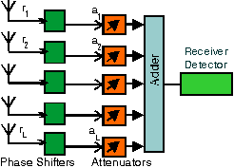
In selection combining technique, it selects the best signal from all the signals from the diversity channels at the receiver. In this technique, the receiver monitors the SNR of the incoming signals using Switch logic. From all Diversity branches, gain of each branch is adjusted to provide average SNR of each branch, comparing is not required. In this technique, strongest signal is selected from all the signals of the channels. When N signals are independent and Rayleigh distributed, the expected Diversity gain is expressed as power ratio. Therefore, any additional gain diminishes rapidly with increasing the number of channels.

Maximum ratio combining
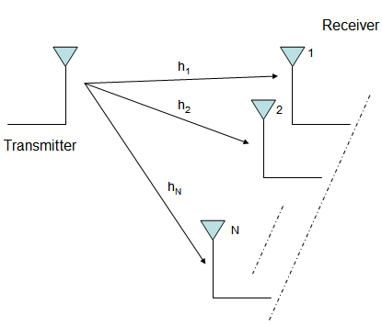
In selection combining technique, it doesn't benefit from the power received from all the diversity branches. But in maximum ratio combining technique, it conducts a weighted sum across all branches according to maximum SNR ratio. Maximum ratio combining method produces an average SNR ratio which is equal to the sum of individual average SNR. Each signal from M channel are co-phased and weighted manner such that large possible SNR at the receiver. In Maximum ratio combining technique, the gain of each channel is made proportional to the rms signal level and inversely proportional to the mean square. In MRC, the voltage signals from each of the diversity branches are co-phased to provide coherent voltage addition. MRC can restore a signal to its original shape.

Conclusion
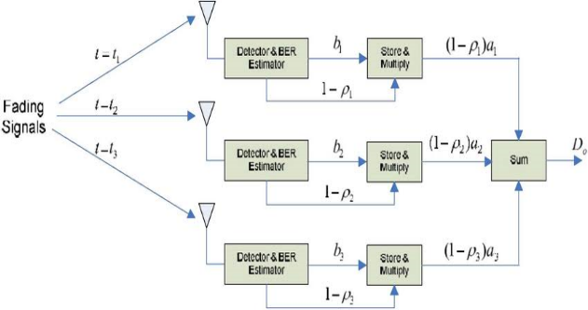
In this paper, we discussed importance of diversity and various diversity techniques to analysis the performance of the wireless communication and we analysis using gain combining technique, maximum ratio combining technique and selection combining technique. We get the output as follows.
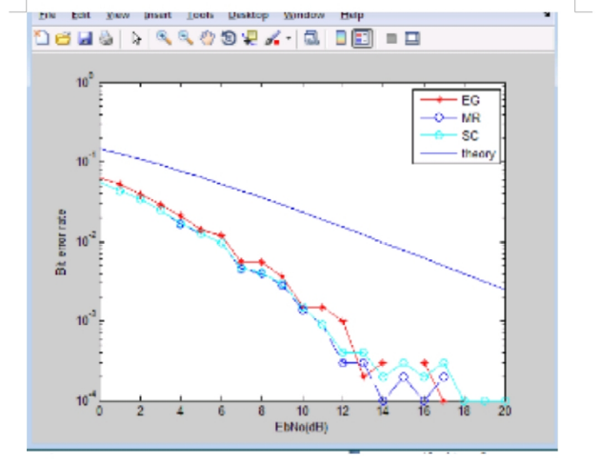
The bit error performance of three different techniques Equal gain combining, maximal ratio combining and selection combining is analysed. From the graph it shows that the bit error rate decreases with increases in energy per bit to noise spectral density(E b /N o ). In ideal case at 10 -2 bit error rate is approximately equals to 14dB of energy per bit to noise spectral density and for the other three techniques, the bit rate is approximately equals to 6dB energy per bit to noise spectral density.

References

- Islam, MD. Jaherul, “Performance Analysis of Diversity Techniques for wireless communication systems”, 2012.
- Hafeth Hourani, ‘An Overview of Diversity Techniques in Wireless Communication Systems’, Helsinki University of Technology, Communications Lab, 2004/2005.
- Markku Juntti, et. al. ,”MIMO Communications with Applications to 3G and 4G”, Oulu University.
- Pravin W.raut,Dr.S.L.Badjate,”Diversity Techniques for Wireless Communication”International journal of Advanced Research in Engineering and Technology,(IJARET),Volume 4,Issue2, March-April,2013.
- Siavash Alamouti, ‘A simple Transmit Diversity Technique for Wireless Communications’, IEEE Journal on selected areas in Communications, Vol. 16, No 8, October 1998.
- J.H Winters, ‘The impact of Antenna Diversity on the Capacity of Wireless Communication System,’ IEEE Transaction of Communications, Vol 42, No. 2/3/4, April 1994.
- P.L. Perini and C.L. Holloway, ‘Angle and Space Diversity Comparisons in different Mobile Radio environments’, IEEE transaction on Antenna and Propagation, Vol 46, June 1998.

