Tab 1
GTM-1 First Digital

Skip to section…
Campaign Goals
Digital Pathways
Themes and Ads
Landing Pages
Conversion Options
Execution Sequence
Reporting and Metrics

Overview
This is a digital marketing campaign for both brand awareness and conversions. We will build ad assets that speak to themes and value propositions, to be targeted to our Ideal Customer Profile (ICP) through various social media channels.

The workflow is 4 steps:
Step 1) Themed ads get attention.
Step 2) Clicking ads goes to landing pages.
Step 3) Landing pages call-to-action encourage 3 unique options.
Step 4) Conversion. See more, or book a demo, or book a trial.

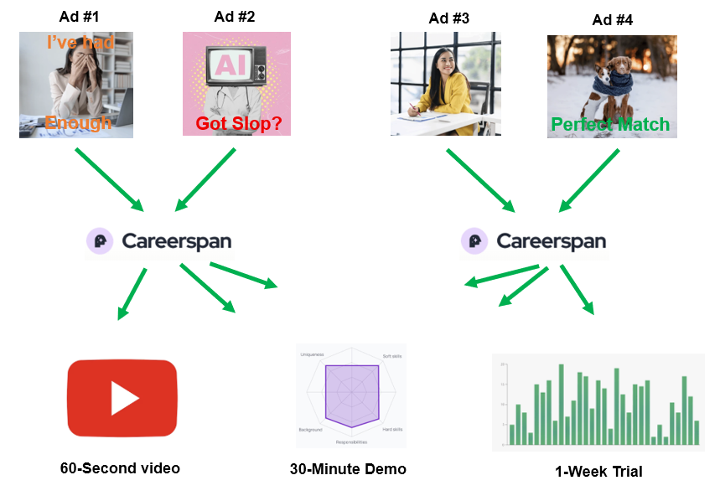

Step 1

Step 2
Step 3

Step 4

Campaign Goals for GTM-1
We have 4 goals in this first GTM-1 effort:

- Brand Awareness - At scale, inform our target audience that we exist, our offering and identity.

- Test the Assets - How is our messaging and art, does it drive interest?

- Test the Mediums - LinkedIn ads and/or Instagram ads are the primary medium, let’s see how they perform.

- Conversion, Build Pipeline - New prospects into the sales funnel.

Brand Awareness. We measure brand awareness by total ad impressions, views, clicks, new followers, likes, click-throughs, website visitors, repeat website visitors, etc. Ideally we will get a measurable spike in website traffic and more followers on both LinkedIn to nurture further.

Test the Assets. We need to test any new ad assets to see which ones resonate best with our target audience. We measure by views and clicks. Some themes will resonate better with our ICP than others.

Test the Medium. We will be looking closely at ROAS (Return on Ad Spend) and overall ROI. We can measure both metrics across any medium of choice. Simply put, how much did we spend and what did we get from it.

Conversion, Pipeline Build. The ultimate goal, measured by the total number of new prospects directly engaging with us. Ideally future campaigns are repeatable and consistent so that we can better forecast and control our pipeline velocity.

Digital Pathways

Ad Assets
We will make our own digital ad assets, to incorporate our own specific language and messaging. All ads can be reused and multi-purposed over the lifetime of the asset, for example, an ad image can also be used in a later blog, or in sales proposals. For this first campaign, assets will be put into B2B ad services LinkedIn and Instagram.

LinkedIn Ads and Instagram Ads
Both platforms offer robust B2B ad services. Upon build-completion of ads and landing pages links, we can load up into each platform and dial-in our target audience, fine-tune our budget and spend. Impressions lead to click-throughs to our Landing pages.

Landing Pages
Serve many purposes: more dialogue on themes and/or value propositions from the ads, a formal introduction to Careerspan, call to action options, unique visitor and click data we can measure. All landing pages can be reused and repurposed. Landing Pages are usually viewed in tandem with the Website.

Website
Campaigns will also drive traffic to the website. Any engagement/conversion options we provide on the Landing Pages should also be available here. We may need to determine an upgrade to website cookies and website visitor consent, because we may want to capture user data for remarketing purposes.

CRM
Web visitors giving consent or filling out forms, all their data lives here.

Themes and Ads
I’d love to see a minimum of 4 themes, each getting built into a beautiful ad. Example…

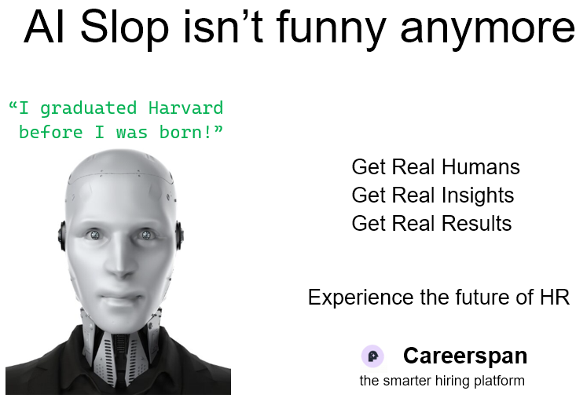
Example ad:

Theme #1: AI Slop

What is the problem or opportunity: Problem. An influx of fake resumes, fake profiles. Speak to and address the tidal wave of fake data plaguing ATS systems and the hiring process.

Quantified: Actual drag on time-to-hire, actual wasted time, slowed down process, crowding out real candidates

Emotions: Feeling stuck, frustrated, anger, disappointment, my failure to filter out slop is exposed to others, unable to do the quality of work I’d like

What does success look like: I never see slop again, slop is contained, slop isn’t slowing me down anymore, slop filter

Example Headlines, Taglines, etc:
“Zero set-up ATS for early-stage founders with built-in AI-slop and candidate lying detection.”
“AI Slop Isn’t Funny Anymore”
“Is AI Slop Clogging Your Pipeline?”
“Regain Your Valuable Time, AI Slop Gets Eliminated”

Theme #2: Stories > Resumes

What is the problem or opportunity: Opportunity. Stories are greater than just resumes. Highlight the Careerspan’s unique approach and immediate value to HR departments.

Quantified: Increased value, more valuable information,

Emotions: A new power, a better future, well-being, satisfied

What does success look like: I have a new and better set of metrics that allow me to perform much better in my job

Example Headlines, Taglines, etc:
“Resumes are 1900’s technology. Stories are 2100 century”
“Zero set-up ATS for early-stage founders that relies on career-coach led narratives so you can judge the real applicant, not just a resume.”
“Are You Tired of Resumes Yet?”
“Resume Fatigue?”
“Resumes Distort Truth, Stories Reveal It”

Theme #3: Insight Engine

What is the problem or opportunity: Opportunity. An advanced match-making engine that surfaces the best candidates from the crowd based on data. We showcase the high-performance candidate insight engine. Allows HR professionals to see into candidates like never before.

Quantified: 100x more, or a lot more data points and parameters to score and match your job descriptions to candidates.

Emotions: I have better control, I have a superpower, I have an advantage

What does success look like: Quality is instantly surfaced and identified. A perfect fit is made from the deepest levels of comparison, I have trust in the Insights Engine, I have a distinct advantage in doing my job.

Example Headlines, Taglines, etc:
“Zero set-up ATS for early-stage founders that provides immediate, first-round interview level insights, without leaving a bad taste in applicants' mouths.”
“Clarity At Scale”
“Advanced match-making, this is how AI is supposed to work!”
“The automation of matching kindred spirits (but for hiring)”
“We agree on 1000 parameters. Literally.”

Theme #4: See What's New!

What is the problem or opportunity: Opportunity. See the latest state-of-the-art tools for your job. An oldie but a goodie. New stuff attracts a steady stream of people, just wanting to see the latest tech.

Quantified: Saves time. This is in fact new to the marketplace, and will challenge you to re-think how you approach and finish your daily workloads.

Emotions: Novelty, excitement, anticipation, validation, exploration. All the classic emotions of shopping.

What does success look like: I know what the latest tools and tech are, I know how to better do my job. I can see how to use this new tool to save a lot of time.

Example Headlines, Taglines, etc:
“A new zero set-up ATS for early-stage founders that solves all the problems chat-gpt brought to hiring.”
“The Future of Hiring”
“AI Done Right”
“Game Changing Hiring Tools”

Theme #5: Fast and Deep

What exactly is the problem or opportunity: Opportunity. The old adage is "good fast cheap, you can only pick two", but we're giving you all three. A classic ATS trade-off and productivity barrier has now fallen. We can do both!

Quantified: Saves a lot of time! Helps load balance workload,

Emotions: Relief, from stress-to-calm, from chaos-to-order, hope for better future

What does success look like: processing tasks and workflow so much faster!

Example Headlines, Taglines, etc:
“Zero set-up ATS for early-stage founders that analyzes applicants across over 30 independent, customizable, axes, to provide greater accuracy and better hires before you schedule a single interview.”
“Now you can do both”
“Yes, you can have it all”
“Thorough analysis, at speed and scale”
“Its not details vs. speed, rather the details drive the speed”

Theme #6: X-Ray Vision Into Candidates
Candidates reveal 100x more detailed information than a resume can hold. This information is analyzed, verified, scored, and then compared directly against your job description. The insights are astounding.
Semantic analysis

What exactly is the problem or opportunity: Opportunity. See beyond the resume, in fact see 100 times more.

Quantified: 100 times more information

Emotions: amazement, relief, awe, wonder, hope for future possibilities

What does success look like: Game changer in how to evaluate a candidate, cannot go back to the old way of doing things, If I can see 100x more, perhaps I can do 100x more?

Example Headlines, Taglines, etc:
“X-ray goggles, but for candidates’ resumes”
“The whole story up front”
“100x times more than a resume could ever hold”
“100x times more insights finally killed the resume”
“Resumes are a nightmare, 100x insights is the dream come true”
“The most candidate insights available anywhere”
“What if there was a way to get candidates to input 100x times more information, and then have it verified, fact checked, and scored. Yeah we built exactly that.”

Theme #7: I Want Greater Automation

What is the problem or opportunity: Problem. Too much manual work sorting through resumes trying to determine a best fit

Quantified: Loss of time on tasks that can or should be automated

Emotions: Always feeling behind, tired of drudgery work

What does success look like: A tool or process that does better and faster than me. (maybe we can tie in the Fast and Deep theme here as well?)

Example Headlines, Taglines, etc:
“Turbo Drive Your Process”
“High Octane Insights for Hiring”
“Speed Matters”
“Its okay to break the speed limit”

Each individual ad will have its own…
Theme: see above, the theme is immediately recognizable by the target buyer.
Artwork: an image is worth 1000 words
Emotion: what is the emotional connection the audience makes with the ad?
Tagline: what words or phrases will resonate and be remembered by the audience.
Keywords: classic keywords and tagging exist under each ad for better targeting.

Need to Decide: which themes we like, approve, and will start building ad images, copy, etc.

Need to Build: Ads!

Landing Pages

Landing pages carry a lot of weight. They should…
- Extend the message or theme from the ad that got the audience to click through.
- Formally introduce Careerspan.
- Have another call to action and a reason for the audience to advance to the next step, the conversion.
- Track everything and everyone, giving us valuable data and metrics of their efficacy.

There is a lot happening on the landing page!

Perhaps give them 3 different icons: video, book a custom demo, I want resumes from the Trial of Service.

Need to Decide: Exact number of Landing pages, who is building, artwork and design, visitor tracking, etc.

Need to Build: # of Landing Pages

Conversion Options
So far we have 3 strong conversion options identified, based on time commitment from the audience.

60-Second Video
What is the best intro to Careerspan that we can cram into 60 seconds or less! Ideally we showcase our strongest value offerings. An awesome video compels people to go for the demo.
60 seconds goes by really fast

0-7 seconds: Resume is broken, hiring crisis, AI slop
7-15 seconds: Careerspan fixes it!
15-55 seconds: Upload job description, Candidate Stories, Analysis Engine
55-60 seconds: Careerspan is the Smart Hiring Platform

30-minute Demo
This is our chance to show the system in all its glory. Our strongest visuals and differentiators should be on display in a swift 30-minute session.
An awesome demo compels people to go for the Trial of Services.

Upon booking a demo, Pre-Demo, Careerspan does:
Careerspan needs from the client… we put the client’s logo or name on their log-in page so they know it's their homebase in the system?

Careerspan needs from the client… we will need at least one real and current job description link from the client

Here is my top list for what we could / should show in a demo:

Feature: How your job description is analyzed by Careerspan
Can we show how a 1-page job description is received, analyzed, and expanded into 100 pages of important details?

Feature: How a candidate is analyzed by Careerspan
Can we show how a candidate's resume and their stories are analyzed and expanded into 100 pages of awesome?

Discussion: what is the science behind the Analysis Engine, why it is so trustworthy, how it eliminates ‘AI Slop’, how it gets to the details that matter.
Feature: Analysis Engine
Ideally with most completing Stories for best results

Feature: Selecting Top 3 Candidates and Processing Interviews

Time’s up. Want to see more… join us in changing the world, err if not ready for that, join a trial.

Qualifying Question to ask each trial user BEFORE the trial: do you want or not want a direct apply link??

1-Week Trial of Services
Ideally we can really impress the client here. As discussed, could we receive a job description from the client, and then within 2-3 days turn around an impressive custom list of perfect candidates, complete with all the deep insights as promised.

 | Client Facing Language | Careerspan Internal Logistics
Timelines | “Let’s get 1 job description set up in our system today, and then we’ll meet in 4 days time to review results in a Trial.” | We need a minimum of 4 days to generate good looking results
Legal | “Please click ‘AGREE’ in the Terms and Conditions checkbox when confirming a trial.” | Any legal or compliance concerns about client-data or anything else needs to be spelled out in our Terms and Conditions.
Careerspan Pre-Work Before Every Trial | “Trials are best with a real and active job description, please send us a link to one of your current job openings.” | Do we need a separate account for each client?  Do we have a ‘client-dashboard’ yet?  Could we put the client’s logo or name on their log-in page so they know it's their homebase in the system?  We will need at least one real and current job description link.  Anything else?
Client Pre-Work | They should have a real and current job opening and job description.  <discussing: here’s your direct apply link… you have homework, go share this?>
Set Expectations | “Thank you for booking a trial.  We are now setting up your private account, with your job description as a real live example of our services.  We’d like to invite you to a trial kick-off call in about 4 days time to show you around the system, tips and tricks of using the Analysis Engine, and more.” | Ilse generates the job and provides back....  a "direct apply link"  a "use this URL to grab a CSV of whoever has applied so far whenever you want, but please don't spam it, maybe 3-4 times a day max"  N.B. We should discuss if this should ONLY include people who completed the application process (i.e. actually SUBMITTED) or if it should include anyone who clicked the job and is mid-process. Ilse leans heavily towards the FORMER for privacy reasons, but it loses some of the "magic" of seeing a big number of "oh wow 200 people are already looking at this job and clicked in"
Kick-Off Call | “Let’s show you around the system…” | We will need a good looking private account for this client!
Feature:  How your job description is analyzed by Careerspan | “This is what happens to a job description in the system.” | Can we show how a 1-page job description is received, analyzed, and expanded into 100 pages of important details?  How much of this could we show?  But realistically… how much of this should we show?
Feature:  How a candidate is analyzed by Careerspan | “This is how much more information we get from candidates. It's 100x more than a resume alone.” | Can we show how a candidate's resume and their stories are analyzed and expanded into 100 pages of awesome?  How much of this could we show?  But realistically… how much of this should we show?
Feature:  Analysis Engine | “And this is what happens when we put it all together, your top candidates, listed right here.” | A fully functioning Analysis Engine with a good amount of candidate profiles completed, ideally with most completing Stories for best results
Feature:  Just the Data | “Check this out…” | UPON REQUEST [for a one-week trial] the employer can request the "full breakdown" and deeper anti-AI detection analysis of a few users.
Feature:  Selecting Top 3 Candidates and Processing Interviews | “Here’s how to move forward with your top choices. You can send them emails from your system and your tools.” | We do not yet support in-system communications from employer-to-candidate, yet.
Feature:  Adding More Job Descriptions | “To add more job descriptions you need to inout…  - Job Title  - Company Name (will already be populated)  - Tentative Job Close Date  - Full job description copy/pasted into the system. | And the process begins again!
Feature:  Adding Teammates to your view | “You can add your teammates to this view.” | Does this exist yet?  This does not exist yet
Feature:  Take Home Candidates | “Thank you for letting us show you Careerspan. Here are some gifts, click this download button.” | As discussed internally, how much do we want to ‘give away for free’ in a Trial?
Feature:  Take Home Data | “Thank you for letting us show you Careerspan. Here are some gifts, click this download button.” | As discussed internally, how much do we want to ‘give away for free’ in a Trial?
Next Steps | “You seem pleased with the quality of candidates and information. Can we talk about putting a ring on your finger, err I meant.. let’s discuss engagement parameters.  When would you want to start?  How many job descriptions would you like to start with?  Payment terms you ask? Of course we have a slight discount if you pay for the whole year in advance” (<-- cash flow!) | The sales pitch!

Need to Decide
-Are these the best 3, or best-3-for-right-now conversion ideas.
-Do clients get ‘free data’ from their Trial of Services? In other words, do they keep the candidate info for free? Or do we charge them?

Need to Build:
-Compelling language and call to actions for all 3 conversions.
-A 60-second video.
-A demo path.
-A Trial of Services path.

Execution Sequence
Possible Timeline for GTM-1

Week of November 3-7th
-Decisions on campaign, themes, messaging, etc.
-Begin writing taglines, messaging, ad copy, sample images for ads, storyboard video, etc.
-Begin building landing pages
-Determine budget for LinkedIn and/or Instagram, research

Week of November 10-14th
-Race to finish all above items, get to a launch date with enough time before Thanksgiving.

Week of November 17-21st
-Ideally we are fully executing the GTM-1 campaign this week.
-Team Boosting. Careerspan team members and friends can post some themed ad images directly into their LinkedIn feed, this way their entire network is exposed for even more visibility. We could take turns posting, for example Vrijen posts on Monday, Ilse posts on Tuesday, Logan posts on Wednesday, etc. this gives the campaign extra boost and impressions.

Week of November 24-28th: Week of Thanksgiving
-Early metrics from GTM-1
-Building towards next GTM-2 campaign

Need to Decide:
-Is this timeline realistic, if not how do we launch even stronger after Thanksgiving.
-all roles and responsibilities throughout the campaign.

Need to Build:
-All ad assets before launch

Reporting and Metrics
We need to collect as much data as possible from early campaigns for fine-tuning of all subsequent campaigns. Some top parameters:

Set Up
-Number of Different Themes or Value Propositions
-Number of Call To Action Types
-Types of Ad Imagery
-Target Personnass
-Target Job Titles
-Duration Of Campaign
-Which Platforms
-Budget
-Ad Auction Strategy

Outcomes
-Number of Impressions per Ad Type
-Total Number of Impressions
-Number of Ad-to-Landing Page Clickthroughs by Ad Type
-Total Number of Ad-to-Landing Page Clickthroughs
-Total Number Of Landing Page To Website Click-Throughs
-Number Of Landing Page To Which Conversion Type
-Total Number Of Landing Page To Conversions, Ratios
-Actual Campaign Duration
-ROAS and ROI

Tools
-Google Analytics for Landing Page and Website Metrics
-LinkedIn Ads Campaign Metrics
-Instagram Ads Campaign Metrics

Need to Decide
-Where to archive the metrics for future analysis.
-What does success look like?
-What does not-good-enough look like? And what metric numbers dictate or trigger a mid-campaign adjustment.

Need to Build: a nice-to-have is a live dashboard of all ongoing campaigns. Is a long-term item.

