Day 20 - 12th Aug 2026

Task 1:
What do you understand about integration testing?
Integration Testing is a type of software testing where we test whether two or more modules, components, or systems work correctly together after they have been individually tested.
The main purpose is to find issues in the interaction and communication between components, such as incorrect data passing, API failures, database connection problems, or incompatible interfaces.
Example:
In a banking application:
- Login module authenticates the user.
- Account module retrieves account details.
- Transaction module performs money transfers.
- Database stores the transaction.
Integration testing checks whether these modules communicate and work correctly together.

Task 2:
Where do you use it and when ?
We use it wherever multiple components or services need to communicate, for example:
- Frontend ↔ Backend API
- Backend ↔ Database
- Microservice ↔ Microservice
- Application ↔ External APIs
- Payment Gateway ↔ Banking Application
- Java Application ↔ MySQL using JDBC/Hibernate
When do we perform it?
Integration testing is generally performed after unit testing and before system testing.

Task 3:
Can you write an integration test for your existing code ?
The test will verify that BankService correctly receives a Customer object and displays its details.
package service;
import com.bank.service.BankService;
import com.model.Customer;
import org.junit.jupiter.api.Test;
import java.io.ByteArrayOutputStream;
import java.io.PrintStream;
import static org.junit.jupiter.api.Assertions.assertTrue;
class BankServiceIntegrationTest {
@Test
void shouldDisplayCustomerDetails() {
// Module 1: Customer
Customer customer =
new Customer(101, "Vicky", "BANK10001");
// Module 2: BankService
BankService bankService = new BankService();
// Capture console output
ByteArrayOutputStream output =
new ByteArrayOutputStream();
PrintStream originalOut = System.out;
System.setOut(new PrintStream(output));
try {
bankService.displayCustomer(customer);
} finally {
System.setOut(originalOut);
}
String result = output.toString();
// Verify integration
assertTrue(result.contains("Customer ID: 101"));
assertTrue(result.contains("Customer Name: Vicky"));
assertTrue(result.contains("Account Number: BANK10001"));
}
}

Task 4:
What are test containers?
Testcontainers is a Java library that allows us to run real services inside temporary Docker containers during automated tests.
For example, suppose our banking application uses MySQL. Instead of connecting our integration test to our actual MySQL database, Testcontainers can:
- Start a temporary MySQL container.
- Run the integration tests against that real database.
- Stop and remove the container after the tests finish.

Task 5:
When do we use ? and what is the need for test containers?
We use Testcontainers mainly during integration testing when our application depends on an external service such as a database, message broker, or cache.
When do we use Testcontainers?
We use it when we want to test our application with a real dependency instead of a mock.
Why do we need Testcontainers?
1. Real environment
We can test against the actual MySQL, PostgreSQL, Redis, Kafka, etc., rather than a fake/mock version.
2. No manual setup
Developers don't need to manually install and configure a database just to run the tests.
3. Isolated tests
Each test environment can have its own temporary container, so tests don't interfere with each other's data.
4. Consistent environment
The same database version and configuration can be used by developers, CI/CD pipelines, and the testing environment.
5. Automatic cleanup
After the tests finish, the containers can be stopped and removed automatically.

Task 6:
Can you write a piece of code for your existing application to see how test container works?
package bank;
import org.junit.jupiter.api.Test;
import org.testcontainers.containers.MySQLContainer;
import org.testcontainers.junit.jupiter.Container;
import org.testcontainers.junit.jupiter.Testcontainers;
import java.sql.Connection;
import java.sql.DriverManager;
import java.sql.ResultSet;
import java.sql.Statement;
import static org.junit.jupiter.api.Assertions.assertEquals;
@Testcontainers
class BankMySQLContainerTest {
@Container
static MySQLContainer<?> mysql =
new MySQLContainer<>("mysql:8.0")
.withDatabaseName("bankdb")
.withUsername("bankuser")
.withPassword("bankpassword");
@Test
void shouldConnectToMySQLContainer() throws Exception {
Connection connection =
DriverManager.getConnection(
mysql.getJdbcUrl(),
mysql.getUsername(),
mysql.getPassword()
);
Statement statement = connection.createStatement();
statement.executeUpdate("""
CREATE TABLE customer (
id INT PRIMARY KEY,
name VARCHAR(100),
account_number VARCHAR(50)
)
""");
statement.executeUpdate("""
INSERT INTO customer
VALUES (101, 'Vicky', 'BANK10001')
""");
ResultSet resultSet =
statement.executeQuery(
"SELECT name FROM customer WHERE id = 101"
);
resultSet.next();
assertEquals("Vicky", resultSet.getString("name"));
connection.close();
}
}

Task 7:
What is code coverage ?
Code coverage is a metric used in software testing to measure how much of our source code is executed by our tests.
For example, if our application has 100 lines of code and our tests execute 80 of those lines, the code coverage is:
80%
There are different types of code coverage:
- Line Coverage – How many lines of code were executed.
- Branch Coverage – How many decision branches (if, else, switch) were tested.
- Method Coverage – How many methods were executed.
- Condition Coverage – Whether different conditions in decision statements were tested.

Task 8:
What’s the need for code coverage?
Code coverage helps us understand whether our tests are actually covering the important parts of the application.
Why do we need it?
1. Identify untested code
It helps us find parts of the application that our tests never execute.
2. Find missing test cases
If an else branch or exception-handling block isn't covered, we know we need additional tests.
3. Improve test quality
It gives us an indication of how thoroughly our automated tests exercise the code.
4. Detect risky areas
Low coverage in important business logic can indicate a higher testing risk.
5. Track testing progress
Teams can monitor coverage as the application grows.

Task 9:

Plz ensure your project is similar to the above structure .. need not have to be exactly same.

Now 1. We will reach out to the Web (Http / Ajax)

lets simulate a backend API call using fetch. In accountDetails.java class in useEffect..

we will use fetch
// we are Simulate backend API call (replace with real endpoint)
fetch("https://api.examplebank.com/accounts/12345")

Sample code for your reference 👍

import React, { useState, useEffect } from "react";

function AccountDetails() {
// State variables to hold account info, loading status, and error messages
const [account, setAccount] = useState(null);
const [loading, setLoading] = useState(true);
const [error, setError] = useState(null);

useEffect(() => {
// 🔄 Simulate backend API call (replace with real endpoint)
fetch("https://api.examplebank.com/accounts/12345")
.then((response) => {
if (!response.ok) throw new Error("Network error"); // Handle HTTP errors
return response.json(); // Parse JSON response
})
.then((data) => {
setAccount(data); // Save account data in state
setLoading(false); // Stop loading spinner
})
.catch((err) => {
setError(err.message); // Capture error message
setLoading(false);
});
}, []); // Empty dependency array → runs once when component mounts

// Conditional rendering based on state
if (loading) return <p>Loading account details...</p>;
if (error) return <p>Error: {error}</p>;

return (
<div>
<h2>Account Details</h2>
{/* Display account info dynamically */}
<p><strong>Account Number:</strong> {account.accountNumber}</p>
<p><strong>Holder Name:</strong> {account.holderName}</p>
<p><strong>Balance:</strong> ₹{account.balance}</p>
</div>
);
}

export default AccountDetails;

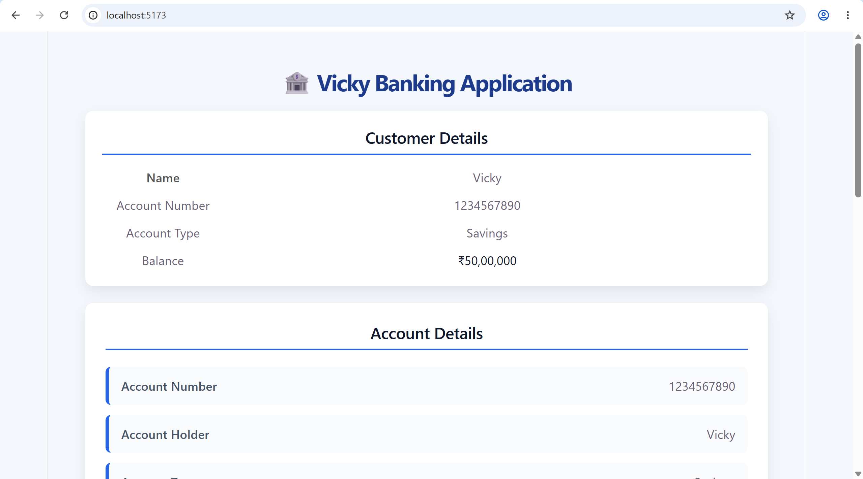

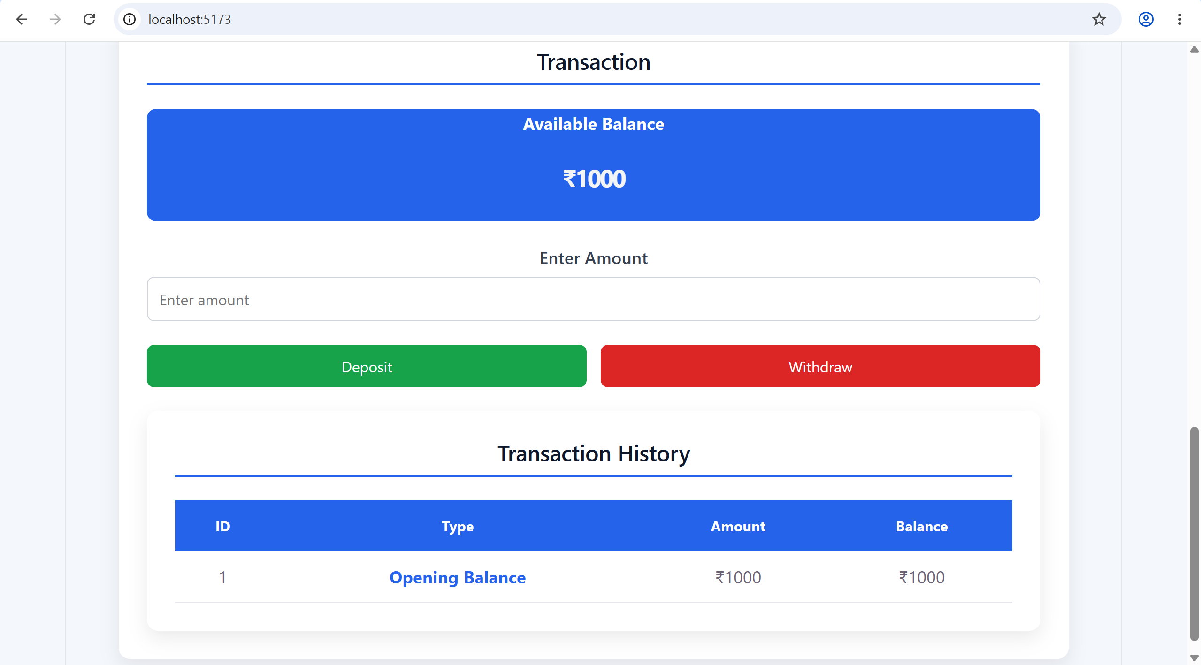

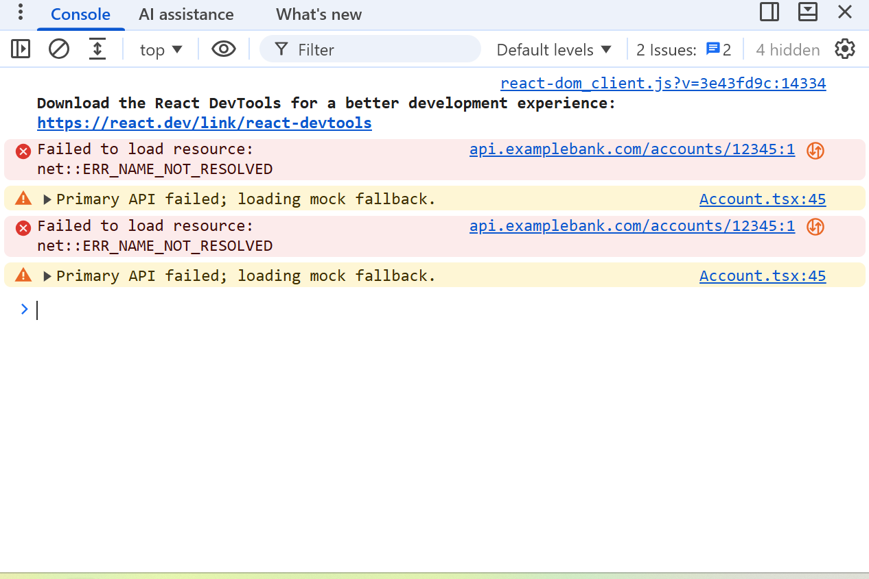

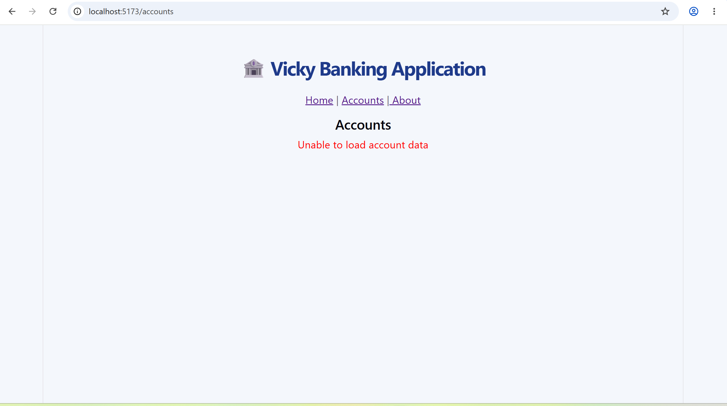

Redux –
Task 10:
What is Redux used for?
Redux is a state management library commonly used with React applications.
It is used to store and manage application-wide state in one central place called the Redux Store.
For example, in a banking application, we may need to maintain:
- User information
- Account balance
- Transaction details
- Account details
Different components can access this shared state without passing data through many intermediate components.
Example
Without Redux:
App → Dashboard → Account → Balance
The balance may need to be passed through several components using props.
With Redux:
Redux Store → Dashboard
Redux Store → Account
Both components can directly access the required state.
Interview Answer
Redux is used for centralized state management in applications, especially when multiple components need to access and update the same data.

Task 11:
Why do we need to maintain the state throughout the app?
We maintain state throughout the application because different components may need to access and update the same data.
For example, in a banking application:
User logs in
↓
User information is stored in state
↓
Dashboard displays the user name
↓
Account page displays account details
↓
Transaction page displays transactions
If each component maintains its own separate copy of the data, it becomes difficult to keep everything synchronized.
Example
Suppose the account balance is:
₹10,000
After a transaction:
₹10,000 - ₹2,000 = ₹8,000
The Dashboard, Account page, and Transaction page may all need the updated balance.
Centralized state management helps keep these components synchronized.
Benefits
- Avoids unnecessary prop drilling
- Keeps shared data consistent
- Makes state easier to manage
- Allows multiple components to access the same state
- Makes complex applications easier to maintain
Interview Answer
We maintain application state so that different components can access and update shared data consistently. Centralized state management becomes particularly useful when the application has complex data shared across many components.

Task 12:
What is useSelector used for?
useSelector is a React-Redux hook used to read data from the Redux store inside a React component.
Syntax
const value = useSelector(state => state.value);
For example, suppose our Redux store contains:
{
balance: 10000
}
A React component can access it using:
import { useSelector } from "react-redux";
function Account() {
const balance = useSelector(
state => state.balance
);

return (
<h2>Balance: ₹{balance}</h2>
);
}
Here:
useSelector(state => state.balance)
means:
"Go to the Redux store and give me the current balance."
Important Difference
useSelector is used to READ data from the Redux store.
useDispatch is generally used to DISPATCH an action that updates the Redux state.
Remember:
useSelector → Read state
useDispatch → Dispatch an action to update state
Interview Answer
useSelector is a React-Redux hook used to access or read data from the Redux store inside a React component. It subscribes the component to the selected part of the Redux state, so the component can re-render when that selected state changes.

Task 13:
After this we would be working with the Redux ..

In this can you create a store

Step 1:
Import createstore from Redux

show how the state changes based on the action type.. Like if with draw , deposit… etc..

Now create store with a reducer..

Step 2:
Now in app.js use – useSelector and useDispatcher from react-redux;

Access balance from redux store and dispatch action to the dispatch function

Step 3:

Create a controller class like BalanceController.js .. which has component for withdraw and deposit.

index.js, html

banking-app/
├── public/
│ └── index.html # Root HTML file
├── src/
│ ├── store.js # Redux store + reducer
│ ├── App.js # Main React component
│ ├── index.js # Entry point, wraps App with Provider
│ └── components/
│ └── BalanceControls.js # Reusable component for deposit/withdraw
├── package.json # Dependencies & scripts
└── README.md # Project instructions

