Day 13 - 03rd Aug 2026

Task 1:

What is an ER diagram? Draw an entity relationship diagram with datatypes .
An Entity Relationship (ER) Diagram is a graphical representation of a database. It shows:
- Entities (tables)
- Attributes (columns)
- Relationships between entities
It is used during database design to understand how data is organized and connected.
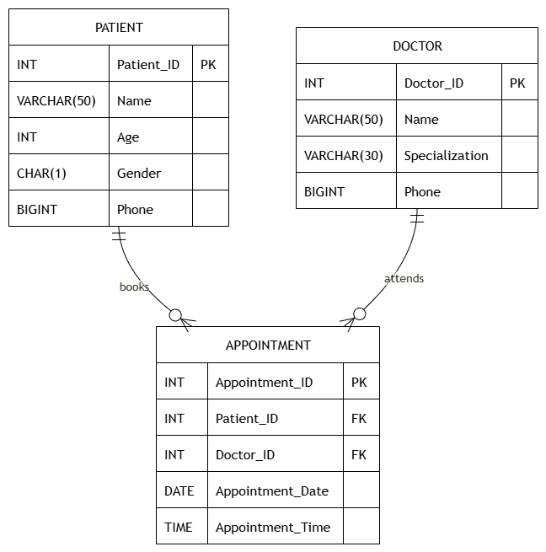

Task 2:
What do you understand by indexing in DBMS? How does it work?
Indexing is a technique used in a Database Management System (DBMS) to improve the speed of data retrieval operations. It creates a separate data structure (called an index) that stores the values of one or more columns along with pointers to the corresponding rows in the table.
Just as the index of a book helps you quickly find a topic without reading every page, a database index helps the DBMS locate records without scanning the entire table.

Task 3:
Do you think Indexing strategy improve the query performance ? explain .
Yes, an indexing strategy significantly improves query performance in a DBMS. An indexing strategy is the process of deciding which columns should be indexed to optimize database performance.
Without an index, the DBMS performs a full table scan, checking every row to find the required data. As the table grows larger, this process becomes slower.
With an index, the DBMS uses the index to quickly locate the required records without scanning the entire table, resulting in much faster query execution.

Task 4:
What are the ACID properties in RDBMS? Explain.
ACID is a set of four properties that ensure database transactions are processed reliably, consistently, and safely. These properties help maintain data integrity even if there is a system failure or multiple users access the database simultaneously.

1. Atomicity
Atomicity means "all or nothing." A transaction is treated as a single unit. Either all operations are completed successfully, or none of them are.
Example:
Suppose ₹1,000 is transferred from Account A to Account B.
- Deduct ₹1,000 from Account A.
- Add ₹1,000 to Account B.

2. Consistency
Consistency ensures that a transaction takes the database from one valid state to another valid state while following all database rules and constraints.
Example:
A bank account balance should never become negative if the database rule does not allow it.
If a transaction violates a constraint, it is rejected and the database remains unchanged.
3. Isolation
Isolation ensures that multiple transactions running at the same time do not interfere with each other. Each transaction behaves as if it is the only one executing.
Example:
Two users try to book the last available train ticket simultaneously.
The database ensures that only one transaction succeeds, preventing both users from booking the same seat.
4. Durability
Durability ensures that once a transaction is successfully committed, the changes are permanently stored in the database, even if the system crashes immediately afterward.
Example:
After an online payment is completed and confirmed, the transaction remains saved even if there is a power failure or server restart.

Task 5:
Alter a table to add a column with unique key
ALTER TABLE Student
ADD COLUMN Email VARCHAR(100);

select * from student;

ALTER TABLE Student
ADD CONSTRAINT unique_email UNIQUE (Email);

INSERT INTO Student (StudentID, Name, Age, Email)
VALUES
(1, 'Vicky', 22, 'vicky@example.com'),
(2, 'Rahul', 21, 'rahul@example.com');

INSERT INTO Student (StudentID, Name, Age, Email)
VALUES
(3, 'Priya', 20, 'vicky@example.com');-- duplicate value

Task 6:
Add a check constraint to your column (eg: balance > 0)
ALTER TABLE Student
ADD CONSTRAINT chk_age
CHECK (Age > 18);
INSERT INTO Student (Student_ID, Name, Age, Email)
VALUES (10, 'Ravi', 16, 'ravi@gmail.com');

Task 7:
use where clause and check if it works
SELECT *
FROM Student
WHERE Student_ID = 1;

SELECT *
FROM Student
WHERE Age > 20;

SELECT *
FROM Student
WHERE Name = 'Vicky';

Task 8:
Use order by
SELECT *
FROM Student
ORDER BY Age ASC;

SELECT *
FROM Student
ORDER BY Age DESC;

Task 9:
use limit
SELECT *
FROM Student
LIMIT 3;

SELECT *
FROM Student
ORDER BY Student_ID DESC
LIMIT 3;

SELECT *
FROM Student
ORDER BY Student_ID DESC
LIMIT 3;

Task 10:
Create queries for left outer join
Right outer join
Inner join
Cross join

Left outer join
select * from student s
left join course c ON s.studentId = c.studentid;

Right outer join
select * from student s
right join course c on s.studentId = c.studentId;

Inner join
SELECT
s.StudentID,
s.Name,
c.Course_Name
FROM Student s
INNER JOIN Course c
ON s.StudentID = c.StudentID;

Cross join
SELECT * from student s
cross join course;

Task 11:

Try playing with indexes on your table.. And see the performance it should increase the query performance.

sample:
-- Create a simple B-tree index
CREATE INDEX idx_customer_name ON customers (name);

-- Create a unique index
CREATE UNIQUE INDEX idx_email_unique ON users (email);

-- Create a partial index
CREATE INDEX idx_unbilled_orders ON orders (status) WHERE status = 'unbilled';

-- Create a GIN index for JSONB
CREATE INDEX idx_data_json ON documents USING GIN (data);

