Day 19 - 11th Aug 2026

Task 1:
What are wrapper class?
Wrapper classes are classes that convert primitive data types into objects.
Examples:
- int → Integer
- double → Double
- char → Character
- boolean → Boolean

Task 2:
What do you understand by auto boxing and unboxing?
Autoboxing: Automatically converting a primitive into its wrapper object.
int a = 10;
Integer b = a;
Unboxing: Automatically converting a wrapper object back into a primitive.
Integer a = 10;
int b = a;

Task 3:
Can you create a program to show the use of wrapper classes
Eg:
// Autoboxing: primitive to wrapper
int primitiveInt = 10;
Integer wrappedInt = primitiveInt; // compiler converts automatically

Integer objInt = new Integer(25); // explicit wrapper object
int unboxedInt = objInt; // compiler converts automatically

public class WrapperExample {
public static void main(String[] args) {
// Autoboxing: primitive to wrapper
int primitiveInt = 10;
Integer wrappedInt = primitiveInt;
// Explicit wrapper object
Integer objInt = Integer.valueOf(25);
// Unboxing: wrapper to primitive
int unboxedInt = objInt;
System.out.println("Wrapped value: " + wrappedInt);
System.out.println("Unboxed value: " + unboxedInt);
}
}

TASK 4:
Where do we use wrapper classes?
Wrapper classes are mainly used:
- In Collections like ArrayList<Integer>.
- When an object is required instead of a primitive.
- For converting between String and primitive values.
- When using Generics, which work with objects.

Task 5:
Can you create a program to show the difference between abstraction and encapsulation
Abstraction hides implementation details, while Encapsulation hides data and controls access to it.
abstract class Vehicle {
abstract void start(); // Abstraction
}
class Car extends Vehicle {
private String model; // Encapsulation
Car(String model) {
this.model = model;
}
public void start() {
System.out.println("Car starts with a key");
}
public String getModel() {
return model;
}
}
public class Main {
public static void main(String[] args) {
Car car = new Car("BMW");
car.start();
System.out.println(car.getModel());
}
}

Task 6:
What is executor framework in Java 5?why do we use? Where do we use?
The Executor Framework was introduced in Java 5 to manage and execute threads easily.
Why do we use it?
- To manage multiple threads.
- To avoid creating threads manually.
- To reuse threads using thread pools.
Where do we use it?
- Web applications
- Background tasks
- Server applications
- Parallel processing

Task 7:
Can you explain.. Executor, executor service and executors?
With sample progrm
- Executor: Basic interface used to execute tasks.
- ExecutorService: Provides methods to manage tasks and shut down the executor.
- Executors: Utility class used to create different types of thread pools.
Sample Program
import java.util.concurrent.ExecutorService;
import java.util.concurrent.Executors;
public class ExecutorExample {
public static void main(String[] args) {
ExecutorService service = Executors.newFixedThreadPool(2);
service.submit(() -> {
System.out.println("Task executed by thread");
});
service.shutdown();
}
}

Task 8:
When do we use callable interface with future?
We use Callable when a task needs to return a result or may throw an exception.
Future is used to get the result returned by the Callable task.
Callable<Integer> task = () -> 10 + 20;
Future<Integer> result = executor.submit(task);
System.out.println(result.get());

Output:
30
Simple difference:
Runnable → performs a task, does not return a result
Callable → performs a task and returns a result
Future → gets the result from Callable

Task 9:
how do we create ExecutorService, Submit Tasks, Manage Results and Shutdown Executor.
Can you explain the flow
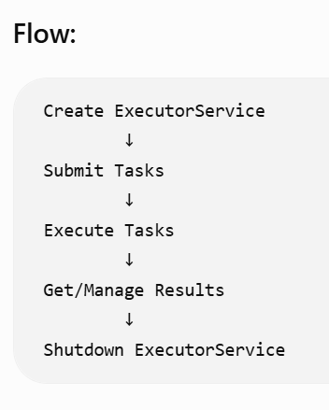
import java.util.concurrent.*;
public class ExecutorExample {
public static void main(String[] args) throws Exception {
ExecutorService executor = Executors.newFixedThreadPool(2);
Future<Integer> result = executor.submit(() -> 10 + 20);
System.out.println("Result: " + result.get());
executor.shutdown();
}
}

Executors.newFixedThreadPool() → creates ExecutorService.
submit() → submits a task.
Future.get() → gets the result.
shutdown() → stops the ExecutorService.

Task 10:
Can you create programs which uses the concepts of character input output in file handling and buffer input output in file handling?
Character I/O
Used to read and write character data using FileReader and FileWriter.
import java.io.*;
public class CharacterIO {
public static void main(String[] args) throws Exception {
FileWriter writer = new FileWriter("data.txt");
writer.write("Hello Java");
writer.close();
FileReader reader = new FileReader("data.txt");
int ch;
while ((ch = reader.read()) != -1) {
System.out.print((char) ch);
}
reader.close();
}
}

Buffered I/O
BufferedReader and BufferedWriter improve performance by using a buffer.
import java.io.*;
public class BufferedIO {
public static void main(String[] args) throws Exception {
BufferedWriter writer = new BufferedWriter(
new FileWriter("data.txt"));
writer.write("Hello Java");
writer.close();
BufferedReader reader = new BufferedReader(
new FileReader("data.txt"));
String line;
while ((line = reader.readLine()) != null) {
System.out.println(line);
}
reader.close();
}
}

Task 11:
What is an Object class?
Why do we use them?
Can you show me the diagramatic representation of object with other classes.

Object is the parent class of all classes in Java. Every Java class directly or indirectly inherits from the Object class.
Why do we use it?
The Object class provides common methods that every Java object can use, such as:
- toString() – represents the object as a string.
- equals() – compares two objects.
- hashCode() – returns the object's hash code.
- getClass() – returns information about the object's class.
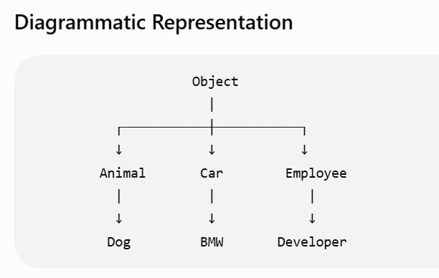
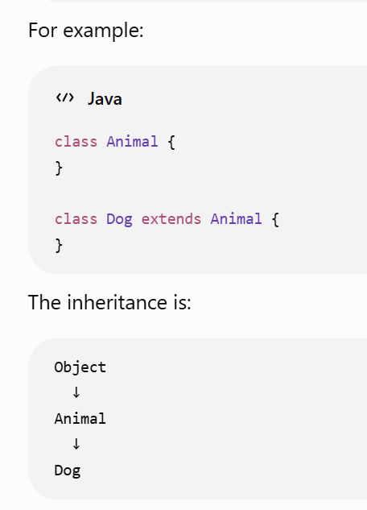
Task 12:
Can you display the methods in Object class
Object is the root class of all Java classes.
Important methods are:
toString()
equals()
hashCode()
getClass()
clone()
finalize()
wait()
notify()
notifyAll()
Examples:
- toString() → returns string representation of an object.
- equals() → compares objects.
- hashCode() → returns hash code.
- getClass() → returns the class information.
- wait() → makes a thread wait.
- notify() → wakes a waiting thread.
- notifyAll() → wakes all waiting threads.

Task 13:
What are generics ? benefits of generics .. can you explain wit a code .
Generics allow us to specify the type of data that a class, interface, or method can work with.
import java.util.*;
public class GenericExample {
public static void main(String[] args) {
ArrayList<String> names = new ArrayList<>();
names.add("Vicky");
names.add("John");
String name = names.get(0);
System.out.println(name);
}
}

Here:
ArrayList<String>
means the list can store only String values.
Benefits of Generics:
- Type safety – prevents incorrect data types.
- No need for type casting.
- Code reusability.
- Errors are detected at compile time.

JAVA 8 FEATURES –
TASK 14
- Explain why lambda expressions were introduced in Java 8.
Answer:
Lambda expressions were introduced in Java 8 to write shorter, cleaner, and more readable code. They are mainly used with functional interfaces, collections, and streams.
Example:
list.forEach(name -> System.out.println(name));
- What is a functional interface? Give two examples from the Java API.
Answer:
A functional interface is an interface that contains only one abstract method. It can be used with lambda expressions.
Examples:
• Runnable
• Predicate
Example:
Predicate p = n -> n > 10;

- Differentiate between Streams and Collections.
Answer:
Collections are used to store and manage data, whereas Streams are used to process and perform operations on data.
Collections:
• Store data
• Can add or remove elements
• Used for data storage
Streams:
• Process data
• Do not store data
• Used for filtering, sorting, and transforming data
Example:
list.stream().filter(n -> n > 10);
- What problem does the Optional class solve?
Answer:
Optional is used to handle null values and helps reduce the chances of NullPointerException.
Example:
Optional name = Optional.ofNullable(null);
- Why were default methods added to interfaces in Java 8?
Answer:
Default methods were introduced so that new methods could be added to existing interfaces without breaking the classes that already implement those interfaces.
Example:
interface Vehicle {
default void start() {
System.out.println("Vehicle starts");
}
}
- What are method references and how do they improve readability?
Answer:
Method references use the :: operator to refer to an existing method. They make lambda expressions shorter and more readable.
Lambda expression:
list.forEach(name -> System.out.println(name));
Method reference:
list.forEach(System.out::println);
- Describe the improvements in the Date-Time API compared to java.util.Date.
Answer:
The Java 8 Date-Time API is simpler, immutable, thread-safe, and easier to use than the older java.util. API.
Examples:
• LocalDate
• LocalTime
• LocalDateTime
• ZonedDateTime
Example:
LocalDate today = LocalDate.now();
- How does the Base64 API simplify encoding/decoding tasks?
Answer:
The Base64 API provides built-in methods to easily encode and decode data without using third-party libraries.
Example:
String encoded = Base64.getEncoder().encodeToString("Hello".getBytes());
- Give a real-world example where static methods in interfaces are useful.
Answer:
Static methods in interfaces are useful for creating utility methods related to that interface. They can be called directly using the interface name.
Example:
interface Calculator {
static int add(int a, int b) {
return a + b;
}
}
int result = Calculator.add(10, 20);

Task 15:
Whats going on in this code snippet? Can you check .. can you imagine a traditional code for performing the same.
public record Customer(String name, int age) {}

public class RecordDemo {
public static void main(String[] args) {
Customer c = new Customer("Prasunamba", 30);
System.out.println(c.name()); // Prasunamba
System.out.println(c); // Customer[name=Prasunamba, age=30]
}
}
Explanation:
A record is a special type of class used to store data. It automatically provides:
- Constructor
- Getter-like methods (name(), age())
- toString()
- equals()
- hashCode()
Explanation:
A record is a special type of class used to store data. It automatically provides:
- Constructor
- Getter-like methods (name(), age())
- toString()
- equals()
- hashCode()

Task 16:
Can you extend this code for creating a fd child class.. Will it work? If not whats stopping to extend fd from Transaction..
java
public sealed class Transaction permits Credit, Debit {}
final class Credit extends Transaction {}
final class Debit extends Transaction {}

Will it work?
No, it will not work.
The reason is that Transaction is a sealed class.
A sealed class specifies exactly which classes are allowed to extend it:
public sealed class Transaction permits Credit, Debit {}
Here, only:
Transaction
├── Credit
└── Debit
are permitted subclasses.
FD is not listed in the permits clause, so Java will not allow:
class FD extends Transaction { }
If we want FD to extend Transaction
We must add FD to the permits list:
public sealed class Transaction permits Credit, Debit, FD {}

final class Credit extends Transaction {}

final class Debit extends Transaction {}

final class FD extends Transaction {}
Now it will work.

Task 18:
We dont know what threads do internally…
And now these imaginary threads????????????????

Whats nonsense ? in this code..

import java.util.concurrent.Executors;

public class VirtualThreadDemo {
public static void main(String[] args) {
try (var executor = Executors.newVirtualThreadPerTaskExecutor()) {
executor.submit(() -> System.out.println("Running on virtual thread"));
}
}
}
What are Virtual Threads?
A normal platform thread is relatively expensive because it is closely associated with an operating-system thread.
A virtual thread is a lightweight thread managed by the JVM. The JVM schedules many virtual threads over a smaller number of OS threads.
Think of it like:
Platform Threads

Java Thread → OS Thread
Java Thread → OS Thread
Java Thread → OS Thread
With virtual threads:
Virtual Thread ─┐
Virtual Thread ─┤
Virtual Thread ─┤──→ JVM ──→ OS Threads
Virtual Thread ─┤
Virtual Thread ─┘
So you can create a very large number of virtual threads without needing the same number of OS threads.
What does this line do?
Executors.newVirtualThreadPerTaskExecutor()
It creates an ExecutorService that creates a new virtual thread for each submitted task.

%%%%%%%%%%%%%%%%%%%%%%%%%%%%%%%%%%%%%%%%%%%%%%%%%%%%%%%%%%%%%%%%%%%%%%%%%%%%%%%%%%%%%%%%%%%%%%
Home Task
%%%%%%%%%%%%%%%%%%%%%%%%%%%%%%%%%%%%%%%%%%%%%%%%%%%%%%%%%%%%%%%%%%%%%%%%%%%%%%%%%%%%%%%%%%%%%%

Create a Mini Banking App project using Java 8 features.
Banking.java
package com.bank.demo;
import java.time.LocalDate;
import java.util.Arrays;
import java.util.List;
import java.util.stream.Collectors;
public class BankingApp {
public static void main(String[] args) {
// 1. Streams + Lambda Expressions
List<Transaction> transactions = Arrays.asList(
new Transaction(500, LocalDate.now()),
new Transaction(2500, LocalDate.now()),
new Transaction(1200, LocalDate.now())
);
List<Transaction> highValue = transactions.stream()
.filter(t -> t.getAmount() > 1000)
.collect(Collectors.toList());
highValue.forEach(
t -> System.out.println("High Value Txn: " + t.getAmount())
);
// 2. Optional for Customer PAN
Customer customer = new Customer("Ravi", null);
customer.getPanCard().ifPresent(
pan -> System.out.println("PAN: " + pan)
);
if (!customer.getPanCard().isPresent()) {
System.out.println("PAN not available");
}
// 3. Date-Time API
LocalDate today = LocalDate.now();
LocalDate nextEmi = today.plusMonths(1);
System.out.println("Next EMI due on: " + nextEmi);
// 4. Default and Static Methods in Interface
Payment payment = new CreditCardPayment();
payment.validate();
Payment.log("Payment processed successfully");
// 5. Method Reference
List<String> logs = Arrays.asList(
"Debit",
"Credit",
"Transfer"
);
logs.forEach(System.out::println);
}
}

CreditCardPayment.java
package com.bank.demo;
public class CreditCardPayment implements Payment {
// Inherits the default validate() method
}

Customer.java
package com.bank.demo;
import java.util.Optional;
public class Customer {
private String name;
private Optional<String> panCard;
public Customer(String name, String panCard) {
this.name = name;
this.panCard = Optional.ofNullable(panCard);
}
public String getName() {
return name;
}
public Optional<String> getPanCard() {
return panCard;
}
}

Payment.java
package com.bank.demo;
public interface Payment {
// Default method
default void validate() {
System.out.println("Basic validation done.");
}
// Static method
static void log(String msg) {
System.out.println("LOG: " + msg);
}
}

Transaction.java
package com.bank.demo;
import java.time.LocalDate;
public class Transaction {
private int amount;
private LocalDate date;
public Transaction(int amount, LocalDate date) {
this.amount = amount;
this.date = date;
}
public int getAmount() {
return amount;
}
public LocalDate getDate() {
return date;
}
}

