Day – 08

Jdk 18 and above

java -version
java version "26.0.2" 2026-07-21
Java(TM) SE Runtime Environment (build 26.0.2+10-55)
Java HotSpot(TM) 64-Bit Server VM (build 26.0.2+10-55, mixed mode, sharing)

mvn -v
Apache Maven 3.9.6 (bc0240f3c744dd6b6ec2920b3cd08dcc295161ae)
Maven home: C:\Program Files\apache-maven-3.9.6
Java version: 17.0.12, vendor: Oracle Corporation, runtime: C:\Program Files\Java\jdk-17
Default locale: en_IN, platform encoding: Cp1252
OS name: "windows 11", version: "10.0", arch: "amd64", family: "windows"

>mvn archetype:generate -DgroupId=com.bank -DartifactId=Demo02_DependencyInjection -DarchetypeArtifactId=maven-archetype-quickstart -DinteractiveMode=false

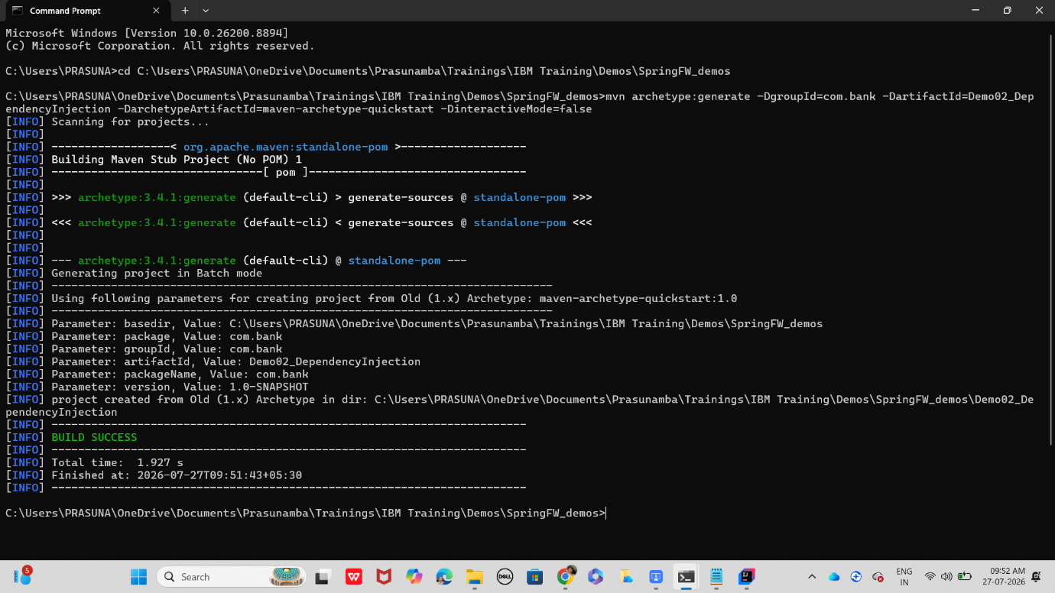

Cd folder name

Project structure
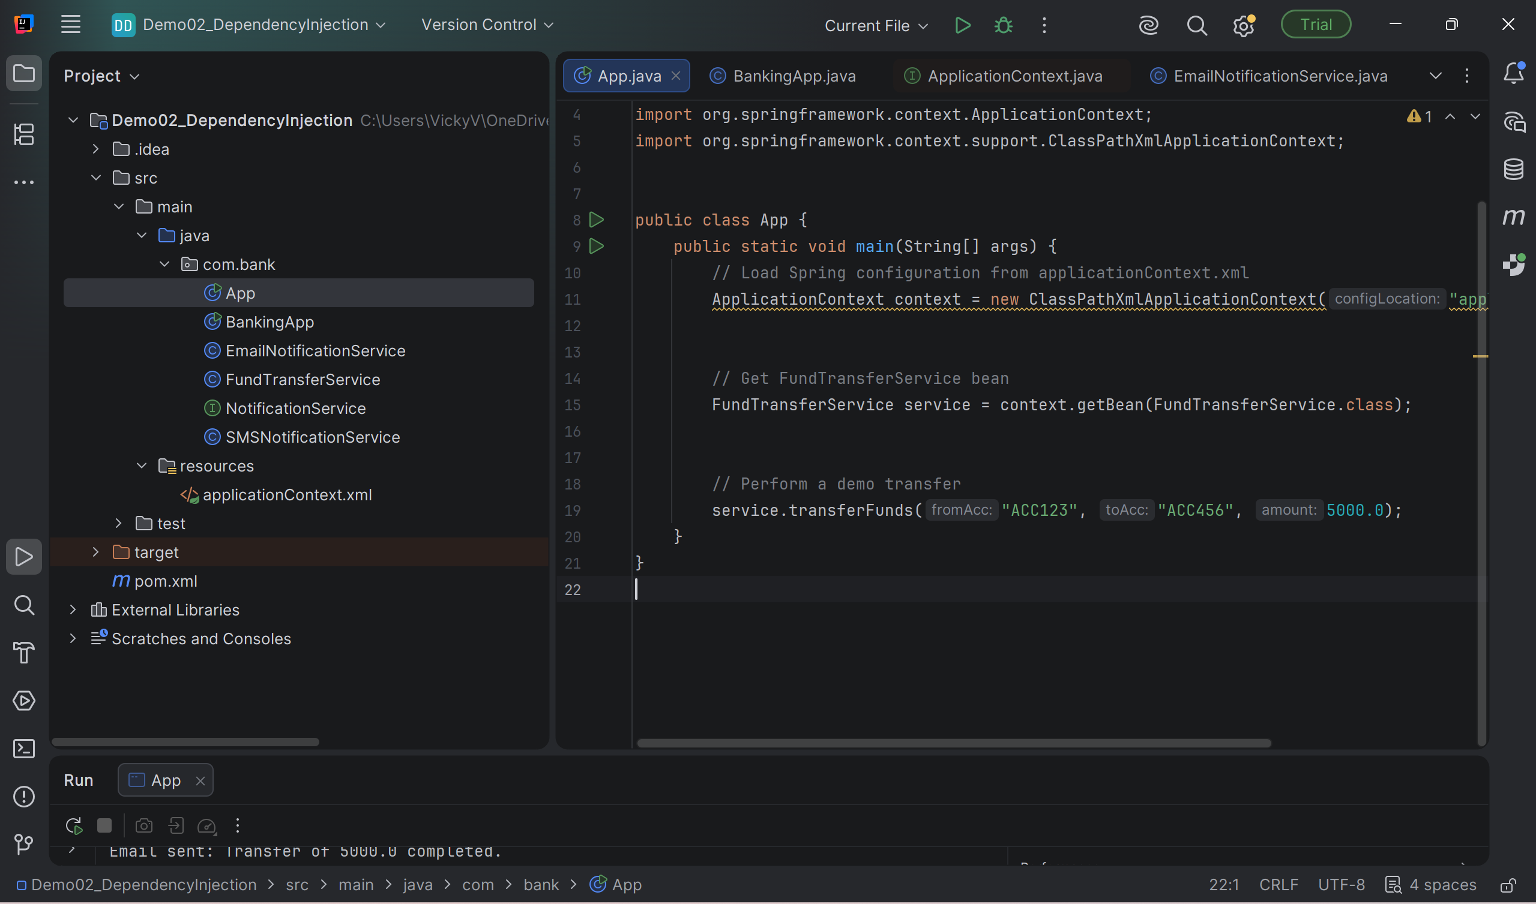

App.java
package com.bank;
import org.springframework.context.ApplicationContext;
import org.springframework.context.support.ClassPathXmlApplicationContext;
public class App {
public static void main(String[] args) {
// Load Spring configuration from applicationContext.xml
ApplicationContext context = new ClassPathXmlApplicationContext("applicationContext.xml");
// Get FundTransferService bean
FundTransferService service = context.getBean(FundTransferService.class);
// Perform a demo transfer
service.transferFunds("ACC123", "ACC456", 5000.0);
}
}

bankingApp.java

package com.bank;
import org.springframework.context.ApplicationContext;
import org.springframework.context.support.ClassPathXmlApplicationContext;

public class BankingApp {
public static void main(String[] args) {
ApplicationContext context = new ClassPathXmlApplicationContext("applicationContext.xml");
FundTransferService service = context.getBean(FundTransferService.class);
service.transferFunds("ACC123", "ACC456", 5000.0);
}
}

EmailNotificationService .java
package com.bank;

import org.springframework.stereotype.Service;

@Service
public class EmailNotificationService implements NotificationService {
@Override
public void notifyCustomer(String message) {
System.out.println("Email sent: " + message);
}
}

FundTransferService.java
package com.bank;

import org.springframework.beans.factory.annotation.Autowired;
import org.springframework.stereotype.Component;

@Component
public class FundTransferService {
private final NotificationService notificationService;

@Autowired
public FundTransferService(NotificationService notificationService) {
this.notificationService = notificationService;
}

public void transferFunds(String fromAcc, String toAcc, double amount) {
System.out.println("Transferred " + amount + " from " + fromAcc + " to " + toAcc);
notificationService.notifyCustomer("Transfer of " + amount + " completed.");
}
}

NotificationService.java
package com.bank;
public interface NotificationService {
void notifyCustomer(String message);
}

SMSNotificationService.java
package com.bank;

public class SMSNotificationService implements NotificationService {
@Override
public void notifyCustomer(String message) {
System.out.println("SMS sent: " + message);
}
}

In src/main add resources folder

applicationContext.xml
<beans xmlns="http://www.springframework.org/schema/beans"
xmlns:xsi="http://www.w3.org/2001/XMLSchema-instance"
xsi:schemaLocation="http://www.springframework.org/schema/beans
http://www.springframework.org/schema/beans/spring-beans.xsd">

<!-- Choose implementation -->
<bean id="notificationService" class="com.bank.EmailNotificationService"/>

<!-- Inject dependency -->
<bean id="fundTransferService" class="com.bank.FundTransferService">
<constructor-arg ref="notificationService"/>
</bean>
</beans>

Now
Mvnn clean compile
mvn clean install
mvn exec:java -Dexec.mainClass="com.bank.App"

mvn clean install

—-------------------------------------------------------------------------------------------------------------------------------------------------------------------------------------------------------------------------

Task 01:

What do you understand by Spring frame work?
Spring Framework is an open-source Java framework used to build enterprise applications. It provides a comprehensive infrastructure for developing Java applications with features like dependency injection, aspect-oriented programming, transaction management, and integration with databases and web technologies.
Key features:
- Dependency Injection (DI) and Inversion of Control (IoC)
- Aspect-Oriented Programming (AOP)
- Spring MVC for web applications
- Transaction management
- Easy integration with databases (JDBC, JPA, Hibernate)
- Security through Spring Security
Advantages:
- Loose coupling between components
- Easy to test and maintain
- Modular architecture
- Reduces boilerplate code

Task 02:

What is spring boot?
Spring Boot is an extension of the Spring Framework that simplifies the development of Spring applications. It provides auto-configuration, embedded servers, and starter dependencies, allowing developers to create production-ready applications with minimal configuration.
Key features:
- Auto-configuration
- Embedded servers (Tomcat, Jetty, Undertow)
- Starter dependencies (e.g., spring-boot-starter-web)
- Minimal XML configuration
- Production-ready features like health checks and metrics (Actuator)
Benefits:
- Faster application development
- Reduced configuration
- Easy deployment as a standalone JAR
- Opinionated defaults for quick setup

Task 03:

What is the diff b/w spring framework and spring boot?
Spring Framework | Spring Boot
Core Java framework for enterprise applications. | Extension of Spring Framework.
Requires manual configuration. | Provides auto-configuration.
Needs external web server deployment. | Comes with embedded servers like Tomcat.
More setup and configuration required. | Minimal configuration required.
Suitable for developers who need full control. | Suitable for rapid application development.
Dependency management is manual. | Starter dependencies simplify dependency management.

Task 04:

What is Dependency Injection?
Dependency Injection (DI) is a design pattern in which the Spring IoC container creates and injects the required objects (dependencies) into a class instead of the class creating them itself. This promotes loose coupling, making applications easier to test, maintain, and extend.

Types of Dependency Injection in Spring:
- Constructor Injection (Recommended)
- Setter Injection
- Field Injection (Less recommended for production code)

Task 05:

create a simple OrderService that depends on a PaymentService. Instead of creating objects manually, inject them.

interfaces:

paymentService ' ----> credit card or debit card class
and orderservice ---> PaymentService implementation class

App.java
package com.bank;
import org.springframework.context.ApplicationContext;
import org.springframework.context.support.ClassPathXmlApplicationContext;
public class App {
public static void main(String[] args) {
ApplicationContext context =
new ClassPathXmlApplicationContext("applicationContext.xml");
OrderService orderService =
context.getBean("orderService", OrderService.class);
orderService.placeOrder(250.00);
}
}

CreditCardPayment.java
package com.bank;
public class CreditCardPayment implements PaymentService {
@Override
public void makePayment(double amount) {
System.out.println("Payment of $" + amount + " made using Credit Card.");
}
}

DebitCardPayment.java
package com.bank;
public class DebitCardPayment implements PaymentService {
@Override
public void makePayment(double amount) {
System.out.println("Payment of $" + amount + " made using Debit Card.");
}
}

PaymentService.java
package com.bank;
public class OrderService {
private PaymentService paymentService;
// Constructor Injection
public OrderService(PaymentService paymentService) {
this.paymentService = paymentService;
}
public void placeOrder(double amount) {
System.out.println("Order placed successfully.");
paymentService.makePayment(amount);
}
}

PaymentService – Interface
package com.bank;
public interface PaymentService {
void makePayment(double amount);
}

applicationContext.xml
<?xml version="1.0" encoding="UTF-8"?>
<beans xmlns="http://www.springframework.org/schema/beans"
xmlns:xsi="http://www.w3.org/2001/XMLSchema-instance"
xsi:schemaLocation="
http://www.springframework.org/schema/beans
https://www.springframework.org/schema/beans/spring-beans.xsd">
<bean id="paymentService"
class="com.bank.CreditCardPayment"/>
<bean id="paymentService1"
class="com.bank.DebitCardPayment"/>
<bean id="orderService"
class="com.bank.OrderService">
<constructor-arg ref="paymentService"/>
</bean>
</beans>

Pom.xml
<?xml version="1.0" encoding="UTF-8"?>
<project xmlns="http://maven.apache.org/POM/4.0.0"
xmlns:xsi="http://www.w3.org/2001/XMLSchema-instance"
xsi:schemaLocation="http://maven.apache.org/POM/4.0.0
http://maven.apache.org/xsd/maven-4.0.0.xsd">
<modelVersion>4.0.0</modelVersion>
<groupId>org.example</groupId>
<artifactId>Demo01_Spring</artifactId>
<version>1.0-SNAPSHOT</version>
<properties>
<maven.compiler.source>26</maven.compiler.source>
<maven.compiler.target>26</maven.compiler.target>
<project.build.sourceEncoding>UTF-8</project.build.sourceEncoding>
</properties>
<dependencies>
<dependency>
<groupId>org.springframework</groupId>
<artifactId>spring-context</artifactId>
<version>6.1.2</version>
</dependency>
</dependencies>
</project>

UML Diagram for Banking Application
