Day 12 - 31th July 2026

DBMS

Task 1:
Why is there a need for DBMS?
A Database Management System (DBMS) is needed to efficiently store, organize, retrieve, and manage large amounts of data. Before DBMS, data was stored in files, making it difficult to manage and maintain.
Need for DBMS
- Reduces data redundancy: Avoids storing duplicate data.
- Improves data consistency: Ensures the same data is accurate across the database.
- Provides data security: Restricts unauthorized access using authentication and permissions.
- Supports data sharing: Multiple users can access the database simultaneously.
- Ensures data integrity: Maintains accurate and valid data using constraints.
- Provides backup and recovery: Restores data in case of system failure.
- Manages concurrent access: Prevents conflicts when multiple users access the same data.

Task 2:
Why not traditional DBMS?
Traditional file-based systems (before DBMS) had several limitations that made data management difficult.
Problems with Traditional File Systems
- Data redundancy: The same data is stored in multiple files.
- Data inconsistency: Updating one file may not update others.
- Difficult data access: Retrieving information requires writing complex programs.
- Poor security: Limited access control.
- No proper backup and recovery: Data loss is difficult to recover.
- Data isolation: Data is scattered across different files and formats.
- Concurrency issues: Multiple users accessing data simultaneously can cause conflicts.
- No relationships: Maintaining relationships between data is difficult.

Task 3:
Explain the concept of data independence in DBMS.
Data Independence is the ability to modify the database structure without affecting the application programs that access the data.
Types of Data Independence
1. Physical Data Independence
- Allows changes to the physical storage of the database without affecting the logical structure or applications.
- Examples:
  - Changing file organization.
  - Creating indexes.
  - Moving data to another storage device.
Example:
If a database administrator adds an index to improve performance, the application continues to work without any changes.

2. Logical Data Independence
- Allows changes to the logical structure of the database without affecting application programs.
- Examples:
  - Adding a new column.
  - Creating a new table.
  - Splitting a table into multiple tables.
Example:
If a Customer table gets a new column called Email, existing applications that don't use the new column continue to work.

Task 4:
What are the different types of database models (hierarchical, network, relational, object-oriented)?
A database model defines how data is organized, stored, and related within a database.
1. Hierarchical Database Model
- Organizes data in a tree-like structure.
- Each parent can have multiple children, but each child has only one parent.
- Represents a one-to-many relationship.
2. Network Database Model
- Organizes data as a graph.
- A child can have multiple parents.
- Supports many-to-many relationships.
3. Relational Database Model
- Stores data in tables (rows and columns).
- Relationships are created using Primary Keys and Foreign Keys.
- Most widely used database model.
4. Object-Oriented Database Model
- Stores data as objects, similar to object-oriented programming.
- Objects contain both data and methods.

Task 5:
Describe concurrency control in DBMS. Why is it important?
Concurrency control is the process of managing multiple users or transactions accessing the same database simultaneously without causing data inconsistency.
Example
Suppose an account balance is ₹10,000.
- User A withdraws ₹2,000.
- User B deposits ₹5,000.
Without concurrency control, one transaction may overwrite the other, resulting in an incorrect balance.
With concurrency control, the DBMS executes transactions safely and maintains the correct balance of ₹13,000.
Why is it important?
- Prevents data inconsistency.
- Avoids lost updates.
- Maintains data integrity.
- Supports multiple users simultaneously.
- Ensures transaction isolation (ACID property).
Techniques
- Locking
- Timestamp Ordering
- Optimistic Concurrency Control
- Multiversion Concurrency Control (MVCC)

Task 6:
What are indexes in DBMS? How do they improve query performance?
An index is a data structure that helps the database locate rows quickly without scanning the entire table.
It works similarly to the index in a book—you look up the topic in the index instead of reading every page.
Without Index
SELECT * FROM Employee
WHERE EmpID = 101;

With Index
The database directly jumps to the required record.
Time Complexity: O(log n) (typically using a B-tree index)

Create an Index
CREATE INDEX idx_empid
ON Employee(EmpID);

Task 7:
Explain deadlock in DBMS. What are the strategies for deadlock prevention and detection?
A deadlock occurs when two or more transactions wait indefinitely for each other to release resources, so none of them can proceed.
Example
- Transaction T1 locks Table A and waits for Table B.
- Transaction T2 locks Table B and waits for Table A.
Deadlock Prevention
Prevent a deadlock before it happens.
Methods:
- Acquire all required locks before starting.
- Always lock resources in the same order.
- Use timestamp-based protocols such as Wait-Die or Wound-Wait.
- Avoid circular waiting.

Deadlock Detection
Allow deadlocks to occur, then detect and resolve them.
Methods:
- Maintain a Wait-for Graph.
- If the graph contains a cycle, a deadlock exists.
- Roll back one of the transactions (victim transaction) to break the deadlock.

Deadlock Recovery
- Roll back one transaction.
- Release its locks.
- Restart the transaction later.

RDBMS:

Task 8:
What do you understand by Relational model?
The Relational Model is a database model proposed by Edgar F. Codd in 1970. It organizes data into tables (relations) consisting of rows (tuples) and columns (attributes). Each table represents an entity, and relationships between tables are established using keys, such as primary keys and foreign keys.
The relational model ensures data integrity, reduces redundancy, and makes it easy to retrieve and manage data using SQL (Structured Query Language). It is the foundation of most modern RDBMSs such as MySQL, Oracle, PostgreSQL, and SQL Server.

Task 9:
Specify key terms that you encounter in RDBMS. Give brief explanation
Key Term | Brief Explanation
Relation (Table) | A collection of related data organized into rows and columns.
Tuple (Row) | A single record in a table.
Attribute (Column) | A property or characteristic of an entity.
Domain | The set of valid values that an attribute can hold.
Schema | The logical structure of a database, including tables, columns, and relationships.
Instance | The actual data stored in the database at a particular time.
Primary Key | A column or set of columns that uniquely identifies each row in a table.
Foreign Key | A column that creates a relationship between two tables by referencing another table's primary key.
Candidate Key | A column (or combination of columns) that can uniquely identify a record.
Super Key | Any set of attributes that uniquely identifies a row.
Composite Key | A key formed by combining two or more columns to uniquely identify a record.
Constraint | Rules applied to data, such as NOT NULL, UNIQUE, PRIMARY KEY, FOREIGN KEY, and CHECK, to maintain accuracy and consistency.

Task 10:
What are different types of keys in RDBMS?
Explain using diagrams ..
1. Super Key
A Super Key is a set of one or more attributes that uniquely identifies a record. It may contain extra attributes.
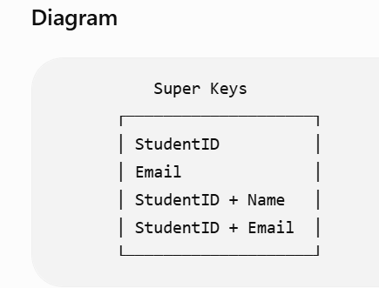

2. Candidate Key
A Candidate Key is the minimum Super Key that uniquely identifies a record.
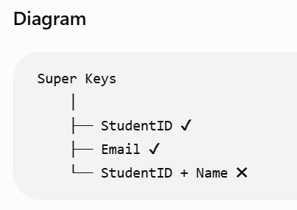

3. Primary Key
A Primary Key is the Candidate Key selected to uniquely identify each row. It cannot contain NULL or duplicate values.
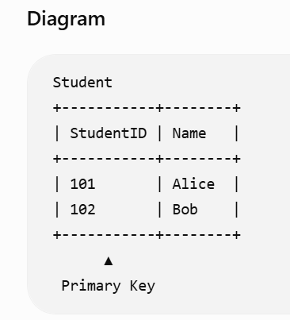

4. Alternate Key
An Alternate Key is a Candidate Key that is not selected as the Primary Key.
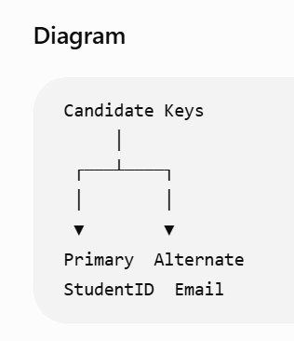

5. Foreign Key
A Foreign Key is a column that refers to the Primary Key of another table.
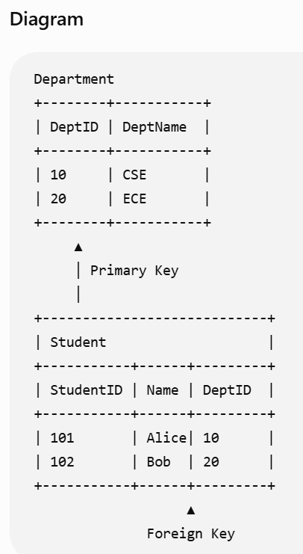
6. Composite Key
A Composite Key consists of two or more columns that together uniquely identify a record.
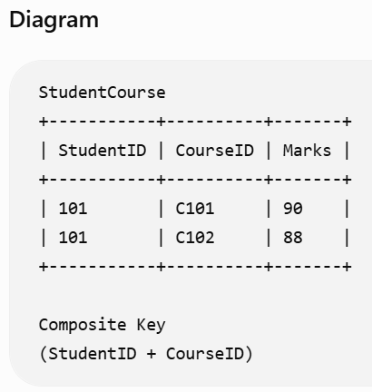
7. Unique Key
A Unique Key ensures that all values are unique. It generally allows one NULL value (depends on the DBMS).
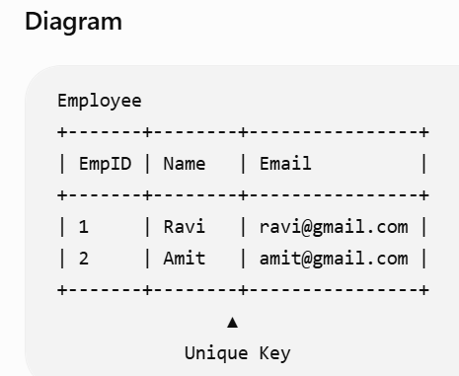

Task 11:
As you know diff keys in RDBMS what is the difference between primary key, foreign key, and unique key?
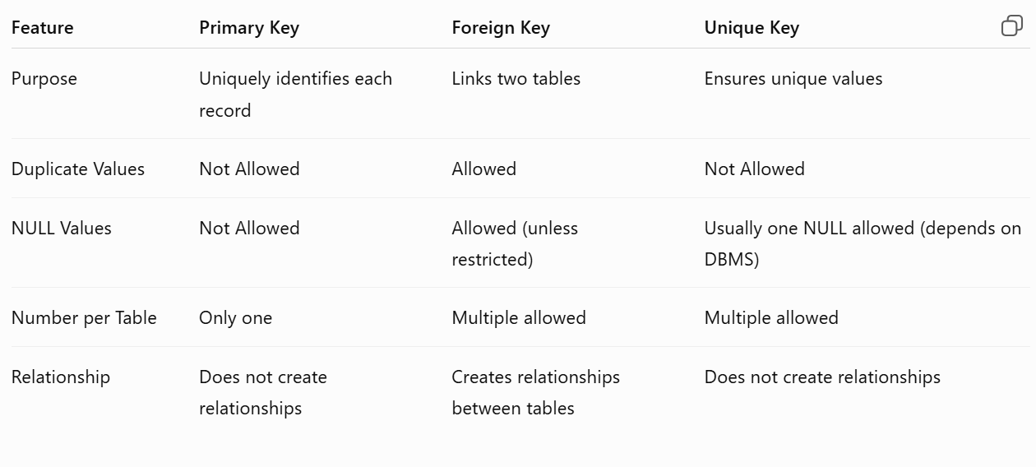
Task 12:
How does transaction management work in DBMS? Give an example of commit and rollback .
A transaction is a sequence of one or more database operations treated as a single unit of work. It ensures that all operations are completed successfully or none of them are applied.
Transactions follow the ACID properties:
- Atomicity – Either all operations succeed or none do.
- Consistency – The database remains valid before and after the transaction.
- Isolation – Transactions do not interfere with each other.
- Durability – Once committed, changes are permanently saved.
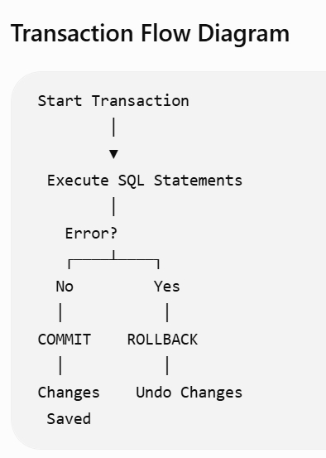
Task 13:
What is normalization? Why is it necessary in database design?
Normalization is the process of organizing data in a database to minimize redundancy and improve data integrity. It divides large tables into smaller, related tables and establishes relationships between them.
Why is Normalization Necessary?
- Eliminates duplicate data.
- Reduces data redundancy.
- Prevents insert, update, and delete anomalies.
- Improves data consistency.
- Makes the database easier to maintain.
- Optimizes storage and improves efficiency.

Task 14:
What do you understand by 1nf? Explain with an example
First Normal Form (1NF) is the first step of database normalization. A table is in 1NF if:
- Each column contains only atomic (single) values.
- There are no repeating groups or multiple values in a single column.
- Each row is unique.
Example (Before 1NF)
StudentID | StudentName | Courses
101 | Alice | Java, SQL
102 | Bob | Python
Problem:
- The Courses column contains multiple values in one cell, violating 1NF.
After Applying 1NF
StudentID | StudentName | Course
101 | Alice | Java
101 | Alice | SQL
102 | Bob | Python
Now:
- Each cell contains only one value.
- The table satisfies 1NF.

Task 15:
What do you understand about 2NF? Explain with an example.
A table is in Second Normal Form (2NF) if:
- It is already in 1NF.
- Every non-key attribute is fully dependent on the entire primary key.
- Partial dependency is removed.
Partial Dependency: A non-key attribute depends on only part of a composite key.
Example (Before 2NF)
StudentID | CourseID | StudentName | CourseName
101 | C101 | Alice | Java
101 | C102 | Alice | SQL
102 | C101 | Bob | Java

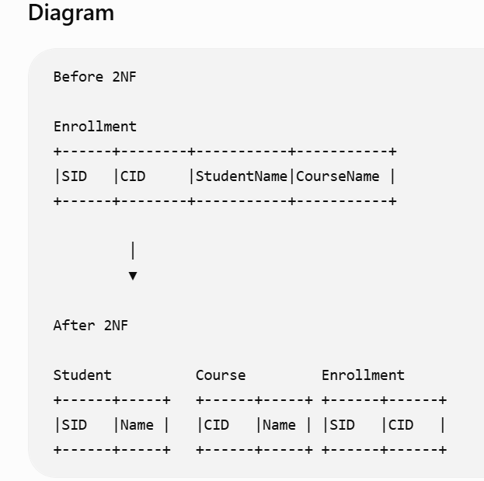

Task 16:
What do you understand by 3 nf ? Explain with an example
A table is in Third Normal Form (3NF) if:
- It is already in 2NF.
- There is no transitive dependency.
- Every non-key attribute depends only on the primary key.
Transitive Dependency: A non-key attribute depends on another non-key attribute instead of directly on the primary key.
