Day 22 - 14th Aug 2026
Task 1:
What are Stereotype Annotations?
Stereotype annotations in Spring are annotations used to tell Spring that a particular Java class is a Spring-managed component/bean.
The main stereotype annotations are:
Annotation | Purpose
@Component | Generic Spring-managed component
@Service | Used for business/service logic
@Repository | Used for database/repository logic
@Controller | Used for Spring MVC controllers
@RestController | Used for REST API controllers

Task 2:
What all Stereotype Annotations have you used till now in Spring
Can you explain with an example.
1. @Component
Used when the class doesn't specifically belong to the controller, service, or repository layer.
2. @Service
Used for business logic.
3. @Repository
Used for database-related operations.
4. @Controller
Used for handling web requests in Spring MVC.
5. @RestController
Commonly used when building REST APIs.

Task 3:
You have used JDBC connection in spring framework..
Juz to re iterate..
Can you give some key concepts of JDBC connection.
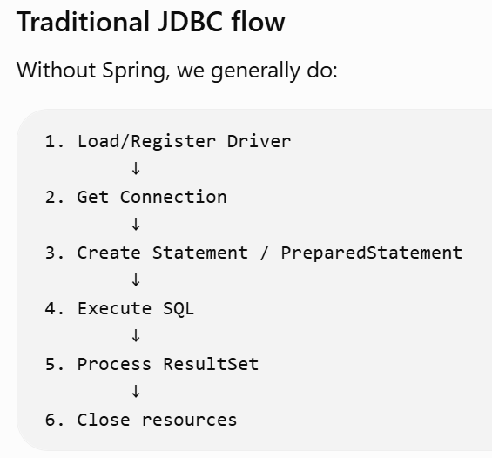
Spring provides JdbcTemplate to simplify JDBC operations.
Instead of manually managing:
- Connection
- PreparedStatement
- ResultSet
- Exception handling
- Closing resources
Spring's JdbcTemplate handles much of this for us.
1. DataSource
Provides database connections.
2. JdbcTemplate
Provides convenient methods for executing SQL.
3. PreparedStatement
Used for parameterized SQL.
4. RowMapper
Converts a database row into a Java object.
5. Transactions
For operations where multiple database changes must succeed or fail together.
6. Exception handling
Traditional JDBC has checked exceptions such as:
SQLException

Task 4:
When you are modernising an application what are the best practices that you need to follow while working on Spring JDBC
This is probably the most important question for your modernization discussion.
When modernizing a legacy application, don't simply migrate the old JDBC code line by line. Try to improve the architecture and maintainability.
1. Use JdbcTemplate instead of raw JDBC where appropriate
Instead of:
Connection
PreparedStatement
ResultSet
prefer: JdbcTemplate
2. Use layered architecture
3. Use dependency injection
Avoid manually creating dependencies:
4. Use parameterized queries
5. Use connection pooling
Creating a new database connection for every request can be expensive.
Use a connection pool such as HikariCP, which is commonly used with modern Spring Boot applications.
6. Externalize database configuration
Don't hardcode:
String username = "root";
String password = "password";
Use configuration:
spring.datasource.url=...
spring.datasource.username=...
spring.datasource.password=...

8. Avoid putting SQL everywhere
Don't write SQL directly inside controllers.

Task 5:
How does Spring integrate with Hibernate or JPA, and what benefits does this bring?
Spring provides integration support for JPA and Hibernate, so you don't have to manually manage things like the EntityManager, transactions, and a lot of ORM infrastructure.
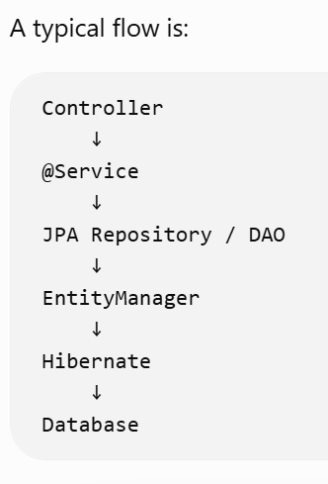

So:
JPA = specification/API
Hibernate = implementation of that specification
Benefits
Spring integration gives you:
- Dependency injection
- Automatic EntityManager management
- Declarative transaction management
- Exception translation
- Easier testing
- Integration with Spring Data JPA
- Less boilerplate code
- Cleaner separation between business and persistence logic

Task 6:
What is the role of @PersistenceContext in Spring ORM?
@PersistenceContext tells Spring to inject a JPA EntityManager into your class.
@PersistenceContext is used to inject a JPA EntityManager managed by the container. The EntityManager is responsible for interacting with the persistence context and performing operations such as persist, find, merge, and remove.

Task 7:
How does Spring’s transaction management improve ORM usage?
When you're using Hibernate/JPA, database operations often need to happen within a transaction.
Spring makes this much easier using:
@Transactional
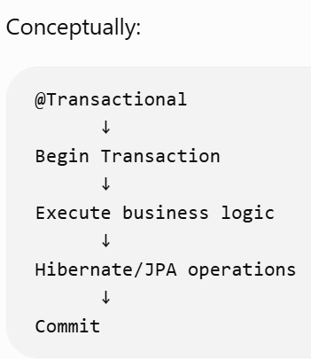

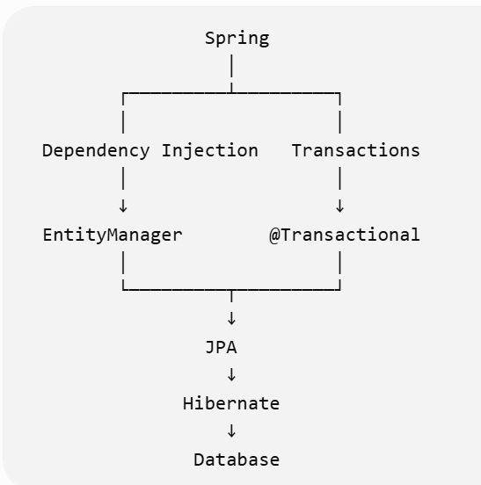

TASK 8:
What is the role of DispatcherServlet in Spring MVC?
DispatcherServlet is the Front Controller of Spring MVC. It receives incoming HTTP requests and decides which controller should handle each request.
Request Flow:
Client
↓
DispatcherServlet
↓
Controller
↓
Service
↓
DAO/Repository
↓
Database
Example:
@RestController
public class EmployeeController {
@GetMapping("/employees/{id}")
public Employee getEmployee(@PathVariable Long id) {
return employeeService.getEmployee(id);
}
}
If the client sends:
GET /employees/101
The DispatcherServlet receives the request and identifies the appropriate controller method based on the URL and HTTP method. It then delegates the request to that controller.
Main responsibilities of DispatcherServlet:
- Receives incoming HTTP requests.
- Finds the appropriate controller and handler method.
- Delegates the request to the controller.
- Processes the response returned by the controller.
- Works with components such as HandlerMapping, HandlerAdapter, ViewResolver, and exception handlers.
Interview Answer:
"DispatcherServlet is the Front Controller of Spring MVC. It receives all incoming requests, identifies the appropriate controller and handler method, delegates the request, and helps process the resulting response."
TASK 9:
How does Spring MVC achieve separation of concerns between Controller, Service, and DAO layers?
Spring MVC separates the application into different layers, where each layer has a specific responsibility.
- Controller Layer
The Controller handles HTTP requests and responses.
Example:
@RestController
public class EmployeeController {
@GetMapping("/employees/{id}")
public Employee getEmployee(@PathVariable Long id) {
return employeeService.getEmployee(id);
}
}
The Controller should not contain complex business rules or database code.
Its main responsibility is handling the request and delegating the work to the Service layer.
- Service Layer
The Service layer contains the business logic.
Example:
@Service
public class EmployeeService {
public Employee getEmployee(Long id) {

// Business logic

return employeeRepository.findById(id);
}
}
The Service layer decides what the application should do and contains the business rules.
- DAO/Repository Layer
The DAO or Repository layer handles persistence and database operations.
Example:
@Repository
public class EmployeeRepository {
public Employee findById(Long id) {

// Database operation

return ...;
}
}
This layer is responsible for communicating with the database using JDBC, JPA, Hibernate, etc.
Overall Flow:
Controller
↓
Service
↓
DAO/Repository
↓
Database
Why is this separation useful?
- Easier maintenance
- Easier unit testing
- Better code organization
- Less coupling between layers
- Easier modernization
- Persistence technology can be changed without changing business logic
For example, if the application currently uses JDBC and later moves to Hibernate, ideally the Service layer should not need major changes. The persistence implementation can be changed inside the Repository/DAO layer.
Interview Answer:
"Spring MVC achieves separation of concerns by assigning different responsibilities to different layers. The Controller handles HTTP requests, the Service contains business logic, and the DAO or Repository handles persistence and database operations. This reduces coupling and makes the application easier to test, maintain, and modernize."

TASK 10:
What is the difference between @RequestMapping and newer annotations like @GetMapping or @PostMapping?
@RequestMapping is the general-purpose request mapping annotation. It can be used to map requests based on different HTTP methods such as GET, POST, PUT, and DELETE.
Example using @RequestMapping:
@RequestMapping(
value = "/employees",
method = RequestMethod.GET
)
public List getEmployees() {
return employeeService.getEmployees();
}
The newer annotations provide a shorter and more readable way to express the same mapping.
Example using @GetMapping:
@GetMapping("/employees")
public List getEmployees() {
return employeeService.getEmployees();
}
Example using @PostMapping:
@PostMapping("/employees")
public Employee createEmployee(@RequestBody Employee employee) {
return employeeService.createEmployee(employee);
}
Common HTTP mapping annotations:
@GetMapping → HTTP GET
@PostMapping → HTTP POST
@PutMapping → HTTP PUT
@DeleteMapping → HTTP DELETE
@PatchMapping → HTTP PATCH
The relationship is:
@GetMapping
@PostMapping
@PutMapping
@DeleteMapping
@PatchMapping
are specialized versions of @RequestMapping for specific HTTP methods.
Comparison:
Using @RequestMapping:
@RequestMapping(
value = "/employees",
method = RequestMethod.GET
)
Using @GetMapping:
@GetMapping("/employees")
Both can be used to map a GET request.
Why use the newer annotations?
- More concise
- Easier to read
- Explicit about the HTTP method
- Commonly preferred in modern Spring applications

Task 8:
DispatcherServlet = Front Controller of Spring MVC.
Task 9:
Controller = Handles HTTP requests
Service = Contain s business logic
DAO/Repository = Handles database and persistence logic
Task 10:
@RequestMapping = General-purpose request mapping
@GetMapping = GET
@PostMapping = POST
@PutMapping = PUT
@DeleteMapping = DELETE
@PatchMapping = PATCH

SPRING MVC + DATA TRANSFER + ORM + AOP
Sending Data from Controller → UI
TASK 1: How does the Model object help in transferring data to the view?
The Model object is used to transfer data from the Controller to the UI/View.
The Controller adds data to the Model using the addAttribute() method.
Example:
@Controller
public class EmployeeController {

@GetMapping("/employee")
public String getEmployee(Model model) {

Employee employee = employeeService.getEmployee(101);

model.addAttribute("employee", employee);

return "employee";
}
}
Here:
model.addAttribute("employee", employee);
adds the Employee object to the Model.
The View can then access this data.
Flow:
Controller
↓
Model
↓
View/UI
The Model acts as a container for the data that needs to be displayed by the UI.

TASK 2: What is the difference between Model, ModelMap, and ModelAndView?
All three can be used to transfer data from the Controller to the View, but they work slightly differently.
Model
Model is an interface that provides methods to add attributes to the model.
Example:
@GetMapping("/employee")
public String getEmployee(Model model) {

model.addAttribute("name", "Vicky");

return "employee";
}
ModelMap
ModelMap is a map-like implementation that can also be used to store model attributes.
Example:
@GetMapping("/employee")
public String getEmployee(ModelMap model) {

model.addAttribute("name", "Vicky");

return "employee";
}
ModelAndView
ModelAndView contains both the Model data and the View name in one object.
Example:
@GetMapping("/employee")
public ModelAndView getEmployee() {

ModelAndView mav = new ModelAndView("employee");

mav.addObject("name", "Vicky");

return mav;
}
Comparison:
Model: Used mainly for adding data to the model.
ModelMap: A map-like implementation for storing model attributes.
ModelAndView: Contains both the model data and the view name.

TASK 3: Why is it important to keep the data transfer layer separate from business logic?
The Controller should primarily handle HTTP requests, prepare the data needed by the UI, and delegate business operations to the Service layer.
Business logic should remain inside the Service layer.
Bad approach:
Controller
↓
Business Logic + Database Logic
↓
Database
Better approach:
Controller
↓
Service
↓
Repository/DAO
↓
Database
Benefits:
- Better separation of concerns
- Easier unit testing
- Easier maintenance
- Reduced coupling
- Better code reusability
- Easier modernization

Sending Data from UI → Controller
TASK 4: How does Spring bind form data to Java objects using @ModelAttribute?
@ModelAttribute is used to bind form fields from the UI to a Java object.
Suppose the UI sends:
name = Vicky
email = vicky@example.com
The Controller can receive this data as an Employee object.
Example:
@PostMapping("/employees")
public String createEmployee(@ModelAttribute Employee employee) {

employeeService.saveEmployee(employee);

return "success";
}
Spring automatically maps the request parameters to the corresponding Java object properties.
Conceptually:
UI Form
↓
HTTP Request Parameters
↓
@ModelAttribute
↓
Employee Object
↓
Service

TASK 5: What is the difference between @RequestParam and @PathVariable?
Both are used to extract values from an HTTP request, but they get the values from different parts of the URL.
@RequestParam
@RequestParam is used to extract query parameters.
Example:
/employees?id=101
Controller:
@GetMapping("/employees")
public Employee getEmployee(@RequestParam Long id) {

return employeeService.getEmployee(id);
}
@PathVariable
@PathVariable is used to extract a value directly from the URL path.
Example:
/employees/101
Controller:
@GetMapping("/employees/{id}")
public Employee getEmployee(@PathVariable Long id) {

return employeeService.getEmployee(id);
}
Comparison:
@RequestParam:
/employees?id=101
@PathVariable:
/employees/101

TASK 6: How does Spring handle type conversion when receiving data from the UI?
HTTP request data generally arrives as strings.
For example:
age = "30"
But the Java object may contain:
private int age;
Spring automatically performs common type conversions.
For example:
String → int
String → long
String → double
String → boolean
String → enum
String → date/time types
For more complex or custom conversions, Spring provides mechanisms such as Converter, Formatter, and ConversionService.

Spring MVC + ORM Integration
TASK 7: What is the typical flow of a request in a Spring MVC + ORM application?
A typical request flows through several layers.
Client
↓
DispatcherServlet
↓
Controller
↓
Service
↓
Repository/DAO
↓
JPA EntityManager
↓
Hibernate
↓
Database
Detailed flow:
- The client sends an HTTP request.
- DispatcherServlet receives the request.
- DispatcherServlet identifies the appropriate Controller.
- Controller calls the Service layer.
- Service executes business logic.
- Service calls the Repository/DAO.
- Repository uses JPA/Hibernate to interact with the database.
- Hibernate generates SQL and communicates with the database.
- The result comes back through the layers.
- Controller returns the response to the client.

TASK 8: How does transaction management ensure consistency between MVC and ORM layers?
Transaction management ensures that related database operations are treated as one logical unit of work.
Spring commonly uses:
@Transactional
Example:
@Service
public class OrderService {

@Transactional
public void placeOrder(Order order) {

orderRepository.save(order);

inventoryService.updateInventory(order);
}
}
Conceptually:
Controller
↓
Service
↓
BEGIN TRANSACTION
↓
Database Operations
↓
COMMIT
If an appropriate failure occurs:
BEGIN TRANSACTION
↓
Operation 1 → SUCCESS
↓
Operation 2 → FAILURE
↓
ROLLBACK
This helps prevent partially completed business operations.

TASK 9: Why is it beneficial to use service and DAO layers instead of directly accessing ORM from controllers?
The Controller should handle HTTP-related responsibilities, not business rules or persistence.
Bad design:
Controller
↓
Hibernate/JPA
↓
Database
Better design:
Controller
↓
Service
↓
DAO/Repository
↓
Hibernate/JPA
↓
Database
Benefits:
- Separation of concerns
- Easier testing
- Better maintainability
- Reduced coupling
- Business logic can be reused
- Persistence implementation can be changed more easily
- Transaction boundaries can be managed at the Service layer

TASK 10: What problem does Aspect-Oriented Programming solve in enterprise applications?
Aspect-Oriented Programming, or AOP, is used to handle cross-cutting concerns.
Common examples include:
- Logging
- Security
- Transaction management
- Auditing
- Performance monitoring
- Exception handling
Without AOP, we might repeat the same logging or security code in many methods.
With AOP, these common concerns can be separated into an Aspect.

TASK 11: What are the differences between @Before, @After, and @Around advice?
@Before
Runs before the target method executes.
@Before("execution(* com.example.service.*.*(..))")
public void logBefore() {
System.out.println("Method is about to execute");
}
Flow:
@Before
↓
Target Method
Typical use cases:
- Logging
- Validation
- Security checks
@After
Runs after the target method finishes, regardless of whether it completes normally or exits by throwing an exception.
@After("execution(* com.example.service.*.*(..))")
public void logAfter() {
System.out.println("Method finished");
}
Flow:
Target Method
↓
@After
Typical use cases:
- Cleanup
- Logging completion
@Around
Wraps the target method and gives the advice control over whether and when the target method executes.
@Around("execution(* com.example.service.*.*(..))")
public Object logExecution(ProceedingJoinPoint joinPoint)
throws Throwable {

long start = System.currentTimeMillis();

Object result = joinPoint.proceed();

long end = System.currentTimeMillis();

System.out.println("Execution time: " + (end - start));

return result;
}
Flow:
@Around - Before
↓
Target Method
↓
@Around - After
@Around can also decide not to call proceed(), which means the target method does not execute.
Comparison:
@Before
→ Before method execution
@After
→ After method completion
@Around
→ Wraps and controls method execution
TASK 12: How does Spring AOP differ from full AspectJ in terms of capabilities?
Spring AOP
Spring AOP is primarily proxy-based.
It generally applies advice to method executions on Spring-managed beans.
Conceptually:
Client
↓
Spring Proxy
↓
Target Bean
Because Spring AOP is proxy-based, it has some limitations.
For example, direct self-invocation within the same object generally does not go through the Spring proxy.
AspectJ
AspectJ provides more comprehensive AOP capabilities and can perform weaving at compile time or load time.
It supports a broader join-point model than the proxy-based interception typically used by Spring AOP.
Conceptually:
Spring AOP
→ Proxy-based interception
→ Spring-managed beans
AspectJ
→ Weaving
→ Broader AOP capabilities
Comparison:
Spring AOP:
- Primarily proxy-based
- Simple to configure within Spring applications
- Works naturally with Spring-managed beans
- Commonly used for transactions, logging, security, etc.
- Has proxy-related limitations
AspectJ:
- Supports compile-time and load-time weaving
- Provides a broader join-point model
- Can apply aspects beyond the usual Spring proxy boundary
- More powerful but generally more complex

