Day 9 - 28th July 2026

Spring Framework - Quick revise

Task 1:

Can you create a Maven based spring project using ide.. To print a welcome..note
package com.example;
import org.springframework.context.ApplicationContext;
import org.springframework.context.annotation.AnnotationConfigApplicationContext;
public class MainApp {
public static void main(String[] args) {
ApplicationContext context =
new AnnotationConfigApplicationContext(AppConfig.class);
WelcomeBean wb = context.getBean(WelcomeBean.class);
wb.showMessage();
}
}

package com.example;
import org.springframework.context.annotation.Bean;
import org.springframework.context.annotation.Configuration;
@Configuration
public class AppConfig {
@Bean
public WelcomeBean welcomeBean() {
return new WelcomeBean();
}
}

package com.example;
public class WelcomeBean {
public void showMessage() {
System.out.println("Welcome to Spring Maven Project!");
}
}

Task 2:

Now create a POJO class for student so that can be managed as a spring bean
Student.java
package com.example;
public class Student {
private int id;
private String name;
private String course;
// Default Constructor
public Student() {
}
// Parameterized Constructor
public Student(int id, String name, String course) {
this.id = id;
this.name = name;
this.course = course;
}
// Getters and Setters
public int getId() {
return id;
}
public void setId(int id) {
this.id = id;
}
public String getName() {
return name;
}
public void setName(String name) {
this.name = name;
}
public String getCourse() {
return course;
}
public void setCourse(String course) {
this.course = course;
}
// Method to display student details
public void display() {
System.out.println("Student ID : " + id);
System.out.println("Student Name : " + name);
System.out.println("Course : " + course);
}
}

AppConfig.java
package com.example;
import org.springframework.context.annotation.Bean;
import org.springframework.context.annotation.Configuration;
@Configuration
public class AppConfig {
@Bean
public Student student() {
Student s = new Student();
s.setId(101);
s.setName("Vicky");
s.setCourse("Java Full Stack");
return s;
}
}

Main class
package com.example;
import org.springframework.context.ApplicationContext;
import org.springframework.context.annotation.AnnotationConfigApplicationContext;
public class MainApp {
public static void main(String[] args) {
ApplicationContext context =
new AnnotationConfigApplicationContext(AppConfig.class);
Student student = context.getBean(Student.class);
student.display();
}
}

Task 3:
Configure the above Student bean in the bean-factory-demo.xml file.
That means you need to configure the Student bean in the XML file so the BeanFactory knows how to create it.
And create a main class and run it.. A pictorial rep of the scenario is given below
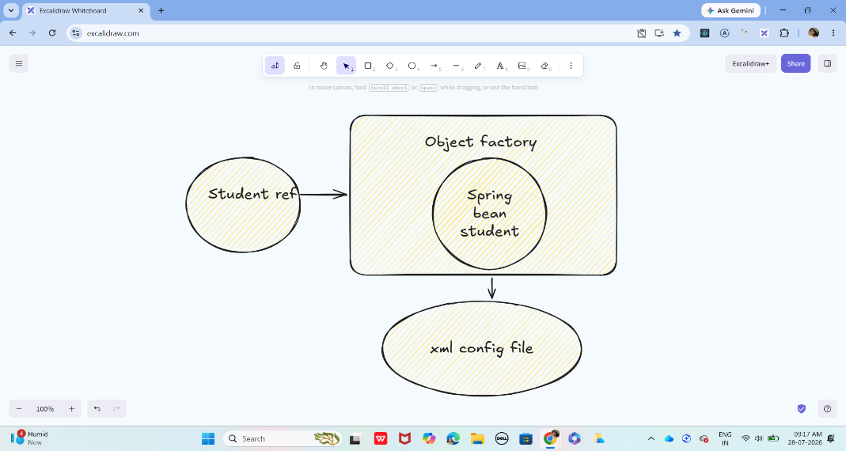
Pom.xml
<project xmlns="http://maven.apache.org/POM/4.0.0"
xmlns:xsi="http://www.w3.org/2001/XMLSchema-instance"
xsi:schemaLocation="http://maven.apache.org/POM/4.0.0
https://maven.apache.org/xsd/maven-4.0.0.xsd">
<modelVersion>4.0.0</modelVersion>
<groupId>com.example</groupId>
<artifactId>SpringBeanFactoryDemo</artifactId>
<version>1.0</version>
<dependencies>
<dependency>
<groupId>org.springframework</groupId>
<artifactId>spring-context</artifactId>
<version>5.3.30</version>
</dependency>
</dependencies>
</project>

Student.java
package com.example;
public class Student {
private int id;
private String name;
private String course;
public Student() {
}
public int getId() {
return id;
}
public void setId(int id) {
this.id = id;
}
public String getName() {
return name;
}
public void setName(String name) {
this.name = name;
}
public String getCourse() {
return course;
}
public void setCourse(String course) {
this.course = course;
}
public void display() {
System.out.println("Student ID : " + id);
System.out.println("Student Name : " + name);
System.out.println("Course : " + course);
}
}

src/main/resources
<?xml version="1.0" encoding="UTF-8"?>
<beans xmlns="http://www.springframework.org/schema/beans"
xmlns:xsi="http://www.w3.org/2001/XMLSchema-instance"
xsi:schemaLocation="
http://www.springframework.org/schema/beans
https://www.springframework.org/schema/beans/spring-beans.xsd">
<bean id="student"
class="com.example.Student">
<property name="id" value="101"/>
<property name="name" value="Vicky"/>
<property name="course" value="Java Full Stack"/>
</bean>
</beans>

MainApp.java
package com.example;
import org.springframework.beans.factory.BeanFactory;
import org.springframework.beans.factory.xml.XmlBeanFactory;
import org.springframework.core.io.ClassPathResource;
import org.springframework.core.io.Resource;
@SuppressWarnings("deprecation")
public class MainApp {
public static void main(String[] args) {
Resource resource =
new ClassPathResource("bean-factory-demo.xml");
BeanFactory factory =
new XmlBeanFactory(resource);
Student student =
(Student) factory.getBean("student");
student.display();
}
}

Task 4:
Can you explain application context with the syntax..
ApplicationContext is an advanced container in the Spring Framework that creates, configures, and manages Spring beans. It is a sub-interface of BeanFactory and provides additional enterprise features.
Syntax -
ApplicationContext context = new ClassPathXmlApplicationContext("bean-factory-demo.xml");
Explanation
- ApplicationContext → Interface provided by Spring.
- context → Reference variable.
- ClassPathXmlApplicationContext → Implementation class that loads the XML configuration file from the classpath.
- "bean-factory-demo.xml" → XML file containing bean definitions.

Task 5:
Why use application context .. plz list some uses?
ApplicationContext is preferred over BeanFactory because it provides many additional features.
Feature | Description
1. Pre-instantiates singleton beans | Creates singleton beans when the container starts, reducing runtime delays.
2. Dependency Injection | Automatically injects dependencies between objects.
3. Internationalization (i18n) | Supports multiple languages using message resource bundles.
4. Event Handling | Allows publishing and listening to application events.
5. Resource Loading | Easily loads resources such as XML files, properties files, and images.
6. Bean Lifecycle Management | Handles bean initialization and destruction callbacks.
7. Annotation Support | Supports annotations like @Component, @Autowired, @Service, @Repository, and @Configuration.
8. AOP Integration | Supports Aspect-Oriented Programming for logging, security, and transaction management.
9. Environment & Properties | Reads configuration from properties or YAML files.
10. Better than BeanFactory | Includes all BeanFactory features plus many enterprise-level capabilities.

Task 6:
What are features of Spring Framework .. list them with 1 or 2 lines explanation?
1. Lightweight
Spring is lightweight because it uses simple Java objects (POJOs) and has a small runtime footprint.
2. Inversion of Control (IoC)
Spring creates and manages objects instead of the programmer creating them using the new keyword.
3. Dependency Injection (DI)
Dependencies are injected automatically into objects, resulting in loosely coupled components.
4. Aspect-Oriented Programming (AOP)
Separates cross-cutting concerns like logging, security, and transaction management from the business logic.
5. Modular Architecture
Spring is divided into independent modules (Core, MVC, JDBC, ORM, Security, etc.), allowing you to use only what your application requires.
6. MVC Framework
Spring MVC helps build web applications using the Model-View-Controller design pattern, making applications easier to organize and maintain.
7. Transaction Management
Spring provides declarative transaction management, ensuring database operations are committed or rolled back correctly.
8. Integration Support
Spring integrates easily with technologies such as Hibernate, JPA, JDBC, Maven, REST APIs, and various databases.
9. Exception Handling
Spring provides a consistent exception hierarchy and simplifies handling application exceptions.
10. Testing Support
Spring offers excellent support for unit testing and integration testing with JUnit and Mockito.

Task 7:
Why do you thunk w e use spring framework.. Advantages list them down?
1. Reduces Boilerplate Code
Spring minimizes repetitive coding by providing built-in features and configuration support.
2. Loose Coupling
Objects are less dependent on each other because Spring manages dependencies through Dependency Injection.
3. Easy Maintenance
A modular architecture makes applications easier to update, debug, and maintain.
4. Better Testability
Applications are easier to test because dependencies can be mocked or injected during testing.
5. Flexible Configuration
Spring supports XML configuration, Java-based configuration, and annotations.
6. Easy Integration
Works seamlessly with Hibernate, JPA, JDBC, REST services, Maven, and many other frameworks.
7. Improved Productivity
Developers can focus on business logic instead of infrastructure code.
8. Scalable Applications
Spring is suitable for small, medium, and enterprise-scale applications.
9. Strong Community Support
Spring has extensive documentation, community support, and frequent updates.
10. Open Source
Spring is free to use and continuously improved by a large open-source community.

Task 8:
What do you understand by IOC? Explain with diagram..
Inversion of Control (IoC) is a design principle in which the responsibility of creating and managing objects is transferred from the programmer to the Spring IoC Container.
Without Spring, the programmer creates objects using the new keyword.
With Spring, the IoC container creates, configures, and manages the objects (beans).
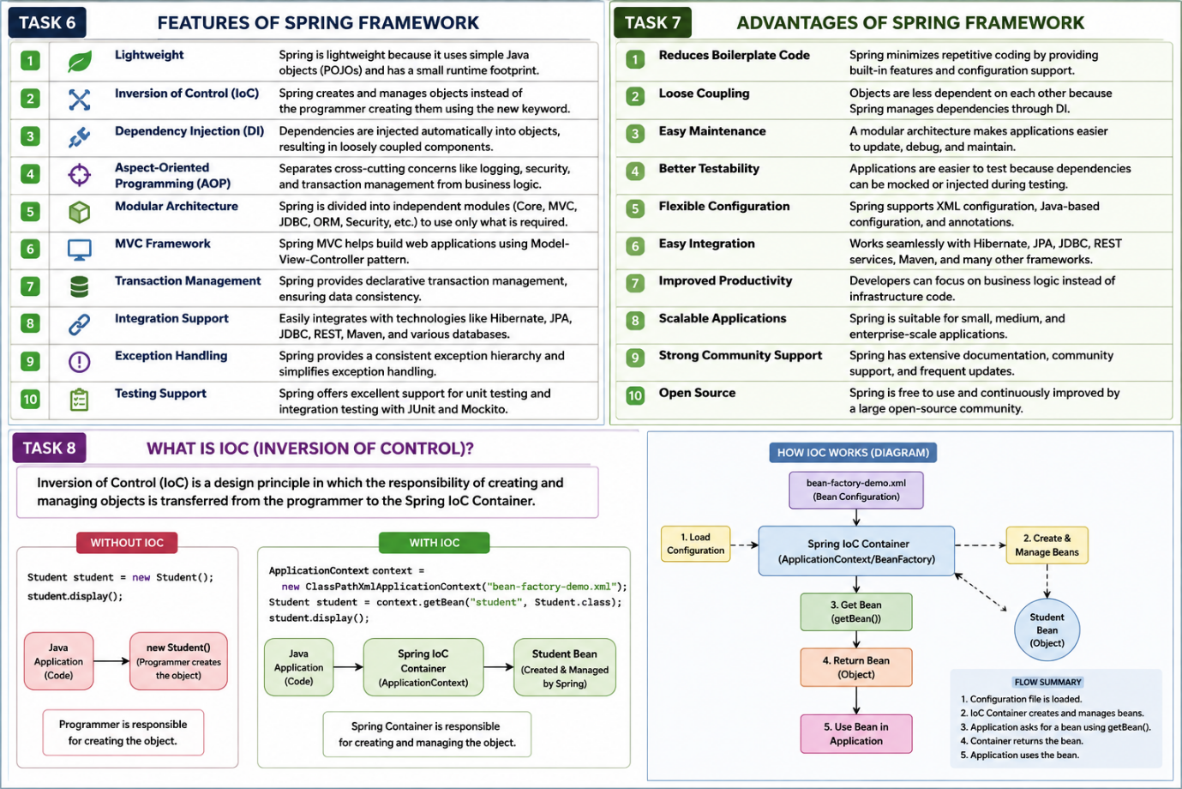

Task 9:
How many types of IOC do you have in spring?
What are they with explanation
1. Dependency Injection (DI)
Dependency Injection is the most commonly used type of IoC. The Spring container creates the object and injects its required dependencies automatically instead of the programmer creating them manually.
2. Dependency Lookup (DL)
In Dependency Lookup, the application explicitly asks the Spring container for an object whenever it is needed by calling getBean().
Dependency Injection (DI) – Spring injects dependencies automatically.
Dependency Lookup (DL) – The application retrieves beans from the container using getBean().

Task 10:
What is DI in spring?
Dependency Injection (DI) is a design pattern in which the Spring IoC container creates objects and injects their required dependencies automatically instead of the programmer creating them manually.
A dependency is an object that another object needs to perform its work.

Task 11:
How many types of DI do we have?
Explain
1. Constructor Injection
Dependencies are provided through the constructor when the object is created.
2. Setter Injection
Dependencies are injected using setter methods after the object is created.
3. Field Injection
Field Injection is a type of Dependency Injection where Spring injects the dependency directly into a class field using the @Autowired annotation. You do not need a constructor or setter method.

Task 12:
What is Spring Application Configuration?
Spring Application Configuration is the process of telling the Spring IoC container how to create, configure, and manage beans (objects) in an application.
It specifies:
- Which classes should be managed as beans.
- How beans are created.
- How dependencies are injected.
- Bean scope and lifecycle.

Task 13:
What are the different ways to configure spring applications?
1. XML-Based Configuration
Bean definitions are written in an XML file.
Example:
<bean id="student" class="com.example.Student"/>
2. Annotation-Based Configuration
Beans are configured using annotations.
Common annotations:
- @Component
- @Service
- @Repository
- @Controller
- @Autowired
Example:
@Component
public class Student {

}
3. Java-Based Configuration
Configuration is written in Java classes using @Configuration and @Bean.
Example:
@Configuration
public class AppConfig {

@Bean
public Student student() {
return new Student();
}
}

Task 14:
Why we need spring application copnfiguration?
Spring Application Configuration is required because it tells the Spring container how to manage the application.
Reasons for Using Spring Application Configuration
1. Bean Creation
Defines which classes should be created as Spring beans.
2. Dependency Injection
Specifies how dependencies should be injected into beans.
3. Centralized Configuration
Keeps all application configuration in one place, making it easier to manage.
4. Loose Coupling
Objects are managed by Spring instead of being created manually using the new keyword.
5. Bean Lifecycle Management
Spring controls bean creation, initialization, and destruction.
6. Easy Maintenance
Configuration changes can often be made without modifying business logic.
7. Better Scalability
Applications become easier to extend and maintain as they grow.

Task 15:
What are the difference ways to configure spring application?
Spring applications can be configured in three ways.
1. XML-Based Configuration
In this approach, bean definitions are written in an XML file.
2. Annotation-Based Configuration
Beans are configured using annotations.
Common annotations:
- @Component
- @Service
- @Repository
- @Controller
- @Autowired
3. Java-Based Configuration
Configuration is done using Java classes with @Configuration and @Bean.

Task 16:
What is bean scope .. give different scopes with description
Spring provides 6 bean scopes.
1. Singleton (Default)
- Only one object is created for the entire Spring container.
- Every request returns the same object.
2. Prototype
- A new object is created every time the bean is requested.
3. Request
- One bean instance is created for each HTTP request.
Use Case: Spring Web MVC applications.
4. Session
- One bean instance is created for each user session.
Use Case: Shopping cart, user profile.

5. Application
- One bean instance is shared across the entire web application.
Use Case: Application-wide configuration.

6. WebSocket
- One bean instance is created for each WebSocket session.
Use Case: Real-time chat applications.

Task 17:
What is autowiring in spring?
Autowiring is a feature of Spring that automatically injects the required dependencies into a bean without explicitly configuring them in XML or Java code.
It reduces manual configuration and simplifies Dependency Injection.
Example
Address.java
@Component
public class Address {

}

Student.java
@Component
public class Student {

@Autowired
private Address address;

}

Task 18:
What are diff ways of autowiring?
1. Autowiring by Name (byName)
- Spring matches the bean name with the property name.
- If both names match, the dependency is injected automatically.
Example
<bean id="address" class="com.example.Address"/>

<bean id="student" class="com.example.Student" autowire="byName"/>
2. Autowiring by Type (byType)
- Spring matches the dependency based on its data type.
- If only one bean of that type exists, it is injected.
Example
<bean id="address" class="com.example.Address"/>

<bean id="student" class="com.example.Student" autowire="byType"/>
3. Constructor Autowiring (constructor)
- Spring injects dependencies through the constructor.
Example
<bean id="address" class="com.example.Address"/>

<bean id="student" class="com.example.Student" autowire="constructor"/>
4. Annotation-Based Autowiring (@Autowired)
- Spring automatically injects dependencies using the @Autowired annotation.
- This is the most commonly used approach in Spring Boot.
Example
@Component
public class Student {

@Autowired
private Address address;

}

Task 19:
What is diff between a normal java object and Spring bean?
Normal Java Object | Spring Bean
Created using the new keyword. | Created and managed by the Spring IoC container.
Lifecycle is managed by the programmer. | Lifecycle is managed by Spring.
Dependencies are created manually. | Dependencies are injected automatically by Spring.
Not managed by the Spring container. | Managed by the Spring container.
Suitable for simple Java programs. | Used in Spring applications.

Task 20:
What is diff between @ component and @ bean
@Component | @Bean
Applied on a class. | Applied on a method.
Spring automatically detects it during component scanning. | Spring creates the bean from the method's return value.
Used for classes that you own. | Used when configuring third-party or external classes, or when custom bean creation is needed.
Requires @ComponentScan. | Declared inside a class annotated with @Configuration.
Automatic bean registration. | Manual bean registration.

Task 21:
A different way to create an application using
https://start.spring.io/ try it .. and let me know what is it?

Spring Initializr is the official Spring tool for creating Spring Boot projects. It generates a preconfigured Maven or Gradle project with the required dependencies, project structure, and configuration files, allowing developers to start building applications quickly without manual setup.

Task 22:
Using Spring initialiser create an employee class , appcofig file, and main class and see how it works
Employee.java
package com.example.demo;
public class Employee {
private int empId;
private String empName;
public Employee() {
System.out.println("Employee Object Created");
}
public void setEmpId(int empId) {
this.empId = empId;
}
public void setEmpName(String empName) {
this.empName = empName;
}
public void display() {
System.out.println("Employee ID : " + empId);
System.out.println("Employee Name : " + empName);
}
}

AppConfig.java
package com.example.demo;
import org.springframework.context.annotation.Bean;
import org.springframework.context.annotation.Configuration;
@Configuration
public class AppConfig {
@Bean
public Employee employee() {
Employee emp = new Employee();
emp.setEmpId(101);
emp.setEmpName("Vicky");
return emp;
}
}

Modify DemoApplication.java
package com.example.demo;
import org.springframework.boot.SpringApplication;
import org.springframework.boot.autoconfigure.SpringBootApplication;
import org.springframework.context.ApplicationContext;
@SpringBootApplication
public class DemoApplication {
public static void main(String[] args) {
ApplicationContext context =
SpringApplication.run(DemoApplication.class, args);
Employee emp = context.getBean(Employee.class);
emp.display();
}
}

Task 23:
We have spring annotations:
Like
@bean
@controller
@value
@conponentScan
@configuration
@service
@repository
@Qualifier
@required
@component
@autowired
@scope

Can you give a liner about these

Annotation | One-line Description
@Bean | Declares a method whose returned object is managed as a Spring bean.
@Controller | Marks a class as a Spring MVC controller that handles web requests and typically returns views.
@Value | Injects values from application.properties, environment variables, or expressions into a field or method.
@ComponentScan | Tells Spring which packages to scan for Spring-managed components.
@Configuration | Marks a class as a source of Spring bean definitions.
@Service | Marks a class as the service layer containing business logic.
@Repository | Marks a class as the data access layer (DAO) and enables database exception translation.
@Qualifier | Specifies which bean to inject when multiple beans of the same type exist.
@Required | Indicates that a bean property must be set during configuration (deprecated in modern Spring).
@Component | Marks a class as a generic Spring-managed component (bean).
@Autowired | Automatically injects the required dependency into a class, constructor, setter, or field.
@Scope | Defines the lifecycle and scope of a bean, such as singleton or prototype.

Spring Boot:

=============================================================================
SpringBoot
=============================================================================
Demo on Spring Boot REST API:
@SpringBootApplication
public class Myapp{

public static void main(String[] args){

// here Tomcat which is embedded in spring boot runs automatically
SpringApplication.run(Myapp.class, args);
}
}

import org.springframework.stereotype.Controller;
import org.springframework.web.bind.annotation.RequestMapping;
import org.springframework.web.bind.annotation.RestController;

@RestController
@RequestMapping("/api/usersApi")
public class MyController{

private List<String> users = List.of("Prasunamba", "Meher", "Kom");

@GetMapping
public List<String> getUsers(){

// this is returning JSON response
return users;
}
}

<!-- Source: https://mvnrepository.com/artifact/org.springframework.boot/spring-boot-dependencies -->
<dependency>
<groupId>org.springframework.boot</groupId>
<artifactId>spring-boot-dependencies</artifactId>
<version>4.1.0</version>
<type>pom</type>
<scope>import</scope>
</dependency>

===================================================================

Connecting to db

Plz install
My sql or sql

3.05 to 3.10

Create a MySql/Sql database ( customerDB).
Create a table (CustomerInfo).
Insert a few records..
Verify data using MySQL Workbench or CLI.

Here is your DAO

import java.sql.*;

public class CustomerDAO {

private String driver;
private String url;
private String userName;
private String password;

// Setter methods for dependency injection
public void setDriver(String driver) {
this.driver = driver;
}
public void setUrl(String url) {
this.url = url;
}
public void setUserName(String userName) {
this.userName = userName;
}
public void setPassword(String password) {
this.password = password;
}

// fetch customer records
public void selectAllRows() throws ClassNotFoundException, SQLException {
System.out.println("Retrieving customer data..");

// driver is loading
Class.forName(driver);

// connection establishment is done here
Connection con = DriverManager.getConnection(url, userName, password);

// Executing our query
Statement stmt = con.createStatement();
ResultSet rs = stmt.executeQuery("SELECT * FROM CustomerDb.CustomerInfo");

while (rs.next()) {
int customerId = rs.getInt(1);
String customerName = rs.getString(2);
double customerFees = rs.getDouble(3);
String custAddress = rs.getString(4);

System.out.println(customerId + " " + customerName + " " + customerFees + " " + custAddress );
}

// Close connection
con.close();
}
}

Spring Configuration (beans.xml):
<?xml version="1.0" encoding="UTF-8"?>
<beans xmlns="http://www.springframework.org/schema/beans/"
xmlns:xsi="https://www.w3.org/2001/XMLSchema-instance"
xsi:schemaLocation="http://www.springframework.org/schema/beans/
https://www.springframework.org/schema/beans/spring-beans.xsd">

<bean id="customerDAO" class="CustomerDAO">
<property name="driver" value="com.mysql.cj.jdbc.Driver"/>
<property name="url" value="jdbc:mysql://localhost:3306/cusytomerdb"/>
<property name="userName" value="root"/>
<property name="password" value="pwd"/>
</bean>

</beans>

public class Main {
public static void main(String[] args) throws SQLException, ClassNotFoundException {

ApplicationContext context = new ClassPathXmlApplicationContext("beans.xml");

// Retrieve bean
CustomerDAO customerDAO = context.getBean("customerDAO", CustomerDAO.class);

// Call method to fetch cust records
customerDAO.selectAllRows();
}
}

Task 24:
What are the features of Spring Boot?
- Auto Configuration – Automatically configures the application based on the dependencies present.
- Embedded Server – Comes with embedded servers like Tomcat, Jetty, or Undertow.
- Starter Dependencies – Provides pre-configured dependency bundles for different applications.
- Production Ready – Includes Spring Boot Actuator for monitoring and managing applications.
- Minimal Configuration – Reduces XML and Java configuration.
- Standalone Applications – Can run as a standalone JAR without deploying to an external server.
- Externalized Configuration – Supports configuration using application.properties or application.yml.
- Opinionated Defaults – Provides sensible default settings to speed up development.

Task 25:
What are the advantages of Spring Boot?
- Faster Development – Reduces development time with auto-configuration.
- Less Boilerplate Code – Eliminates most XML configuration.
- Easy Deployment – Creates executable JAR files with embedded servers.
- Microservices Friendly – Well-suited for developing microservices.
- Easy Dependency Management – Starter dependencies simplify library management.
- Production Ready Features – Includes health checks, metrics, and monitoring through Actuator.
- Easy Testing – Provides strong support for unit and integration testing.
- Improved Productivity – Developers can focus on business logic instead of configuration.

Task 26:
What are the key components of Spring Boot?
- Spring Boot Starters – Predefined dependency packages for different application types.
- Auto Configuration – Automatically configures beans based on project dependencies.
- Spring Boot CLI – Command-line tool for quickly creating and running Spring applications.
- Spring Boot Actuator – Provides endpoints for monitoring and managing applications.
- Embedded Web Server – Built-in Tomcat, Jetty, or Undertow.
- Application Properties/YAML – External configuration using application.properties or application.yml.
- SpringApplication Class – Starts the Spring Boot application and initializes the Spring context.

Task 27:
Why Spring Boot over Spring?
Spring Framework | Spring Boot
Requires extensive configuration | Auto-configuration reduces setup
Requires external Tomcat deployment | Embedded Tomcat included
More XML configuration | Minimal or no XML
Manual dependency management | Starter dependencies simplify dependencies
Slower project setup | Faster project creation and development
More boilerplate code | Less boilerplate code
Better for traditional applications | Ideal for REST APIs and microservices
Conclusion: Spring Boot is built on top of the Spring Framework and makes development faster by reducing configuration and providing sensible defaults.

Task 28:
Explain the internal working of Spring Boot
- The JVM executes the main() method.
- SpringApplication.run() is called.
- Spring Boot creates the ApplicationContext (IoC Container).
- It reads the @SpringBootApplication annotation.
- Component scanning begins to find Spring beans (@Component, @Service, @Repository, etc.).
- Auto-configuration configures beans based on project dependencies.
- Dependencies are injected using Dependency Injection (DI).
- The embedded Tomcat server starts.
- The application becomes ready to accept HTTP requests.
- When a request arrives, Tomcat forwards it to the DispatcherServlet, which invokes the appropriate controller and returns the response.

Task 29:
List out the starter dependencies for Spring Boot
Spring Boot starter dependencies are pre-configured dependency packages that simplify adding related libraries to your project. Instead of adding many individual dependencies, you add one starter.
Common Spring Boot Starter Dependencies
Starter Dependency | Purpose
spring-boot-starter | Core starter with auto-configuration, logging, and basic Spring support.
spring-boot-starter-web | Develop REST APIs and web applications using Spring MVC and embedded Tomcat.
spring-boot-starter-data-jpa | Database access using JPA and Hibernate.
spring-boot-starter-jdbc | JDBC support for relational databases.
spring-boot-starter-security | Authentication and authorization features.
spring-boot-starter-test | Unit and integration testing support with JUnit, Mockito, and Spring Test.
spring-boot-starter-thymeleaf | Build server-side web applications using Thymeleaf templates.
spring-boot-starter-validation | Validate input using Jakarta Bean Validation.
spring-boot-starter-actuator | Monitor and manage applications with health checks and metrics.
spring-boot-starter-mail | Send emails from Spring Boot applications.
spring-boot-starter-cache | Add caching support.
spring-boot-starter-websocket | Build WebSocket-based real-time applications.
spring-boot-starter-data-mongodb | Integrate with MongoDB.
spring-boot-starter-data-redis | Integrate with Redis.
spring-boot-starter-oauth2-client | OAuth2 client support for secure login and APIs.

Task 30:
import org.springframework.boot.SpringApplication;
import org.springframework.boot.autoconfigure.SpringBootApplication;
@SpringBootApplication
public class MyApplication
{
public static void main(String[] args) {
SpringApplication.run(MyApplication.class, args);
}
}
In this above code ..
What is the internal working of above code ..
Give thhe step by step explanation

When the application starts, the Java Virtual Machine (JVM) executes the main() method. Inside the main() method, SpringApplication.run(MyApplication.class, args) is called. Spring Boot reads the MyApplication.class and processes the @SpringBootApplication annotation, which combines @Configuration, @EnableAutoConfiguration, and @ComponentScan. It then creates the ApplicationContext (IoC Container), which is responsible for creating, configuring, and managing all Spring beans.
Next, Spring Boot performs component scanning to identify classes annotated with @Component, @Service, @Repository, @Controller, and @RestController. It creates objects (beans) for these classes, stores them in the IoC container, and automatically injects dependencies using Dependency Injection (DI). Spring Boot also performs auto-configuration, configuring required components such as the embedded Tomcat server, DispatcherServlet, and Jackson library based on the dependencies present in the project.
Finally, Spring Boot starts the embedded Tomcat server and the application becomes ready to accept HTTP requests. When a client sends a request, Tomcat forwards it to the DispatcherServlet, which finds the appropriate controller and invokes the corresponding method. The controller executes the business logic and returns a Java object. Spring Boot then uses the Jackson library to automatically convert the Java object into JSON and sends it back to the client as the HTTP response.

Task 31:
What is the syntax to change the port of the embedded Tomcat server in Spring Boot?
To change the default port (8080) of the embedded Tomcat server, add the following property to the application.properties file:
server.port=9090
the application will start on:
http://localhost:9090

