Day 7 - 24th July 2026

Task 01

Basic Test Case
public class Calculator {
public int add(int a , int b){
return a+b;
}
}

import org.junit.jupiter.api.Assertions;
import org.junit.jupiter.api.Test;
import static org.junit.jupiter.api.Assertions.assertEquals;
public class CalculatorTest {
Calculator cal = new Calculator();
@Test
void additionPass() {
assertEquals(15, cal.add(10, 5),"Expected 15");
}
@Test
void additionFail(){
Assertions.assertNotEquals(17, cal.add(10,7),"Expected 20");
}
}

Task – 02
Basic BankAccount testCase

public class BankAccount {
private String accountNumber;
private double balance;
public BankAccount(String accnumber, double balance){
this.accountNumber = accnumber;
this.balance = balance;
}
public void withdraw(double amount){
if(amount > balance){
throw new IllegalArgumentException("Insufficient Balance");
}
balance -= amount;
}
public double getBalance() {
return balance;
}
}

import org.junit.jupiter.api.Assertions;
import org.junit.jupiter.api.Test;
import static org.junit.jupiter.api.Assertions.assertEquals;
import static org.junit.jupiter.api.Assertions.assertThrows;
public class BankAccountTest {
@Test
void testWithdrawSuccess() {
BankAccount account = new BankAccount("123", 1000);
account.withdraw(200);
assertEquals(800, account.getBalance());
}
// Test withdrawal with insufficient balance
@Test
void testWithdrawInsufficientFunds() {
BankAccount account = new BankAccount("123", 100);
Exception ex = assertThrows(IllegalArgumentException.class, () -> {
account.withdraw(200);
});
assertEquals("Insufficient balance", ex.getMessage());
}
}

Task 03:

For above code create fail test cases
import org.junit.jupiter.api.Assertions;
import org.junit.jupiter.api.Test;
import static org.junit.jupiter.api.Assertions.assertEquals;
import static org.junit.jupiter.api.Assertions.assertThrows;
public class BankAccountTest {
@Test
void testWithdrawSuccess() {
BankAccount account = new BankAccount("123", 1000);
account.withdraw(200);
assertEquals(800, account.getBalance());
}
// Test withdrawal with insufficient balance
@Test
void testWithdrawInsufficientFunds() {
BankAccount account = new BankAccount("123", 100);
Exception ex = assertThrows(IllegalArgumentException.class, () -> {
account.withdraw(200);
});
assertEquals("Insufficient balance", ex.getMessage());
}
@Test
void testWithdrawFailMessage() {
BankAccount account = new BankAccount("123", 100);
Exception ex = assertThrows(IllegalArgumentException.class, () -> {
account.withdraw(200);
});
assertEquals("Balance is Low", ex.getMessage()); // Fails
}
}

Task 04:

Create a java code for the Parameterised Test case

public class Palindrome {
public static boolean isPalindrome(String str){
String reverse = new StringBuilder(str).reverse().toString();
return str.equalsIgnoreCase(reverse);
}
}

import org.junit.jupiter.api.Assertions;
import org.junit.jupiter.api.Test;
import org.junit.jupiter.params.ParameterizedTest;
import org.junit.jupiter.params.provider.ValueSource;
public class ParameterizedUnitTest {
@ParameterizedTest
@ValueSource(strings = {"amma", "mom", "nitin", "madam", "racecar"})
void isPalindromeTrue(String candidate){
Assertions.assertTrue(Palindrome.isPalindrome(candidate));
}
// Fail Test Case
@Test
void testPalindromeFail() {
// This test will fail because "hello" is not a palindrome
Assertions.assertTrue(Palindrome.isPalindrome("hello"),
"Expected true but got false");
}
// Not Palindrome Test Cases
@ParameterizedTest
@ValueSource(strings = {"java", "spring", "bank", "hello", "world"})
void testNotPalindrome(String candidate) {
Assertions.assertFalse(Palindrome.isPalindrome(candidate));
}
}

Task 05:
What is Junit Life cycle hook (set up tear down) ?
JUnit Life Cycle Hooks are special methods that execute before and after test methods. They are used to prepare the test environment (Setup) and clean up resources (Teardown).
They help avoid writing the same initialization and cleanup code in every test.

JUnit 5 Life Cycle Annotations
Annotation | Purpose | Executes
@BeforeAll | Setup before all test methods | Once before all tests
@BeforeEach | Setup before each test | Before every test method
@AfterEach | Cleanup after each test | After every test method
@AfterAll | Cleanup after all tests | Once after all tests

Task 06:

Create a java code for life cycle hook setup/ tear down test file
package Junit;
import org.junit.jupiter.api.*;
import static org.junit.jupiter.api.Assertions.assertEquals;
public class Demo04_LifeCycleHooks_Setup_TearDown {
private Junit.Demo04_DatabaseService db;
@BeforeEach
void init() {
db = new Junit.Demo04_DatabaseService();
db.connect();
}
@AfterEach
void cleanup() {
db.disconnect();
}
// Pass Test
@Test
void testInsertAndFetchPass() {
db.insert("user1", "Prasunamba");
assertEquals("Prasunamba", db.fetch("user1"));
}
// Fail Test
@Test
void testInsertAndFetchFailValue() {
db.insert("user1", "Prasunamba");
assertEquals("WrongName",
db.fetch("user1"),
"Expected WrongName but got " + db.fetch("user1"));
}
// Fail Test
@Test
void testFetchNonExistentKeyFail() {
assertEquals("SomeValue",
db.fetch("missingKey"),
"Expected SomeValue but got null");
}
}

package Junit;
import java.util.HashMap;
import java.util.Map;
public class Demo04_DatabaseService {
private Map<String, String> database;
// Connect to database
public void connect() {
database = new HashMap<>();
System.out.println("Database Connected");
}
// Disconnect from database
public void disconnect() {
database.clear();
System.out.println("Database Disconnected");
}
// Insert data
public void insert(String key, String value) {
database.put(key, value);
}
// Fetch data
public String fetch(String key) {
return database.get(key);
}
}

Task 07:
What are Assertions in JUnit 5? Explain
Assertions in JUnit 5 are methods used to verify that the actual result of a test matches the expected result.
If the assertion is true, the test passes. If it is false, the test fails.
Assertions are provided by the Assertions class in JUnit 5.
Assertion | Purpose
assertEquals() | Checks if expected and actual values are equal
assertNotEquals() | Checks if two values are different
assertTrue() | Checks if a condition is true
assertFalse() | Checks if a condition is false
assertNull() | Checks if an object is null
assertNotNull() | Checks if an object is not null
assertThrows() | Checks if a specific exception is thrown
assertDoesNotThrow() | Checks that no exception is thrown
assertSame() | Checks if two references point to the same object

Task 08:
What is Time Test Performance Service in JUnit 5?
Time Test Performance in JUnit 5 is used to verify that a piece of code or a method completes its execution within a specified time limit.
JUnit provides the assertTimeout() assertion to check the execution time.
If the method finishes within the specified duration, the test passes. Otherwise, the test fails.

Task 09:

For the given timeout test Performance Service can you create a java code
public class Demo06_PerformanceService {
// Completes in about 100 ms
public void quickOperation() throws InterruptedException {
Thread.sleep(100);
}
// Completes in about 1000 ms
public void slowOperation() throws InterruptedException {
Thread.sleep(1000);
}
}

import org.junit.jupiter.api.Test;
import java.time.Duration;
import static org.junit.jupiter.api.Assertions.assertTimeout;
public class Demo06_TimeoutTest_PerformanceCheck {
// Pass Test
@Test
void testQuickExecutionPass() {
Demo06_PerformanceService service = new Demo06_PerformanceService();
assertTimeout(Duration.ofMillis(500), () -> {
service.quickOperation();
});
}
// Fail Test
@Test
void testSlowExecutionFail() {
Demo06_PerformanceService service = new Demo06_PerformanceService();
assertTimeout(Duration.ofMillis(500), () -> {
service.slowOperation();
});
}
// Fail Test
@Test
void testUnrealisticTimeoutFail() {
Demo06_PerformanceService service = new Demo06_PerformanceService();
assertTimeout(Duration.ofMillis(50), () -> {
service.quickOperation();
});
}
}

Task 10:

Now what do you think are the different types of Junit 5 tests we have … list them down
JUnit 5 provides different types of tests to verify various aspects of an application. Some of the commonly used test types are:

Test Type | Purpose
Unit Test | Tests a single method or unit
Parameterized Test | Runs the same test with multiple inputs
Exception Test | Checks expected exceptions
Timeout Test | Checks execution time
Lifecycle Hook Test | Performs setup and teardown
Repeated Test | Executes the same test multiple times
Disabled Test | Skips a test temporarily
Nested Test | Groups related test cases
Dynamic Test | Generates tests at runtime
Assertion Test | Verifies expected results

Task 11:

Write about JVM architecture using a diagram.
JVM (Java Virtual Machine) is a part of the Java Runtime Environment (JRE) that executes Java bytecode. It provides platform independence by allowing Java programs to run on any operating system that has a JVM installed.

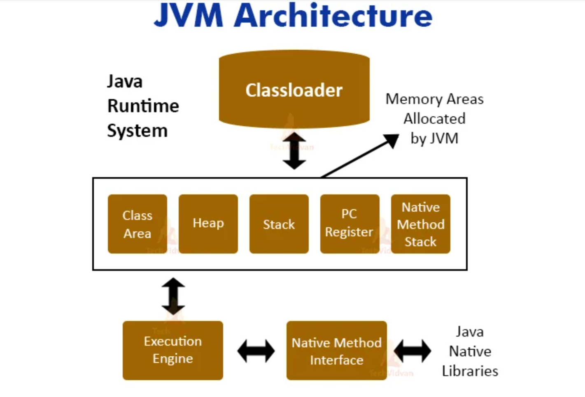

Task 12:

Why are enums useful?
What is an Enum?
An enum (short for enumeration) is a special Java type used to define a fixed set of constant values. Enums were introduced in Java 5 (JDK 1.5).
Syntax:
enum Day {
MONDAY,
TUESDAY,
WEDNESDAY,
THURSDAY,
FRIDAY,
SATURDAY,
SUNDAY
}

Task 13:

Wap to show the importance of enums in real world banking application
In a banking application, certain values are fixed and should not be entered randomly. For example:
- Account Type → SAVINGS, CURRENT, FIXED_DEPOSIT
- Transaction Status → SUCCESS, FAILED, PENDING
- Card Type → DEBIT, CREDIT
Using enums ensures only valid values are used, making the application more secure and reducing errors.
enum AccountType {
SAVINGS,
CURRENT,
FIXED_DEPOSIT
}

enum TransactionStatus {
SUCCESS,
FAILED,
PENDING
}

public class BankingApplication {

public static void main(String[] args) {

AccountType account = AccountType.SAVINGS;
TransactionStatus status = TransactionStatus.SUCCESS;

System.out.println("----- Banking Details -----");
System.out.println("Account Type : " + account);
System.out.println("Transaction Status: " + status);

switch (account) {
case SAVINGS:
System.out.println("Interest will be provided.");
break;

case CURRENT:
System.out.println("Business account with unlimited transactions.");
break;

case FIXED_DEPOSIT:
System.out.println("Higher interest with fixed tenure.");
break;
}

if (status == TransactionStatus.SUCCESS) {
System.out.println("Transaction completed successfully.");
} else if (status == TransactionStatus.PENDING) {
System.out.println("Transaction is under processing.");
} else {
System.out.println("Transaction failed. Please try again.");
}
}
}

Task 14:

List down all the string handling functions with example in a single java code.. With respect to banking application
public class BankingStringFunctions {

public static void main(String[] args) {

String customerName = " Vicky Kumar ";
String bankName = "State Bank of India";
String accountNumber = "SBI123456789";
String transaction = "Deposit";
String amount = "5000";
String message = "Welcome to SBI Banking";
String emptyString = "";

// 1. length()
System.out.println("1. Length: " + bankName.length());

// 2. charAt()
System.out.println("2. Character at index 4: " + bankName.charAt(4));

// 3. toUpperCase()
System.out.println("3. Upper Case: " + bankName.toUpperCase());

// 4. toLowerCase()
System.out.println("4. Lower Case: " + bankName.toLowerCase());

// 5. trim()
System.out.println("5. Trim: '" + customerName.trim() + "'");

// 6. concat()
System.out.println("6. Concat: " + bankName.concat(" Branch"));

// 7. equals()
System.out.println("7. Equals: " + transaction.equals("Deposit"));

// 8. equalsIgnoreCase()
System.out.println("8. Equals Ignore Case: " + transaction.equalsIgnoreCase("deposit"));

// 9. contains()
System.out.println("9. Contains SBI: " + bankName.contains("SBI"));

// 10. startsWith()
System.out.println("10. Starts With State: " + bankName.startsWith("State"));

// 11. endsWith()
System.out.println("11. Ends With India: " + bankName.endsWith("India"));

// 12. substring()
System.out.println("12. Substring: " + accountNumber.substring(3));

// 13. replace()
System.out.println("13. Replace: " + bankName.replace("India", "Bharat"));

// 14. indexOf()
System.out.println("14. Index Of Bank: " + bankName.indexOf("Bank"));

// 15. lastIndexOf()
System.out.println("15. Last Index Of a: " + bankName.lastIndexOf('a'));

// 16. isEmpty()
System.out.println("16. Is Empty: " + emptyString.isEmpty());

// 17. isBlank() (Java 11+)
System.out.println("17. Is Blank: " + " ".isBlank());

// 18. split()
String[] words = message.split(" ");
System.out.println("18. Split:");
for (String word : words) {
System.out.println(word);
}

// 19. valueOf()
int balance = 25000;
String balanceString = String.valueOf(balance);
System.out.println("19. Value Of: " + balanceString);

// 20. compareTo()
System.out.println("20. Compare To: " + "Savings".compareTo("Current"));

// 21. compareToIgnoreCase()
System.out.println("21. Compare Ignore Case: " + "SBI".compareToIgnoreCase("sbi"));

// 22. matches()
System.out.println("22. Matches Account Format: "
+ accountNumber.matches("[A-Z]{3}[0-9]{9}"));

// 23. join()
String joined = String.join("-", "TXN", "2026", "1001");
System.out.println("23. Join: " + joined);

// 24. repeat() (Java 11+)
System.out.println("24. Repeat: " + "*".repeat(20));

// 25. toCharArray()
System.out.print("25. To Char Array: ");
char[] chars = transaction.toCharArray();
for (char c : chars) {
System.out.print(c + " ");
}
System.out.println();

// 26. hashCode()
System.out.println("26. HashCode: " + accountNumber.hashCode());

// 27. intern()
String s1 = new String("SBI");
String s2 = s1.intern();
System.out.println("27. Intern: " + (s2 == "SBI"));

// 28. replaceAll()
System.out.println("28. Replace All Digits: "
+ accountNumber.replaceAll("[0-9]", "*"));

// 29. replaceFirst()
System.out.println("29. Replace First: "
+ bankName.replaceFirst("State", "National"));

// 30. strip() (Java 11+)
System.out.println("30. Strip: '" + customerName.strip() + "'");
}
}

