Day - 03
Task 1:
What do you understand by Big O notation?
Big O notation is used to measure the performance of an algorithm. It tells us how much time or memory an algorithm needs when the input size increases.
It helps us compare different algorithms and choose the faster one.

Task 2:
What are arrays? How many types of arrays?
An array is a collection of similar types of data stored in a single variable. It stores multiple values of the same data type.

Types of Arrays in Java:
1. One-dimensional Array
2.Two-dimensional Array

Task 3:
What do you understand by Strings in Java?
A String is a sequence of characters used to store text in Java.

Task 4:
Create an array in Java
An array in Java can be created by declaring the array type and specifying its size or values.

Task 5:
Create a java program to print the String in reverse order.
public class ReverseString {
public static void main(String[] args) {
String str = "Vicky";
StringBuilder reverseStr = new StringBuilder(str).reverse();
System.out.println("Original str "+ str);
System.out.println("Reversed str " + reverseStr);
}
}

Task 6:
Wap to declare static and normal variable and increment the values of both.. What do you observe.

class Counter{
static int staticCount = 0;
int normalCount = 0;
void increment(){
staticCount++;
normalCount++;
System.out.println("staticCount "+ staticCount);
System.out.println("normalCount "+ normalCount );
}
}
public class StaticNormalCompare {
public static void main(String[] args) {
Counter obj1 = new Counter();
Counter obj2 = new Counter();
System.out.println("Object 1 value");
obj1.increment();
System.out.println("Object 1 value again");
obj1.increment();
System.out.println("Object 2 value");
obj2.increment();
}
}

Output:
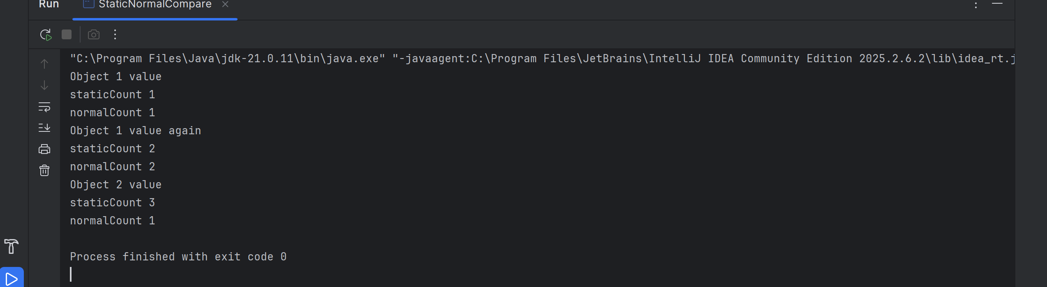

Task 7:
Wap to print numbers from 100 to 10
public class Print100to1 {
public static void main(String[] args) {
for(int i = 100 ; i >= 10 ; i--){
System.out.println(i);
}
}
}

Task 8:

Wap to accept logon id and pwd from the user and display welcome message if
Login id is “Prasunamba” pwd is “4321”
Use while loop …
import java.util.Scanner;
public class LoginProgram {
public static void main(String[] args) {
Scanner sc = new Scanner(System.in);
String loginId;
String password;
while (true) {
System.out.print("Enter Login ID: ");
loginId = sc.nextLine();
System.out.print("Enter Password: ");
password = sc.nextLine();
if (loginId.equals("Prasunamba") && password.equals("4321")) {
System.out.println("Welcome Prasunamba!");
break;
}
else {
System.out.println("Invalid Login ID or Password. Try again.");
}
}
sc.close();
}
}

Task 9:

Wap to accept login id and pwd from the user and display welcome message and then check for the login id and pwd ..
Use do while loop..
import java.util.Scanner;
public class LoginDoWhile {
public static void main(String[] args) {
Scanner sc = new Scanner(System.in);
String loginId;
String password;
do {
System.out.print("Enter Login ID: ");
loginId = sc.nextLine();
System.out.print("Enter Password: ");
password = sc.nextLine();
if (loginId.equals("Prasunamba") && password.equals("4321")) {
System.out.println("Welcome Prasunamba!");
break;
}
else {
System.out.println("Invalid Login ID or Password. Try again.");
}
} while (true);
sc.close();
}
}

Task 10:
Wap to display the use of
If
Else if
Nested if

import java.util.Scanner;
public class ConditionsDemo {
public static void main(String[] args) {
Scanner sc = new Scanner(System.in);
System.out.print("Enter your marks: ");
int marks = sc.nextInt();
// If statement
if (marks >= 40) {
System.out.println("You are Pass");
}
// Else If statement
if (marks >= 90) {
System.out.println("Grade: A+");
}
else if (marks >= 75) {
System.out.println("Grade: A");
}
else if (marks >= 60) {
System.out.println("Grade: B");
}
else {
System.out.println("Grade: C");
}
// Nested If statement
if (marks >= 40) {
if (marks >= 18) {
System.out.println("Eligible for next level");
}
}
sc.close();
}
}

Task 11:
Wap to display the use of switch case

import java.util.Scanner;
public class SwitchExample {
public static void main(String[] args) {
Scanner sc = new Scanner(System.in);
System.out.println("1. Add");
System.out.println("2. Subtract");
System.out.println("3. Multiply");
System.out.println("4. Divide");
System.out.print("Enter your choice: ");
int choice = sc.nextInt();
System.out.print("Enter first number: ");
int a = sc.nextInt();
System.out.print("Enter second number: ");
int b = sc.nextInt();
switch(choice) {
case 1:
System.out.println("Addition = " + (a + b));
break;
case 2:
System.out.println("Subtraction = " + (a - b));
break;
case 3:
System.out.println("Multiplication = " + (a * b));
break;
case 4:
System.out.println("Division = " + (a / b));
break;
default:
System.out.println("Invalid choice");
}
sc.close();
}
}

Task 12:
What are access modifiers in java … give detailed explanation?
Access modifiers in Java are keywords that control the visibility and accessibility of classes, variables, methods, and constructors.

Types of modifiers
1. Private - Only inside the class.
2. Default - Same package only.
3. Protected - Same package + child classes.
4. Public - Accessible everywhere.

Task 13:
Wap to accept cust names and display them using for each loop
import java.util.Scanner;
public class CustomerNames {
public static void main(String[] args) {
Scanner sc = new Scanner(System.in);
String[] customers = new String[5];
// Accept customer names
for (int i = 0; i < customers.length; i++) {
System.out.print("Enter customer name " + (i + 1) + ": ");
customers[i] = sc.nextLine();
}
// Display customer names using for-each loop
System.out.println("\nCustomer Names:");
for (String name : customers) {
System.out.println(name);
}
sc.close();
}
}

Task - 14
Wap to show the difference between break and continue.
Use for loop to show the diff

public class BreakContinueDemo {
public static void main(String[] args) {
System.out.println("Using break:");
for (int i = 1; i <= 10; i++) {
if (i == 5) {
break; // stops the loop completely
}
System.out.println(i);
}
System.out.println("\nUsing continue:");
for (int i = 1; i <= 10; i++) {
if (i == 5) {
continue; // skips only the current iteration
}
System.out.println(i);
}
}
}

Task – 15

Single Inheritance
class Employee{
int method1(){
int age = 23;
System.out.println(age);
return age;
}
class employee02{
void method2(){
int age = 200;
System.out.println(age);
}
class Manager extends Employee{
void method2(){
super.method1();
}
}
public class EmployeeDetails {
public static void main(String[] args) {
Manager manager1 = new Manager();
manager1.method2();
}
}

Task – 16
Public , Private and protected variables
class publicVar {
public int number01 = 199;
}
class privateVar{
private int number02 = 299;
public void privateMethod(){
System.out.println(number02);
}
}
class protectedVar{
protected int number03 = 399;
}
public class PublicPrivateProtected {
public static void main(String[] args) {
publicVar pv = new publicVar();
System.out.println("public variable "+pv.number01);
privateVar privateVar = new privateVar();
privateVar.privateMethod();
protectedVar protectedVar = new protectedVar();
System.out.println(protectedVar.number03);
}
}

