Day 11 - 30th July 2026

Task 1:
What is an Actuator in Spring boot?
Spring Boot Actuator is a module that provides built-in features to monitor and manage a Spring Boot application while it is running. It exposes information about the application's health, performance, metrics, environment, beans, and other runtime details through HTTP endpoints or JMX.
It is mainly used by developers and system administrators to:
- Monitor application health.
- Check application status.
- Collect metrics.
- Troubleshoot issues.
- Manage production applications.

Task 2:
Advantages of Actuator
- Application Health Monitoring
  - Checks whether the application is UP or DOWN.
- Performance Metrics
  - Provides CPU, memory, request count, JVM, and garbage collection statistics.
- Easy Troubleshooting
  - Helps identify runtime issues quickly.
- Production Monitoring
  - Enables continuous monitoring of live applications.
- Built-in Endpoints
  - No need to write custom monitoring code.
- Supports Monitoring Tools
  - Can integrate with Prometheus, Grafana, Micrometer, and other monitoring platforms.
- Secure Access
  - Endpoints can be exposed selectively and protected using Spring Security.

Task 3:
What are the commonly used Actuator end points?
Endpoint | Purpose
/actuator | Lists all available actuator endpoints
/actuator/health | Displays application health status
/actuator/info | Shows application information
/actuator/metrics | Displays application metrics
/actuator/env | Shows environment properties
/actuator/beans | Lists all Spring Beans
/actuator/mappings | Shows all URL mappings
/actuator/loggers | View or change log levels
/actuator/threaddump | Displays thread dump
/actuator/heapdump | Downloads JVM heap dump

Task 4:
Create a Small demo of Actuator to know the functionality
SpringActuatorApplication.java

package com.Actuator.SpringActuator;
import org.springframework.boot.SpringApplication;
import org.springframework.boot.autoconfigure.SpringBootApplication;
@SpringBootApplication
public class SpringActuatorApplication {
public static void main(String[] args) {
SpringApplication.run(SpringActuatorApplication.class, args);
}
}

HomeController.java
package com.Actuator.SpringActuator.Controller;
import org.springframework.web.bind.annotation.GetMapping;
import org.springframework.web.bind.annotation.RestController;
@RestController
public class HomeController {
@GetMapping("/")
public String home() {
return "Welcome to Spring Boot Actuator Demo";
}
}

application.properties
spring.application.name=SpringActuator
management.endpoints.web.exposure.include=*
management.endpoint.health.show-details=always

pom.xml
<?xml version="1.0" encoding="UTF-8"?>
<project xmlns="http://maven.apache.org/POM/4.0.0" xmlns:xsi="http://www.w3.org/2001/XMLSchema-instance"
xsi:schemaLocation="http://maven.apache.org/POM/4.0.0 https://maven.apache.org/xsd/maven-4.0.0.xsd">
<modelVersion>4.0.0</modelVersion>
<parent>
<groupId>org.springframework.boot</groupId>
<artifactId>spring-boot-starter-parent</artifactId>
<version>4.1.0</version>
<relativePath/> <!-- lookup parent from repository -->
</parent>
<groupId>com.Actuator</groupId>
<artifactId>SpringActuator</artifactId>
<version>0.0.1-SNAPSHOT</version>
<name/>
<description/>
<url/>
<licenses>
<license/>
</licenses>
<developers>
<developer/>
</developers>
<scm>
<connection/>
<developerConnection/>
<tag/>
<url/>
</scm>
<properties>
<java.version>26</java.version>
</properties>
<dependencies>
<dependency>
<groupId>org.springframework.boot</groupId>
<artifactId>spring-boot-starter-actuator</artifactId>
</dependency>
<dependency>
<groupId>org.springframework.boot</groupId>
<artifactId>spring-boot-starter-webmvc</artifactId>
</dependency>
<dependency>
<groupId>org.springframework.boot</groupId>
<artifactId>spring-boot-starter-actuator-test</artifactId>
<scope>test</scope>
</dependency>
<dependency>
<groupId>org.springframework.boot</groupId>
<artifactId>spring-boot-starter-webmvc-test</artifactId>
<scope>test</scope>
</dependency>
</dependencies>
<build>
<plugins>
<plugin>
<groupId>org.springframework.boot</groupId>
<artifactId>spring-boot-maven-plugin</artifactId>
</plugin>
</plugins>
</build>
</project>

Task 5:
What is Spring Security Architecture?
Spring Security Architecture is the framework used by Spring Boot to secure web applications and REST APIs. It controls who can access the application (authentication) and what they are allowed to do (authorization).
It works by intercepting every incoming request, verifying the user's identity, checking their permissions, and then either allowing or denying access.

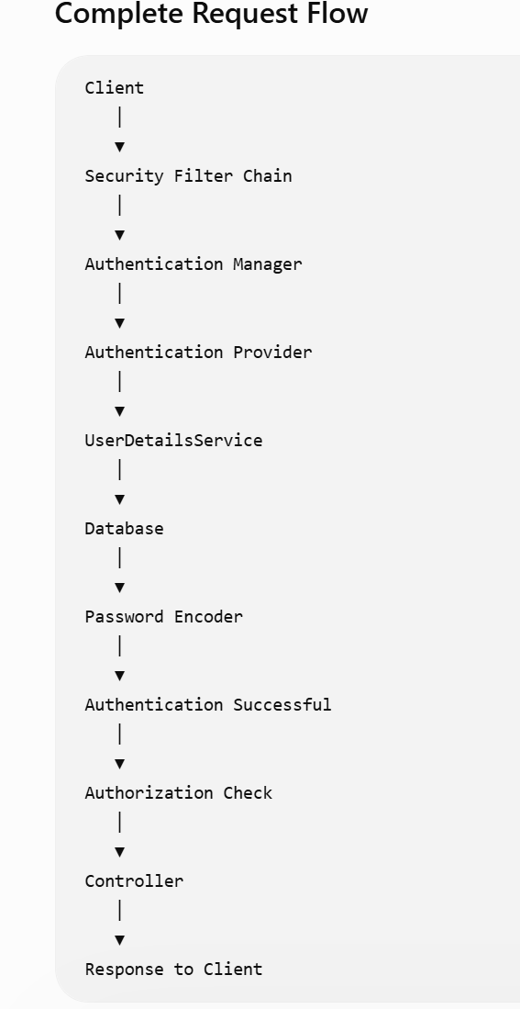
Task 6:
What are the core components of Spring security architecture
Spring Security consists of several core components that work together to authenticate users and authorize access to resources.
1. Security Filter Chain
- The first component that receives every HTTP request.
- Applies security checks before the request reaches the controller.
- Handles authentication, authorization, CSRF protection, session management, etc.

2. Authentication Manager
- Coordinates the authentication process.
- Receives the authentication request and delegates it to an AuthenticationProvider.

3. Authentication Provider
- Contains the actual authentication logic.
- Validates the user's credentials.
- Uses UserDetailsService and PasswordEncoder.

4. UserDetailsService
- Loads user information from a database, memory, or another source.
- Returns a UserDetails object.

5. PasswordEncoder
- Encrypts passwords before storing them.
- Compares the entered password with the stored encrypted password.

6. UserDetails
- Represents the authenticated user.
- Contains username, password, roles, and account status.

7. Security Context
- Stores the authenticated user's information during the request.
- Accessible throughout the application.

Task 7:
Can you create a diagrammatic representation of Spring Security architecture
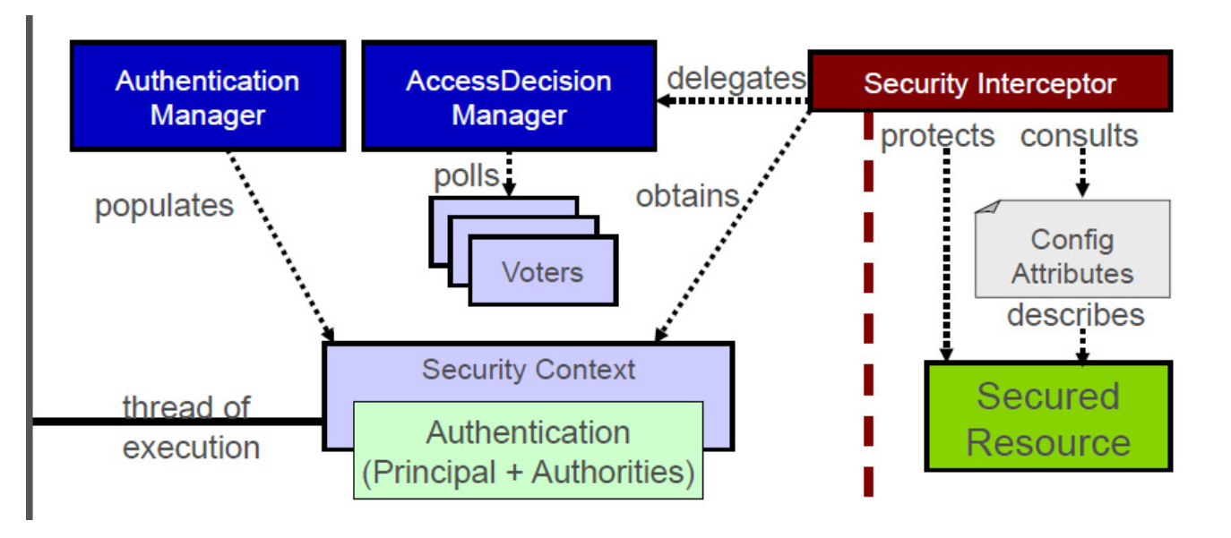

Task 8:
What is a Security filter chain? Give example code
The Security Filter Chain is the heart of Spring Security. Every incoming HTTP request passes through it before reaching the controller. It performs authentication, authorization, CSRF protection, session management, and other security-related tasks.
Example
@Configuration
@EnableWebSecurity
public class SecurityConfig {
@Bean
public SecurityFilterChain securityFilterChain(HttpSecurity http)
throws Exception {
http
.authorizeHttpRequests(auth -> auth
.requestMatchers("/public/**").permitAll()
.requestMatchers("/admin/**").hasRole("ADMIN")
.anyRequest().authenticated()
)
.formLogin();
return http.build();
}
}

Task 9:
What is an Authentication Manager? Give example code
The AuthenticationManager is responsible for authenticating users. It receives the username and password and delegates the authentication process to an AuthenticationProvider.
@Bean
public AuthenticationManager authenticationManager(
AuthenticationConfiguration configuration)
throws Exception {
return configuration.getAuthenticationManager();
}

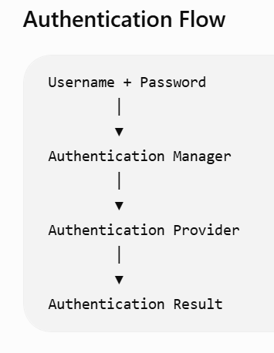

Task 10:
What are Authentication Proividers? Give example and code
An AuthenticationProvider performs the actual authentication by verifying the user's credentials. It loads user details and compares the entered password with the stored encrypted password.
Example
Suppose the user enters:
Username : admin
Password : admin123

The AuthenticationProvider:
- Loads the user using UserDetailsService.
- Uses PasswordEncoder to compare passwords.
- Returns a successful authentication if they match.
@Bean
public AuthenticationProvider authenticationProvider(
UserDetailsService userDetailsService,
PasswordEncoder passwordEncoder) {
DaoAuthenticationProvider provider =
new DaoAuthenticationProvider();
provider.setUserDetailsService(userDetailsService);
provider.setPasswordEncoder(passwordEncoder);
return provider;
}
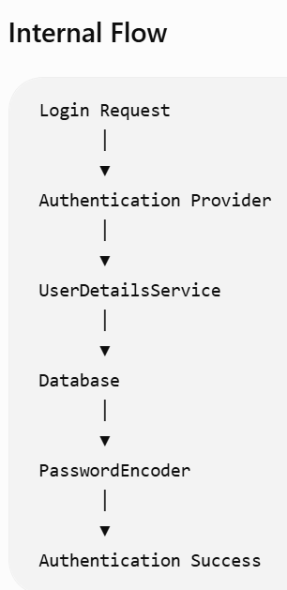

Task 11:
What is USerDeatilsService? Give example
UserDetailsService is an interface in Spring Security used to load user information from a database, memory, or another data source during authentication.
It contains one method:
UserDetails loadUserByUsername(String username);
@Service
public class CustomUserDetailsService
implements UserDetailsService {
@Override
public UserDetails loadUserByUsername(String username)
throws UsernameNotFoundException {
if ("admin".equals(username)) {
return User.builder()
.username("admin")
.password("$2a$10$EncryptedPassword")
.roles("ADMIN")
.build();
}
throw new UsernameNotFoundException("User not found");
}
}

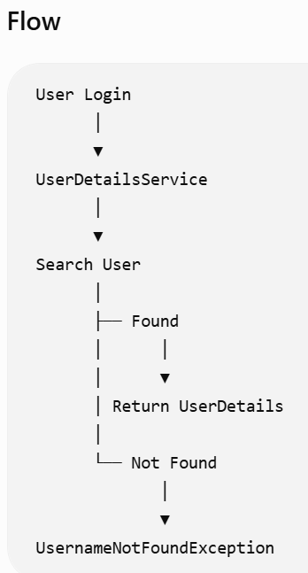

Task 12:
What is Password encoder? Give example
PasswordEncoder is an interface in Spring Security used to encrypt (hash) passwords before storing them in the database and to verify passwords during login.
Instead of storing passwords as plain text, Spring Security stores an encrypted (hashed) version, making user credentials much more secure.
Why is it used?
- Protects user passwords.
- Prevents storing plain-text passwords.
- Uses secure hashing algorithms such as BCrypt.
- Verifies passwords without decrypting them.
How PasswordEncoder Works
Suppose a user registers with:
Username : vicky
Password : welcome123
Instead of storing:
welcome123
Spring Security stores:
$2a$10$zO7H5jYl8QmD5....
During login:
- User enters welcome123.
- Spring hashes it again.
- Compares it with the stored hash.
- If both match, authentication succeeds.

Task 13:
What is SecurityContextHolder?
SecurityContextHolder is a Spring Security class that stores the currently authenticated user's security information during a request.
Once a user logs in successfully, Spring Security stores the user's authentication object in the SecurityContextHolder.
It allows any part of the application to know:
- Who is logged in.
- What roles the user has.
- Whether the user is authenticated.
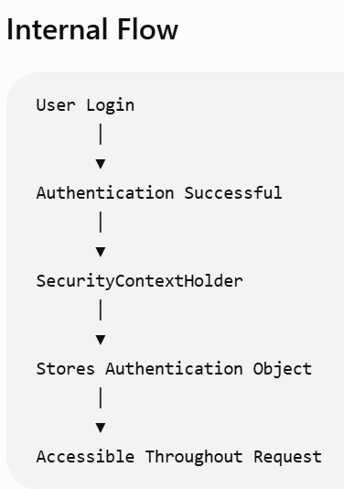

Task 14:
Finally give the security Architecture internal functionality? How actually it works internally… step by step if you can explain
Step 1: User Sends Login Request
Step 2: Security Filter Chain Intercepts the Request
Step 3: AuthenticationManager Receives the Request
Step 4: AuthenticationManager Calls AuthenticationProvider
Step 5: AuthenticationProvider Calls UserDetailsService
Step 6: UserDetailsService Reads the Database
Step 7: PasswordEncoder Verifies Password
Step 8: Authentication Object is Created
Step 9: Store in SecurityContextHolder
Step 10: Authorization
Step 11: Controller Executes
Step 12: Response Sent Back
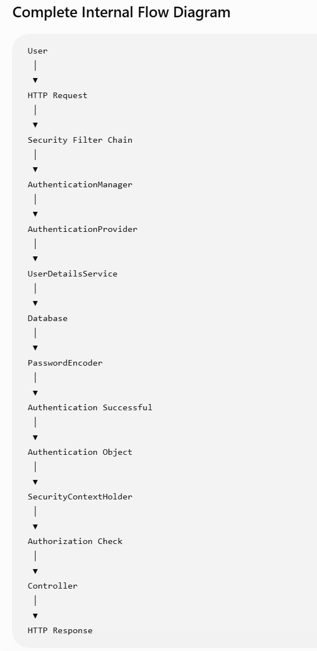

Task 15:
What is Thymeleaf? Explain? Why is it used?
Thymeleaf is a Java server-side template engine used with Spring Boot to create dynamic HTML pages.
It allows developers to combine HTML with Java data so that web pages are generated dynamically on the server before being sent to the browser.

Why is Thymeleaf Used?
- Creates dynamic web pages.
- Integrates seamlessly with Spring Boot and Spring MVC.
- Displays data from controllers in HTML pages.
- Supports loops, conditions, forms, and expressions.
- Uses natural HTML templates that can be opened directly in a browser.

Task 16:
Create a demo on thymeleaf .
package SpringThymeleaf;
import org.springframework.boot.SpringApplication;
import org.springframework.boot.autoconfigure.SpringBootApplication;
@SpringBootApplication
public class SpringThymeleafApplication {
public static void main(String[] args) {
SpringApplication.run(SpringThymeleafApplication.class, args);
}
}

package SpringThymeleaf;
import org.springframework.stereotype.Controller;
import org.springframework.ui.Model;
import org.springframework.web.bind.annotation.GetMapping;
@Controller
public class HomeController {
@GetMapping("/")
public String home(Model model) {
model.addAttribute("name", "Vicky");
model.addAttribute("course", "Spring Boot");
return "index";
}
}

<!DOCTYPE html>
<html xmlns:th="http://www.thymeleaf.org">
<head>
<title>Thymeleaf Demo</title>
</head>
<body>
<h2>Welcome</h2>
<p>Name :
<span th:text="${name}"></span>
</p>
<p>Course :
<span th:text="${course}"></span>
</p>
</body>
</html>

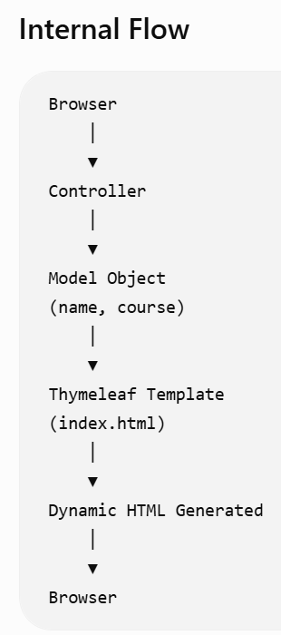

Task 17:
What do you think are the advantages of using thymeleaf?
Thymeleaf provides several advantages when building Spring Boot web applications:
1. Easy Integration with Spring Boot
Works seamlessly with Spring MVC and Spring Boot.
2. Dynamic HTML Pages
Displays dynamic data received from controllers.
3. Natural Templates
HTML files can be opened directly in a browser even without running the application.
4. Supports Forms
5. Supports Conditions
6. Supports Loops
7. Secure
Automatically escapes HTML to reduce XSS attacks.
8. Easy to Learn
Uses standard HTML with a few additional attributes.
Task 18:
What is Caching in Springboot?
Caching is the process of storing frequently accessed data in temporary memory so that future requests can be served faster without repeatedly accessing the database or performing expensive computations.
Instead of fetching the same data again and again, Spring Boot returns it from the cache.

Why is Caching Used?
- Improves application performance.
- Reduces database load.
- Decreases response time.
- Saves CPU resources.
- Improves scalability.

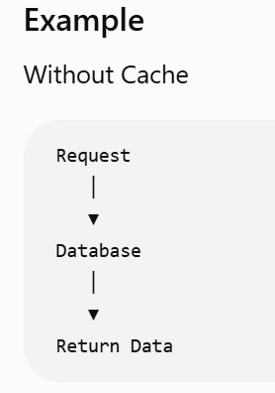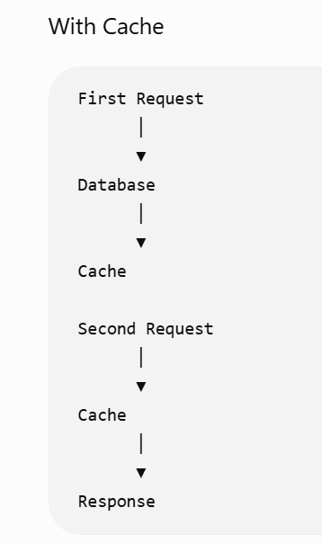

Task 19:
What are the Features of Caching?
Spring Boot simplifies Java application development by providing many built-in features.
up application development.
1. Faster Data Access
Frequently used data is stored in the cache, allowing it to be retrieved much faster than querying the database.
2. Reduced Database Load
Caching minimizes the number of database queries, reducing the workload on the database server.
3. Improved Application Performance
Since data is served from memory instead of the database, the application's response time is significantly improved.
4. Lower Response Time
Users receive responses more quickly because cached data can be accessed in milliseconds.
5. Increased Scalability
Caching enables the application to handle more users and requests without overloading the database.
6. Automatic Cache Management
Spring Boot provides annotations to automatically manage caching operations without writing complex code.
7. Multiple Cache Providers
Spring Boot supports different caching implementations, such as: Redis
8. Cache Synchronization
The cache can be updated or cleared automatically when data changes, ensuring users receive the latest information.
9. Flexible Cache Eviction
Spring Boot allows you to remove specific cache entries or clear the entire cache when data becomes outdated.
10. Annotation-Based Configuration
Caching can be enabled and managed using simple annotations instead of writing manual caching logic.

Task 20:
What are the types of Caching ?explain each type.
Caching can be classified into several types based on where the cached data is stored.
1. In-Memory Cache
Stores data in the application's memory (RAM).
Examples:
- ConcurrentHashMap
- Caffeine
- Ehcache
Advantages
- Very fast.
- Easy to configure.
Disadvantages
- Cache is lost when the application restarts.
- Suitable for a single application instance.

2. Distributed Cache
Stores cache in a separate server shared by multiple application instances.
Examples:
- Redis
- Hazelcast
- Memcached
Advantages
- Shared across multiple servers.
- Highly scalable.
- Supports clustering.
Disadvantages
- Requires an additional cache server.

3. Database Cache
Some databases cache frequently accessed data internally.
Examples:
- MySQL Query Cache (legacy)
- Oracle Buffer Cache
Advantages
- Reduces repeated database operations.
Disadvantages
- Slower than in-memory or distributed caches.

4. HTTP Cache
Caches HTTP responses in browsers or proxy servers.
Examples:
- Browser Cache
- CDN Cache
Advantages
- Faster page loading.
- Reduces network traffic.

5. Application Cache
Managed by the application using Spring Cache annotations.

Task 21:
List down annotations of Caching with usage.
1. @EnableCaching
Purpose
Enables caching support in a Spring Boot application.
2. @Cacheable
Purpose
Stores the result of a method in the cache.
3. @CachePut
Purpose
Always executes the method and updates the cache with the latest result.
4. @CacheEvict
Purpose
Removes data from the cache.
5. @Caching
Purpose
Allows multiple caching annotations to be used on the same method.
6. @CacheConfig
Purpose
Defines common cache settings for an entire class.

Sample Demo on Mockito
package com.SpringMockito;
public class BankAccount {
private String accountNumber;
private double balance;
public BankAccount(String accountNumber, double balance) {
this.accountNumber = accountNumber;
this.balance = balance;
}
public String getAccountNumber() {
return accountNumber;
}
public double getBalance() {
return balance;
}
public void setBalance(double balance) {
this.balance = balance;
}
}

package com.SpringMockito;
public interface BankRepository {
BankAccount findByAccountNumber(String accountNumber);
void save(BankAccount account);
}

package com.SpringMockito;
public class BankService {
private BankRepository repository;
public BankService(BankRepository repository) {
this.repository = repository;
}
public void deposit(String accountNumber, double amount) {
BankAccount account =
repository.findByAccountNumber(accountNumber);
account.setBalance(
account.getBalance() + amount);
repository.save(account);
}
public void withdraw(String accountNumber, double amount) {
BankAccount account =
repository.findByAccountNumber(accountNumber);
if(account.getBalance() < amount){
throw new IllegalArgumentException("Insufficient funds");
}
account.setBalance(
account.getBalance()-amount);
repository.save(account);
}
}

package com.SpringMockito;
import org.springframework.boot.SpringApplication;
import org.springframework.boot.autoconfigure.SpringBootApplication;
@SpringBootApplication
public class SpringMockitoApplication {
public static void main(String[] args) {
SpringApplication.run(SpringMockitoApplication.class, args);
}
}

package com.SpringMockito;
import org.junit.jupiter.api.Test;
import org.mockito.Mockito;
import static org.junit.jupiter.api.Assertions.*;
import static org.mockito.Mockito.*;
class BankServiceTest {
@Test
void testDeposit() {
BankRepository mockRepo = Mockito.mock(BankRepository.class);
BankAccount account = new BankAccount("123", 500);
when(mockRepo.findByAccountNumber("123"))
.thenReturn(account);
BankService service = new BankService(mockRepo);
service.deposit("123", 200);
assertEquals(700, account.getBalance());
verify(mockRepo).save(account);
}
@Test
void testWithdrawSuccess() {
BankRepository mockRepo = Mockito.mock(BankRepository.class);
BankAccount account = new BankAccount("123", 500);
when(mockRepo.findByAccountNumber("123"))
.thenReturn(account);
BankService service = new BankService(mockRepo);
service.withdraw("123", 200);
assertEquals(300, account.getBalance());
verify(mockRepo).save(account);
}
@Test
void testWithdrawInsufficientFunds() {
BankRepository mockRepo = Mockito.mock(BankRepository.class);
BankAccount account = new BankAccount("123", 100);
when(mockRepo.findByAccountNumber("123"))
.thenReturn(account);
BankService service = new BankService(mockRepo);
Exception ex = assertThrows(
IllegalArgumentException.class,
() -> service.withdraw("123", 200));
assertEquals("Insufficient funds", ex.getMessage());
verify(mockRepo, never()).save(account);
}
}

Task 22:

What do you think is @InjectMocks annotation does?
@InjectMocks is a Mockito annotation that creates an instance of the class being tested and automatically injects all the mock objects (@Mock) into it.
Instead of manually creating the object using new, Mockito creates it and supplies the mocked dependencies.

Task 23:
Write about @spy annotation and explain the functionality in a small piece of code
A Spy is a real object that Mockito wraps.
Unlike a Mock, where every method is fake, a Spy executes the real methods unless you specifically override them.
import org.junit.jupiter.api.Test;
import org.mockito.Spy;
import java.util.ArrayList;
import java.util.List;
import static org.junit.jupiter.api.Assertions.assertEquals;
class SpyExample {
@Spy
List<String> list = new ArrayList<>();
@Test
void testSpy() {
list.add("Java");
list.add("Spring");
assertEquals(2, list.size());
System.out.println(list.get(0));
}
}

Overriding a Method in a Spy
@Spy
List<String> list = new ArrayList<>();
@Test
void testSpyOverride() {
doReturn(100).when(list).size();
System.out.println(list.size());
}

Task 24:
Why is @Mock annotation used?
@Mock is a Mockito annotation used to create a fake implementation of a class or interface.
It allows you to test the class under test without depending on real objects such as databases, APIs, or external services.
Example
@Mock
private BankRepository repository;
Mockito automatically creates a fake BankRepository.
Equivalent to:
BankRepository repository =
Mockito.mock(BankRepository.class);

Task 25:
What is Partial mocking? Which annotation is used for partial mocking?
Partial Mocking means that some methods of an object execute their real implementation, while other methods are mocked (overridden).
Unlike a full mock (@Mock), where every method is fake, a partial mock allows you to keep the real behavior of the object and mock only specific methods.

Which Annotation is Used?
The annotation used for Partial Mocking is:
@Spy

Task 26:
For the code given what is @verify annotation used for and why do we use it?
What is verify()?
verify() is a Mockito method used to check whether a specific method on a mock object was called during the execution of the test.
It does not verify the returned value—it verifies the interaction between objects.
Why Do We Use verify()?
- Ensures important methods are called.
- Confirms business logic behaves correctly.
- Verifies interactions between objects.
- Helps detect missing or unnecessary method calls.

Task 27:
List down few more annotations that we use for mocking ..
Mockito provides several useful annotations for writing clean and maintainable unit tests.
Annotation | Purpose
@Mock | Creates a fake (mock) object.
@Spy | Creates a real object and allows partial mocking.
@InjectMocks | Creates the object under test and injects all @Mock dependencies.
@Captor | Creates an ArgumentCaptor to capture method arguments passed to mocked methods.

