Day 21 - 13th Aug 2026

Node JS

Task 1:
Create a common js module in nodejs to do some arithmetic operation.
9.05 to 9.08

Note:
Common Module JS.
- Key features:
  - Uses require() to import.
  - Uses exports or module.exports to export.
  - Each file is wrapped in its own function scope (variables are private).
  - Supports caching: once loaded, modules are cached for efficiency.
- File types treated as CommonJS:
  - .cjs files
  - .js files if package.json has "type": "commonjs" or no type specified.

Arithmetic.js

function add(a, b) {
return a + b;
}

function subtract(a, b) {
return a - b;
}

function multiply(a, b) {
return a * b;
}

function divide(a, b) {
return a / b;
}

module.exports = {
add,
subtract,
multiply,
divide
};
App.js
const arithmetic = require("./arithmetic");

console.log("Addition:", arithmetic.add(10, 5));
console.log("Subtraction:", arithmetic.subtract(10, 5));
console.log("Multiplication:", arithmetic.multiply(10, 5));
console.log("Division:", arithmetic.divide(10, 5));

Task 2:
Create the same task 1 code using ecmascript.
Note:
ES Modules:
- Key features:
  - Uses import and export.
  - Supports top-level await.
  - Better interoperability with modern tooling.
- File types treated as ES Modules:
  - .mjs files
  - .js files if package.json has "type": "module".
Arithmetic.js
export function add(a,b) {
return a + b;
}

export function sub(a,b){
return a -b;
}

export function div(a,b){
return a/b;
}

export function mul(a,b){
return a*b;
}

App.js
import {add, sub, div , mul} from './arithmetic.js';

console.log("Addition :", add(10,5));
console.log("Subtraction :", sub(10,5));
console.log("Division :", div(10,5));
console.log("Multiplication :", mul(10,5));

Task 3:
Complete 1 to 5 of home tasks.
Done

Task 4:
Given 2 files app.js and home.ejs
Can you let me know we are doing in this code.. Give comments for this code in your document.

app.js
// app.js

const express = require('express')
const bodyParser = require('body-parser')
const notes = [{
noteId: 1,
noteContent: "Hey, Prasunamba you can add your important notes here."
}
]

const app = express()

app.set('view engine', 'ejs')

app.use(bodyParser.json());
app.use(bodyParser.urlencoded({
extended: true
}))

app.get("/", function (req, res) {
res.render("home", {
data: notes
})
})

app.post("/", (req, res) => {
const noteContent = req.body.noteContent
const noteId = notes.length + 1;

notes.push({
noteId: noteId,
noteContent: noteContent
})

res.render("home", {
data: notes
})
})

app.post('/update', (req, res) => {
var noteId = req.body.noteId;
var noteContent = req.body.noteContent;

notes.forEach(note => {
if (note.noteId == noteId) {
note.noteContent = noteContent;
}
})
res.render("home", {
data: notes
})
})

app.post('/delete', (req, res) => {
var noteId = req.body.noteId;

var j = 0;
notes.forEach(note => {
j = j + 1;
if (note.noteId == noteId) {
notes.splice((j - 1), 1)
}
})

res.render("home", {
data: notes
})
})

app.listen(3000, (req, res) => {
console.log("App is running on port 3000")
})

home.ejs

<!DOCTYPE html>
<html>

<head>
<title>Note Keeper</title>
</head>

<body>
<h1>Note Keeper</h1>

<div style="display: flex;">

<% data.forEach(element=> { %>

<form action="/update" method="post">
<input type="number" style="display: none;"
name="noteId" value="<%= element.noteId %>">
<textarea type="text" rows="6" cols="30"
placeholder="Type Here..." name="noteContent"
value="<%= element.noteContent %>">
<%= element.noteContent %></textarea>
<br>
<button type="submit">Update</button>
</form>

<form action="/delete" method="post">
<input type="number" style="display: none;"
name="noteId" value="<%= element.noteId %>">
<button type="submit"
style="margin: 0px 4px;">&#10005</button>
</form>
<% }) %>
</div>

<h1>Add Note</h1>
<form action="/" method="post">
<input type="number" style="display: none;"
name="noteId">
<textarea type="text" rows="6" cols="30"
placeholder="Type Here..."
name="noteContent"></textarea>
<br>
<button type="submit">Add</button>
</form>
</body>

</html>

Expected output:

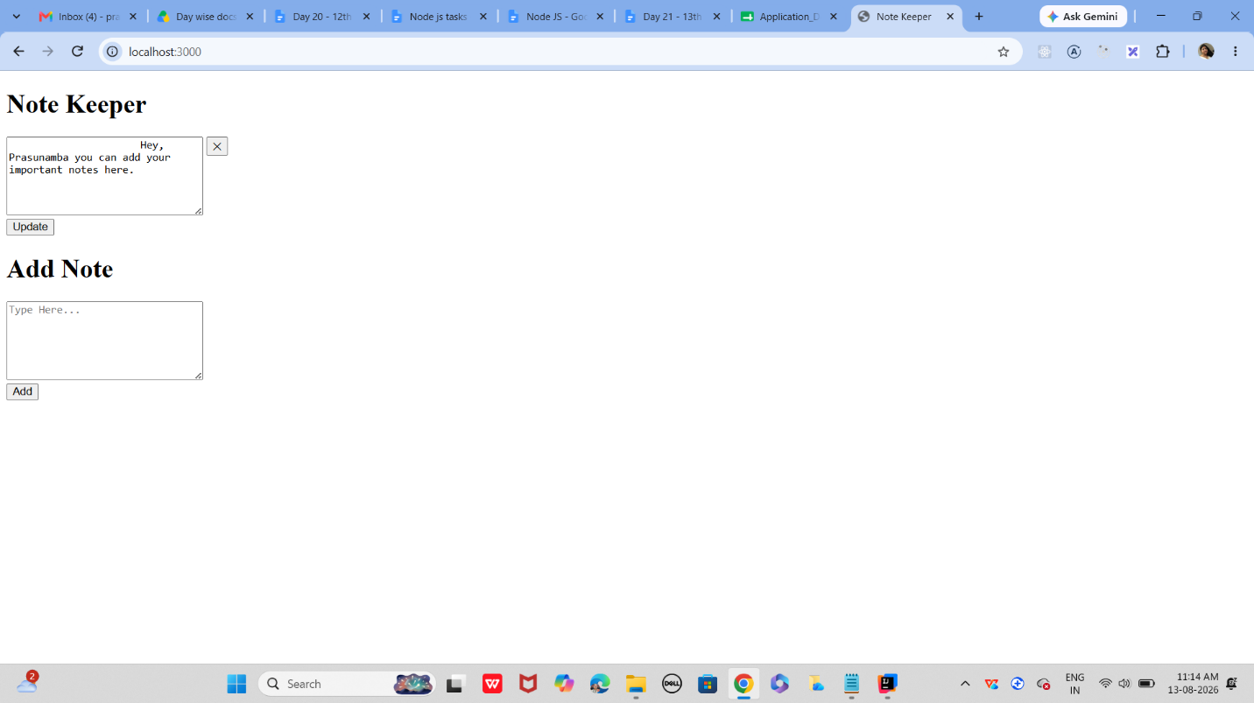

The whole application is doing one simple thing: it creates a small website where you can add, view, update, and delete notes.
Think of it as a mini Note Keeper app.

Task 5:
- Import all the required modules like express…
- Initialize the express app
- Create a async function for getting weather.
  - Use await Fetch for `https://api.openweathermap.org/data/2.5/weather?q=${city}&appid=${process.env.WEATHER_KEY}&units=metric`
And assign to response.
- Now convert response to json..
- Then return weather info like city , forecast. Temp…etc..
- Iff any error catch it in catch block
- Next call the web server route.
Like sample
app.get('/weather', async (req, res) => {
const city = req.query.city || "Bengaluru"; // default city
const weatherData = await getWeather(city); // async call
res.json(weatherData); // send JSON response
});

- Finally start the server.
// Import Express
const express = require("express");

// Import dotenv
// This loads variables from the .env file into process.env
require("dotenv").config();

// Initialize the Express application
const app = express();

// Serve static files (CSS, images) from the "public" folder
app.use(express.static('public'));

// Function to get weather information
async function getWeather(city) {

try {

// Use Open-Meteo geocoding to get coordinates for the city
const geoRes = await fetch(
`https://geocoding-api.open-meteo.com/v1/search?name=${encodeURIComponent(city)}&count=1`
);
const geoData = await geoRes.json();

if (!geoRes.ok || !geoData.results || geoData.results.length === 0) {
throw new Error('Location not found');
}

const loc = geoData.results[0];
const lat = loc.latitude;
const lon = loc.longitude;
const displayName = loc.name + (loc.country ? `, ${loc.country}` : '');

// Fetch current weather from Open-Meteo (no API key required)
const weatherRes = await fetch(
`https://api.open-meteo.com/v1/forecast?latitude=${lat}&longitude=${lon}&current_weather=true&timezone=auto`
);
const weatherJson = await weatherRes.json();

if (!weatherRes.ok || !weatherJson.current_weather) {
throw new Error('Unable to fetch weather from Open-Meteo');
}

const current = weatherJson.current_weather;

// Map common weather codes to human-friendly text
const codeMap = {
0: 'Clear sky',
1: 'Mainly clear',
2: 'Partly cloudy',
3: 'Overcast',
45: 'Fog',
48: 'Depositing rime fog',
51: 'Light drizzle',
53: 'Moderate drizzle',
55: 'Dense drizzle',
61: 'Slight rain',
63: 'Moderate rain',
65: 'Heavy rain',
71: 'Slight snow',
73: 'Moderate snow',
75: 'Heavy snow',
80: 'Rain showers',
81: 'Heavy rain showers',
82: 'Violent rain showers',
95: 'Thunderstorm',
96: 'Thunderstorm with hail',
99: 'Thunderstorm with heavy hail'
};

return {
city: displayName,
forecast: codeMap[current.weathercode] || `Weather code ${current.weathercode}`,
temperature: current.temperature,
windspeed: current.windspeed,
winddirection: current.winddirection
};

} catch (error) {

// Handle errors
return {
error: error.message
};
}
}

// Weather route
app.get("/weather", async (req, res) => {

// Get city from query parameter.
// If city is not provided, use Bengaluru.
const city = req.query.city || "Bengaluru";

// Call the asynchronous weather function
const weatherData = await getWeather(city);

// Send weather information as JSON
res.json(weatherData);
});

// Start the server (use port 3005 to avoid conflicts)
const PORT = process.env.PORT || 3005;
app.listen(PORT, () => {
console.log(`Weather server is running on port ${PORT}`);
});

Task 6:
What is Mongoose? What are the key features?why do we use ?
Mongoose is an ODM (Object Data Modeling) library for Node.js and MongoDB.
It makes it easier for a Node.js application to connect to MongoDB and work with MongoDB data using JavaScript objects, schemas, and models.
Why do we use Mongoose?
MongoDB is a NoSQL database, so its documents can have flexible structures.
Mongoose gives your application a more organized way to work with those documents.

Task 7:
Is this statement true or false?
Mongoose acts as a bridge between Node.js and MongoDB, giving you a structured way to manage your data.
True.
Mongoose can be described as a bridge between a Node.js application and MongoDB because it provides a structured way for Node.js code to interact with MongoDB.

Task 8:
Now in your project
- Import mongoose
- Connect to mongodb
- Lets define a schema..
// Import mongoose
const mongoose = require("mongoose");

// Connect to MongoDB
mongoose.connect("mongodb://127.0.0.1:27017/nodejsdb")
.then(() => {
console.log("Connected to MongoDB");
})
.catch((error) => {
console.error("MongoDB connection error:", error);
});

// Define the user schema
const userSchema = new mongoose.Schema({

name: String,

age: Number,

email: {
type: String,
required: true
}

});

// Create the User model
const User = mongoose.model("User", userSchema);

// Create a new user/document
const newUser = new User({
name: "Vicky",
age: 23,
email: "vicky@example.com"
});

// Save the document into MongoDB
newUser.save()
.then(() => {
console.log("User saved successfully!");
})
.catch((error) => {
console.error("Error saving user:", error);
});

