Day 10 - 29th July 2026

Task 1:
What is spring data JPA?
Spring Data JPA is a Spring module that makes it easy to connect a Java application to a database.
It automatically provides methods to save, update, delete, and retrieve data without writing most of the SQL code. It uses JPA as the standard and Hibernate to communicate with the database.

Task 2:
What are the key features of Spring data JPA?
- Easy CRUD operations – Save, Read, Update, and Delete data easily.
- Less coding – No need to write SQL for common operations.
- Repository interface – Just create an interface, and Spring provides the implementation.
- Automatic query generation – Creates queries from method names like findByName().
- Pagination and sorting – Easily display data page by page and sort it.
- Works with Hibernate – Uses Hibernate to interact with the database.

Task 3:
What are core components of Spring data JPA?
1. Entity
- A Java class that represents a database table.
- Example: Employee class → employee table.
2. Repository
- An interface used to access the database.
- It contains methods like save(), findAll(), and delete().
3. JpaRepository
- A ready-made interface that provides many database methods.
- You simply extend it instead of writing the methods yourself.
4. EntityManager
- The component that actually performs database operations behind the scenes.
5. Persistence Context
- A temporary memory where JPA keeps track of objects before updating the database.
6. Hibernate (JPA Provider)
- The tool that converts Java code into SQL and communicates with the database.

Task 4:
Now create a spring application using initializer
Create a customer entity with id and account type
Task 5:
Add this interface to your above code
package com.example.customerapp.controller;
import org.springframework.beans.factory.annotation.Autowired;
import org.springframework.web.bind.annotation.*;
import com.example.customerapp.entity.Customer;
import com.example.customerapp.repository.CustomerRepository;
@RestController
@RequestMapping("/customers")
public class CustomerController {
@Autowired
private CustomerRepository repository;
@PostMapping
public Customer saveCustomer(@RequestBody Customer customer) {
return repository.save(customer);
}
}

package com.example.customerapp.repository;
import org.springframework.data.jpa.repository.JpaRepository;
import com.example.customerapp.entity.Customer;
public interface CustomerRepository extends JpaRepository<Customer, Long> {
}

package com.example.customerapp.entity;
import jakarta.persistence.Entity;
import jakarta.persistence.Id;
@Entity
public class Customer {
@Id
private Long id;
private String accountType;
public Customer() {
}
public Customer(Long id, String accountType) {
this.id = id;
this.accountType = accountType;
}
public Long getId() {
return id;
}
public void setId(Long id) {
this.id = id;
}
public String getAccountType() {
return accountType;
}
public void setAccountType(String accountType) {
this.accountType = accountType;
}
}

spring.application.name=customerapp
spring.datasource.url=jdbc:h2:mem:testdb
spring.datasource.driverClassName=org.h2.Driver
spring.datasource.username=sa
spring.datasource.password=
spring.jpa.hibernate.ddl-auto=update
spring.jpa.show-sql=true
spring.h2.console.enabled=true
spring.h2.console.path=/h2-console

<?xml version="1.0" encoding="UTF-8"?>
<project xmlns="http://maven.apache.org/POM/4.0.0"
xmlns:xsi="http://www.w3.org/2001/XMLSchema-instance"
xsi:schemaLocation="https://maven.apache.org/POM/4.0.0 https://maven.apache.org/xsd/maven-4.0.0.xsd">
<modelVersion>4.0.0</modelVersion>
<parent>
<groupId>org.springframework.boot</groupId>
<artifactId>spring-boot-starter-parent</artifactId>
<version>3.5.4</version>
<relativePath/>
</parent>
<groupId>com.example</groupId>
<artifactId>customerapp</artifactId>
<version>0.0.1-SNAPSHOT</version>
<name>customerapp</name>
<description>Spring Data JPA Demo</description>
<properties>
<java.version>17</java.version>
</properties>
<dependencies>
<!-- Spring Boot Web -->
<dependency>
<groupId>org.springframework.boot</groupId>
<artifactId>spring-boot-starter-web</artifactId>
</dependency>
<!-- Spring Data JPA -->
<dependency>
<groupId>org.springframework.boot</groupId>
<artifactId>spring-boot-starter-data-jpa</artifactId>
</dependency>
<!-- H2 Database -->
<dependency>
<groupId>com.h2database</groupId>
<artifactId>h2</artifactId>
<scope>runtime</scope>
</dependency>
<!-- MySQL Driver (optional) -->
<dependency>
<groupId>com.mysql</groupId>
<artifactId>mysql-connector-j</artifactId>
<scope>runtime</scope>
</dependency>
<!-- Testing -->
<dependency>
<groupId>org.springframework.boot</groupId>
<artifactId>spring-boot-starter-test</artifactId>
<scope>test</scope>
</dependency>
</dependencies>
<build>
<plugins>
<plugin>
<groupId>org.springframework.boot</groupId>
<artifactId>spring-boot-maven-plugin</artifactId>
</plugin>
</plugins>
</build>
</project>

Task 6:
What is Application.proteries file is about?
application.properties is the main configuration file in a Spring Boot application. It stores application settings such as the server port, database connection details, logging configuration, application name, and other Spring Boot properties. Spring Boot automatically reads this file during application startup and applies the configured values.
Example:
server.port=8081
spring.application.name=Student-Service

spring.datasource.url=jdbc:mysql://localhost:3306/studentdb
spring.datasource.username=root
spring.datasource.password=root

Task 7:
Why use application properties… uses?
The application.properties file is used to externalize application configuration, meaning configuration is kept separate from the Java code. This makes the application easier to maintain and modify without recompiling the project.
Uses:
- Configure server port.
- Store database connection details.
- Configure logging levels.
- Set application name.
- Configure Hibernate and JPA properties.
- Store custom application properties.
- Configure email, security, caching, etc.

Task 8:
What is application.yml?
application.yml (or application.yaml) is another configuration file used in Spring Boot. It serves the same purpose as application.properties but uses YAML syntax, which is hierarchical and easier to read for complex configurations.
Example:
server:
port: 8081

spring:
application:
name: Student-Service
datasource:
url: jdbc:mysql://localhost:3306/studentdb
username: root
password: root

Task 9:
Why use/prefer to use application.yml instead of application.properties?
Many developers prefer application.yml because it is cleaner and better organized, especially when there are many related configuration properties.
Advantages of application.yml:
- Less repetitive than .properties.
- Easier to read due to hierarchical structure.
- Better for complex configurations.
- Groups related properties together.
- Reduces duplication and improves maintainability.

Task 10:
What is Eureka Server?
Eureka Server is a service registry provided by Netflix and supported by Spring Cloud. It allows microservices to register themselves and discover other services dynamically without hardcoding their locations.
When a microservice starts, it registers itself with the Eureka Server. Other services can then query the Eureka Server to find and communicate with it.
Example:
- User Service starts and registers with Eureka.
- Order Service also registers with Eureka.
- When Order Service needs User Service, it asks Eureka for its location instead of using a fixed IP address.

Task 11:
Purpose of Eureka Server.
The main purpose of Eureka Server is to enable service discovery in a microservices architecture.
Purposes:
- Registers all available microservices.
- Helps services discover each other dynamically.
- Eliminates hardcoded IP addresses and URLs.
- Supports load balancing by providing multiple service instances.
- Handles service registration and deregistration automatically.
- Improves scalability and fault tolerance.
- Simplifies communication between microservices.

Home Task:

Task 1:
What do you know about Spring MVC framework?
Spring MVC (Model-View-Controller) is a web framework provided by the Spring Framework that is used to build web applications and RESTful APIs. It follows the MVC design pattern, which separates an application into three parts: Model, View, and Controller. This separation makes the application easier to develop, maintain, and test.
Components of Spring MVC
- Model – Contains the application data and business logic.
- View – Displays the data to the user (JSP, Thymeleaf, HTML, etc.).
- Controller – Receives user requests, processes them, and returns the appropriate response.
Features of Spring MVC
- Follows the MVC architecture.
- Uses annotations like @Controller, @RequestMapping, and @RestController.
- Supports form handling and validation.
- Integrates easily with Spring Boot.
- Supports RESTful web services.
- Provides loose coupling between components.
Advantages
- Easy to develop and maintain.
- Better separation of concerns.
- Highly flexible and scalable.
- Easy integration with Spring modules like Spring Boot, Spring Security, and Spring Data JPA.

Task 2:
What is Dispatcher Servlet?
Dispatcher Servlet is the front controller of the Spring MVC framework. It receives every client request, processes it, sends it to the appropriate controller, and returns the response to the client.
Responsibilities of Dispatcher Servlet
- Receives the HTTP request.
- Identifies the correct controller.
- Calls the controller method.
- Receives the response from the controller.
- Sends the response to the client.
Advantages
- Centralized request handling.
- Reduces code complexity.
- Improves maintainability.
- Supports flexible request mapping.

Task 3:
Can you explain Spring MVC with diagram
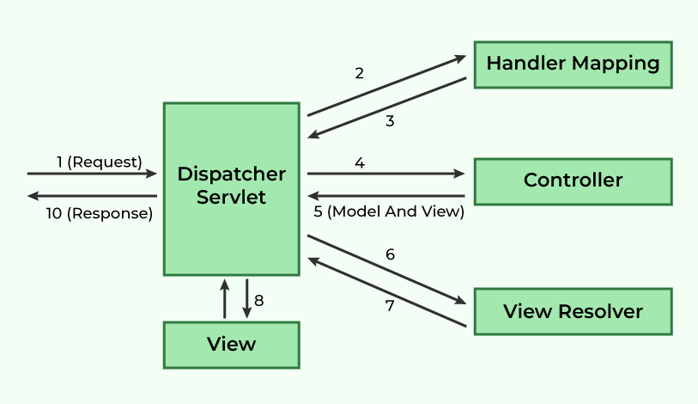

Working of Spring MVC
- The client sends an HTTP request.
- The Dispatcher Servlet receives the request.
- It forwards the request to the appropriate Controller.
- The Controller calls the Service layer to execute business logic.
- The Service interacts with the Repository, which communicates with the Database.
- The result is returned to the Controller.
- The Controller returns a View or JSON response.
- The Dispatcher Servlet sends the final response back to the client.

