Day 34 - 01st Sept 2026

Task 1:

- Run docker --version → shows installed version
- Run: docker pull hello-world
Fetches the latest hello-world image
Confirms internet connectivity
Prepares for container run

C:\Users\PRASUNA>docker pull hello-world
Using default tag: latest
latest: Pulling from library/hello-world
Digest: sha256:5dd0d3e6e255913fc30f90b9f2b1d359cc2cbdb48090cc4b65f1676e203243cc
Status: Image is up to date for hello-world:latest
docker.io/library/hello-world:latest

- Run docker run hello-world → should print Hello from Docker!

C:\Users\PRASUNA>docker run hello-world

Hello from Docker!
This message shows that your installation appears to be working correctly.

To generate this message, Docker took the following steps:
1. The Docker client contacted the Docker daemon.
2. The Docker daemon
- Docker run ubuntu
C:\Users\PRASUNA>docker run ubuntu
Unable to find image 'ubuntu:latest' locally
latest: Pulling from library/ubuntu
f3db1cd94078: Pull complete
06e9d71331fb: Pull complete
f79afc4bbefe: Download complete
Digest: sha256:2260313b31c8c011cd2eebe728008efac1b3982be73eb71348ea2648d2c0e09b
Status: Downloaded newer image for ubuntu:latest

- Try interactive mode: docker run -it ubuntu bash

- docker run -d nginx —> runs service in background.
C:\Users\PRASUNA>docker run -d nginx
B9b8a491f74738bf770321b19fd6c4244c3f56402ca7c0657c56e6736e5196f6

- Docker ps
C:\Users\PRASUNA>docker ps
CONTAINER ID IMAGE COMMAND CREATED STATUS PORTS NAMES
b9b8a491f747 nginx "/docker-entrypoint.…" About a minute ago Up About a minute 80/tcp infallible_noyce

- Map Ports for Access
Expose container services to your host machine.
docker run -d -p 8080:80 nginx
Maps host port 8080 → container port 80
Access via browser at http://localhost:8080

- Name Your Container
Assign a custom name for easier management.
C:\Users\PRASUNA>docker run -d --name PrasunambaContainer nginx
187adec159ccd3fa3cc93909c750084daf2e61b129b4c66d569ecfa94b362b93
Use docker stop mynginx to stop
Use docker rm mynginx to remove

- docker run -d -p 8081:80 -v "C:\Users\PRASUNA\OneDrive\Documents\Prasunamba\Trainings\IBM Training\docker":/mydata nginx

C:\Users\PRASUNA>docker run -d -p 8081:80 -v "C:\Users\PRASUNA\OneDrive\Documents\Prasunamba\Trainings\IBM Training\docker":/mydata nginx
56e1b128127df982f7f4136d4f24221f51b35a6afcc5154a69ec48d52a52afbb
Now you can access it at http://localhost:8081.

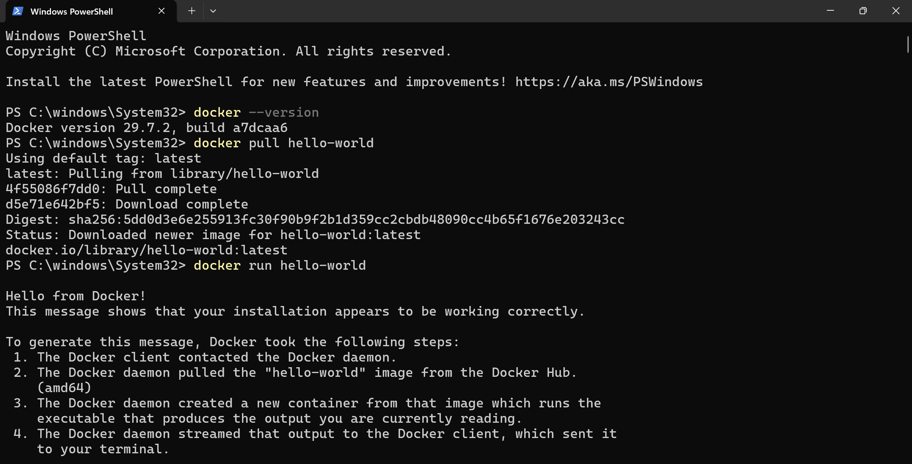


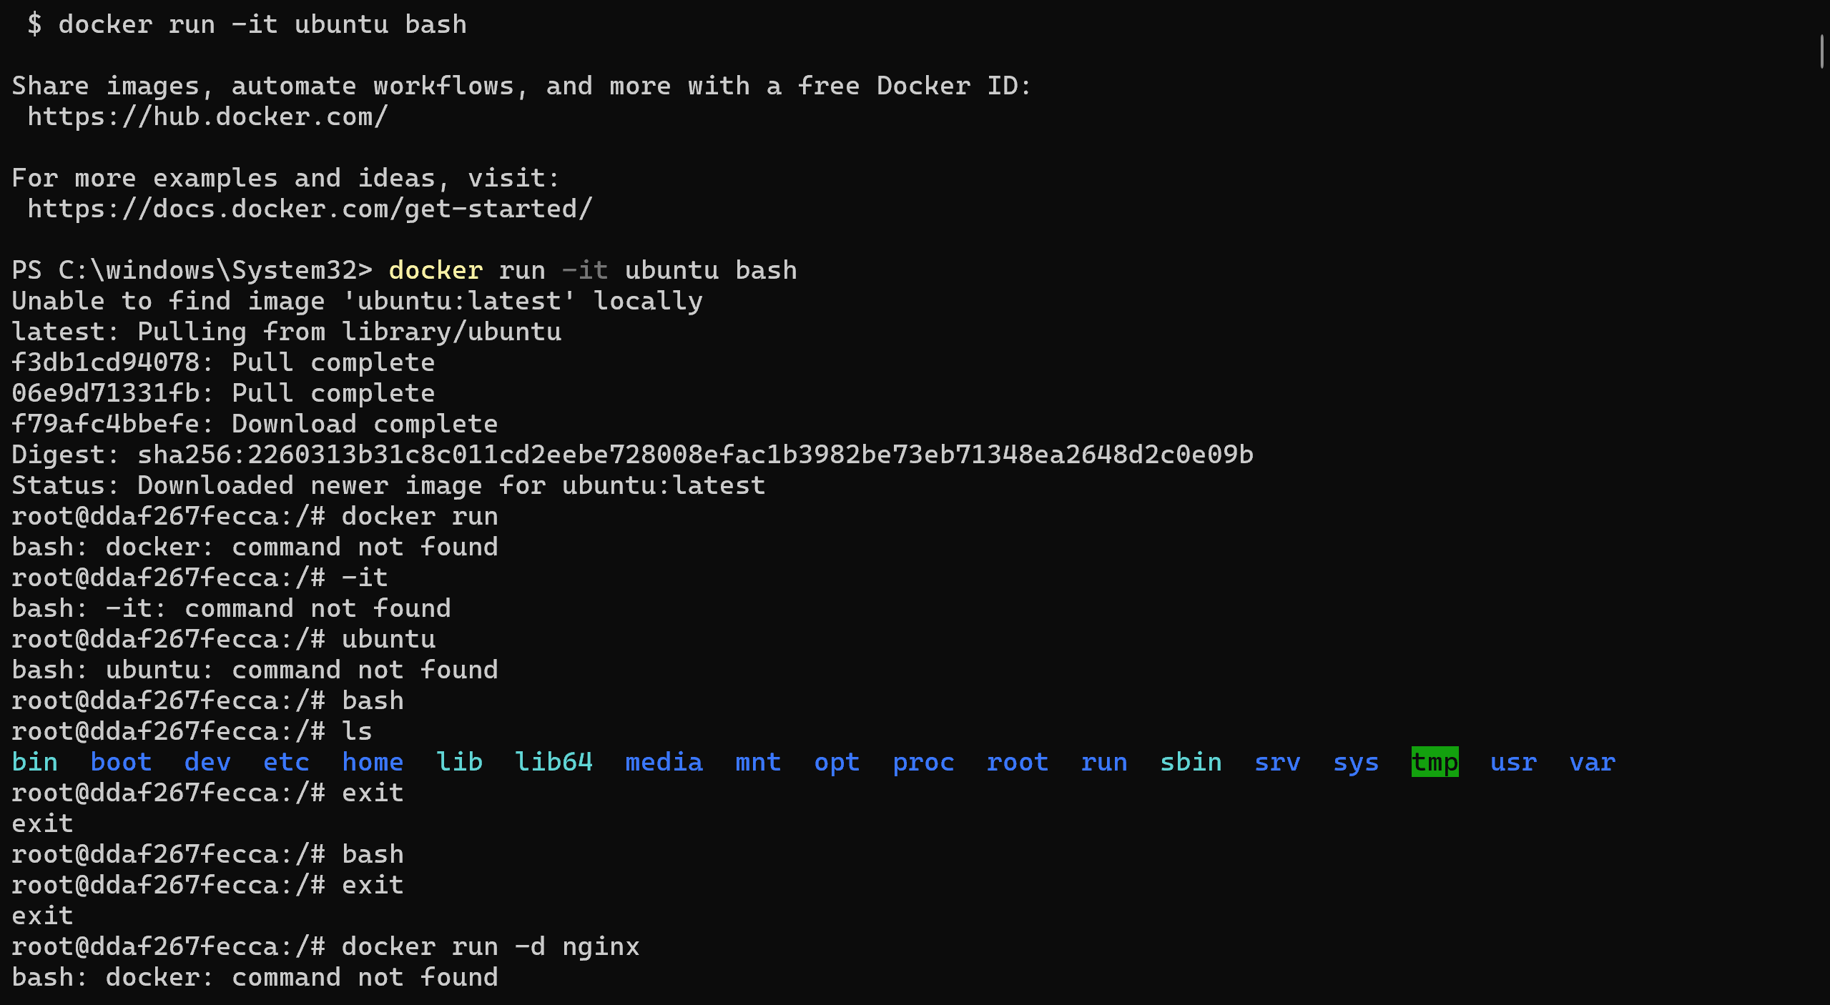

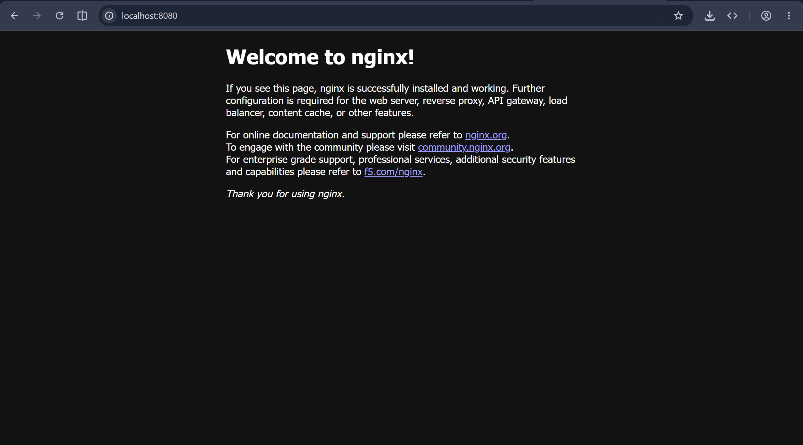

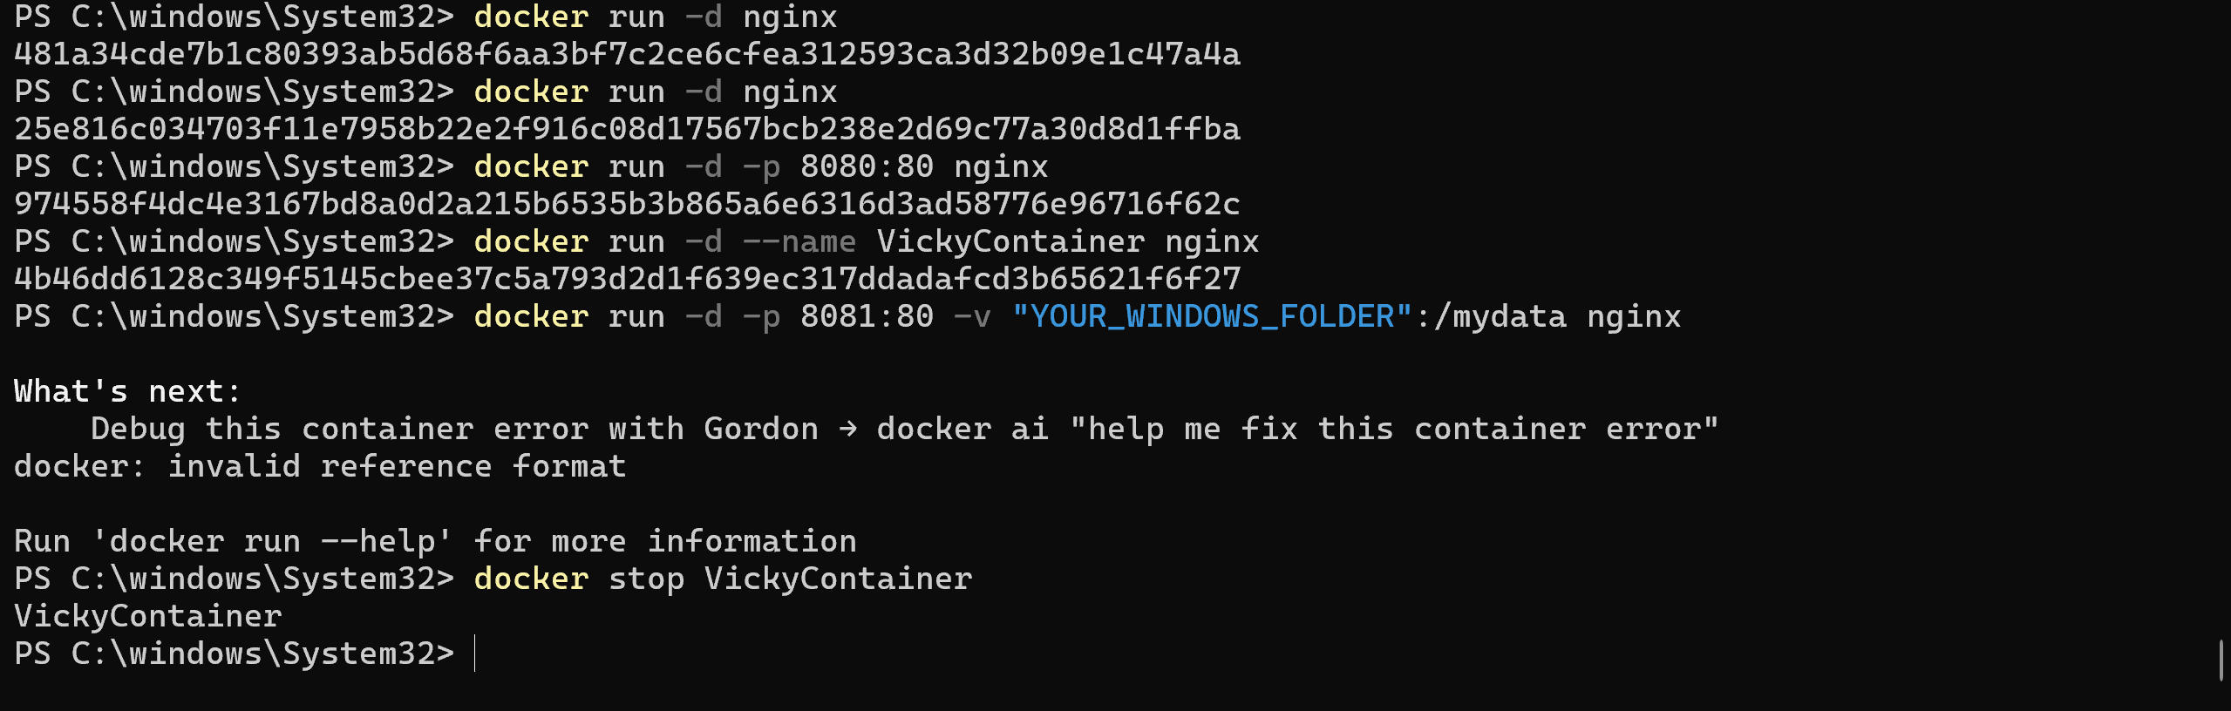

Task 2:

to serve your own HTML file from that mounted folder instead of the default Nginx page

Index.html file in (C:\Users\PRASUNA\OneDrive\Documents\Prasunamba\Trainings\IBM Training\docker)

<!DOCTYPE html>
<html>
<head>
<title>Prasunamba's Docker Site</title>
</head>
<body>
<h1>this is Prasunamba.. Hello from Docker + Nginx!</h1>
<p>This page is served from my Windows folder.</p>
</body>
</html>

🔧 Step-by-step: Adjust Nginx config
Create a custom Nginx config file on your host
In your Windows folder (C:\Users\PRASUNA\OneDrive\Documents\Prasunamba\Trainings\IBM Training\docker), create a file named default.conf with this content:
nginx
server {
listen 80;
server_name localhost;

location / {
root /mydata;
index index.html;
}
}
- 👉 This tells Nginx to serve files directly from /mydata.
- Run the container with both volume mounts
  - Mount your folder to /mydata (where your HTML lives).
  - Mount the config file into Nginx’s config directory.
cmd

C:\Users\PRASUNA>docker run -d -p 8082:80 -v "C:\Users\PRASUNA\OneDrive\Documents\Prasunamba\Trainings\IBM Training\docker":/mydata -v "C:\Users\PRASUNA\OneDrive\Documents\Prasunamba\Trainings\IBM Training\docker\default.conf":/etc/nginx/conf.d/default.conf nginx

ce8aec62c2380e2767722a0a5d7ba441d5a75aa89e786752770e3feeee0c7937

Verify the container
powershell
docker ps
- You should see the container running with port mapping 0.0.0.0:8082->80/tcp.
- 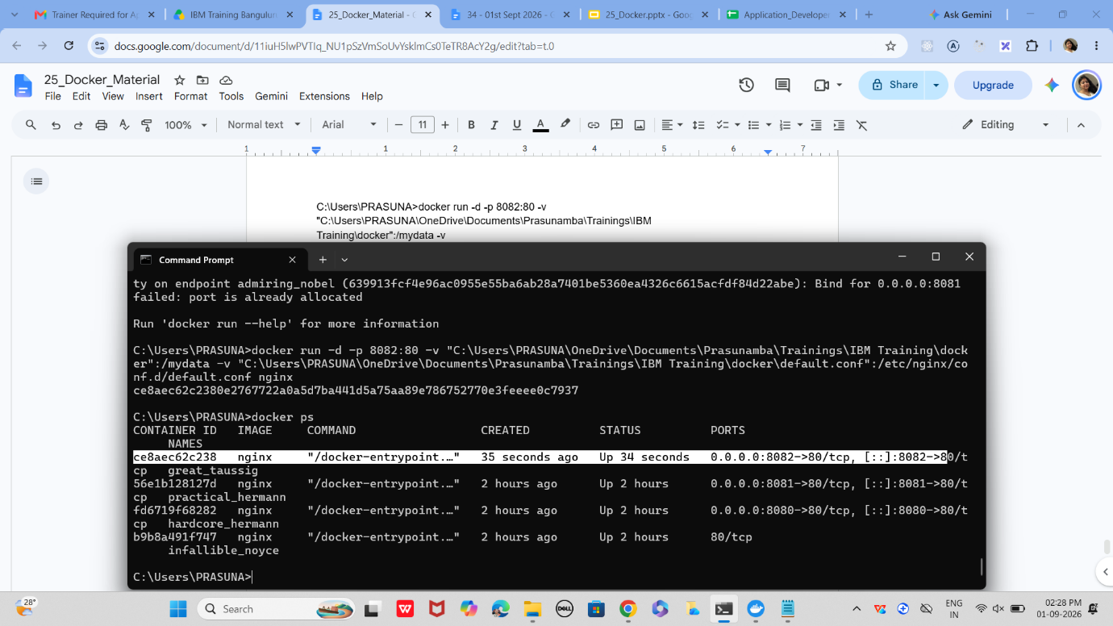
Test in browser
Open:
Code
http://localhost:8081
- Now Nginx will serve your index.html directly from /mydata.
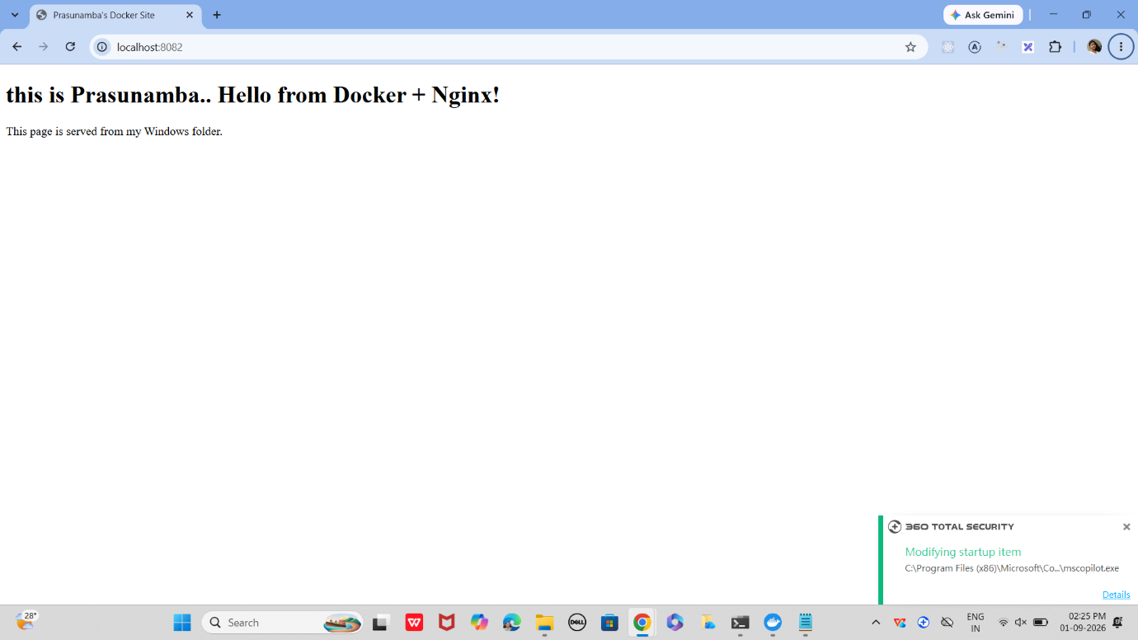
Result
- You don’t need to copy files into /usr/share/nginx/html anymore.
- Any file you place in your Windows folder will be served immediately by Nginx.
- This setup is perfect for training demos — you can edit HTML locally and refresh the browser to see changes instantly.

Task 3:

You now have a full-stack Docker project with app, DB, and proxy.
It demonstrates images, compose, registry, engine, storage, and networking in one workflow.

================================================================================================================================

docker-project/
├── app/
│ ├── Dockerfile
│ ├── server.js
│ └── package.json
├── nginx/
│ └── nginx.conf
└── docker-compose.yml

Step 1:

1. Node.js App (app/server.js)

// Simple Express app connecting to Postgres
const express = require("express");
const { Pool } = require("pg");

const app = express();
const port = 3000;

// Database connection (matches docker-compose.yml)
const pool = new Pool({
user: "user",
host: "db", // service name in docker-compose
database: "mydb",
password: "password",
port: 5432,
});

app.get("/", async (req, res) => {
try {
const result = await pool.query("SELECT NOW()");
res.send(`Hello from Node.js! DB time: ${result.rows[0].now}`);
} catch (err) {
res.send("Error connecting to DB: " + err);
}
});

app.listen(port, () => {
console.log(`App running on port ${port}`);
});

2. Node.js Package File (app/package.json)

{
"name": "docker-node-app",
"version": "1.0.0",
"main": "server.js",
"scripts": {
"start": "node server.js"
},
"dependencies": {
"express": "^4.18.2",
"pg": "^8.11.1"
}
}

3. Dockerfile for App (app/Dockerfile)

# Use Node.js base image
FROM node:18

# Set working directory
WORKDIR /app

# Copy package.json and install dependencies
COPY package.json .
RUN npm install

# Copy rest of the app
COPY . .

# Expose port
EXPOSE 3000

# Start app
CMD ["npm", "start"]

4. Nginx Config (nginx/nginx.conf)

events {}

http {
server {
listen 80;

location / {
proxy_pass http://app:3000; # Forward traffic to Node.js service
}
}
}

5. Docker Compose (docker-compose.yml)

version: "3.8"
services:
app:
build: ./app
container_name: nodeapp
depends_on:
- db
networks:
- mynet

db:
image: postgres:15
container_name: postgresdb
environment:
POSTGRES_USER: user
POSTGRES_PASSWORD: password
POSTGRES_DB: mydb
volumes:
- db_data:/var/lib/postgresql/data
networks:
- mynet

nginx:
image: nginx:latest
container_name: nginxproxy
ports:
- "8080:80"
volumes:
- ./nginx/nginx.conf:/etc/nginx/nginx.conf:ro
depends_on:
- app
networks:
- mynet

volumes:
db_data:

networks:
mynet:

now execute
Build & start services:

docker compose up -d --build
Check containers:

docker ps
Yu should see all our nodeapp, postgresdb, and nginxproxy.

Test in browser:
Open http://localhost:8080 (localhost in Bing) → You’ll see output from Node.js app with DB time.

Logs:

bash
docker logs nodeapp
docker logs postgresdb
docker logs nginxproxy
Stop project:

bash
docker compose down

this is a fully-fledged project:
- Images: Node.js app built, Postgres & Nginx pulled.
- Compose: Multi-container orchestration.
- Registry: You can tag & push nodeapp to Docker Hub.
- Engine: Runs containers.
- Storage: Postgres data persisted in db_data volume.
- Networking: Custom network mynet connects all services.

