Day 18 – 10th August 2026
Redirecting Output (> and >>)
> redirects normal output to a file and overwrites the existing content.
ls > files.txt
To view the content:
cat files.txt
Append Instead of Overwrite
>> redirects output to a file without deleting the existing content. It adds the new content at the end.
echo "New entry" >> files.txt
Redirecting Input (<)
The < operator is used to take input from a file and provide it to a command.
echo -e "banana\napple\ncherry" > fruits.txt
-e allows echo to interpret escape characters such as \n, which creates a new line.
Redirecting Errors (2>)
2> redirects error messages (stderr) to a file instead of displaying them on the terminal.
ls /not_a_real_folder 2> errors.txt
Here, 2 represents standard error (stderr), and errors.txt stores the error message.

Filter processes

ps aux | grep bash

Check with
Ps a → Shows processes running on the current terminal and other terminals.
Ps au → Shows detailed information about processes running for all users, including CPU and memory usage.
Ps aux → Shows detailed information about all running processes on the system.

Ps aux | grep bash → Shows all running processes and filters the output to display only processes containing bash.

| (pipe) → Sends the output of ps aux as input to grep bash.
grep bash → Searches for and displays lines containing the word bash.

du -sh * | sort -rh | head -5

vicky@IBM-C1CKC64:/mnt/c/Linux_folder$ du -sh * | sort -rh | head -5
4.0K errors.txt
0 fruits.txt
0 file1.txt
0 file.txt

Multi-stage Pipeline

Du -sh * → Shows the size of each file and folder in the current directory in a human-readable format.

du -sh * | sort -rh → Gets the sizes and sorts them from largest to smallest.
- sort → sorts the output.
- -r → reverse order.
- -h → understands human-readable sizes such as K, M, and G.

du -sh * | sort -rh | head -5 → Gets the sizes, sorts them from largest to smallest, and displays only the top 5 largest files/folders.

du -sh * | sort | head -5 → Gets the sizes, sorts them using normal alphabetical/text sorting, and displays the first 5 lines.

./script.sh >/dev/null 2>&1
./script.sh
→ Executes the script.sh file from the current directory.
>/dev/null
→ Redirects normal output (stdout) to /dev/null, so it is discarded.
2>&1
→ Redirects error output (stderr) to the same place as stdout (/dev/null).

./ filr.txt

Silent Execution will Suppress output

./script.sh > /dev/null 2>&1

Task 1: Sed
What is sed?
sed stands for Stream Editor. It is a Linux command used to search, replace, delete, and print specific lines from text files.
Create a file named:
filename.txt
Add some dummy text to the file for practicing the following commands.

1. Display the contents of a file
sed filename.txt
→ This is not the correct syntax for simply displaying a file because sed requires an editing command.
To display the contents of the file, use:
cat filename.txt

2. Replace a word with another word
sed 's/old/new/' filename.txt
→ Searches for the first occurrence of old on each line and replaces it with new.
- s → Substitute
- old → Word to search for
- new → Replacement word
- filename.txt → File to process
Example:
sed 's/lorem/python/' filename.txt

3. Replace all occurrences using the g flag
sed 's/old/new/g' filename.txt
→ Replaces all occurrences of old with new on each line.
- g → Global, meaning all matching occurrences are replaced.
Example:
sed 's/lorem/python/g' filename.txt

4. Delete lines using the d flag
sed '/word/d' filename.txt
→ Deletes every line containing the specified word from the output.
- d → Delete
Example:
sed '/lorem/d' filename.txt
This displays the file without the lines containing lorem.

5. Print a specific line
To print line 3 of the file:
sed -n '3p' filename.txt
→ Prints only line 3.
- -n → Suppresses the default output.
- 3 → Specifies line number 3.
- p → Print the selected line.

6. Print a range of lines
To print lines 2 through 5:
sed -n '2,5p' filename.txt
→ Prints only lines 2, 3, 4, and 5.
- 2,5 → Specifies the range from line 2 to line 5.
- p → Prints those lines.
- -n → Prevents other lines from being displayed.

Task 2: Awk
Awk is used for pattern scanning and processing. It is especially useful for processing text files, filtering rows, and working with columns or fields.
1. Print the contents of a file
awk '{print}' filename
→ Prints the entire contents of the file.

2. Print a specific column
awk '{print $2}' filename
→ Prints only the second column from each line.
- $1 → First column
- $2 → Second column
- $3 → Third column

3. Print multiple columns
awk '{print $1, $3}' filename
→ Prints the first and third columns from each line.
- $1 → First column
- $3 → Third column
- , → Adds a space between the columns.

4. Filter rows using a condition
To print the 1st and 3rd columns only when the value in the 3rd column is greater than 50:
awk '$3 > 50 {print $1, $3}' filename
→ Checks whether the value in the 3rd column is greater than 50. If the condition is true, it prints the 1st and 3rd columns.
- $3 > 50 → Condition
- $1 → First column
- $3 → Third column

5. Use a custom delimiter
If the fields in the file are separated by a comma (,), use -F, to specify the comma as the field separator.
awk -F, '{print $1, $2}' filename
→ Uses the comma as the delimiter and prints the first two fields.
- -F, → Sets comma as the field separator.
- $1 → First field.
- $2 → Second field.
For example, if the file contains:
John,25,Bangalore
David,30,Mumbai
Alex,28,Chennai
The output will be:
John 25
David 30
Alex 28

6. Count the number of lines
awk 'END {print NR}' filename
→ Prints the total number of lines (records) in the file.
- NR → Number of records (lines) processed.
- END → Runs after all lines have been processed.
- print NR → Prints the final value of NR, which gives the total number of lines.

Task 3:

Ping google.com
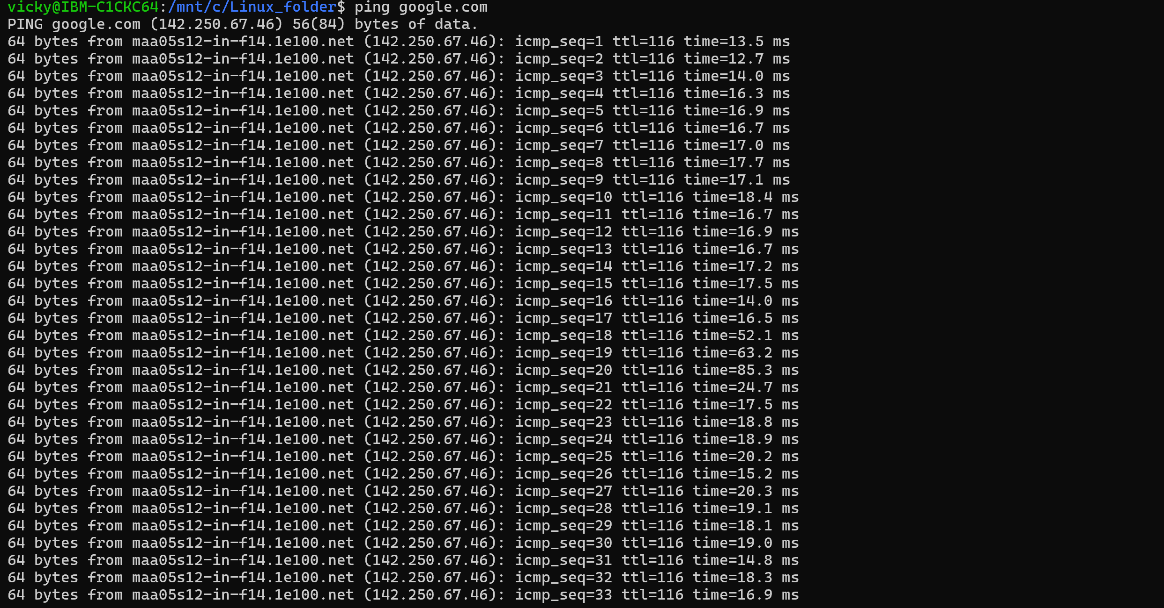
Curl https://google.com

Task 4:

Install open ssl in your system

https://www.xolphin.com/support/OpenSSL/OpenSSL_-_Installation_under_Windows#:~:text=Download%20the%20OpenSSL%20for%20Windows,file%20can%20be%20downloaded%20here.

Or

https://slproweb.com/products/Win32OpenSSL.html

Step 2 Generate a certificate signing request (CSR)

openssl genrsa -out localhost.key 2048
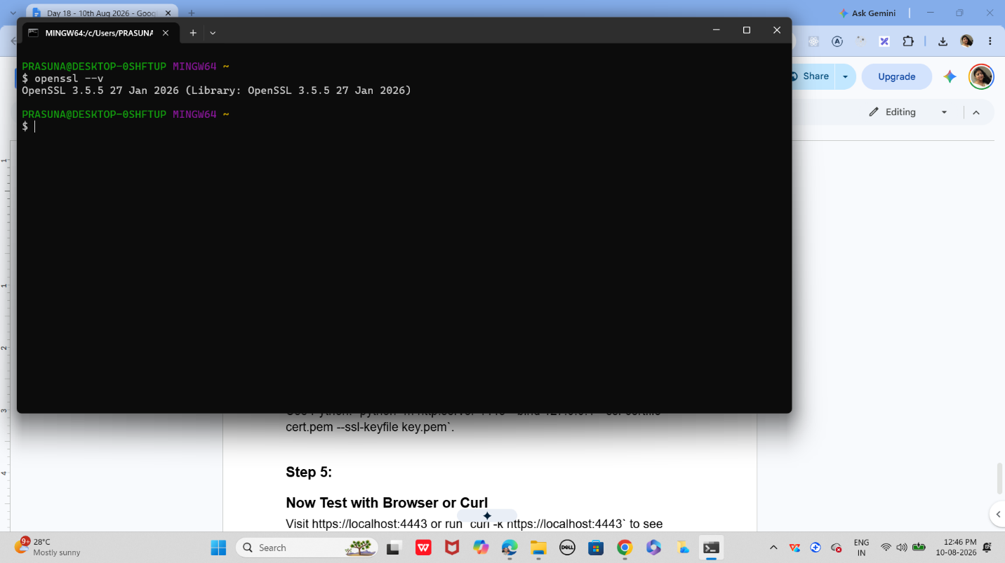

Step 3:

Generate a self-signed certificate
In bash
openssl x509 -req -days 365 -in localhost.csr -signkey localhost.key -out localhost.crt

Step 4:

Now Start a Simple HTTPS Server
Use Python: `python -m http.server 4443 --bind 127.0.0.1 --ssl-certfile cert.pem --ssl-keyfile key.pem`.

Step 5:

Now Test with Browser or Curl
Visit https://localhost:4443 or run `curl -k https://localhost:4443` to see encrypted communication.

Step 6:

Did u Observe TLS Handshake
Use Wireshark or `openssl s_client -connect localhost:4443` to watch how TLS negotiates keys and ciphers.

Step 7:

Verify Certificate Trust
Browsers will warn about self-signed certs; in real deployments, use CA-issued certificates for trust.

Task 5:
What are trees ? where do you implement them?
A tree is a non-linear data structure that organizes data in a hierarchical structure using nodes and edges.
Each tree has a root node, and nodes can have child nodes. A tree does not contain cycles.
Where are Trees Implemented?
Trees are commonly used in:
- File systems → Folders and files are organized hierarchically.
- Databases → B-Trees and B+ Trees are used for indexing.
- HTML/XML DOM → Web pages are represented as a tree of elements.
- Searching → Binary Search Trees help organize data for efficient searching.
- Compilers → Abstract Syntax Trees (ASTs) represent program structure.
- Artificial Intelligence → Decision trees are used for decision-making.
- Networking → Routing and hierarchical network structures.

Task 6:
Can you give types of trees?
- Binary Tree → Each node can have at most two children.
- Binary Search Tree (BST) → Left child contains smaller values and right child contains larger values.
- AVL Tree → A self-balancing Binary Search Tree.
- Red-Black Tree → A self-balancing binary search tree using color properties.
- Heap → A complete binary tree commonly used for priority queues.
- B-Tree → A balanced tree commonly used in databases and file systems.
- B+ Tree → A variation of B-Tree widely used for database indexing.
- Trie → A tree used for storing and searching strings efficiently.
- N-ary Tree → A node can have more than two children.
- Decision Tree → Used in machine learning for making decisions based on conditions.

Task 7:
What is binary search tree?
A Binary Search Tree (BST) is a type of binary tree where each node follows a specific ordering rule:
- Values smaller than the node are stored in the left subtree.
- Values greater than the node are stored in the right subtree.
- Each node can have a maximum of two children.

Task 8:
Can you create a simple binary tree using a node and insert values in it?

Like in java

class Node {
int val;
Node left, right;
Node(int val) { this.val = val; }
}

Insert values in left side and right side of the nodes and display the tree values
class Node {
int val;
Node left, right;
Node(int val) {
this.val = val;
}
}
public class BinaryTree {
public static void main(String[] args) {
// Create the root node
Node root = new Node(50);
// Insert nodes
root.left = new Node(30);
root.right = new Node(70);
// Insert nodes under 30
root.left.left = new Node(20);
root.left.right = new Node(40);
// Insert nodes under 70
root.right.left = new Node(60);
root.right.right = new Node(80);
// Display tree values
System.out.println("Root: " + root.val);
System.out.println("Left of root: " + root.left.val);
System.out.println("Right of root: " + root.right.val);
System.out.println("Left of 30: " + root.left.left.val);
System.out.println("Right of 30: " + root.left.right.val);
System.out.println("Left of 70: " + root.right.left.val);
System.out.println("Right of 70: " + root.right.right.val);
}
}

Task 9
Now extend the above code to search a no in your list.
We can extend the previous code by adding a search() method. Since our tree is a Binary Search Tree (BST), we compare the number with the current node and decide whether to search on the left or right side.
class Node {
int val;
Node left, right;
Node(int val) {
this.val = val;
}
}
public class BinaryTree {
// Search for a value in the BST
static boolean search(Node root, int value) {
// Value not found
if (root == null) {
return false;
}
// Value found
if (root.val == value) {
return true;
}
// Search in the left subtree
if (value < root.val) {
return search(root.left, value);
}
// Search in the right subtree
return search(root.right, value);
}
public static void main(String[] args) {
// Create the root node
Node root = new Node(50);
// Insert values
root.left = new Node(30);
root.right = new Node(70);
root.left.left = new Node(20);
root.left.right = new Node(40);
root.right.left = new Node(60);
root.right.right = new Node(80);
// Search for a number
int number = 60;
if (search(root, number)) {
System.out.println(number + " is found in the tree.");
} else {
System.out.println(number + " is not found in the tree.");
}
}
}

Task 10:
Now can you do inorder traversal in your bst?
Inorder traversal visits the nodes in this order:
Left → Root → Right
For a Binary Search Tree, inorder traversal prints the values in ascending order.
class Node {
int val;
Node left, right;
Node(int val) {
this.val = val;
}
}
public class BinaryTree {
// Inorder traversal
static void inorder(Node root) {
if (root == null) {
return;
}
// Visit left subtree
inorder(root.left);
// Visit root
System.out.print(root.val + " ");
// Visit right subtree
inorder(root.right);
}
public static void main(String[] args) {
// Create the root
Node root = new Node(50);
// Insert values
root.left = new Node(30);
root.right = new Node(70);
root.left.left = new Node(20);
root.left.right = new Node(40);
root.right.left = new Node(60);
root.right.right = new Node(80);
// Perform inorder traversal
System.out.println("Inorder Traversal:");
inorder(root);
}
}

Task 11:
What is the fundamental difference between BFS and DFS?
BFS (Breadth-First Search) and DFS (Depth-First Search) are graph/tree traversal algorithms. The fundamental difference is how they explore the nodes.

BFS – Breadth-First Search
BFS explores nodes level by level. It visits all neighboring nodes first before moving to the next level.
- Uses a Queue (FIFO).
- Useful for finding the shortest path in an unweighted graph.
Example:
1
/ \
2 3
/ \ \
4 5 6

DFS – Depth-First Search
DFS explores as far as possible along one branch before backtracking and exploring another branch.
- Uses a Stack (LIFO) or recursion.
- Useful for exploring paths, detecting cycles, and solving maze-like problems.
DFS order can be:
1 → 2 → 4 → 5 → 3 → 6

Task 12:
Which underlying data structures are used to implement BFS and DFS?

BFS – Breadth-First Search
BFS uses a Queue data structure.
BFS → Queue → FIFO
FIFO (First In, First Out) means the node that enters the queue first is processed first.
Example:
Queue: [2, 3]
↑
process 2 first

DFS – Depth-First Search
DFS uses a Stack data structure.
DFS → Stack → LIFO
LIFO (Last In, First Out) means the most recently added node is processed first.
DFS can also be implemented using recursion, because the program's call stack acts like a stack.

Task 13:
How do you find the shortest path in an unweighted graph?
To find the shortest path in an unweighted graph, we use BFS (Breadth-First Search).
BFS visits nodes level by level, so the first time we reach the destination node, we have found the shortest path in terms of the number of edges.

Example
A
/ \
B C
/ \
D E
\ /
F
To find the shortest path from A to F:
A → B → D → F
There are 3 edges, so this is the shortest path.

Task 14:
How do you detect a cycle in a graph?
A cycle exists when you can start from a node and follow edges to eventually return to the same node.

1. Cycle Detection in an Undirected Graph
Use DFS (Depth-First Search) and keep track of the parent node.
While traversing:
- If a neighbor is not visited, continue DFS.
- If a neighbor is already visited and it is not the parent, a cycle exists.
Example:
A ─── B
| |
└─── C
Here:
A → B → C → A
forms a cycle.

2. Cycle Detection in a Directed Graph
Use DFS with a recursion stack.
- Mark a node as visited.
- Keep track of nodes currently in the recursion path.
- If you reach a node that is already in the current recursion stack, a cycle exists.

task 15:
Explain the internal working of a HashMap.
Java's HashMap stores data in key-value pairs.
Internally, HashMap works roughly like this:
- The key's hashCode() is calculated.
- The hash is used to determine the bucket/index where the entry should be stored.
- The key-value pair is stored in that bucket.
- When using get(key), Java calculates the hash again and goes to the appropriate bucket.
- It then uses equals() to identify the exact key.
- If multiple keys map to the same bucket, Java handles this using a linked structure/tree structure.

Task 16:
Which property of a hashmap is used to find the intersection of two arrays?
The important property is that a HashMap provides fast key-based lookup.
For example, if we have:
Array 1: 1 2 3 4 5
Array 2: 3 4 5 6 7
We can store the elements of the first array as keys:
HashMap:
1 → true
2 → true
3 → true
4 → true
5 → true
Then check each element of the second array using containsKey().
if (map.containsKey(value)) {
System.out.println(value);
}
The common elements are:
3 4 5

Task 17:
What is collision in HashMap?
A collision occurs when two different keys produce the same bucket/index after hashing.
For example:
Key A → Bucket 5
Key B → Bucket 5
Both keys want to be stored in the same bucket.
Java's HashMap handles collisions by storing multiple entries in the same bucket using a linked structure, and in certain situations the structure can be converted into a balanced tree to improve performance.
Example:
Bucket 5
|
↓
[Key A, Value A]
↓
[Key B, Value B]
When retrieving a value, HashMap uses:
hashCode()
↓
Find bucket
↓
equals()
↓
Find correct key
So, collision does not mean that data is lost; HashMap has mechanisms to store and retrieve the colliding entries.

Task 18:
How Does Java's Capacity And Size Of Hashmap Differ?
Capacity and size are two different things.
Capacity
Capacity is the number of buckets available internally in the HashMap.
For example:
HashMap<Integer, String> map = new HashMap<>(16);
The initial capacity is 16.
Size
Size is the number of key-value pairs currently stored in the HashMap.
For example:
map.put(1, "A");
map.put(2, "B");
map.put(3, "C");
Now:
Capacity → 16
Size → 3
So:
Capacity = number of buckets available internally.
Size = number of key-value entries currently stored.

Task 19:
Does hashmap allow you to store null values?
Yes, We can store as many null values in a hashmap as we want but only one null key can be stored not more than that.

Let’s see a program that depicts how we can store null values in a hashmap.

import java.util.*;
import java.io.*;
public class interviewBit {
public static void main(String[] args)
{
HashMap hmap=new HashMap();
hmap.put(1,"Program to store null value");
hmap.put(null,"InterviewBit");
System.out.println(hmap);
}
}

Can you predict the output and also explain.. I or 2 lines
{null=InterviewBit, 1=Program to store null value}
Explanation: HashMap allows one null key, while multiple different keys can have null values. In this program, the null key stores "InterviewBit".

Task 20:
hashmaps in Java are not thread-safe.can you juztify?
Yes, HashMap is not thread-safe because multiple threads can access and modify it simultaneously without automatic synchronization.
For example, if two threads modify the same HashMap at the same time, it can lead to inconsistent or unexpected results.
For thread-safe operations, you can use ConcurrentHashMap or synchronize access to the HashMap.

Task 21:
Can you store multiple keys with the same value in a hashmap?
Yes. A HashMap allows multiple different keys to have the same value.
Example:
HashMap<Integer, String> map = new HashMap<>();

map.put(1, "Java");
map.put(2, "Java");
map.put(3, "Java");

System.out.println(map);
Output:
{1=Java, 2=Java, 3=Java}
Explanation: Keys must be unique, but multiple keys can have the same value.

Task 22:
can you tell the differences between a Hashmap and a Hashtable in Java.
HashMap | Hashtable
Not synchronized | Synchronized
Not thread-safe by default | Thread-safe
Allows one null key | Does not allow null key
Allows multiple null values | Does not allow null values
Generally faster | Generally slower due to synchronization
Introduced with Java Collections Framework | Legacy class
Preferred for most single-threaded use cases | Mostly maintained for legacy compatibility

Sorting Algorithms
Task 23:
Can you create a java code for bubble sort …
The snippet for your ref is given below
1. Bubble Sort
- Concept: Repeatedly swaps adjacent elements if they are in the wrong order.
- Complexity: O(n2)
- Best for: Small datasets or teaching algorithm basics.
java
for (int i = 0; i < n-1; i++)
for (int j = 0; j < n-i-1; j++)
if (arr[j] > arr[j+1])
swap(arr[j], arr[j+1]);

Visualization: Each pass “bubbles” the largest element to the end.
public class BubbleSort {
public static void main(String[] args) {
int[] arr = {5, 3, 8, 4, 2};
// Bubble Sort
for (int i = 0; i < arr.length - 1; i++) {
for (int j = 0; j < arr.length - 1 - i; j++) {
// Compare adjacent elements
if (arr[j] > arr[j + 1]) {
// Swap elements
int temp = arr[j];
arr[j] = arr[j + 1];
arr[j + 1] = temp;
}
}
}
// Display sorted array
System.out.println("Sorted Array:");
for (int num : arr) {
System.out.print(num + " ");
}
}
}

Task 24:
Can you create a java code for selection sort …
The snippet for your ref is given below
2. Selection Sort
- Concept: Selects the smallest element and places it at the beginning.
- Complexity: O(n2)
- Best for: Simple, predictable sorting.
java
for (int i = 0; i < n-1; i++) {
int min = i;
for (int j = i+1; j < n; j++)
if (arr[j] < arr[min]) min = j;
swap(arr[i], arr[min]);
}
public class SelectionSort {
public static void main(String[] args) {
int[] arr = {64, 25, 12, 22, 11};
int n = arr.length;
// Selection Sort
for (int i = 0; i < n - 1; i++) {
// Assume current element is minimum
int min = i;
// Find the smallest element
for (int j = i + 1; j < n; j++) {
if (arr[j] < arr[min]) {
min = j;
}
}
// Swap the minimum element with arr[i]
int temp = arr[i];
arr[i] = arr[min];
arr[min] = temp;
}
// Display sorted array
System.out.println("Sorted Array:");
for (int num : arr) {
System.out.print(num + " ");
}
}
}

Task 25:
searching Algorithms
Can you create a java code for linear search …
The snippet for your ref is given below
1. Linear Search
- Concept: Sequentially checks each element.
- Complexity: O(n)
- Best for: Unsorted or small datasets.
java
for (int i = 0; i < n; i++)
if (arr[i] == key) return i;
1. Linear Search
Concept: Linear Search checks each element one by one until the required value is found.
- Time Complexity: O(n)
- Best for: Unsorted or small datasets.
- Approach: Check each element → If it matches, return its index.

public class LinearSearch {
public static void main(String[] args) {
int[] arr = {10, 25, 30, 45, 50};
int key = 30;
int result = -1;
// Linear Search
for (int i = 0; i < arr.length; i++) {
if (arr[i] == key) {
result = i;
break;
}
}
// Display result
if (result != -1) {
System.out.println("Element found at index: " + result);
} else {
System.out.println("Element not found");
}
}
}

Home tasks:
Can you create a java code for earch of the below sort and search …

The snippet for your ref is given below
3. Insertion Sort
- Concept: Builds the sorted array one element at a time.
- Complexity: O(n2)
- Best for: Nearly sorted data.
java
for (int i = 1; i < n; i++) {
int key = arr[i];
int j = i - 1;
while (j >= 0 && arr[j] > key)
arr[j+1] = arr[j--];
arr[j+1] = key;
}
public class InsertionSort {
public static void main(String[] args) {
int[] arr = {12, 11, 13, 5, 6};
// Insertion Sort
for (int i = 1; i < arr.length; i++) {
int key = arr[i];
int j = i - 1;
// Shift elements greater than key to the right
while (j >= 0 && arr[j] > key) {
arr[j + 1] = arr[j];
j--;
}
// Insert key at the correct position
arr[j + 1] = key;
}
// Display sorted array
System.out.println("Sorted Array:");
for (int num : arr) {
System.out.print(num + " ");
}
}
}

4. Merge Sort
- Concept: Divide and conquer — splits array, sorts halves, merges results.
- Complexity: O(nlog⁡n)
- Best for: Large datasets.
java
void mergeSort(int[] arr, int l, int r) {
if (l < r) {
int m = (l + r) / 2;
mergeSort(arr, l, m);
mergeSort(arr, m+1, r);
merge(arr, l, m, r);
}
}
public class MergeSort {
// Merge two sorted parts
static void merge(int[] arr, int l, int m, int r) {
int n1 = m - l + 1;
int n2 = r - m;
int[] left = new int[n1];
int[] right = new int[n2];
// Copy data into temporary arrays
for (int i = 0; i < n1; i++) {
left[i] = arr[l + i];
}
for (int j = 0; j < n2; j++) {
right[j] = arr[m + 1 + j];
}
int i = 0;
int j = 0;
int k = l;
// Compare and merge
while (i < n1 && j < n2) {
if (left[i] <= right[j]) {
arr[k] = left[i];
i++;
} else {
arr[k] = right[j];
j++;
}
k++;
}
// Copy remaining elements from left
while (i < n1) {
arr[k] = left[i];
i++;
k++;
}
// Copy remaining elements from right
while (j < n2) {
arr[k] = right[j];
j++;
k++;
}
}
// Merge Sort
static void mergeSort(int[] arr, int l, int r) {
if (l < r) {
int m = (l + r) / 2;
mergeSort(arr, l, m);
mergeSort(arr, m + 1, r);
merge(arr, l, m, r);
}
}
public static void main(String[] args) {
int[] arr = {38, 27, 43, 3, 9, 82, 10};
mergeSort(arr, 0, arr.length - 1);
System.out.println("Sorted Array:");
for (int num : arr) {
System.out.print(num + " ");
}
}
}

5. Quick Sort
- Concept: Selects a pivot, partitions array around it.
- Complexity: Average O(nlog⁡n), Worst O(n2)
- Best for: Fast in practice, widely used.
java
int partition(int[] arr, int low, int high) {
int pivot = arr[high];
int i = low - 1;
for (int j = low; j < high; j++)
if (arr[j] < pivot) swap(arr[++i], arr[j]);
swap(arr[i+1], arr[high]);
return i+1;
}

Search
public class QuickSort {
// Partition the array
static int partition(int[] arr, int low, int high) {
int pivot = arr[high];
int i = low - 1;
for (int j = low; j < high; j++) {
if (arr[j] < pivot) {
i++;
// Swap arr[i] and arr[j]
int temp = arr[i];
arr[i] = arr[j];
arr[j] = temp;
}
}
// Place pivot in its correct position
int temp = arr[i + 1];
arr[i + 1] = arr[high];
arr[high] = temp;
return i + 1;
}
// Quick Sort
static void quickSort(int[] arr, int low, int high) {
if (low < high) {
int pivotIndex = partition(arr, low, high);
quickSort(arr, low, pivotIndex - 1);
quickSort(arr, pivotIndex + 1, high);
}
}
public static void main(String[] args) {
int[] arr = {10, 7, 8, 9, 1, 5};
quickSort(arr, 0, arr.length - 1);
System.out.println("Sorted Array:");
for (int num : arr) {
System.out.print(num + " ");
}
}
}

2. Binary Search
- Concept: Repeatedly divides sorted array in half.
- Complexity: O(log⁡n)
- Best for: Sorted data.
java
int binarySearch(int[] arr, int key) {
int low = 0, high = arr.length - 1;
while (low <= high) {
int mid = (low + high) / 2;
if (arr[mid] == key) return mid;
if (arr[mid] < key) low = mid + 1;
else high = mid - 1;
}
return -1;
}
public class BinarySearch {
static int binarySearch(int[] arr, int key) {
int low = 0;
int high = arr.length - 1;
while (low <= high) {
int mid = (low + high) / 2;
if (arr[mid] == key) {
return mid;
}
if (arr[mid] < key) {
low = mid + 1;
} else {
high = mid - 1;
}
}
return -1;
}
public static void main(String[] args) {
int[] arr = {10, 20, 30, 40, 50, 60, 70};
int key = 50;
int result = binarySearch(arr, key);
if (result != -1) {
System.out.println("Element found at index: " + result);
} else {
System.out.println("Element not found");
}
}
}

Algorithm | Type | Time Complexity | Space Complexity | Stability
Bubble Sort | Sorting | O(n2) | O(1) | ✅
Selection Sort | Sorting | O(n2) | O(1) | ❌
Insertion Sort | Sorting | O(n2) | O(1) | ✅
Merge Sort | Sorting | O(nlog⁡n) | O(n) | ✅
Quick Sort | Sorting | O(nlog⁡n) | O(log⁡n) | ❌

