Day 16 - 06th Aug 2026

Task 1:
In yesterday's project can you implement a custom pipe to mask the account number..
import { Pipe, PipeTransform } from '@angular/core';

@Pipe({
name: 'uppercase'
})
export class UppercasePipe implements PipeTransform {

transform(value: string): string {
return value.toUpperCase();
}

}

import { UppercasePipe } from './uppercase-pipe';

describe('UppercasePipe', () => {
it('create an instance', () => {
const pipe = new UppercasePipe();
expect(pipe).toBeTruthy();
});
});

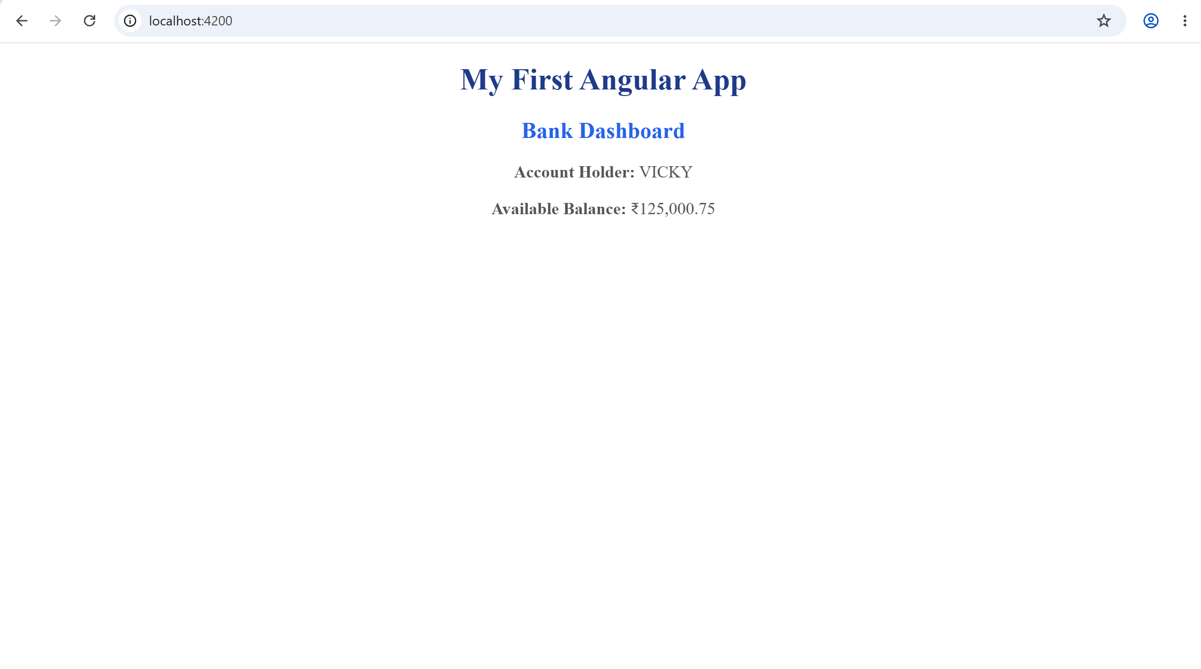

Task 2:
Also use currency pipe for the amount.

For eg In you dashboard.component.ts a sample code for your ref.
import { CurrencyPipe } from '@angular/common';

And

@Component({
selector: 'app-dashboard',
standalone: true,
imports: [CurrencyPipe],
template: `
<h2>Account Dashboard</h2>
<p>Balance: {{ balance | currency: 'INR' }}</p>
`,
})

dashboard.component.ts
import { Component } from '@angular/core';
import {CurrencyPipe} from "@angular/common"
@Component({
selector: 'app-dashboard',
standalone: true,
imports:[CurrencyPipe],
templateUrl: './dashboard.html',
styleUrl: './dashboard.css'
})
export class Dashboard {
title: string = 'Dashboard';
accountHolder = "Vicky";

balance = 125000.75;
}

dashboard.component.html
<h2>Bank Dashboard</h2>

<p><strong>Account Holder:</strong> {{ accountHolder }}</p>

<p><strong>Available Balance:</strong>
{{ balance | currency:'INR' }}
</p>

Task 3:

Create a service banking.service.ts or fund-transfer.service.ts

Http requests.. Use the Crud operations for – post , get, delete, patch ….

import { HttpClient } from '@angular/common/http';

Task 4:

Create authentication for your account’s id and password..
For eg : auth.service.ts
And then add a protection card to your auth.service - like if he is valid user he has to see the transactions..
Name it as auth.gaurd.ts

