Day 14 - 04th Aug 2026

Task 1:
What do you understand by Git collaboration?
Git collaboration is the process of multiple developers working together on the same project using Git. Each developer works on their own branch, makes changes independently, and then shares those changes by pushing them to a remote repository (such as GitHub, GitLab, or Bitbucket). The changes are then reviewed and merged into the main branch.
Multiple developers can work on the same project simultaneously.
Developers create separate branches for different features or bug fixes.
Changes are shared through a remote repository.
Pull requests (or merge requests) are used to review and merge code.

Task 2:
Why is collaboration necessary while working on git?
Collaboration is necessary because software projects are usually developed by teams rather than individuals. Git enables team members to work efficiently without overwriting each other's work.
- Allows multiple developers to work on the same project at the same time.
- Prevents conflicts by using separate branches.
- Makes it easier to track who made each change.
- Supports code reviews before merging changes.
- Helps manage bug fixes, new features, and releases efficiently.
- Maintains a complete version history, making it easy to revert changes if needed.

Task 3:
What are the commands that we use while collaborating?
Command | Purpose
git clone <repository-url> | Copies the remote repository to your local machine.
git branch | Lists all local branches.
git checkout <branch-name> | Switches to an existing branch.
git checkout -b <branch-name> | Creates and switches to a new branch.
git status | Shows the current status of the working directory.
git add <file> or git add . | Stages changes for commit.
git commit -m "message" | Saves the staged changes locally with a message.
git pull origin <branch> | Downloads and merges the latest changes from the remote repository.
git push origin <branch> | Uploads local commits to the remote repository.
git fetch | Downloads the latest changes without merging them.
git merge <branch> | Merges another branch into the current branch.
git rebase <branch> | Reapplies commits on top of another branch to maintain a cleaner history.
git log | Displays the commit history.

Task 4:
Can you show the typical work flow while working on Git ?
Clone → Pull → Create Branch → Code → Add → Commit → Push → Pull Request → Review → Merge

Task 5:
Give some to do practices that we need to follow while working on Git Repo on a daily basis.
Pull the latest changes before starting work.
- Keeps your local repository up to date.
Always work on a separate branch.
- Never develop directly on the main or master branch.
Commit frequently with meaningful commit messages.
Push your changes regularly.
- This creates a backup of your work and allows teammates to see your progress.
Resolve merge conflicts carefully.
- Review conflicting code before committing.
Review your changes before committing.
Keep branches focused on one task.
- One feature or one bug fix per branch.
Delete merged branches.
- Helps keep the repository clean.
Write clear Pull Request (PR) descriptions.
- Explain what changes were made and why.
Never commit sensitive information.
- Avoid passwords, API keys, or confidential files.
Follow your team's branching strategy.
- Examples: Git Flow, GitHub Flow, or feature-branch workflow.

Task 6:
Create a demo typescript file and execute it
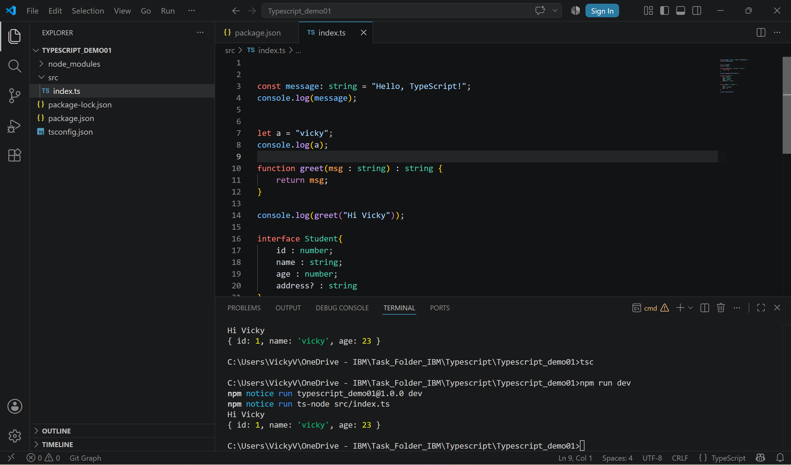

Task 7:
Create an interface and try it out?
interface Student{
id : number;
name : string;
age : number;
address? : string
}

const student1 : Student = {
id : 1,
name : "vicky",
age : 23
};

console.log(student1);

Task 8:
In the above code use optional variable ?
interface Student{
id : number;
name : string;
age : number;
address? : string
}

const student1 : Student = {
id : 1,
name : "vicky",
age : 23
};

console.log(student1);

Task 9:
Create a demo with constructor, default and with parameterised..
class Student {

id: number = 0;
name: string = "";

constructor() {
console.log("Default Constructor Called");
}
}

const s1 = new Student();

console.log(s1.id);
console.log(s1.name);

Task 10;
What are primitive and special data types in typescript?
Data Type | Description | Example
number | Stores integers and floating-point numbers | let age: number = 22;
string | Stores text | let name: string = "Vicky";
boolean | Stores true or false | let isActive: boolean = true;
bigint | Stores very large integers | let big: bigint = 12345678901234567890n;
symbol | Stores unique identifiers | let id: symbol = Symbol("id");
null | Represents an intentional empty value | let data: null = null;
undefined | Represents an uninitialized value | let value: undefined = undefined;

Task 11:
Create a class with access modifiers.

class Employee {

public id: number;
private salary: number;
protected department: string;

constructor(id: number, salary: number, department: string) {
this.id = id;
this.salary = salary;
this.department = department;
}

public display(): void {
console.log("Employee ID:", this.id);
console.log("Salary:", this.salary);
console.log("Department:", this.department);
}
}

const emp = new Employee(101, 50000, "IT");

console.log(emp.id);
emp.display();

Task 12:
To create a typescript file and run it… what are the steps … that we need to follow.. (lets suppose if I am creating ts file for the first time in my sys).
Step 1: Install Node.js
- Download and install the LTS (Long Term Support) version of Node.js from the official website.
- Verify the installation by running:
- node -v
npm -v
Step 2: Create a Project Folder
Create a new folder and navigate into it:
mkdir Typescript_Demo
cd Typescript_Demo
Step 3: Initialize a Node.js Project
Initialize the project using npm:
npm init -y
This command creates a package.json file.
Step 4: Install TypeScript and Required Packages
Install TypeScript and the required development dependencies:
npm install typescript ts-node nodemon @types/node --save-dev
Packages Installed:
- typescript – TypeScript compiler.
- ts-node – Runs TypeScript files directly without generating JavaScript files.
- nodemon – Automatically restarts the application whenever changes are made.
- @types/node – Provides TypeScript type definitions for Node.js.
Step 5: Create the TypeScript Configuration File
Generate the TypeScript configuration file:
npx tsc --init
This creates a tsconfig.json file.
Step 6: Create the Source Folder
Create a folder named src and inside it create a file named index.ts.
Project structure:
Typescript_Demo
│
├── node_modules
├── src
│ └── index.ts
├── package.json
├── package-lock.json
└── tsconfig.json
Step 7: Write the TypeScript Program
Open src/index.ts and write:
let message: string = "Hello TypeScript";

console.log(message);
Step 8: Configure the Run Script
Open package.json and add the following inside the scripts section:
"scripts": {
"dev": "ts-node src/index.ts"
}
Step 9: Run the TypeScript File
Execute the following command:
npm run dev

Task 13:
Create a demo and see how generics work in ts.
What are Generics?
Generics allow you to write reusable code that works with different data types while maintaining type safety. Instead of creating separate functions or classes for each data type, you can use a generic type parameter.

function display<T>(value: T): T {
return value;
}

console.log(display<number>(100));
console.log(display<string>("Vicky"));
console.log(display<boolean>(true));

Explanation
- <T> is a generic type parameter.
- T acts as a placeholder for the actual data type.
- When calling the function, we specify the type:
  - display<number>(100) → T becomes number
  - display<string>("Vicky") → T becomes string
  - display<boolean>(true) → T becomes boolean

Example 2: Generic Class

class Student1<T> {

value: T;

constructor(value: T) {
this.value = value;
}

display(): void {
console.log(this.value);
}
}

const s1 = new Student1<number>(101);
const s3 = new Student1<string>("Vicky");

s1.display();
s3.display();

Task 14:
What are type annotations in typescript?
Type annotations are used to explicitly specify the data type of a variable, function parameter, return value, or object property. They help TypeScript perform type checking at compile time and prevent type-related errors.
Example 1: Variable Type Annotation
let name: string = "Vicky";
let age: number = 22;
let isStudent: boolean = true;
Example 2: Function Type Annotation
function add(a: number, b: number): number {
return a + b;
}

console.log(add(10, 20));
Example 3: Array Type Annotation
let marks: number[] = [80, 90, 95];

Task 15:
What is the purpose of the any keyword in typescript?
The any type allows a variable to store any type of value. When a variable is declared as any, TypeScript disables type checking for that variable.
Example
let data: any;

data = 100;
console.log(data);

data = "Hello";
console.log(data);

data = true;
console.log(data);

Example with Function
function display(value: any): void {
console.log(value);
}

display(100);
display("TypeScript");
display(true);

Task 16:
Can you give an example to show the difference between any and unknown.
any | unknown
Disables type checking | Requires type checking
Can perform any operation directly | Cannot use the value without checking its type
Less safe | More type-safe
May cause runtime errors | Helps prevent runtime errors

Task 17:
What is the tsconfig.json file used for ?
The tsconfig.json file is the TypeScript configuration file. It tells the TypeScript compiler (tsc) how to compile the project.
It defines compiler options, source file locations, output directories, and other project settings.

Task 18:
Code
banking-app/
├── backend/
│ ├── src/
│ │ ├── index.ts
│ │ ├── routes/
│ │ │ └── accountRoutes.ts
│ │ ├── controllers/
│ │ │ └── accountController.ts
│ │ ├── models/
│ │ │ └── account.ts
│ │ └── services/
│ │ └── accountService.ts
└── frontend/
└── Angular project (ng new banking-ui)

