Day 17 - 07th Aug 2026

Task 1:
What is data binding?
Data binding is the process of connecting the data (variables) in a component with the user interface (UI). It keeps the data and the UI connected so that changes can be displayed correctly.
Example:
<h1>{{ name }}</h1>
If:
name = "Vicky";

Task 2:
What do you understand by one way data binding and two way data binding?
One-Way Data Binding
In one-way data binding, data flows in one direction only. The data moves either:
- From the component to the UI, or
- From the UI to the component.
A change in one place does not automatically update the other unless you write code for it.
Example:
<h1>{{ name }}</h1>
If:
name = "Vicky";
The page displays:
Vicky
If the value of name changes, the UI updates automatically.
Two-Way Data Binding
In two-way data binding, data flows in both directions.
- If the component data changes, the UI updates automatically.
- If the user changes the value in the UI, the component data also updates automatically.
Example:
<input [(ngModel)]="name">
<p>{{ name }}</p>
If the user types:
John
The value of name becomes "John" automatically, and the paragraph also shows:
John

Task 3:
When do you use one way data binding and when to use two way data binding?give examples.
Use One-Way Data Binding when:
- You only want to display data.
- The user does not need to change the data.
- Examples:
  - Displaying a user's name.
  - Showing product details.
  - Displaying marks or results.
  - Showing weather information.
Example:
<h2>{{ productName }}</h2>
Output:
Laptop
Use Two-Way Data Binding when:
- The user needs to enter or edit data.
- The component should immediately receive the updated value.
- Examples:
  - Login form.
  - Registration form.
  - Search box.
  - User profile edit form.
Example:
<input [(ngModel)]="username">
If the user types:
Vicky
The variable username is automatically updated to "Vicky".

Task 4:
What is the state in react?
Task 4: What is State in React?
State is a built-in feature in React that stores data for a component. The data in the state can change over time, and whenever it changes, React automatically updates the user interface (UI).
In simple words, state is the current information or data of a component.
Example:
A counter application:
- Initial state: count = 0
- After clicking the button: count = 1
- Click again: count = 2
React updates the displayed count automatically whenever the state changes.

Task 5:
Can you explain SPA?
SPA stands for Single Page Application.
A Single Page Application is a web application that loads only one HTML page. When the user navigates between pages, only the required content is updated without refreshing the entire page.
This makes the application faster and provides a smoother user experience.
Examples:
- Gmail
- Facebook
- Instagram
- Netflix
Advantages of SPA:
- Faster page loading.
- Better user experience.
- No full page refresh.
- Less communication with the server.

Task 6:
What is DOM?
DOM stands for Document Object Model.
The DOM is a tree-like structure created by the browser from an HTML document. It represents every HTML element as an object, allowing JavaScript to access and modify the page.
For example, JavaScript can:
- Change text.
- Change styles.
- Add new elements.
- Remove elements.

Task 7:
What is virtual DOM?
The Virtual DOM is a lightweight copy of the real DOM used by React.
Whenever the state or data changes:
- React creates a new Virtual DOM.
- It compares the new Virtual DOM with the previous Virtual DOM.
- It finds only the changed elements.
- React updates only those changes in the real DOM.
This process makes React applications faster and more efficient because it avoids updating the entire page.

Task 8:
What are props in react ? can you explain about prop drilling?
Props (short for Properties) are used to pass data from a parent component to a child component.
Props are read-only, which means the child component cannot change the values it receives.
Prop Drilling is the process of passing props through multiple components to reach a deeply nested child component.
Sometimes, intermediate components do not use the data, but they still have to pass it to the next component.
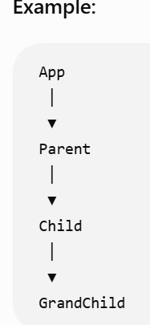
If the GrandChild needs a username, the data must be passed like this:
App → Parent → Child → GrandChild

Task 9:
Why do we use react?give importance and describe in detail.
React is a JavaScript library developed by Meta (Facebook) for building fast and interactive user interfaces.
It is mainly used to build Single Page Applications (SPAs).
Importance of React
1. Component-Based Architecture
React divides the UI into small reusable components.
Example:
- Header
- Navbar
- Footer
- Login Form
These components can be reused in multiple places.

2. Fast Performance
React uses the Virtual DOM, which updates only the changed parts of the page instead of reloading the entire page.

3. Reusable Code
Components can be reused, reducing code duplication and making maintenance easier.

4. Easy to Learn
React has a simple syntax and is easier to learn compared to many other frontend frameworks.

5. Supports Single Page Applications (SPA)
React updates only the required content without refreshing the whole page, providing a smooth user experience.

6. Large Community Support
React has a large community, extensive documentation, and many third-party libraries.

7. Easy State Management
React provides Hooks, Context API, and Redux for managing application state.

Applications built using React
- Facebook
- Instagram
- WhatsApp Web
- Netflix
- Airbnb

Task 10:
What do you understand by component based architecture?
reusable components.
Each component performs a specific task and can be reused in different parts of the application.
Example:
App
│
├── Header
├── Navbar
├── Content
├── Sidebar
└── Footer

Task 11:
Explain lifecycle of react component with diagram.. Describe mounting , unmounting etc ..
The Lifecycle of a React Component describes the different stages a component goes through from creation until it is removed.
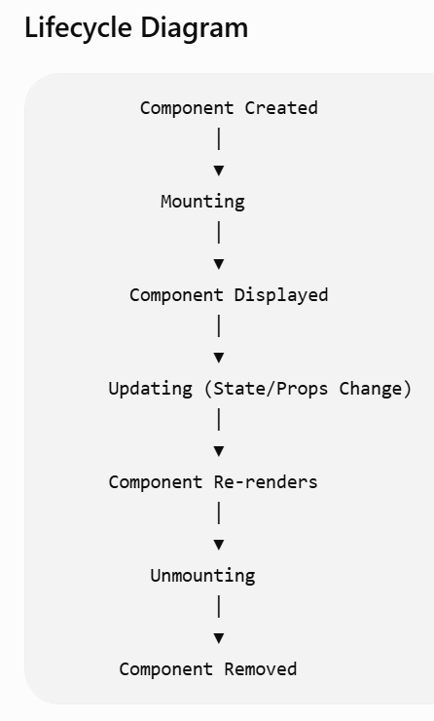

Task 12:
What are Hooks in react?why use hooks- importance ? What are different types of hooks?
What are Hooks?
Hooks are special functions introduced in React 16.8 that allow functional components to use features like state, lifecycle methods, context, and more.
Before Hooks, these features were only available in class components.

Why do we use Hooks?
Hooks are used to:
- Store component state.
- Perform API calls.
- Handle side effects.
- Access DOM elements.
- Share logic between components.
- Improve code readability.
- Replace class components with functional components.

Importance of Hooks
- Makes code shorter and cleaner.
- Improves code reusability.
- Simplifies state management.
- Supports reusable custom Hooks.
- Makes applications easier to maintain.

Common Types of Hooks
1. useState()
Stores and updates component state.
2. useEffect()
Handles side effects such as API calls, timers, and event listeners.
3. useContext()
Shares data between components without prop drilling.
4. useRef()
Accesses DOM elements and stores mutable values.
5. useMemo()
Optimizes performance by caching expensive calculations.
6. useCallback()
Prevents unnecessary recreation of functions.
7. useReducer()
Manages complex state logic.
8. useLayoutEffect()
Runs after the DOM updates but before the browser paints.
9. useId()
Generates unique IDs for accessibility.

Task 13:
What is react redux architecture ?explain in detail.
Redux is a state management library used with React to manage application data in a centralized way.
Instead of passing data through many components (prop drilling), Redux stores the data in a single central store.
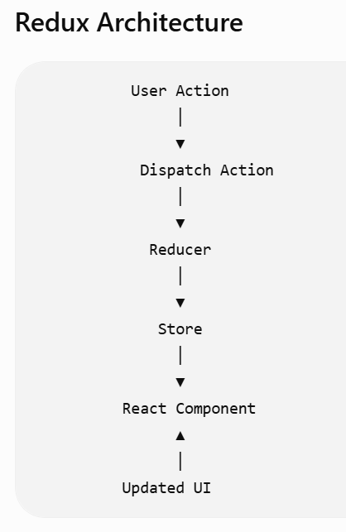

Main Parts of Redux

1. Store
The Store is the central place where the application's state is stored.
There is only one store in a Redux application.

2. Action
An Action is an object that describes what happened in the application.
Example:
{
type: "INCREMENT"
}

3. Reducer
A Reducer is a function that receives the current state and an action, then returns a new updated state.
Example:
function counterReducer(state, action) {
if (action.type === "INCREMENT") {
return state + 1;
}
return state;
}

4. Dispatch
Dispatch is used to send an action to the reducer.
Example:
dispatch({ type: "INCREMENT" });

How Redux Works
- The user performs an action (for example, clicks a button).
- The component dispatches an action.
- The reducer receives the action.
- The reducer updates the state.
- The store saves the new state.
- React automatically updates the UI with the new state.

Advantages of Redux
- Centralized state management.
- Avoids prop drilling.
- Predictable state updates.
- Easier debugging.
- Better code organization.
- Suitable for large applications.

Demo1:

10.52 to 11.07 break..

Step 1:

Create the root app —> app.jsx – with h1 tag in the function app
And export it..

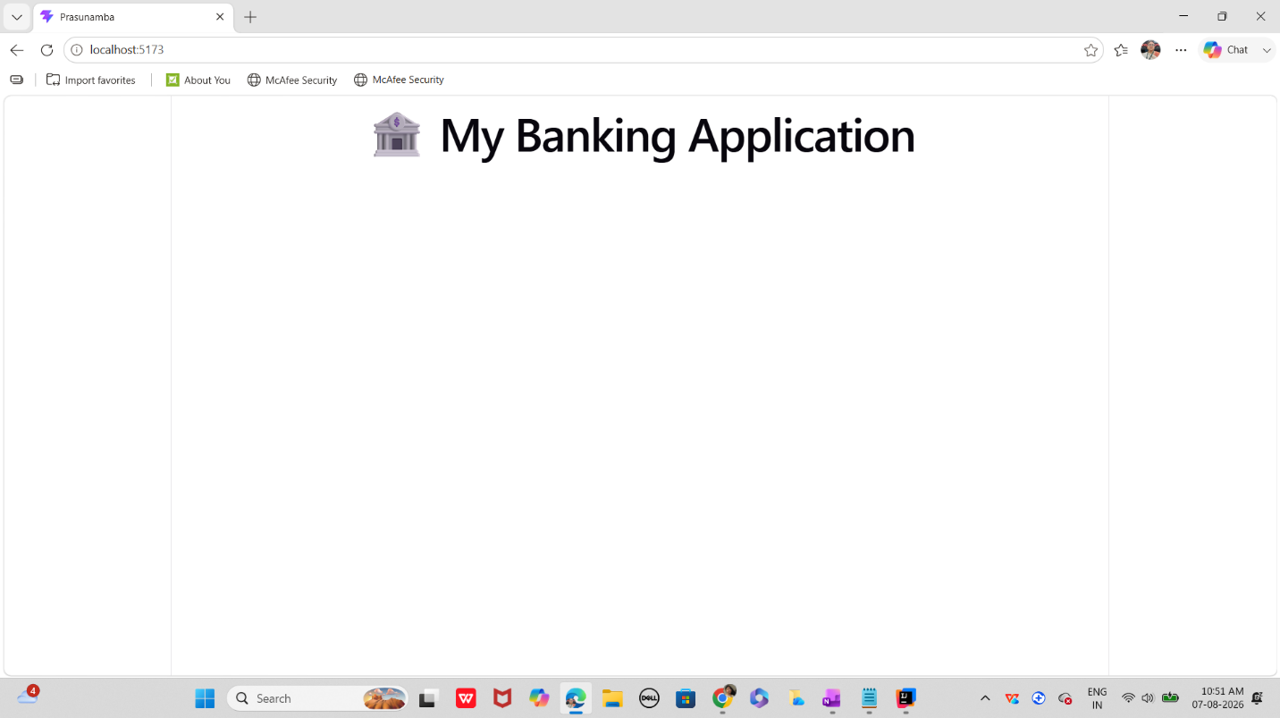

Step 2:
In src..
Create a components folder and add a function component.

Like dashboard.jsx

Step 3:
In components/ create Accounts.jsx

Step 4:

Create a usestate … initialize and use it to display the current balance

Import useState hook

import React, { useState } from "react";// react hook - usestate

Initialize the useState

const [balance, setBalance] = useState(1000);

// Handle new transaction
const handleTransaction = (type, amount) => {
let newBalance = balance;
if (type === "Deposit") newBalance += amount;
if (type === "Withdraw") newBalance -= amount;
setBalance(newBalance);

Step 4:

Conditional rendering like
Balance <0 —>

{balance < 0 && <p style={{ color: "red" }}>⚠️ Overdraft Alert!</p>}

Step 5:

In components / create TransactionForm.jsx

Now
Step 6:
Can you implement use state hook in TransactionForm.jsx
For setAmmount
Set Type → deposit.. Or so

Step 7:
Use the concept of prop drilling

Ex: prop drilling… from APP →parent → child → grand child.. Any connection break will lead to disturb prop drilling..
Note: If you add more nested layers, the chain grows longer.
Refactoring becomes painful because every layer is tied to the prop.

function App() {
const user = "Prasunamba";
return <Parent user={user} />;
}

function Parent({ user }) {
return <Child user={user} />;
}

function Child({ user }) {
return <GrandChild user={user} />;
}

function GrandChild({ user }) {
return <p>Hello {user}</p>;
}

Finally the output

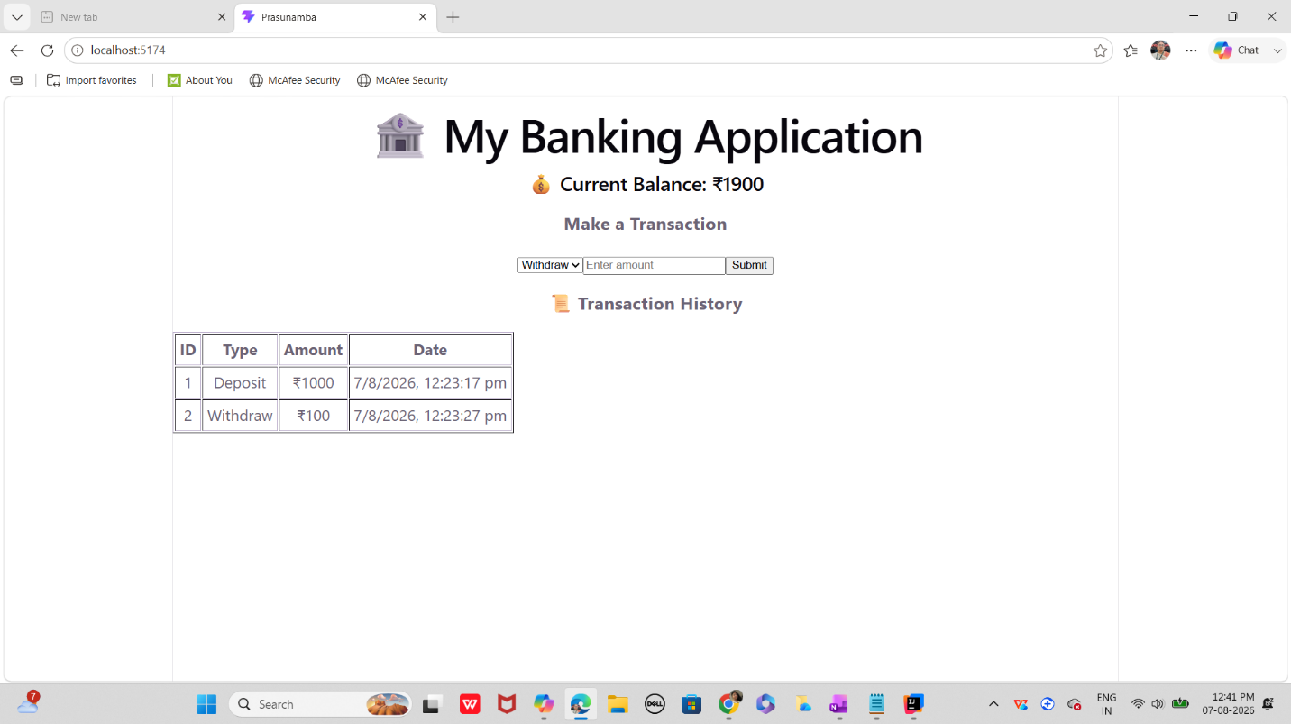

Step 8:

As you have already implemented state hooks..

Eg :useState - -> Declares a state variable and updater function.

const [count, setCount] = useState(0);

Can you try to implement one more state hook .. useReducer?

Like eg:
useReducer -> → Manages complex state logic with a reducer function.

const [state, dispatch] = useReducer(reducer, initialState);

Step 9:

Effect Hooks:

useEffect → Handles side effects (API calls, subscriptions, DOM updates).
Like example
useEffect(() => {
document.title = `Count: ${count}`;
}, [count]);

Step 10:
useLayoutEffect → Runs before the browser repaints (for layout measurements).

useInsertionEffect → Used mainly by libraries to inject styles before DOM updates.

Step 11:
Use contextHooks:

useContext → Accesses values from React Context without prop drilling.

Like eg

const theme = useContext(ThemeContext);

Step 12:
Ref Hooks:

useRef → Stores mutable values (like DOM nodes or timers) without causing re-renders.

const inputRef = useRef(null);

Step 13:
Performance Hooks
useMemo → Memoizes expensive calculations.

useCallback → Memoizes functions to avoid unnecessary re-renders.

useTransition → Manages concurrent rendering for smoother UI.

useDeferredValue → Defers updating non-critical UI parts.

Step 14:
useId → Generates unique IDs for accessibility.

useDebugValue → Labels custom hooks for debugging.

=================================================
Juz fyi only:

App.jsx

import React from "react";
import Dashboard from "./components/Dashboard";
function App() {
return (
<div>
<title>Prasunamba </title>
<h1>🏦 My Banking Application</h1>
<Dashboard />
</div>
);
}
export default App

Account.jsx

import React from "react";
function Account({ balance }) {
return (
<div>
<h2>💰 Current Balance: ₹{balance}</h2>
{balance < 0 && <p style={{ color: "red" }}>⚠️ Overdraft Alert!</p>}
</div>
);
}
export default Account;
Dash board.jsx

import React, { useState } from "react";// react hook - usestate
import Account from "./Account";
import TransactionForm from "./TransactionForm";
import TransactionHistory from "./TransactionHistory";
function Dashboard() {
// State hooks
const [balance, setBalance] = useState(1000);
const [transactions, setTransactions] = useState([]);
// Handle new transaction
const handleTransaction = (type, amount) => {
let newBalance = balance;
if (type === "Deposit") newBalance += amount;
if (type === "Withdraw") newBalance -= amount;
setBalance(newBalance);
// Add to transaction history
const newTransaction = {
id: transactions.length + 1,
type,
amount,
date: new Date().toLocaleString(),
};
setTransactions([...transactions, newTransaction]);
};
return (
<div>
<Account balance={balance} />
<TransactionForm onTransaction={handleTransaction} />
<TransactionHistory transactions={transactions} />
</div>
);
}
export default Dashboard;

TransactionForm.jsx

import React, { useState } from "react";
function TransactionForm({ onTransaction }) {
const [amount, setAmount] = useState("");
const [type, setType] = useState("Deposit");
const handleSubmit = (e) => {
e.preventDefault();
if (!amount || amount <= 0) return alert("Enter valid amount");
onTransaction(type, parseFloat(amount));
setAmount("");
};
return (
<form onSubmit={handleSubmit}>
<h3>Make a Transaction</h3>
<select value={type} onChange={(e) => setType(e.target.value)}>
<option value="Deposit">Deposit</option>
<option value="Withdraw">Withdraw</option>
</select>
<input
type="number"
placeholder="Enter amount"
value={amount}
onChange={(e) => setAmount(e.target.value)}
/>
<button type="submit">Submit</button>
</form>
);
}
export default TransactionForm;

TransactionHistory.jsx

import React from "react";
function TransactionHistory({ transactions }) {
return (
<div>
<h3>📜 Transaction History</h3>
{transactions.length === 0 ? (
<p>No transactions yet.</p>
) : (
<table border="1" cellPadding="5">
<thead>
<tr>
<th>ID</th>
<th>Type</th>
<th>Amount</th>
<th>Date</th>
</tr>
</thead>
<tbody>
{transactions.map((txn) => (
<tr key={txn.id}>
<td>{txn.id}</td>
<td>{txn.type}</td>
<td>₹{txn.amount}</td>
<td>{txn.date}</td>
</tr>
))}
</tbody>
</table>
)}
</div>
);
}
export default TransactionHistory;

