Day 23 – 17th August 2026

Brownfield vs. Greenfield
1. What distinguishes a Brownfield application from a Greenfield one in terms of constraints and opportunities?
Answer:
A Brownfield application is an existing system that already has code, databases, integrations, users, and business rules. It has more constraints because modernization must consider existing dependencies and functionality. A Greenfield application is built from scratch, so developers have more freedom to choose modern technologies, architecture, and design patterns without being restricted by a legacy system.
2. Why might modernization of a Brownfield system be more complex than building a Greenfield solution?
Answer:
Brownfield modernization is more complex because the existing system may contain legacy code, outdated technologies, undocumented dependencies, technical debt, and tightly coupled components. The system must also continue supporting existing users and business operations during modernization. A Greenfield solution does not have these legacy constraints.

Business Drivers
3. How do business drivers such as cost reduction, agility, and compliance influence migration decisions?
Answer:
Business drivers determine why migration is needed and what outcomes are expected. Cost reduction may encourage moving to cloud infrastructure, agility may encourage modernization and automation, and compliance may require upgrading security and technology. These drivers help organizations select the right migration strategy and prioritize applications.
4. Can modernization be justified purely on technical grounds without business drivers? Why or why not?
Answer:
Technical improvements alone may not be sufficient to justify modernization. Modernization requires significant time, money, and resources, so there should be a clear business benefit such as reducing costs, improving performance, increasing agility, reducing risk, or meeting compliance requirements. Technical benefits are important, but they should support business objectives.

Application Portfolio Assessment
5. What is the purpose of conducting an application portfolio assessment before migration?
Answer:
Application portfolio assessment helps an organization understand its existing applications, their business value, technical condition, dependencies, costs, and risks. It helps determine which applications should be migrated, modernized, replaced, retired, or retained.
6. How does inventorying applications and dependencies reduce risk during modernization?
Answer:
Creating an inventory provides visibility into applications and their relationships with databases, APIs, servers, users, and other systems. This helps identify critical dependencies before migration and reduces the possibility of unexpected failures or service disruptions.

Discovery & Mapping
7. Why is mapping integration points critical when planning migration?
Answer:
Integration points show how an application communicates with other applications, databases, APIs, and external systems. Mapping them helps ensure that all required connections are maintained or redesigned during migration. This prevents functionality from breaking after the migration.
8. How can overlooked dependencies derail a migration project?
Answer:
An overlooked dependency can cause applications or services to stop working after migration. For example, an application may depend on an old database, API, server, or authentication service that was not identified during planning. Such issues can cause downtime, delays, additional costs, and data problems.

Technical Debt & Stack Evaluation
9. How does technical debt impact modernization strategy selection?
Answer:
High technical debt makes modernization more difficult because the application may contain outdated code, unsupported frameworks, poor architecture, or complex dependencies. Depending on the level of debt, an organization may choose refactoring, rearchitecting, rebuilding, or replacing the application instead of simply rehosting it.
10. What role does evaluating runtime dependencies play in migration planning?
Answer:
Runtime dependency evaluation identifies the operating systems, frameworks, libraries, middleware, databases, and other components required for an application to run. This helps determine whether the application can run in the target environment and identifies components that need to be upgraded or replaced.

Database & Infrastructure
11. What are the main risks in database migration, and how can they be mitigated?
Answer:
Major risks include data loss, data corruption, downtime, compatibility issues, performance problems, and security risks. These can be reduced through data backups, validation, testing, migration rehearsals, synchronization, rollback plans, and careful monitoring.
12. How does hosting infrastructure assessment influence cloud-readiness decisions?
Answer:
Infrastructure assessment examines servers, operating systems, storage, networking, performance, utilization, and dependencies. It helps determine whether an application can be moved directly to the cloud or requires changes such as modernization, containerization, or rearchitecture.

Security & Compliance
13. Why must security and compliance be reassessed during migration, even if the application was previously compliant?
Answer:
Migration can change the application's infrastructure, network architecture, data locations, access controls, and security mechanisms. These changes can introduce new risks or compliance requirements. Therefore, security controls and compliance requirements must be reassessed in the target environment.
14. How does modernization affect risk posture?
Answer:
Modernization can reduce risks by removing outdated technologies, improving security controls, automating processes, and improving monitoring. However, it can also introduce new risks during migration, such as data exposure, configuration errors, and integration failures. Proper testing and security assessment help manage these risks.

Migration Strategies – 6 R's
15. How do the 6 R's of migration provide a framework for decision-making?
Answer:
The 6 R's provide different options for handling an existing application during migration. They are Rehost, Replatform, Refactor, Repurchase, Retire, and Retain. Organizations evaluate each application and select the strategy that best balances business value, cost, technical complexity, risk, and future requirements.
16. In what scenario would refactoring be preferable to rehosting?
Answer:
Refactoring is preferable when an application needs significant architectural or code changes to achieve better scalability, performance, maintainability, or cloud-native capabilities. Rehosting is better when the goal is to move the application quickly with minimal changes.

Cost & Effort Analysis
17. How does TCO (Total Cost of Ownership) differ from upfront migration cost?
Answer:
Upfront migration cost includes the initial expenses required to move or modernize an application. TCO considers the complete cost of owning and operating the application over a period of time, including infrastructure, licenses, maintenance, support, staffing, security, and operational costs.
18. Why is effort, complexity, and risk scoring essential for prioritization?
Answer:
Scoring effort, complexity, and risk helps organizations compare applications objectively. It identifies applications that can provide high business value with manageable effort and helps avoid migrations that have excessive risk or complexity without sufficient business benefits.

Prioritization & Planning
19. What factors determine wave planning for application migration?
Answer:
Wave planning considers business priority, application dependencies, technical complexity, migration effort, risk, resource availability, testing requirements, and application readiness. Applications are grouped into migration waves so that migration can be performed in a controlled and manageable manner.
20. How does prioritization balance business urgency with technical feasibility?
Answer:
Prioritization considers both how important an application is to the business and how realistically it can be migrated. A highly important application may receive high priority, but if it has significant technical risks, it may require preparation or dependency migrations first.

Target-State Architecture & Patterns
21. How does defining a target-state architecture guide modernization choices?
Answer:
Target-state architecture defines what the application and infrastructure should look like after modernization. It provides direction for selecting technologies, cloud services, integration patterns, databases, security controls, and deployment models. It also prevents modernization from becoming a series of disconnected technical changes.
22. Compare the Strangler Fig pattern with the Anti-Corruption Layer in terms of risk mitigation.
Answer:
The Strangler Fig pattern gradually replaces parts of a legacy application with new components while keeping the existing system operational. This reduces the risk of a large, sudden migration. An Anti-Corruption Layer (ACL) creates a translation layer between the legacy and modern systems so that legacy models and rules do not directly affect the new system. Both reduce risk, but they solve different problems.

Containerization & Cloud-Readiness
23. What are the key indicators that an application is cloud-ready?
Answer:
Key indicators include minimal dependence on physical infrastructure, externalized configuration, scalable architecture, manageable dependencies, automated deployment, good security practices, compatibility with cloud services, and the ability to handle failures and scaling.
24. How does containerization support modernization goals?
Answer:
Containerization packages an application and its dependencies into a consistent, portable unit. It improves deployment consistency, portability, scalability, and resource utilization. Containers also make it easier to deploy applications across development, testing, and cloud environments.

Success Metrics & Roadmap
25. Why are KPIs critical in measuring migration success?
Answer:
KPIs provide measurable evidence of whether migration achieved its intended goals. Common KPIs include cost savings, application availability, performance, deployment speed, security incidents, migration completion rate, and user satisfaction.
26. How does a migration roadmap align technical execution with business case justification?
Answer:
A migration roadmap defines the sequence, timeline, priorities, dependencies, resources, and expected outcomes of migration activities. It connects technical work with business objectives and helps stakeholders understand how migration investments will produce measurable business value.

Tools & Documentation
27. What role do assessment tools play in reducing subjectivity during migration planning?
Answer:
Assessment tools collect and analyze application data such as dependencies, infrastructure usage, performance, compatibility, and technical characteristics. This provides objective evidence for migration decisions and reduces dependence on assumptions or personal opinions.
28. Why is documenting findings essential for stakeholder buy-in?
Answer:
Documentation provides clear evidence about the current environment, risks, costs, dependencies, recommendations, and expected benefits. It helps stakeholders understand why particular migration decisions are being made and builds confidence in the modernization plan.

Redis – Tasks and Answers
Task 1: What is Redis used for? Why?
Answer:
Redis is an open-source, in-memory data store that is commonly used as a cache, database, message broker, and session store.
Redis stores data primarily in RAM (memory), which makes data access much faster than retrieving the same data repeatedly from a traditional disk-based database.
Why is Redis used?
Redis is mainly used to:
- Improve application performance – Frequently requested data can be retrieved quickly from memory.
- Reduce database load – Redis prevents the application from querying the database repeatedly for the same data.
- Store sessions – User login sessions and session information can be stored in Redis.
- Cache frequently accessed data – Examples include product details, user profiles, and frequently accessed API responses.
- Support real-time applications – Redis provides features such as Pub/Sub, streams, and counters that are useful for real-time systems.
- Store temporary data – Data such as OTPs, tokens, and temporary information can be stored with an expiration time.
Simple Example:
Suppose an application frequently requests a product:
User
↓
Application
↓
Redis Cache
↓
Product Data
If the product is already present in Redis, the application can return it directly without querying the database.
This results in:
Faster response + Lower database load + Better application performance

Task 2: Can you explain the architecture of Redis with a diagram?
Answer:
A typical Redis-based application architecture looks like this:
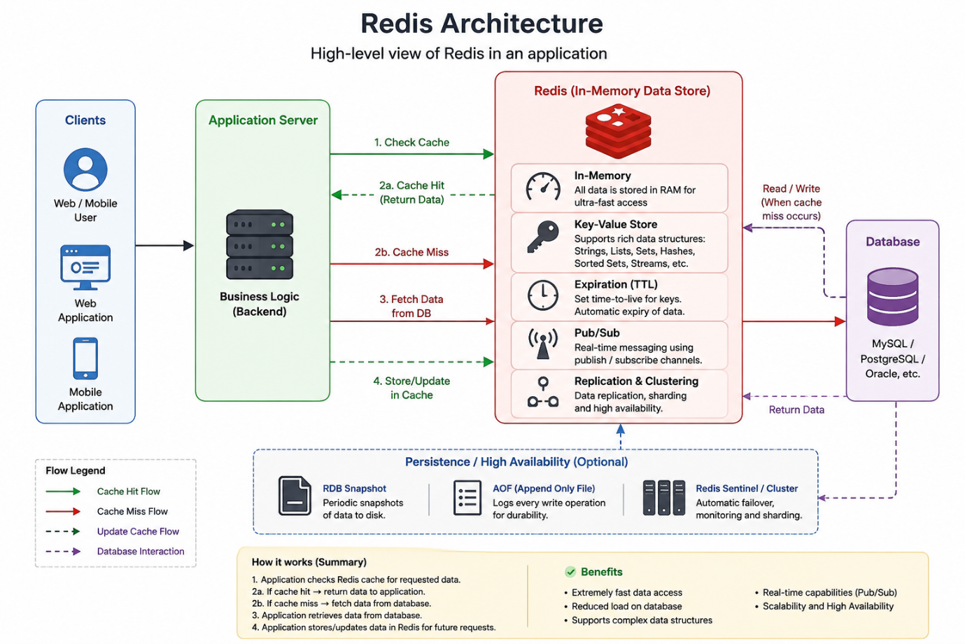

How the architecture works:
Step 1: User sends a request
GET /users/101
The request reaches the backend application.
Step 2: Application checks Redis
The application first checks whether the requested data is available in Redis.
Step 3: Cache Hit
If the data exists:
Application → Redis → Return Data
The database does not need to be accessed.
Step 4: Cache Miss
If the data does not exist in Redis:
Application → Redis → Data Not Found
↓
Database
↓
Get Data
↓
Store in Redis
↓
Return Data
This approach is commonly called the Cache-Aside Pattern.
What happens when database data is updated?
When data is changed in the database, the corresponding Redis cache entry should usually be invalidated or updated.
Update Request
↓
Update Database
↓
Invalidate/Update Redis
↓
Next Request
↓
Get Fresh Data
This prevents the application from returning stale cached data.

Task 3: What are the advantages and disadvantages of Redis?
Advantages of Redis
1. Very Fast
Redis stores data in memory, so read and write operations are very fast.
2. Reduces Database Load
Frequently requested data can be served from Redis instead of repeatedly querying the database.
3. Improves Application Performance
Because data can be retrieved quickly, application response times can be reduced.
4. Supports Multiple Data Types
Redis supports data structures such as:
- Strings
- Lists
- Sets
- Sorted Sets
- Hashes
- Streams
5. Supports Expiration
Redis allows developers to set an expiration time for data.
For example:
OTP → Expire after 5 minutes
After the specified time, Redis automatically removes the data.
6. Useful for Distributed Applications
Redis can be used as a shared cache when multiple application servers need access to the same cached data.
7. Supports High Availability and Scalability
Redis provides features such as replication, clustering, and Sentinel that can help applications achieve higher availability and scale.

Disadvantages of Redis
1. Memory Usage
Redis primarily uses RAM, which is more expensive than disk storage. Large amounts of data can therefore become costly.
2. Data Loss Risk
If Redis is being used without appropriate persistence and the Redis instance fails, data stored only in memory may be lost.
3. Cache Invalidation Complexity
When the database changes, cached data can become stale. Developers need to properly manage cache invalidation or updates.
4. Not Always Suitable as the Primary Database
Redis is excellent for caching and specific high-speed workloads, but it should not automatically replace a relational database such as MySQL or PostgreSQL.
5. Memory Management
Developers need to carefully manage memory usage, especially when storing large amounts of data.
6. Additional Infrastructure
Adding Redis introduces another component that needs to be deployed, monitored, secured, and maintained.

Task 4:
Install docker in your system
Steps
- Download from https://www.docker.com/products/docker-desktop
- Run installer
- Enable hyper-v
- Restart the system
- Check docker version in cmd
  - docker –version
- Done installed docker ..

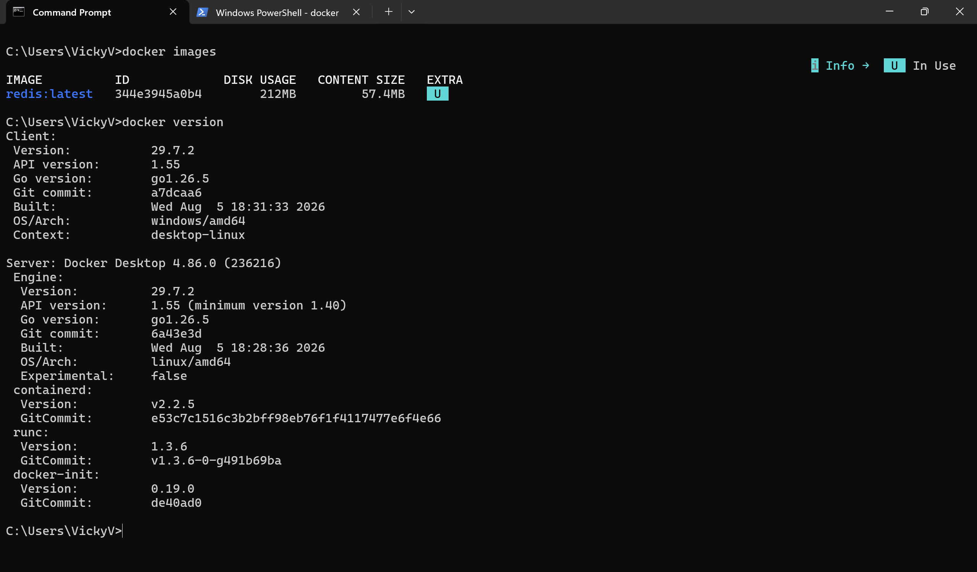

Task 5:
Open docker from the start menu
Now check
Docker version
It should show
Client and server version information like the below ss



Use command to pull image
docker pull redis

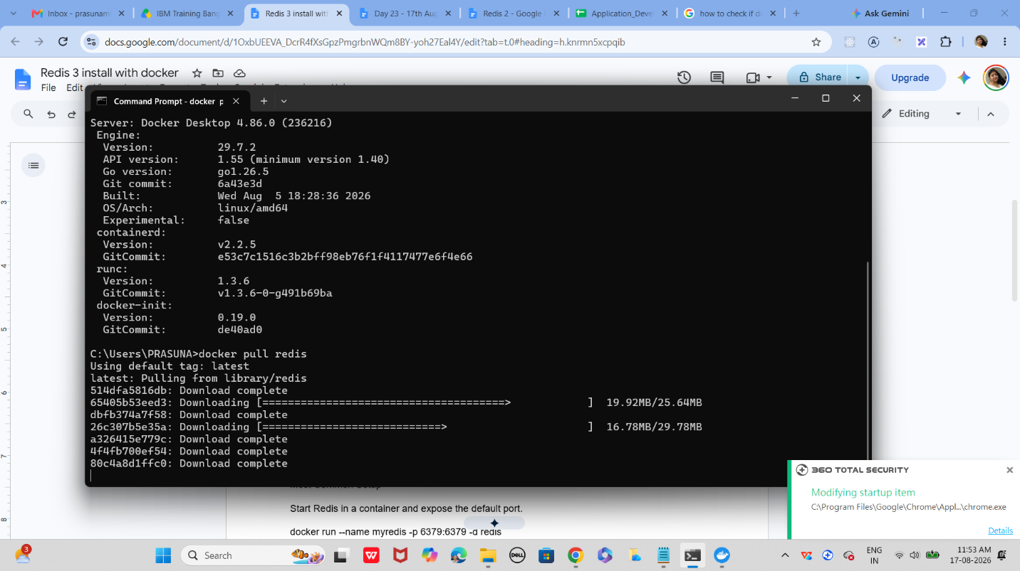
If pull is success

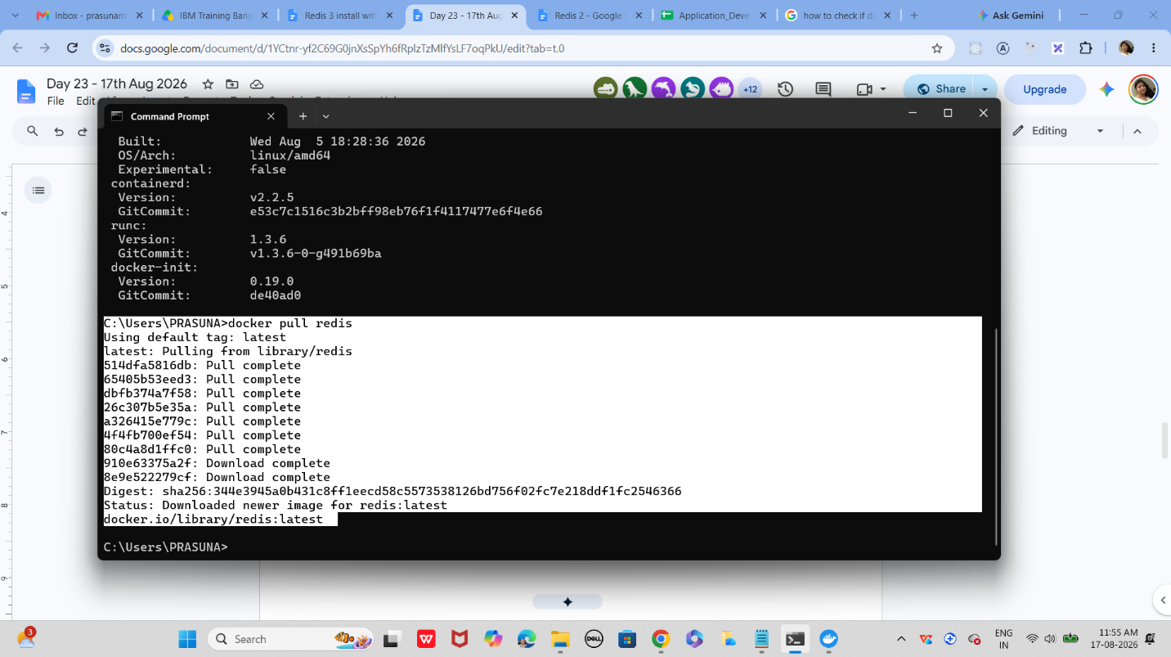

Use the command to check image

Docker images

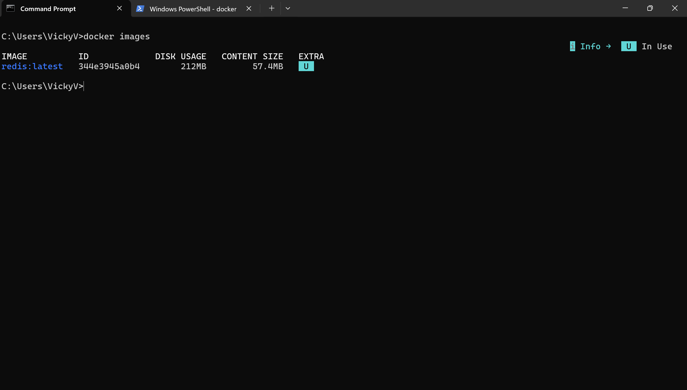

Task 6:

Now run redis container

docker run --name myredis -p 6379:6379 -d redis
Myredis is the name of the container i m creating you can give ur own
-p 6379:6379 this will map the port no to th local host.
-d redis means we RE RUNNING IN detached mode..
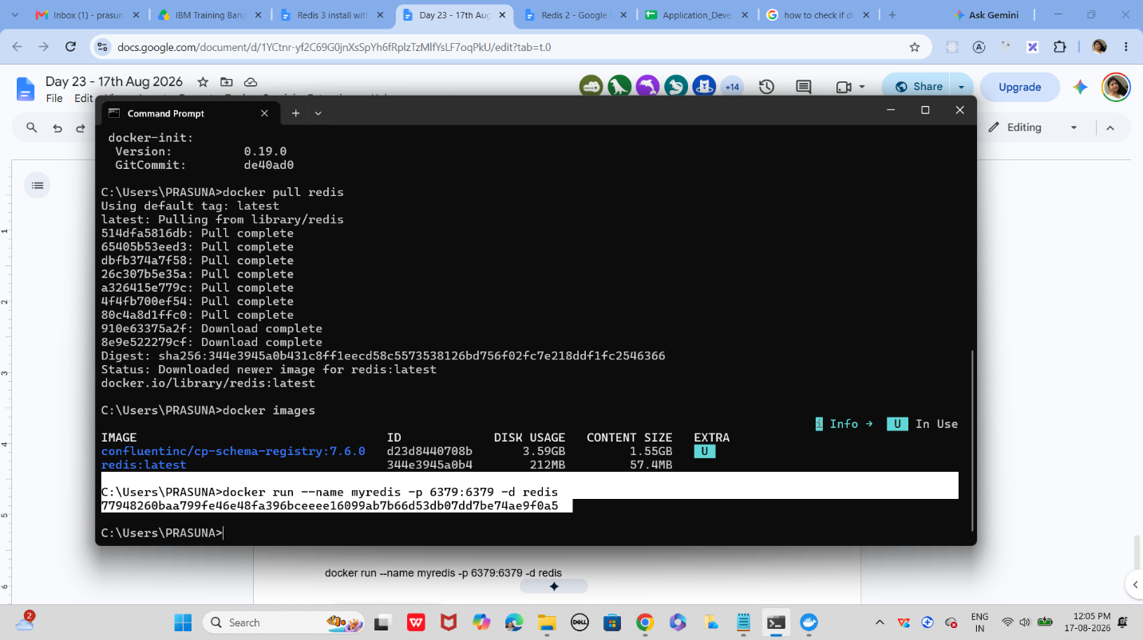
Task 7:
Now will test the connection
docker exec -it myredis redis-cli
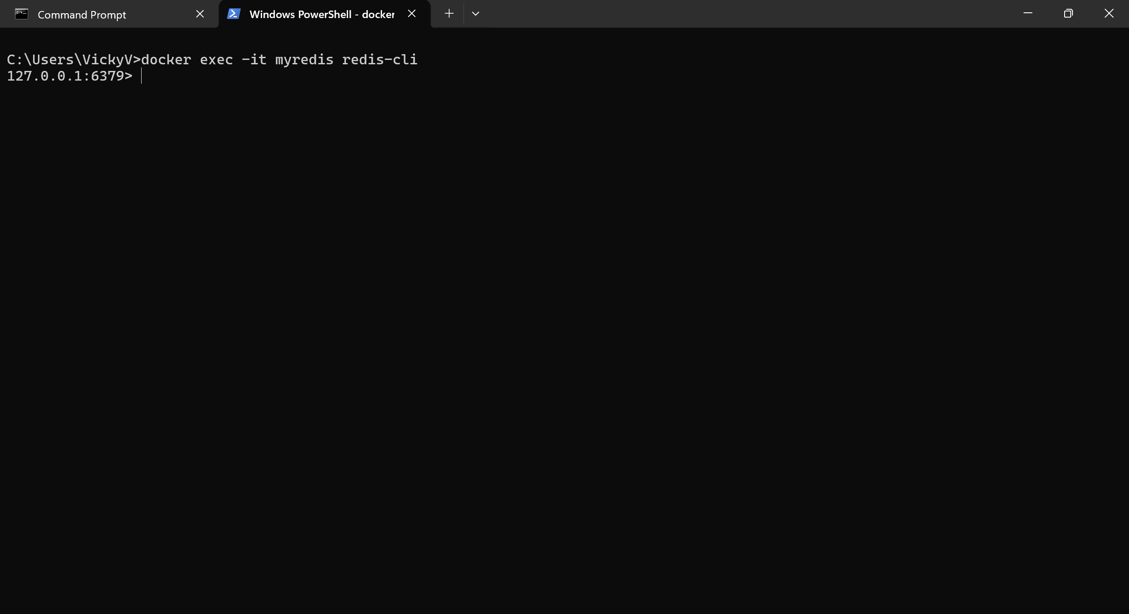

Task 8:
Type Ping
The output should be pong
Pong
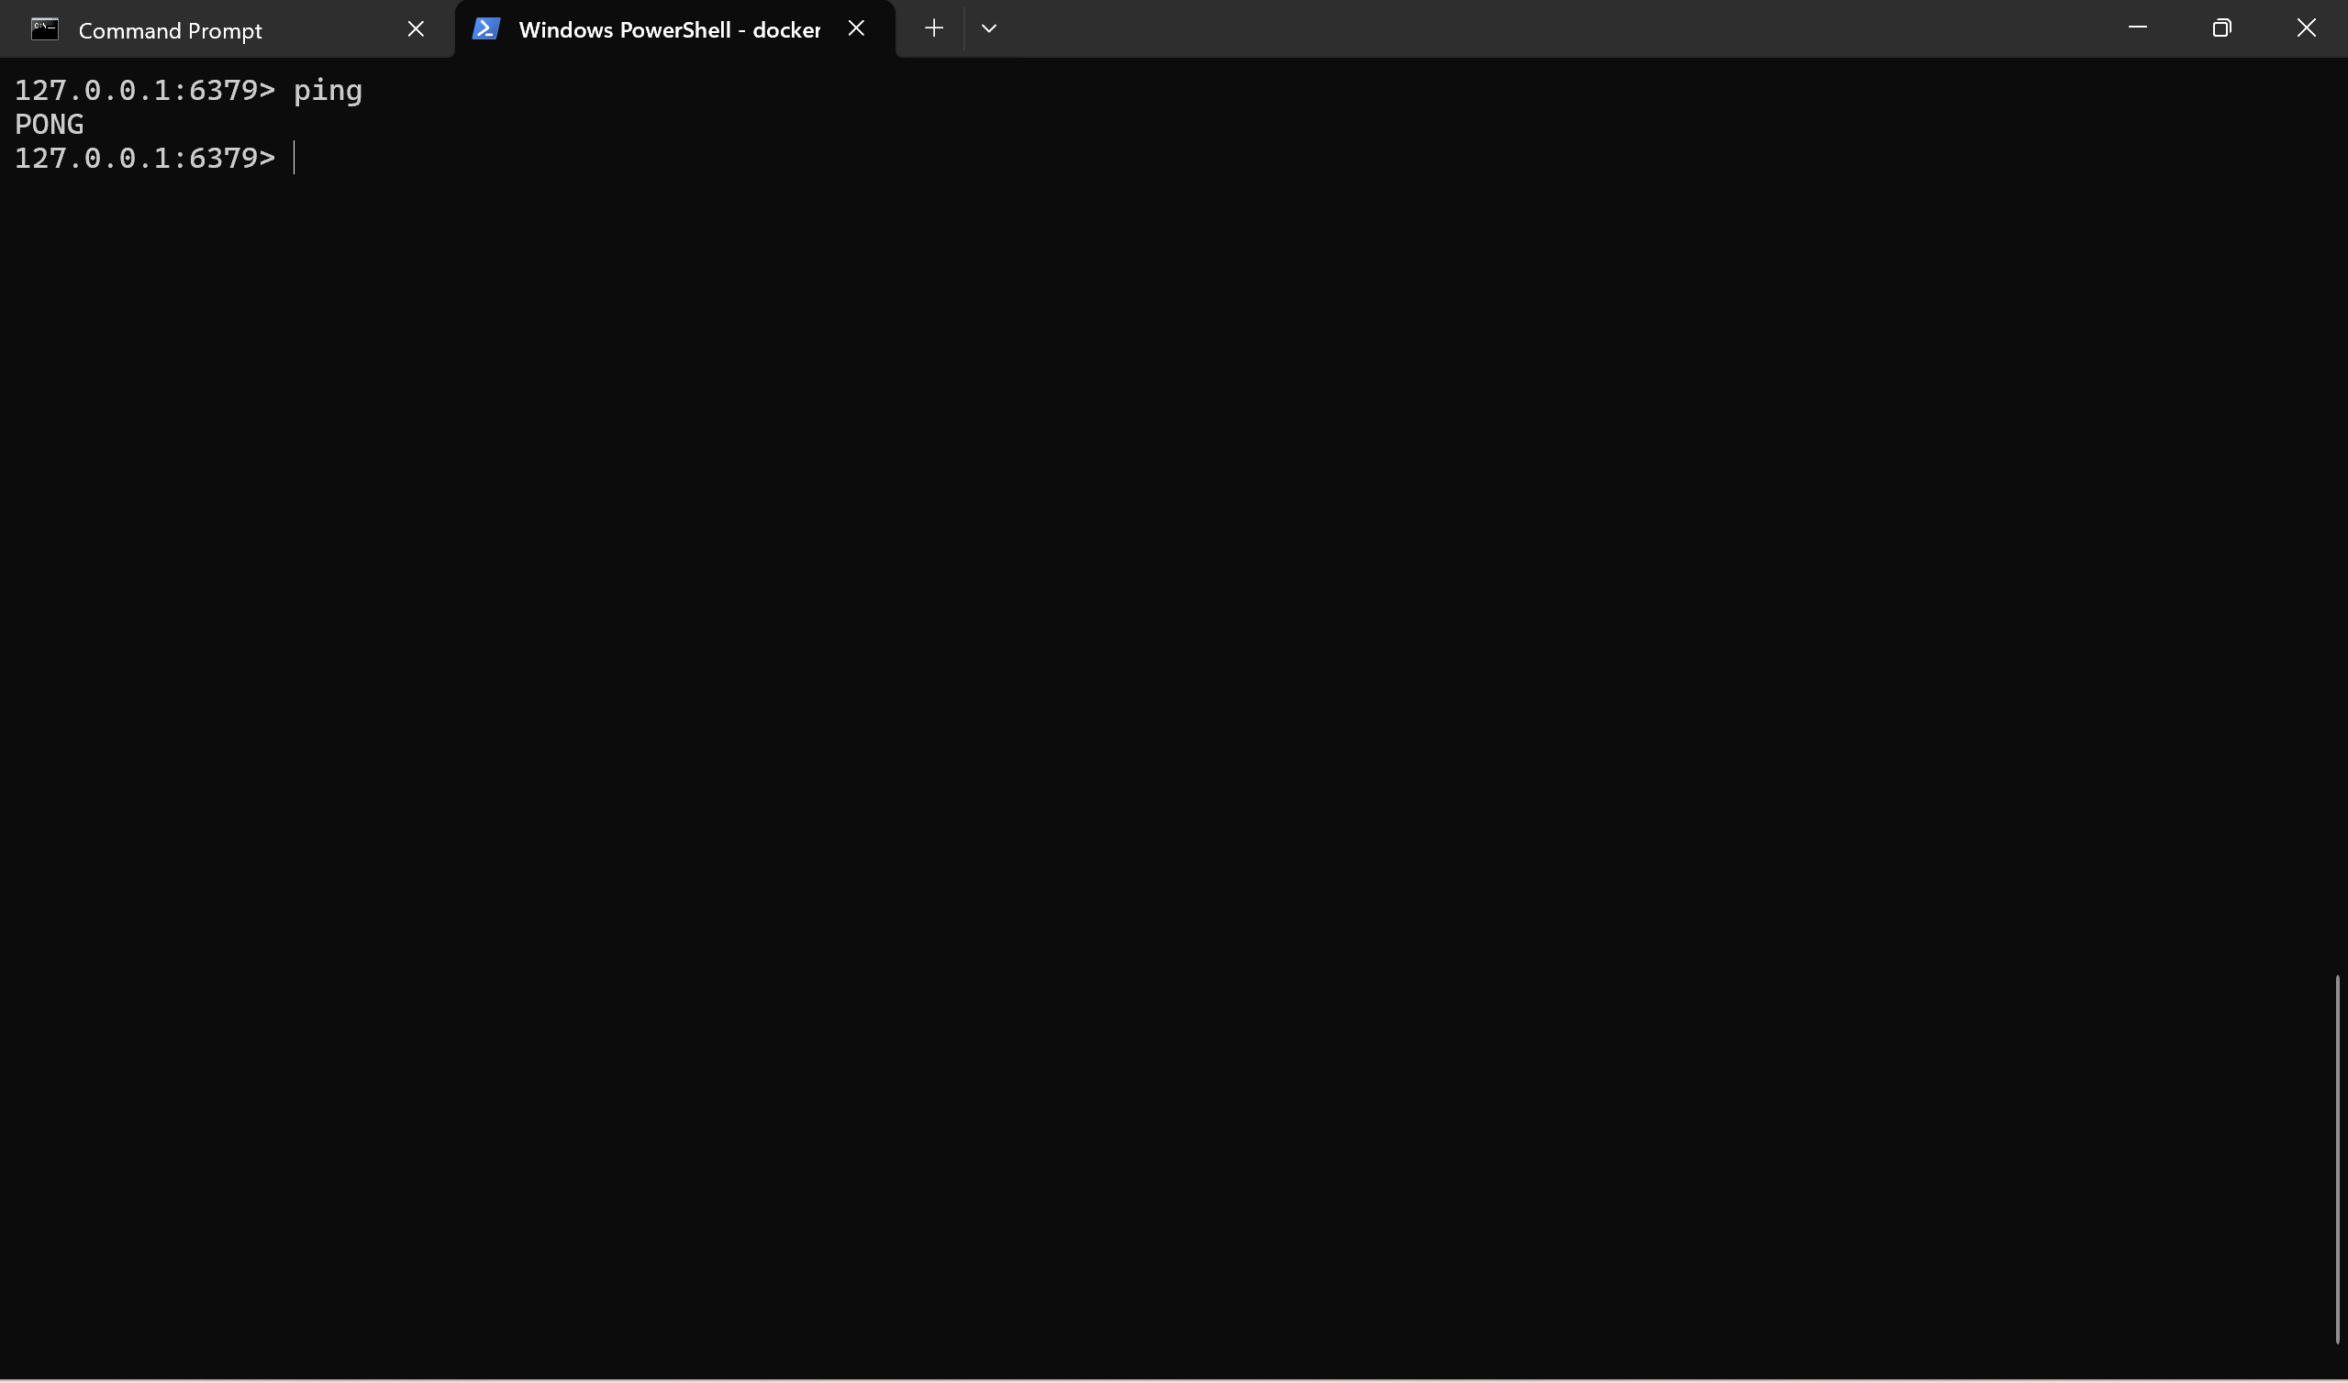

Task 9:

127.0.0.1:6379> set mykey1 "hello Vicky from redis"
OK
127.0.0.1:6379> get mykey1
"hello Vicky from redis"

Task 10:

127.0.0.1:6379> incr counter
(integer) 1
127.0.0.1:6379> get counter
"1"
127.0.0.1:6379> incr counter
(integer) 2
127.0.0.1:6379> get counter
"2"
127.0.0.1:6379>

Task 11:
To run hashset you need to open redis - cli
How to do that
- Use command you will see redis if its working or else it will show exit status
  - docker ps -a
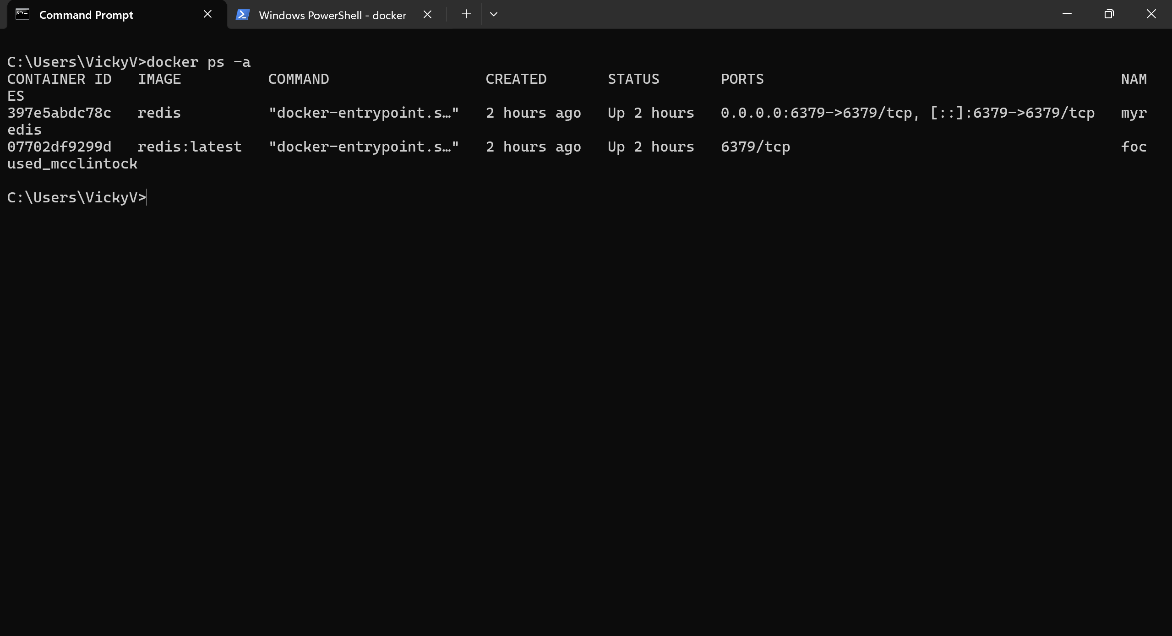

Now open another command promt
And use
HSET user:101 name "vicky" email "Vicky.v@ibm.com"

And get using
hgetall user:101
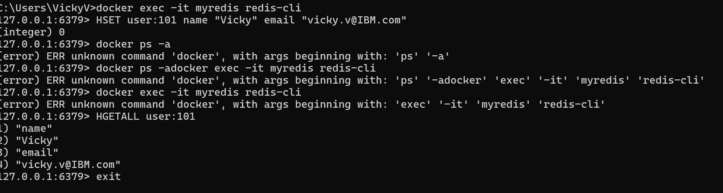

Task 12:
List of ordered collections
LPUSH tasks "Task1"
LPUSH tasks "Task2"
LRANGE tasks 0 -1
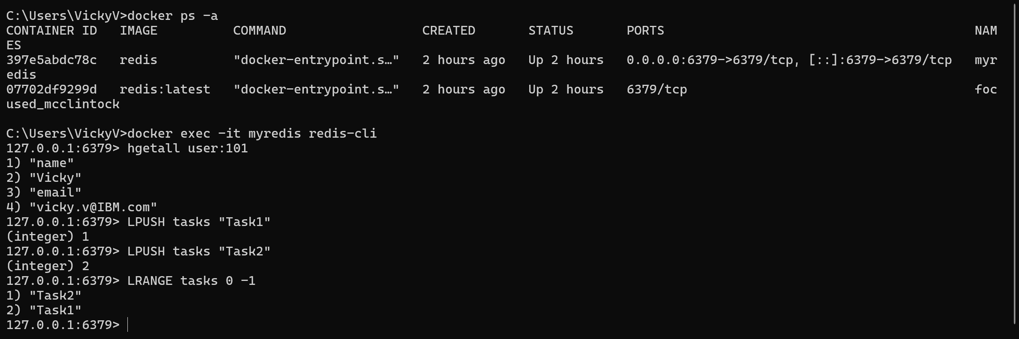

Task 13:
Sets (unique value)
SADD customrs1 "Prasunamba" "Meher" "K"
SMEMBERS customrs1
SISMEMBER customrs1 "K" (sismember is checking if the value exists or not.
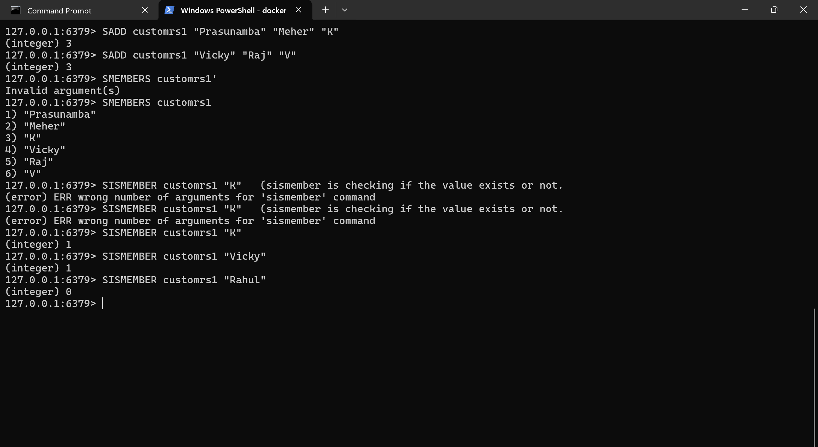

Task 14:
In the same way can you check sorted set … zsets .. what are they ?why they are used ? how to use ? cn you try ?
Like zadd leaderboard 100 “Prasunamba”
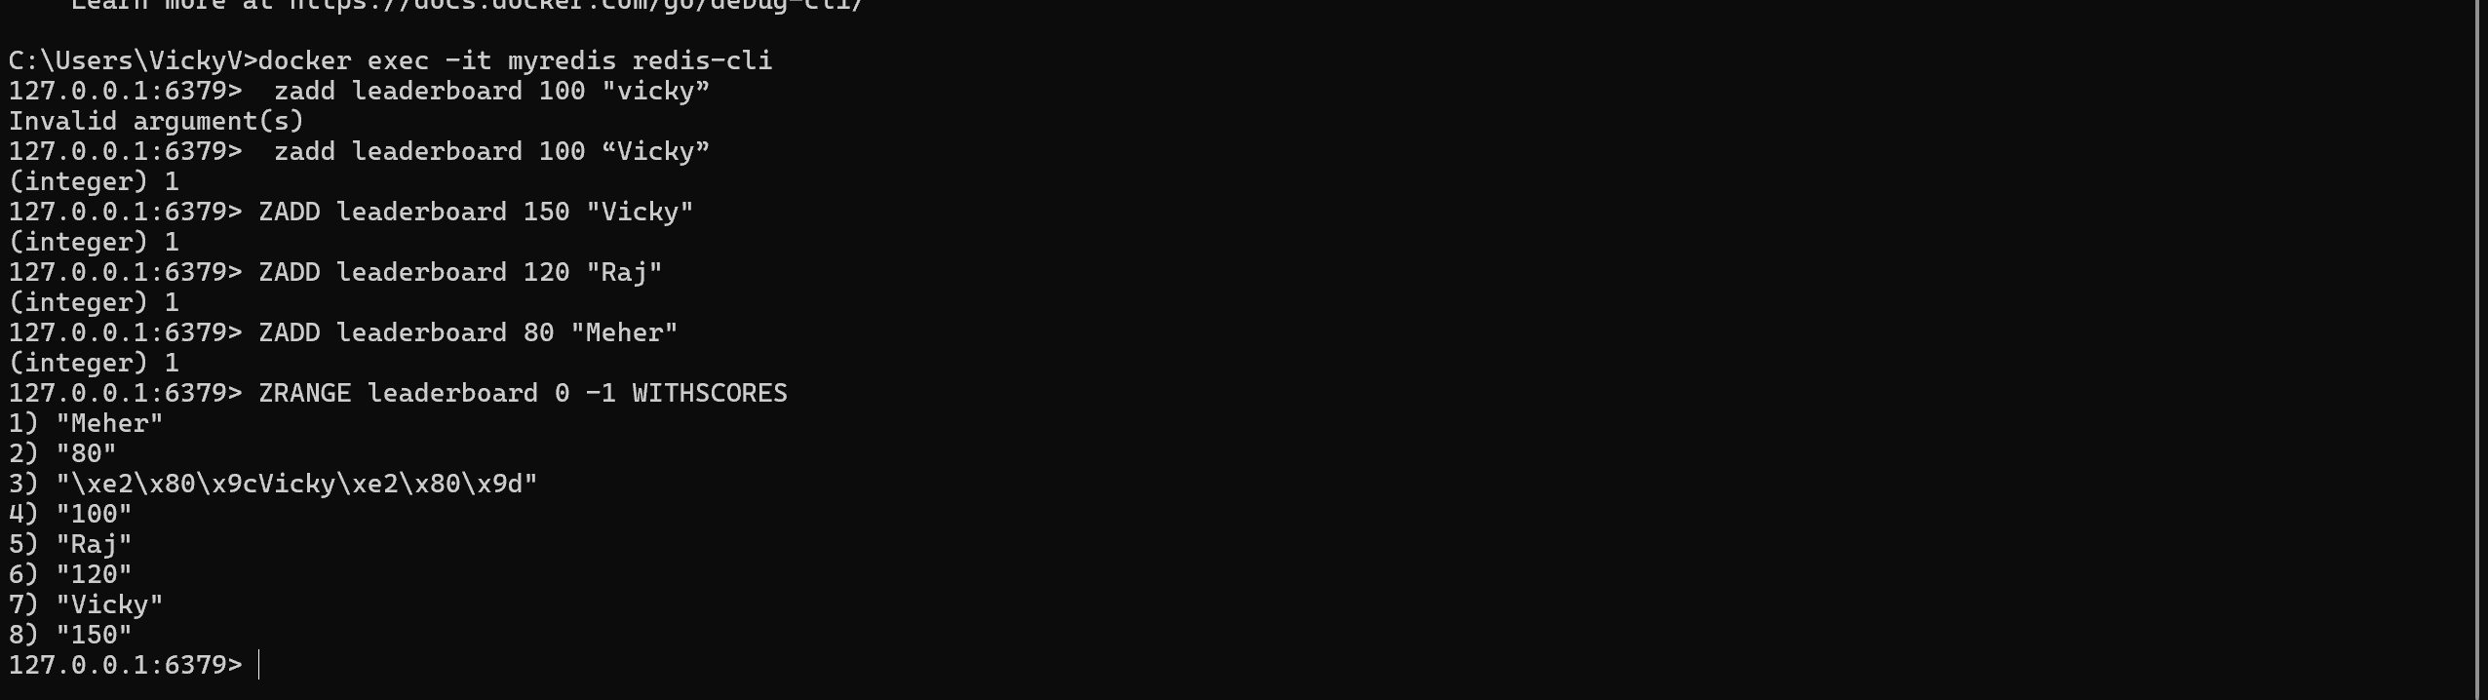

Task 15:
127.0.0.1:6379> set user:1 "Vicky"
OK
127.0.0.1:6379> exists user:1
(integer) 1
127.0.0.1:6379> del user:1
(integer) 1
127.0.0.1:6379> keys *
1) "user:101"
2) "customrs"
3) "user"
4) "tasks"
5) "customrs1"
127.0.0.1:6379> rename user:1 user:100
(error) ERR no such key
127.0.0.1:6379> rename user:2 user:100
(error) ERR no such key
127.0.0.1:6379> set user:1 "Vicky"
OK
127.0.0.1:6379> rename user:1 user:100
OK
127.0.0.1:6379> keys *
1) "user:100"
2) "user:101"
3) "customrs"
4) "user"
5) "tasks"
6) "customrs1"
127.0.0.1:6379> expire session:123 10
(integer) 0
127.0.0.1:6379> expire session:123 10 ttl session:123
(error) ERR Unsupported option ttl
127.0.0.1:6379> SET session:123 "active"
OK
127.0.0.1:6379> expire session:123 10
(integer) 1
127.0.0.1:6379> ttl session:123
(integer) -2
127.0.0.1:6379> expire session:123 1000
(integer) 0
127.0.0.1:6379> ttl session:123
(integer) -2
127.0.0.1:6379> expire session:123 1000000
(integer) 0
127.0.0.1:6379> ttl session:123
(integer) -2
127.0.0.1:6379> get session:123
(nil)
127.0.0.1:6379>

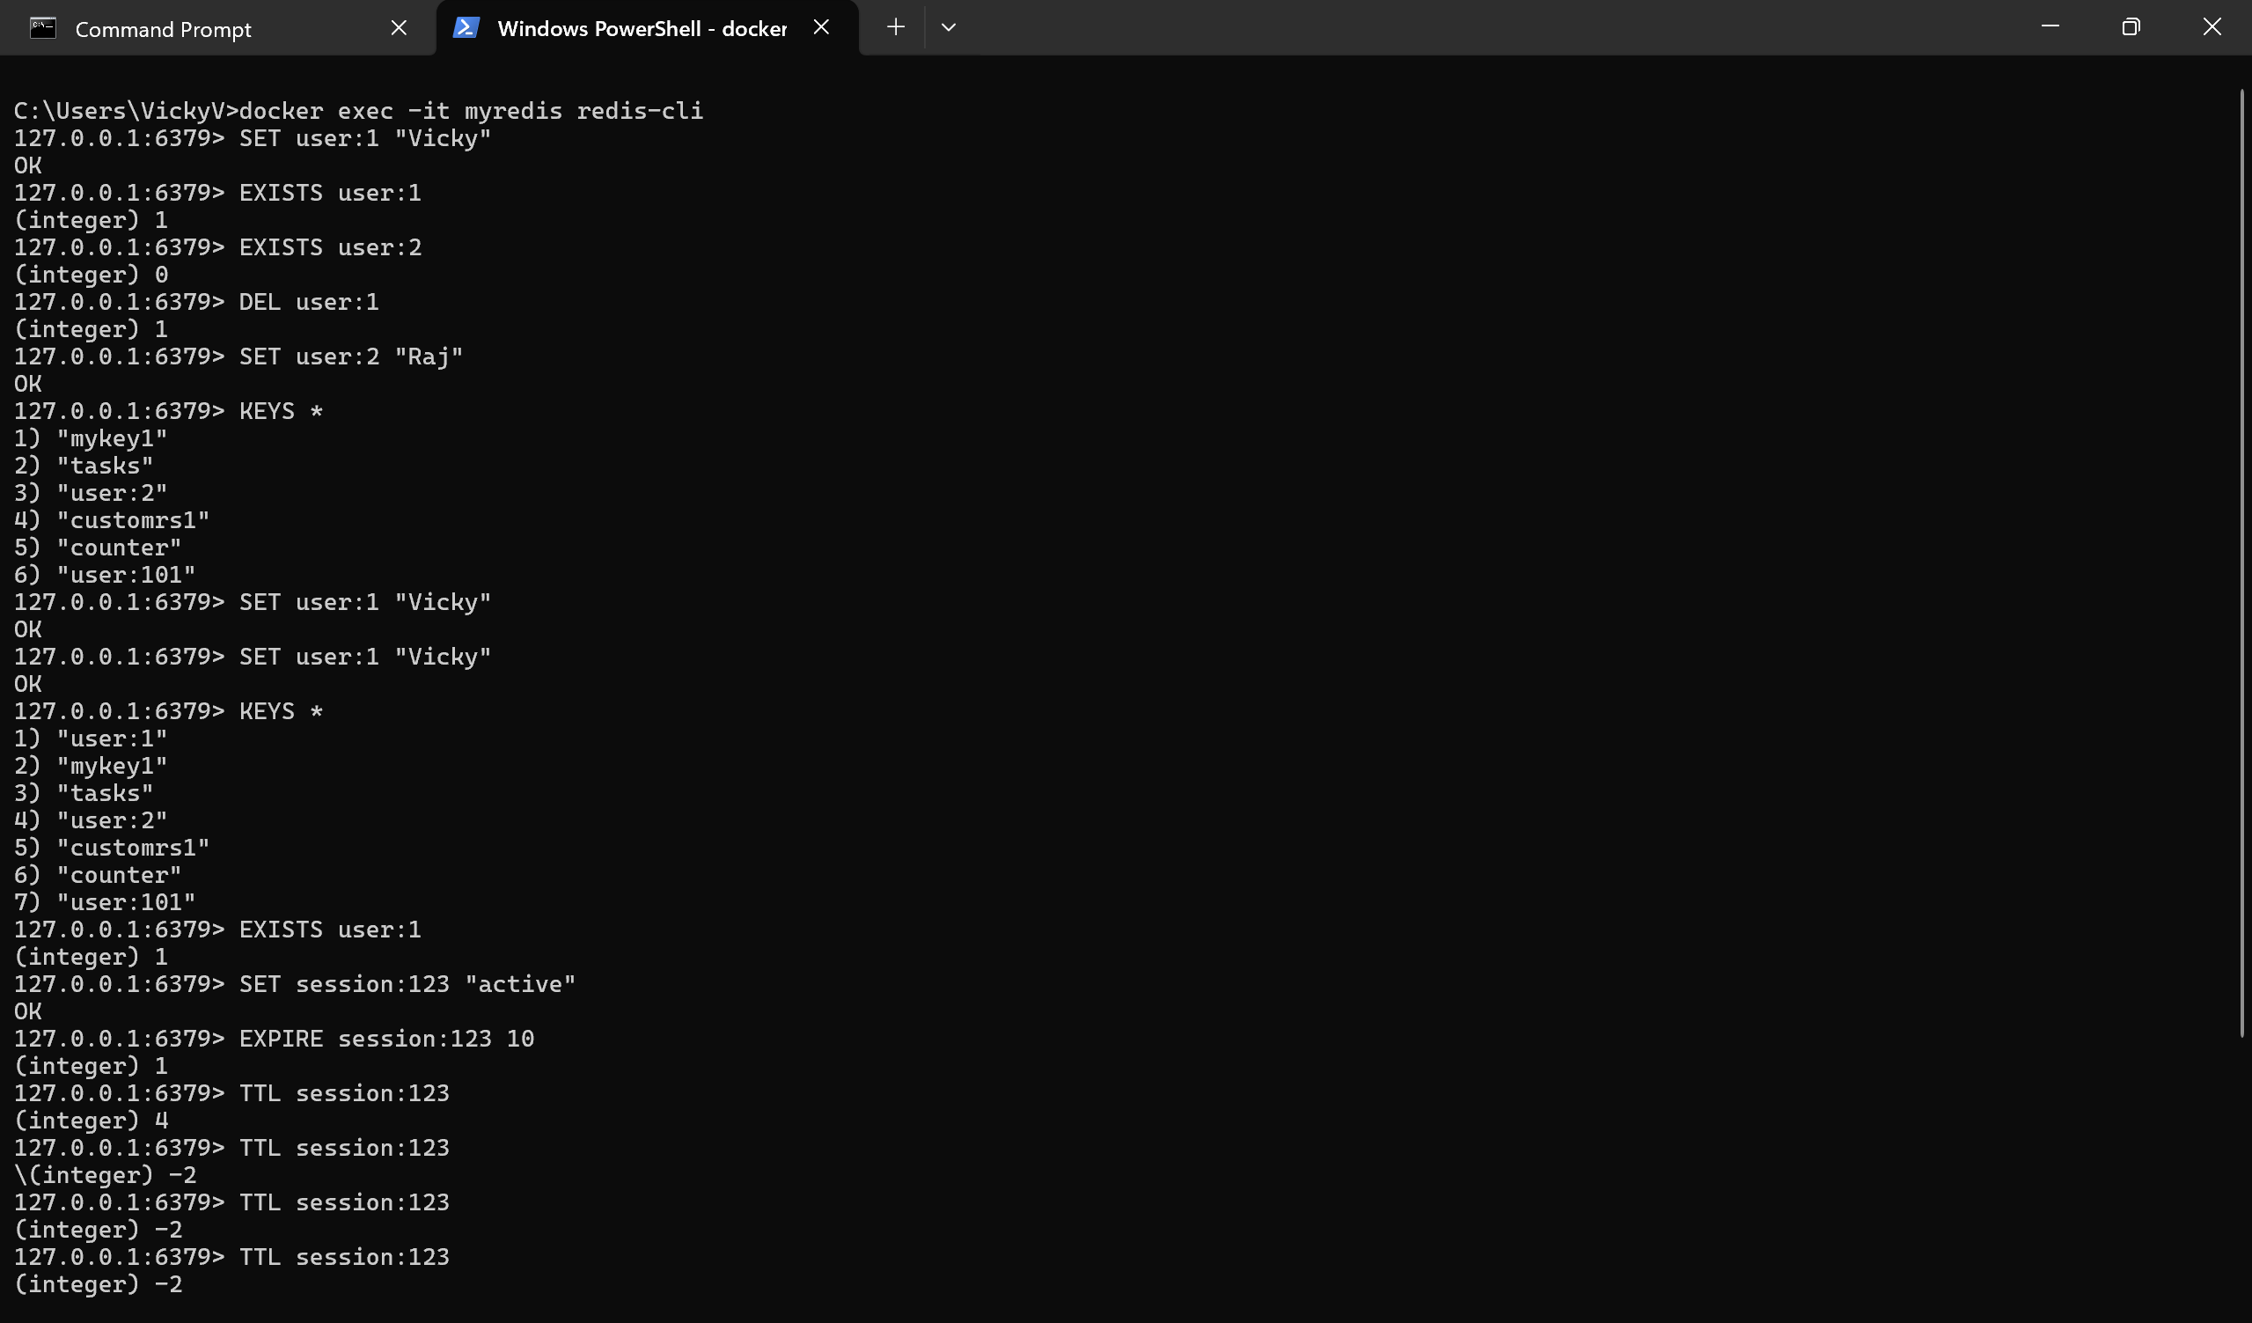

Task 16:
expire session:123 10000 // setting expiry to 10000
(integer) 1
127.0.0.1:6379> ttl session:123
(integer) 9993 // plz observe every time you check ttl it will decrease.
127.0.0.1:6379> ttl session:123
(integer) 9989 // still time to live is 9989 sec
127.0.0.1:6379> ttl session:123
(integer) 9987
127.0.0.1:6379> ttl session:123
(integer) 9985
127.0.0.1:6379> ttl session:123
(integer) 9984
127.0.0.1:6379> ttl session:123
(integer) 9983
127.0.0.1:6379> ttl session:123
(integer) 9977
127.0.0.1:6379> PERSIST session:123 // checking if still persists or not 1 says yes 0 says expired.
(integer) 1
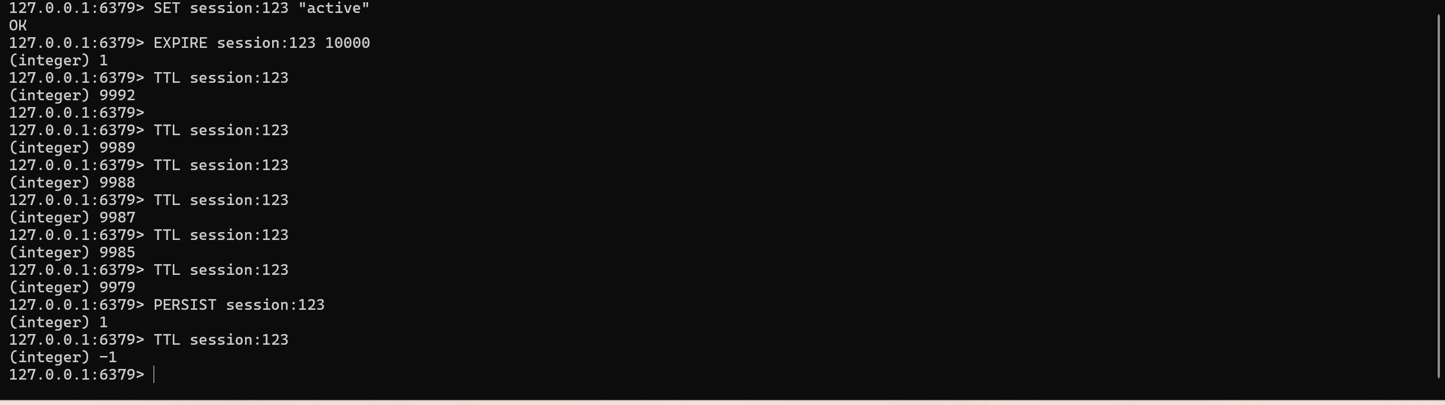

Important distinction
Command | Meaning
EXPIRE session:123 10000 | Set expiration to 10,000 seconds
TTL session:123 | Check remaining expiration time
PERSIST session:123 | Remove the expiration
TTL → -1 | Key exists but has no expiry
TTL → -2 | Key does not exist / has expired

Task 17: How does Cache-Aside balance freshness and performance, and what risks arise if the database is updated frequently?
Answer:
Cache-Aside is a caching strategy where the application first checks the cache for data. If the data is available, it returns the cached value. If it is not available, the application reads the data from the database and stores it in the cache.
The flow is:
Request
↓
Check Cache
↓
Cache Hit → Return cached data
↓
Cache Miss
↓
Read Database
↓
Update Cache
↓
Return data
It balances performance and freshness because frequently requested data can be served quickly from the cache, reducing database queries. Cache expiration or invalidation can be used to ensure that old data is eventually removed.
However, if the database is updated frequently, the cache may contain stale data. This can cause users to receive outdated information until the cache expires or is explicitly invalidated.
Main risks:
- Stale or outdated data
- Cache invalidation complexity
- Temporary inconsistency between the cache and database
- Increased database load after frequent cache misses

Task 18: In what type of workload would Write-Behind caching introduce consistency challenges compared to Write-Through?
Answer:
Write-Behind caching first writes the data to the cache and updates the database later, usually asynchronously.
The flow is:
Application
↓
Cache
↓
Return immediately
↓
Database updated later
This provides fast write performance, but it can introduce consistency problems when the workload requires immediate and accurate database persistence.
For example, consider a banking, payment, inventory, or financial transaction system. If many updates occur rapidly and the cache fails before the data is written to the database, some changes could be lost.
In contrast, Write-Through caching updates the cache and database as part of the write operation:
Application
↓
Cache + Database
↓
Return response
Therefore, Write-Behind is more suitable for workloads where high write performance is more important than immediate database consistency, while Write-Through is safer when consistency is more important.

Task 19: Why might LFU eviction be more suitable than LRU eviction in recommendation systems?
Answer:
LFU (Least Frequently Used) removes the items that have been accessed the least number of times.
LRU (Least Recently Used) removes the items that have not been accessed recently.
In a recommendation system, some recommendations may be accessed frequently over a long period, even if they were not accessed very recently. LFU can keep these frequently used recommendations in the cache.
For example:
Product A → accessed 1,000 times
Product B → accessed 10 times
Product C → accessed 5 times
LFU is more likely to keep Product A because it has a high access frequency.
Comparison:
LRU → Focuses on when data was last accessed
LFU → Focuses on how frequently data is accessed
Therefore, LFU can be more suitable when long-term access frequency is a better indicator of future usefulness than recent access time.

Task 20: What are the trade-offs between time-based invalidation and event-based invalidation?
Answer:
Time-based invalidation removes cached data after a predefined amount of time using a TTL.
Example:
EXPIRE product:101 300
The cache entry expires after 300 seconds.
Advantages:
- Simple to implement
- Easy to manage
- Does not require event infrastructure
Disadvantages:
- Data may remain stale until the TTL expires
- Short TTLs can increase database load
- Long TTLs can increase the chance of stale data

Event-based invalidation removes or updates cache data whenever the underlying data changes.
Example:
Database updated
↓
Change event
↓
Invalidate Cache
↓
Next request gets fresh data
Advantages:
- Provides fresher data
- Cache can be invalidated immediately after changes
- Useful for frequently changing data
Disadvantages:
- More complex to implement
- Requires event/message infrastructure
- Events can be delayed, duplicated, or lost if not handled correctly
Comparison:
Time-Based Invalidation | Event-Based Invalidation
Simple | More complex
Uses TTL | Uses change events
Data can temporarily be stale | Can provide fresher data
Easy to implement | Requires event handling
Suitable for relatively stable data | Suitable for frequently changing data

Task 21: How would you design cache invalidation for a real-time stock trading system?
Answer:
A real-time stock trading system requires very fresh and accurate data, so relying only on a long TTL would not be appropriate.
A suitable approach would combine event-based invalidation with short TTLs as a safety mechanism.
The architecture could look like:
Stock Exchange / Market Data
↓
Change Event
↓
Event Processor
↓
Update / Invalidate
↓
Redis
↓
Trading Application
When a stock price changes, an event can immediately update or invalidate the corresponding Redis entry.
For example:
Stock A = ₹500
↓
Redis stores ₹500
↓
Market price changes to ₹505
↓
Price-change event
↓
Redis updated to ₹505
A short TTL can also be used as a backup mechanism in case an invalidation event is delayed or missed.
For critical trading operations, Redis should not be treated as the only source of truth. The authoritative market data or transactional system should remain the source of truth.
Important design considerations:
- Use event-based cache updates or invalidation.
- Use short TTLs as a safety mechanism.
- Ensure events are reliable and ordered where necessary.
- Monitor cache consistency.
- Avoid serving stale prices for critical trading decisions.
- Keep the authoritative data source separate from the cache.

Home Task
Task 22: How does sharding in Redis clusters improve scalability, and what complexity does it add to key management?
Answer:
Sharding divides data across multiple Redis nodes instead of storing everything on a single Redis server.
For example:
Redis Cluster
|
┌────────────┼────────────┐
↓ ↓ ↓
Node 1 Node 2 Node 3
Users Products Sessions
Each node stores a portion of the overall data.
How sharding improves scalability:
- Increases storage capacity – Data can be distributed across multiple machines.
- Improves throughput – Multiple nodes can process requests in parallel.
- Reduces load on individual nodes – No single node needs to handle all requests.
- Allows horizontal scaling – Additional Redis nodes can be added as the workload grows.
Complexity introduced by sharding:
Because data is distributed across different nodes, key management becomes more complicated.
Applications need to consider:
- Which node contains a particular key
- How keys are distributed
- Moving data when nodes are added or removed
- Cross-node operations
- Multi-key commands involving keys on different nodes
- Maintaining an even distribution of data
Redis Cluster uses hash slots to determine where keys are stored.
A simplified view is:
Key
↓
Hash Function
↓
Hash Slot
↓
Redis Cluster Node
For example:
user:101
↓
Hash calculation
↓
Hash Slot
↓
Node 2
Therefore:
Sharding improves Redis scalability by distributing data and workload across multiple nodes, but it adds complexity around key distribution, data movement, and operations involving multiple keys.

