Day 28 - 24th Aug 2026

Task 1:

Task 5 demo of Day 27 – ensure you all are done with..
Done
Task 2: Role of API Gateway in Microservices
The API Gateway acts as a single entry point between clients and microservices. It receives client requests and routes them to the appropriate microservice. It can also handle authentication, authorization, request validation, logging, rate limiting, and load balancing. This simplifies communication between clients and multiple microservices and improves security and management.
Task 3: Why do we need an API Gateway in Microservices?
We need an API Gateway to provide a single entry point for clients to access multiple microservices. It reduces the complexity of communicating with different services and provides common features such as authentication, authorization, routing, security, logging, and rate limiting. It also improves the overall management, security, and scalability of the microservices architecture.
Task 4:

ensure you have these services in your earlier projects .. (account-service, transaction-service, auth-service)

If you don't have

step 01 :
Set up microservices
Create independent services like Account, Transaction, and Auth using Spring Boot.

Step 02:

This is the project structure.. Keep account services and transaction services ready..

Project Structure
Code
banking-microservices/
│
├── gateway-service/
│ ├── src/main/java/com/example/gateway/
│ │ ├── GatewayApplication.java
│ │ ├── config/RouteConfig.java
│ │ ├── filter/JwtAuthFilter.java
│ │ └── controller/FallbackController.java
│ └── src/main/resources/application.yml
│
├── account-service/
│ ├── src/main/java/com/example/account/
│ │ ├── AccountApplication.java
│ │ └── controller/AccountController.java
│ └── src/main/resources/application.yml
│
├── transaction-service/
│ ├── src/main/java/com/example/transaction/
│ │ ├── TransactionApplication.java
│ │ └── controller/TransactionController.java
│ └── src/main/resources/application.yml
│
└── pom.xml (parent for all modules)

Step 03:

Now create a GatewayApplication.java file

Juz for ref if you want to have a look

@SpringBootApplication
public class GatewayApplication {
public static void main(String[] args) {
SpringApplication.run(GatewayApplication.class, args);
}
}

Step 04:

Create RouteConfig.java for routing.. Accounts …. Etc services

Juz for ref if you want to have a look
@Configuration
public class RouteConfig {
@Bean
public RouteLocator routes(RouteLocatorBuilder builder) {
return builder.routes()
.route("account_route", r -> r.path("/account/**")
.uri("http://localhost:8082"))
.route("transaction_route", r -> r.path("/transaction/**")
.uri("http://localhost:8083"))
.build();
}
}

Step 05:

We need to create filter – jwtauthFilter for auth check

This file is a gatekeeper .. its a security gatekeeper for API gateway..
lets create it

This is how we crete

@Component
public class JwtAuthFilter implements GlobalFilter {
@Override
public Mono<Void> filter(ServerWebExchange exchange, GatewayFilterChain chain) {
String token = exchange.getRequest().getHeaders().getFirst("Authorization");
if (token == null || !token.startsWith("Bearer ")) {
exchange.getResponse().setStatusCode(HttpStatus.UNAUTHORIZED);
return exchange.getResponse().setComplete();
}
// TODO: validate JWT properly
return chain.filter(exchange);
}
}

Step 06:

Now a safety net for API gateway .. this provides a beautiful response if any of our microservices gets failed.

@RestController
public class FallbackController {
@GetMapping("/fallback/transaction")
public String transactionFallback() {
return "Transaction service is currently unavailable. Please try later.";
}
}

Step 07:
Create application.yml as usual

application.yml
yaml
server:
port: 8080

spring:
application:
name: gateway-service

# Rate Limiting + Circuit Breaker
spring:
cloud:
gateway:
routes:
- id: account_route
uri: http://localhost:8082
predicates:
- Path=/account/**
- id: transaction_route
uri: http://localhost:8083
predicates:
- Path=/transaction/**
filters:
- name: CircuitBreaker
args:
name: transactionCB
fallbackUri: forward:/fallback/transaction

Step 08:

Now start the services in different port nos

Like
Start account-service (8082)
Start transaction-service (8083)
Start gateway-service (8080)

Step 09:

Test them..

For more info on services..

//AccountApplication.java

@SpringBootApplication
public class AccountApplication {
public static void main(String[] args) {
SpringApplication.run(AccountApplication.class, args);
}
}

//AccountController.java
@RestController
@RequestMapping("/account")
public class AccountController {
@GetMapping("/{id}/balance")
public Double getBalance(@PathVariable Long id) {
// Demo: return static balance
return 5000.75;
}
}

// application.yml

server:
port: 8082
spring:
application:
name: account-service

//TransactionApplication.java
@SpringBootApplication
public class TransactionApplication {
public static void main(String[] args) {
SpringApplication.run(TransactionApplication.class, args);
}
}
//TransactionController.java
@RestController
@RequestMapping("/transaction")
public class TransactionController {
@GetMapping("/{id}")
public List<String> getTransactions(@PathVariable Long id) {
return List.of("TXN1001 - Debit 500", "TXN1002 - Credit 2000");
}
}

//application.yml
server:
port: 8083
spring:
application:
name: transaction-service
Pushed to GitHub

Next
Task 5:

Routing and Request Aggregation at the Gateway
Step 01:

In our same old project we have RouteConfig file

In that we will make some changes like

will include
stripPrefix(1) removes the first path segment so /account/1/balance becomes /1/balance when forwarded.

This keeps microservice endpoints clean and avoids duplication of path segments.

This is my routeconfig… file did few updates

@Configuration
public class RouteConfig {
@Bean
public RouteLocator routes(RouteLocatorBuilder builder) {
return builder.routes()
// Account Service
.route("account_route", r -> r.path("/account/**")
.filters(f -> f.stripPrefix(1)) // removes "/account" before forwarding
.uri("http://localhost:8082"))
// Transaction Service
.route("transaction_route", r -> r.path("/transaction/**")
.filters(f -> f.stripPrefix(1))
.uri("http://localhost:8083"))
.build();
}
}

Step 2:

what is Aggregation in gateway?
Aggregation means the Gateway can call multiple different services, combine their responses, and return a single unified result to the client.

So

Will Add a DashboardController.java in gateway-service

we will let Gateway itself make two backend calls (Account + Transaction).
so will combine them into a single JSON response.
and client will only call /dashboard/{id} once, instead of hitting multiple services.

@RestController
@RequestMapping("/dashboard")
public class DashboardController {

private final RestTemplate restTemplate = new RestTemplate();

@GetMapping("/{id}")
public Map<String, Object> getDashboard(@PathVariable Long id) {
// Call Account Service
Double balance = restTemplate.getForObject(
"http://localhost:8082/account/" + id + "/balance", Double.class);

// Call Transaction Service
List<String> transactions = restTemplate.getForObject(
"http://localhost:8083/transaction/" + id, List.class);

// Aggregate response
return Map.of(
"accountId", id,
"balance", balance,
"transactions", transactions
);
}
}

Step 3: this is what happens ….

1st Client calls:
curl -H "Authorization: Bearer testtoken" http://localhost:8080/dashboard/1

2nd Gateway:
Calls account-service → balance = 5000.75
Calls transaction-service → transactions = [TXN1001, TXN1002]

3rd it Aggregates → and returns:
json
{
"accountId": 1,
"balance": 5000.75,
"transactions": [
"TXN1001 - Debit 500",
"TXN1002 - Credit 2000"
]
}

Zist:

why???????????????????
As we know Routing → keeps microservices clean, hides internal URLs, centralizes traffic control.
and when we use
Aggregation → it improves client experience by reducing multiple calls into one, especially useful for dashboards or composite views in banking apps.
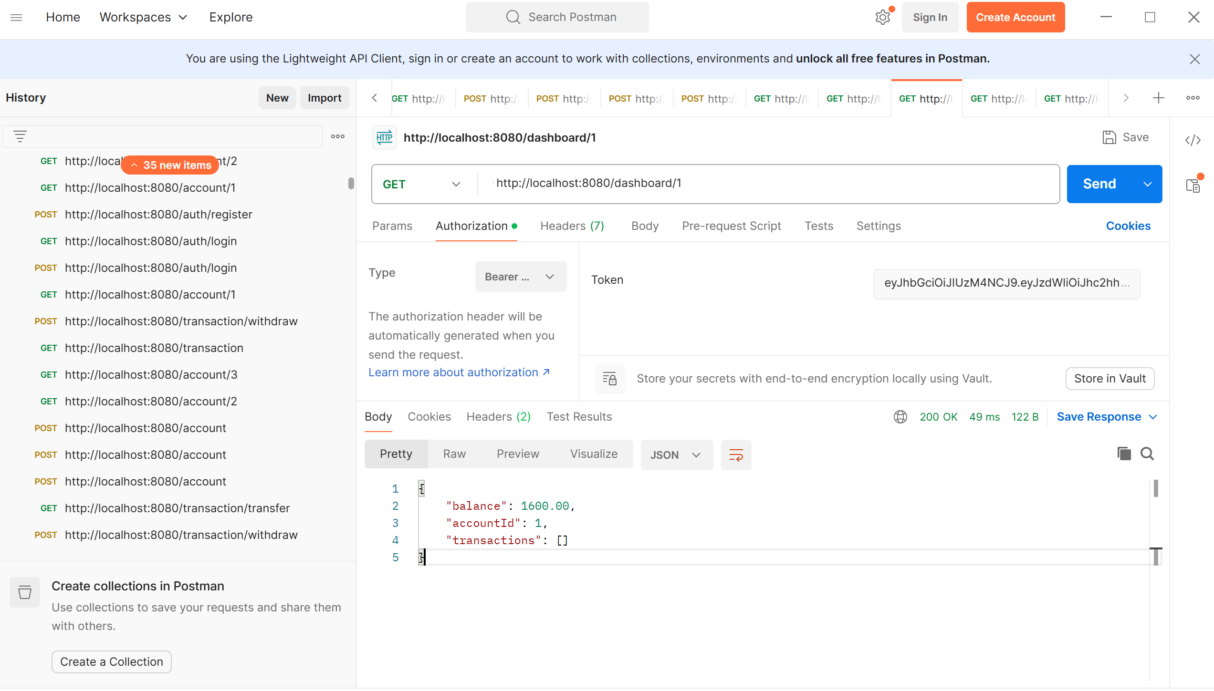

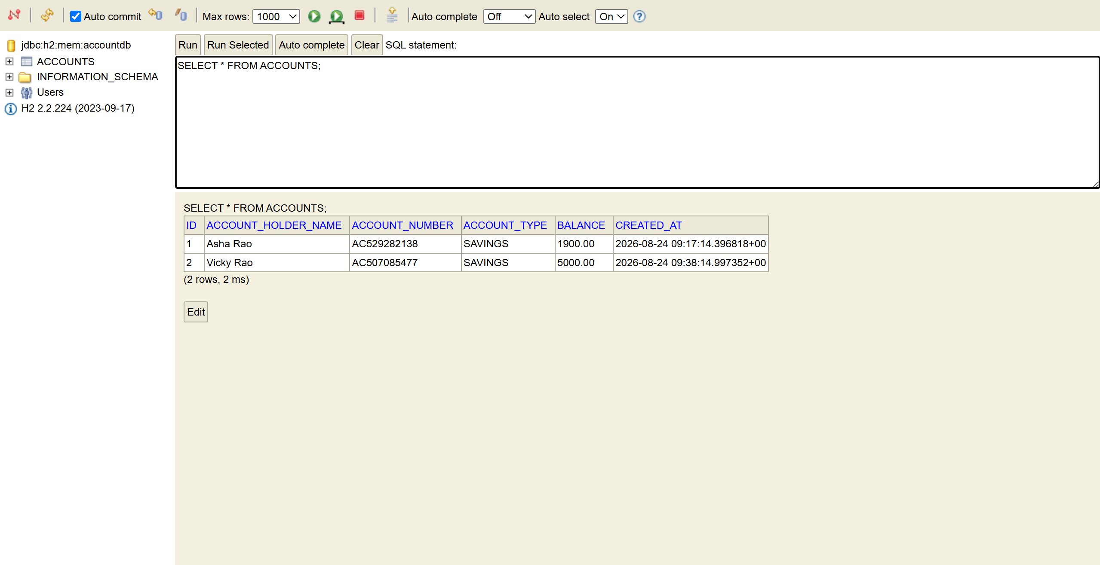

Task 6:

Rate Limiting and Throttling

Inextension to your earlier project…

Step 1:
In Redis we use rate limiting by Spring Cloud Gateway to store counters for requests per client.

So add Redis Dependency..
In our gateway-service/pom.xml.

xml
<dependency>
<groupId>org.springframework.boot</groupId>
<artifactId>spring-boot-starter-data-redis-reactive</artifactId>
</dependency>

Step 2:
Now lets configure rate limit in application.yml file
yaml
server:
port: 8080

spring:
application:
name: gateway-service

# -----------------------------
# Circuit Breaker configuration
# -----------------------------
spring:
cloud:
gateway:
routes:
- id: account_route
uri: http://localhost:8082
predicates:
- Path=/account/**
# ✅ Added Rate Limiting filter for Account Service
filters:
- name: RequestRateLimiter
args:
redis-rate-limiter.replenishRate: 5 # Allow 5 requests per second
redis-rate-limiter.burstCapacity: 10 # Allow short bursts up to 10 requests
key-resolver: "#{@userKeyResolver}" # Identify client by JWT or IP

- id: transaction_route
uri: http://localhost:8083
predicates:
- Path=/transaction/**
filters:
# ✅ Circuit Breaker remains for Transaction Service
- name: CircuitBreaker
args:
name: transactionCB
fallbackUri: forward:/fallback/transaction

# ✅ Added Rate Limiting filter for Transaction Service
- name: RequestRateLimiter
args:
redis-rate-limiter.replenishRate: 3 # Allow 3 requests per second
redis-rate-limiter.burstCapacity: 6 # Allow short bursts up to 6 requests
key-resolver: "#{@userKeyResolver}" # Identify client by JWT or IP

Here replenishRate -> give steady rate of requests allowed per sec.
burstCapacity -> gives max no of request allowed in a short burst
Key- resolver -> gives or defines how to identify each client (ip, jwt, etc)

Now let us create a key resolver.
In gateway-service add UserKeyResolver.java file.
java
@Component
public class UserKeyResolver implements KeyResolver {
@Override
public Mono<String> resolve(ServerWebExchange exchange) {
// Use JWT token if available, else fallback to client IP
String authHeader = exchange.getRequest().getHeaders().getFirst("Authorization");
if (authHeader != null && authHeader.startsWith("Bearer ")) {
return Mono.just(authHeader); // identify by token
}
return Mono.just(exchange.getRequest().getRemoteAddress().getAddress().getHostAddress());
}
}

Step 3:

Throttling Behavior
- When a client exceeds the limit, Gateway automatically returns HTTP 429 Too Many Requests.
- You can customize the error response with a filter or controller if you want a JSON message instead of plain text.
Lets create fallback for throttling like this in ur proj folder..

gateway-service/
├── src/main/java/com/example/gateway/
│ ├── GatewayApplication.java
│ ├── config/RouteConfig.java
│ ├── filter/JwtAuthFilter.java
│ ├── controller/FallbackController.java
│ └── controller/RateLimitController.java ===> Add here
└── src/main/resources/application.yml

The name of my RateLimitController.java

@RestController
public class RateLimitController {
@GetMapping("/rate-limit-error")
public ResponseEntity<String> rateLimitError() {
return ResponseEntity.status(HttpStatus.TOO_MANY_REQUESTS)
.body("You have exceeded the allowed request limit. Please try again later.");
}
}

In our banking demo
- Account Service → 5 requests/sec per user.
- Transaction Service → 3 requests/sec per user (more sensitive).
- Dashboard Aggregation → can be throttled to 1 request/sec to prevent dashboard spamming.

What are the Benefits of These Changes?????
- Protects backend services from overload.
- Ensures fair usage among multiple clients.
- Provides predictable performance under heavy load.
- Easy to extend with custom rules (per endpoint, per user role, etc.).

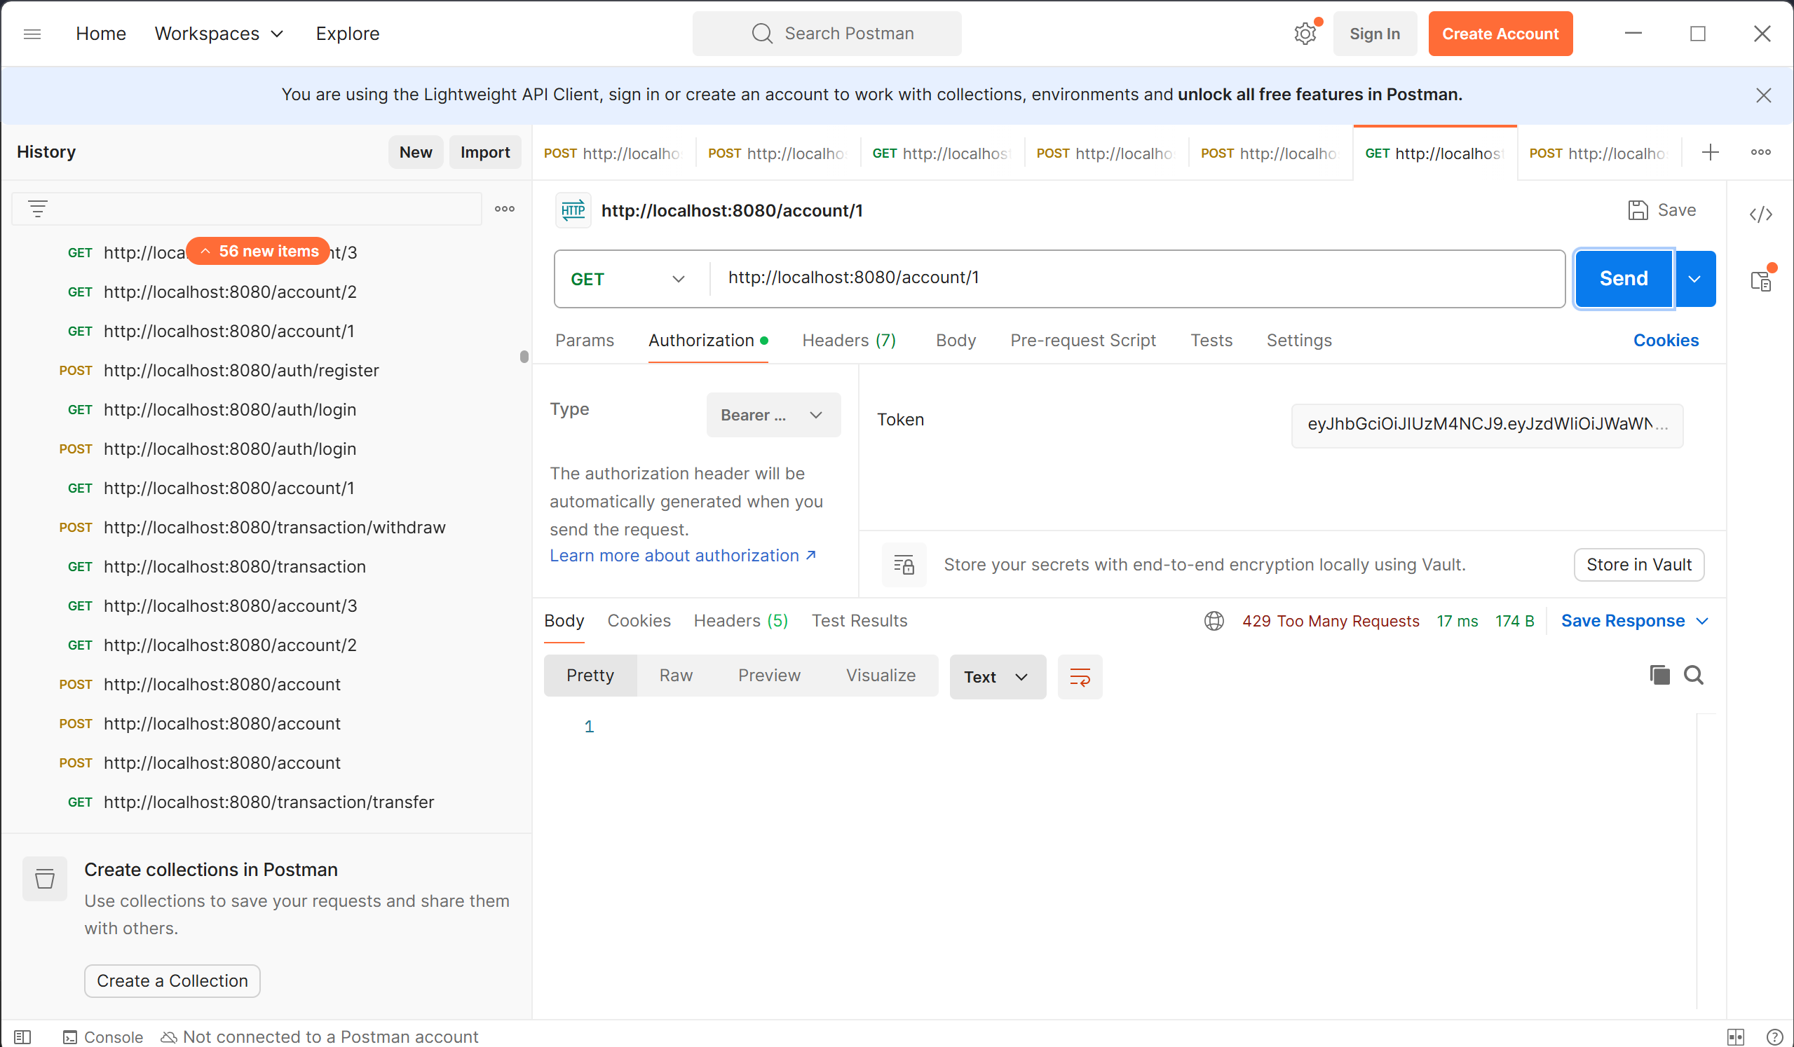
—----------------------------------------------------------------------------------------------------------------

Home Task:

Task 7:
Authentication and Authorization at the Edge
To implement Authentication and Authorization at the Edge (API Gateway) in our project, we willl extend the Gateway so that it enforces security before requests reach microservices.
Same our earlier project ..
gateway-service/
├── src/main/java/com/example/gateway/
controller/FallbackController.java
│ ├── controller/RateLimitController.java
│ └── controller/AuthController.java → Optional: issue tokens for demo
└── src/main/resources/application.yml│ ├── GatewayApplication.java
│ ├── config/RouteConfig.java
│ ├── filter/JwtAuthFilter.java —> Authentication filter
│ ├── util/JwtUtil.java —> Utility for JWT validation
│ ├──

1: JwtAuthFilter.java (Authentication at the Edge)
This file is the security guard at the API Gateway’s front door. Its purpose is to enforce Authentication and Authorization at the Edge, meaning every request is checked before it even reaches your microservices.

Use of JwtAuthFilter
- Intercepts All Requests
-> Because it implements GlobalFilter, this filter runs for every incoming request to the Gateway.
-> It ensures no request bypasses security.
- Now Authentication (Token Validation)
  - It looks for the Authorization header.
  - If the header is missing or doesn’t start with "Bearer ", the request is a blocked (401 Unauthorized).
  - It extracts the JWT and passes it to JwtUtil for validation (signature check, expiry check).
- Authorization (Role/Claims Extraction)
  - Once validated, it extracts claims (like userId, role) from the token.
  - These claims are added as custom headers (X-User-Id, X-User-Role) so downstream microservices can enforce role-based access.
  - Example: transaction-service can allow only ADMIN role to view all transactions.
- Centralized Security
  - Instead of duplicating JWT checks in every microservice, the Gateway enforces it once.
  - This reduces complexity and ensures consistent security across the system.
@Component
public class JwtAuthFilter implements GlobalFilter {
@Autowired
private JwtUtil jwtUtil; // Utility to validate tokens
@Override
public Mono<Void> filter(ServerWebExchange exchange, GatewayFilterChain chain) {
String authHeader = exchange.getRequest().getHeaders().getFirst("Authorization");

if (authHeader == null || !authHeader.startsWith("Bearer ")) {
exchange.getResponse().setStatusCode(HttpStatus.UNAUTHORIZED);
return exchange.getResponse().setComplete();
}
String token = authHeader.substring(7);
// now Validate JWT
if (!jwtUtil.validateToken(token)) {
exchange.getResponse().setStatusCode(HttpStatus.UNAUTHORIZED);
return exchange.getResponse().setComplete();
}
// Extract roles/claims and set in request headers for downstream services
Claims claims = jwtUtil.getClaims(token);
exchange.getRequest().mutate()
.header("X-User-Id", claims.getSubject())
.header("X-User-Role", claims.get("role", String.class))
.build();
return chain.filter(exchange);
}
}

Step 2: JwtUtil.java (JWT Validation Utility)
This file is a helper utility class whose job is to handle all the JWT (JSON Web Token) parsing and validation logic.
Centralized Token Handling like
Instead of writing JWT parsing code inside filters or controllers, you keep it in one utility class.
Of course makes the code cleaner, reusable, and easier to maintain.
Extract Claims from JWT
The getClaims(String token) method decodes the JWT using the secret key.
It returns the payload (claims) such as username, role, expiry, etc.
@Component
public class JwtUtil {
private final String SECRET = "mySecretKey123"; // Demo secret key
public Claims getClaims(String token) {
return Jwts.parser()
.setSigningKey(SECRET.getBytes())
.parseClaimsJws(token)
.getBody();
}
public boolean validateToken(String token) {
try {
Claims claims = getClaims(token);
return !claims.getExpiration().before(new Date());
} catch (Exception e) {
return false;
}
}
}

Step 03. AuthController.java (Demo Token Issuer)
This is a authentication endpoint.

Use of AuthController
- Login Endpoint
  - Exposes /auth/login as a REST API.
  - Accepts a username (and optionally password in a real system).
- JWT Token Issuer
  - Generates a JWT (JSON Web Token) when a user logs in.
  - The token contains:
    - sub → subject (username).
    - role → user’s role (e.g., USER, ADMIN).
    - exp → expiry time (1 hour in this demo).
- Response to Client
Returns the token in JSON format:
json
{ "token": "<jwt>" }
- The client must include this token in the Authorization: Bearer <jwt> header for subsequent requests.
why?
- Authentication Flow:
  - Without this controller, clients wouldn’t have a way to obtain a JWT.
  - It simulates a login process and issues tokens for demo purposes.
- Integration with Gateway:
  - The Gateway’s JwtAuthFilter uses JwtUtil to validate tokens.
  - Tokens issued by AuthController are what clients present to the Gateway.
  - This creates a complete flow: Login -> Get Token → Use Token → Gateway validates → Microservices accessed.

java
@RestController
@RequestMapping("/auth")
public class AuthController {

@PostMapping("/login")
public Map<String, String> login(@RequestBody Map<String, String> user) {
// Demo: issue token with role claim
String token = Jwts.builder()
.setSubject(user.get("username"))
.claim("role", "USER")
.setIssuedAt(new Date())
.setExpiration(new Date(System.currentTimeMillis() + 3600000)) // 1 hour
.signWith(SignatureAlgorithm.HS256, "mySecretKey123".getBytes())
.compact();

return Map.of("token", token);
}
}

Step 4.

application.yml (No major changes, but Gateway now enforces JWT filter)
yaml
spring:
cloud:
gateway:
default-filters:
- JwtAuthFilter #here apply JWT filter globally

How it flow
Login to get JWT
bash
curl -X POST http://localhost:8080/auth/login \
-H "Content-Type: application/json" \
-d '{"username":"prasunamba","password":"demo"}'
- → Returns { "token": "<jwt>" }
Call Account Service via Gateway
bash
curl -H "Authorization: Bearer <jwt>" http://localhost:8080/account/1/balance

  - Gateway validates token in JwtAuthFilter.
  - If valid → forwards request with user claims in headers.
  - If invalid/missing → returns 401 Unauthorized.
- Authorization Example
  - Microservices can read X-User-Role header to enforce role-based access.
  - Example: Only ADMIN can view all transactions.

What all Changes v made?
- Added JwtAuthFilter → enforces authentication at Gateway.
- Added JwtUtil → validates JWT tokens.
- Added AuthController → demo endpoint to issue tokens.
- Updated application.yml → apply filter globally.
- Downstream services can use headers (X-User-Id, X-User-Role) for authorization.
