Cart Abandonment Analysis — Final Consulting Report
Prepared by: Vikhyat Singh
Tools:
Python | Pandas | NumPy | Matplotlib | Seaborn | Scikit-Learn
Objective:
Identify why customers abandon shopping carts, discover behavioural patterns,
and create a predictive recovery strategy.

Executive Summary
This report presents a complete analytical study of ecommerce cart abandonment behaviour.
The purpose of this project was not only to measure abandonment but to understand the
customer journey: where users leave, which behaviours indicate risk, and how the business
can recover lost opportunities.
The project followed a complete analytics workflow:
data understanding, data quality assessment, preprocessing, exploratory data analysis,
predictive modelling, and business recommendations.

Key Finding
Approximately 75.8% of customers who added products to their cart did not complete
the purchase journey.
These customers already showed buying intent, meaning abandonment recovery represents
a significant business opportunity.
Finding | Business Meaning
75.8% abandonment after cart creation | Large recovery opportunity
317 customers lost before checkout | Checkout transition is the largest friction point
62.3% model recall | Majority of abandoners can be identified
Seasonal variation exists | Campaign timing can be optimized

Phase 1 — Problem Definition and Data Understanding
The client observed that many customers interact with the platform and place items
inside the cart but leave before completing transactions.
This creates lost revenue because acquisition efforts successfully brought customers
to the website, but conversion did not happen.

Business Questions
- Where exactly does customer drop-off happen?
- Which customer behaviours increase abandonment risk?
- Can we predict customers likely to abandon?
- Which business actions should be prioritized?

Dataset Overview
Attribute | Value
Original rows | 1010
Final cleaned rows | 1000
Columns | 31
Observation unit | One customer session
Period | January 2023 - December 2024

Phase 2 — Data Cleaning and Preparation
Before analysis, the dataset was audited for quality problems.
Cleaning decisions were made carefully because incorrect preprocessing can create
misleading insights.
Issue | Why it matters | Solution
Duplicates | Inflates customer counts | Removed 10 duplicate sessions
Date inconsistency | Blocks time analysis | Converted into datetime
Category errors | Creates false groups | Standardized text values
Missing values | Can bias results | Handled according to meaning
Outliers | Can distort averages | Reviewed using business logic

Missing Value Strategy
Missing values were separated into random missing information and structural missing
information.
Structural missing values were preserved when absence itself represented customer behaviour.
Variable | Interpretation | Treatment
Coupon code | No coupon used | Structural missing
Payment failed | Customer never reached payment | Structural missing
Previous purchases | New user history unavailable | Filled logically

Phase 3 — Exploratory Data Analysis

3.1 Funnel Analysis
Business Question:
At which stage of the purchase journey do most customers leave?
Funnel analysis tracks customers from website visit to successful purchase.
Stage | Sessions
Visited Site | 1000
Added To Cart | 707
Reached Checkout | 390
Entered Payment | 255
Completed Purchase | 171
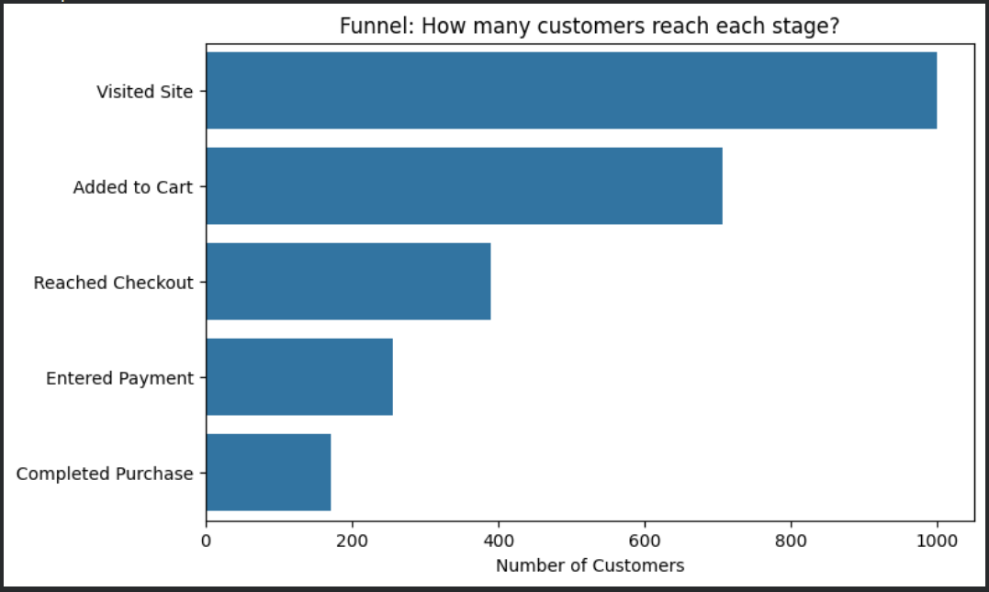
Business Interpretation:
The largest customer loss happens between adding items to cart and reaching checkout.
317 customers leave during this transition, suggesting friction before the payment stage.

3.2 Device Analysis
Business Question:
Does device experience influence abandonment?
Different screen sizes and checkout experiences can affect purchase completion.
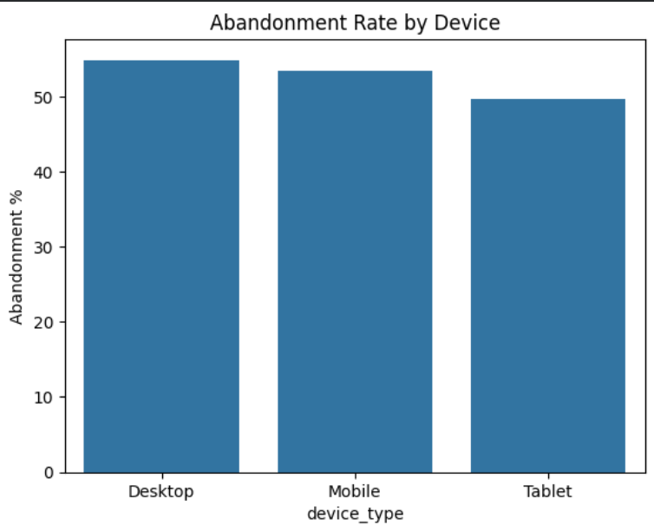
Observation:
Desktop abandonment = 54.9%
Mobile abandonment = 53.4%
Tablet abandonment = 49.6%
The difference is small, indicating abandonment is a general journey problem rather than
only a mobile issue.

3.3 Seasonality Analysis
Business Question:
Does abandonment change during different months?
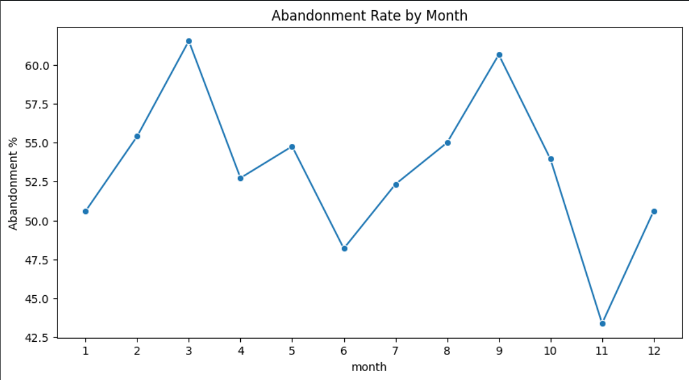
Observation:
Highest abandonment occurred in March (61.5%).
Lowest abandonment occurred in November (43.4%).
Marketing recovery strategies should consider seasonal behaviour.

3.4 City Tier Analysis
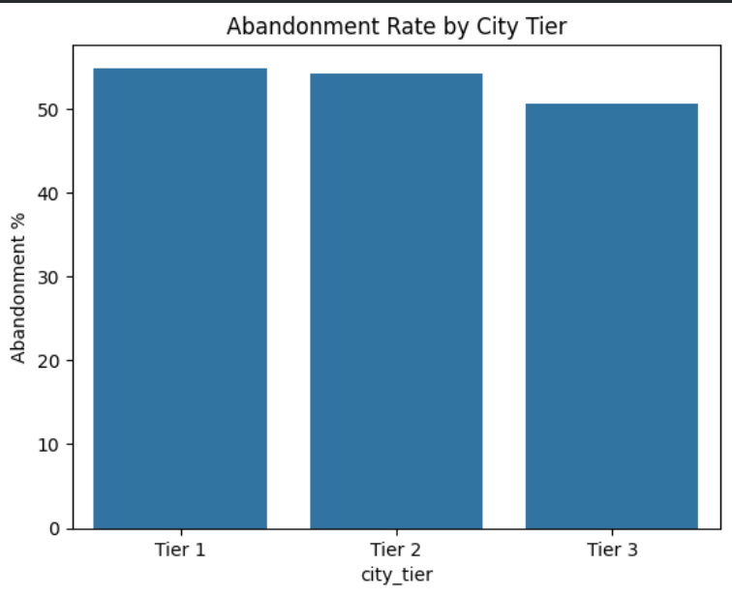
Tier differences were relatively small, suggesting geographical targeting alone will
not solve abandonment.

3.5 Cart Value Behaviour
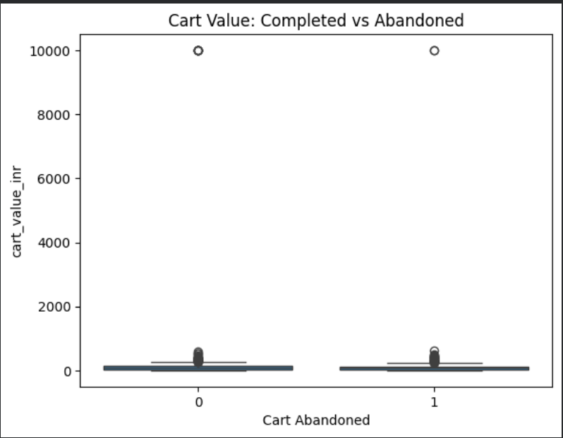
Cart value was analysed to understand whether purchase size influences hesitation.
Higher value purchases often involve more comparison and decision time.

3.6 Weekend Behaviour
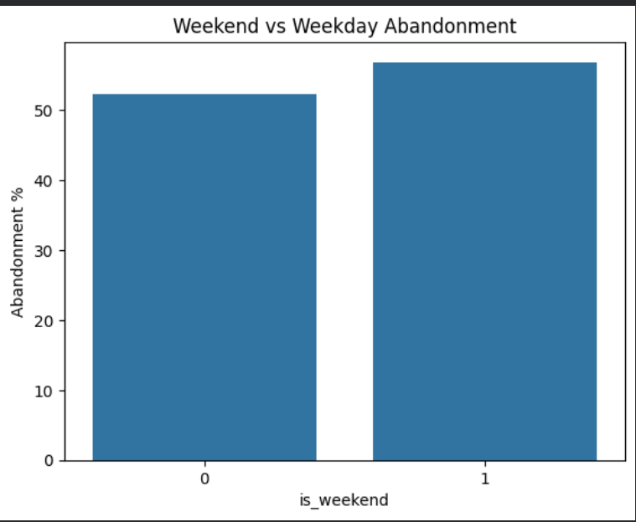
Weekend sessions showed slightly higher abandonment, suggesting browsing behaviour
may differ from weekday shopping.

3.7 Technical Experience Analysis
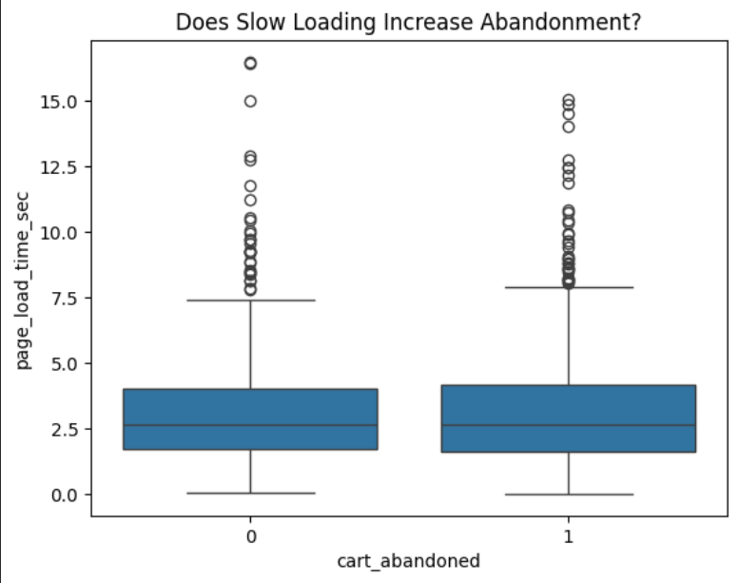
Page loading speed was evaluated because slow digital experiences increase customer
friction and can reduce conversion.

3.8 Discount Analysis
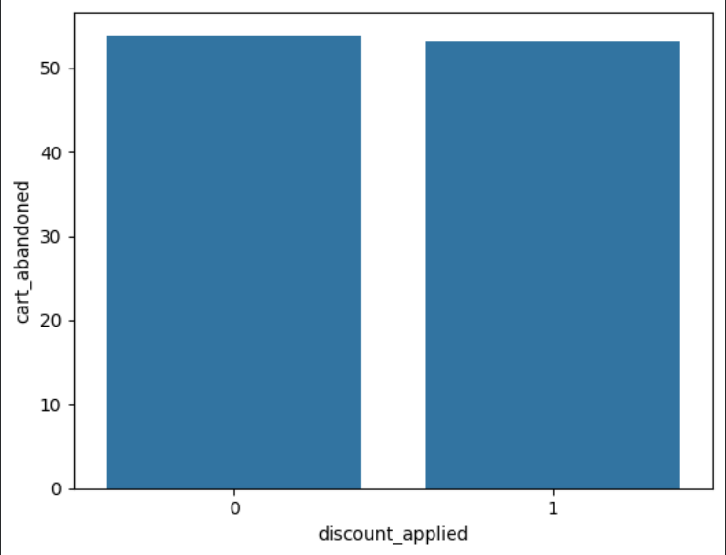
Discount behaviour was reviewed to understand whether incentives improve conversion.
Discounts showed a small positive influence.

Phase 4 — Predictive Model

Why Logistic Regression?
Logistic regression was selected because the business problem is a binary classification
problem: predicting whether a session becomes abandoned or completed.
The model also provides interpretable coefficients, making results easier to explain
to business stakeholders.

Data Leakage Prevention
Variables created after abandonment events were excluded.
A prediction system should only use information available before the customer leaves.

Important Model Drivers
Feature | Coefficient | Meaning
entered_payment_details | -3.3527 | Strongly reduces abandonment
previous_purchases | -0.0056 | Customer loyalty reduces risk
page_load_time_sec | 0.0158 | Slow pages increase risk
page_views | 0.0191 | More browsing indicates hesitation
is_weekend | 0.2298 | Weekend risk higher
reached_checkout | 2.7382 | Strong funnel indicator

Model Performance
Metric | Value | Meaning
Accuracy | 62.5% | Overall prediction correctness
Precision | 68.9% | Quality of abandonment predictions
Recall | 62.3% | Abandoners successfully detected
ROC-AUC | 0.6968 | Ranking ability

Phase 5 — Business Recommendations

Recommendation 1: Improve Checkout Experience
Evidence:
The biggest customer drop happens before checkout.
Action:
Simplify checkout steps, improve transparency, and reduce unnecessary friction.
Measurement:
Monitor checkout progression rate.

Recommendation 2: Predictive Recovery Campaign
Evidence:
The model captures 62.3% of abandoning customers.
Action:
Use abandonment probability scores to trigger personalized recovery actions.

Recommendation 3: Improve Future Data Collection
Additional variables such as shipping cost, inventory status, and marketing campaign IDs
should be collected to improve future prediction accuracy.

Appendix
Package | Purpose
Pandas | Data cleaning
NumPy | Numerical analysis
Matplotlib | Visualization
Seaborn | Statistical visualization
Scikit-Learn | Machine learning
Term | Meaning
Cart abandonment | Customer adds product but does not purchase
Recall | Percentage of abandoners correctly detected
Precision | Correctness of abandonment predictions
Data leakage | Using unavailable future information

