Grafana Graphs

Zone1

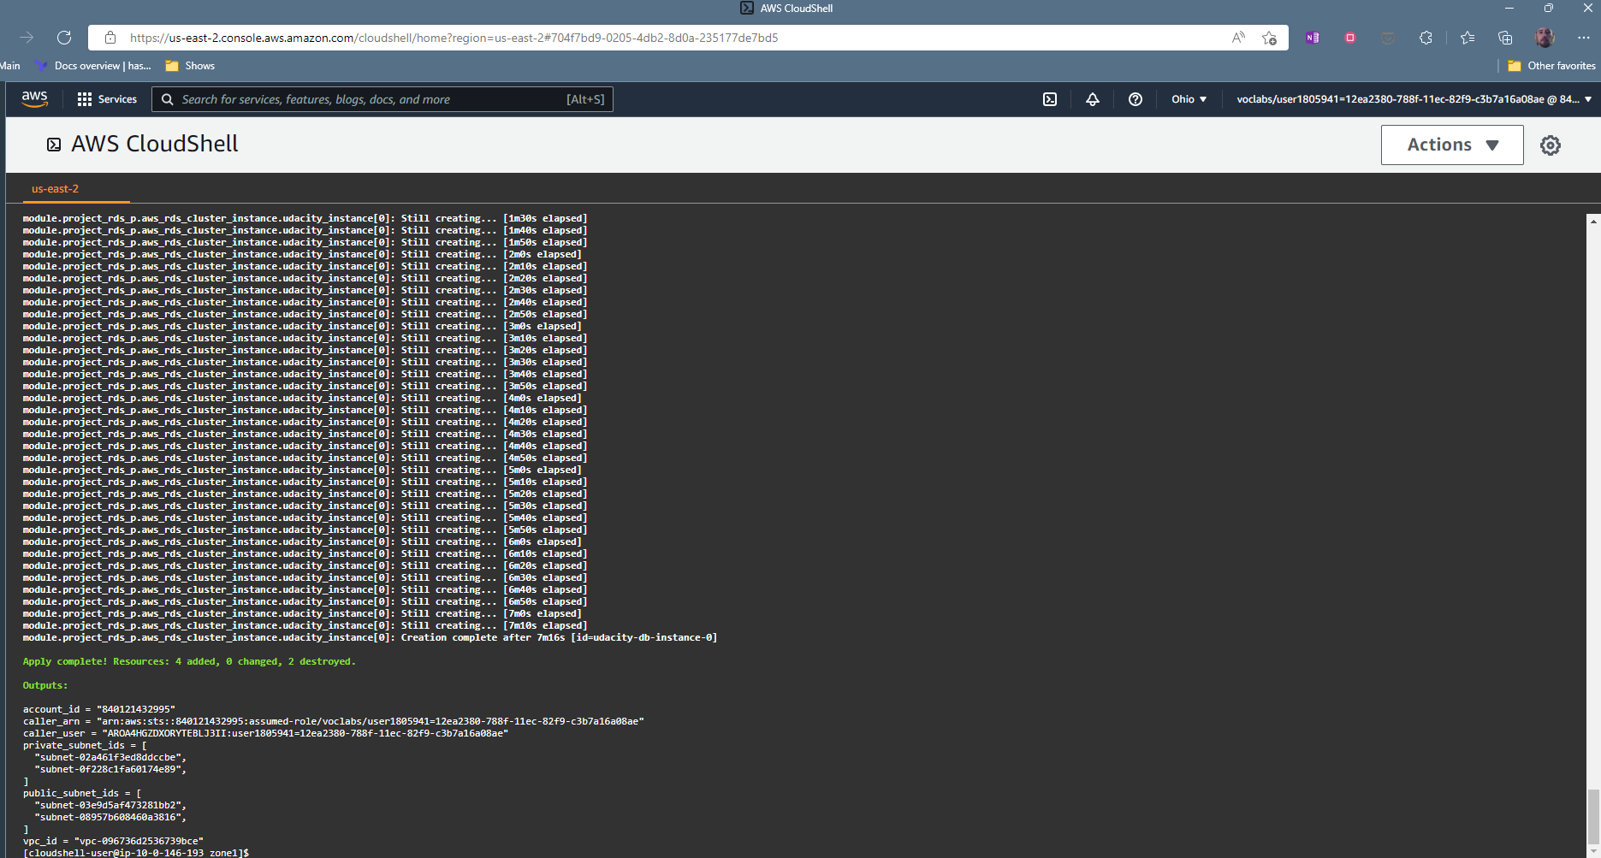

Zone 2

RDS/DB   
Completed successfully and then got an amazon screen cloud shell timeout. Came back in and did a reapply:

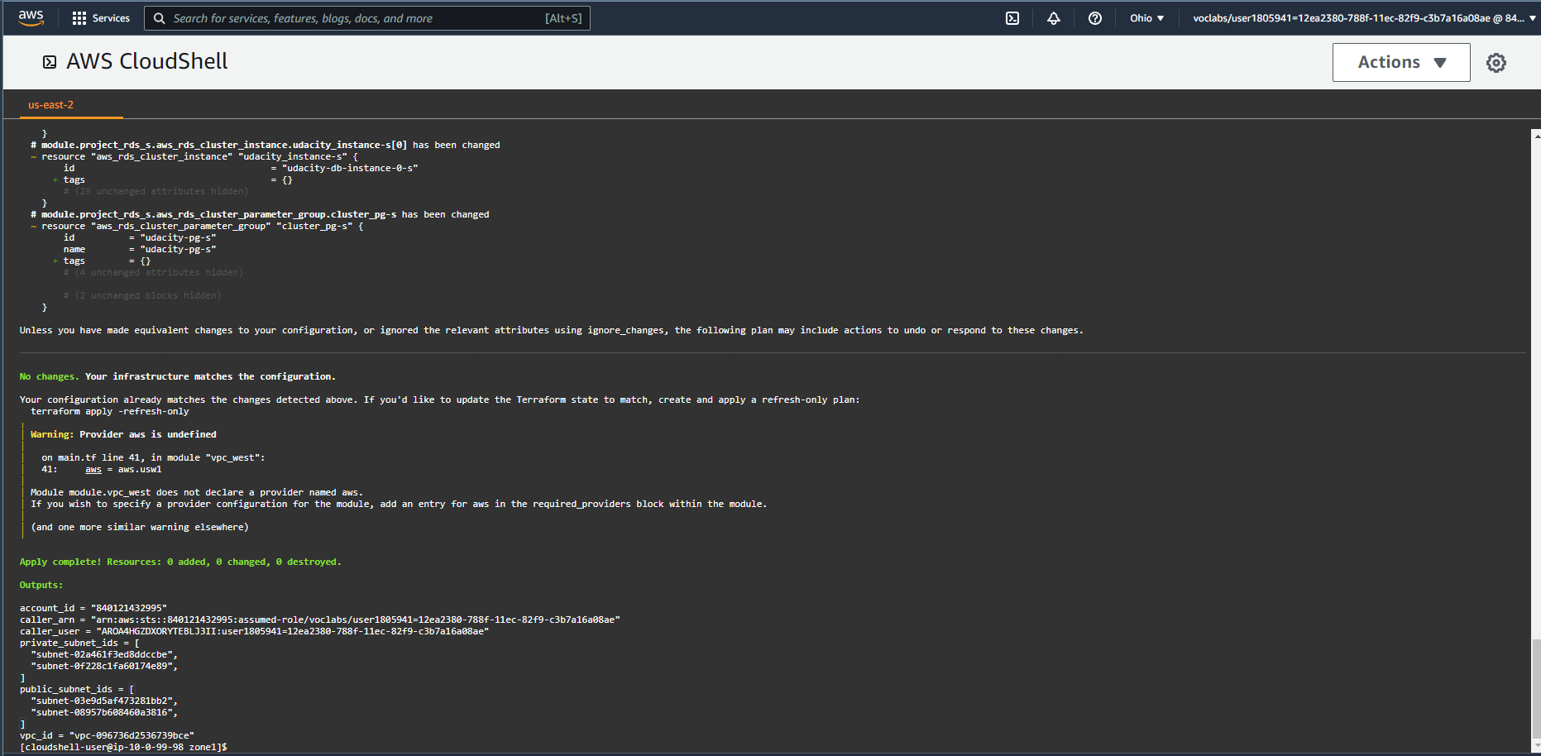

DESTROY

