Slide 1

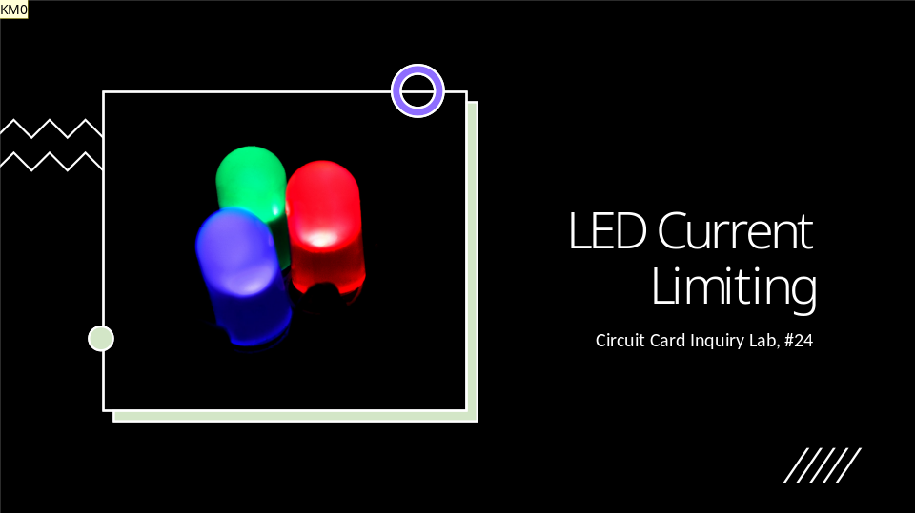

Welcome to my presentation on LED Current Limiting, for course RBT125, Fall 2023. My name is Kevin Millard, and I will be guiding you through my presentation.

Slide 2

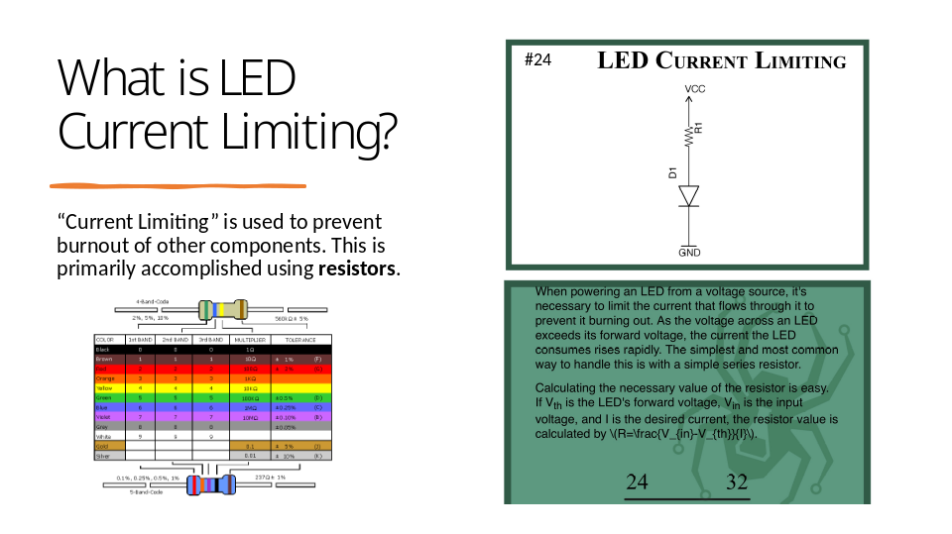

In the simplest of terms, what current limiting does is prevent burnout or damage to other components (like LEDs) from excessive energy flowing from the voltage source (i.e.: A 9V Battery). More commonly, the circuit will be built with resistors to create the current limitations on LEDs (as their tolerance is more likely to decline quickly with higher voltages). The card on the left hand of this slide explains the concept in more detail.

Slide 3

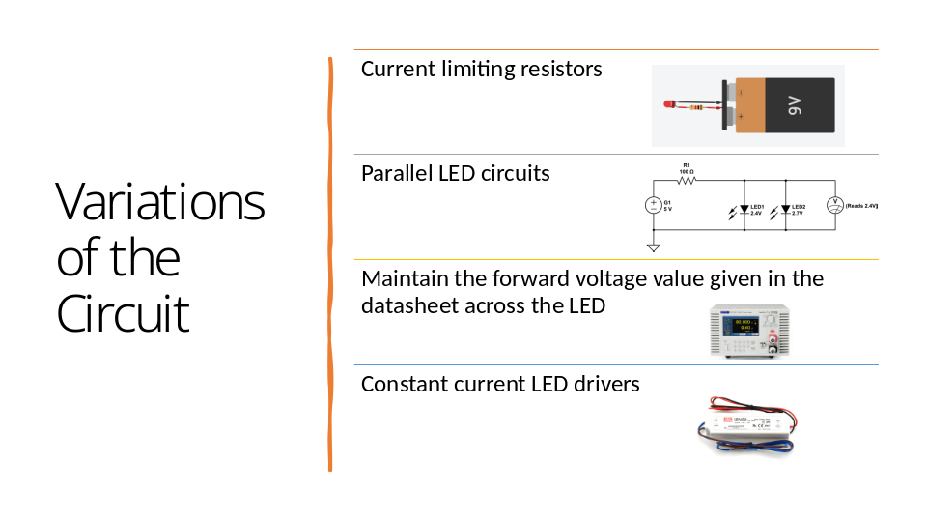

In addition to resistors, there are other methods and devices to assist with current limiting. One method is done by aligning the LEDs in a parallel circuit (versus that of a series circuit), which reduces the overall load into two paths (though resistors are still commonly added to this type of circuit, as well).

The alternative solutions to achieve current limiting to the LEDs (and other components) is to use devices like a DC Power Supply to manually control the voltage, or an LED Driver to provide constant current throughout a series circuit.

[Additional note: Diodes can also be a useful component to control forward current to the LEDs in a circuit.]

Slide 4

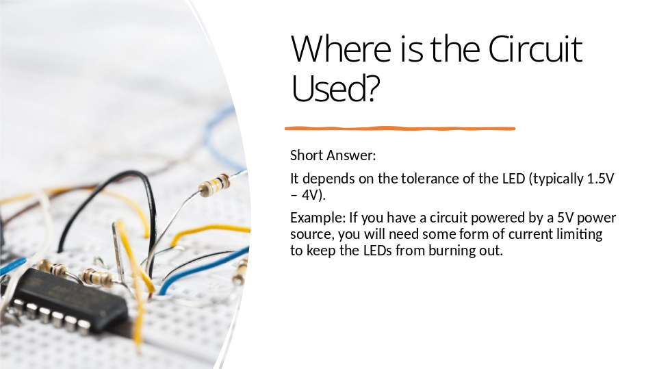

Where is the this circuit format used? The short answer is that it depends on the tolerance of the LEDs being used in the circuit (which is typically between 1.5V – 4V). An example of this might include using a 5V power source to power your circuit. You would need some form of current limiting component or device to protect the LEDs from burnout.

Slide 5

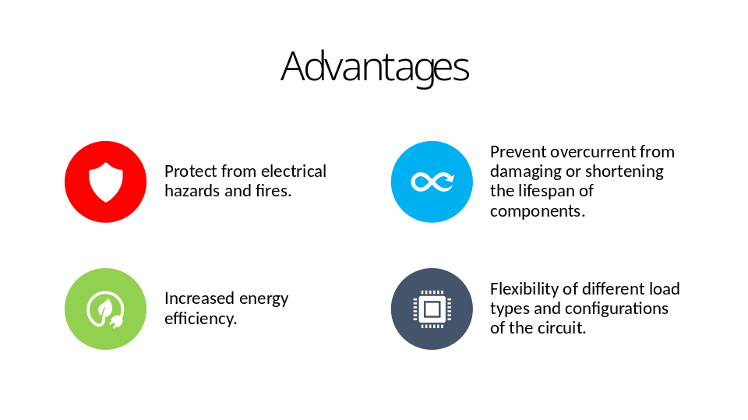

Now that we know a bit more about current limiting, let us look at some of the advantages and disadvantages of using this method in a circuit.

As you can see, some advantages include (1) protection from electrical hazards and fire, (2) preventing overcurrent from damaging the LEDs (immediately or long-term), (3) increasing energy efficiency of the circuit, and (4) allowing for more flexibility in circuit configurations and load types.

Slide 6

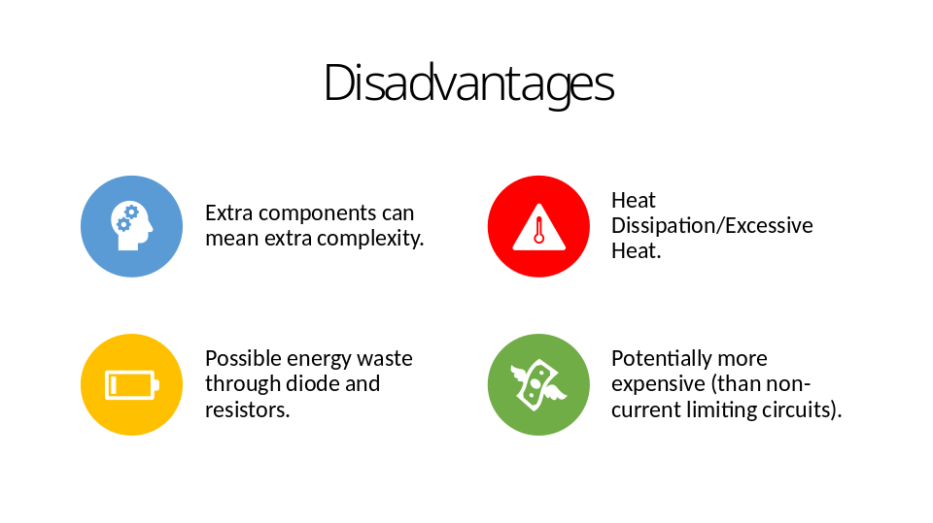

As for the disadvantages of current limiting, four main disadvantages stand out. (1) The extra components mean extra complexity for the overall circuit build. (2) With the addition of these components, excessive heat and heat dissipation can become a problem. In contrast to potentially being energy efficient, a circuit with current limiting can also (3) waste energy through the diodes and resistors. Lastly, (4) the need to include current limiting components or use current limiting devices has the potential to be more expensive than a non-current limiting circuit.

Slide 7

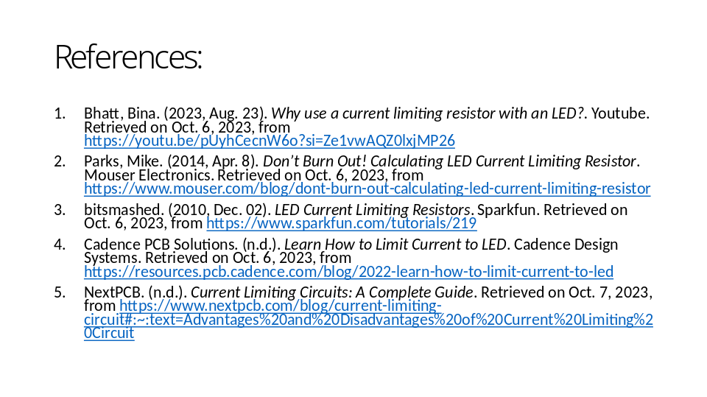

This has been a presentation on LED Current Limiting (and current limiting to other components). The references listed are the primary references from which I collected information for this presentation. Please check out these links for further explanation on LED current limiting.

Thank you for your time and attention, and I hope you’ve learned something new about the use of this method.

Slide 8



