Source Repo: <https://github.com/thewabbit/CPA-Material-Generator>

Download: <https://drive.google.com/file/d/1LdZeSmdlbjchZ6BUT_MtPT9GJ2e9Vb5P/view?usp=sharing>

**Setup**

1. You need Microsoft Office installed
2. Download the zip from the above download URL
3. Extract the zip to a local location
4. Your folder structure should look like this:  
   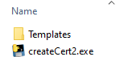
5. Under the templates fold you should have  
   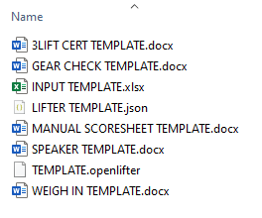
6. Double click on “createCert2.exe”. If you get any warnings, please accept/allow them
7. A window like below should open, with a black box behind it  
   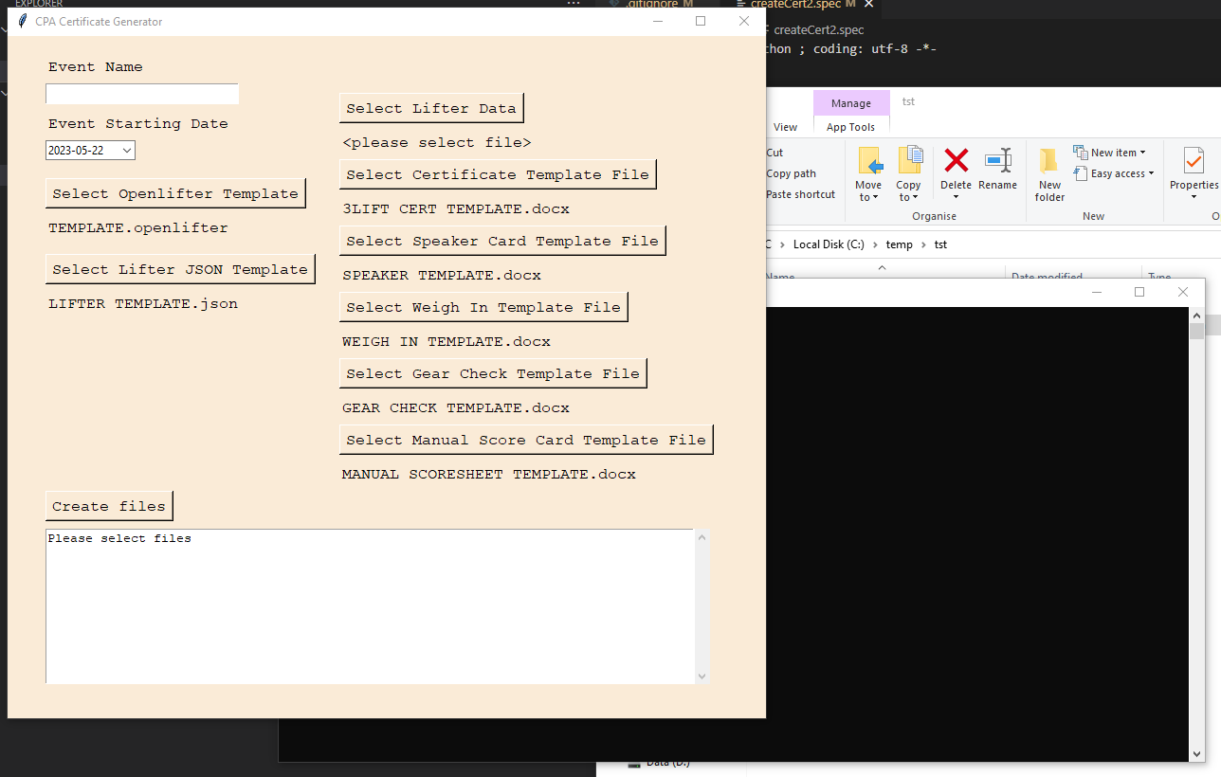
8. Note how the templates are automatically selected. If the process can’t find them in the template folder, you will need to click the appropriate button and that will open a dialogue to select the file.

**Setting up the lifter data**

1. In the template folder, there is a spreadsheet, all lifter data to be entered in here. This is the only place you need to enter the data!
2. **DO NOT CHANGE THE HEADINGS OR THE ORDER OF THE COLUMNS**
3. Days are numeric ie 1,2,3
4. Flight is lower case ie a,b
5. The other fields are to be copied directly from the Sporty Output
6. Save this, and click the “Select Lifter Data” and select the file

**Running**

1. Make sure all the fields are populated, including the event name and lifter data input
2. **Close any open word documents or excel files**
3. Click “Create Files”
4. You will begin to see some text appear in box the box at the bottom of the window, and in the black window behind it
5. This will take a couple of minutes to complete.
6. Once its completed, you will see a message like:  
   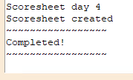
7. You should also find 5 pdfs, each containing the respective information, ready to print

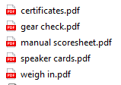

1. You will also see some files ending in “.openlifter”. These are used to run open lifter. You can test that they work by loading them in here: <https://www.openlifter.com/en/>

**Updating Templates**

1. The templates for the PDFs are word files. These can be updated as required. Please make sure the words contained in “zz” (ie “zzEVENTzz” “zzSESSION”) are unchanged