# 2 Fineos

## 2.1 Profile

The FINEOS Corporation is a privately owned, Dublin-based, software company who provide solutions for life, accident and health insurance. To evaluate Situational context can be defined as “The circumstances that a software development effort are faced with”[1]. These circumstances include, but are not limited to, customer profile, market, company scale, budget, application type and experience etc. In the case of FINEOS, we will analyse each of these areas sequentially to gain a perspective on how and why their software development process developed in the manner that is has.

**Company Scale.** FINEOS currently employs over 500 people globally, with offices in Ireland, Poland, North America and Australia. Their Dublin headquarters has in excess of 250 employees [2]. They earn 60 million in annual revenue which puts them firmly in the medium to large sized company in relation to other indigenous software companies [2]. Their project teams are comparatively smaller than some of their larger competitors which grants them flexibility in respect to the how rigidly they must employ their software development process.

**Experience.** Despite the fact that they are a medium sized indigenous software company, FINEOS has over 20 years of experience solely focused on health insurance software [2]. Their rapid growth and expansion is evidence of this experience. Moreover, their software stack largely consists of industry leading tools in areas of continuous integration, version control, testing etc. Their willingness to keep learning and adapting to their market in this way can also be reflected in their consistent evolution of their software development process.

**Market.** FINEOS operates within the insurance market, specifically geared towards health. Despite being an indigenous to Ireland, their primary markets include Australia, New Zealand, London, America and Sweden [2].

The insurance market deals with very sensitive information and therefore maintain the integrity and security of FINEOUS’ software is paramount.

**Application Type.** Their product suite, which sits on the same digital platform, consists of three main modules, namely, their Claims System, Policy System and Billing System[2]. When discussing any application, it is important to consider the criticality of the software. In the case of FINEOS, their risk involves paying out money in the form of claims. Furthermore, these applications typically must process huge amounts of information at any given time which makes the cost a software malfunction or breach tremendous. Both of these facts make accuracy and reliability of their software a key concern.

**Customer Profile.** FINEOS’ customer base is quite diverse and is split among privately owned companies and government agencies. Some of their most notable clients include American-based company, Cigna, who are valued above four billion dollars, two out of five of the major Lloyd’s Insurance syndicates in London and the New Zealand Government [2]. Working with clients of this scale, although profitable, poses many additional concerns. Being some of the biggest players in the industry, there is a large degree of communication between them and any project that FINEOS underperforms in, will likely be scrutinized at large. Additionally, these customers must be able to adapt to sudden changes in the market which can lead to rapid developments in their requirements during a software development cycle. The nature of their clientele forces FINEOS to find a balance between speed to market, quality and budget.

## 2.2 Current Software Development Process

FINEOUS currently operates under a Scaled Agile Framework (SAFe) which is intended to provide a modular solution for integrating agile development processes which best suite their situational context. Typically, agile approaches struggle in terms of scalability. Extensive research has been done which demonstrates the difficulty in scaling agile approaches for larger global companies as outlined in works by Donald J. et al[3]. Despite this, the SAFe framework aims to overcome these shortcomings by providing a blueprint for scaling specific components of traditional agile processes across an entire organisation. The diagram below gives a high level overview of the SAFe framework:

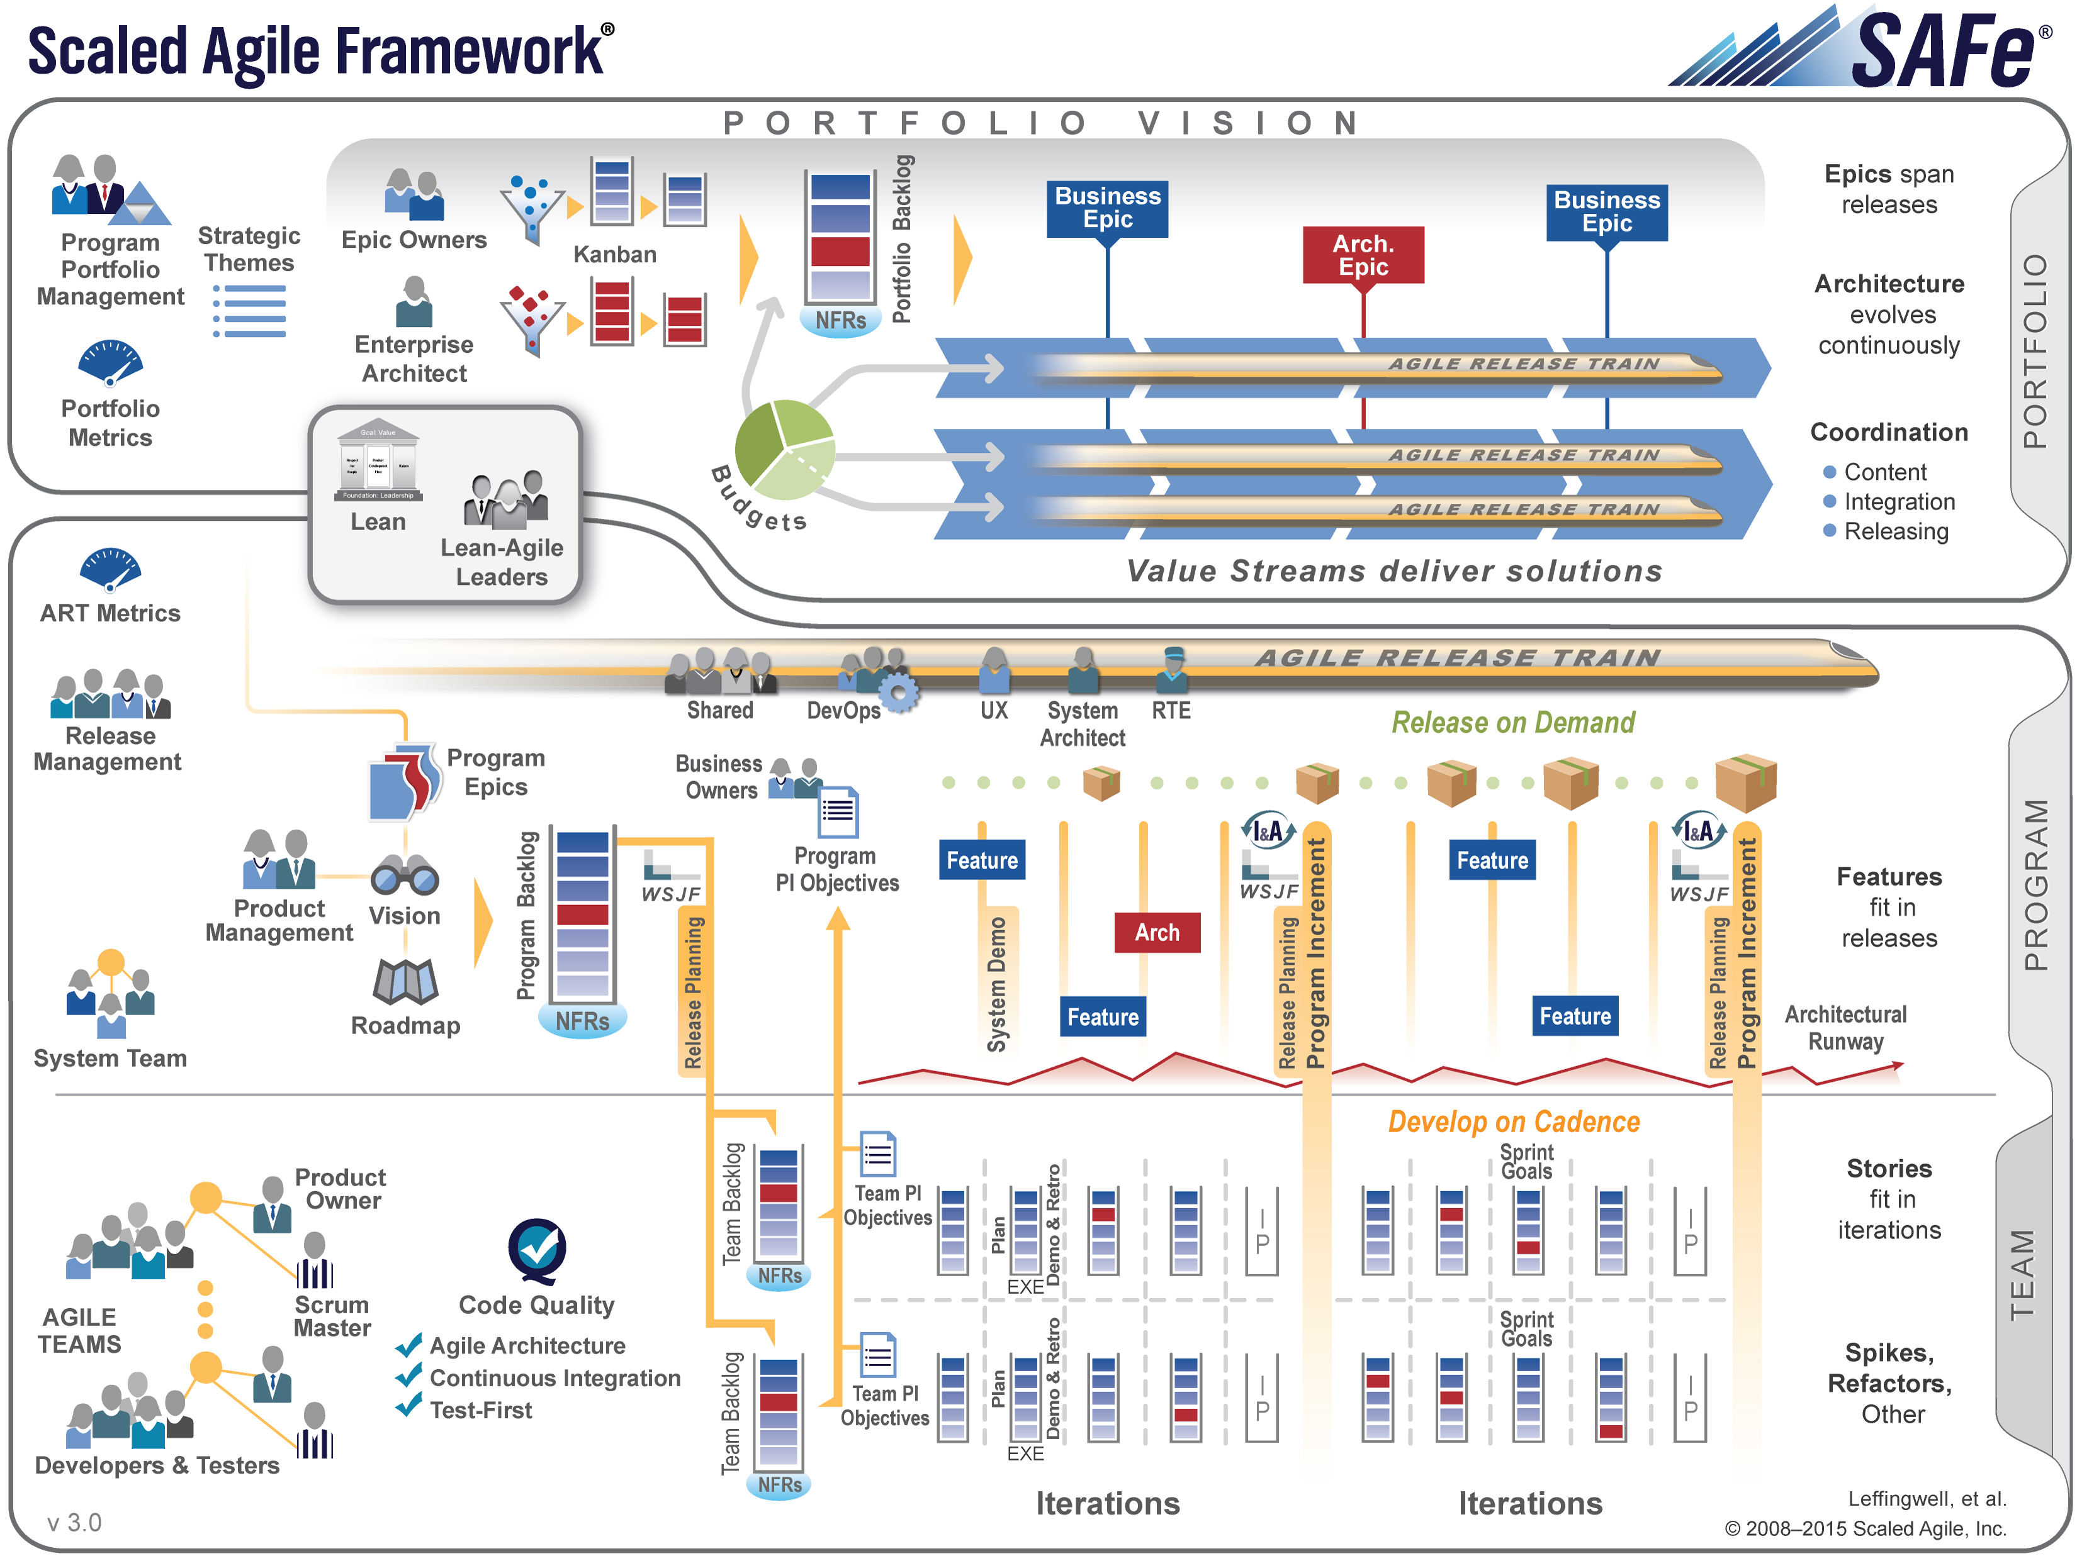

The framework is divided into 3 distinct tiers:

**Team Level.** This is the lowest and most granular level of the SAFe framework and consists of software development teams which employ an agile process to build, test and release software, according to pre-defined development cycles. FINEOS staff at this level choose the components of traditional agile development processes, such as Scrums and Extreme Programming, which tie in with their situational context.

**Program Level.** This intermediate level is responsible for organising and improving efficiency of the agile teams at the team level at scale. At this level, product and release management teams produce a roadmap for development which outlines time frames and goals in regards to incrementally adding new features. These high level features are typically referred to as “Program Epics” [2].

**Portfolio Level.** The top level of the SAFe framework is responsible for ensuring consistency between the company’s business strategy and software development cycle. High level management typically use ‘Value Streams’ to make executive decisions about the how the company should be organised. Value Steams are defined as “long-lived series of system definition, development, and deployment steps used to build and deploy systems that provide continuous flow of value to the business or customer” [4].

# 7 References

1. Clarke, P.: Traditional Life Cycles. Dublin City university, January 31st. (2017)

2. Solan, D.: FINEOS: Process and Agile Journey. Dublin City University. February 23rd. (2017)

3. Reifer D, Maurer F, Erdogmus H.: Scaling Agile Methods. In: IEEE Software, vol. 20, pp. 12-14. June 25th (2003) **doi:**[10.1109/MS.2003.1207448](https://doi-org.dcu.idm.oclc.org/10.1109/MS.2003.1207448)

4. Turetken O, Stojanov I, Trienekens J.: Accessing the adoption level of scaled agile development: a maturity model for Scaled Agile Framework. In:J. Softw. Evol. And Proc., July 10th (2016) doi: 10.1002/smr.1796 <http://onlinelibrary.wiley.com/doi/10.1002/smr.1796/full>