**Abstract**

A student’s online voting system is designed to facilitate online voting process in educational institutions. This abstract summarizes the key ideas, objectives, and methods, highlighting its potential benefits and implications for using online voting in institutions.

Through the elimination of traditional paper-based ballots and manual vote-counting procedures, this technology simplifies the voting process. Rather, it makes use of technology to facilitate accurate and efficient voting, improving students' convenience and accessibility. The provision of preliminary voting facilitates student ballot casting at their convenience, thereby mitigating the logistical obstacles linked to conventional voting techniques.

The capacity of the student online voting system to display vote results graphically in real-time is one of its primary features. Students may easily follow the election's progress by examining visually appealing graphs and charts that show the percentage of votes each candidate has gotten and the overall number of votes cast. Election process confidence is increased and accountability is encouraged by this transparency.

This system's main goal is to create, develop, and implement a web-based voting platform that works well and is adapted to the demands of student communities. The system strives to promote democratic engagement among students by giving priority to efficiency, use, and accessibility, all the while upholding values of justice and integrity.

In conclusion, the student online voting system, which uses technology to streamline and improve the voting process, is an example of a cutting-edge and contemporary approach to student elections. Students have an easy way to be part in the democratic process in their educational institutions because to the system's user-friendly interface, secure authentication methods, and real-time result reporting.

# CHAPTER 1

# INTRODUCTION

## Background

University student leaders are the core link between the university students and the university administration. These leaders are therefore elected democratically to represent the interests of the students as per the university act. It is always an expectation of every student that elections be held fairly and results computed accurately. In the previous elections, there have been challenges in the turnout of voters due to some challenges they face on the voting day. Initially the students were expected to queue and cast their votes in the ballots as per their various schools. The current system does not verify and account for the persons to vote since no voting registration is done prior. This has been bringing some loopholes in that even a student who is not in session can queue and vote as long as he/she has a student identification Card. The current system does not also tell the number of expected voters since they rely on the population of the student of which not all students are interested in these elections. This is the main challenge to the voters and officials of election commission. Candidates are expected to reach voters through door the door campaigns, rallies and debates which has been a challenge for a while due to the busy environment in the school. Many students do not attend rallies because of their busy schedules and also, it’s hard for candidates to find students in their houses since availability is an issue. This mode of campaigning has been yielding less fruits and thus voters would cast votes with either no or less knowledge about the candidates and their manifestos.

When it gets to counting, a lot of time man power are consumed following the large population of voters. With the nature of human being not being so diligent, a lot of flaws are found which brings a lot of chaos from the stakeholders. Following these challenges, I saw it good to come up with a system that could curb these problems and speed up the election system to ensure free and fair elections. When a system that is based on pens and ballot papers is used at a large population, the results can be ambiguous and that questions the intelligibility of the system used. Hand counting votes is time consuming especially at a turnout of many voters and many positions being voted for. In a case of disabled or duty-bound people, they struggle to cast their votes the system makes it easy for them since they can vote at their comfort of their places. This system also curbs the chances of the manipulation of results from influencing authorities and thus generate transparency to the highest levels.

## Problem statement

In the modern educational landscape, fostering student engagement and participation in governance processes is paramount for promoting a vibrant and inclusive campus community.

However, the current system in many educational institutions is a manual system where everything is done minus computers. The aspiring candidates apply through their various schools’ departments for the various posts of interests. They are therefore vetted by the senior authorities and nominated for the posts. Afterwards they are given a duration of campaign where they have to sell their policies and agendas to the voters and win their votes. On the voting day, voting is done manually using pen and ballot papers where a student is supposed to tick or put a mark alongside the candidate of choice. These many times leads to so many spoilt votes due to ignorance or violation of rules of the students who are hungry to vote. The students make long queues to cast their votes as voting is done one student at a time. Counting of votes is done handily with the candidate’s agents witnessing the process. The candidate with the majority of votes is declared winner and sometimes once the candidate with major votes is noticed, the counting process is stopped. How then will the other candidates know they lost by how many votes? This is the reason for our proposed system. The current system is slow, tiresome and with a lot of loopholes as there may be some essence of manipulation of results from the higher authorities in favor of their preferred candidates who may not be the choice of the people.

The primary objective of this project is to design and implement an intuitive, user-friendly and scalable online voting platform that streamlines the entire election process for students and administrators alike. This system should facilitate seamless voter registration, ballot casting, and result tabulation while upholding the highest standards of integrity and trust.

## Proposed system

The proposed system will provide online voters registration forms for students which they will fill and upon registration of their details, they will be allowed to log in and interact with the system. The student details will be saved in the student details database. The user will be allowed to create their various passwords which they will use along their email to log into the system. The users will be able to log in as normal students. Delegates details are saved in the delegate database while candidates details are saved in the candidate’s database. The system will be able to perform some sort of tallying after voting. The results of the election will be shown and be updated properly and instantly. The system shall also allow results to be displayed openly to both the voter and the admin sides. The proposed system will therefore compute the election results for all the posts voted.

## Objectives

### Main Objective

To design, develop, and implement an efficient, user-friendly, interactive web-based student voting system.

### Specific Objectives

* To develop a system that will capture voters’ details.
* To provide an online voting platform students can vote for their preferred candidates.
* To develop a system that is accessible to all students.
* To develop a system that will promote transparency and accountability by providing real-time updates on candidate standings and election results, thereby fostering trust in the electoral process.
* Design an intuitive dashboard for administrators to manage election timelines, add candidates, add new positions, and view the results of the election.
* Enhance student engagement and participation in governance processes by providing a convenient and accessible platform for voting.

## Research Questions

The proposed system is based on the following research questions.

1. How will the proposed system capture candidates and voters’ details?

2. How will the proposed system facilitate online voting?

3. How will the proposed system ensure voters and candidates interact?

4. How will the proposed system generate reports for the election process?

## Justification

The success of this research will ensure the scalability of School online voting system to be used in other institutions of higher levels and even the secondary schools since the benefits upon successful implementation of the proposed system justifies its system development and deployment. The proposed system will ensure transparency and high integrity in the election process. The system will be user friendly and provide great efficiency in the election process. Its success can also be replicated in other universities.

## System Methodology

The system will involve the following steps:

1. Defining research objectives.
2. Conducting literature review on online voting systems.
3. Designing data collection methods.
4. Implementing the voting stems.
5. Testing for usability and effectiveness.
6. Analyzing data and evaluating system performance.
7. Iteratively refining the system based on feedback for continuous improvement.

## Scope

The online voting system for students’ leaders project entails creating, developing and putting into use a web-based platform that allows students to hold elections. In order to achieve efficiency, transparency and accessibility, it includes features like secure login, candidate selection, real time result visualization and scalability to accommodate different student populations.

# CHAPTER 2

# LITERATURE REVIEW

## 2.0 Introduction

Online student voting systems have gained significant attention in recent years as educational institutions seek to enhance student engagement, streamline administrative processes, and promote democratic participation within the student body. This literature review provides an overview of existing research, technologies, and frameworks relevant to the development and implementation of online student voting systems.

## 2.1 Voting methods

Today, voting methods that are widely adopted in many countries may be divided into five different types. These have been described as below:

Paper Ballots: Ballot voting is a democratic process whereby a group of individuals express their opinions and choices by way of casting a ballot (McCallum, 2015). The ballot process involves presenting a voter with a list of choices to mark against their favorite choice. In the paper-based system, voting is performed by using ballot paper and then the counting is executed manually. This is a time-consuming process and involves manual effort (McCallum, 2015). It might also lead to the possibility of invalid votes. All the above tedious tasks are eliminated in the above process. In internet voting systems, the counting of votes is done by using a computer (Kobie, 2015). This saves time and also avoids the errors that might occur during the election process at CoCIS (Nzoka et al., 2013)

Lever voting Machine**:** Lever machine is peculiar equipment, and each lever is assigned a corresponding candidate. The voter pulls the lever to vote for his favorite candidate. This kind of voting machine can count up the ballots automatically. Because its interface is not user-friendly enough, giving some training to voters is necessary (Schneier, 2015)

Punch card**:** The voter uses metallic hole-punch to punch a hole on the blank ballot. It can count votes automatically, but if the voter’s perforation is incomplete, the result is probably determined wrongly (Germann & Serdült, 2017)

Optical voting machine**:** In this type, each voter fills a circle corresponding to their favorite candidate on the blank ballot, this machine selects the darkest mark on each ballot for the vote then computes the total result. This kind of machine counts up ballots rapidly. However, if the voter overfills over the circle, it will lead to an error (Schneier, 2015)

Electronic voting**:** This is a voting system where the recording, casting and counting of votes involves information and communication technology. The main principle of e-voting system is the replica of the regular voting system as much as possible it is compliant with the election legislation and principles and be at least secure as the regular voting. In a nutshell, e-voting strives to be uniform and secret, only eligible persons are to be allowed to e-vote and a voter should only cast one vote and the collections are to be secure, reliable and accountable. This system gives loopholes to election theft and manipulation of votes especially during the collection of votes. The proposed research works on filling this gap. The process of this system is ambiguous in a manner that a voter has to register and keep confirming whether his/her details are in the system and on the voting day, voters have to cast their votes in the ballot. It is proved to be challenging for the system to accommodate the disabled and multilingual voters hence it is also time consuming. for the e-voting system to function properly, it should ensure error-free and robust electronic voting over the internet which has been a difficult for this system hence it could not be implemented in most of the institutions worldwide.

Online voting: Nzoka, et al (2013) suggested online voting as a solution to curb the challenge of cheating in elections and provide a baseline for online voting system, such a system should provide a high level of security and establish five core requirements of an electronic voting system to address issues of privacy, authentication, anonymity, uniqueness and coercion. According to Zissis (2011), online voting system shows that web technologies can be harnessed to facilitate voting processes and one no longer needs to be physically at the Campus setting to exercise their democratic rights as students. The system exposes a web interface through which students’ login and cast their votes during the election period. In Kenya, universities and colleges have to rely on the human clerk electoral processes (Feldman, 2015)

## 2.3 Critique of the existing voting systems

The table below gives a detailed critique of the existing voting methods:

|  |  |  |  |
| --- | --- | --- | --- |
| **System** | **Description** | **Strengths** | **Weaknesses** |
| Paper-based ballots systems | The voter gets a blank ballot and uses a pen or a marker to tick the candidate he desires to vote for. Hand-counted ballots are a time and labor consuming process, although it is easy to manufacture paper ballots and the ballots can be retained for verification. | I. Paper Ballots Are Easily Understood by Voters  ii. Paper Ballot Systems Easily Accommodate Additional Voters at Low Cost  iii. Voters Can Continue to Vote in the Event of Equipment Failure | i. Expensive and Time consuming  ii. Too much paper work  iii. Errors during data entry  iv. Loss of registration forms  v. Cases of some voters being locked out of the voting premises |
| Lever voting machine system | Lever machine is peculiar equipment, and each lever is assigned to a corresponding candidate. The voter pulls the lever to vote for his favorite candidate. This kind of voting machine can count up the ballots automatically. Because its interface is not user-friendly enough, giving some training to voters is necessary. | It auto counts the votes, the counter inside the machine keeps track of the votes therefore there are few chances of vote miscounting. | They were very fragile machines, once they would get spoilt. |
| Punch card system | The voter uses metallic hole-punch to punch a hole on the blank ballot. It can count votes automatically, but if the voter’s perforation is incomplete, the result is probably determined wrongly. | Voters cannot easily verify that their ballots are properly punched  ii. If there is a hand count of punched card ballots, the counters cannot easily interpret improperly made punches | While the ballot is in the automatic machine, the voter can punch holes in it but is unable to see the ballot itself. Once removed from the machine, the voter can see the holes, but without the ballot labels printed on the machine, the voter is unable to tell what those holes mean |

Table 1: comparison

## Summary

paper-based voting methods are often time-consuming, resource-intensive, and prone to errors. Also, students are required to queue for a long to vot**e.** The lever machine and the punch card system have more cons than pros.Online student voting systems represent a promising approach to promoting democratic participation, enhancing student engagement, and streamlining administrative processes within educational institutions. However, the successful implementation of these systems requires careful consideration of security, privacy, usability, and accessibility considerations. Future research should focus on addressing the remaining challenges and evaluating the effectiveness of online voting systems in improving student governance and academic outcomes.

## Identified Gaps

1. lack of transparency in the election systems

2. lack of robust and error-free systems for election process

# CHAPTER 3

## METHODOLOGY

## 3.1 Introduction

In the project, the online voting system for student leaders, we start by conducting a thorough examination of the research existing in the field, specifically focusing on the problems faced by students when practicing their right to vote for their leaders. By researching and looking into existing literature resources online we gain valuable results to work on our system. As part of our duty to provide the most suitable way of voting, we thought it was better to come up with a user-friendly online system that would benefit the targeted users. This involves designing intuitive user interfaces, ensuring reliability and flexibility to enhance accessibility and usability for students voting.

## 3.2 Methodological Approach

This section involves the procedures, steps, and methods that were used to collect, store, highlight, and present information. A formal method of system development, the system development life cycle was used in the design and construction of the system.

The agile methodology, which stresses adaptability, client collaboration, and incremental delivery is a flexible and iterative approach to software development that will be employed in this project. The development process will be guided by agile principles, which will enable the project team to adapt to changing requirements, give stakeholder feedback top priority, and produce a voting system that successfully satisfies the needs of student leaders, as depicted in figure 1 below,

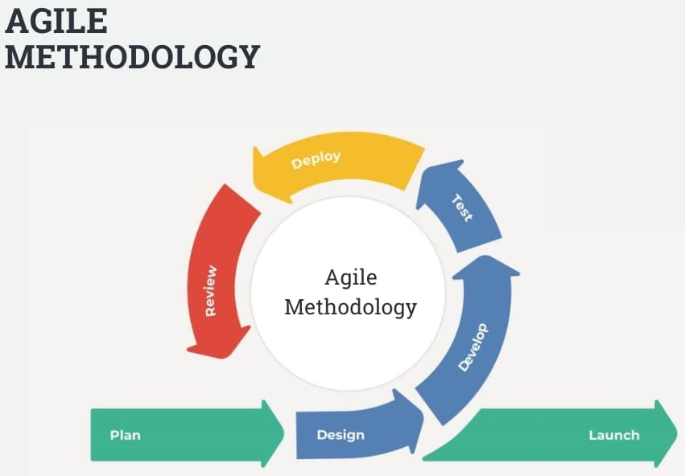

Figure 1: Agile methodology

These stages coexist and develop simultaneously, enabling ongoing development and adaptability to shifting requirements. The agility of the model is its capacity to adapt to changing needs and take feedback into account at every turn. Using strong cooperation between the development team and stakeholders, every iteration endeavors to provide incremental value by building upon prior discoveries. Throughout the software project life cycle, this dynamic method facilitates efficient requirement analysis, iterative design and development, continuous testing, frequent deployments, and continuous maintenance.

## 3.3 Steps to follow

### 3.3.1 Sprint planning

Agile Project Management Software: Define user stories, prioritize features, and allocate tasks for each sprint. Sprint planning sessions will involve the project team and stakeholders, ensuring alignment on project goals and objectives. We gathered information from students and online literature regarding how to solve the problem of elections in the institution. Data gathered were carefully combined, compared, and examined to identify their effectiveness in the voting system creation process.

### 3.3.2 Iterative Development

Integrated Development Environments E.g. Visual Studio: Implementation of features incrementally depending on user stories, regular conduction of code reviews, and refactoring code as required. These activities will ensure the code changes are integrated seamlessly into the system.

### 3.3.3 Continuous Integration

Version Control Systems E.g. Git: Integrate code changes frequently, automate builds, and run automated tests to maintain code quality and detect issues early in development. Continuous integration pipelines will facilitate the seamless integration of new code into the system.

### 3.3.4 User Acceptance Testing

Testing frameworks: Develop test cases based on user stories, conduct acceptance testing of the stakeholders in the validation of system functionality, and gather feedback for sophistication. User acceptance testing will ensure that the system meets the requirements and expectations of end users.

### 3.3.5 Documentation and Knowledge Sharing

Documentation Platforms: Document system requirements, design decisions, and technical specifications to ensure clarity and transparency throughout the development process. Knowledge sharing will facilitate collaboration and ensure that team members have access to relevant information.

### 3.4 Data Analysis and Presentation

Following the collection of all the data, a thorough analysis was conducted to determine the best course of action for developing the system.

## 3.4.1 Methods of Data Analysis

1. **Restructuring Data**

The collected data is examined and reorganized to optimize the performance of the modules and subsystems. This entails determining the fundamental requirements and the framework necessary to complete this job. To facilitate entering the data into the system, the data is reorganized.

1. **Input analysis**

To make sure the data can be submitted into the input form, it is examined. This entails ensuring that the data is accurate and comprehensive and determining any missing information that must be gathered.

1. **Process analysis**

The data is transformed into a more intelligible format to be entered into the system. This entails determining the crucial details required for the system to operate, such as the kind and volume of trash, and processing the information.

1. **Output analysis**

The system uses the supplied data to generate its output. To make sure the voting system is working effectively and to track its progress, the system produces output on parcel receipt and delivery information.

1. **Model development**

Use cases, entity-relationship diagrams (ER) and data flow diagrams (DFDS) are created using the information gathered. The conceptual and physical model for the system is then created using these diagrams.

# CHAPTER FOUR

## SYSTEM ANALYSIS AND DESIGN

## 4.1 Introduction

The online Student Voting System is designed to facilitate the process of conducting elections and polls within educational institutions. This chapter focuses on the feasibility study of the system, analysis and design of the system, which involves understanding the requirements, defining the system architecture, and outlining the functionalities of the system.

## 4.2 Requirements Analysis

**4.2.1 Functional requirements**

* User Registration - Students should be able to register on the platform using their institutional email addresses.
* Voting Interface- Provide a user-friendly interface for voters to cast their votes easily and anonymously.
* Results Generation - Automatically generate election results after the voting ends.
* Security Measure - Implement security measures to prevent unauthorized access, tampering, or manipulation of votes.
* Accessibility - Ensure that the system is accessible to all eligible voters.

**4.2.2 Non-functional requirements**

* Performance- A large number of concurrent users should not significantly impair the system's performance.
* Reliability - Maintain a high degree of availability and dependability to avoid system malfunctions during crucial voting times.
* Scalability - Future increases in the number of users and elections should be supported by the system's scalability
* Usability - To improve the user experience, create an interface that is clear and easy to use.
* Compatibility- To accommodate a range of users, the system should work with different web browsers and devices.

## 4.3 Requirement elicitation

### Data collection

The data collection tool for requirements elicitation in the SOVS project is a Google Forms questionnaire. Google Forms offers a user-friendly interface that allows for the creation of customized questionnaires with various question types such as multiple-choice, open-ended, and Likert scale. This tool enables efficient data collection and provides a structured approach to gathering insights from the target users.

To prepare the questionnaire, a systematic approach was followed. The research team identified key areas of interest such as what areas of operations the users will interact with during their runtime, and formulated relevant questions to capture the requirements for the SOV website system. The questions were designed to elicit information on user preferences, desired features, usability, and any specific needs or concerns. The questionnaire was structured in a logical flow, ensuring clarity and ease of understanding for the respondents.

The questionnaire was distributed electronically through media platforms like WhatsApp statuses, WhatsApp direct messages and WhatsApp groups to the target users from different learning institutions. Clear instructions and a brief explanation of the purpose of the questionnaire were provided to encourage participation. The respondents were given a 5-day timeframe to complete the questionnaire, and reminders were sent to maximize response rates. Confidentiality measures were ensured throughout the data collection process as no respondent was asked to give any personal or identifying information while filling out the Google form.

Appendix: SOVS User Requirements Questionnaire (Google Forms):

https://docs.google.com/forms/d/1QdlLseu6NRQEPP8bZVwpvBfg7o3QyMVkk1rJ2kLsgX0

The SOVS Questionnaire in the provided appendix demonstrates the structure, layout, and types of questions utilized in the data collection process.

## 4.4 Data Analysis

## A Google form questionnaire was created and tailored to capture information on what the user needs for the target clients of the counseling platform. We distributed the questionnaire through s online social media platforms such as WhatsApp. The following are images of what the response entailed:

The first step was to understand the current year of the students.

## Forms response chart. Question title: 1. What is your year of study?. Number of responses: 34 responses.

## The majority of students were 4th years meaning that most of them had participated in school election more than two times or more.

## Forms response chart. Question title: 2. Have you ever voted in your institution?. Number of responses: 34 responses.

## The majority of respondents agreed to have participated in elections in their respective institutions.

## Forms response chart. Question title: 3. If yes, Which method did you use to vote?. Number of responses: 32 responses.

Ballot papers are the most commonly used voting method in many institutions. Only a few percentages of respondents use online voting methods in their respective institutions.

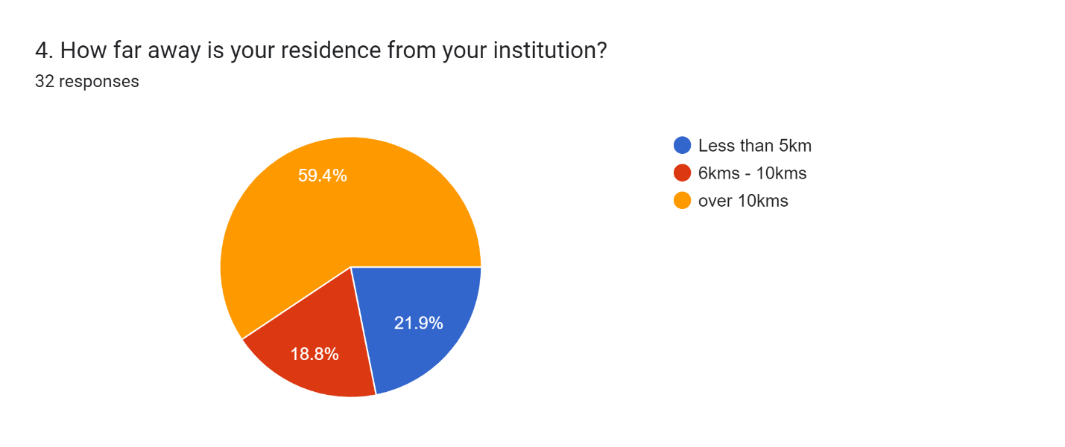

Most students live far away from their institutions meaning that an online voting system would be easier to use as students could perform their right to vote from the comfort of their homes or place of residence.

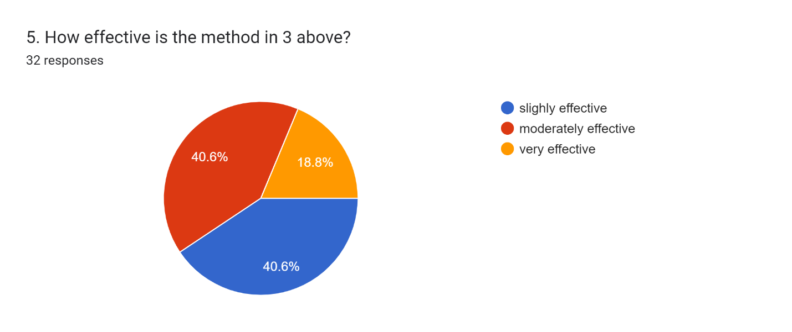

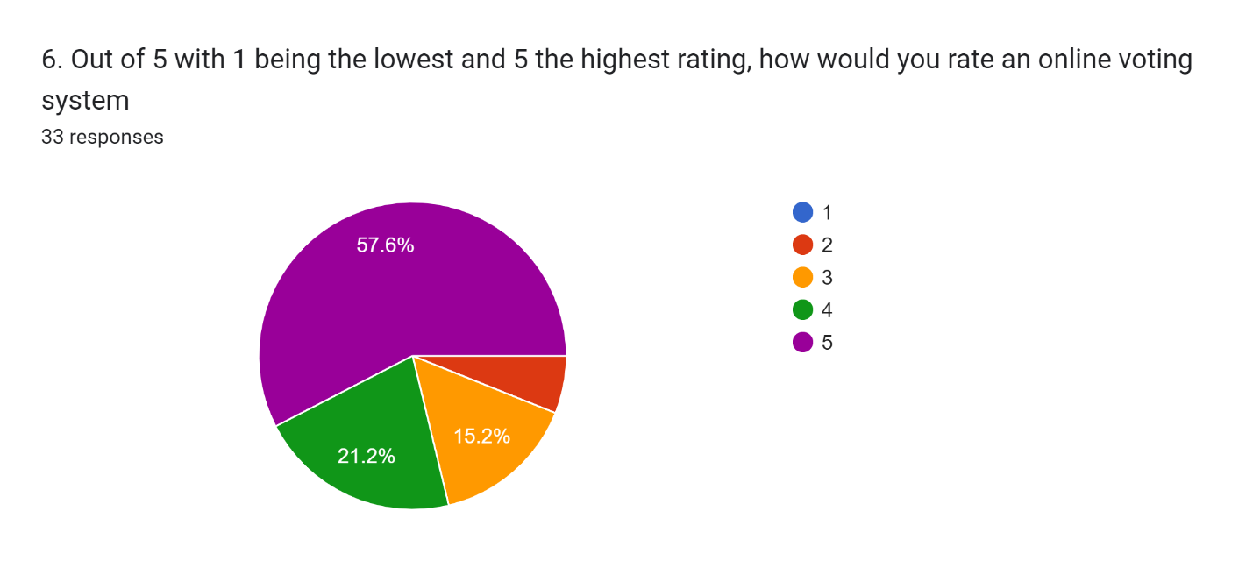

More than half of the respondents agree that an online voting system would be more effective hence gave it a 4-5 ratio. 5 was the highest ration and a bigger percentage voted for it.

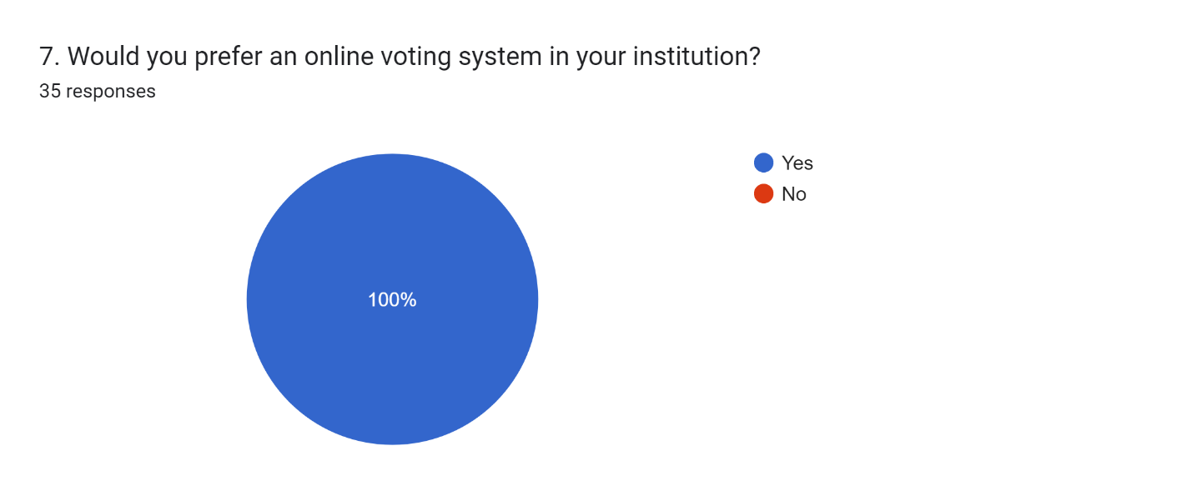

Since all respondents preferred an online voting system for their institutions, we went ahead to design a system that would be user-friendly and would meet the user’s requirements.

## 4.5 System Design

The system design for the Student’s Online Voting System involves defining the architecture, components, modules, interfaces, and data necessary to meet the specified

requirements. The system design process starts with the identification of the basic needs and the

structure required for the project. This is followed by the development of the conceptual and

physical models for the system.

The conceptual model is developed through the use of diagrams such as use cases, data flow

diagrams (DFDs), and entity-relationship diagrams (ERDs). These diagrams provide a high-level

view of the system and help to identify the main components and interfaces.

The physical model is developed based on the conceptual model and includes the detailed

specifications of the hardware and software components, as well as the database schema. The

physical model defines the actual implementation of the system and includes information such as

programming languages, operating systems, and databases.

The system design for the Student’s Online Voting System also involves the development

of the user interface, which is the front-end of the system that interacts with the users. The user

interface is designed to be intuitive and user-friendly, with features such as easy navigation and

clear instructions.

Finally, the system design involves testing and validation to ensure that the system meets the

specified requirements. This includes unit testing, integration testing, and acceptance testing,

which are designed to identify and fix any issues with the system before it is deployed.

**4.3.1 Use Case Modelling**

The use case modeling for the system project includes a use case diagram and documentation for each use case. The use case diagram provides an overview of the system's functionalities based on 16 customer needs, while the documentation use case provides detailed steps for each use case. The use case focuses on the interaction between normal users and the administrator. The use case, describes the process by which normal users can create their account, upload the needed data for the garbage collector, and later on search for the garbage collector favorable for the garbage collection in their account with the assistance of the administrator. The normal user logs into the system and navigates to the services offered in their user page, input their location details. Then later on check for the request of the collection from the garbage collectors. If any issues arise, they can contact the administrator for assistance. The administrator verifies the compatibility between the garbage collector and the user, then helps with linking of the two. Hence changing the earlier allocated collector

voter

Admin

Figure 2: use case diagram

**Flow chart Diagram**

The flowcharts below show a representation of two processes; the user processes. The representation shows how each of user interacts with the system through a step-by-step process.

Register voter

Display error message

Is voter registered

no

yes

Voter login

Display error message

Is username and password correct

no

yes

Voting page

Display error message

Has the voter voted for all positions

no

yes

View results

logout

Figure 3: Flowchart

**System architecture**

The system architecture of our online voting platform plays a crucial role in ensuring scalability, reliability, and efficiency in facilitating the electoral process. This section provides an overview of the architectural design principles, components, and interactions within our online voting system.

### **Client**

The client refers to the end-user or the individual accessing the voting platform. The client is typically a web browser installed on a user's device, such as a computer, smartphone, or tablet. The client interacts with the website's user interface, accessing various features and functionalities provided by the server. In the case of OVS, the client uses the website to view candidates. Vote for the candidate of their choice, check all positions, view results and log out of the system.

### **Server**

The server is responsible for hosting the voting system and managing the backend operations. In this case, we used a development server since it is costly to host the system in a production server. However, this has provided, even though limited, the necessary infrastructure and resources to support the website's functionality. The server receives details of registered voters and stores them in the database, it saves the votes that have been cast, tallies the votes, outputs, and stores the results.

### **Middle tier**

In the OVS, the middle tier acts as an intermediary between the client and server components. It includes the application logic and components that process the voting process. The middle tier may include various software modules or plugins implemented within the server. The middle tier bridges the gap between the client and server, facilitating the smooth flow of information and communication.

## 4.6 Database Design

A database system's main function is to store data and give users access to it so they can update and retrieve it as needed. On the other hand, a well-designed database creates a system that effectively and accurately offers the information needed for the decision-making process to succeed.

**User Table**

|  |  |  |  |
| --- | --- | --- | --- |
| FIELD | DATA TYPE | SIZE | DESCRIPTION |
| Id | Int | 1 | Primary key |
| First name | Varchar | 255 |  |
| Last name | Varchar | 255 |  |
| Email | Varchar | 255 |  |
| Reg No. | String | 18 |  |
| Upload_ID | JPEG | 1 |  |
| password | Int | 10 |  |

Table 2: User database table

**Admin Table**

|  |  |  |  |
| --- | --- | --- | --- |
| FIELD | DATA TYPE | SIZE | DESCRIPTION |
| id | int | 2 | Primary key |
| Email | varchar | 255 |  |
| password | int | 10 |  |

Table 3: Admin table

**Candidates Table**

|  |  |  |  |
| --- | --- | --- | --- |
| FIELD | DATA TYPE | SIZE | SIZE |
| Id | Int | 2 | Primary key |
| First_name | Varchar | 255 |  |
| Last_name | Varchar | 255 |  |
| Email | Varchar | 255 |  |
| Phone | Int | 10 |  |
| Candidate_img |  |  |  |
| Bio | Varchar | 255 |  |
| Position_id | int | 1 | Foreign key |

Table 4: candidates database table

**Voting period Table**

|  |  |  |  |
| --- | --- | --- | --- |
| FIELD | DATA TYPE | SIZE | DESCRIPTION |
| Id | Int | 1 | Primary key |
| Start_time | Date |  |  |
| End_time | Date |  |  |
| Position_id | int | 1 | Foreign key |

Table 5: voting period table

**Ballot position**

|  |  |  |  |
| --- | --- | --- | --- |
| FIELD | DATA TYPE | SIZE | DESCRIPTION |
| Id | Int | 1 | Primary key |
| Candidate_id | Int | 2 | Foreign key |
| User_id | Int | 2 | Foreign key |
| Position_id | int | 1 | Foreign key |

Table 6: Ballot positions table

**Position Table**

|  |  |  |  |
| --- | --- | --- | --- |
| FIELD | DATA TYPE | SIZE | DESCRIPTION |
| Id | Int | 1 | Primary key |
| Position | varchar | 255 |  |

Table 7: positions table

## 4.7 Interface design

This section will have screenshots that depict graphic user interface.

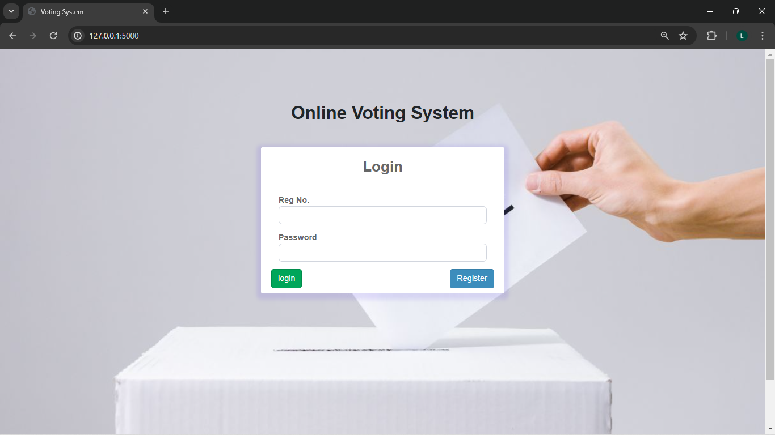

Figure 4: Login form

The login form shown above can be used by both admin and the voter. It requires one to enter the registration number and the password. If a voter is not registered, he/she will have to register first before logging in to the system. Below is the registration form.

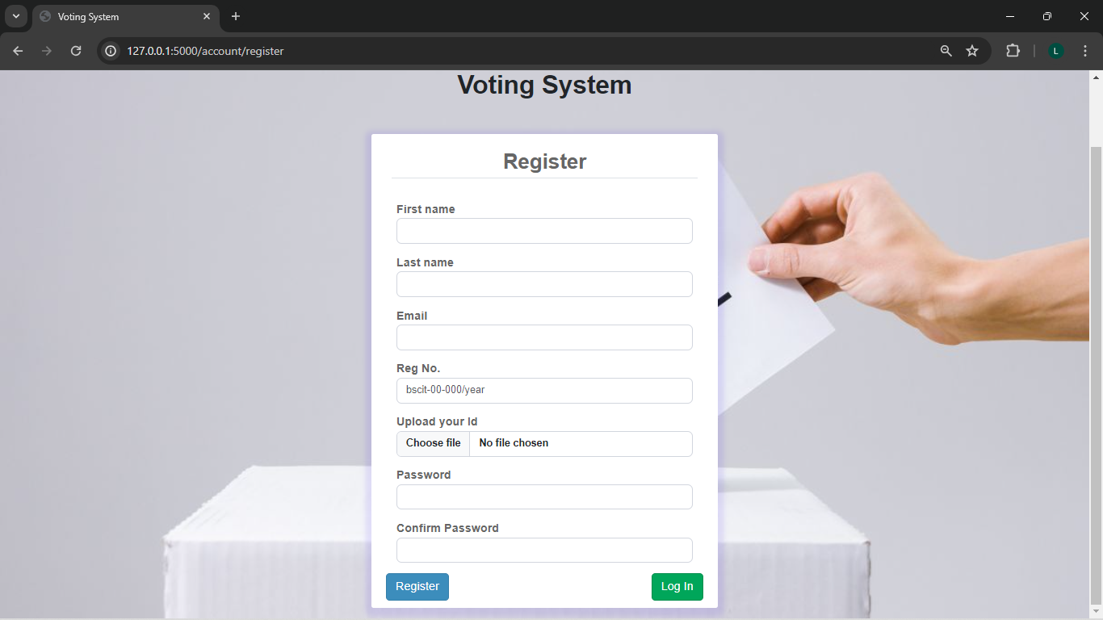

Figure 5: Registration form

After the admin logs in, a dashboard is displayed. Below is the page that is displayed.

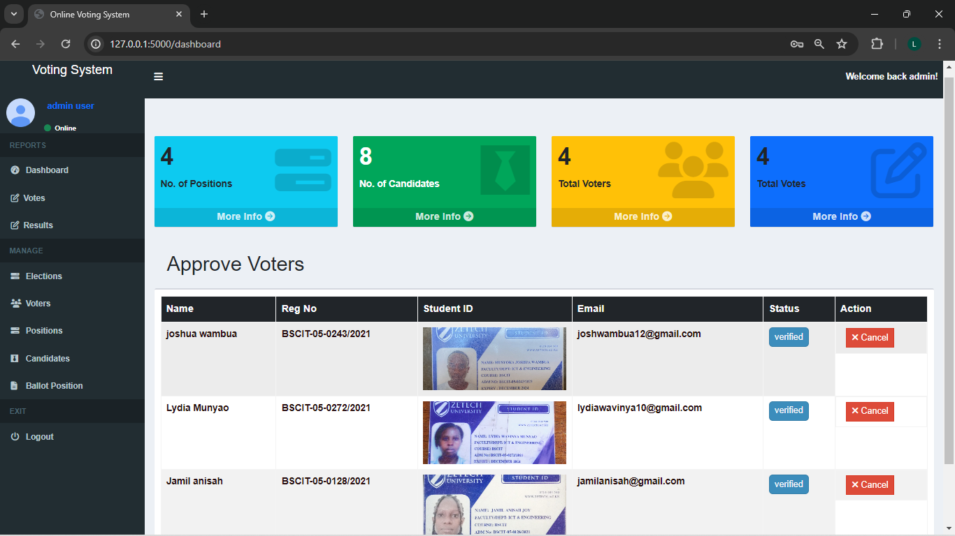

Figure 6: Admin's dashboard

From this dashboard, the admin is able to perform the following;

1. Approve new voters
2. Add a candidate’s details
3. View voters
4. View the results and total votes for each candidate
5. Add a new election
6. Add new positions
7. Log out of the system

The admin can add new candidates using the form shown below;

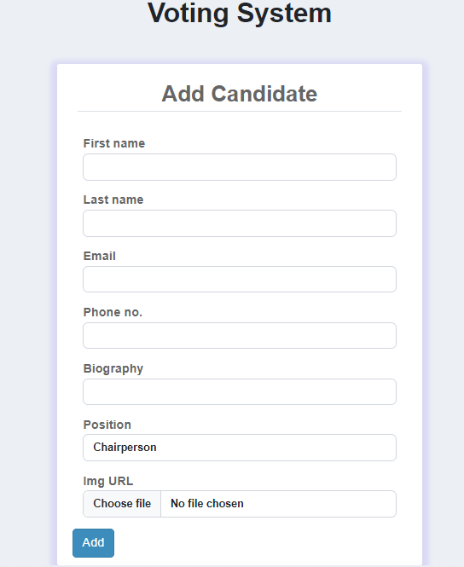

Figure 7: Candidate's details form

After adding a new candidate, the admin can now edit the candidate’s details using the edit/delete buttons as shown in the diagram below;

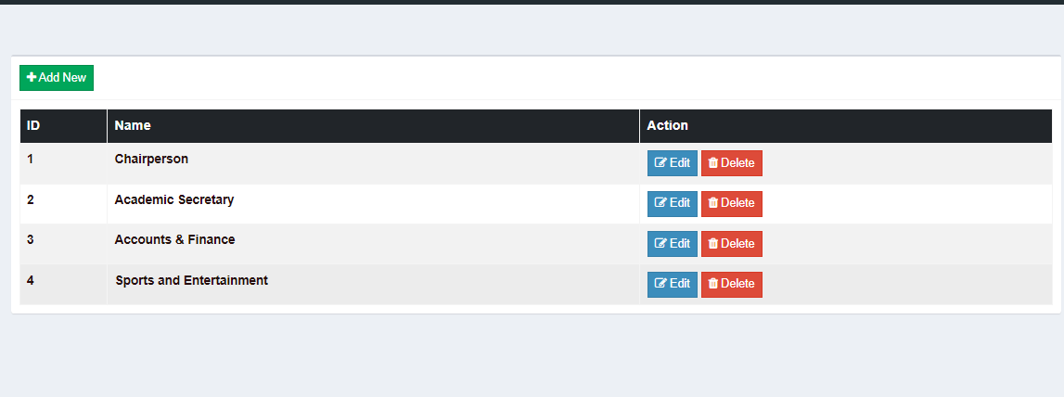

Figure 8: positions

Once a user is registered, he/she now logs into the system. The dashboard below is displayed

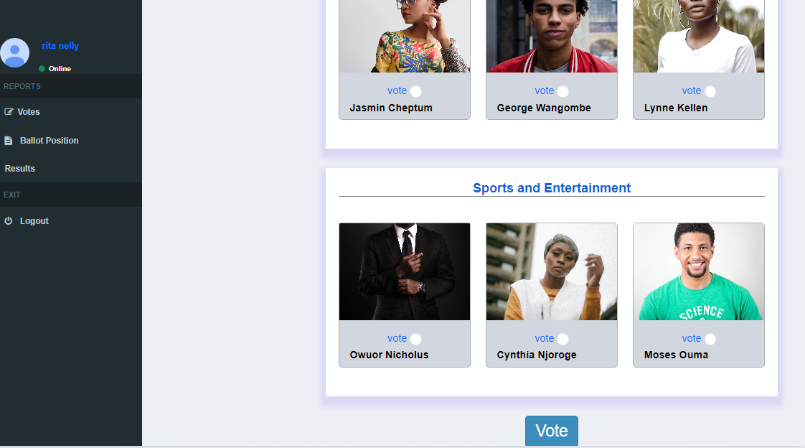

Figure 9:Voter's dashboard

From the above dashboard, the student voter is able to view the candidates for particular positions. The voter can vote for his/her preferred candidate by clicking on a box and then submitting. The voter can also see the results and the total number of votes for each candidate. The voter is required to vote for all positions before proceeding. The voter can also view all the ballot positions available. After voting and viewing the results, the voter can then log out of the system. Once the voter casts the vote and logs in back to the system, he/she cannot be allowed to vote again.

# CHAPTER 5

## SYSTEM CODE GENERATION AND TESTING, CONCLUSIONS AND RECOMMENDATIONS

## 5.1 Introduction

We offer a description of the Online Voting System for Student Leaders and its revolutionary features in this last chapter, which represents the conclusion of our system design and implementation. We provide a graphical depiction of the system based on a thorough analysis of its parts and functionalities, so you can see how it works and comprehend the advantages it offers.

**Project source code**

The following screenshots show the main source code used to run the online student voting system:

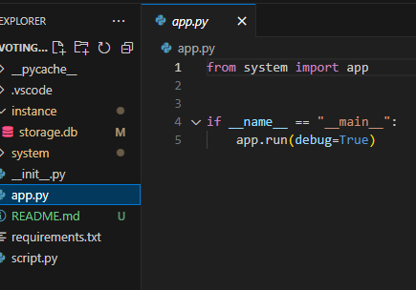

Figure 10: main code

The above code snippet is the code that is used to run the system.

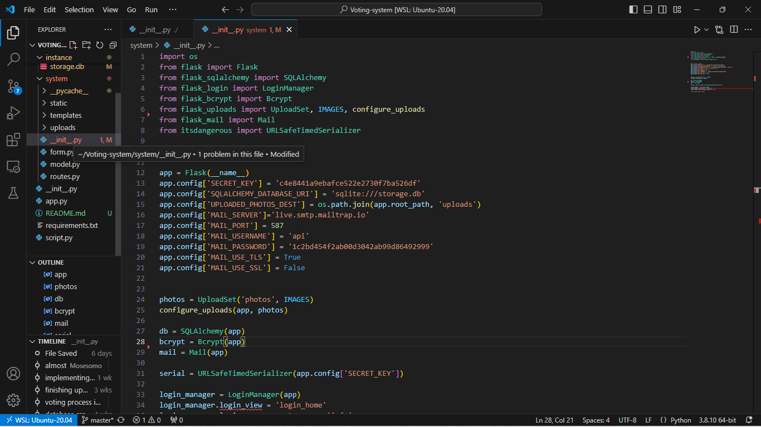

This code snippet is the code that connects the database to the front-end user interface.

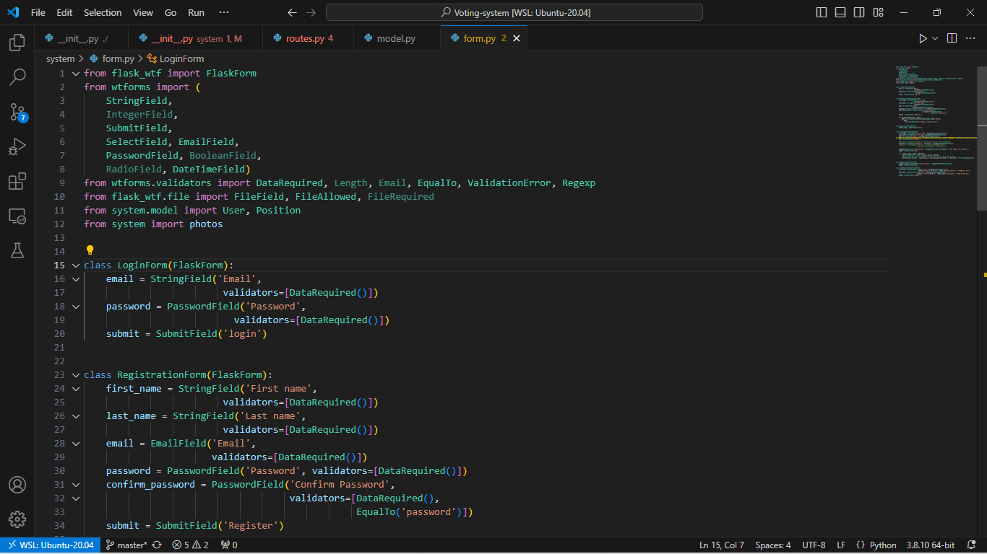

Figure 11: form code

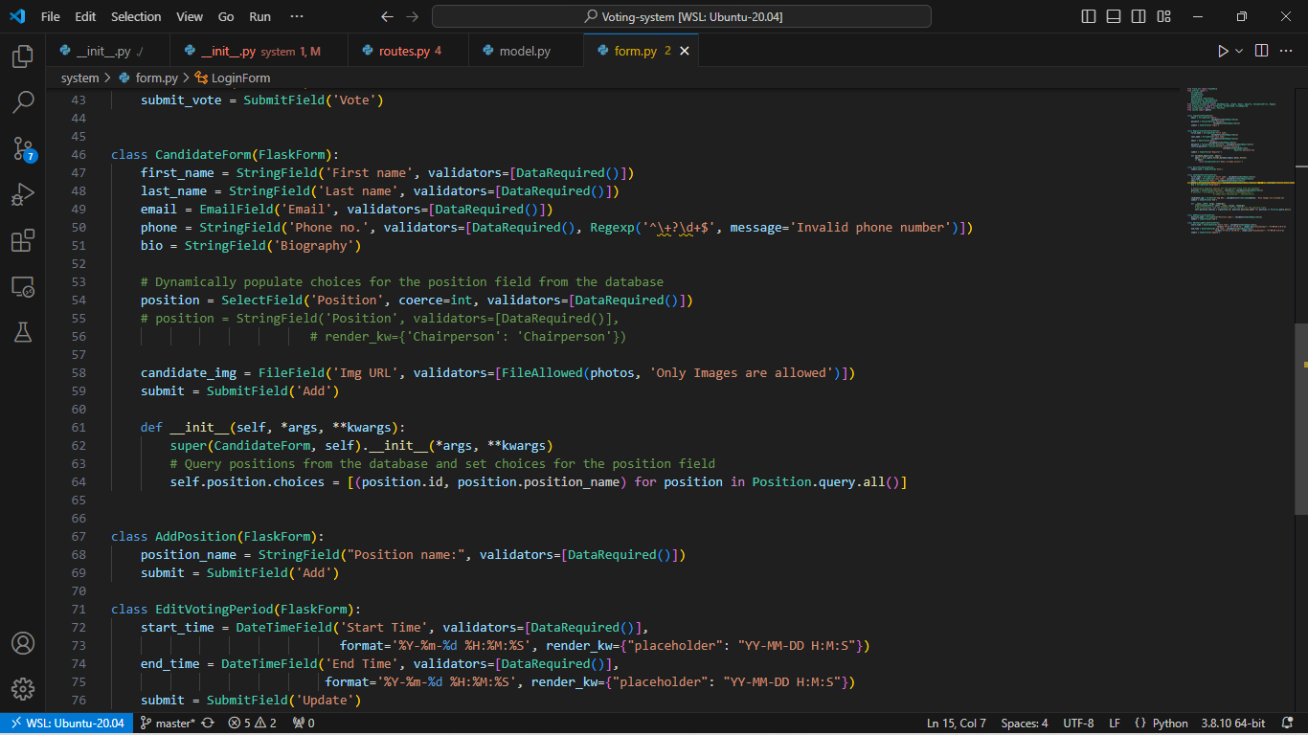

The above code snippet shows the code that generates both the login form ad the registration form for the users.

## 5.2 System Testing

Following the complete implementation of the information system, usability and performance testing were carried out along with several other tests to evaluate the efficacy and efficiency of the various functionalities.

*5.2.1 Usability Testing*

Users may quickly navigate and complete work on the system because of its user-friendly design. Overall usability was enhanced by the usage of positive comments in all text situations. Students will find it easy to access the system because it has been optimized to function flawlessly on a variety of platforms, such as wide-screen displays and mobile devices. But to take full advantage of all the features and updates available, system managers might need a computer system.

All of the major web browsers, including Microsoft Edge, Brave, Google Chrome, Opera, and Internet Explorer, are compatible with the information system. As a result, users should not have any trouble accessing the system through their favorite browser.

*5.2.2Integration Testing*

This checks whether the various components of the system are integrated and working in sync. All the screens, functions, stores, data tables and other modules were connected with seamless interfacing. All the required outputs were produced successfully as expected from the systems and all inputs were validated and stored in the correct formats

*5.2.3 Recovery Testing*

When evaluating the system's resilience to possible malfunctions and disturbances, recovery testing was essential. The recovery methods of the system were rigorously put to the test by simulating network outages, database failures, and server downtime. Positive recovery rates were found in the data, demonstrating the efficacy of strategies including frequent backups, redundant infrastructure, and strong error-handling procedures. By minimizing downtime and facilitating a smooth service restoration, these initiatives improve the website's resilience and guarantee continuous access to counseling resources.

## 5.3 Limitations

Despite its effectiveness, the online voting system for student leaders has some challenges. These challenges include some of the following:

* Limited accessibility. Some students may not be able to use online voting systems especially those who do not have dependable internet access. This restriction can deny voting rights to student groups and jeopardize the electoral process’s inclusivity.
* Voter fraud risk. Despite safeguards against it such as voter fraud authentication and voter registration, there is still a chance that fraudulent acts like vote buying, coercion, or impersonation will be able to manipulate the online voting system. It is still difficult to guarantee the fairness and integrity of the democratic process.
* Infrastructure dependency. The system’s capacity to function properly is dependent on the availability and dependability of the underlying infrastructure, which includes servers, hosting services, and internet access. The voting system’s usability and accessibility may be impacted by any infrastructure malfunctions or outages.

## 5.4 Recommendations

Some suggestions that could improve the efficacy and efficiency of the system have been made in light of the evaluation of the website. Among these suggestions are:

*Boost Accessibility*

Add features like keyboard navigation, screen reader compatibility, and alternate input ways to make the website more accessible to people with impairments. To make sure that the voting mechanism is usable by all pupils, test its usefulness with a variety of skill levels.

*Promote Openness*

To boost confidence in the electoral process, use measures that promote transparency. To help stakeholders monitor and validate voting actions and guarantee the fairness and integrity of elections, put in place audit trails, verification procedures, and transparency reports.

*Enhance User Education*

To acquaint students with the voting process and encourage conscientious voting, offer thorough user education and training materials. Provide interactive tools, tutorials, and user manuals so that students can safely and confidently complete the voting process.

*Increase Stakeholder Engagement*

Encourage constant interaction and cooperation with stakeholders to get their opinions, solve their issues, and get suggestions for new developments. Plan frequent focus groups, town hall meetings, and feedback sessions to include stakeholders in the creation and enhancement of the voting system.

*Continuously Iterate and Improve*

Iteratively refine and improve the online voting system in response to user input, emerging best practices, and technology improvements. Adopt an innovative and continuous improvement culture. To swiftly iterate and adjust to changing user demands and preferences, employ agile development approaches.

*Monitor system performance*

Enable performance measurements and monitoring tools to keep an eye on the online voting system's usage and performance over time. System performance can be improved over time by keeping an eye on response times, uptime, and data related to user engagement and trend analysis.

## 5.6 Conclusion

A number of important findings and insights have come from the system performance evaluation.

The project objectives of creating an effective, user-friendly, web-based voting platform have been met with notable progress thanks to the online voting system's installation. The system's functionality and usability have been enhanced by the successful implementation of features such as voter registration, candidate selection, and real-time result visualization.

Positive results in terms of dependability, and usability have been found during system performance evaluation. The system's resilience, ease of use, and responsiveness have all been confirmed by user and performance testing, which has increased trust in the system's dependability and efficiency.

Several suggestions for future improvements and iterations of the online voting system have been made in light of the findings discussed in this chapter. These suggestions include tightening security measures to reduce potential risks and vulnerabilities, increasing accessibility for users with impairments, and increasing transparency through audit trails and verification processes.

The chapter's conclusions and findings, taken together, highlight the importance of the online voting system for student leaders as a useful instrument for encouraging democratic involvement and participation in educational settings. The online voting method has the potential to aid in fair, transparent, and accessible elections for student leaders, promoting a democratic and accountable culture within the campus community by resolving the project's acknowledged weaknesses and building on its strengths.

# REFERENCES

[1] Al-Ameen, A.; Talab, S.A., "E-voting systems vulnerabilities," Information Science and Digital

Content Technology (ICIDT), 2012 8th International Conference on, vol.1, no., pp.67,73, 26-28 June

2012 URL: http://ieeexplore.ieee.org/stamp/stamp.jsp?tp=&arnumber=6269229&isnumber =6269212

[2] Cui Zhe; Dai Xiang, "A practical distributed electronic voting system," Electric Information and

Control Engineering (ICEICE), 2011 International Conference on, vol., no., pp.1095,1099, 15-17 April

2011 Doi: 10.1109/ICEICE.2011.5777548 URL:

http://ieeexplore.ieee.org/stamp/stamp.jsp?tp=&arnumber=5777548&isnumber =5776798

[3] Gritzalis, D. (2002). Secure Electronic voting. Seventh Computer Security Incident Response Team

Workshop Syros, Greece.

[4] Krejcie, R. & Morgan D. (1970). Determining Sample Size for Research Activities Educational and

Psychological Measurement.

[5] Melanie Volkamer (2010), ―Electronic Voting in Germany‖, Data Protection in a Profiled World, DOI

10.1007/978-90-481-8865-9_10, © Springer Science+Business Media B.V. 2010

[6] TahaKh. Ahmed and Mohamed Aborizka (2011), ―Secure Biometric E-Voting Scheme‖, ICICIS

2011, Part I, CCIS 134, pp. 380–388, 2011. © Springer-Verlag Berlin Heidelberg 201

Nzoka, J. M. Muthama, N. M. Mung’ithya, N. M. (2013). Taita Taveta University College EVoting System: A Web Based Approach to Elections Management. International Journal

of Intelligent Information Systems. Vol. 2, No. 5, 2013, pp. 70-76. doi:

10.11648/j.ijiis.20130205.11

Osho, Y. (2015). E-voting in Nigeria: A survey of voters' perception of security and other trust

factors. 2015 International Conference on Cyberspace (CYBER-Abuja): 202–211.

Roland, W. (2015) Lessons Learned for E-Voting: A Case Study of the VEC vVote Project. Tech.

rep. UNSW-CSE-TR-201509. (To appear). UNSW Computer Science and Engineering.

Retrieved from https://www.cse.unsw.edu.au/~reports/.

Schneier, B. (2015). What's Wrong with Electronic Voting Machines? Schneier on Security.

Victorian Electoral Commission. (2014) Victorian Electoral Commission comment on DemTech

Report. Retrieved from http://vec.vic.gov.au/files/demtech.pdf.

# APPENDICES

**Appendix A: QUESTIONNAIRRE**

1. What is your year of study?

………………………………………………………………………………………..

1. Have you ever voted in your institution?

Yes No

1. If yes, which method did you use?

Ballot papers

Voted Online

Show of hands

Lined behind candidate

1. How far is your residence from your institution?

Less than 5km

6km-10km

More than 10km

1. How effective is the method in 3 above?

Slightly effective

Moderately effective

Very effective

1. Out of 5 with 1 being the lowest and 5 the highest rating, how would you rate an online voting system?

1 2 3 4 5

1. Would you prefer an online voting system?

Yes No

**Appendix B: QUESTIONNAIRE FOR SYSTEM VALIDATION**

**Scale: Strongly agree (1), Agree (2), Disagree (4), and Strongly Disagree (5)**

|  |  |  |  |  |  |  |
| --- | --- | --- | --- | --- | --- | --- |
| **Feature** | **Question** | **Option** | | | | |
| scalability | The student online voting system enables many additional users to use it | 1 | 2 | 3 | 4 | 5 |
| authentication | The student online voting system cannot allow unauthorized users to use it. | 1 | 2 | 3 | 4 | 5 |
| efficiency | The student online voting system can enable a voter to access information about voting status. | 1 | 2 | 3 | 4 | 5 |
| effectiveness | The student online voting system can enable users to easily generate voting status reports. | 1 | 2 | 3 | 4 | 5 |
| User friendliness | The student online voting system is easy to use by any novice user. | 1 | 2 | 3 | 4 | 5 |
| Flexibility | The student online voting system can enable many users to use it concurrently. | 1 | 2 | 3 | 4 | 5 |