

**DIAMOND SHOP SYSTEM**

**Software Requirement Document**

– HoChiMinh, JUNE 2024 –

**Table of Contents**

Record of Changes 4

Definition and Acronyms 5

I. Introduction 6

1. Product Background 6

2. Existing Systems 6

2.1 System name1 6

2.2 System name2 6

3. Business Opportunity 6

4. Software Product Vision 6

5. Major Features 6

6. Limitations and Exclusions 6

II. Overall Description 7

1. Product Overview 7

2. Business Process 8

III. User Requirements 9

1. Actors 9

2. Use Cases 9

2.1 Diagram 9

2.2 Descriptions 9

3. Business Rules 12

IV. Functional Requirements 14

1. System Functional Overview 14

1.1 Screen Flow 14

1.2 Screen Descriptions 14

1.3 Screen Authorization 14

1.4 Non-Screen Functions 15

2.1 Logical Data Model 15

2.2 Data Dictionary 15

2.3 Reports 16

3. <<Feature Name 1>> 18

3.1 <<Function Name 1>> 18

3.2 <<Function Name 2>> 19

4. <<Feature Name 2>> 19

5. Function requirement 19

**V. Non-Functional Requirements 22**

1. External Interface Requirements 22

1.1 User Interfaces 22

1.2 Software Interfaces 23

1.3 Hardware Interfaces 23

1.4 Communications Interfaces 25

2. Quality Attributes 25

2.1 Usability 25

2.2 Performance 25

2.3 Security 26

2.4 Safety 26

2.5 Availability 26

2.6 Reliability 27

2.7 Design Contrainsts 27

2.8 [Others as relevant] 27

# Record of Changes

|  |  |  |  |
| --- | --- | --- | --- |
| **Date** | **A* M, D** | **In charge** | **Change Description** |
|  |  |  |  |
|  |  |  |  |
|  |  |  |  |
|  |  |  |  |
|  |  |  |  |
|  |  |  |  |
|  |  |  |  |
|  |  |  |  |
|  |  |  |  |
|  |  |  |  |
|  |  |  |  |
|  |  |  |  |
|  |  |  |  |

*A - Added M - Modified D - Deleted

# Definition and Acronyms

|  |  |
| --- | --- |
| **Acronym** | **Definition** |
| PWM | Psychology website |
| AWS | Amazon Web Services |
| BA | Business Analysis |
| BR | Business Rule |
| ERD | Entity Relationship Diagram |
| GUI | Graphical User Interface |
| PM | Project Manager |
| SDD | Software Design Description |
| SPMP | Software Project Management Plan |
| SRS | Software Requirement Specification |
| UAT | User Acceptance Test |
| UC | Use Case |
| API | Application Program Interface |

# I. Introduction

## 1. Product Background

## 2. Existing Systems

*…*

### 2.1 System name1

…

### 2.2 System name2

…

## 3. Business Opportunity

*…*

## 4. Software Product Vision

*…*

## 5. Major Features

*…*

## 6. Limitations and Exclusions

*…*

# II. Overall Description

## 1. Product Overview

*…*

>>

## 2. Business Process

*…*

|  |  |  |
| --- | --- | --- |
| **#** | **Process Step** | **Description** |
| 1 | Create a chemical request | <<Process Step description>> |
| 2 | Create a vendor purchase order |  |
| 3 | … |  |

>>

# III. User Requirements

## 1. Actors

|  |  |  |
| --- | --- | --- |
| **#** | **Actor** | **Description** |
| 1 | Guest |  |
| 2 | Customer |  |
| 3 | Sales Staff |  |
| 4 | Delivery Staff |  |
| 5 | Manager |  |
| 6 | Admin |  |

## 2. Use Cases

### 2.1 Diagram

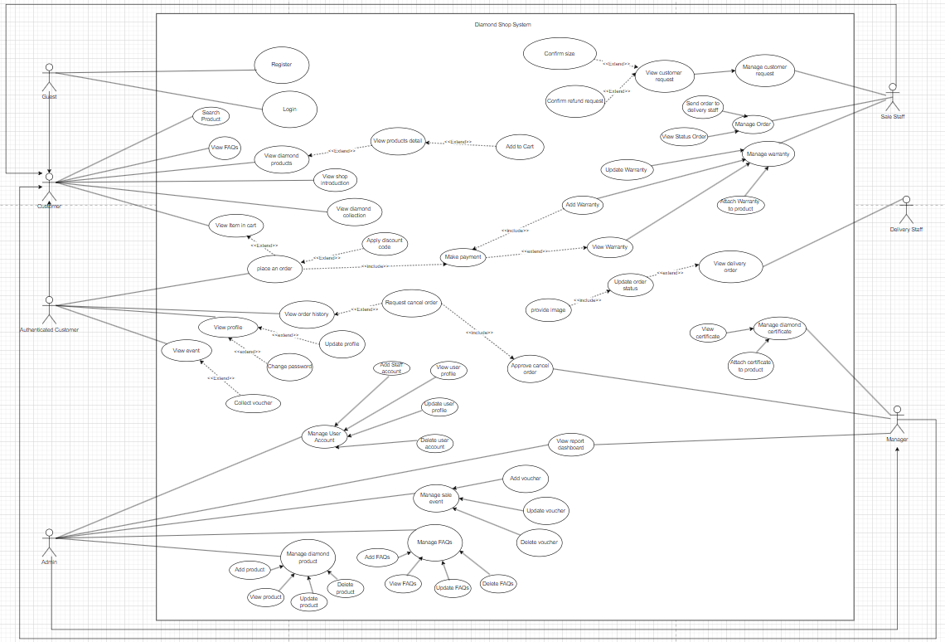

### 2.2 Descriptions

|  |  |  |  |
| --- | --- | --- | --- |
| **ID** | **Use Case** | **Actor** | **Use Case Description** |
| UC1 | Register | Guest | Allows a new user to register an account in the system. |
| UC2 | Login | Guest | Allows a registered user to log into the system. |
| UC3 | Search Product | Guest | Enables the user to search for products in the system. |
| UC4 | View FAQs | Guest | Allows the user to view frequently asked questions. |
| UC5 | View Diamond Products | Guest | Enables the user to view the list of diamond products available. |
| UC6 | View Shop Introduction | Guest | Allows the user to view the shop's introduction information. |
| UC7 | View Diamond Collection | Guest | Enables the user to view the diamond collection. |
| UC8 | View Products Detail | Guest | Shows detailed information about a specific product selected by the user. |
| UC9 | Add to Cart | Guest | Adds a selected product to the user's shopping cart. |
| UC10 | Confirm Size | Customer | Allows the customer to confirm the size of the product. |
| UC11 | Confirm Refund Request | Customer | Allows the customer to confirm a refund request. |
| UC12 | View Customer Request | Sales Staff | Enables sales staff to view customer requests. |
| UC13 | Manage Customer Request | Sales Staff | Allows sales staff to manage customer requests. |
| UC14 | Send Order to Delivery Staff | Sales Staff | Sends the order to the delivery staff for processing. |
| UC15 | Manage Order | Sales Staff | Allows sales staff to manage orders in the system. |
| UC16 | View Status Order | Customer | Allows the customer to view the status of their order. |
| UC17 | Update Warranty | Sales Staff | Allows sales staff to update the warranty information for a product. |
| UC18 | Add Warranty | Sales Staff | Enables sales staff to add warranty information for a product. |
| UC19 | View Warranty | Customer | Allows the customer to view the warranty information for their products. |
| UC20 | Manage Warranty | Sales Staff | Allows sales staff to manage warranties associated with products. |
| UC21 | Match Warranty to Product | Sales Staff | Enables sales staff to match a warranty to a specific product. |
| UC22 | View Delivery Order | Delivery Staff | Enables the delivery staff to view delivery orders. |
| UC23 | Manage Diamond Certificate | Sales Staff | Allows sales staff to manage diamond certificates. |
| UC24 | View Certificate | Customer | Allows the customer to view the certificate of their purchased diamond. |
| UC25 | Attach Certificate to Product | Sales Staff | Enables sales staff to attach a certificate to a specific product. |
| UC26 | Approve Cancel Order | Manager | Allows the manager to approve the cancellation of an order. |
| UC27 | Provide Image | Sales Staff | Allows sales staff to provide an image for the product. |
| UC28 | View Item in Cart | Customer | Enables the customer to view items in their shopping cart. |
| UC29 | Place an Order | Customer | Allows the customer to place an order for items in their cart. |
| UC30 | Apply Discount Code | Customer | Allows the customer to apply a discount code to their order. |
| UC31 | Make Payment | Customer | Allows the customer to make a payment for the items in the cart. |
| UC32 | View Order History | Authenticated Customer | Enables the customer to view their past orders. |
| UC33 | Request Cancel Order | Authenticated Customer | Allows the customer to request the cancellation of an order. |
| UC34 | View Profile | Authenticated Customer | Enables the customer to view their profile information. |
| UC35 | Update Profile | Authenticated Customer | Allows the customer to update their profile information. |
| UC36 | Change Password | Authenticated Customer | Allows the customer to change their password. |
| UC37 | Collect Voucher | Authenticated Customer | Enables the customer to collect vouchers. |
| UC38 | View Event | Authenticated Customer | Allows the customer to view upcoming events. |
| UC39 | Manage User Account | Admin | Allows the admin to manage user accounts in the system. |
| UC40 | View User Profile | Admin | Enables the admin to view user profiles. |
| UC41 | Update User Profile | Admin | Allows the admin to update user profiles. |
| UC42 | Delete User Account | Admin | Enables the admin to delete user accounts. |
| UC43 | Manage Diamond Product | Admin | Allows the admin to manage diamond products in the system. |
| UC44 | Add Product | Admin | Enables the admin to add new products to the system. |
| UC45 | View Product | Admin | Allows the admin to view products in the system. |
| UC46 | Update Product | Admin | Allows the admin to update information about an existing product. |
| UC47 | Delete Product | Admin | Enables the admin to delete a product from the system. |
| UC48 | Manage Sale Event | Admin | Allows the admin to manage sale events in the system. |
| UC49 | Add Voucher | Admin | Enables the admin to add vouchers to the system. |
| UC50 | Update Voucher | Admin | Allows the admin to update information about an existing voucher. |
| UC51 | Delete Voucher | Admin | Enables the admin to delete a voucher from the system. |
| UC52 | Add FAQs | Admin | Allows the admin to add frequently asked questions to the system. |
| UC53 | Update FAQs | Admin | Enables the admin to update information in the frequently asked questions. |
| UC54 | Delete FAQs | Admin | Allows the admin to delete frequently asked questions from the system. |
| UC55 | View Report Dashboard | Manager | Enables the manager to view various reports on the dashboard. |

|  |  |  |  |
| --- | --- | --- | --- |
| ID and Name: | **UC-01 Order a Meal** | | |
| Created By: | Prithvi Raj | Date Created: | 10/4/13 |
| Primary Actor: | Patron | Secondary Actors: | Cafeteria Inventory System |
| Description: | A Patron accesses the Cafeteria Ordering System from the corporate intranet or from home, views the menu for a specific date if desired, selects food items, and places an order for a meal to be delivered to a specified location within a specified 15-minute time window. | | |
| Trigger: | A Patron indicates that he wants to order a meal | | |
| Preconditions: | PRE-1. Patron is logged into COS.  PRE-2. Patron is registered for meal payments by payroll deduction. | | |
| Postconditions: | POST-1. Meal order is stored in COS with a status of “Accepted”.  POST-2. Inventory of available food items is updated to reflect items in this order.  POST-3. Remaining delivery capacity for the requested time window is updated. | | |
| Normal Flow: | **1.0 Order a Single Meal**   1. Patron asks to view menu for a specific date. (see 1.0.E1, 1.0.E2) 2. COS displays menu of available food items and the daily special. 3. Patron selects one or more food items from menu. (see 1.1) 4. Patron indicates that meal order is complete. (see 1.2) 5. COS displays ordered menu items, individual prices, and total price, including taxes and delivery charge. 6. Patron either confirms meal order (continue normal flow) or requests to modify meal order (return to step 2). 7. COS displays available delivery times for the delivery date. 8. Patron selects a delivery time and specifies the delivery location. 9. Patron specifies payment method. 10. COS confirms acceptance of the order. 11. COS sends Patron an email message confirming order details, price, and delivery instructions. 12. COS stores order, sends food item information to Cafeteria Inventory System, and updates available delivery times. | | |
| Alternative Flows: | **1.1 Order multiple identical meals**   1. Patron requests a specified number of identical meals. (see 1.1.E1) 2. Return to step 4 of normal flow.   **1.2 Order multiple meals**   1. Patron asks to order another meal. 2. Return to step 1 of normal flow. | | |
| Exceptions: | **1.0.E1 Requested date is today and current time is after today’s order cutoff time**  1. COS informs Patron that it’s too late to place an order for today.  2a. If Patron cancels the meal ordering process, then COS terminates use case.  2b. Else if Patron requests another date, then COS restarts use case.  **1.0.E2 No delivery times left**  1. COS informs Patron that no delivery times are available for the meal date.  2a. If Patron cancels the meal ordering process, then COS terminates use case.  2b. Else if Patron requests to pick the order up at the cafeteria, then continue with normal flow, but skip steps 7 and 8.  **1.1.E1 Insufficient inventory to fulfill multiple meal order**  1. COS informs Patron of the maximum number of identical meals he can order, based on current available inventory.  2a. If Patron modifies number of meals ordered, then Return to step 4 of normal flow.  2b. Else if Patron cancels the meal ordering process, then COS terminates use case. | | |
| Priority: | High | | |
| Frequency of Use: | Approximately 300 users, average of one usage per day. Peak usage load for this use case is between 9:00 A.M. and 10:00 A.M. local time. | | |
| Business Rules: | **BR-1, BR-2, BR-3, BR-4, BR-11, BR-12, BR-33** | | |
| Other Information: | 1. Patron shall be able to cancel the meal ordering process at any time prior to confirming it. 2. Patron shall be able to view all meals he ordered within the previous six months and repeat one of those meals as the new order, provided that all food items are available on the menu for the requested delivery date. (Priority = M) 3. The default date is the current date if the Patron is using the system before today’s order cutoff time. Otherwise, the default date is the next day that the cafeteria is open. | | |
| Assumptions: | Assume that 15 percent of Patrons will order the daily special (source: previous 6 months of cafeteria data). | | |

|  |  |  |  |
| --- | --- | --- | --- |
| ID and Name: | **UC-02 Register for Payroll Deduction** | | |
| Created By: | Nancy Anderson | Date Created: | 9/15/13 |
| Primary Actor: | Patron | Secondary Actors: | Payroll System |
| Description: | Cafeteria patrons who use the COS and have meals delivered must be registered for payroll deduction. For noncash purchases made through the COS, the cafeteria will issue a payment request to the Payroll System, which will deduct the meal costs from the next scheduled employee payday direct deposit. | | |
| Trigger: | Patron requests to register for payroll deduction, or Patron says yes when COS asks if he wants to register | | |
| Preconditions: | PRE-1. Patron is logged into COS. | | |
| Postconditions: | POST-2. Patron is registered for payroll deduction. | | |
| Normal Flow: | **5.0 Register for Payroll Deduction**   1. COS asks Payroll System if Patron is eligible to register for payroll deduction. 2. Payroll System confirms that Patron is eligible to register for payroll deduction. 3. COS asks Patron to confirm his desire to register for payroll deduction. 4. If so, COS asks Payroll System to establish payroll deduction for Patron. 5. Payroll System confirms that payroll deduction is established. 6. COS informs Patron that payroll deduction is established. | | |
| Alternative Flows: | None | | |
| Exceptions: | 5.0.E1 Patron is not eligible for payroll deduction  5.0.E2 Patron is already enrolled for payroll deduction | | |
| Priority: | High | | |
| Business Rules: | BR-86 and BR-88 govern an employee’s eligibility to enroll for payroll deduction. | | |
| Other Information: | Expect high frequency of executing this use case within first 2 weeks after system is released. | | |

## 3. Business Rules

|  |  |  |
| --- | --- | --- |
| **ID** | **Rule Definition** | **UC** |
| BR-01 | The home page must display complete information about the store, diamond products, collections, diamond price list, jewelry knowledge, diamond knowledge, ring selection guide, and frequently asked questions. | UC-03 |
| BR-02 | Each product sold must come with a warranty card and diamond certification according to GIA’s 4C standard. | UC-20, UC-13 |
| BR-03 | The system must manage and track warranty cards and certificates for each product sold | UC-13, UC-17 |
| BR-04 | The system must support the declaration and management of promotional programs. | UC-05, UC-07 |
| BR-05 | Customers must be able to accumulate points from transactions and use accumulated points to exchange for rewards or discounts for subsequent transactions. |  |
| BR-06 | The diamond price list must be declared based on the criteria: origin type, weight (Carat), color (Color), purity (Clarity), and cut (Cut). |  |
| BR-07 | The diamond shell price list must be declared separately. |  |
| BR-08 | The system must manage product information including diamond shell, main diamond, and auxiliary diamonds. |  |
| BR-09 | The selling price of the product must be calculated by the formula: Selling price = Cost of goods * Price ratio, where Cost of goods = Diamond money + Diamond shell + Labor money. |  |
| BR-10 | The system must provide statistical reports on revenue, profit, number of products sold, and other business metrics. |  |
| BR-11 | The dashboard must display important information and update in real-time to support decision-making. |  |

# IV. Functional Requirements

## 1. System Functional Overview

*]*

### 1.1 Screen Flow

1.1a) User screen flow

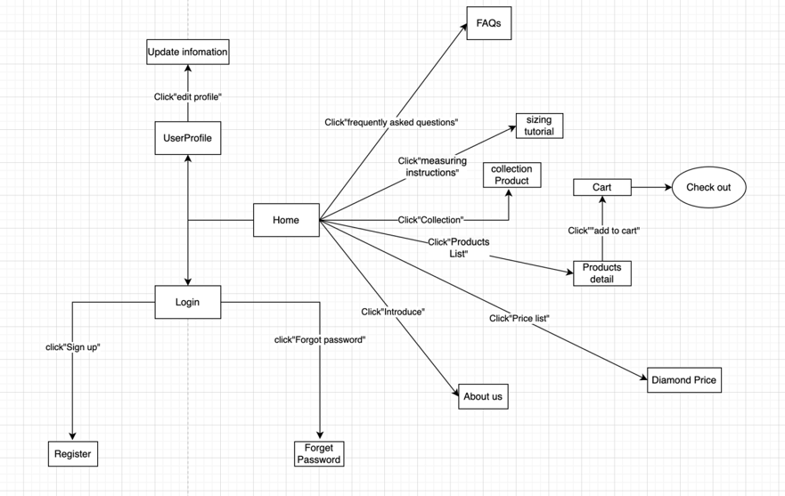

1.1b)Admin screen flow

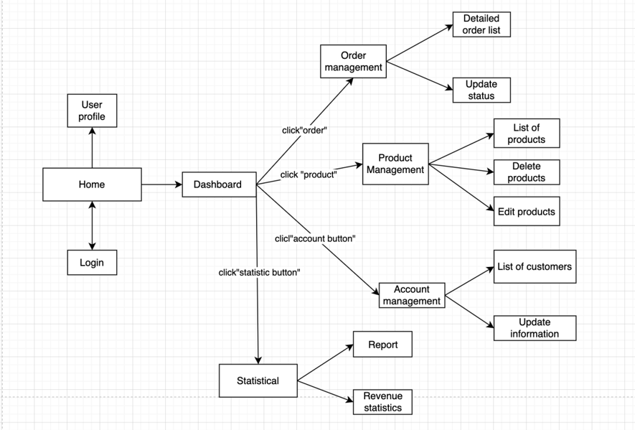

### 1.2 Screen Descriptions

:

|  |  |  |  |
| --- | --- | --- | --- |
| **#** | **Screen** | **Feature** | **Description** |
| FR-01 | Create Order | Order Meals | <<Screen Brief description>> |
| FR-02 | Change Order | Order Meals |  |
| FR-03 | .. |  |  |

### 1.3 Screen Authorization

|  |  |  |  |  |  |
| --- | --- | --- | --- | --- | --- |
| **Screen** | **Role1** | **Role2** | **Role3** | **Role4** | **RoleX** |
| <<Screen Name1>> | X |  |  | X | X |
| <<Screen Activity>> |  |  |  | X | X |
| <<Screen Name2>> | X |  |  | X |  |
| Query All Data | X |  |  |  |  |
| Query Own Data |  |  |  | X |  |
| Query Managed Data |  |  |  | X |  |
| Add New Data |  |  |  | X | X |
| Update All Data |  |  |  |  | X |
| Update Own Data |  |  |  |  | X |
| Update Managed Data |  |  |  |  | X |
| Delete Data |  |  |  |  |  |
| … |  |  |  |  |  |

In which:

* Role1: <<role1 description>>
* Role2: <<role2 description>>
* …

### 1.4 Non-Screen Functions

|  |  |  |  |
| --- | --- | --- | --- |
| **#** | **System Function** | **Feature** | **Description** |
| FR-11 | <<Function Name1>> | <<Feature Name>> | <<Function Name1 Description>> |
| FR-12 | … |  |  |

>2. Data Requirements

### 2.1 Logical Data Model

* **ERD:**

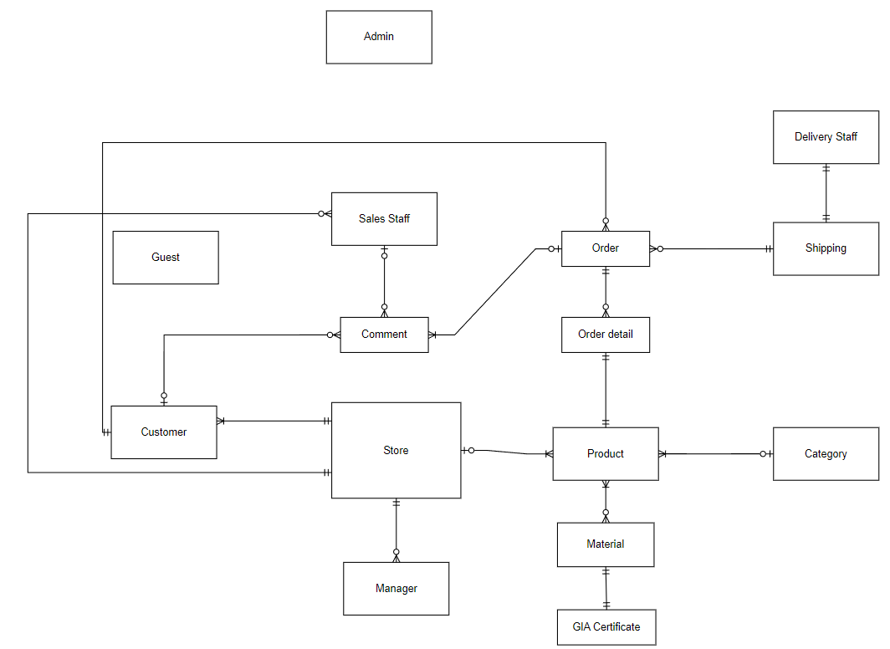

### 2.2 Data Dictionary

|  |  |  |  |  |
| --- | --- | --- | --- | --- |
| **Data Element** | **Description** | **Composition or Data Type** | **Length** | **Values** |
|  |  |  |  |  |
|  |  |  |  |  |
|  |  |  |  |  |
|  |  |  |  |  |
|  |  |  |  |  |
|  |  |  |  |  |
|  |  |  |  |  |
|  |  |  |  |  |
|  |  |  |  |  |
|  |  |  |  |  |
|  |  |  |  |  |
|  |  |  |  |  |
|  |  |  |  |  |
|  |  |  |  |  |
|  |  |  |  |  |
|  |  |  |  |  |
|  |  |  |  |  |
|  |  |  |  |  |
|  |  |  |  |  |
|  |  |  |  |  |
|  |  |  |  |  |
|  |  |  |  |  |
|  |  |  |  |  |
|  |  |  |  |  |
|  |  |  |  |  |
|  |  |  |  |  |

>>

### 2.3 Reports

|  |  |  |
| --- | --- | --- |
| **#** | **Report Name** | **Description** |
| RPT-01 | Ordered Meal History | Patron wants to see a list of all meals that he had previously ordered from the Process Impact cafeteria or local restaurants over a specified time period up to six months prior to the current date, so he can reorder a particular meal he liked. |
| RPT-02 | … |  |

|  |  |
| --- | --- |
| Report ID: | RPT-01 |
| Report Title: | Ordered Meal History |
| Report Purpose: | Patron wants to see a list of all meals that he had previously ordered from the Process Impact cafeteria or local restaurants over a specified time period up to six months prior to the current date, so he can reorder a particular meal he liked. |
| Priority: | Medium |
| Report Users: | Patrons |
| Data Sources: | Database of previously placed meal orders |
| Frequency and Disposition; | Report is generated on demand by a Patron. Data in the report is static. Report is displayed on user's web browser screen on a computer, tablet, or smartphone. It can be printed if the display device permits printing. |
| Latency: | Complete report must be displayed to Patron within 3 seconds after it is requested. |
| Visual Layout: | Landscape mode |
| Header and Footer: | Report header shall contain the report title, Patron's name, and date range specified. If printed, report footer shall show the page number. |
| Report Body: | Fields shown and column headings:   * Order Number * Meal Date * Ordered From ("Cafeteria" or restaurant name) * Items ordered (list all items in the meal order, their quantity, and their prices) * Total Food Price * Tax * Delivery Charge * Total Price (sum of food item prices, tax, and delivery charge)   Selection Criteria: date range specified by Patron, inclusive of end points  Sort Criteria: reverse chronological order |
| End-of-Report Indicator: | None |
| Interactivity: | Patron can drill down to see ingredients and nutritional information for each item in the order |
| Security Access Restrictions: | A Patron may retrieve only his own meal order history |

2.4 State transition diagram

*[This part shows state transition of main entities in the system]*

<<Sample: a state-transition diagram that shows the possible meal order statuses and the allowed changes in status.

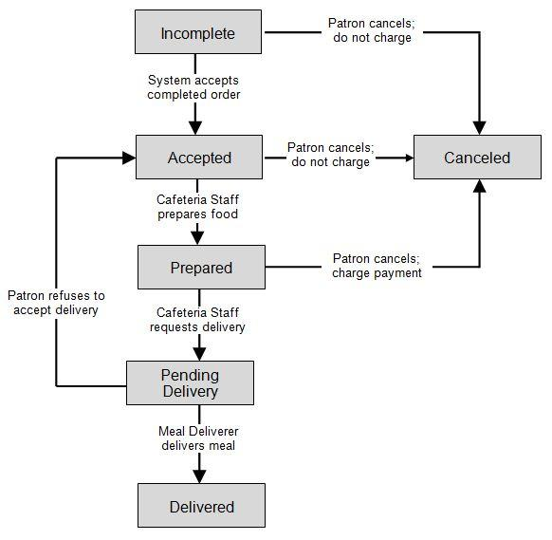

>>

## 3. <<Feature Name 1>>

### 3.1 <<Function Name 1>>

*[A function can be a screen or a non-screen function (listed in the part 5.1 above). In this part, you need to provide the details on the related function, focus on mentioning below information*

* *Function trigger: how this function is triggered (navigation path, a timing frequency, etc.*
* *Function description: actors/roles, purpose, interface, data processing, etc.*
* *Screen layout: mockup prototype of the screen, sample below is for Manage Products screen*

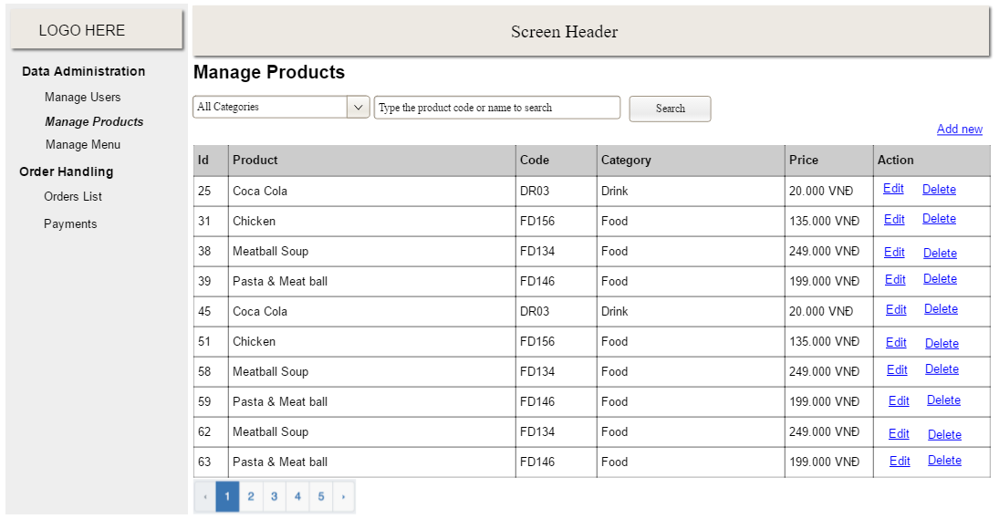

* *Function Details: provide explanation for the data, validation, business logics, functionalities (for both normal cases and abnormal cases), etc. of the function so that the reader can image how it work.*

*]*

### 3.2 <<Function Name 2>>

…

## 4. <<Feature Name 2>>

…

## 5. Function requirement

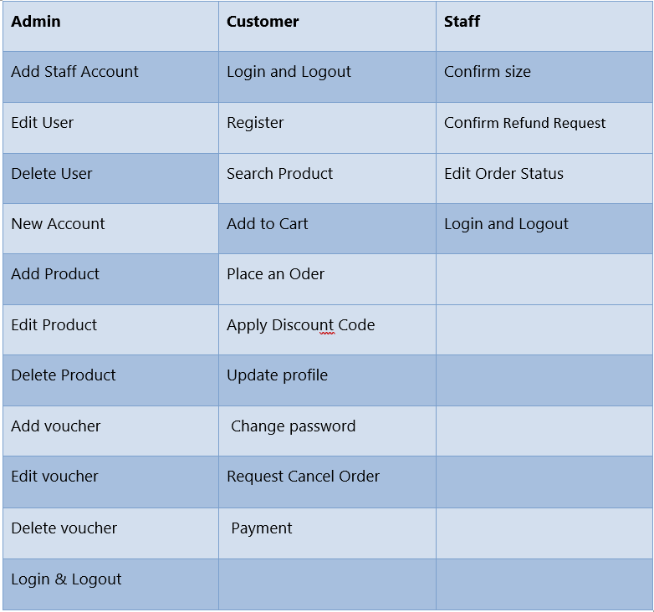

**6. Technical requirement**

**User registration:**

* T1: Họ is required.
* T2: Họ cannot contain special characters.
* T3: Họ cannot contain a number.
* T4: The first character of Họ cannot be a space.
* T5: Tên is required.
* T6: Tên cannot contain special characters.
* T7: Tên cannot contain a number.
* T8: The first character of Tên cannot be a space.
* T9: Ngày sinh is required.
* T10: Số điện thoại is required.
* T11: Số điện thoại cannot contain special characters.
* T12: Số điện thoại cannot contain characters.
* T13: The first character of Số điện thoại cannot be a space.
* T14: Địa chỉ is required.
* T15: Địa chỉ cannot contain special characters except “\” and “/”.
* T16: The first character of Địa chỉ cannot be a space.
* T17: Giới tính is required.
* T18: Email is required.
* T19: The first character and the end of a character cannot contain “.” or “-” or “_”
* T20: Mật khẩu is required.
* T21: The first character of Mật khẩu cannot be a space
* T20: Xác nhận mật khẩu is required.
* T21: The first character of Xác nhận mật khẩu cannot be a space.
* T22: Xác nhận mật khẩu must be match with mật khẩu.

**User authentication:**

* T23: Email is required.
* T24: Mật khẩu is required.
* T25: Login attempts - Maximum 5 failed attempts allowed.

**Forgot password:**

* T26: Email is required.

**Search browser:**

* T27: The search term must not be blank.
* T28: Special characters are not allowed.
* T29: Product ID must be valid.

**Product detail:**

* T30: Chất liệu must not be blank.
* T31: Số lượng must not be blank.
* T32: Size must not be blank.

**Shopping cart:**

* T33: Items must be added to cart before checkout.
* T34: Cart must not be empty during checkout.
* T35: Mã giảm giá/quà tặng cannot contain special character.
* T36: Mã giảm giá/quà tặng must be valid and not expired.

**Check out:**

* T37: Họ tên is required.
* T38: Họ tên cannot contain special character.
* T39: The first character of Họ tên cannot be a space.
* T40: Họ tên cannot contain number characters.
* T41: Điện thoại is required.
* T42: Điện thoạ cannot contain special characters.
* T43: The first character of Điện thoạ cannot be a space.
* T44: Điện thoạ cannot contain characters.
* T45: Email is required.
* T46: The first character and the end of a character cannot contain “.” or “-” or “_”.
* T47: Ngày sinh is required.
* T48: Chọn Tỉnh/TP is required
* T49: Chọn Quận/Huyện is requied
* T50: Chọn Xã/Phường is requied
* T51: Địa chỉ is required.
* T52: Địa chỉ cannot contain special characters except “\” and “/”.
* T53: The first character of Địa chỉ cannot be a space.
* T54: Thời gian nhận hàng method must be selected.
* T55: Hình thức thanh toán method must be selected.
* T56: Mã giảm giá/voucher cannot contain special characters
* T57: Mã giảm giá/voucher must be valid and not expired.

**Product Management: (Từ chỗ này trở xuống cần double check vs chính chủ để xem xét xem đã hiểu đúng như ý định ban đầu của chính chủ dự tính hay chưa rồi mới làm vào jira)**

* T58: Tỷ lệ áp giá is required.
* T59: Số chỉ is required.
* T60: Số chỉ cannot contain character.
* T61: Số chỉ cannot contain special characters.
* T62: Kim cương is required.
* T63: Vỏ kim cương is required.
* T64: Danh mục is required.
* T65: Special is required.
* T66: The first character of Imagine URL cannot be a space.

**Diamond Management:**

* T67: Hình dáng is required.
* T68: Hình dáng cannot contain special characters.
* T69: Hình dáng cannot contain number.
* T70: The first character of Hình dáng cannot be a space.
* T71: Size is required.
* T72: Size cannot contain special characters.
* T73: Size cannot contain characters.
* T74: The first character of Size cannot be a space.
* T75: Màu sắc is required.
* T76: Màu sắc cannot contain special characters.
* T77: Màu sắc cannot contain numbers.
* T78: The first character of Màu sắc cannot be a space.
* T79: Độ tinh khiết is required.
* T80: Carat is required.
* T81: Carat cannot contain special characters.
* T82: Carat cannot contain characters.
* T83: The first character of Carat cannot be a space.
* T84: Độ cắt is required.
* T85: Chứng chỉ is required.
* T86: The first character of Chứng chỉ cannot be a space.
* T87: Nguồn gốc is required.
* T88: Giá is required.
* T89: Giá cannot contain special characters.
* T90: Giá cannot contain characters.
* T91: The first character of Giá cannot be a space.
* T92: The first character of Imagine URL cannot be a space.
* T93: The first character of Loại cannot be a space.

**Diamond Shell Management:**

* T94: Kim loại is required.
* T95: Kim loại cannot contain special characters.
* T96: Kim loại cannot contain numbers.
* T97: The first character of Kim loại cannot be a space.
* T98: Karat is required.
* T99: Nặng is required.
* T100: Nặng cannot contain special characters.
* T101: Nặng cannot contain characters.
* T102: The first character of Nặng cannot be a space.
* T103: Số lượng đá phụ is required.
* T104: Số lượng đá phụ cannot contain special characters.
* T105: Số lượng đá phụ cannot contain characters.
* T106: The first character of Số lượng đá phụ cannot be a space.
* T107: Loại is required.
* T108: Loại cannot contain special characters.
* T109: Loại cannot contain numbers.
* T110: The first character of Loại cannot be a space.

**Diamond Certificate Management:**

* T111: Số chứng chỉ is required.
* T112: Số chứng chỉ cannot contain special characters except “-”.
* T113: The first character of Số chứng chỉ cannot be a space.
* T114: fileURL is required.
* T115: fileURL cannot contain special characters.
* T116: The first character of fileURL cannot be a space.

**Category Management:**

* T117: Tên danh mục is required.
* T118: Tên danh mục cannot contain special characters.
* T119: Tên danh mục cannot contain numbers.
* T120: The first character of Tên danh mục cannot be a space.
* T121: Mô tả is required.
* T122: Mô tả cannot contain special characters.
* T123: Mô tả cannot contain numbers.
* T124: The first character of Mô tả cannot be a space.

#### Profile Management:

* T125: Profile Update - All fields must be validated.
* T126: Password - Password change must meet security criteria.

**Tracking order:**

* T127: Ngày giao hàng dự kiến must be clearly stated.
* T128: Giao hàng bởi must be clearly stated.
* T129: Trạng thái is always update.

**Collection:**

* T130: Collection details must be complete and accurate.

**Knowledge ( Jewelry, Size, Diamond):**

* T131: Content knowledge details must be complete and accurate.

**Diamond price:**

* T132: Diamond prices are updated continuously.
* T133: Diamond prices are clearly shown by day and month.

**FAQs:**

* T134: Question and answer must be complete.
* T135: Must be updated regularly.

**Manage user:**

* T136: Data must be up-to-date.
* T137: User details must be complete and accurate.

**Manage order:**

* T138: Order details must be complete and accurate.

**Manage delivery order:**

* T139: Delivery order details must be complete and accurate.
* T139: Tình trạng cannot contain numbers.
* T140:Tình trạng cannot contain special characters.
* T141:Cập nhật cannot contain numbers.
* T142:Cập nhật cannot contain special characters.

# 

# V. Non-Functional Requirements

## 1. External Interface Requirements

*[This section provides information to ensure that the system will communicate properly with users and with external hardware or software elements.]*

### 1.1 User Interfaces

*[Describe the logical characteristics of each interface between the software product and the users. This may include sample screen images, any GUI standards or product family style guides that are to be followed, screen layout constraints, standard buttons and functions (e.g., help) that will appear on every screen, keyboard shortcuts, error message display standards, and so on. Define the software components for which a user interface is needed. Details of the user interface design should be documented in a separate user interface specification.]*

<<Sample:

UI-1: The Cafeteria Ordering System screen displays shall conform to the *Process Impact Internet Application User Interface Standard, Version 2.0* [3].

UI-2: The system shall provide a help link from each displayed webpage to explain how to use that page.

UI-3: The webpages shall permit complete navigation and food item selection by using the keyboard alone, in addition to using mouse and keyboard combinations.

>>

### 1.2 Software Interfaces

*[Describe the connections between this product and other software components (identified by name and version), including other applications, databases, operating systems, tools, libraries, websites, and integrated commercial components. State the purpose, formats, and contents of the messages, data, and control values exchanged between the software components. Specify the mappings of input and output data between the systems and any translations that need to be made for the data to get from one system to the other. Describe the services needed by or from external software components and the nature of the intercomponent communications. Identify data that will be exchanged between or shared across software components. Specify nonfunctional requirements affecting the interface, such as service levels for responses times and frequencies, or security controls and restrictions.]*

<<Sample:

SI-1: Cafeteria Inventory System

SI-1.1: The COS shall transmit the quantities of food items ordered to the Cafeteria Inventory System through a programmatic interface.

SI-1.2: The COS shall poll the Cafeteria Inventory System to determine whether a requested food item is available.

SI-1.3: When the Cafeteria Inventory System notifies the COS that a specific food item is no longer available, the COS shall remove that food item from the menu for the current date.

SI-2: Payroll System

The COS shall communicate with the Payroll System through a programmatic interface for the following operations:

SI-2.1: To allow a Patron to register and unregister for payroll deduction.

SI-2.2: To inquire whether a Patron is registered for payroll deduction.

SI-2.3: To inquire whether a Patron is eligible to register for payroll deduction.

SI-2.4: To submit a payment request for a purchased meal.

SI-2.5: To reverse all or part of a previous charge because a patron rejected a meal or wasn’t satisfied with it, or because the meal was not delivered per the confirmed delivery instructions.

>>

### 1.3 Hardware Interfaces

*[Describe the characteristics of each interface between the software and hardware (if any) components of the system. This description might include the supported device types, the data and control interactions between the software and the hardware, and the communication protocols to be used. List the inputs and outputs, their formats, their valid values or ranges, and any timing issues developers need to be aware of. If this information is extensive, consider creating a separate interface specification document.]*

<<Sample:

HI-1: ***Server Configuration***

*Application Server*

CPU : Intel Xeon 8 Core 2.40 GHz

Memory Space : 128 GB RAM 1333 MHz

Storage Space : 2 TB

Operating System : MS Windows Server 2012 R2

Software : Microsoft IIS 8.x, .NET Framework 4.5

*Database Server*

CPU : Intel Xeon 12 Core 2.40 GHz

Memory Space : 256 GB RAM 1333 MHz

Storage Space : 3 TB

Operating System : MS Windows Server 2012 R2

Software : Microsoft SQL Server 2000

HI-2: ***Client Configuration***

*PC Device*

CPU : Intel Core 2 Dual 2.00 GHz

Memory Space : 4 GB RAM 1333MHz

Storage Space : HDD: 500GB, 2.5" SATA x 2, RAID 1

Operating System : Windows Win7/Win8/Win10

Operator Display : 18.5-inch widescreen, 16:9 format

1280 x 720 pixel, 1024 x 768 pixel

*POS Device*

CPU : Intel® Celeron® Processor G1820TE (2.2GHz, Dual Core)

Memory Space : 2GB (Max. 4GB), DDR3 SO-DIMM slot x 2 (1 open)

Storage Space : HDD: 500GB, 2.5" SATA x 2, RAID 1

Operating System : Windows Embedded POS Ready 7

Operator Display : 15" XGA TFT color LCD with resistive touch screen (TeamTouch), Integrated

1024 x 768 pixel

Proximity Sensor

Option: Integrated Camera/Mic

*Mobility Device*

CPU : Quad-Core 1.2 GHz

Memory Space : 1.5 GB

Storage Space : 8 GB

Operating System : Android 8.0

Wifi Standard : 5GHz Wi-fi

Operator Display : 7.0 inches

1280 x 800 Pixels

HI-3: ***Network***

LAN Network : Speed ≥ 1 Gbps

WAN Network : Speed ≥ 2Mbps/10 Users operate together

>>

### 1.4 Communications Interfaces

*[State the requirements for any communication functions the product will use, including e-mail, Web browser, network protocols, and electronic forms. Define any pertinent message formatting. Specify communication security or encryption issues, data transfer rates, handshaking, and synchronization mechanisms. State any constraints around these interfaces, such as whether e-mail attachments are acceptable or not.]*

<<Sample:

CI-1: The COS shall send an email or text message (based on user account settings) to the Patron to confirm acceptance of an order, price, and delivery instructions.

CI-2: The COS shall send an email or text message (based on user account settings) to the Patron to report any problems with the meal order or delivery.

>>

## 2. Quality Attributes

### 2.1 Usability

*[Specify any requirements regarding characteristics that will make the software appear to be “user-friendly.” Usability encompasses ease of use, ease of learning; memorability; error avoidance, handling, and recovery; efficiency of interactions; accessibility; and ergonomics. Sometimes these can conflict with each other, as with ease of use over ease of learning. Indicate any user interface design standards or guidelines to which the application must conform.]*

<<Sample:

USE-1: The COS shall allow a Patron to retrieve the previous meal ordered with a single interaction.

USE-2: 95% of new users shall be able to successfully order a meal without errors on their first try.

>>

### 2.2 Performance

*[State specific performance requirements for various system operations. If different functional requirements or features have different performance requirements, it's appropriate to specify those performance goals right with the corresponding functional requirements, rather than collecting them in this section.]*

<<Sample:

PER-1: The system shall accommodate a total of 400 users and a maximum of 100 concurrent users during the peak usage time window of 9:00 A.M. to 10:00 A.M. local time, with an estimated average session duration of 8 minutes.

PER-2: 95% of webpages generated by the COS shall download completely within 4 seconds from the time the user requests the page over a 20Mbps or faster Internet connection.

PER-3: The system shall display confirmation messages to users within an average of 3 seconds and a maximum of 6 seconds after the user submits information to the system.

>>

### 2.3 Security

*[Specify any requirements regarding security or privacy issues that restrict access to or use of the product. These could refer to physical, data, or software security. Security requirements often originate in business rules, so identify any security or privacy policies or regulations to which the product must conform. If these are documented in a business rules repository, just refer to them.]*

<<Sample:

SEC-1: All network transactions that involve financial information or personally identifiable information shall be encrypted per BR-33.

SEC-2: Users shall be required to log on to the COS for all operations except viewing a menu.

SEC-3: Only authorized Menu Managers shall be permitted to work with menus, per BR-24.

SEC-4: The system shall permit Patrons to view only orders that they placed.

>>

### 2.4 Safety

*[Specify requirements that are concerned with possible loss, damage, or harm that could result from use of the product. Define any safeguards or actions that must be taken, as well as potentially dangerous actions that must be prevented. Identify any safety certifications, policies, or regulations to which the product must conform.]*

<<Sample:

SAF-1: The user shall be able to see a list of all ingredients in any menu items, with ingredients highlighted that are known to cause allergic reactions in more than 0.5 percent of the North American population.

>>

### 2.5 Availability

*[Availability is a measure of the planned up time during which the system’s services are available for use and fully operational. Formally, availability equals the ratio of up time to the sum of up time and down time. Still more formally, availability equals the mean time between failures (MTBF) for the system divided by the sum of the MTBF and the mean time to repair (MTTR) the system after a failure is encountered. Scheduled maintenance periods also affect availability. Availability is closely related to reliability and is strongly affected by the maintainability subcategory of modifiability. ]*

<<Sample:

AVL-1: The COS shall be available at least 98% of the time between 5:00 A.M. and midnight local time and at least 90% of the time between midnight and 5:00 A.M. local time, excluding scheduled maintenance windows.

>>

### 2.6 Reliability

*[The probability of the software executing without failure for a specific period of time is known as reliability.]*

<<Sample:

REL-1: No more than 5 experimental runs out of 1,000 can be lost because of software failures.

REL-2: The mean time between failures of the card reader component shall be at least 90 days.

>>

### 2.7 Design Contrainsts

*[Describe constraints in the software development process]*

<<Sample:

DES-1: Programming languages: ASP.NET (VB), VB.NET

DES-2: Web server: IIS 5.0

DES-3: Web browser: IE 6.0

DES-4: Database: SQL Server 2000

DES-5: Report: Crystal Report 10 + Excel

DES-6: Design tools: Power Designer 10, ERWin 4.1, Rational Rose

DES-7: Programming Tool: MS Visual Studio .Net 2003

>>

### 2.8 [Others as relevant]

*[Create a separate section in the SRS for each additional product quality attribute to describe characteristics that will be important to either customers or developers. Possibilities include efficiency, installability, integrity, interoperability, modifiability, portability, reusability, robustness, scalability, and verifiability. Write these to be specific, quantitative, and verifiable. Clarify the relative priorities for various attributes, such as security over performance.]*

<<Sample:

…

>>