1. **Download and install Docker Desktop for Windows:**

<https://hub.docker.com/editions/community/docker-ce-desktop-windows/>

1. **Run the following command using CLI (i.e. Windows PowerShell as Administrator):**

docker run -d --name mycontainer --rm --network turno -v PATH_TO_YOUR_PROJECTS:/var/www/public -p 8000:8080 thewebmaster/turno-php-ubuntu

**Note: Change PATH_TO_YOUR_PROJECTS with actual directory**

**Example:**

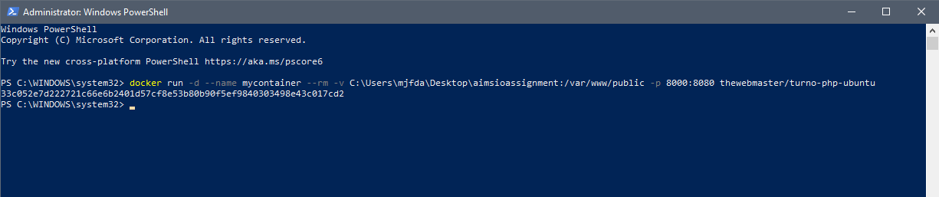

1. **Open browser and type localhost:8000**