Basic Programming (Comparative)

By ***Whiteant***.

The basics of programming that are common across every programming language include:

0. program file

1. Input/Output (I/O)

2. Data Types and Variables

3. Conditions

4. Loops

5. Lists

6. Concepts like Object-Oriented Programming (OOP)

Let’s Talk more about these things.

**NOTE:** There are multiple programming examples in examples section. Choose your one and practice. (c ,c++, python , java, php, javascripts)

**Chapter0:File and Basics**

**In** this part, many people try to memorize everything rather than understanding it. It's not that no one can understand this, but for beginners, it's not necessary.

**C programming**

1. Create a **File**
2. **File** name **Extension** must be “.c” for example “Test.c”
3. Open In Code Editor
4. Write Basic Structure given below

Code:

#include <stdio.h>

int main() {

    printf("Hello, World!\n");

    return 0;

}

**Learnings:**

1. ‘/n’ for new lines
2. <stdio.h> means the standard input-output header, which is used to define functions for input and output operations.

**C++**

1. Create a File
2. File Name Extension: The file extension must be .cpp”, for example, “Test.cpp”.
3. Open in Code Editor
4. Write Basic Structure given below:

Code:

#include <iostream>

using namespace std;

int main() {

    cout << "Hello, World!" <<endl;

    return 0;

}

**Learnings:**

1. In cpp we use **“cout<<” for output** and **“cin>>” for input**
2. **endl** (end line) use for next line

**Python**

1. Create a File
2. File Name Extension: The file extension must be “.py”, for example, “Test.py”.
3. Open in Code Editor
4. Write Basic Structure given below:

Code:

print("Hello, World!")

**Learnings:**

1. There are no compulsory main function concepts in python
2. 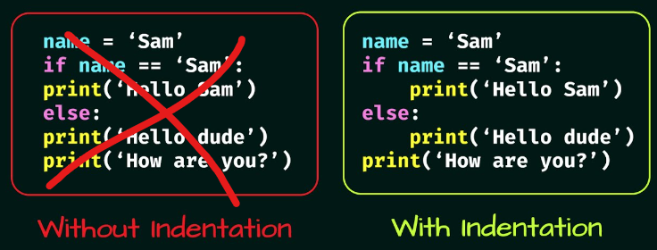There is no semicolon also but line indentation matter

**Chapter1:Input/Output**

Input refers to getting data from the user or another system Output is about displaying data to the user or sending data to another system.