CUSTOMER RISK INTELLIGENCE
An Explainable and Revenue-Aware Framework for Telecom Churn Prioritization
Sudeen Koyande
Upgraded research manuscript draft | September 2026
Abstract. Customer churn prediction is often evaluated primarily through classification performance, yet operational retention requires more than a binary label. This study develops an explainable and revenue-aware customer risk intelligence framework that links churn prediction, probability calibration, SHAP explanation, calibrated risk segmentation, expected monthly revenue-at-risk, and retention prioritization. The research model is a Random Forest trained on the Telco Customer Churn dataset with business-oriented features for annualized revenue, tenure bands, and monthly-charge bands. On a held-out test set, the research Random Forest achieved 0.7686 accuracy, 0.5548 precision, 0.6497 recall, 0.5985 F1, 0.8208 ROC-AUC, and 0.6069 PR-AUC. Sigmoid calibration reduced Brier score from 0.1562 to 0.1431 and log loss from 0.4768 to 0.4397, while calibrated ROC-AUC was 0.8276. Risk segmentation produced observed churn rates of 11.78%, 44.63%, and 69.73% for Low, Medium, and High risk, respectively. Expected monthly revenue exposure was $27,257.11 across the held-out evaluation population. A 60/40 churn-probability/revenue-risk priority score produced retention tiers and a resource-allocation framework. Sensitivity analysis across four tested weight configurations yielded similar churn capture while changing financial exposure per targeted customer. The contribution is an integrated decision-support framework rather than a novel predictive algorithm. Results are interpreted as predictive and operational evidence, not as causal estimates of prevented churn.
Keywords: customer churn; telecom analytics; Random Forest; probability calibration; SHAP; explainable AI; revenue at risk; retention prioritization

1. Introduction
Customer churn is a recurring problem in subscription businesses because customer departure can reduce recurring revenue and increase the resources required to replace lost customers. Machine-learning models can identify customers with elevated churn likelihood, but a class label alone does not tell a retention team how reliable the probability is, why the model is concerned, how customers should be segmented operationally, or how much financial exposure is associated with a predicted churn event.
This study frames telecom churn as a customer-risk intelligence problem rather than a classification-only problem. The central research question is: Can an explainable machine-learning framework identify high-risk telecom customers and prioritize retention interventions using churn probability and customer value?
The framework is deliberately modular. A research Random Forest produces churn probabilities; post-hoc calibration improves the probability scale; SHAP provides global and local explanations; calibrated probabilities define risk bands; revenue-at-risk introduces customer value; and a retention-priority score ranks intervention candidates. The contribution is therefore an integrated, decision-centric framework assembled from established methods, not a claim of a new learning algorithm.

Research objectives:
- Evaluate baseline versus research predictive performance.
- Assess probability quality before and after calibration.
- Test whether calibrated probabilities create useful risk bands.
- Translate churn probability into expected revenue exposure.
- Evaluate retention prioritization and targeting efficiency under resource constraints.

2. Related Work
Telecom churn research spans logistic and other statistical models, decision trees and ensembles, support vector methods, boosting algorithms, and more recent deep-learning approaches. A recent systematic review of peer-reviewed telecom churn studies reports substantial methodological diversity across both benchmark and operator datasets [1]. This body of work establishes churn prediction as a mature applied machine-learning task, but it also shows that performance comparisons alone do not fully address deployment and retention decision needs.
Explainability has increasingly become part of churn analytics. SHAP provides an additive feature-attribution framework that can be used to explain individual model outputs and summarize global feature importance [2]. Recent telecom studies have explicitly paired churn prediction with SHAP-style explanations to make model outputs more interpretable for decision support [3,4].
Probability quality is a different property from ranking discrimination. Niculescu-Mizil and Caruana demonstrated that classifiers can produce probabilities that are systematically distorted and that post-hoc calibration can improve their usefulness [5]. This is directly relevant when predicted probabilities are subsequently multiplied by customer value to estimate expected exposure.
Class imbalance further motivates careful metric selection. Precision-recall analysis can be more informative than ROC analysis when the positive class is relatively uncommon [6]. Accordingly, this study reports PR-AUC for the research model and supplements standard predictive metrics with risk-concentration and targeting analyses.

3. Dataset and Data Preparation
The study uses the Telco Customer Churn benchmark distributed as an IBM Cognos sample and widely reused in churn analytics [7]. The dataset contains 7,043 customers and 21 original variables covering demographics, service subscriptions, contract characteristics, payment methods, and billing information.
Data preparation included numeric conversion of TotalCharges, missing-value handling within the modeling pipeline, duplicate-row checks, duplicate-customer checks, and construction of three business-oriented research features. The audit found zero duplicate rows and zero duplicate customer identifiers; 11 TotalCharges entries were blank before numeric conversion.

Dataset property | Result | Treatment / interpretation
Observations | 7,043 | Full benchmark dataset
Original variables | 21 | Demographic, service, contract, payment, billing
Duplicate rows | 0 | No duplicate rows detected
Duplicate customer IDs | 0 | Customer identifiers unique
Blank TotalCharges | 11 | Converted to numeric; handled in modeling pipeline
Overall churn | 26.54% | 1,869 churners; 5,174 non-churners
Table 1. Dataset audit summary.

3.1 Research feature engineering
AnnualRevenue = MonthlyCharges x 12. TenureGroup uses five bands (0-6, 7-12, 13-24, 25-48, 49-72 months). MonthlyChargeGroup uses four bands (Low, Medium-Low, Medium-High, High). These engineered variables add business-oriented structure while preserving the original customer records.

4. Experimental Design
The research experiment uses a stratified 80/20 train-test split with random_state=42, yielding 5,634 training observations and 1,409 held-out evaluation observations. The research preprocessing pipeline uses median imputation and standardization for numerical variables and most-frequent imputation followed by one-hot encoding for categorical variables. The Random Forest uses 300 trees, balanced class weights, random_state=42, and parallel execution across available CPU cores [8].
The held-out set is reserved for final model evaluation, calibration assessment, risk validation, and downstream targeting evaluation. This separation is important because revenue-at-risk and retention prioritization are intended to use predictions generated for customers who were not used to fit the predictive model.
For reproducibility, the study records the dataset source, split rule, random seed, preprocessing configuration, model hyperparameters, calibration method, risk thresholds, and retention weighting. The production code developed alongside the research artifacts is designed to reproduce the scoring pipeline rather than alter the research point estimates.

5. Baseline and Research Model Results
Baseline experiments compare Logistic Regression with a baseline Random Forest. The research Random Forest extends the feature space with AnnualRevenue, TenureGroup, and MonthlyChargeGroup. The research model is not presented as universally superior; instead, it is selected as the probability-generating model for the downstream risk-intelligence framework because it provides a useful recall profile and supports the subsequent calibration and explainability steps.

Model | Accuracy | Precision | Recall | F1 | ROC-AUC | PR-AUC
Logistic Regression | 0.8055 | 0.6572 | 0.5588 | 0.6040 | 0.8419 | -
Baseline Random Forest | 0.7658 | 0.5521 | 0.6230 | 0.5854 | 0.8218 | -
Research Random Forest | 0.7686 | 0.5548 | 0.6497 | 0.5985 | 0.8208 | 0.6069
Table 2. Established model performance on the held-out evaluation set.
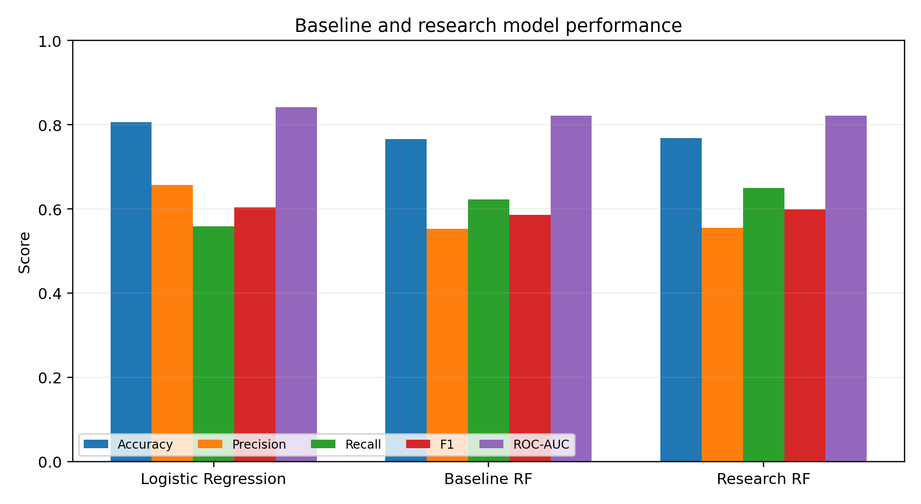
Figure 1. Baseline and research model performance across standard classification metrics.

6. Probability Calibration
Because the downstream framework uses churn probability as an expected-exposure input, calibration is treated as a first-class evaluation problem. The research Random Forest is calibrated using sigmoid calibration with five-fold cross-validation on the training data while the held-out test set remains reserved for final evaluation [5,8].
The Brier score decreases from 0.1562 to 0.1431, and log loss decreases from 0.4768 to 0.4397. The calibrated ROC-AUC is 0.8276 compared with 0.8208 before calibration. The improvement in Brier score and log loss provides evidence of better probability quality under the selected measures. The small ROC-AUC change is not interpreted as an intrinsic property of calibration; the cross-validated calibrated estimator generates a different ensemble of predictions rather than applying a deterministic monotonic transformation to one fixed classifier.
Metric | Original | Calibrated | Change
Brier score | 0.1562 | 0.1431 | -0.0131
ROC-AUC | 0.8208 | 0.8276 | +0.0068
Log loss | 0.4768 | 0.4397 | -0.0371
Table 3. Probability-quality metrics before and after sigmoid calibration.
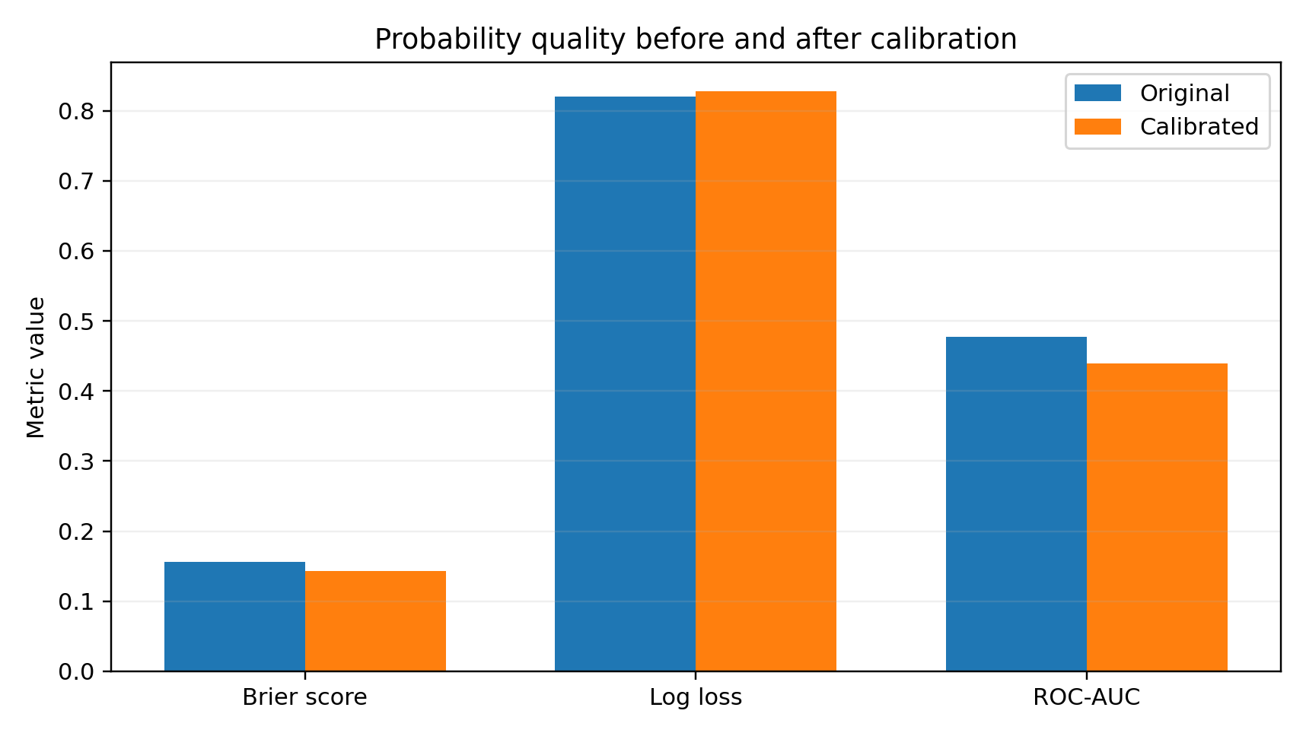
Figure 2. Established calibration metrics; lower is better for Brier score and log loss.

7. Explainability with SHAP
SHAP is used at global and individual levels. Global mean absolute SHAP values identify influential features including month-to-month contract status, tenure, fiber-optic service, TotalCharges, two-year contract status, absence of online security, absence of technical support, electronic-check payment method, and MonthlyCharges [2]. Individual customer explanations are represented with SHAP waterfall plots.
SHAP is used as a model-explanation mechanism, not a causal inference tool. A feature with a large positive or negative attribution indicates how the fitted model uses that feature in a prediction; it does not establish that changing the feature would necessarily change the real-world probability of churn. This distinction is preserved throughout the retention discussion.

8. Calibrated Risk Segmentation
Customers are segmented from calibrated churn probabilities using predefined operational bands: Low below 0.30, Medium from 0.30 to below 0.60, and High at 0.60 or above. These thresholds are treated as an operational segmentation scheme rather than as a statistically optimized decision threshold.
The held-out evaluation population contains 917 Low-risk customers, 307 Medium-risk customers, and 185 High-risk customers. Observed churn increases monotonically across the groups from 11.78% to 44.63% to 69.73%, providing evidence that the calibrated probability scale produces a useful risk ordering in this evaluation population.
Risk level | Customers | Customer share | Observed churn
Low | 917 | 65.08% | 11.78%
Medium | 307 | 21.79% | 44.63%
High | 185 | 13.13% | 69.73%
Table 4. Calibrated risk segmentation on the held-out evaluation set.
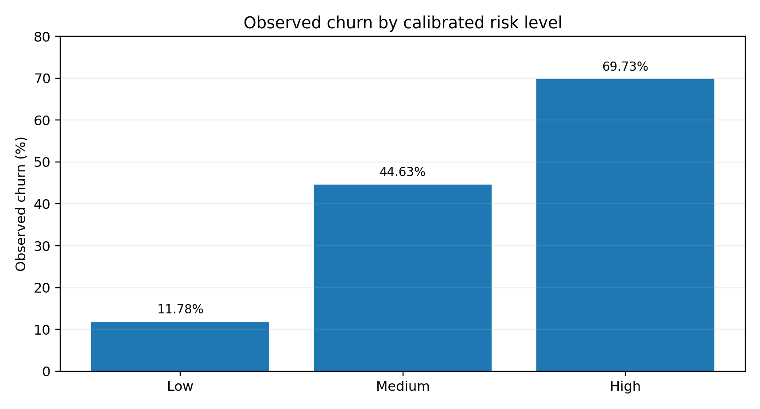
Figure 3. Observed churn rises across calibrated risk bands.

9. Revenue-at-Risk Modeling
Expected monthly revenue at risk is defined as calibrated churn probability multiplied by MonthlyCharges. This formulation converts an individual risk probability into an expected monthly financial exposure. It is intentionally interpreted as exposure rather than guaranteed lost revenue.
Across the 1,409 held-out customers, total expected monthly revenue exposure is $27,257.11. The measure is suitable for prioritization because it preserves customer-value information that a probability-only ranking would ignore.
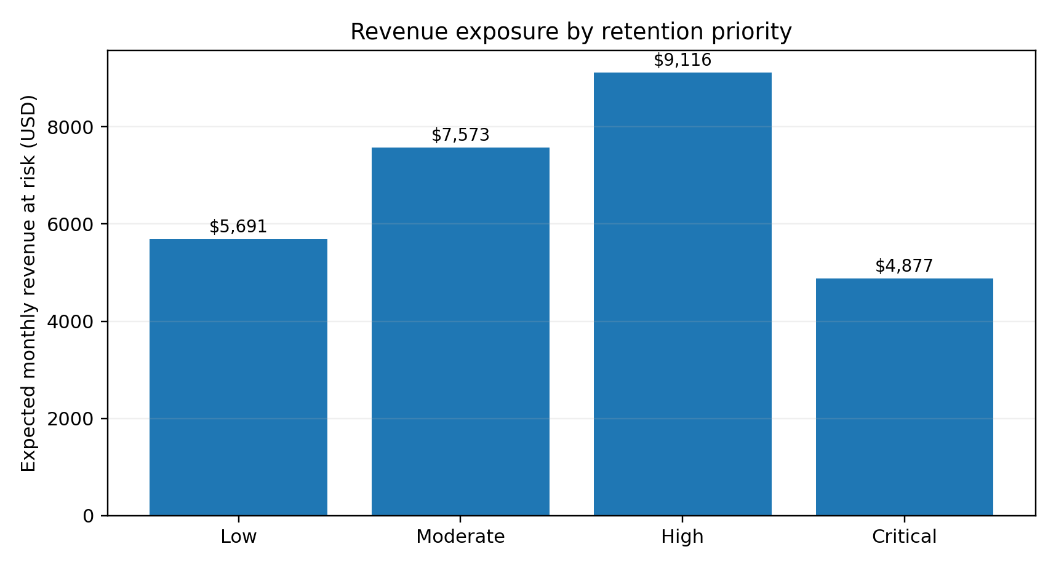
Figure 4. Expected monthly revenue-at-risk concentration by retention priority.

10. Revenue-Aware Retention Prioritization
RevenueRiskScore is formed by normalizing RevenueAtRisk by the maximum RevenueAtRisk observed in the held-out evaluation set. The established retention-priority score combines 60% calibrated churn probability and 40% normalized revenue risk. The resulting Low, Moderate, High, and Critical tiers show increasing observed churn rates from 10.69% to 76.39%.
The 60/40 configuration is the default operating configuration used in the project, not a universal optimum. The priority tiers are intended to support resource allocation when retention capacity is limited, while retaining the distinction between predicted exposure and realized business outcomes.
Priority | Customers | Churners | Observed churn | Revenue at risk
Low | 870 | 93 | 10.69% | $5,691.25
Moderate | 280 | 119 | 42.50% | $7,573.33
High | 187 | 107 | 57.22% | $9,115.72
Critical | 72 | 55 | 76.39% | $4,876.81
Table 5. Established retention-priority results.

11. Retention Targeting Efficiency
Targeting only the High-risk group requires intervention for 13.13% of customers while capturing 34.49% of observed churners, corresponding to a capture-efficiency ratio of 2.63 relative to targeting the full population. Expanding the pool to High + Medium increases customer coverage to 34.92% and churner capture to 71.12%, while reducing concentration efficiency to 2.04.
The results illustrate a practical coverage-versus-focus trade-off. A retention team with limited capacity can concentrate on High-risk customers for stronger selectivity or expand into Medium-risk customers to capture a larger fraction of historical churners. This is resource-allocation evidence, not a causal estimate of intervention effectiveness.
Targeted group | Customers | Customer share | Churner capture | Efficiency
High | 185 | 13.13% | 34.49% | 2.63
High + Medium | 492 | 34.92% | 71.12% | 2.04
All | 1409 | 100.00% | 100.00% | 1.00
Table 6. Cumulative targeting coverage and churner capture.
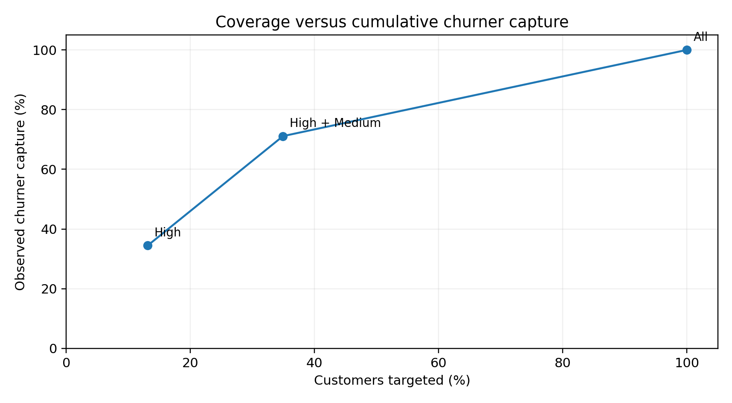
Figure 5. Coverage versus cumulative churner capture.

12. Retention Weight Sensitivity
Sensitivity analysis evaluates 50/50, 60/40, 70/30, and 80/20 churn-probability/revenue-risk weightings at the tested 10% intervention budget. Churn capture ranges only from 27.27% to 27.54%, while revenue risk per targeted customer ranges from $61.19 to $62.90.
The relative stability of churn capture suggests that the targeting ranking is not highly fragile across the tested weights. However, the sensitivity experiment is not an optimization proof. A production organization should select weights from measurable intervention costs, expected treatment effects, customer lifetime value, strategic priorities, and campaign constraints.
Weights | Customers targeted | Churners captured | Churn capture | Revenue risk / customer | Revenue at risk targeted
50/50 | 141 | 103 | 27.54% | $62.90 | $8,869.52
60/40 | 141 | 102 | 27.27% | $62.57 | $8,822.55
70/30 | 141 | 103 | 27.54% | $62.18 | $8,766.83
80/20 | 141 | 103 | 27.54% | $61.19 | $8,627.75
Table 7. Weight sensitivity under the tested 10% intervention budget.
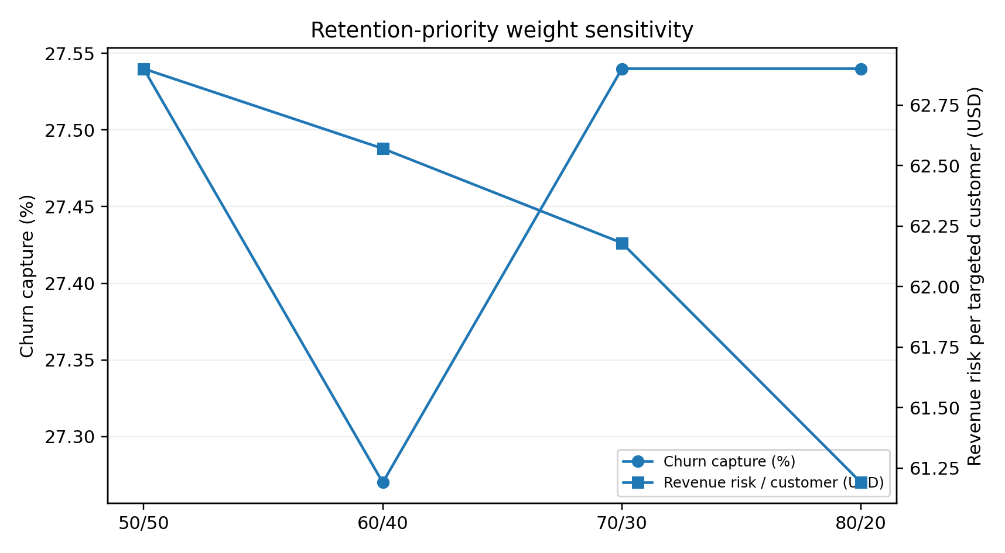
Figure 6. Sensitivity of churn capture and revenue exposure per targeted customer to weighting choice.

13. Discussion
The main empirical result is not a single best classifier. Rather, the findings support a staged transformation of model output into a decision-support artifact. Predictive performance provides the initial risk signal; calibration makes the probability scale more useful; SHAP adds interpretability; calibrated segmentation creates operational risk bands; revenue-at-risk introduces customer value; and retention prioritization converts these inputs into an intervention ranking.
The strongest operational concentration occurs in the High-risk group: 13.13% of customers account for 34.49% of observed churners in the held-out population. Adding Medium-risk customers raises coverage to 34.92% while capturing 71.12% of churners. This supports the proposition that retention planning can benefit from a risk-concentration view rather than treating every customer equally.
The revenue-aware layer adds a second dimension of value. A high-probability churn customer with a low monthly charge and a moderate-probability churn customer with a high monthly charge need not have the same financial priority. The RevenueAtRisk construct makes this trade-off explicit without claiming a complete customer-lifetime-value model.
Compared with recent telecom XAI literature, the project deliberately focuses on an integrated chain from calibrated probability to financial exposure and targeting. Recent studies often emphasize multi-model prediction accuracy and explainability [3,4]; the present study instead emphasizes how a single calibrated model can be translated into a transparent and financially informed retention workflow. This distinction is the intended contribution.

14. Threats to Validity and Limitations
The dataset is a static benchmark and may not represent the behavior, pricing, service mix, or retention practices of a live telecom operator. External validity is therefore limited.
The calibration and risk thresholds are evaluated on one held-out split. Confidence intervals, repeated cross-validation, and external validation on independent telecom datasets would strengthen claims about statistical stability and generalization.
The risk thresholds of 0.30 and 0.60 are operationally chosen rather than derived from an explicit cost-sensitive optimization. A future study should compare alternative thresholding strategies using business costs and capacity constraints.
The retention-priority score uses a weighted combination of risk probability and normalized revenue exposure. The weights are evaluated through sensitivity analysis but are not identified from randomized intervention outcomes. Consequently, high-priority status does not imply that a retention treatment will be effective.
Revenue-at-risk is an expected exposure measure based on monthly charges. It does not model customer lifetime value, gross margin, discounting, acquisition cost, service cost, or the probability that a retention offer changes customer behavior.
SHAP explanations describe the fitted model and should not be interpreted as causal explanations. Production deployment would also require monitoring for feature drift, calibration drift, data-quality degradation, and changes in customer behavior.

15. Reproducibility and Research Artifacts
The study is supported by a structured project repository containing the analytical notebooks, research-results workbook, production-oriented Python modules, SQL artifacts, tests, application code, and documentation. The analytical path remains organized across notebooks 01-04, while the master-results notebook and workbook serve as consolidation artifacts.
The research notebook records the core experimental configuration, including the 80/20 stratified split, random seed, preprocessing design, Random Forest configuration, calibration method, risk thresholds, and downstream revenue-aware scoring logic. The implementation also distinguishes research evidence from future production components so that deployment code does not silently replace the original research experiment.

16. Conclusion
This study developed an explainable and revenue-aware customer risk intelligence framework for telecom churn. The research Random Forest achieved useful predictive performance, probability calibration improved Brier score and log loss, and calibrated risk bands showed strong separation in observed churn. The framework then translated probability into expected revenue exposure and retention priority, enabling a resource-allocation view of customer retention.
The contribution is best understood as an integrated applied research framework: it connects predictive modeling, probability quality, explainability, risk segmentation, financial exposure, and retention prioritization in one auditable workflow. The study does not claim causal treatment effects or a universally optimal weighting scheme. Future work should address repeated and external validation, confidence intervals, threshold optimization under explicit intervention costs, causal retention-effect estimation, richer customer-value measures, and live operational feedback.

17. References
[1] Telecom customer churn prediction in telecom: a detailed systematic review of data, methodology, and evaluation methods. Telecommunication Systems, 2026.
[2] Lundberg, S. M., & Lee, S.-I. (2017). A Unified Approach to Interpreting Model Predictions. Advances in Neural Information Processing Systems 30, 4765-4774.
[3] Zerine, I., et al. (2026). Explainable churn prediction in telecom with tabular ML five model benchmark and SHAP analysis. Discover Artificial Intelligence, 6, 263.
[4] Gaddamwar, S. (2026). Explainable Artificial Intelligence for Customer Churn Prediction in Telecommunications: A Framework for CRM Integration. arXiv:2608.26151.
[5] Niculescu-Mizil, A., & Caruana, R. (2005). Predicting Good Probabilities with Supervised Learning. Proceedings of ICML 2005, 625-632. doi:10.1145/1102351.1102430.
[6] Saito, T., & Rehmsmeier, M. (2015). The Precision-Recall Plot Is More Informative than the ROC Plot When Evaluating Binary Classifiers on Imbalanced Datasets. PLOS ONE, 10(3), e0118432. doi:10.1371/journal.pone.0118432.
[7] IBM Cognos Analytics. Telco Customer Churn sample dataset.
[8] Project research artifact: 03_research_model_calibration.ipynb and 04_risk_revenue_retention.ipynb (internal reproducibility sources).

