Transmission Type and Fuel Efficiency

Alyssa Goldberg

January 10, 2016

# Executive Summary

## Hypotheses and Questions

Using the mtcars dataset from a 1974 Motor Trend US magazine, we examine the following hypotheses: $H_{0}$ = There is no significant difference in fuel efficiency between cars with **automatic** and **manual** transmission. $H_{01}$ = There are no confounding variables that contribute to the acceptance or rejection of $H_{0}$.

1. Is an automatic or manual transmission better for MPG ?
2. If so, quantify the MPG difference between automatic and manual transmissions

## Summary of Findings

*All figures are in the appendix* 1. Cars with manual transmission get **7.24** more mpg than automatic transmission when only transmission type is considered 2. Exploring regression models using multivariate analysis strongly suggests that both weight wt, number of cylinders cyl and hp have a significant confounding effect on fuel efficiency as it relates to transmission type.  
With other variables factored in, cars with manual transmission get an additional **1.8** mpg better than those with automatic transmission.

# Data

The data was extracted from the 1974 Motor Trend US magazine, and comprises fuel consumption and 10 aspects of automobile design and performance for 32 automobiles (1973-74 models).

Note: The 1/4 mile time qsec is a measure of performance rather than a manufacturing variable and thus we remove qsec from the dataset for the purposes of analysis.

## Factors and Measurements

mpg Miles/(US) gallon (the measure of, performance we are interested in), disp Displacement (cu.in.), hp Gross horsepower, drat Rear axle ratio, wt Weight (lb/1000), qsec 1/4 mile time, cyl Number of cylinders, vs V/S, am Transmission (0 = automatic, 1 = manual), gear Number of forward gears, carb Number of carburetors.

Figure 1 and Table 1 (below) include only mpg and am indicate that manual transmission has a mean mpg 7.245 automatic.

A t-test of mpg and am can reveal both the confidence interval and p-values for the two factors in the am variable:

t.test(mtcars[,-7]$mpg~mtcars[,-7]$am)

##   
## Welch Two Sample t-test  
##   
## data: mtcars[, -7]$mpg by mtcars[, -7]$am  
## t = -3.7671, df = 18.332, p-value = 0.001374  
## alternative hypothesis: true difference in means is not equal to 0  
## 95 percent confidence interval:  
## -11.280194 -3.209684  
## sample estimates:  
## mean in group Automatic mean in group Manual   
## 17.14737 24.39231

The CI, -11.2801944, -3.2096842, does not contain zero *and* a p-value of 0.0013736, significantly better than our 95% confidence level $alpha=0.05$. If the only two variable measured were fuel efficiency and transmission type, we could safely reject $H_{0}$.

There are 8 additional manufacturing variables in the data set and the adjusted $R^{2}$ for mpg~am is low, only 0.338, so transmission alone accounts for only 33.85% of the total effect. We need to find a better model.

kable(xt, caption = "Table 1: Linear Regression Coefficients for Automatic vs. Manual Transmission")

|  |  |  |  |  |
| --- | --- | --- | --- | --- |
|  | Estimate | Std. Error | t value | Pr(>|t|) |
| (Intercept) | 17.147368 | 1.124602 | 15.247492 | 0.000000 |
| amManual | 7.244939 | 1.764422 | 4.106127 | 0.000285 |

Table 1: Linear Regression Coefficients for Automatic vs. Manual Transmission

Figure 2 shows that cyl, disp, wt and hp all have a negative effect on fuel efficiency.

# Find the Best Model

## Step Analysis for AIC

We employ R's step() function to find the model with the lowest AIC. (results hidden to limit length of report) and produce a table comparing our three models, mpg ~ am, mpg ~ . and the result of the step analysis, mpg ~ cyl + hp + wt + am.

fitAIC=extractAIC(lm(mpg ~ am, mtcars[,-7]))  
allAIC=extractAIC(lm(mpg ~ ., mtcars[,-7]))  
bestAIC=extractAIC(lm(mpg ~ cyl + hp + wt + am, mtcars[,-c(7)]))  
tblAIC<-as.data.frame(rbind("mpg ~ am"= fitAIC[2],"mpg ~ ." = allAIC[2],"mpg ~ cyl + hp + wt + am" = bestAIC[2]))  
names(tblAIC)<-"AIC"  
kable(tblAIC, caption = "Comparison of AIC Values of Three Models")

|  |  |
| --- | --- |
|  | AIC |
| mpg ~ am | 103.67231 |
| mpg ~ . | 74.73161 |
| mpg ~ cyl + hp + wt + am | 61.65483 |

Comparison of AIC Values of Three Models

The model which includes: mpg~cyl + hp + wt + am has the lowest AIC value of 61.654829 and is recommended as the best fit by the step analysis. A summary of the best fit model coefficients confirm we are moving in the right direction. The net influence of the am variable when am = 1 (manual transmission) is 1.809. We will continue to test this model against the others.

|  |  |  |  |  |
| --- | --- | --- | --- | --- |
|  | Estimate | Std. Error | t value | Pr(>|t|) |
| (Intercept) | 33.7083239 | 2.6048862 | 12.940421 | 0.0000000 |
| cyl6 | -3.0313445 | 1.4072835 | -2.154040 | 0.0406827 |
| cyl8 | -2.1636753 | 2.2842517 | -0.947214 | 0.3522509 |
| hp | -0.0321094 | 0.0136926 | -2.345025 | 0.0269346 |
| wt | -2.4968294 | 0.8855878 | -2.819404 | 0.0090814 |
| amManual | 1.8092114 | 1.3963045 | 1.295714 | 0.2064597 |

## Analysis of Variance

An analysis of variance shows us that number of cyl, wt and disp are significant at a 95% confidence level, while the p-value of hp is higher than .05 indicating we *might* reject it as a significant factor.

kable(as.data.frame(summary(aov(mpg~., data))[[1]]))

|  |  |  |  |  |  |
| --- | --- | --- | --- | --- | --- |
|  | Df | Sum Sq | Mean Sq | F value | Pr(>F) |
| cyl | 2 | 824.784590 | 412.392295 | 54.2425208 | 0.0000001 |
| disp | 1 | 57.642804 | 57.642804 | 7.5818366 | 0.0141316 |
| hp | 1 | 18.502205 | 18.502205 | 2.4336203 | 0.1383175 |
| drat | 1 | 11.914476 | 11.914476 | 1.5671272 | 0.2286170 |
| wt | 1 | 55.786898 | 55.786898 | 7.3377268 | 0.0154894 |
| vs | 1 | 1.391962 | 1.391962 | 0.1830867 | 0.6744376 |
| am | 1 | 13.368787 | 13.368787 | 1.7584147 | 0.2034425 |
| gear | 2 | 3.390542 | 1.695271 | 0.2229813 | 0.8025747 |
| carb | 5 | 17.620932 | 3.524186 | 0.4635410 | 0.7976639 |
| Residuals | 16 | 121.643991 | 7.602749 | NA | NA |

The next step in finding out how closely correlated these confounding variables are. A correlation matrix (figure X) shows that disp and cyl have a correlation of 90% while wt and disp are 89%. Both show significantly lower p-values so it is possible that including disp to a model might result in "overfit."

kable(c4, caption = "Correlation among variables with lowest p-value in analysis of variance model")

|  |  |
| --- | --- |
|  | correlation |
| wt & cyl | 0.7824958 |
| wt & disp | 0.8879799 |
| cyl & disp | 0.9020329 |

Correlation among variables with lowest p-value in analysis of variance model

We compare several models to determine which one is truly "best" and the fourth model which retains hp does have the highest $R^{2}$: 0.8400875, accounting for 84% of the variability in fuel efficiency.

kable(fitsummary)

|  |  |
| --- | --- |
|  | Adj. R-squared |
| mpg ~ . | 0.8015942 |
| mpg ~ am | 0.3384589 |
| mpg ~ cyl + wt + am | 0.8121603 |
| mpg ~ cyl + hp + wt + am | 0.8400875 |

An ANOVA test of the best fit model and the original model provides a p-value of 1.6910^{-8} indicating that we can reject $H_{01}$-that number of cylinders, weight and horsepower are not confounding factors (more cylinders = lower mpg, higher weight = lower mpg, higher horsepower=lower mpg ) to transmission type as regards fuel efficiency.

When number of cylinders, weight and horsepower are included as confounding variables, the net increase in fuel efficiency for an automobile with automatic transmission is ** 1.809**

The table below generated with R's bootstrap function lists the relative importance of each variable and how much it contributes to the final $R^{2}$ value of 84%.

kable(btbl,caption = "% contribution to R-squared value of best fit model" )

|  |  |
| --- | --- |
|  | % Contribution |
| cyl | 32.12 |
| hp | 29.59 |
| wt | 24.80 |
| am | 13.49 |

% contribution to R-squared value of best fit model

## Residuals

The Residual Plots (Figure 4) confirm our model in the following ways: 1. Residuals vs. Fitted plot points are randomly distributed confirming independence. 2. Points on the Normal Q-Q plot hug the normal line with some outliers in the tails confirming normal distribution of the residuals. 3. The Scale-Location plot displays a regular band pattern of points confirming constant variance.

# Appendix

figure 1: Boxplot mpg ~ am (mpg vs transmission type) 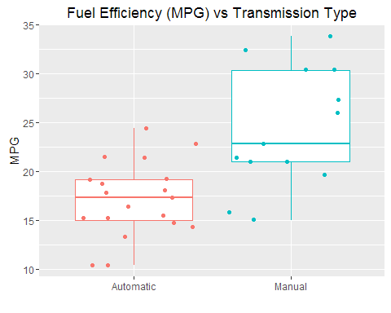

Figure 2: Pairs Plot 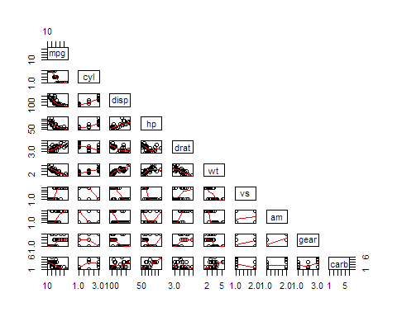

Figure 3: Correlation Matrix 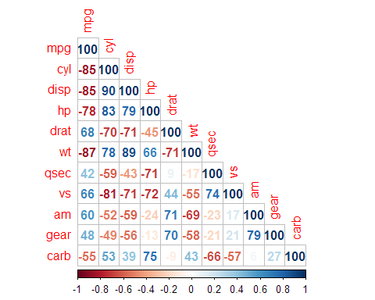

Figure 4: Residual Plots 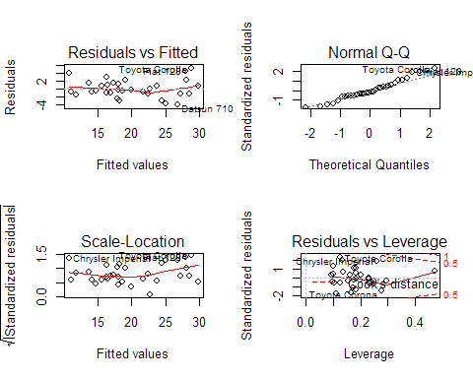

it) ```